Journaling has been a good tradition of self-awareness, personal development, and emotional knowledge. A desktop application would allow making this process in the digital age easier, more predictable, and informative. The given project will focus on creating a safe and convenient journaling tool that will enable users to record their daily experiences and monitor their moods, as well as structure their thoughts in the most efficient manner. The app will also aim to promote regular journaling, allow visual insights that are meaningful, and provide privacy by storing local data and authenticating it. The ability to customize the themes and organize the data makes it both practical and personalized, and the system will help a person interested in exploring his or her feelings and being able to stick to the journaling routine.
The project focuses on a single user desktop journalizing system that performs completely daily self- expression and emotional awareness. The system is developed to support users in:
- Developing a regular journalizing routine through streak monitoring and progress tracking.
- Collecting emotions in an organized way using clearly defined mood categorizations.
- Securing personal thoughts by storing data internally with secure access control
- Obtaining self- awareness by analyzing writing habits and emotional trends over time.

1.3 Project Objectives
- The primary objectives of this project are as follows:
- To develop a desktop journaling application leveraging the .NET MAUI framework.
- To enable users to create, view, update, and delete one journal entry per day, with automatic timestamps for creation and modification.
- To provide support for rich-text and Markdown formatting, allowing flexible and expressive content creation.
- To implement mood tracking, including one required primary mood and up to two optional secondary moods per entry.
- To allow users to categorize and tag journal entries using both custom and predefined options.
- To provide calendar-based and timeline/list navigation for efficient access to past entries.
- To implement search and filter functionality, enabling queries by date, content, mood, or tags.
- To monitor journaling consistency, tracking daily streaks, longest streaks, and missed days.
- The scope of this project includes the following features and functionalities:
- Implementation of secure authentication for users using a password or PIN.
- Management of daily journal entries, including creating, reading, updating, and deleting entries (one entry per day).
- Mood tracking with classification into Positive, Neutral, or Negative categories.
- Organization of entries through tags and categories, supporting both predefined and custom options.
- Provision of analytics and visual summaries, including insights into moods, tags, and writing trends.
- Ability to export journal entries as PDF files for selected date ranges.
- Local storage of all journal data using an SQLite database.
- Theme customization, allowing users to switch between light and dark modes for a personalized interface.

This application will be targeted at:
- People who need a privacy and confidentiality when documenting their daily activities and reflections.
- It can be used by students, professionals, and any other person who wants to cope with stress, consider the goals, or track the personal development.
- Users wishing to follow and study their emotional trends over a period of time.
- Individuals who like offline desktop programs to be able to have data privacy and control.
The main target of this application is the personal use of the application by single users and ease of use, confidentiality, and simplicity remains the primary focus.

Identification of Entity and Attributes
User (User_id, username, password_hash)
Journal Entry (Journal Entry_id, title, content, entry_date, entry_time)
Mood (Mood_id, mood_name, mood_type)
Tags (tag_id, name, is_predefined, created_at)
Category (category_id, name, description, created_at)
Streak_stats (Streak tracking_id, current_streak, longest_streak, last_ entry date, missed_days)
Export-Tracking (export-tracking_id, start_date, end_date, expored_at)
Application Settings (Application settings_id, theme, created_at, updated_at)

- One user can create many journal entries
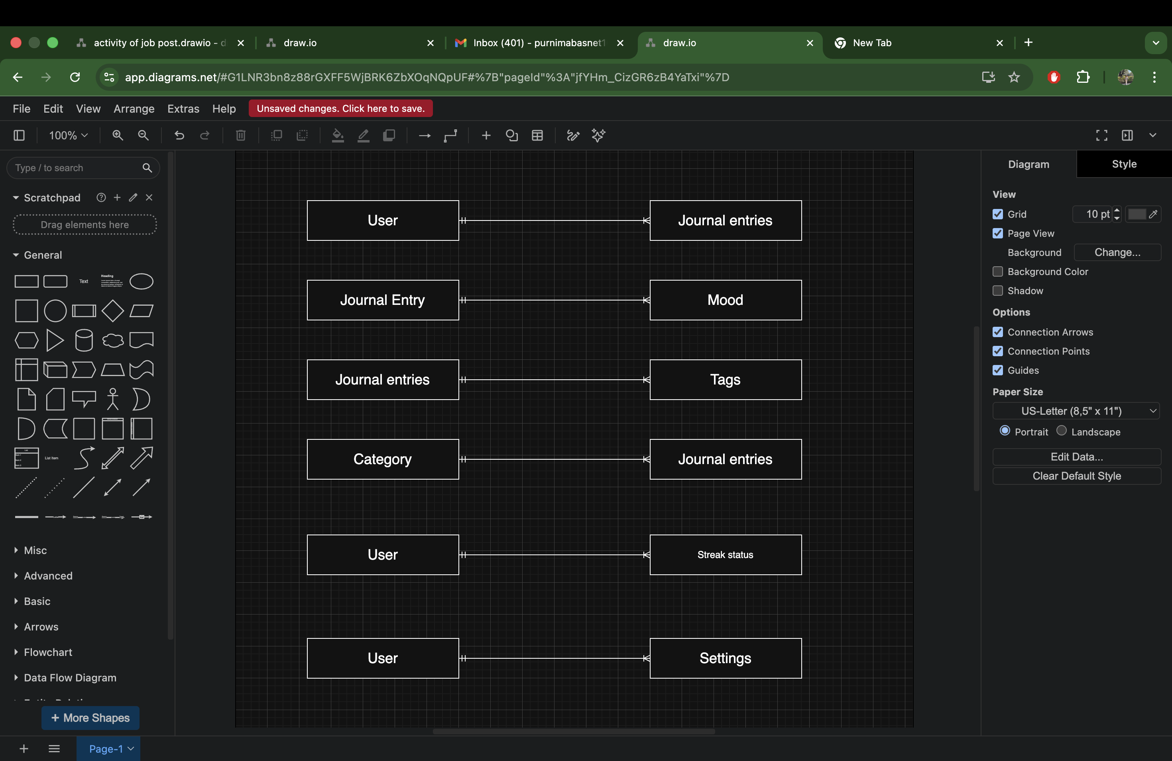
- One journal entry can have multiple mood
- A journal entry can have multiple tags
- One category contains many journal entries
- Each user has exactly one streak statistics record
- Each user stores one settings profile

