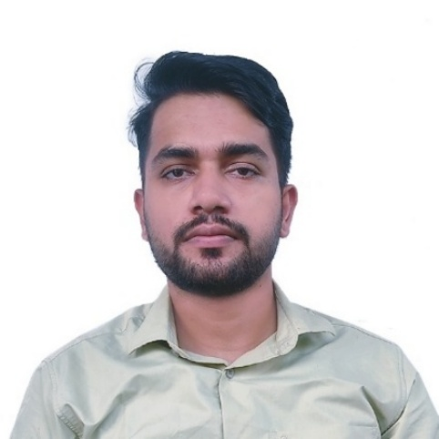
SUMAN REGMI
Full Stack Web Developer
I am a Full Stack Web Developer with a strong passion for technology and continuous learning. I am Skilled in building and debugging web applications, with a keen interest in exploring new areas of IT and enhancing problem-solving capabilities.

EXPERTISE
- Python
- Laravel
- Django
- MERN
- Next.js

LANGUAGE
- English
- Nepali
- Hindi

EDUCATION
- 2017 – 2019 Koshi St. James College
+2 in science
- 2020 – 2025 Koshi St. James College
Bachelor in Computer Application (BCA)

CERTIFICATE

- Web Development
Code IT, Nepal
- Laravel
Hunchha Digital, Itahari
- Django
Hunchha Digital, Itahari
- Other (Python, Git, React, bootstrap, etc.)
Udemy

WORK EXPERIENCE
Graphics Designer and IT Instructor 2020
Prime Cyber Cafe, Kathmandu
I worked as a photo and video editor and instructed the workers on technical problems.
While working at Prime Cyber Cafe, I also learned to interact with customers and the value of Time.
Online Jobs (part-time) 2019 - Present
I have been working on different online platforms for a long time. I have also worked in development of few web-based applications. I have worked as a content creator on YouTube and blogger. I have also worked as a freelancer in different freelancing platforms.
Jr. Full Stack Web Developer 2024
I worked as a Jr. Full stack web developer at Hunchha Digital, Itahari. My stacks were: Laravel (API, Sanctum, Socialite Package), React (Material UI, TypeScript, Redux, Axios)
Python Django Full Stack Mentor 2025
I have been working as a Python and Django Mentor as well as Full stack developer in Digital Pathshala Nepal, Itahari. I work on Django MVT as well as Rest framework APIs with implementation of DRF, RBAC, JWT, permissions, viewsets, serializers, custom validation,views, django-taggit, django-allauth and many more. The projects were deployed with cPanel, AWS.

Contact
Phone: +9779862364762
Email: regmisuman2019@gmail.com
GitHub: https://www.github.com/SumaniqueCode
Website: https://sumanr.com.np
Address: Itahari, Nepal

