Name:Purnima Basnet
ID :23056706
Section: L3C12

Creating a .NET Console App
Project Creation
- Starting a New Solution: Launch Rider and select New Solution.

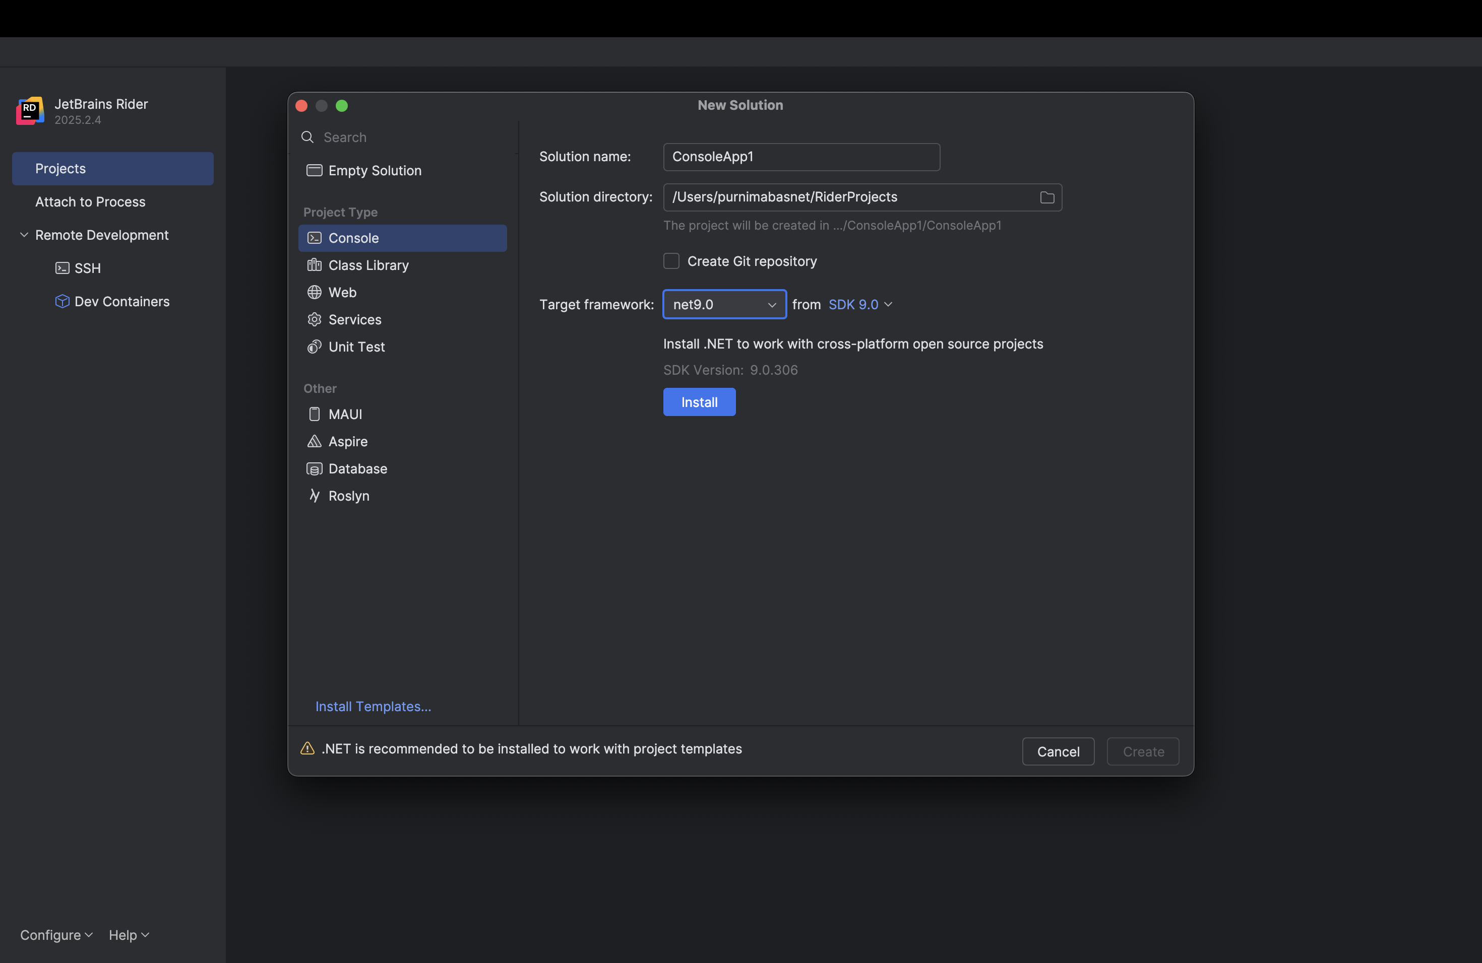

2. Choose Template: Select the Console Application template under the C# section.
Configure: Set the Project Name, Solution Name, and choose the Target Framework (.NET 9.0).
Create: Click Create

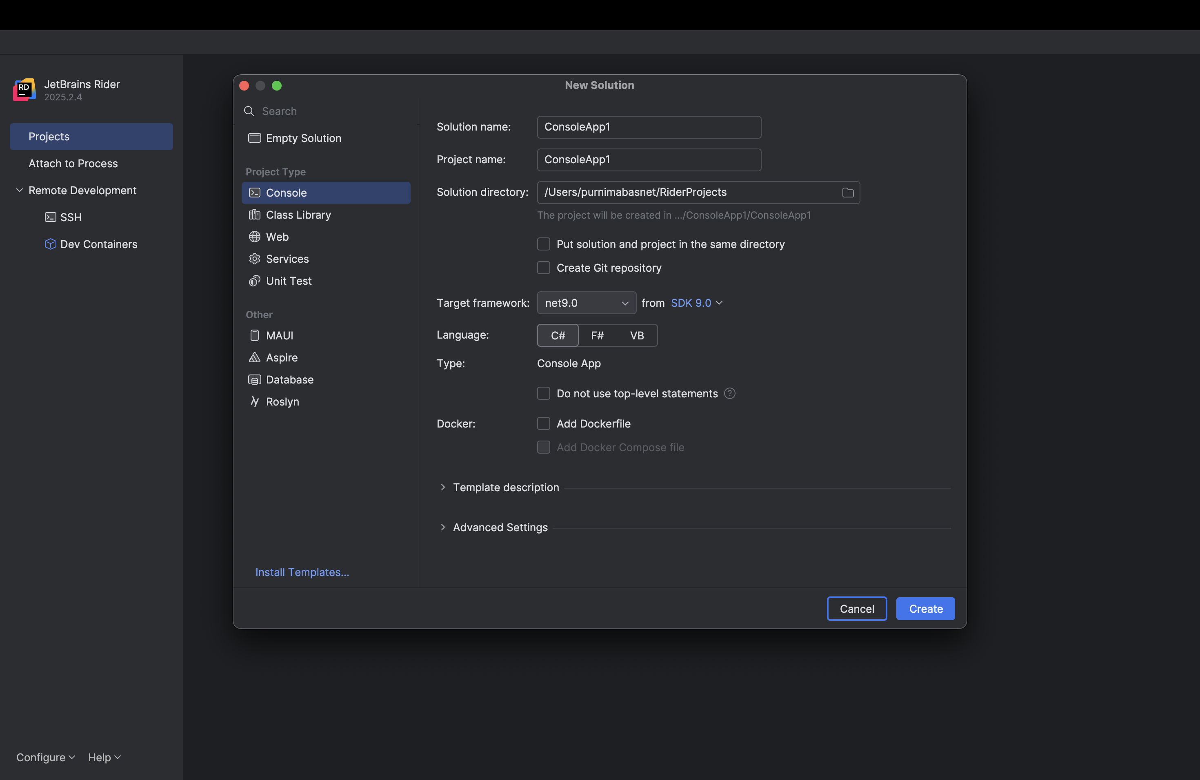

Running via the IDE
Open Program.cs : The default "Hello, World!" code should be displayed.
Run: Click the Run button in the top toolbar.

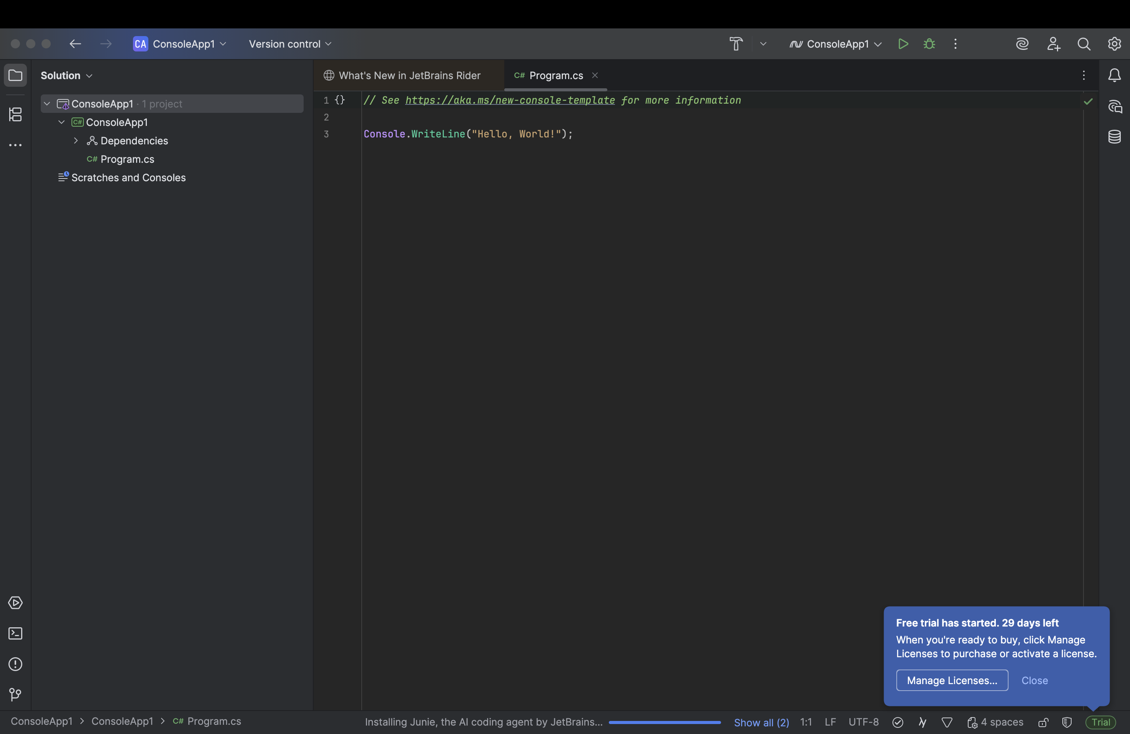
Check the Run Tool Window at the bottom of the IDE for the output.

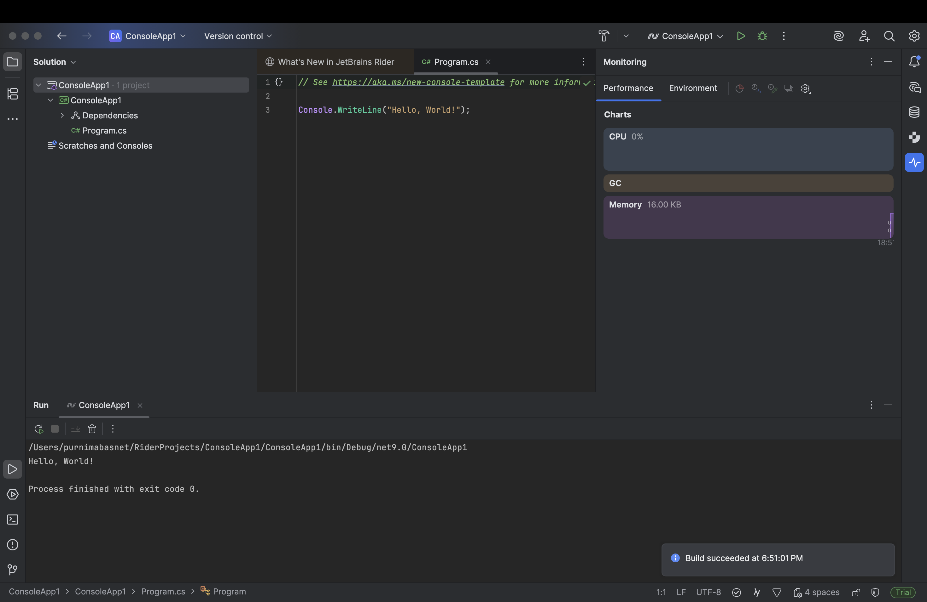

Running via the Command Line (CLI)
Open Terminal: Click the Terminal tab on the bottom-left of the IDE.
Navigate: Use the cd command to move into the specific project directory (the folder containing the .csproj file).

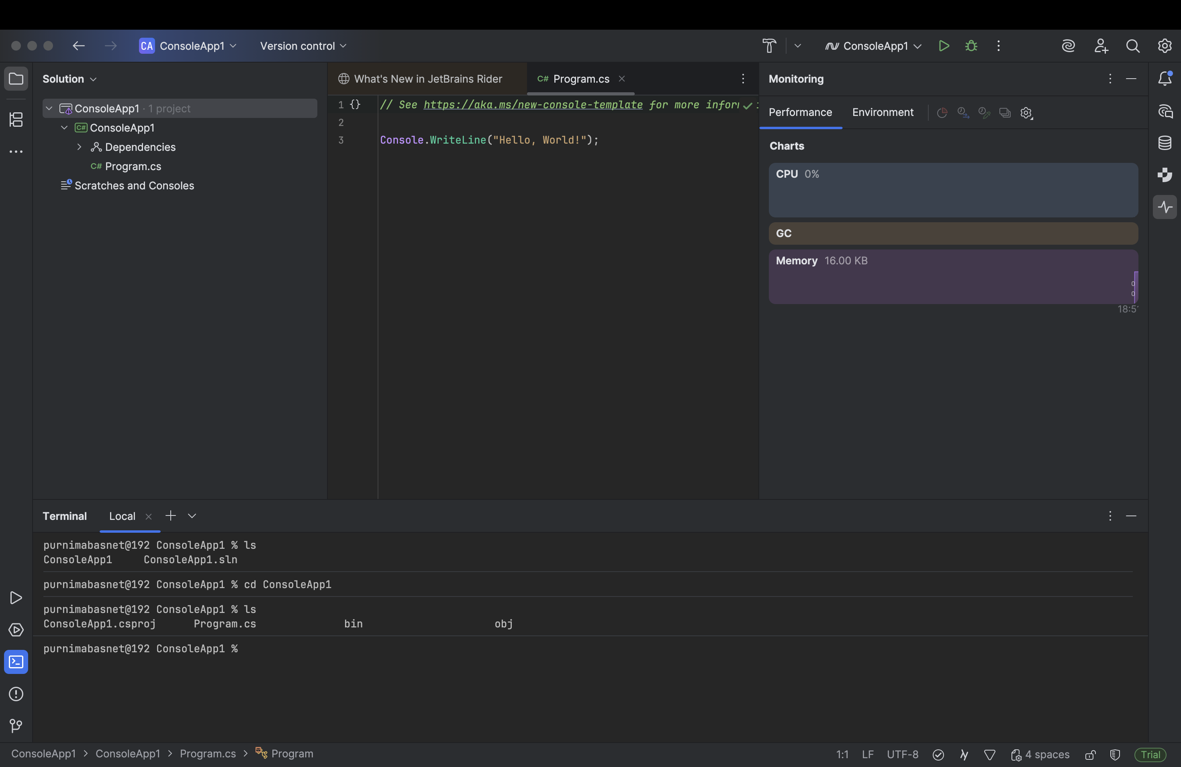

Execute: Run the command dotnet run.
Verify: The program output will appear directly in the terminal

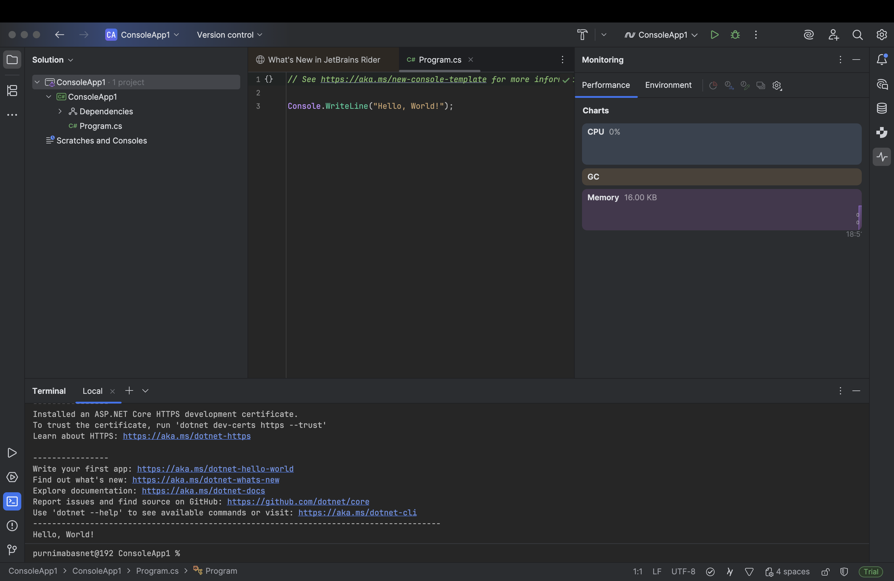

Step 1: Visit the Official Website

Go to the official JetBrains Rider download page:
👉 https://www.jetbrains.com/rider/
You will see download options for Windows, macOS, and Linux.

Step 2: Download Rider for macOS

Click on the macOS version and the installer package (.dmg file) will start downloading.
Wait until the download is complete.

Step 3: Open the Installer File

Once the download finishes:
Locate the .dmg file in the Downloads folder.
Double-click to open it.
You will see a window with the Rider icon and the Applications folder.

Step 4: Install Rider on macOS

Drag the Rider icon to the Applications folder to install it.
Wait for the copying process to complete.
Once installed, close the installer window and eject the Rider disk image.

Step 5: Launch JetBrains Rider

Open Finder → Applications → Rider.
Double-click on Rider to launch it for the first time.
macOS might show a security prompt – click Open to proceed.

Step 6: Activate Your License
Click Activate → JetBrains Account.
Log in with your educational email (e.g., .edu or .ac email).
Rider will automatically detect and activate your license.

Step 7: Install .NET SDK (if not installed)

Rider requires the .NET SDK to build and run C# programs.
Visit https://dotnet.microsoft.com/download.
Download the latest version of the .NET SDK for macOS (x64 or ARM64).
Open the downloaded .pkg file and follow the installation instructions.
Once installed, verify by opening Terminal and typing:
dotnet --version
If you see a version number, the installation was successful.

