- Write a report program to display below output and same output need to print in a smartform based on radio button selection.
Selection screen- Sales Org (VBAK-VKORG) Mandatory, single value, Creation Date (VBAK-ERDAT) Mandatory, Range
Two Radio Button - ALV Display and Form Display
Based on the selection fields below fields need to fetch and display
VBAK-VBELN, VBAP-POSNR, VBAP-MATNR,MAKT-MAKTX,VBAK-NEWR, VBAK-WAERK.

- Create a report

*&---------------------------------------------------------------------*
REPORT ZSALES_OOPS_ALV.
TABLES: vbak, vbap, makt.
TYPES: BEGIN OF ty_sales,
vbeln TYPE vbak-vbeln,
posnr TYPE vbap-posnr,
matnr TYPE vbap-matnr,
maktx TYPE makt-maktx,
netwr TYPE vbak-netwr,
waerk TYPE vbak-waerk,
END OF ty_sales.
DATA: it_sales TYPE STANDARD TABLE OF ty_sales,
wa_sales TYPE ty_sales.
* Selection Screen - enhanced
SELECTION-SCREEN BEGIN OF BLOCK blk1 WITH FRAME TITLE text-001.
PARAMETERS: p_vkorg TYPE vbak-vkorg OBLIGATORY.
SELECT-OPTIONS: s_erdat FOR vbak-erdat OBLIGATORY.
SELECTION-SCREEN COMMENT /1(50) text-003.
SELECTION-SCREEN END OF BLOCK blk1.
SELECTION-SCREEN BEGIN OF BLOCK blk2 WITH FRAME TITLE text-002.
PARAMETERS: r_alv RADIOBUTTON GROUP grp DEFAULT 'X',
r_form RADIOBUTTON GROUP grp.
SELECTION-SCREEN COMMENT /1(50) text-004.
SELECTION-SCREEN END OF BLOCK blk2.
* ALV Objects
DATA: o_alv_grid TYPE REF TO cl_gui_alv_grid,
o_container TYPE REF TO cl_gui_custom_container,
o_layout TYPE lvc_s_layo,
o_fieldcat TYPE lvc_t_fcat.
* Screen Container
DATA: ok_code TYPE sy-ucomm.
*---------------------------------------------------------------------*
* Event Handler Class for ALV Toolbar
*---------------------------------------------------------------------*
CLASS lcl_event_handler DEFINITION.
PUBLIC SECTION.
METHODS: handle_toolbar FOR EVENT toolbar OF cl_gui_alv_grid
IMPORTING e_object e_interactive,
handle_user_command FOR EVENT user_command OF cl_gui_alv_grid
IMPORTING e_ucomm.
ENDCLASS.
CLASS lcl_event_handler IMPLEMENTATION.
METHOD handle_toolbar.
" Add custom button only for ALV output
IF r_alv = 'X'.
APPEND VALUE #( function = 'MYBTN'
icon = '@01@'
text = 'Custom'
quickinfo = 'Custom Action' )
TO e_object->mt_toolbar.
ENDIF.
ENDMETHOD.
METHOD handle_user_command.
CASE e_ucomm.
WHEN 'MYBTN'.
MESSAGE 'Custom Button Clicked!' TYPE 'I'.
ENDCASE.
ENDMETHOD.
ENDCLASS.
DATA: lo_event_handler TYPE REF TO lcl_event_handler.
*---------------------------------------------------------------------*
* START-OF-SELECTION *
*---------------------------------------------------------------------*
START-OF-SELECTION.
SELECT a~vbeln b~posnr b~matnr c~maktx a~netwr a~waerk
INTO TABLE it_sales
FROM vbak AS a
INNER JOIN vbap AS b ON a~vbeln = b~vbeln
INNER JOIN makt AS c ON b~matnr = c~matnr
WHERE a~vkorg = p_vkorg
AND a~erdat IN s_erdat
AND c~spras = sy-langu.
IF r_alv = 'X'.
CALL SCREEN 100.
ELSE.
PERFORM call_smartform.
ENDIF.
*---------------------------------------------------------------------*
* MODULE status_0100 *
*---------------------------------------------------------------------*
MODULE status_0100 OUTPUT.
SET PF-STATUS 'STANDARD'.
SET TITLEBAR 'ALV DISPLAY'.
ENDMODULE.
*---------------------------------------------------------------------*
* MODULE display_alv_oops *
*---------------------------------------------------------------------*
MODULE display_alv_oops OUTPUT.
IF o_container IS INITIAL.
CREATE OBJECT o_container
EXPORTING container_name = 'ALV_CONTAINER'.
CREATE OBJECT o_alv_grid
EXPORTING i_parent = o_container.
PERFORM build_fieldcatalog.
o_layout-zebra = 'X'.
" Register event handler
CREATE OBJECT lo_event_handler.
SET HANDLER lo_event_handler->handle_toolbar FOR o_alv_grid.
SET HANDLER lo_event_handler->handle_user_command FOR o_alv_grid.
CALL METHOD o_alv_grid->set_table_for_first_display
EXPORTING
is_layout = o_layout
CHANGING
it_outtab = it_sales
it_fieldcatalog = o_fieldcat.
ENDIF.
ENDMODULE.
*---------------------------------------------------------------------*
* MODULE user_command_0100 *
*---------------------------------------------------------------------*
MODULE user_command_0100 INPUT.
CASE sy-ucomm.
WHEN 'BACK' OR 'EXIT' OR 'CANCEL'.
SET SCREEN 0.
LEAVE SCREEN.
ENDCASE.
ENDMODULE.
*---------------------------------------------------------------------*
* FORM build_fieldcatalog *
*---------------------------------------------------------------------*
FORM build_fieldcatalog.
DATA: ls_fcat TYPE lvc_s_fcat.
CLEAR o_fieldcat.
ls_fcat-fieldname = 'VBELN'.
ls_fcat-scrtext_m = 'Sales Doc'.
APPEND ls_fcat TO o_fieldcat.
ls_fcat-fieldname = 'POSNR'.
ls_fcat-scrtext_m = 'Item'.
APPEND ls_fcat TO o_fieldcat.
ls_fcat-fieldname = 'MATNR'.
ls_fcat-scrtext_m = 'Material'.
APPEND ls_fcat TO o_fieldcat.
ls_fcat-fieldname = 'MAKTX'.
ls_fcat-scrtext_m = 'Description'.
APPEND ls_fcat TO o_fieldcat.
ls_fcat-fieldname = 'NETWR'.
ls_fcat-scrtext_m = 'Net Value'.
APPEND ls_fcat TO o_fieldcat.
ls_fcat-fieldname = 'WAERK'.
ls_fcat-scrtext_m = 'Currency'.
APPEND ls_fcat TO o_fieldcat.
ENDFORM.
*---------------------------------------------------------------------*
* FORM call_smartform *
*---------------------------------------------------------------------*
FORM call_smartform.
DATA: fm_name TYPE rs38l_fnam.
CALL FUNCTION 'SSF_FUNCTION_MODULE_NAME'
EXPORTING
formname = 'ZSMART_SALES_DISPLAY'
IMPORTING
fm_name = fm_name.
CALL FUNCTION fm_name
EXPORTING
it_sales = it_sales
EXCEPTIONS
others = 1.
ENDFORM.

- Go to se80 open your program expand it right click on program create screen give screen number In the Element List, add:
- A Custom Control named ALV_CONTAINER.
- A GUI Status (e.g., STANDARD) with buttons like BACK, EXIT, CANCEL.
- In the Flow Logic, add:

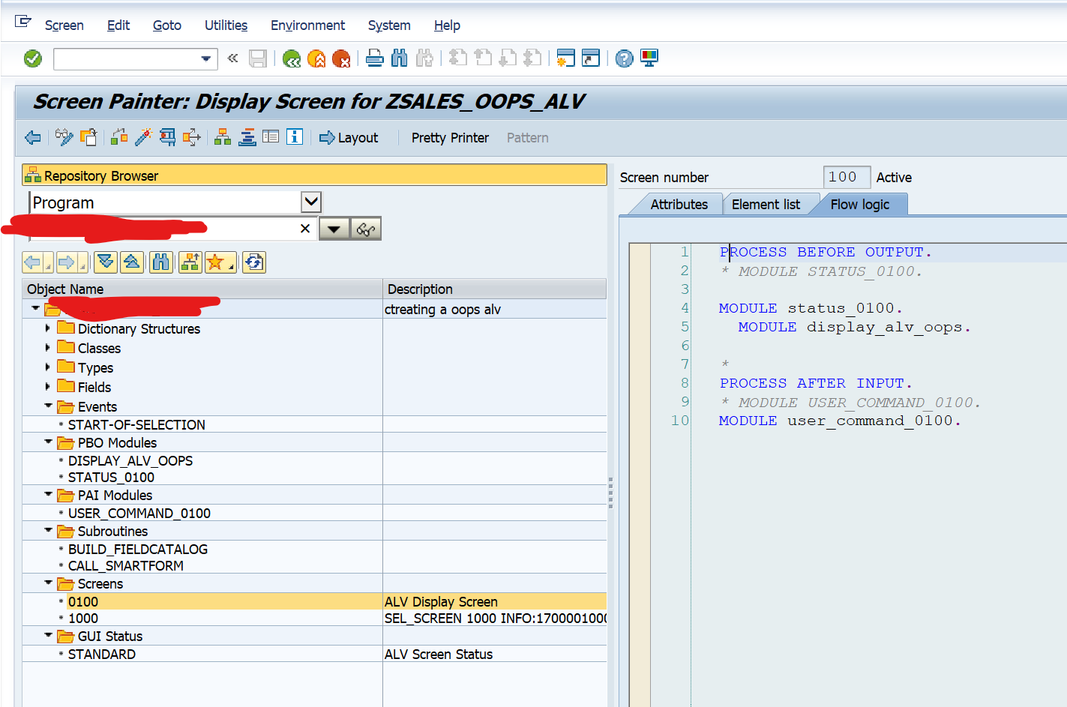

Create the Smartform
- Go to Transaction SMARTFORMS.
- Create a new Smartform (e.g., ZSMART_SALES_DISPLAY).
- In Global Definitions:
  - Create a Table Type parameter IT_SALES of type TABLE OF TY_SALES.
- In Main Window:
  - Create a Table.
  - Bind it to IT_SALES.
  - Add columns for VBELN, POSNR, MATNR, MAKTX, NETWR, WAERK.
- Save and activate the Smartform.

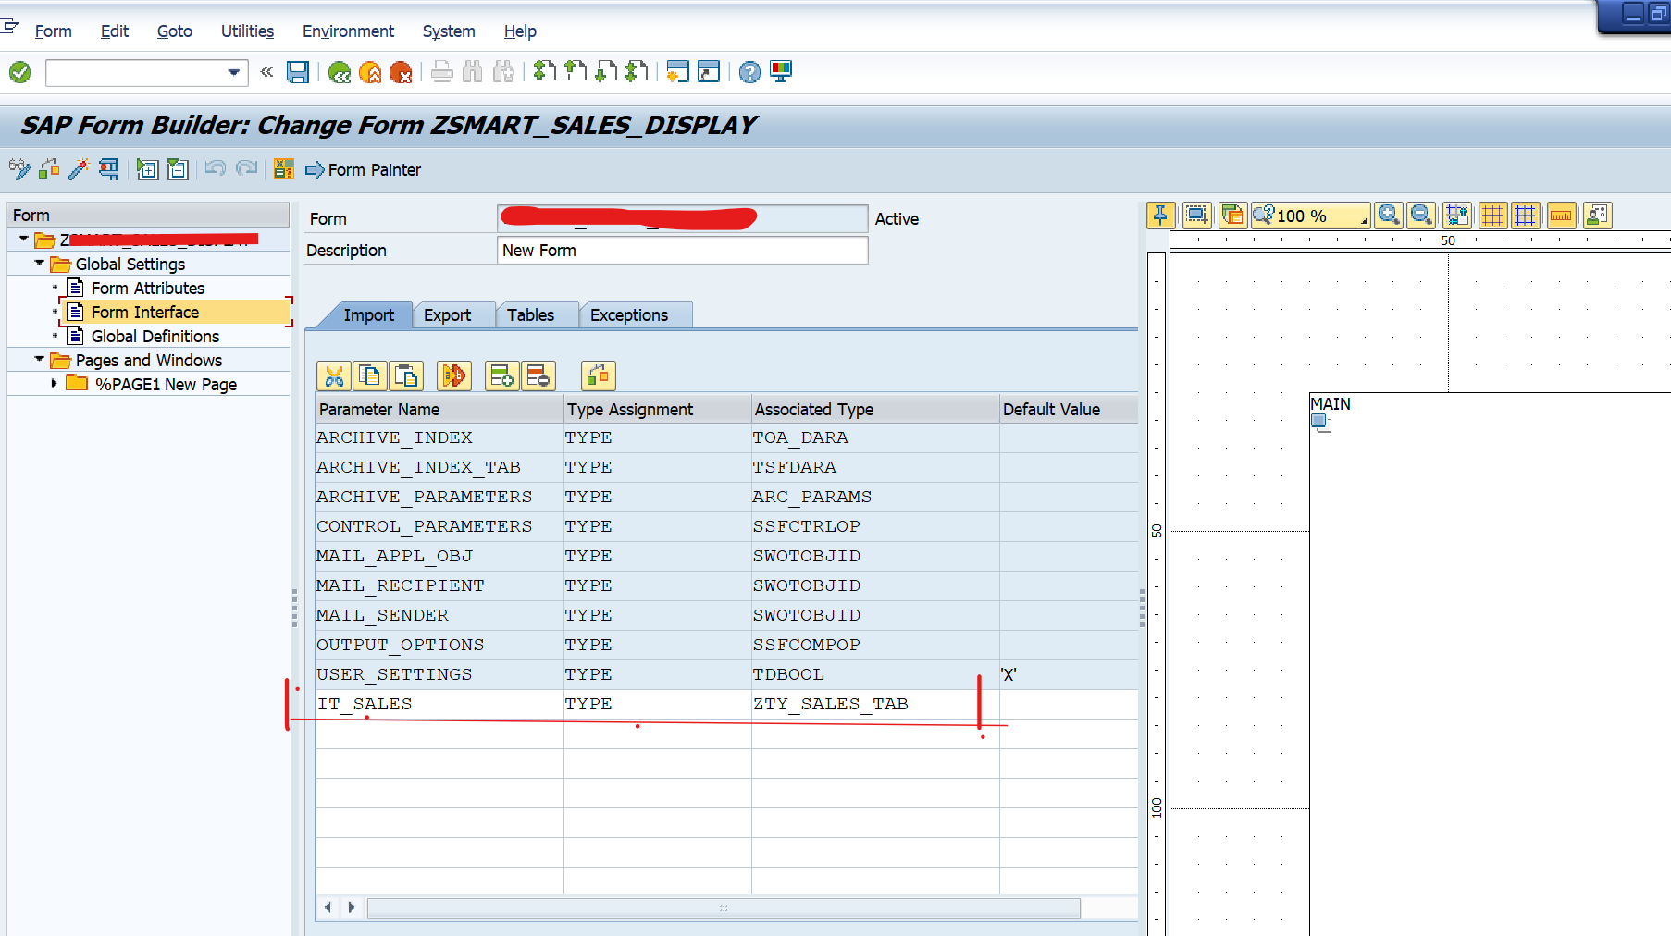

Step-by-Step in SE80:
- Open your program ZSALES_OOPS_ALV in SE80.
- Expand the GUI Status node under your program.
- Right-click → Create GUI Status.
- Enter:
  - Status Name: STANDARD
  - Short Description: ALV Screen Status
- In the Function Keys tab, add:
  - F3 → Function Code: BACK
  - F12 → Function Code: CANCEL
  - F15 → Function Code: EXIT
- Save and activate the GUI status.

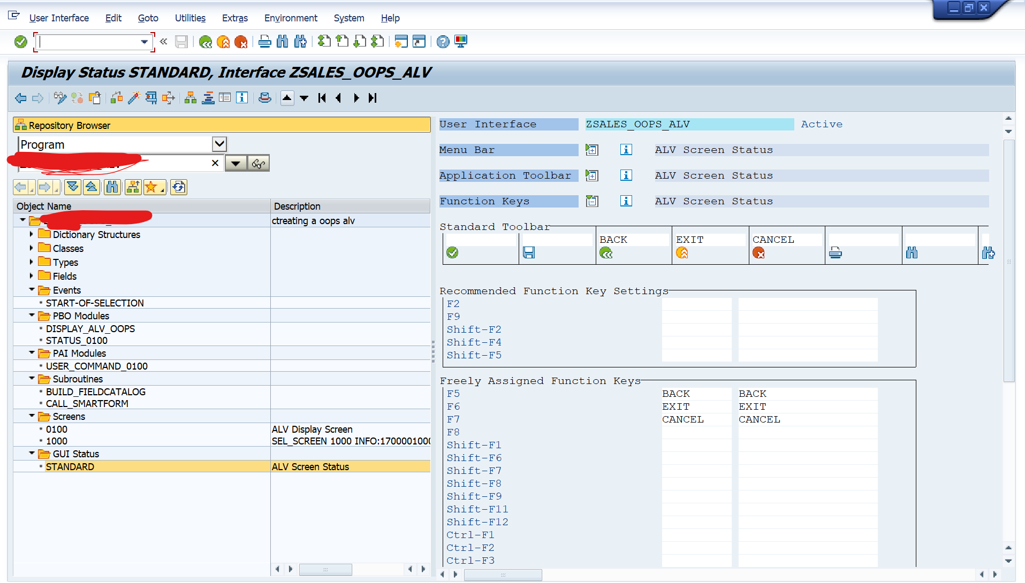

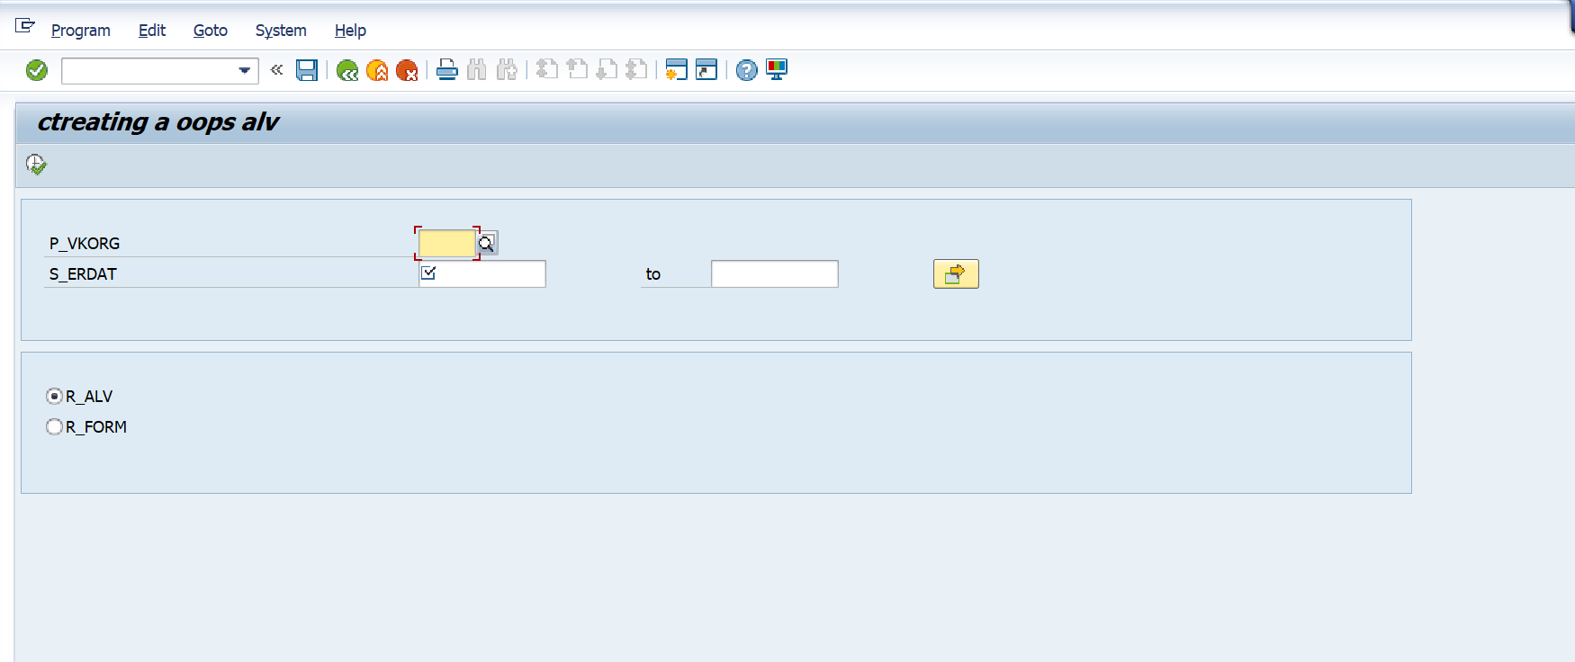
- Sorting in ascending order
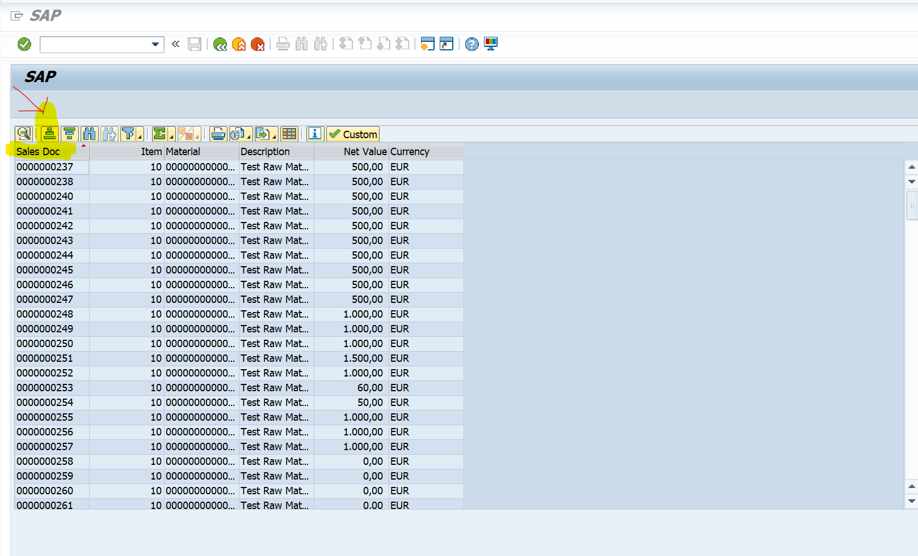
- Sorting in descending order
