- How to secure form submision?
Many way to make you form more secure;
- Use htaccess, make your website can not to access your file directly.
- Use form validation, better practices with this, create to all side. I mean create to client side and server side.
- Don't always use "Get", use this as last option.
- Use security like xss, csrf to handle injection etc.
- Use recaptcha.
- Use 2-Factor Authentication in Login form.
- Encrypt your data when you execute.

- How would you optimize your a website's assets/resource?
- Name the assets.
- Use a CDN (content delivery network).
- Host assets on different domains but reduce dns lookups.
- Place assets on a cookie-free domain and split the assets among domains.
- Use CSS Sprites.
- Disable etags.
- Use and implement features page speed from google developer.
- Implement progressive css in frontend side to increase speed page.
- Compress and optimize the image before you upload to website. Usually i use tinypng.com

- What UI, Security, Performance, SEO, Maintainability or Technology considerations do you make while building a web application or site ?
- UI: I like minimal UI which contains only what it should. I believe it results in the better user experience, as a user knows what to do intuitively.
- Security: I always try to make both frontend and backend secure, concerning CSRF, XSS, etc.
- Performance: I consider space and time complexity for the algorithms and logics I use and write.
- SEO: Set meta tags for search engines and consider and consider server-side rendering for SPA.
- Maintainability: Try to keep the source code consistent and make objects immutable. Use statically typed languages such as TypeScript. Use CI with tests and lints.
- Technology: I like to learn new technologies, but if the project is in production, I would consider using technologies which is well-documented and widely used.

- What do you know about Design Pattern ?
- Singleton
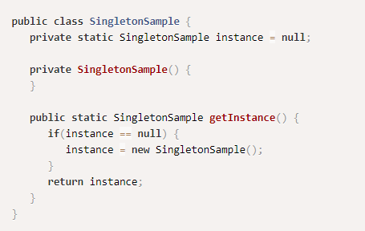
- Initialization on demand holder
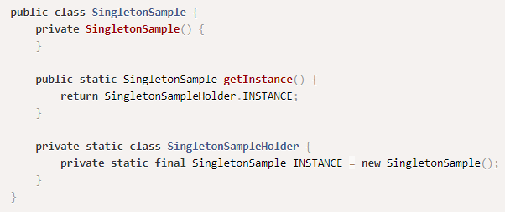
- The strategy and the factory pattern
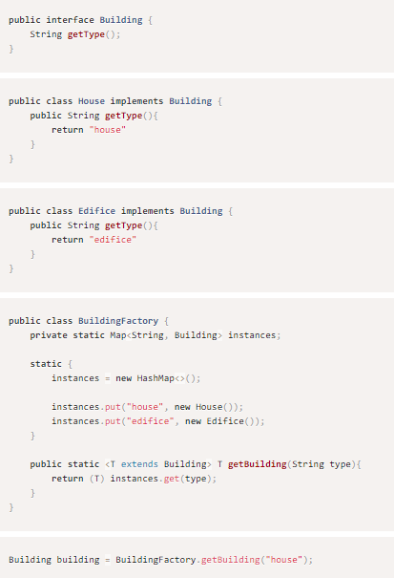
- Fluent builder
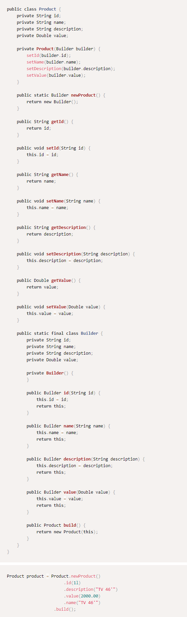
- Chain of responsibility
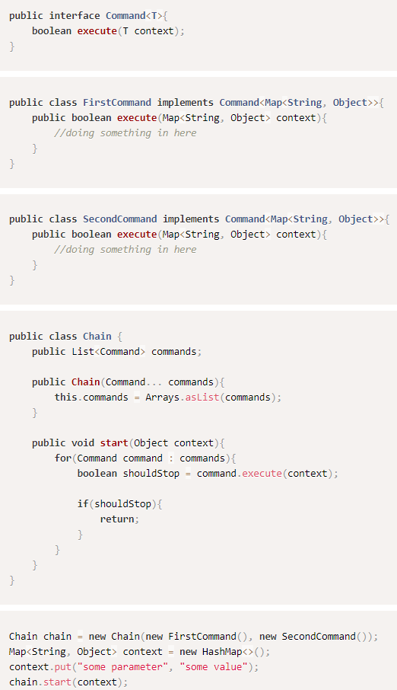
- Template method
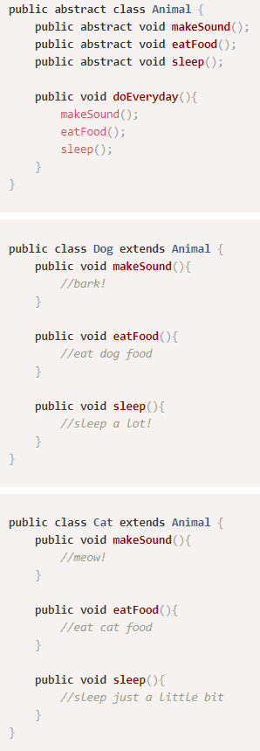
- State pattern
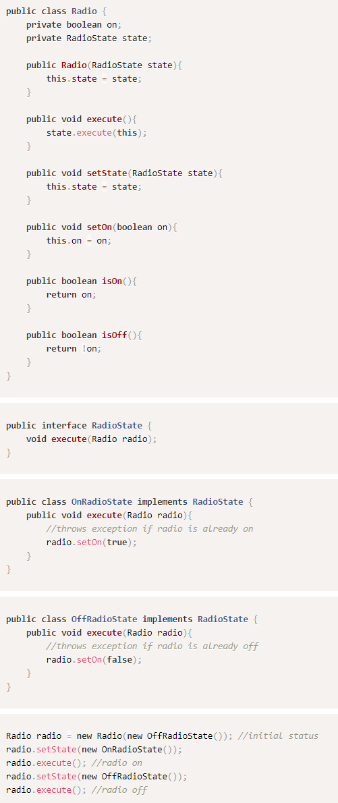
- What are HTTP methods?
Several ways for request-response between a client and server
List HTTP methods:
1. GET = Request data/retrieve data
2. POST = Used for send data to the server
3. PUT = Replace/update all current resource
4. DELETE = Remove all Current resource
5. HEAD —-> same with a get but transfers the status line and header section only
6. TRACE —> perform a message loop-back test along the path to the target resource

- Database: What is the difference between a View and a Table?
- Table = Table stores the data in database and contains the data.
- View = View is an imaginary table, contains only the fields(columns) and does not contain data(row) which will be framed at run time Views created from one or more than one table by joins, with selected columns

- What’s Two Factor Authentication? How would you implement it in an existing web application ?
Two Factor Authentication is an extra layer of security that is known as "multi factor authentication" that requires not only a password and username but also something that only, and only, that user has on them
Ex: - question
- physical token
- etc
How to implement?
Usually two factor authentication will be implement in login feature using 3rd party such as Google authenticator, Facebook SMS ,etc

The flow :

Without 2FA
Input username & password in login page—> login handler —> to homepage

With 2FA
Input username & password in login page —-> primary login handler —-> 3rd Party —-> secondary login handler —-> to homepage

