CloudPi Master Service Account (MSA) Creation
Two ways to provide cloud credentials: Access Keys and Instance Profile (keyless)

Overview
A Master Service Account (MSA) is a domain-level cloud credential that CloudPi uses to collect data (billing, recommendations, automation). You create an MSA once and reuse it across projects. AWS MSAs support two authentication methods:
- Access keys (IAM) — a static Access Key ID + Secret Access Key.
- Instance profile (keyless) — uses the IAM role attached to the EC2 host running CloudPi; no static secrets.
Create or manage MSAs from Admin Settings → Service Accounts → Master Accounts, or inline while onboarding a cloud (the AWS wizard's Credentials step).

Common steps (both methods)
- Admin Settings → Service Accounts → Master Accounts → Create MSA (or Create New MSA in the cloud wizard).
- Basic Information: give the MSA a unique Name, choose Cloud Provider = AWS, and select the Service Types it may perform (Billing, Recommendations, Automation).
- Click Next to the Credentials step and choose an AWS Authentication method (below).
- Click Test Connection, confirm success, then Create MSA / Update MSA.

Method A — Access keys (IAM)
Use when CloudPi is not on EC2, or when you prefer explicit credentials. Required for AWS billing (CUR/FOCUS) data collection.
- Select AWS Authentication → Access keys (IAM).
- Enter Access Key ID and Secret Access Key for an IAM user (or role) that can read the billing S3 bucket.
- Enter the Region.
- Optional (cross-account): Target Account ID, Role ARN, and External ID if CloudPi must assume a role in another account.
- Test Connection → Create MSA.
Permissions the credential needs: s3:GetObject, s3:ListBucket, s3:GetBucketLocation on the billing bucket (and bucket/*), plus ce:GetCostAndUsage / ce:GetCostForecast / ce:GetDimensionValues / ce:GetTags for Cost Explorer data.

Method B — Instance profile (keyless)

Prerequisites for keyless
- The CloudPi EC2 instance must have an IAM instance profile (role) attached.
- IMDSv2 hop limit must be at least 2. CloudPi runs in a Docker container (one extra network hop); with the default hop limit of 1 the container cannot read instance credentials and you will see 'No IAM role credentials found'.
aws ec2 modify-instance-metadata-options \
--instance-id <cloudpi-ec2-instance-id> \
--http-put-response-hop-limit 2 --http-tokens required --http-endpoint enabled

Cross-account assume-role (keyless + Role ARN)
To have the instance profile assume another role (entered as Role ARN, with Target Account ID), both sides must agree:
- Target role TRUST policy must allow the CloudPi host's instance-profile role to assume it. For a self-assume (Role ARN = the host's own role), add that role's own ARN as a trusted principal in a statement with NO ExternalId condition (otherwise the assume is rejected unless CloudPi sends a matching External ID).
- The instance-profile role must have an identity policy granting sts:AssumeRole on the target Role ARN.
// target role trust — allow self/host assume (no condition):
{ "Effect":"Allow",
"Principal":{ "AWS":"arn:aws:iam::<ACCOUNT>:role/<host-role>" },
"Action":"sts:AssumeRole" }

// host role permission policy:
{ "Effect":"Allow", "Action":"sts:AssumeRole",
"Resource":"arn:aws:iam::<ACCOUNT>:role/<target-role>" }

Use when CloudPi runs on AWS EC2 with an attached IAM instance profile. No secrets are stored — CloudPi reads temporary credentials from the instance.
- Select AWS Authentication → Instance profile (keyless). The Access Key / Secret fields disappear.
- The fields to be entered: Region, and Target Account ID (account ID of the EC2), Role ARN (role assigned to EC2)
- , External ID.
- Test Connection → Create MSA.

Choosing a method
Keyless: No secrets to rotate; best when CloudPi runs on EC2 in the same or a connected account. Good for connection/recommendation roles.
Access keys: Portable and explicit; currently required for AWS billing (CUR/FOCUS) data collection.

Editing an MSA
Service Accounts → Master Accounts → (pencil) Edit. Secrets are hidden for security; leave credential fields blank to keep existing values, or enter new ones to rotate. Use Test Connection before Update MSA.

Troubleshooting
“No IAM role credentials found” (keyless): No instance profile attached to the EC2, or the IMDSv2 hop limit is 1 — attach a role and set hop limit ≥ 2.
“AssumeRole denied … check the role ARN and trust policy”: The target role's trust does not allow the host identity, the host role lacks sts:AssumeRole, or an ExternalId condition is blocking the assume. Fix the trust/permission as above.
“Invalid credentials / AWS Access Key ID is required” on billing: The billing path requires an access-key MSA — create the MSA with Method A (Access keys) for billing.

Appendix:

Screeen shots of Keyless config prerequisites
- Go to instances select the EC2 instance Actions Instance settings Modify instance metadata options
  - 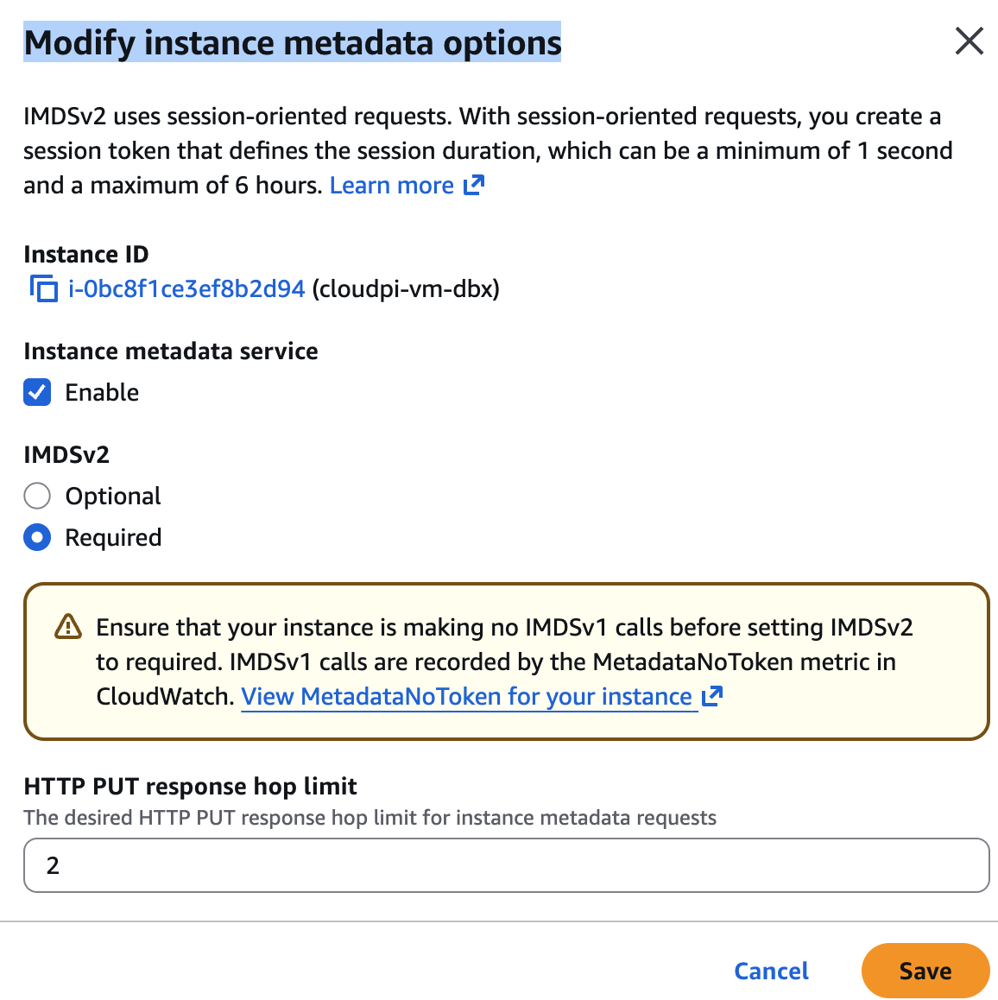
- Go to IAM Roles select the role assigned to EC2 Trust relationships – then paste or append theequivalent of this Json snippet
{
"Version": "2012-10-17",
"Statement": [
{
"Effect": "Allow",
"Principal": {
"Service": "ec2.amazonaws.com"
},
"Action": "sts:AssumeRole"
},
{
"Effect": "Allow",
"Principal": {
"AWS": "arn:aws:iam::<Account id>:role/cloudpi-ec2-role"
},
"Action": "sts:AssumeRole"
}
]
}
- This step is to add a org read permission
Go to IAM Roles select the role assigned to EC2 Add Permission Create inline policy select JSON give unique name create policy. (you can create two different policies, one for each block of code if preferred for cleaner look and one permission covered per policy)
  - This will create a policy as below in Json (verify)

{
"Version": "2012-10-17",
"Statement": [
{
"Sid": "VisualEditor0",
"Effect": "Allow",
"Action": [
"sts:GetSessionToken",
"sts:GetDelegatedAccessToken",
"sts:DecodeAuthorizationMessage",
"sts:GetWebIdentityToken",
"sts:TagGetWebIdentityToken",
"sts:GetAccessKeyInfo",
"sts:GetCallerIdentity",
"sts:GetServiceBearerToken"
],
"Resource": "*"
},
{
"Sid": "VisualEditor1",
"Effect": "Allow",
"Action": "sts:*",
"Resource": "arn:aws:iam::<Account ID>:role/cloudpi-ec2-role"
},
{
"Sid": "OrganizationsRead",
"Effect": "Allow",
"Action": [
"organizations:ListRoots",
"organizations:ListAccounts",
"organizations:DescribeOrganization",
"organizations:DescribeAccount",
"organizations:ListOrganizationalUnitsForParent",
"organizations:ListAccountsForParent",
"organizations:ListChildren"
],
"Resource": "*"
}
]
}

