**Exercise1**

** Click on following link to get all the datasets required for this exercises [https://github.com/PurpleGrad/2203/blob/main/Dataset%20for%20Exercise1.zip](https://github.com/PurpleGrad/2203/blob/main/Dataset%20for%20Exercise1.zip%20)

1. For this Exercise use the **Movies with sequels** dataset from the given link

Create a new Power BI Desktop file, and get a list of the top films sequels, as rated by IMDB

Create a table to look something like this:

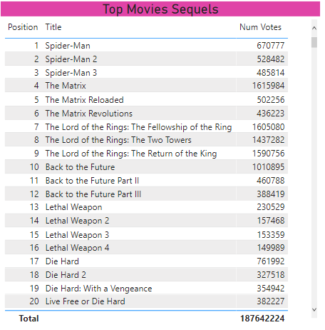

*The films are in position order, and the table has a title and IMDB Ratings.*

Also try to show the above data in one of the chart.

Save this Power BI file with the name **Movies and Sequels**, then exit this instance of Power BI Desktop.

**2)** Using the **Age specific Genres.xlsx** file in the above Link create a matrix showing the **Count** of films by **Certificate** rating and **Genre:**

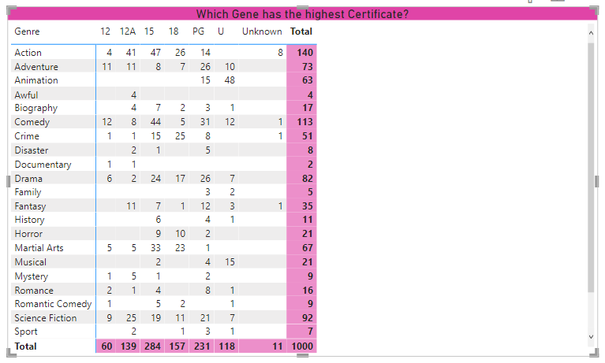

Now Create a bar chart showing above data.

 save this report as **Still a better matrix than reloaded.pbix** and close it down.

**3)** For this Exercise use the **GOT** dataset from the given link

Create a new Power BI report, and load into it data from both worksheets in the workbook in the folder above:

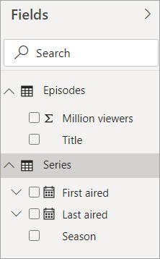

*Hide some columns, and rename the U.S. viewers (millions) column to get a tidier data model, as shown here.*

Create a table to show average viewers by season:

Delete the extra date hierarchy fields added by Power BI to show the average viewers by season/year:

*A table showing the average number of viewers of Games of Thrones episodes by season and year..*

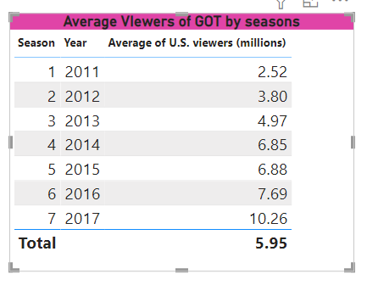

*These are suggestions only! Someone has made changes to parts of the****Title****,****Total****and****Column headers****format sections for the table.*

Now create a Pie chart showing Average viewers by Year.

Save this report as **GOT it.pbix**, then close it down.

**4)** For this Exercise use the **Top Websites** dataset from the given link

Create a matrix analysing these as follows:

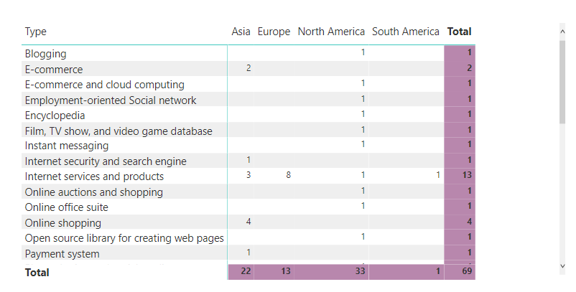

*This matrix has a title and coloured totals.*

On another page, create a matrix summarising the number of websites by continent and country:

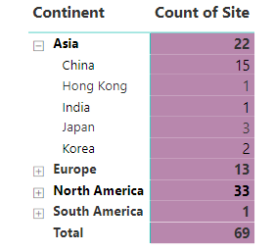

*The expand/collapse icons should be added automatically when you include more than one row field in your matrix.*

Save this report with the **Top Website.pbix**, then close it down.

**5)**

The Link folder contains 3 files: two in CSV format and one in Excel.  Create a new Power BI report, and load these 3 files : Director ,Genre and Netfilx titles

Rename the fields in the field well to make it more obvious what they represent:

Create a table listing out the Genre:

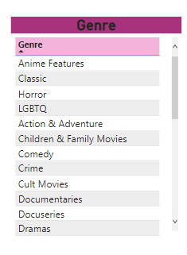

*A table listing the Genre - feel free to do your own thing with the formatting.*

Now create another table to list out the Directors using the same look-and-feel:

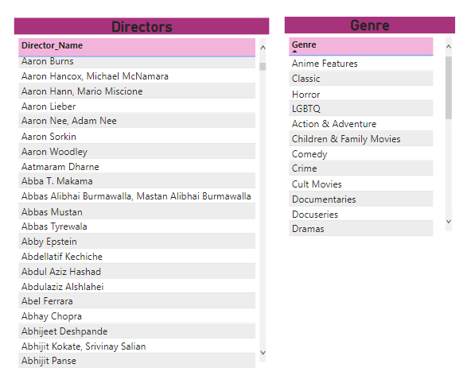

*Remember that you can use the****Format Painter****tool to copy the formatting from one visual to another!*

Create a third table to list out the films made by the director (or genre) that you've selected:

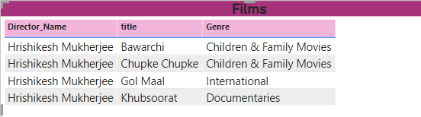

*The list of films you should see when you click on****Hrishikesh Mukherjee****.*

Save this report as **Gol Maal**, then close it down.

**6)** Create a new Power BI file, and connect to **Construct-a-Creature** database from sqlserver.

Now load the following tables:

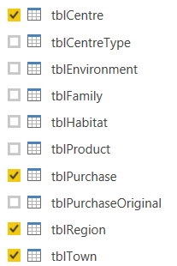

*Choose the tables shown to load into your model.*

Hide columns and tables so that you see a tidier list of fields:

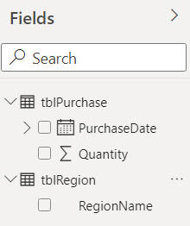

*This is what Microsoft call the "field well".*

Create a matrix showing the average quantity sold by year/quarter and region:

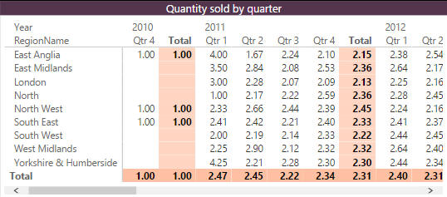

*Note that the averages are formatted to two decimal places.*

Also try to show the data in any of the chart format . Save this Power BI file with the name **That was easy**, then exit this instance of Power BI Desktop.

**7)** Create a new Power BI report.  Load the **world events** worksheets from the workbook in the above folder, and use them to create a data model:

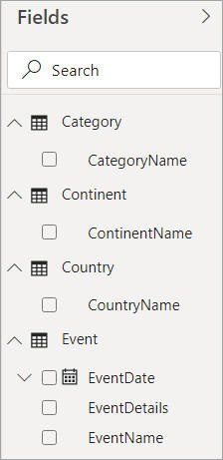

*Your data model should only include columns you might want to display in reports.*

Now create a slicer and matrix, such that when you click on a continent (such as **Asia** for this example) you see the number of events in each of its countries, by year:

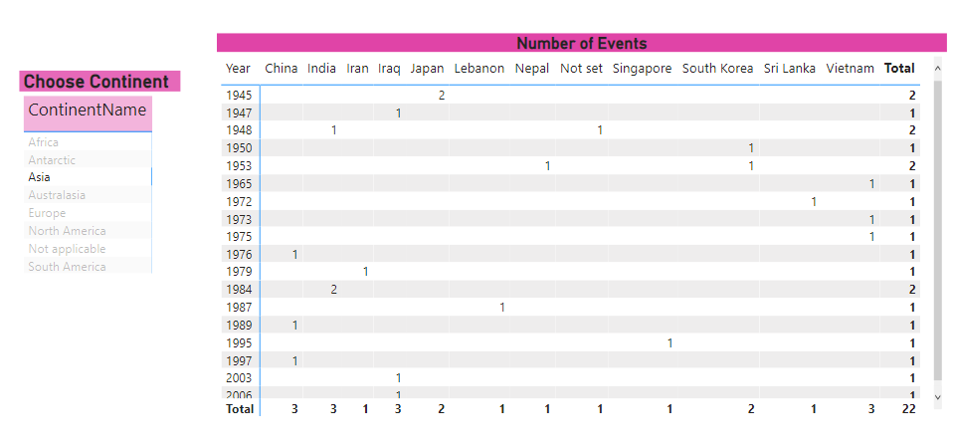

*Your matrix should count the number of events for each year and country.*

Save this report as **Out of Asia**, then close it down

**8)** For this Exercise use the **List of Songs** dataset from the given link

Create a new report:

Give the song title and release year columns in the imported table better names

Create a column chart to compare the number of Arijeet sings songs released in each year

 Save your report as **Arijeet Special**, then close it down.