***\*\* To submit all this Exercise Create a Single word file and copy all your scripts along with screenshot of the Output. And Share it on nehalole1115@gmail.com***

* 1. If you haven't already done so, run the script in the folder above to generate the **Doctor Who**database.

Create a query linking these two tables:

Add filters to your query so that it shows who wrote the "special" episodes (there should be 13 listed out, of which the first few in alphabetical order are shown below):

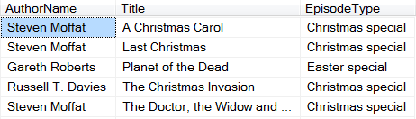

Save this query as **No joins necessary**, then close it down.

* 1. Right-click on a new query, then create this query:

*Choose to show the country name, event name and event date in ascending date order, giving aliases to each column.*

you should see this:

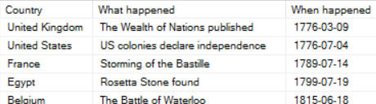

*The first few events listed.*

Save this query as **Superb Quality Layout**, then close it down.

3) If you haven't already done so, run the script in the folder above to generate the **Doctor Who**database.

Each episode in the database has assigned to it the doctor who played the starring role:

Create a join to list out all of the doctors who appeared in episodes made in 2010.  As a help, here's the syntax of an inner join:

When you run your query, you should see that all but one of the 15 episodes made in this year starred **Matt Smith**:

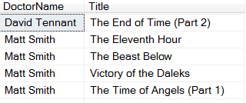

Save your query as **David and Matt**, then close it down.

Write a query to show all of the authors who have written episodes featuring the Daleks

You should find that there are 16 such episodes!

When you've finished, save this as **Enough joins for now**, then close it down.

4)Create a query to list out the appearances of enemies in episodes which have length under 40 characters, where the length is defined as the sum of:

* the number of characters in the author's name;
* the number of characters in the episode's title;
* the number of characters in the doctor's name; and
* the number of characters in the enemy's name.

This should reveal two episodes:

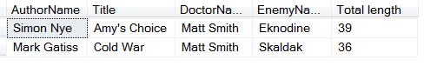

*The two episodes which make it under the very low bar.*

You are now a master (or mistress) of joins!  Save this as **Time for a coffee**, then close it down.

5)If you haven't already done so, run the script in the above folder to generate the Doctor Who database.

Use this to list the names of the companions who haven't featured in any episodes.  You should find there's one of them, but we won't spoil the surprise by saying who it is!

Save this query as **outre.sql**(that's neither a misspelling nor a funny joke), and close it down.

1. The aim of this exercise is to find **this**and **that**in the **EventDetails** column (in that order).  Your final query should show this:

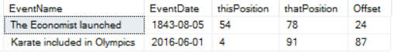

You should find the **CHARINDEX**function useful.

This would return 8, since **Trump** begins in **Donald Trump** at the 8th character (starting from 1).

When you've got this working (and it's fiddly), save this as **This and that**, then close it down.

1. Create a query to show the full dates for any event:

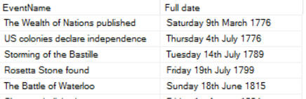

Save this query as **Query suffices**(marvelling at the wordplay involved in the title), then close it down.

8) First create a query showing events which took place in your year of birth, neatly formatted.

This should give you something like this:

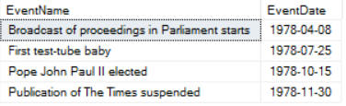

*These are the events for 1978, the second-best year to be born in.*

Amend your query so that it shows the event date neatly formatted:

* Once using the **FORMAT** function; and
* Once using the **CONVERT** function.

Here's what the final results should look like (don't forget, your events will be different):

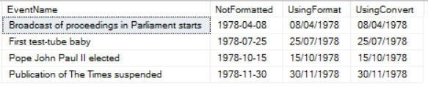

Save this query as **The Great Owl sees all**, and close it down.

9)Write a query using inner joins to show all of the authors who have written episodes featuring the Daleks.

You should find that there are 16 such episodes!

When you've finished, save this as **Enough joins for now**, then close it down.

You can unzip [this file](https://www.wiseowl.co.uk/files/exercise-answer-files/af-744.zip) to see the answers to this exercise, although please remember this is for your personal use only.

10)Right-click in a new query Add columns and filters to your query so that it shows who wrote the "special" episodes (there should be 13 listed out, of which the first few in alphabetical order are shown below):



*The first few episodes containing the word****special****in the title.*

Now tidy up the generated query so that it looks more like proper SQL!  Here's a suggestion:

Save this query as **No joins necessary**, then close it down.

11) Right-click on a new query and choose to design a query in the editor,

When you choose **OK** and run this query back in Management Studio, you should see this:



*The first few events listed.*

Now tidy up your query's SQL to look beautiful, complete with comments!  Here's a suggestion (and only a suggestion!):

Save this query as **Superb Quality Layout**, then close it down.