Computer Graphics (UCS505)

Tetris

B.E. 3rd Year – CSE

Submitted By –
Tanishq (102217227)
Shivanshu (102217200)
Anmol (102217236)
Submitted To –
Dr. Rajkumar Tekchandani


Computer Science and Engineering Department
Thapar Institute of Engineering and Technology
Patiala – 147001

INTRODUCTION

Project Overview:

This project is a 2D Tetris game developed using OpenGL (GLUT) for graphics rendering and SFML (Simple and Fast Multimedia Library) for audio playback. It recreates the classic gameplay mechanics of Tetris falling geometric shapes .
(Tetrominoes) that the player must rotate and position to fill horizontal lines on a game board. When a line is filled completely, it disappears and the player scores points. The game incorporates key computer graphics concepts such as 2D transformations, user input handling, real-time rendering, and frame-based updates. To enhance the visual experience, the project includes special effects like semi-transparent fog and a red atmospheric glow, giving the game a distinctive aesthetic. Additionally, background music adds to the ambiance, creating a more immersive experience for the player. The code is written in C++ and demonstrates modular programming through userdefined functions that handle rendering, game logic, collision detection, and audio playback. It also adapts to various screen sizes through dynamic viewport and aspect ratio handling.
This project serves both as a recreational game and a demonstration of applying fundamental and advanced concepts in computer graphics, game development, and multimedia integration. It is ideal for showcasing interactive graphics skills and multimedia handling in a C++ environment.

Scope of the Project:

1.To develop a fully playable Tetris game with modern visual and audio enhancements.

- To demonstrate the use of OpenGL for 2D graphics rendering including blocks, game board, and effects.

- To handle user input using the GLUT keyboard functions for controlling game pieces.

- To implement collision detection, line clearing, score tracking, and game over conditions.

- To integrate ambient visual effects such as fog and glow for aesthetic improvement.

- To incorporate audio playback using SFML for enhancing user engagement.

- To maintain compatibility with standard Windows/Linux systems

USER DEFINED FUNCTIONS

S No. | Function Name | Function Description
1. | drawText ⁠ | Displays a string on the game screen using bitmap characters.
2. | drawBlock | Renders a single block with specific color and grid coordinates.
3. | check ⁠ | Validates if the current Tetromino position is within bounds and not overlapping.
4. | spawnPiece | Initializes a new Tetromino at the top of the board with random shape and color.
5. | tick ⁠ | Updates the Tetromino movement, handles rotation and collision, and spawns new one.
6. | clearLines | Checks for and clears full lines, updating the score accordingly.
7. | drawFog | Draws a semi-transparent fog effect over the entire game board.
8. | drawGlow | Renders a glowing red overlay at the top of the game screen for atmospheric effect.
9. | display | The main render loop that draws all game elements and handles game over display.
10. | timerFunc | Handles timing logic for game progression and animation refresh.
11. | keyboard ⁠ | Captures and processes keyboard inputs for movement and rotation.
12. | keyboardUp ⁠ | Resets delay when down key is released.
13. | init | Initializes OpenGL settings, background color, and spawns the first Tetromino.
14. | reshape | Maintains aspect ratio during window resize to prevent distortion.
15 | playMusic ⁠ | Loads and plays background music in a loop using SFML

CODE SNIPPETS

#include <GL/glut.h>
#include <ctime>
#include <vector>
#include <string>
#include <SFML/Audio.hpp>

sf::Music music;
const int WIDTH = 10;
const int HEIGHT = 20;
const int BLOCK_SIZE = 30;
int field[HEIGHT][WIDTH] = { 0 };

struct Point { int x, y; };
Point current[4], backup[4];

int figures[7][4] = {
{1, 3, 5, 7}, {2, 4, 5, 7}, {3, 5, 4, 6}, {3, 5, 4, 7},
{2, 3, 5, 7}, {3, 5, 7, 6}, {2, 3, 4, 5}
};

int dx = 0, score = 0;
bool rotate = false, gameOver = false;
int color = 1;
float timer = 0, delay = 0.3;

void drawText(float x, float y, std::string text) {
glRasterPos2f(x, y);
for (char c : text) {
glutBitmapCharacter(GLUT_BITMAP_HELVETICA_18, c);
}
}

void drawBlock(int x, int y, int color) {
float colors[8][3] = {
{0, 0, 0}, {1, 0, 0}, {0, 1, 0}, {0, 0, 1},
{1, 1, 0}, {1, 0, 1}, {0, 1, 1}, {1, 0.5, 0}
};
glColor3f(colors[color][0], colors[color][1], colors[color][2]);
glBegin(GL_QUADS);
glVertex2i(x * BLOCK_SIZE, y * BLOCK_SIZE);
glVertex2i((x + 1) * BLOCK_SIZE, y * BLOCK_SIZE);
glVertex2i((x + 1) * BLOCK_SIZE, (y + 1) * BLOCK_SIZE);
glVertex2i(x * BLOCK_SIZE, (y + 1) * BLOCK_SIZE);
glEnd();
glColor3f(0.1f, 0.1f, 0.1f);
glBegin(GL_LINE_LOOP);
glVertex2i(x * BLOCK_SIZE, y * BLOCK_SIZE);
glVertex2i((x + 1) * BLOCK_SIZE, y * BLOCK_SIZE);
glVertex2i((x + 1) * BLOCK_SIZE, (y + 1) * BLOCK_SIZE);
glVertex2i(x * BLOCK_SIZE, (y + 1) * BLOCK_SIZE);
glEnd();
}

bool check() {
for (int i = 0; i < 4; ++i) {
int x = current[i].x, y = current[i].y;
if (x < 0 || x >= WIDTH || y >= HEIGHT) return false;
if (y >= 0 && field[y][x]) return false;
}
return true;
}

void spawnPiece() {
int n = rand() % 7;
color = 1 + rand() % 7;
for (int i = 0; i < 4; ++i) {
current[i].x = figures[n][i] % 2 + WIDTH / 2 - 1;
current[i].y = figures[n][i] / 2 - 1;
if (current[i].y >= 0 && field[current[i].y][current[i].x]) {
gameOver = true;
}
}
}

void tick() {
if (gameOver) return;

for (int i = 0; i < 4; ++i) backup[i] = current[i];
for (int i = 0; i < 4; ++i) current[i].x += dx;
if (!check()) for (int i = 0; i < 4; ++i) current[i] = backup[i];

if (rotate) {
Point p = current[1];
for (int i = 0; i < 4; ++i) {
int x = current[i].y - p.y;
int y = current[i].x - p.x;
current[i].x = p.x - x;
current[i].y = p.y + y;
}
if (!check()) for (int i = 0; i < 4; ++i) current[i] = backup[i];
}

for (int i = 0; i < 4; ++i) backup[i] = current[i];
for (int i = 0; i < 4; ++i) current[i].y += 1;

if (!check()) {
for (int i = 0; i < 4; ++i)
if (backup[i].y >= 0)
field[backup[i].y][backup[i].x] = color;
spawnPiece();
}

dx = 0;
rotate = false;
}

void clearLines() {
for (int i = HEIGHT - 1; i >= 0; --i) {
bool full = true;
for (int j = 0; j < WIDTH; ++j)
if (field[i][j] == 0) full = false;
if (full) {
for (int row = i; row > 0; --row)
for (int col = 0; col < WIDTH; ++col)
field[row][col] = field[row - 1][col];
for (int j = 0; j < WIDTH; ++j)
field[0][j] = 0;
score += 100;
++i;
}
}
}

void drawFog() {
glEnable(GL_BLEND);
glBlendFunc(GL_SRC_ALPHA, GL_ONE_MINUS_SRC_ALPHA);

glColor4f(0.8f, 0.8f, 0.8f, 0.2f);
glBegin(GL_QUADS);
glVertex2i(0, 0);
glVertex2i(WIDTH * BLOCK_SIZE, 0);
glVertex2i(WIDTH * BLOCK_SIZE, HEIGHT * BLOCK_SIZE);
glVertex2i(0, HEIGHT * BLOCK_SIZE);
glEnd();

glDisable(GL_BLEND);
}

void drawGlow() {
glEnable(GL_BLEND);
glBlendFunc(GL_SRC_ALPHA, GL_ONE_MINUS_SRC_ALPHA);

glColor4f(0.8f, 0.1f, 0.1f, 0.3f);
glBegin(GL_QUADS);
glVertex2i(0, 0);
glVertex2i(WIDTH * BLOCK_SIZE, 0);
glVertex2i(WIDTH * BLOCK_SIZE, HEIGHT * BLOCK_SIZE / 2);
glVertex2i(0, HEIGHT * BLOCK_SIZE / 2);
glEnd();

glDisable(GL_BLEND);
}

void display() {
glClear(GL_COLOR_BUFFER_BIT);

drawFog();
drawGlow();

for (int i = 0; i < HEIGHT; ++i)
for (int j = 0; j < WIDTH; ++j)
if (field[i][j])
drawBlock(j, i, field[i][j]);

for (int i = 0; i < 4; ++i)
if (current[i].y >= 0)
drawBlock(current[i].x, current[i].y, color);

glColor3f(1, 1, 1);
drawText(10, 30, "Score: " + std::to_string(score));

if (gameOver)
drawText(110, HEIGHT * BLOCK_SIZE / 2, "GAME OVER");

glutSwapBuffers();
}

void timerFunc(int) {
glutPostRedisplay();
if (gameOver) return;

timer += 0.05;
if (timer > delay) {
tick();
clearLines();
timer = 0;
}
glutTimerFunc(50, timerFunc, 0);
}

void keyboard(int key, int, int) {
dx = 0; rotate = false;
if (gameOver) return;
if (key == GLUT_KEY_LEFT) dx = -1;
else if (key == GLUT_KEY_RIGHT) dx = 1;
else if (key == GLUT_KEY_UP) rotate = true;
else if (key == GLUT_KEY_DOWN) delay = 0.05;
}

void keyboardUp(int key, int, int) {
if (key == GLUT_KEY_DOWN) delay = 0.3;
}

void init() {

glClearColor(0.2f, 0.1f, 0.3f, 1.0f);
glEnable(GL_TEXTURE_2D);
glMatrixMode(GL_PROJECTION);
glLoadIdentity();
gluOrtho2D(0, WIDTH * BLOCK_SIZE, HEIGHT * BLOCK_SIZE, 0);
srand(time(0));
spawnPiece();
}

void reshape(int w, int h) {
float gameAspect = (float)(WIDTH * BLOCK_SIZE) / (HEIGHT * BLOCK_SIZE);
float windowAspect = (float)w / h;

int vpWidth, vpHeight;
int vpX = 0, vpY = 0;

if (windowAspect > gameAspect) {
vpHeight = h;
vpWidth = (int)(h * gameAspect);
vpX = (w - vpWidth) / 2;
} else {

vpWidth = w;
vpHeight = (int)(w / gameAspect);
vpY = (h - vpHeight) / 2;
}

glViewport(vpX, vpY, vpWidth, vpHeight);

glMatrixMode(GL_PROJECTION);
glLoadIdentity();
gluOrtho2D(0, WIDTH * BLOCK_SIZE, HEIGHT * BLOCK_SIZE, 0);
glMatrixMode(GL_MODELVIEW);
}

void playMusic() {
if (!music.openFromFile("tetris_audio.wav")) {
printf("Failed to load music!\n");
return;
}
music.setLoop(true);
music.play();
}

int main(int argc, char** argv) {
glutInit(&argc, argv);
glutInitDisplayMode(GLUT_DOUBLE | GLUT_RGB);
glutInitWindowSize(WIDTH * BLOCK_SIZE, HEIGHT * BLOCK_SIZE);
glutCreateWindow("Tetris - OpenGL");

init();
glutDisplayFunc(display);
glutSpecialFunc(keyboard);
glutSpecialUpFunc(keyboardUp);
glutReshapeFunc(reshape);
glutTimerFunc(50, timerFunc, 0);
playMusic();
glutMainLoop();
return 0;
}

SCREENSHOTS

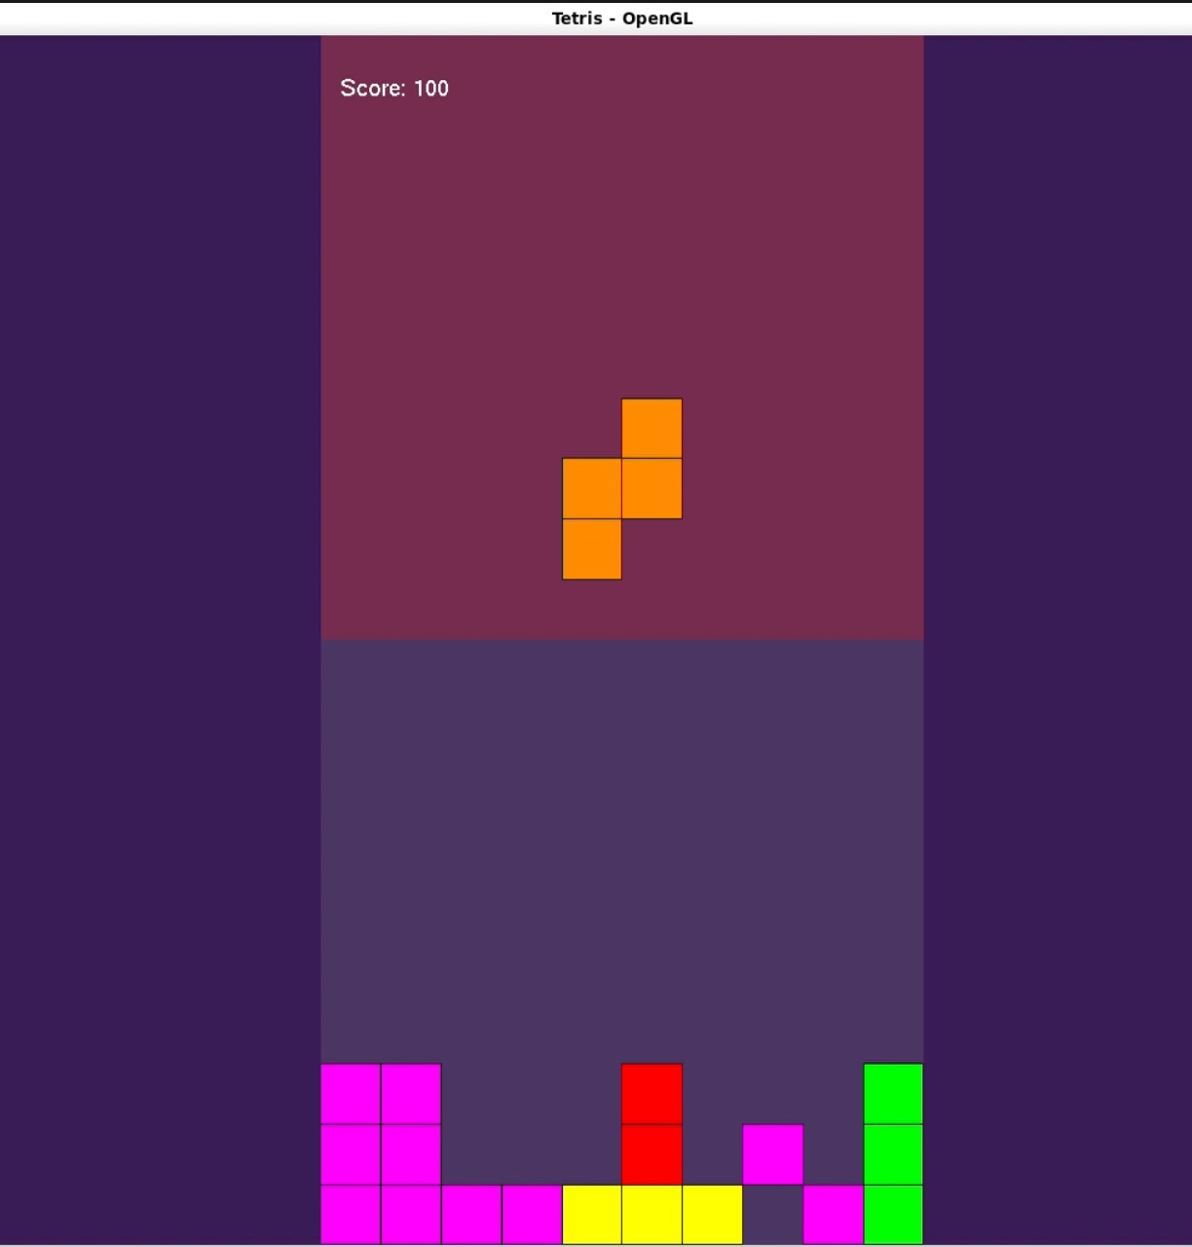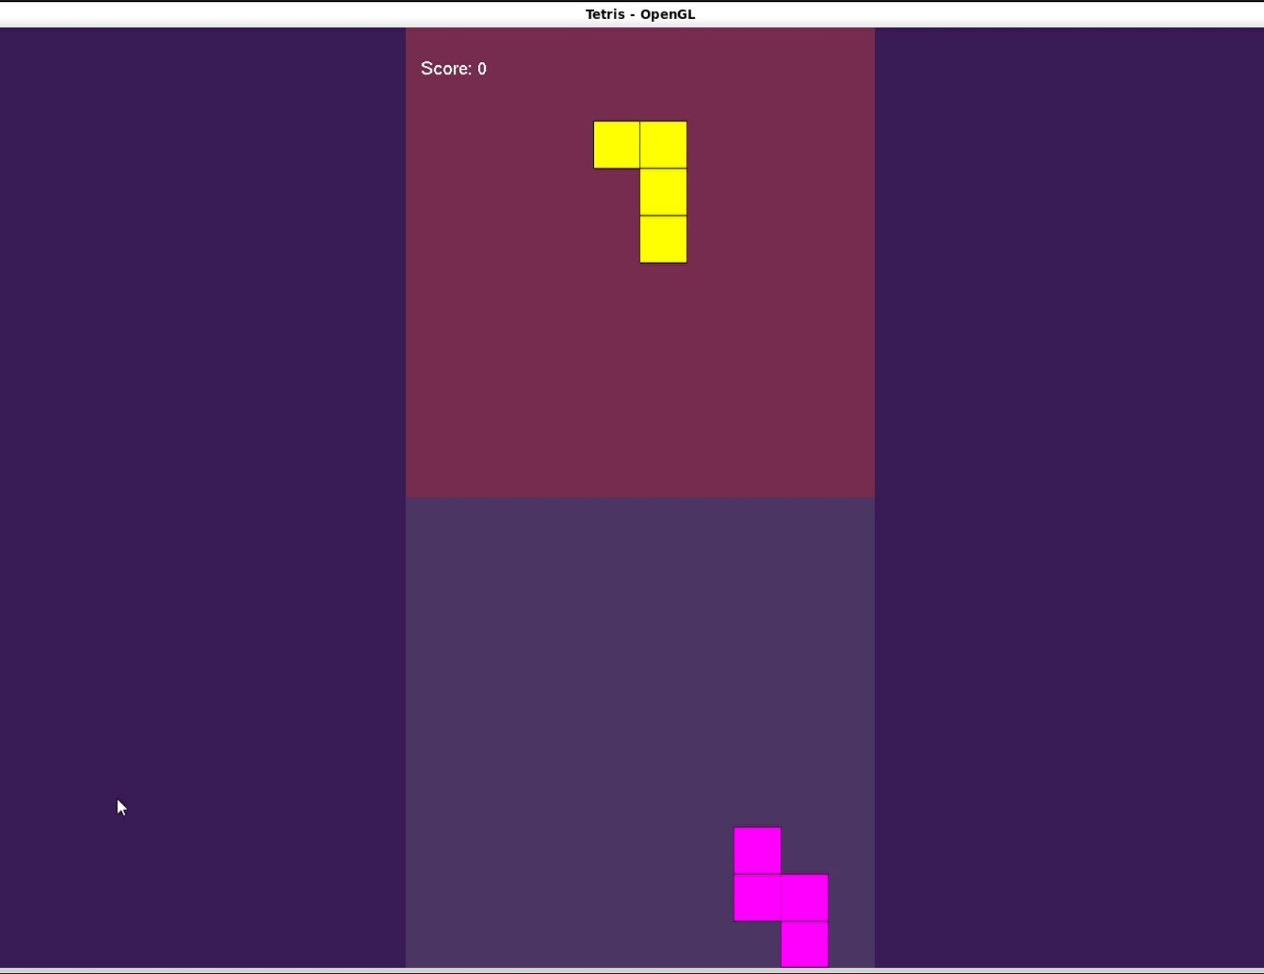

References

www.learnopengl.com

