Network Design for Starlight Company

Annabel okungbowa okungbowa
23761382
2026

Contents
Abstract 2
Introduction 2
Aim and Objectives 2
Network Design 3
Network Verification or Configuration Test Error! Bookmark not defined.
Network Evaluation and Discussion 10
Conclusion 10
References 11
Appendix A: 12

Abstract
This project focused on designing and configuration of a secure, scalable and functional network across five different locations, supporting a total of 50 hosts. Cisco Packet Tracer was used to simulate the design, permitting thorough testing of connectivity, routing, and security features. VLAN’s (40, 50, and 60) were implemented to reducing broadcast traffic and improving efficiency. RIP version 2 was chosen as a dynamic routing protocol between the sites, ensuring seamless inter-site connectivity and automatic routing. SS was configured to provide encrypted remote management, protecting administrative access from potential threats. DHCP was used to automate IP address assignment for hosts, reducing manual configuration, preventing errors, and demonstrating how dynamic addressing supports larger networks. Connectivity between Newcastle and Liverpool was used as key examples to illustrate inter-site connectivity, with successful communication verified between PCs across all locations. The final configuration demonstrated a secure and scalable network suitable for small business environments.

Introduction
Starlight company is a small business that requires a reliable and secure network to connect five different locations, supporting a total of 50 hosts. Each site consists of two offices and one workshop, with 10 PCs per location. The purpose of the network design is to enable seamless communication and connectivity between sites while ensuring that each location has is assigned its own IP addressing scheme to prevent traffic conflicts and maintaining performance.

The design process began with a simple topology of one router, one switch, and one PC. This allowed initial testing before adding more complex features. This approach ensured that the network could be tested for efficiency and scalability, meaning additional devices could be integrated without redesigning the entire system. Cisco Packet Tracer was used to create and test the design, providing a clear environment for configuring and verifying each technology.
Four key technologies used across all sites:
- VLANs for logical segmentation and improved performance.
- RIP version 2 for dynamic routing between sites
- DHCP for automatic host assignation.
- SSH for sure remote management.

Serial connection between routers was established using WIC-2T. this enables point to point inter-site communication. This report demonstrates the designing, configuration and verification of how standard protocols can meet the requirements of a small business environment.

Aim and Objectives
Aim:
To design a secure and scalable network for StarLight Company, connecting five locations with 50 hosts in total. The aim is to ensure seamless communication between sites by implementing RIP version 2, allowing routers to dynamically exchange routing information so traffic can travel efficiently across the network.
Objectives:
- Develop an IP addressing plan using CIDR to assign address efficiently.
- Configure router password and secure shell (SSH) for secure remote access.
- Implement DHCP to automate IP assignment for hosts within each site.
- Configure VLAN to logically segment traffic inside each location and improve network performance

Network Design
Network design:
The expected network for Starlight Company connects five different locations, each consisting of two offices and one workshop, with a total of 50 hosts. The design ensures reliable communication between sites while maintaining efficiency and scalability. Cisco Packet Tracer was used to simulate the environment, providing a platform to configure, test and verify the design.

Physical Equipment:
Each site includes one router, one switch, and multiple PCs. Routers are essential for inter-site connectivity, enabling traffic to travel between different subnets. Switches manage local traffic within each site, connecting PCs and supporting VLAN segmentation. PCs acts as end devices representing the hosts used by employees and are critical for testing connectivity. Routers were equipped with WIC-2T modules to provide serial interface, allowing point to point links between sites.

Addressing Scheme:
A structured IP address scheme was built using CIDR configuration to allocate subnets efficiently (AWS, 2024). Each site was assigned a unique subnet to prevent address conflicts and simplify routing:

- Newcastle: Router IP 192.168.80.1, PC IP 192.168.80.3, default gateway 192.168.80.1
- Liverpool: Router Ip 192.168.90.1, PC IP 192.168.90.3, default gateway 192.168.90.1
- Manchester: Router IP 192.168.55.1, PC IP 192.168.55.3, default gateway 192.168.55.1
- London: Router IP 192.168.45.1, PC IP 192.168.45.3, default gateway 192.168.45.1
- Bradford: Router IP 192.168.95.1, PC IP 192.168.95.3, default gateway 192.168.45.1
This scheme ensures that each location operates within its own subnet, avoiding overlap and supporting scalability if more hosts are added in the future

Topology and layout:

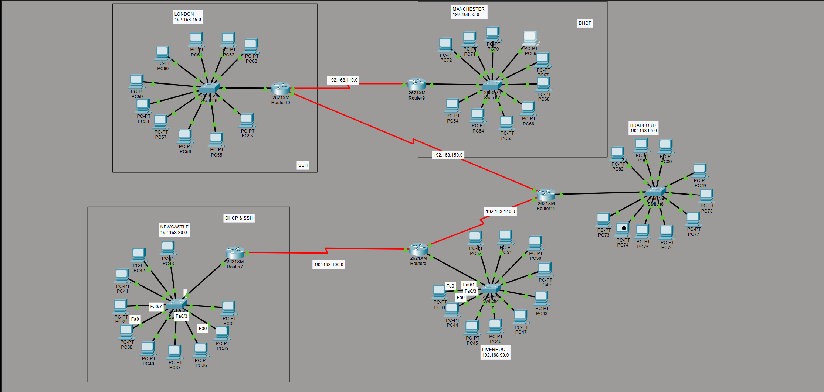

VLANs
Within each site, VLANs were configured to segment traffic logically between offices and workshops. This reduces broadcasting traffic, improves performance, and enhances security by isolating departments. In the case of router 7, VLAN 40 was assigned to office A, VLAN 50 was assigned to B, and VLAN 60 to the workshop. Inter-VLAN routing was permitted on routers accessing communication between VLANs when required. Inter-VLAN routing was enabled on routers to allow communication between VLANs when required (Vance, J. 2022).

Routing version 2;
RIP version 2 was configured across all routers to permit dynamic routing. It was selected over RIP v1 because it supports subnet masks and multicasting, making it more efficient. RIP v2 automatically extend routes, ensuring that traffic can move between sites without using manual static route. For a small business, RIP v2 provides a balance of simplicity and functionality.
DHCP:
Routers are set up using DHCP to automatically allocate IP addresses to host. This reduces administrative costs while ensuring consistency across 50 PCs. Each site’s DHCP pool was configured to assign addresses inside its subnet, with the router being used as the default gateway. For example, Newcastle’s DHCP pool assigned address in VLANs 40, 50, and 60.
SSH
SSH was enabled on routers for secure remote management. This ensures that administrative access is encrypted, preventing unauthorised interception. Passwords were set up to provide secure access, and SSH was selected over Telnet because of its stronger security.

  - Network configuration:
Ensures that the network meets the design objectives, a set of structured tests were conducted across al 5 locations: London, Manchester, Liverpool, Newcastle and Bradford. The main purpose of these tests was to verify interconnectivity, DHCP functionality, SSH access and routing accuracy.

InterLAN connectivity test:
This test is done by pinging from PC 77 in Bradford to PC46 in Liverpool which failed due to the missing RIP configuration. After checking the RIP assigned on each router it was then clear where the error came from. After assigning the RIP version 2 on the serial link 192.168.140.0 the ping then succeeded demonstrating full reachability.

DHCP functionality test:
DHCP was configures on routers to automate IP assignment for hosts (Dirk (2025). DHCP was assigned to PCs in Manchester and Newcastle. These two locations have been set up to DHCP mode and successfully receiving IP address from their respective pools, demonstrating automated IP configuration. Each site’s DHCP pool was defined to allocate addresses within its subnet, with the router acting as the default gateway. For example, Newcastle’s DHCP pool allocated addresses in the 192.168.40.1, 192.168.50.1, and 192.168.60.1 range. There are three different ones because there are 3 VLANs assigned to the router.

SSH Access Test:
SSH was enabled on routers to provide secure remote management. This ensures that administrative access is encrypted, protecting against unauthorised interception. Password were configured to secure access, and SSH was chosen over Telnet because of its stronger security (Loshin, P. 2021). Configuration of SSH was done on router10 (London) and router7 (Newcastle). Remote login attempts using ssh -l succeeded, confirming secure management access.

Routing table Validation:
The ‘show Ip route’ command confirms that all routers have connection all the routes and every LAN, this also verifies RIP version2 functioning and complete network visibility.

RIP Version 2
RIP Version 2 was implemented across all routers to enable dynamic routing. RIP version 2 allows routers to exchange routing information automatically, ensuring that traffic can travel between sites without manual static router (GeeksforGeeks, 2022). It was chosen over RP version1 because it supports subnet masks and multicasting, making it more efficient. RIP version 2 isa also simple to configure, and it is also more suitable for larger networks. For a small business with sites, RIP version 2 provides the right balance right of simplicity and functionality (GeeksforGeeks, 2022).

Network Configuration Tests

To ensure that the network meets the design and meets the objectives, connectivity and security, a series of structured tests were conducted across all five locations: LONDON, MANCHESTER, NEWCASTLE, LIVERPOOL, and BRADFORD. This test focuses on verifying interconnectivity, functionality in DHCP and SSH, and routing accuracy. Screenshots highlighting focused aspects of the scheme and tests to provide visual evidence of successful outcomes.

InterLAN connectivity tests:
Aim: Ensure that all PCs across different LANs can communicate through configured WAN.

Method: A ping test has been done from the PC77 in Bradford to PC46 in Liverpool. When the ping was first attempted it failed due to now having the RIP version2 not being set up through the serial link. After assigning the RIP between both routers (192.168.140.0) the ping succeeded. (The IP address of PC46 (192.168.70.6).

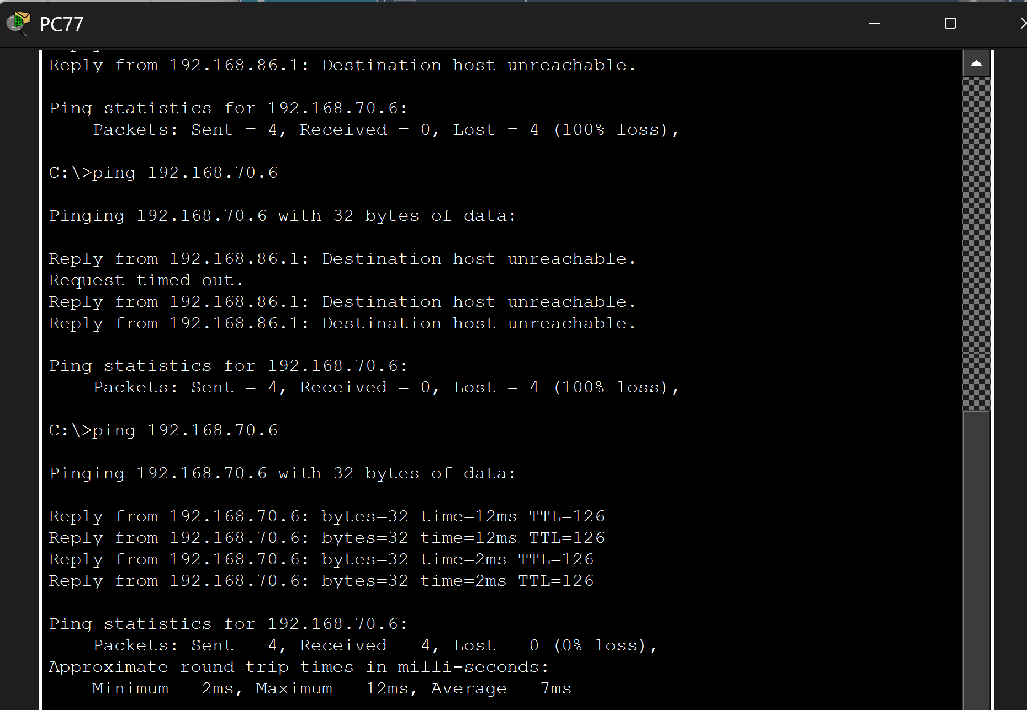
This shows that RIP Version 2 is correctly configured and working between LAN and WAN subnets. This supports connectivity and demonstrates full network reachability.

DHCP functionality TEST:
Aim: Ensuring that PCs in Manchester and Newcastle receive IP addresses dynamically.

Method: PCs are set to DHCP mode and observe for correct IP assignment. Router9 (Manchester), router7(Newcastle) were configured with separate DHCP pool for VLANs 15,25, and 35
(Manchester). Each pool excluded reversed addresses and assigned appropriate default gateways.

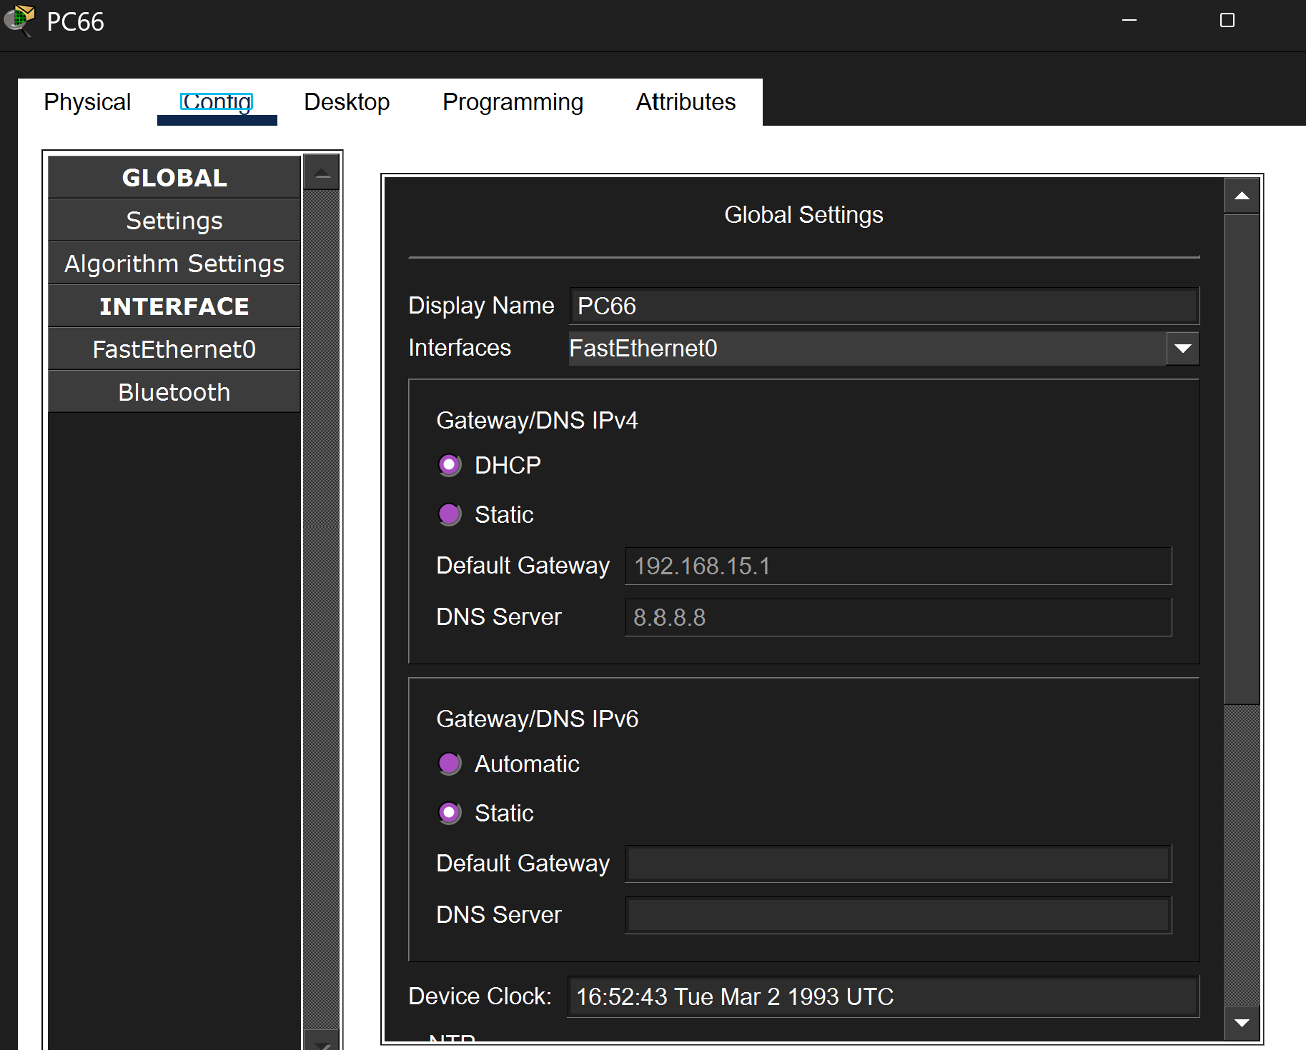
NEWCASTLE

This shows that the DHCP is functioning as intended. This reduced manual configuration.

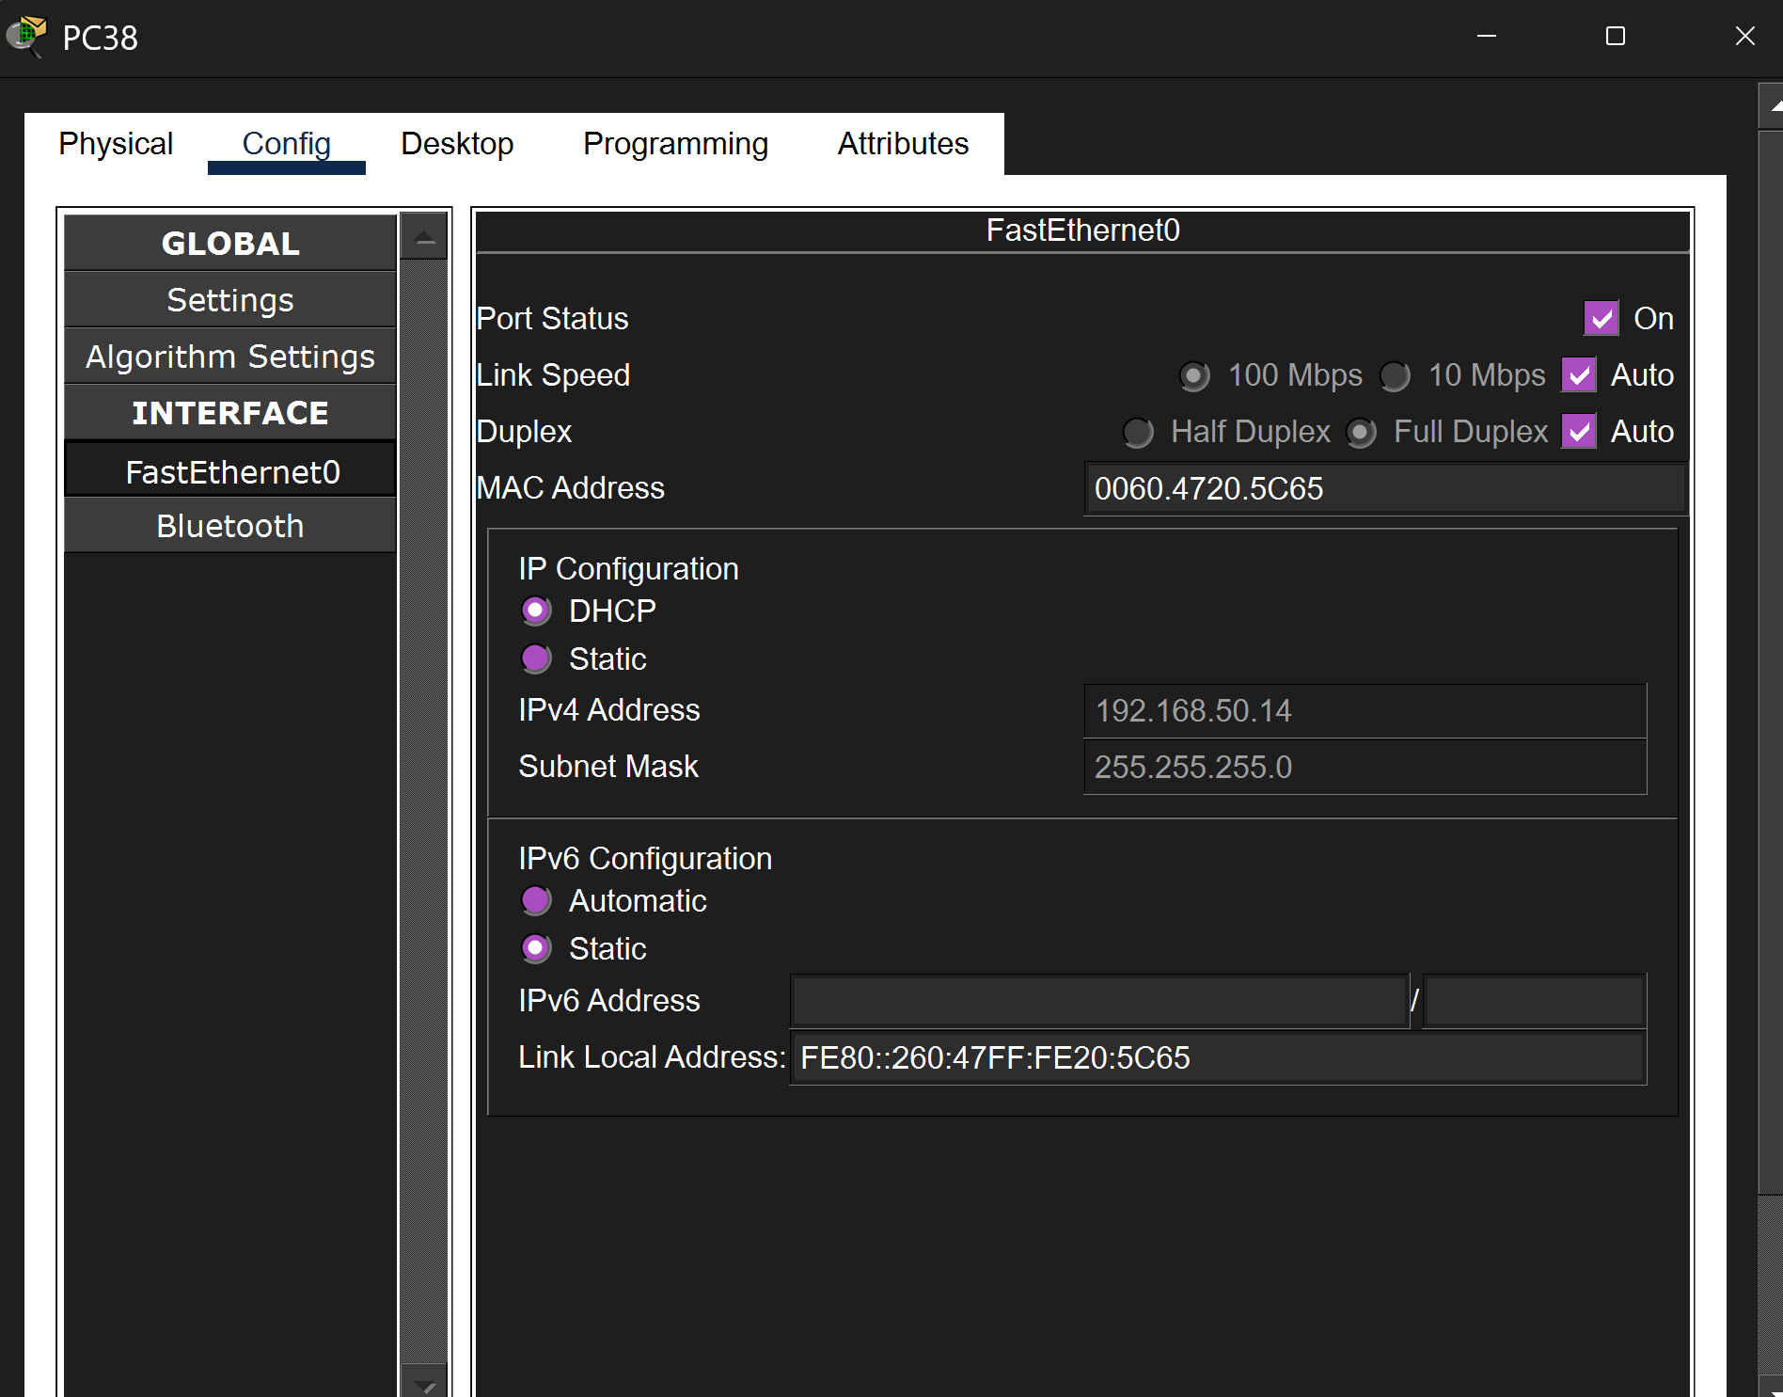
MANCHESTER

SSH Access test:
Aim: secure access to routers.

Method: SSH was configured on router 10 (London) and router 7 (Newcastle), RSA key generation, local user authentication. A remote log in attempt was made from a PC using ssh -l command.

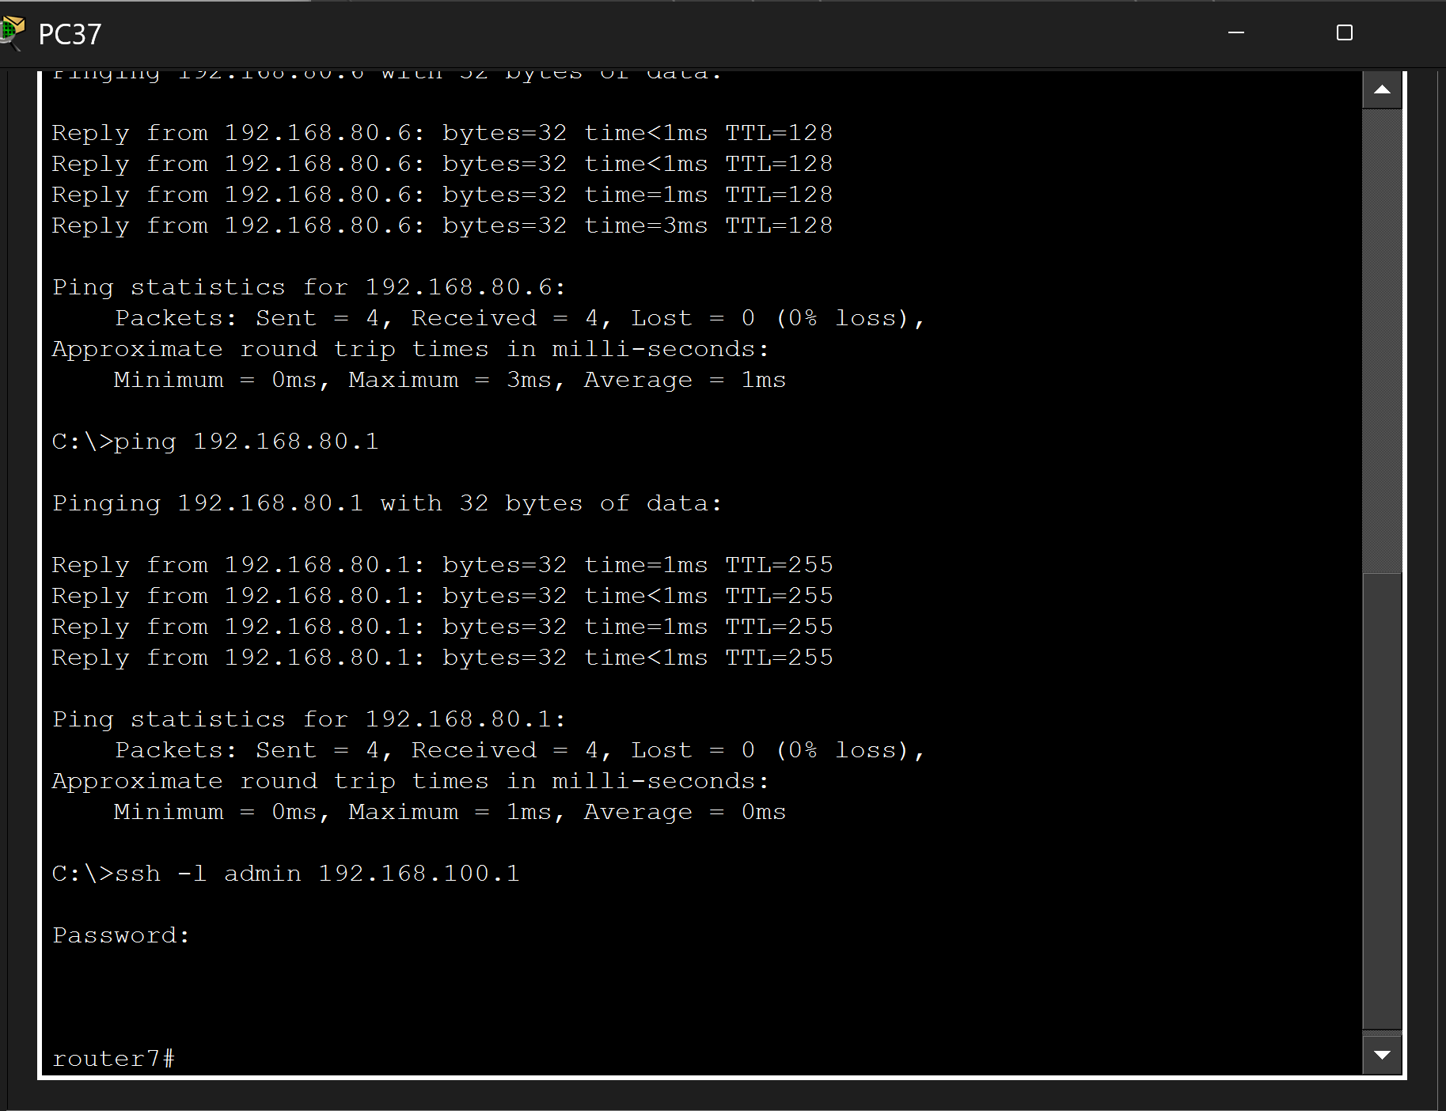

This shows successful SSH login demonstrates secure management access is enabled.

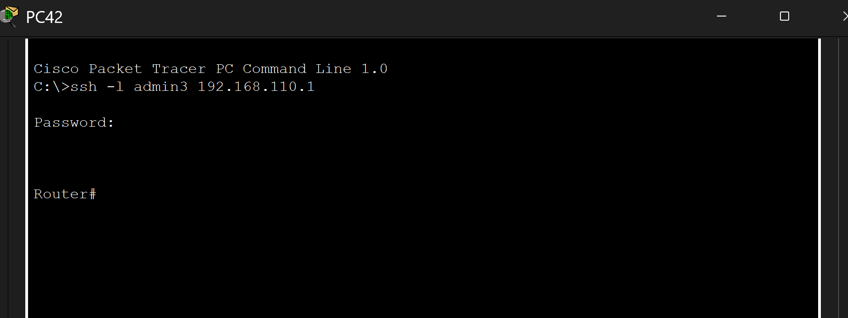
Router 10

Routing Table:
Aim: Confirms that all routers have learned routes to every LAN.

Method: “show IP route” command executed on each router. Routers have 5 LANs (192.168.45.0, 192.168.55.0, 192.168.80.0, 192.168.90.0, 192.168.95.0) were verified.

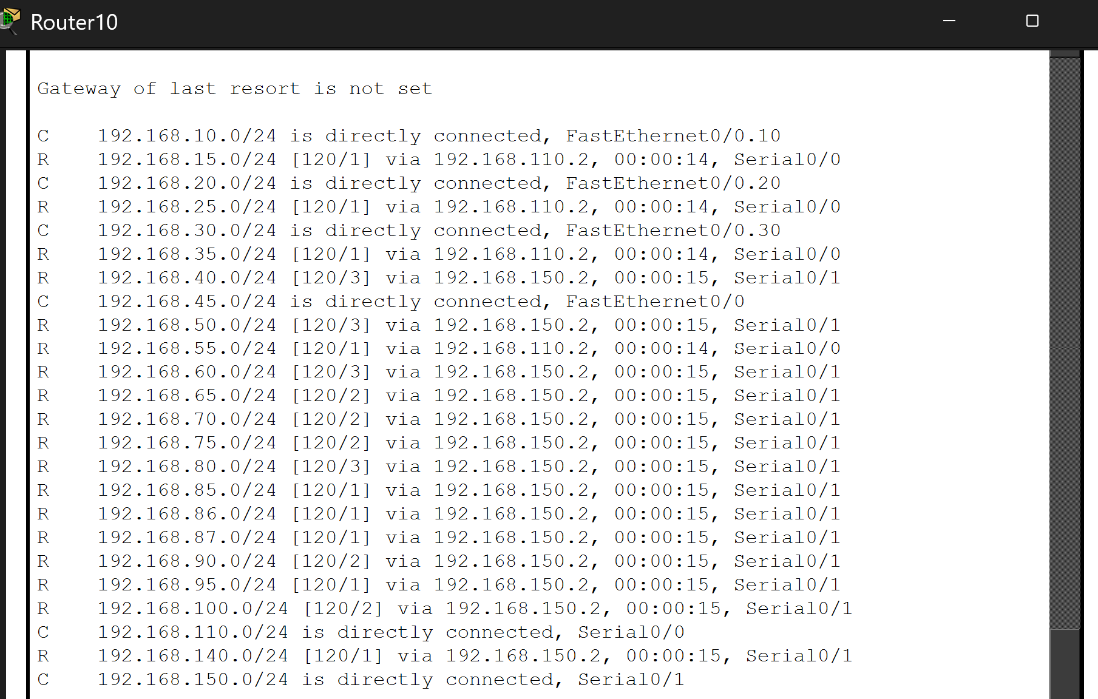

This test confirms that RIP v2 is functioning correctly and that all routers have full visibility of network topology, supporting performance and reliability.

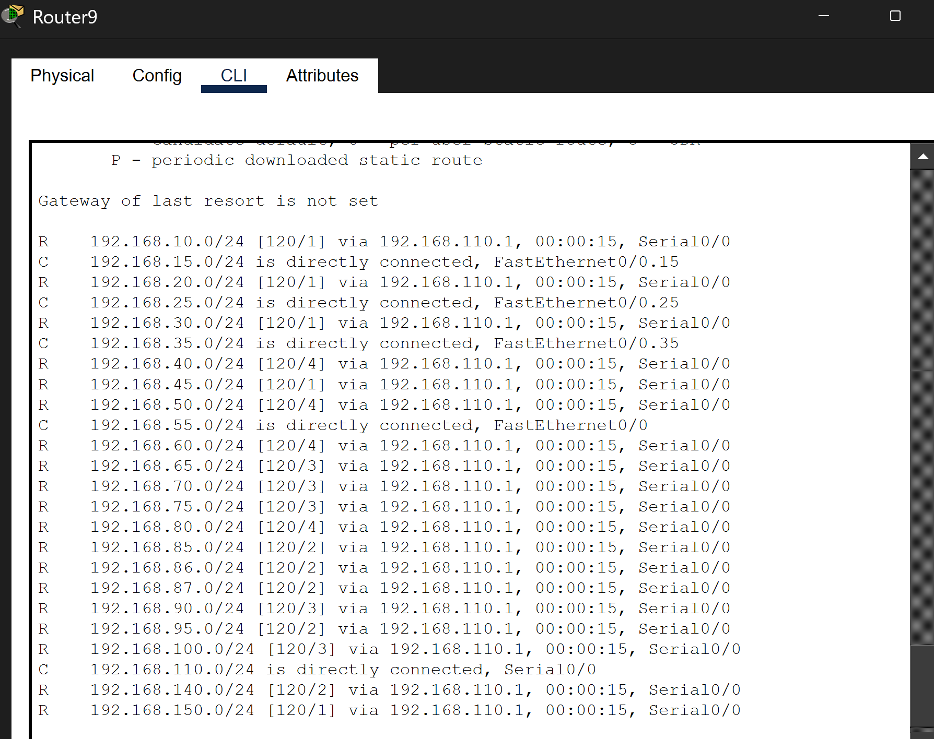

Network Evaluation and Discussion

A network design must demonstrate rigour, scalability, and balance cost, complexity and the client’s priorities. The 5-site topology, connecting London, Manchester, Newcastle, Liverpool and Bradford; meets the core assessment requirements by providing full inter-LAN connectivity, secure remote access (SSH), and automated host configuration (DHCP). There are strengths and weaknesses to this topology.

To create this network a serial-based WAN with RIP version has been set as the routing protocol. This protocol ensures that all outers dynamically learn routes to every LAN, reducing manual configuration errors and supporting consistent routing behaviour. Then ping tests between remote sites confirming that the routing tables are correctly assigned and that the WAN links are functioning as intended. However, this topology follows a large linear structure. An example, Bradford connect to Liverpool, which then connects to Newcastle, and then similarly with the other locations. If a serial link fails, like Bradford and the Liverpool connection, this will then make Bradford isolated from the other networks. This then creates a fault leading to possible failure. A stronger design would introduce redundant paths, such as connecting Bradford directly to London or Manchester. This will allow traffic to route automatically if a link fails, improving availability.

The design supports scalability. Each LAN uses a private IP range, and the WAN links uses separate subnets, preventing address conflicts and allowing additional sites to be added without readdressing the existing network. RIP v2 also supports automatic route assignments, which simplifies expansion. However, RIP has limitations in larger or more complex network. If a client decides to expand or add more offices or expand their growth there are better options for a more scalable routing protocol. The design is simple, which benefits maintenance. VLANs are used where required, DHCP is configured in 2 locations and SSH provides secure router management. This keeps the operational complexity low whilst still meeting the requirements. However, a more efficient design might use load balancing, dual WAN paths, but this would increase the configuration complexity.

Conclusion
The design and implementation of Starlight Company’s network successfully connect five locations with 50 hosts. By using RIP v2, routers dynamically exchange routing information, permitting seamless inter-site communication. DHCP automates host configuration, VLANs segment traffic logically, and SSH secures remote management. Testing confirmed that connectivity was achieved both locally and across sites. The design demonstrates technical accuracy and sound reasoning, meeting the requirements of small business environment while providing scalability for future growth. There is a chance of improvements to make the company stronger however those involved different modules or physical layers.

References

AWS (2024). What is CIDR? - CIDR blocks and notation explained - AWS. [online] Amazon Web Services, Inc. Available at: https://aws.amazon.com/what-is/cidr/.

Dirk (2025). DHCP: Automating IP Address Assignment. [online] Network-Guides.com. Available at: https://network-guides.com/dhcp-automating-ip-address-assignment/.

GeeksforGeeks (2022). Configuring RIP Versions 1 and 2 in Cisco. [online] GeeksforGeeks. Available at: https://www.geeksforgeeks.org/computer-networks/configuring-rip-versions-1-and-2-in-cisco/.

Loshin, P. (2021). What is SSH (Secure Shell)? Definition from SearchSecurity. [online] TechTarget. Available at: https://www.techtarget.com/searchsecurity/definition/Secure-Shell.

‌Vance, J. (2022). What is a VLAN and how does it work? [online] Network World. Available at: https://www.networkworld.com/article/971100/what-is-a-vlan-and-how-does-it-work.html.
‌

Appendix A:

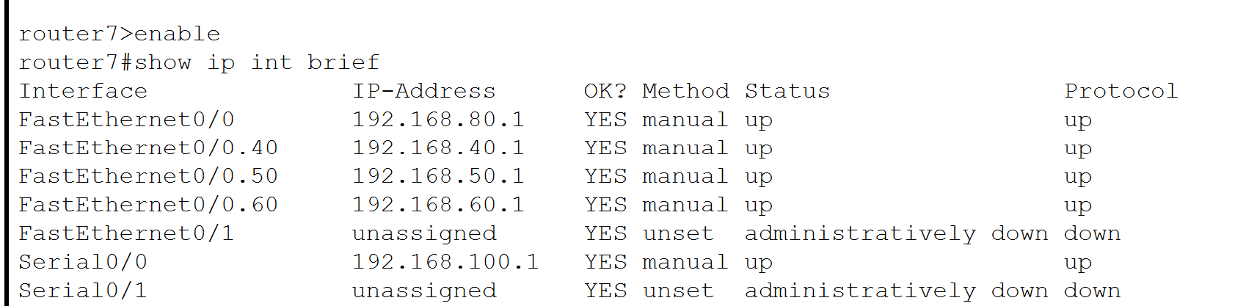
Figure 1 – this shows the IP address assigned to the main router and also the ones assigned to the subnet.(router 7)

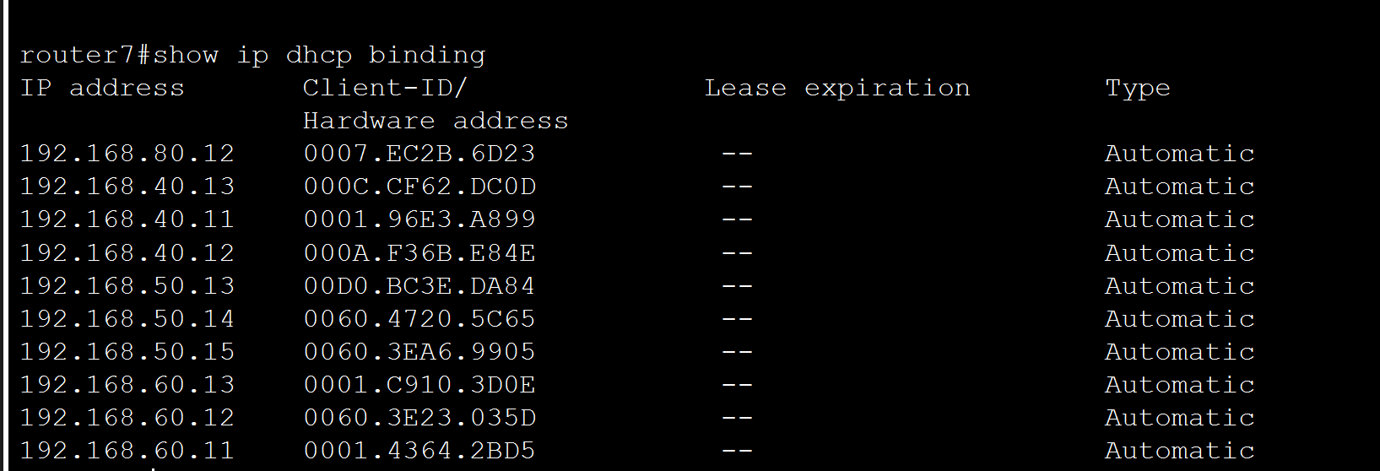
Figure 2- from the router I was able to show all the IP addresses assigned to each PC. (Router 7)

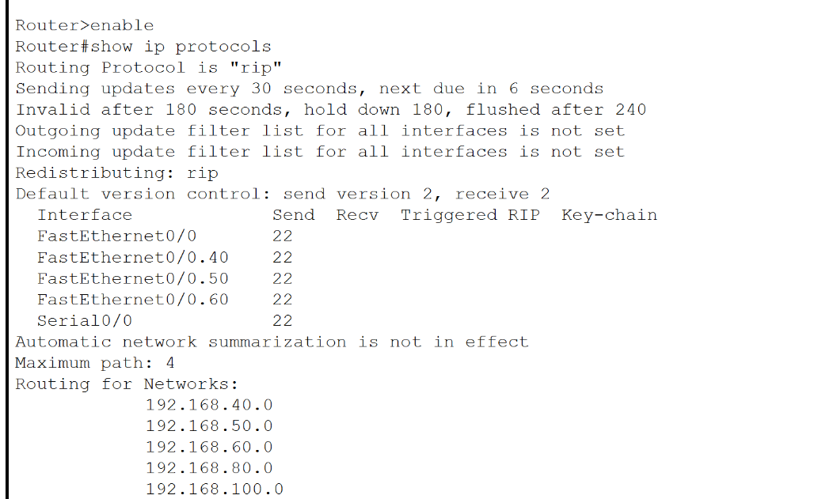

Figure 4- this shows the assigning of RIP Version 2 in router 7. This enables the routers to communicate with each other from different locations.

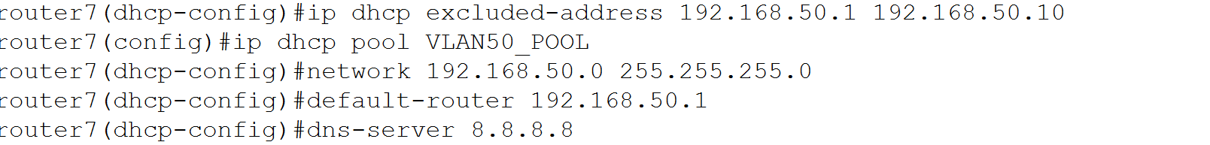
Figure 5- this shows the routing used to configure each VLAN into DHCP. This was repeated two more times.

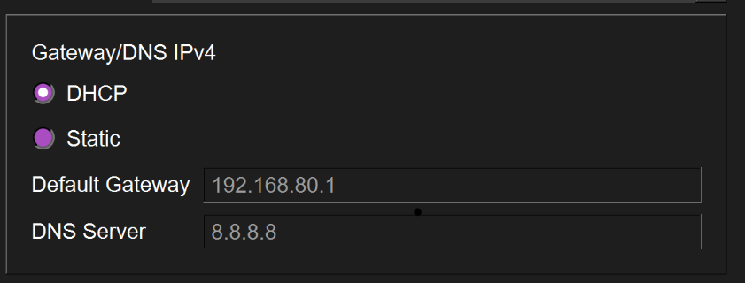
Figure 6- this is the result when going back into a PC and instead of selecting static DHCP is selected meaning that each pc is now automatically assigned with its own IP address and gateway. There is no requirement to manual assign them.

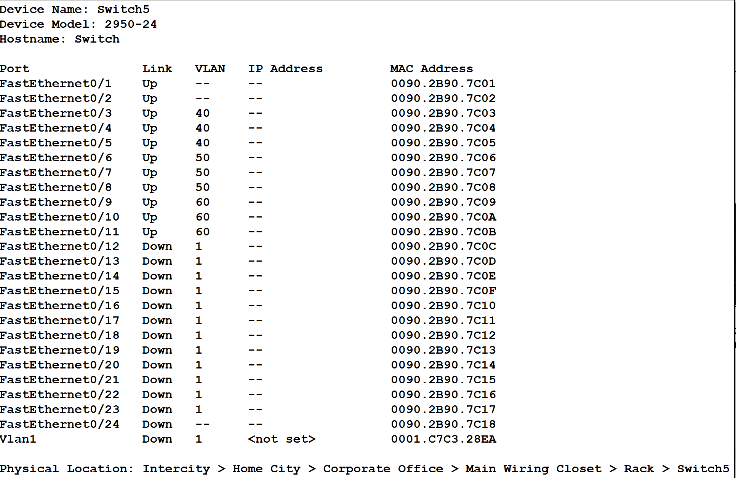
Figure 7: demonstrates which pc is assigned to what VLAN. 3 different VLANs used to differentiate the different roles in one office (office 1 VLAN40, office 2 VLAN50 and workshop VLAN60). (router 7)

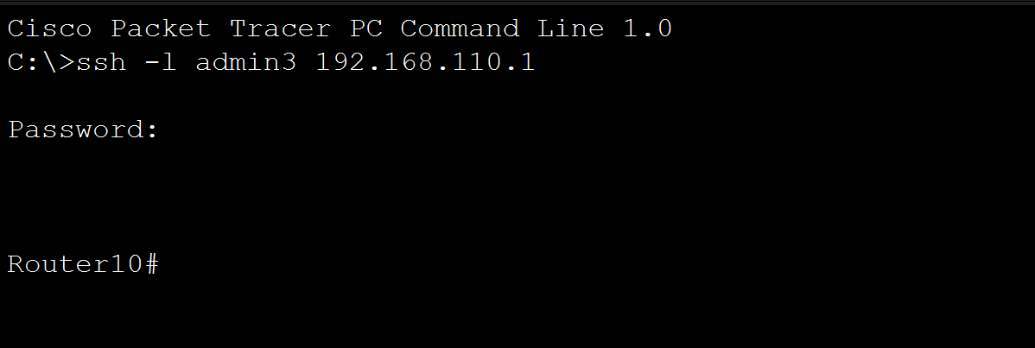
Figure 8 shows the use of SSH to secure the router. Router 10 has been assigned a login username and password. (ADMIN3 and light28).

INTER-VLAN CONNECTIONS
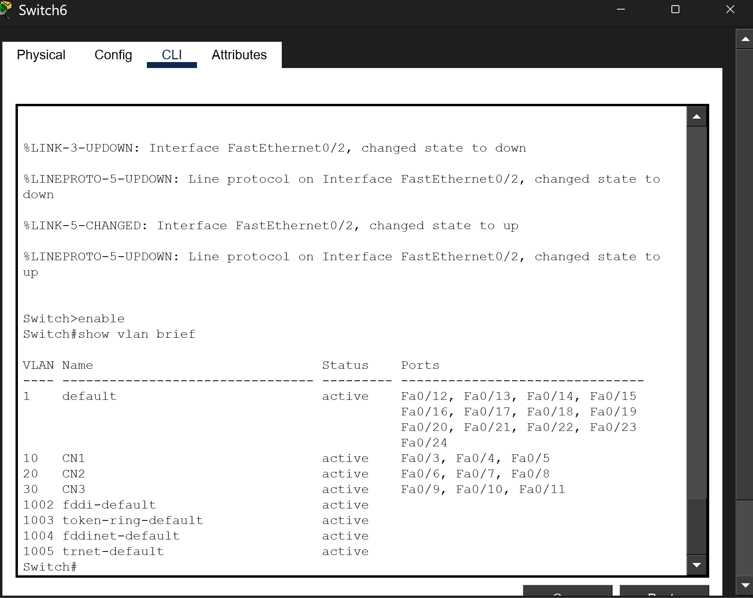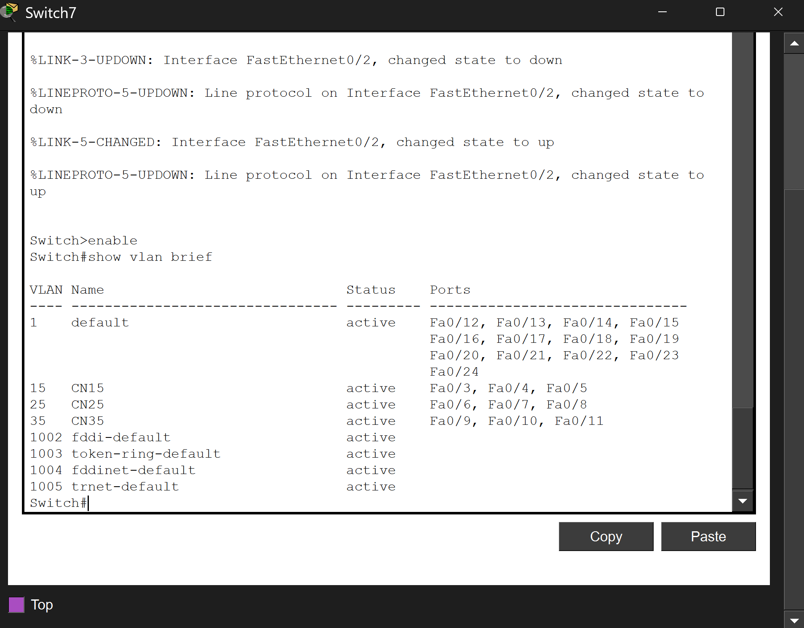
Switch 6- London Switch 7-Manchester

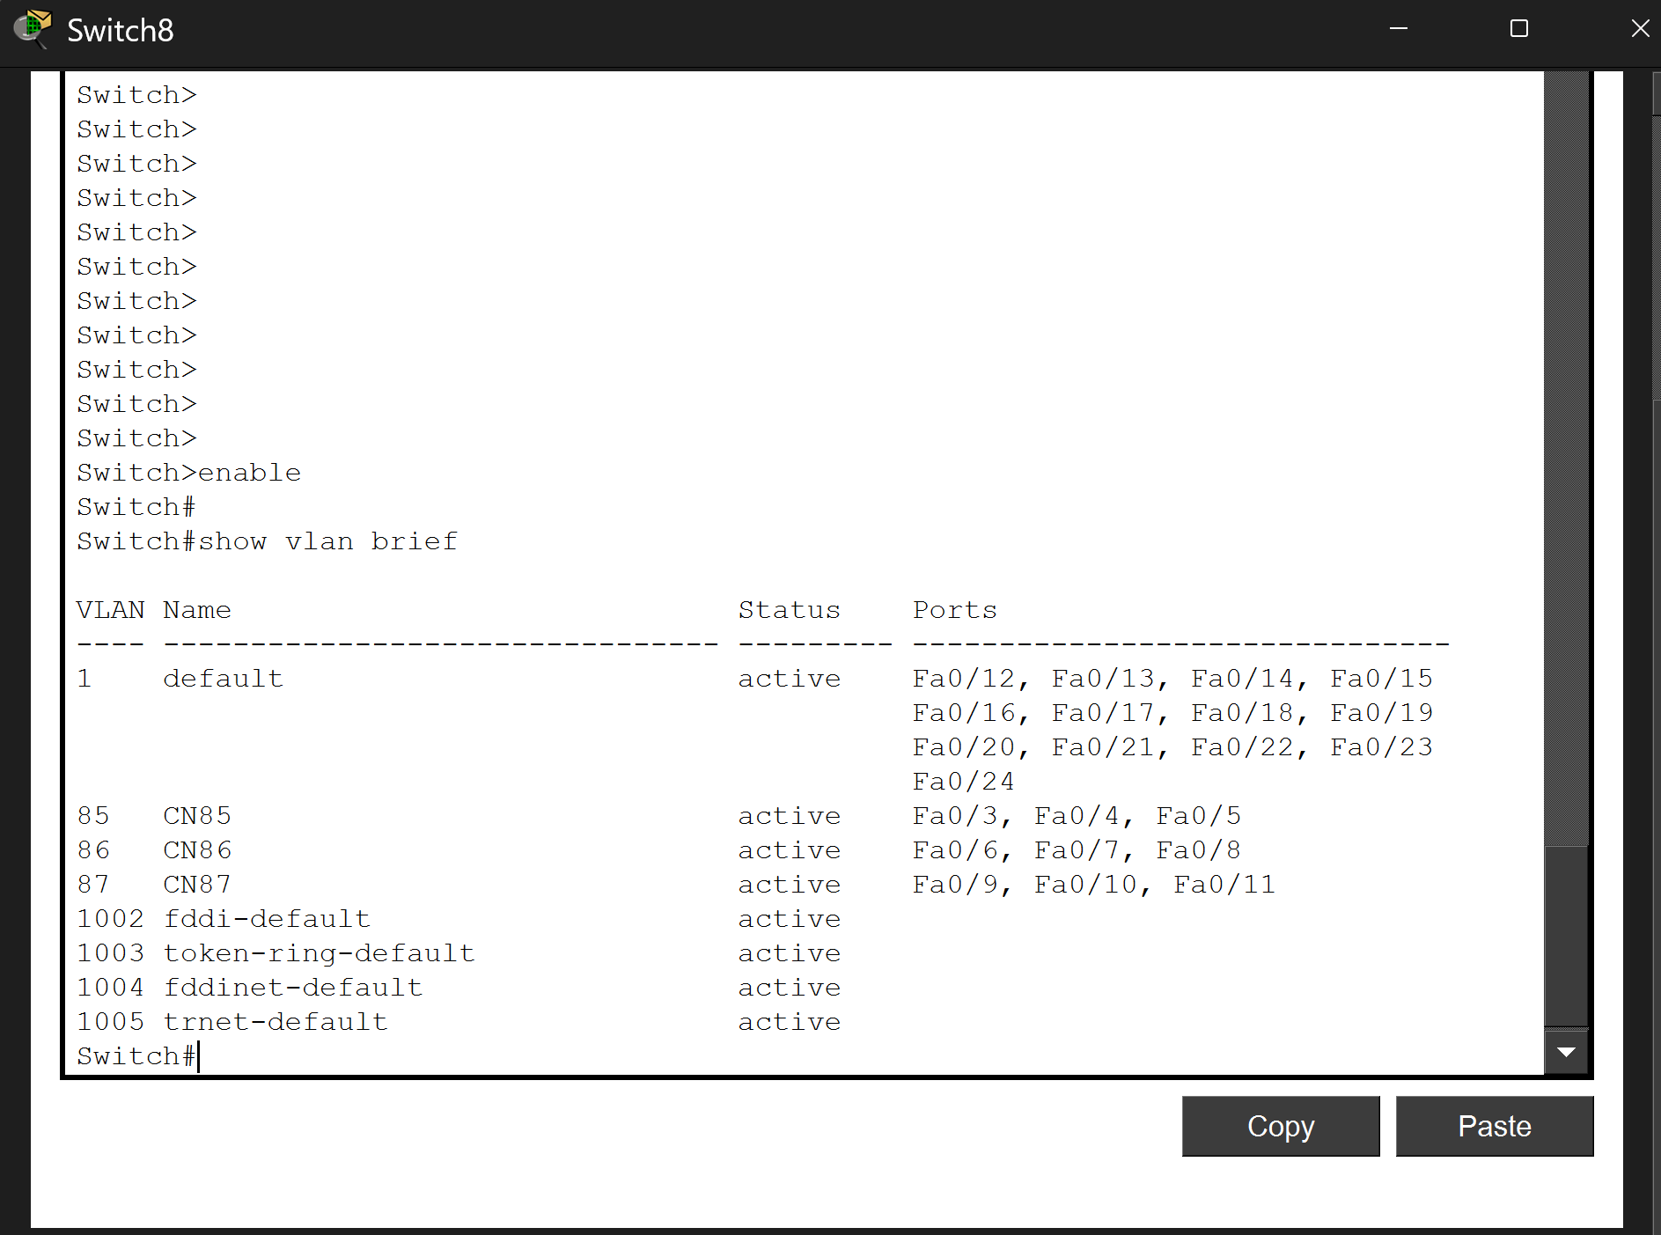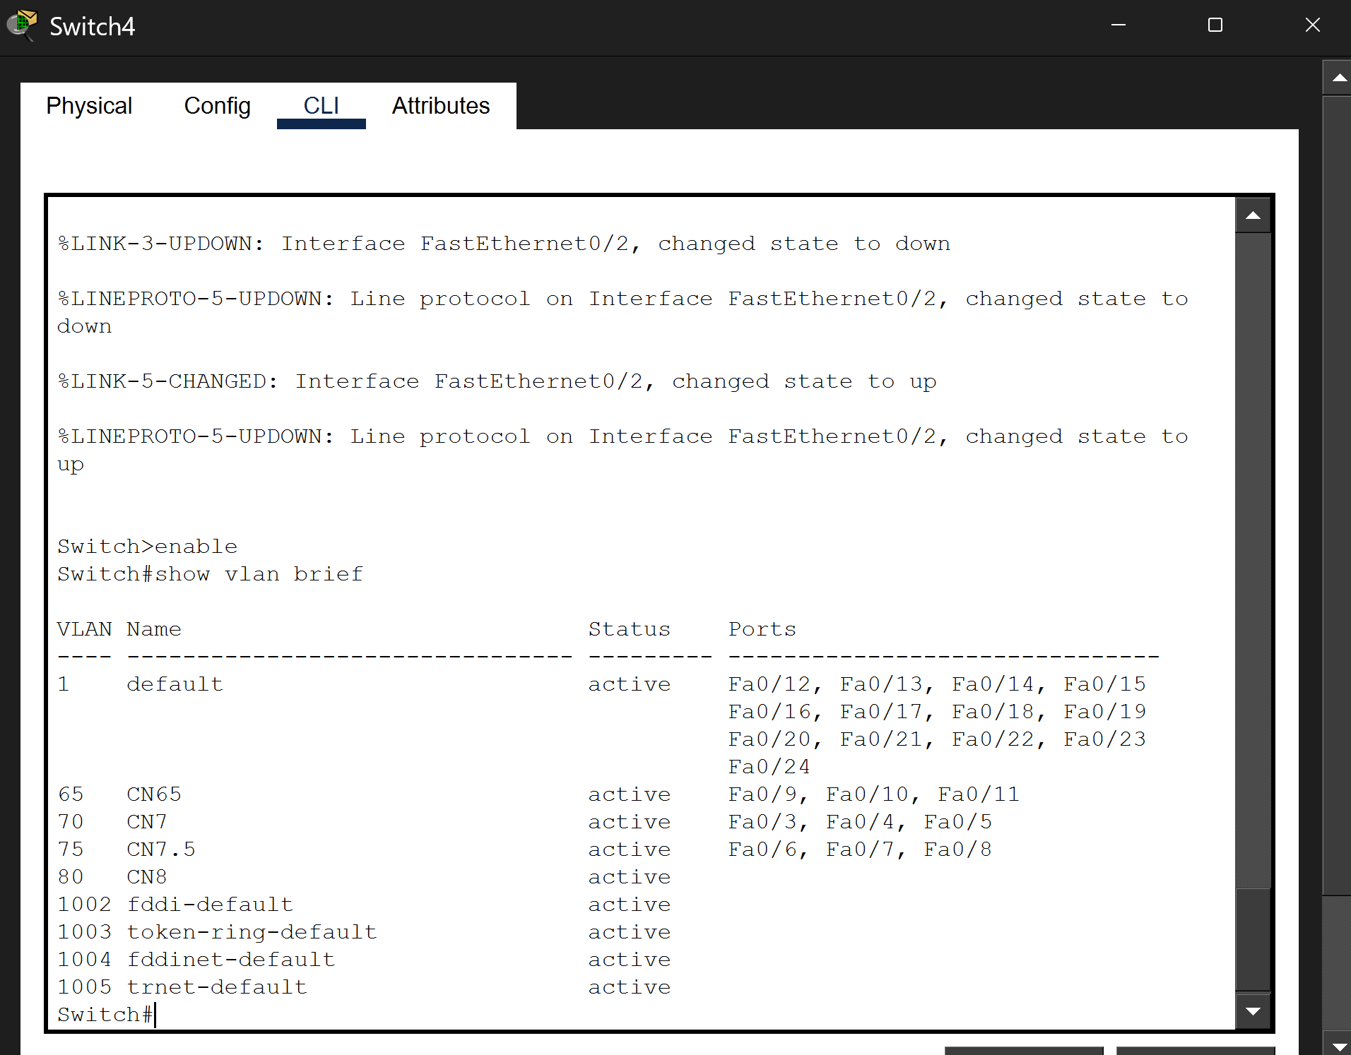
Switch 8- Bradford Switch 4- Liverpool

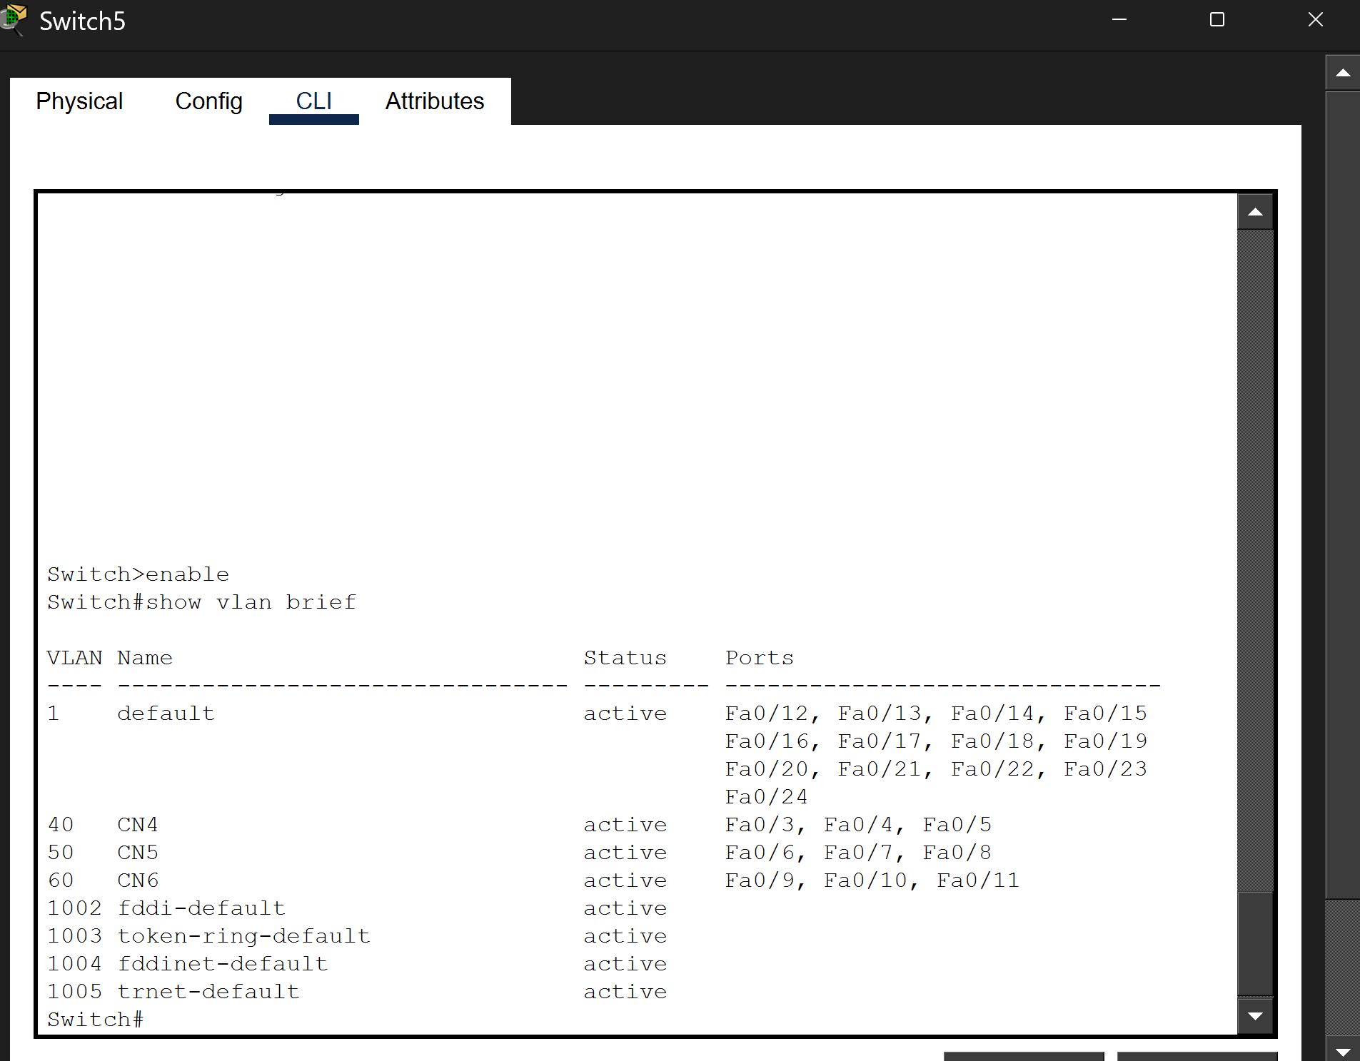
Switch 5- Newcastle

DHCP CONNECTIONS

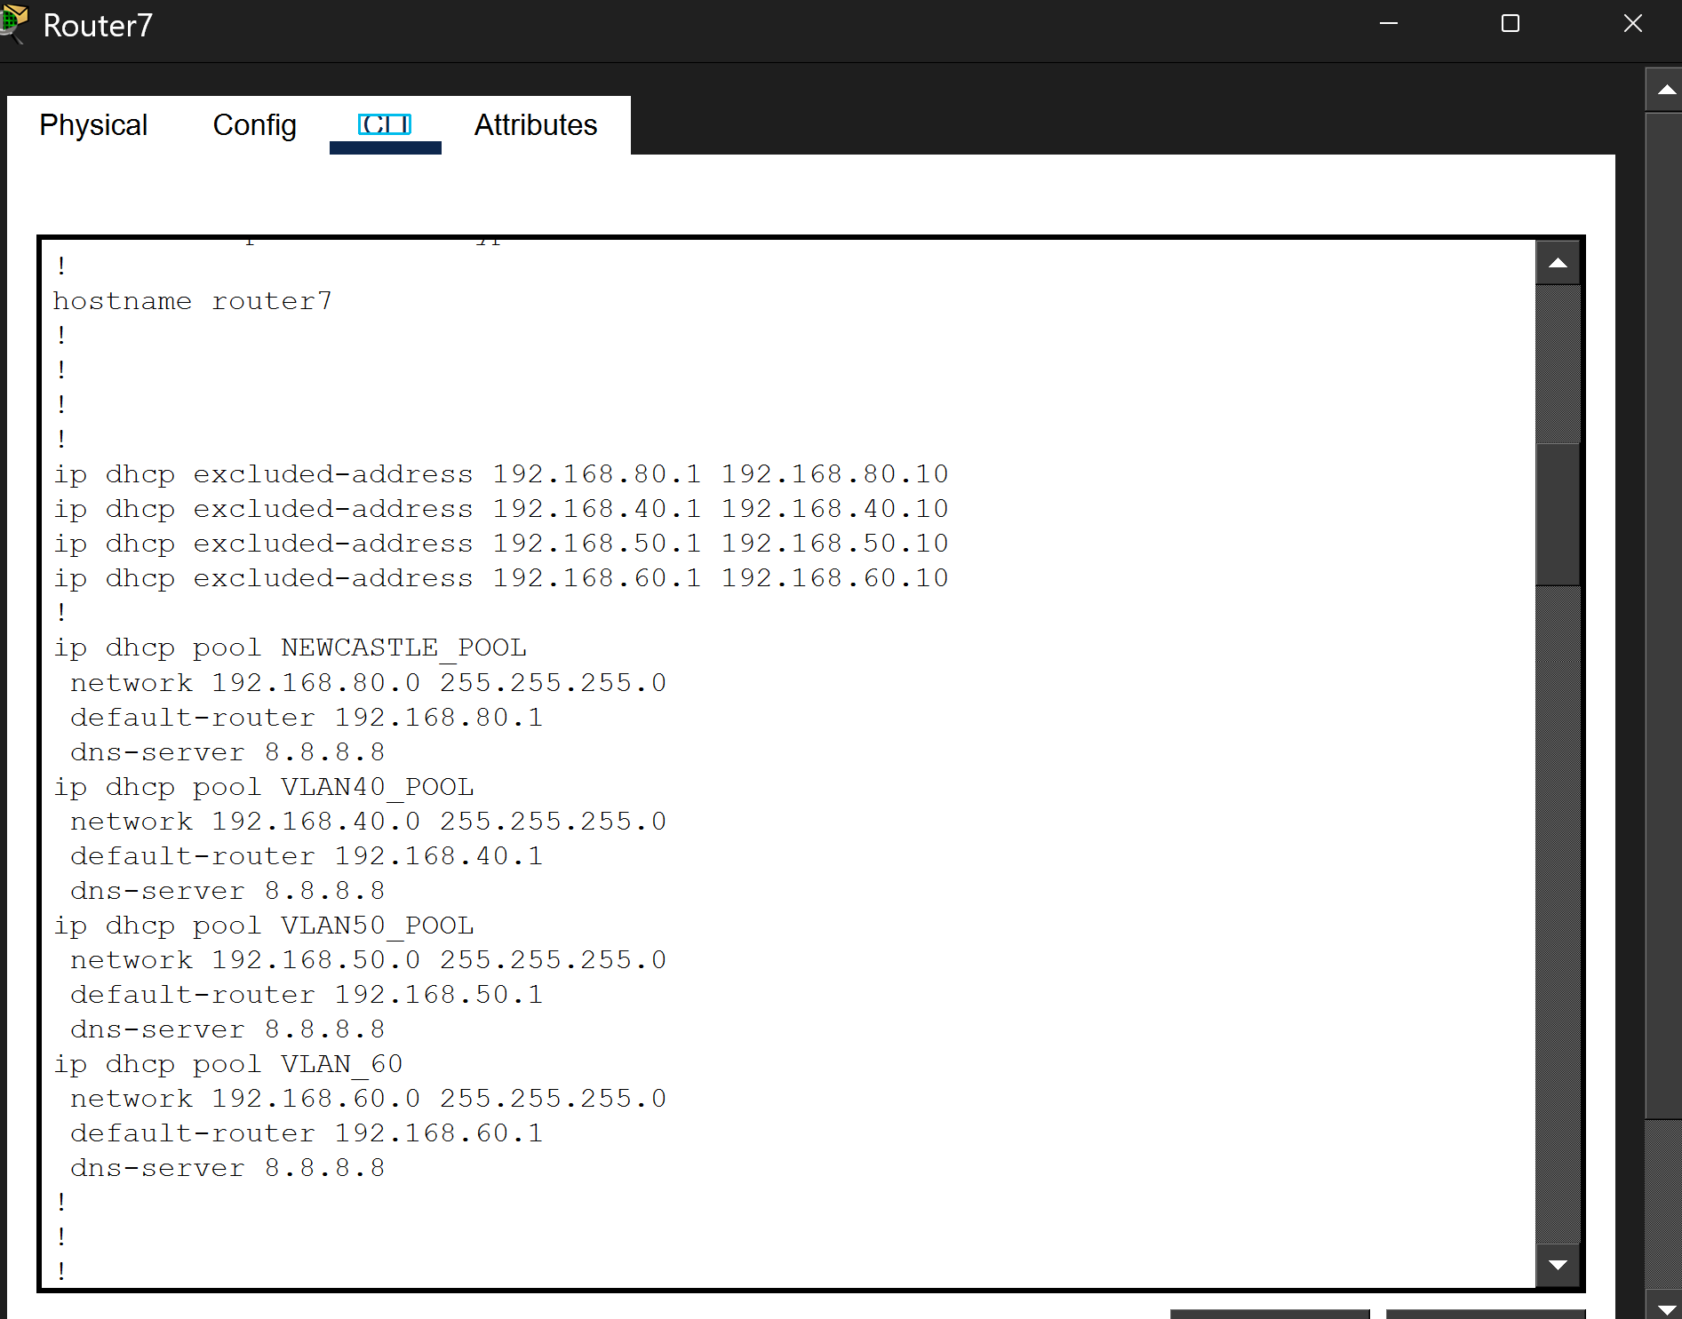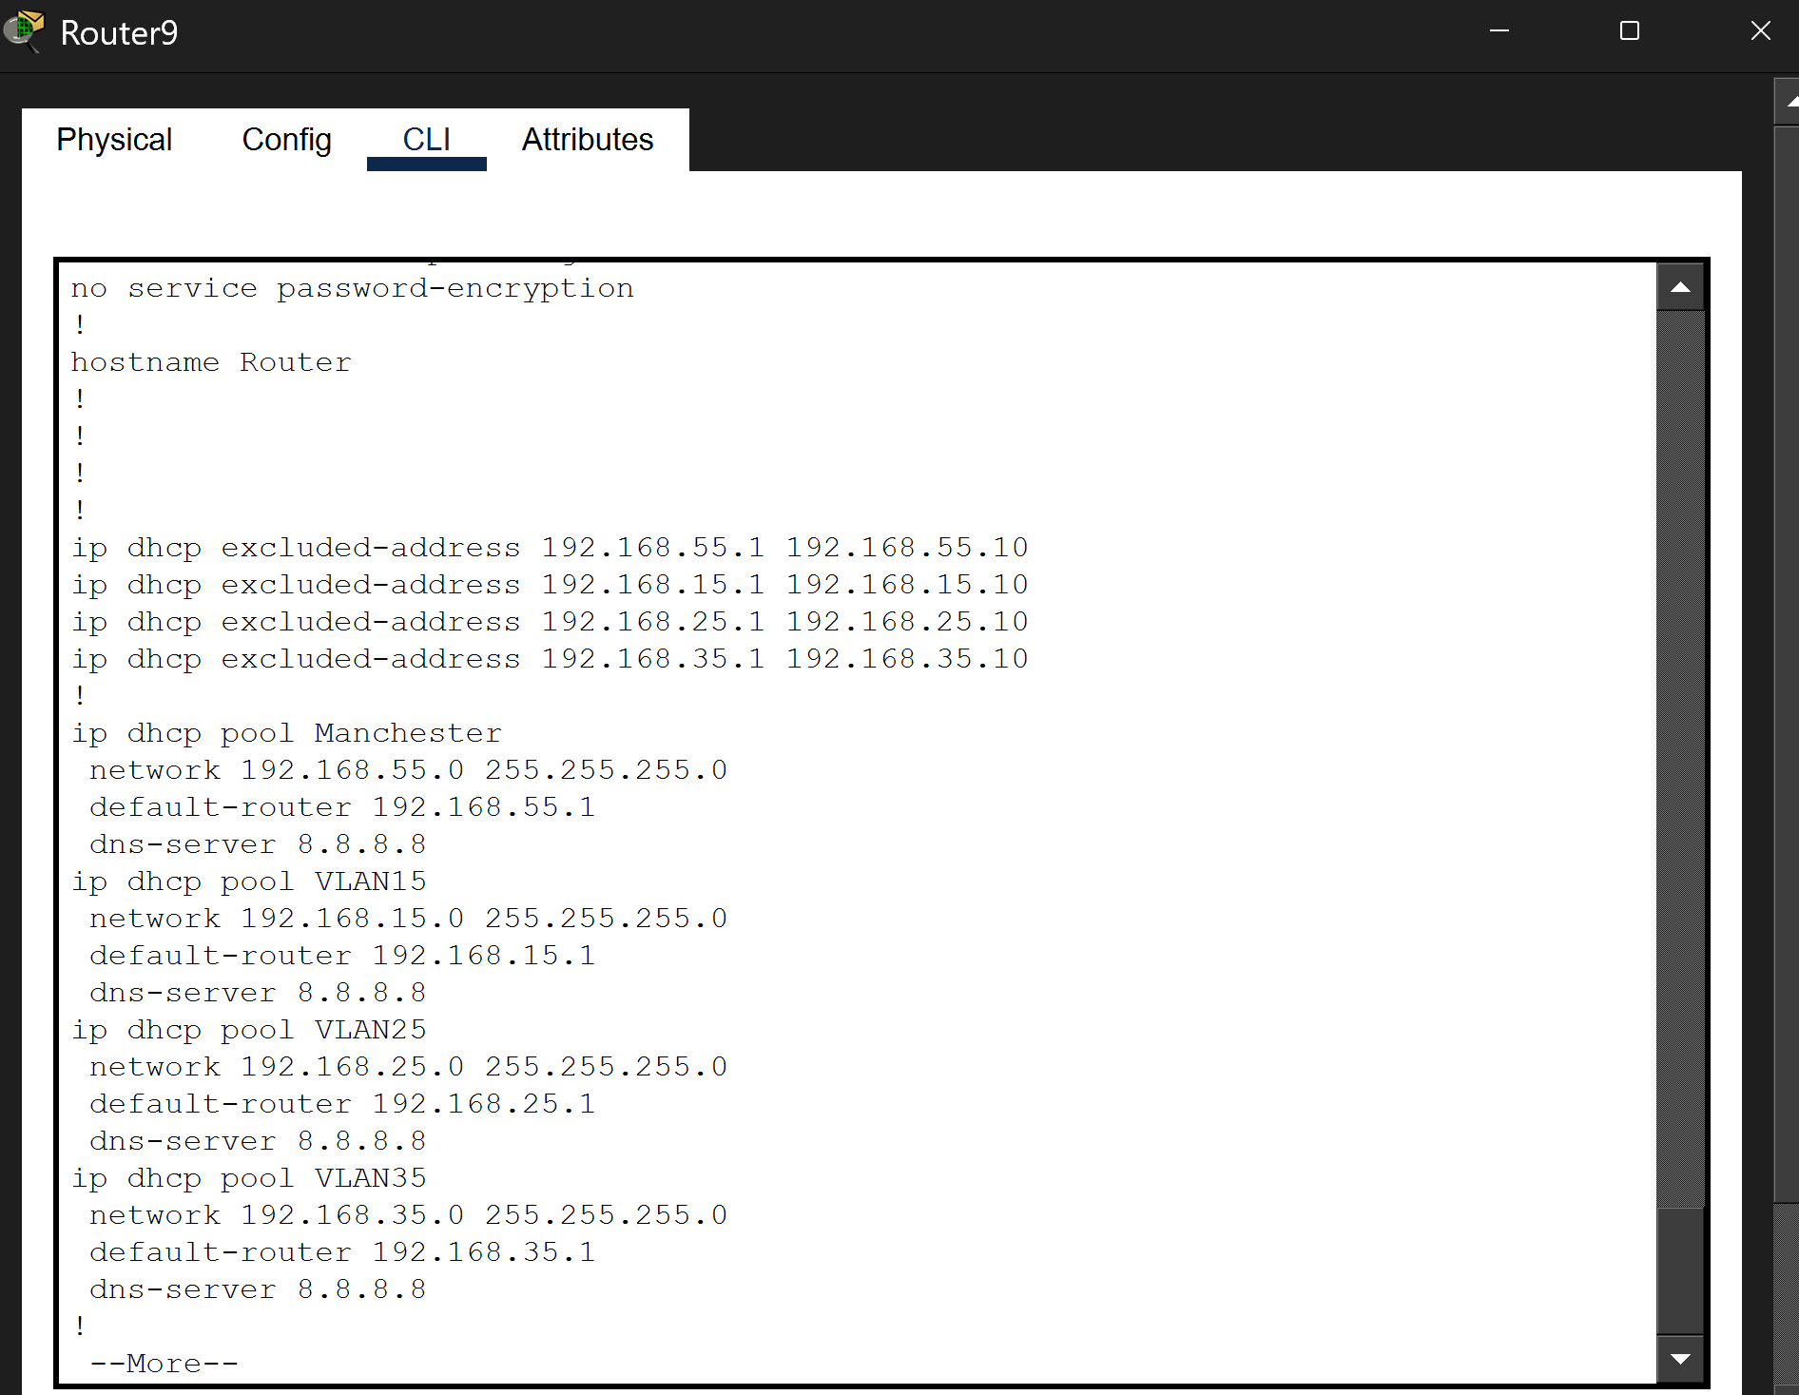
Router 7-Newcastle Router 9- Manchester

SSH CONNECTIONS

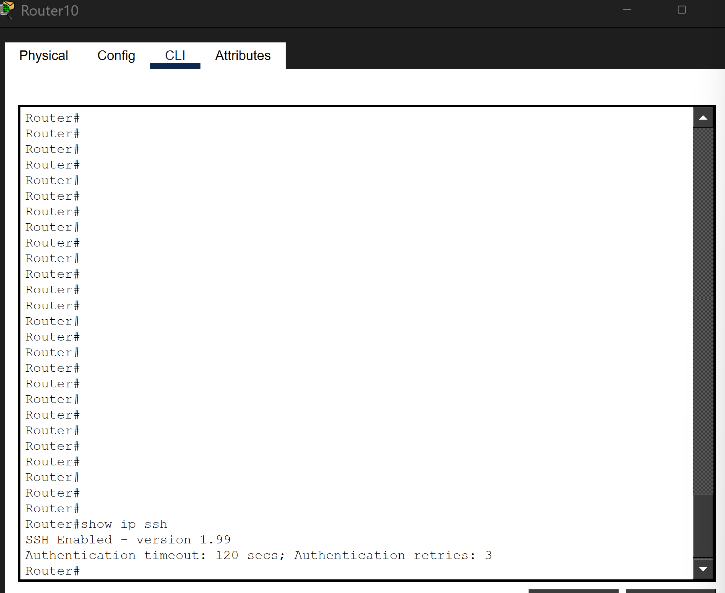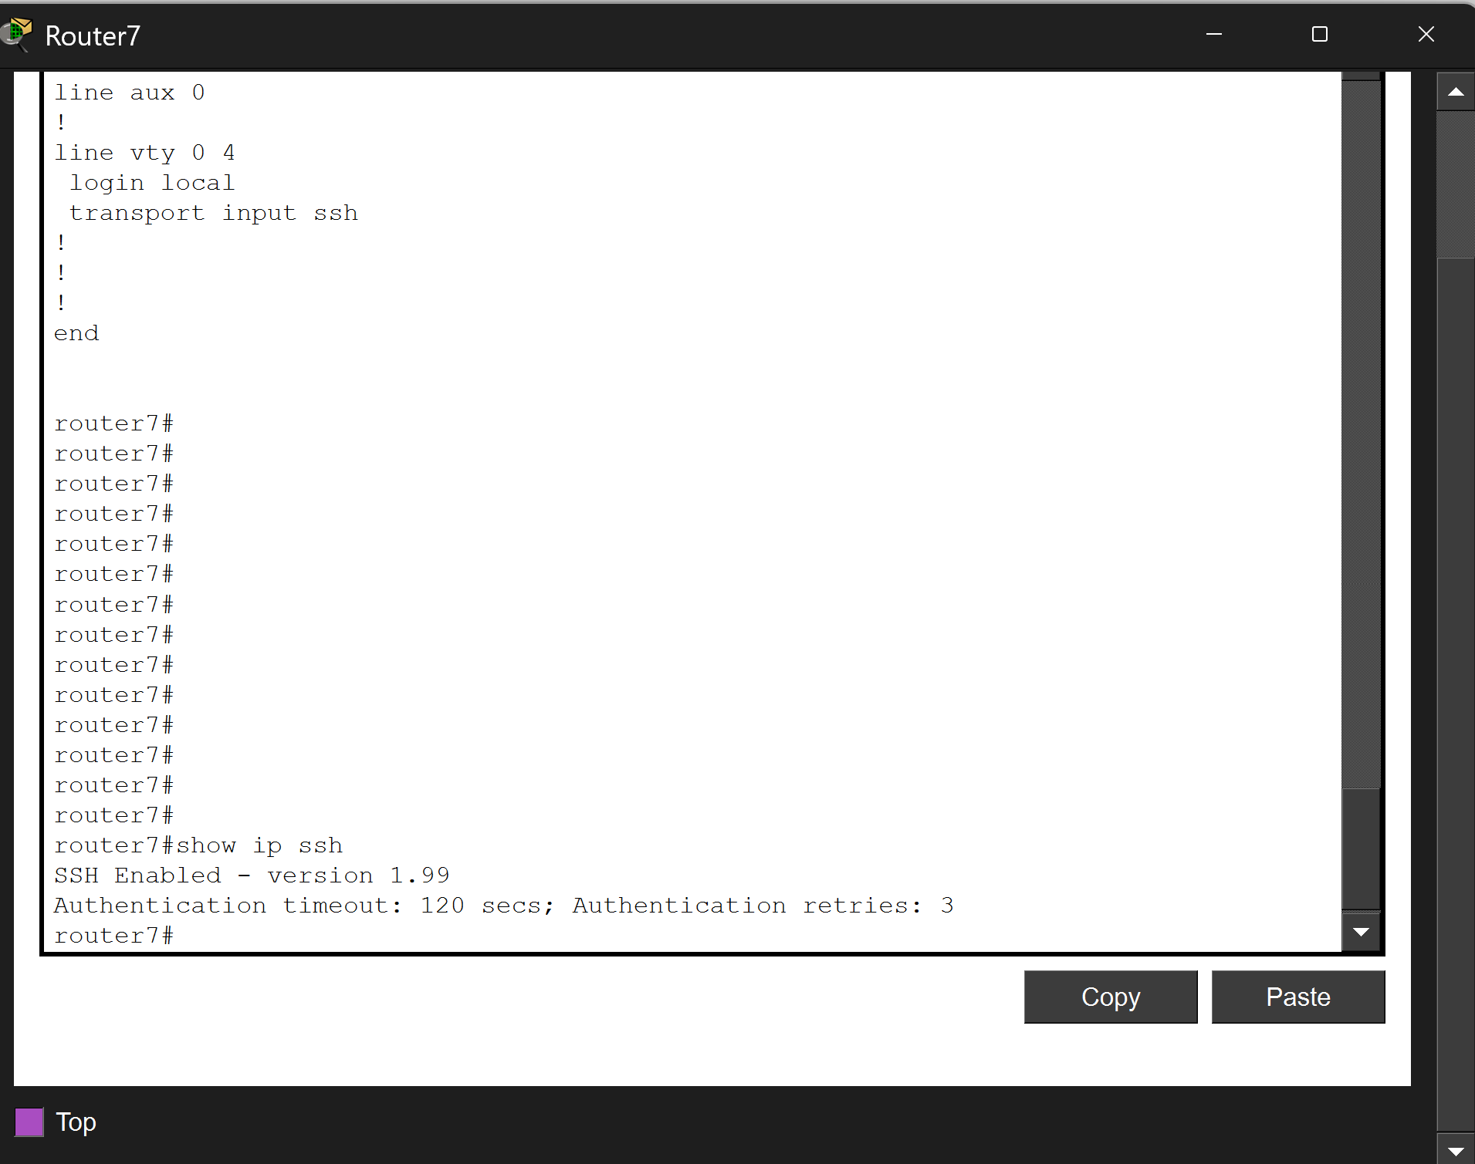
Router 10- London Router 7- Newcastle

ROUTING TABLE CONNECTION
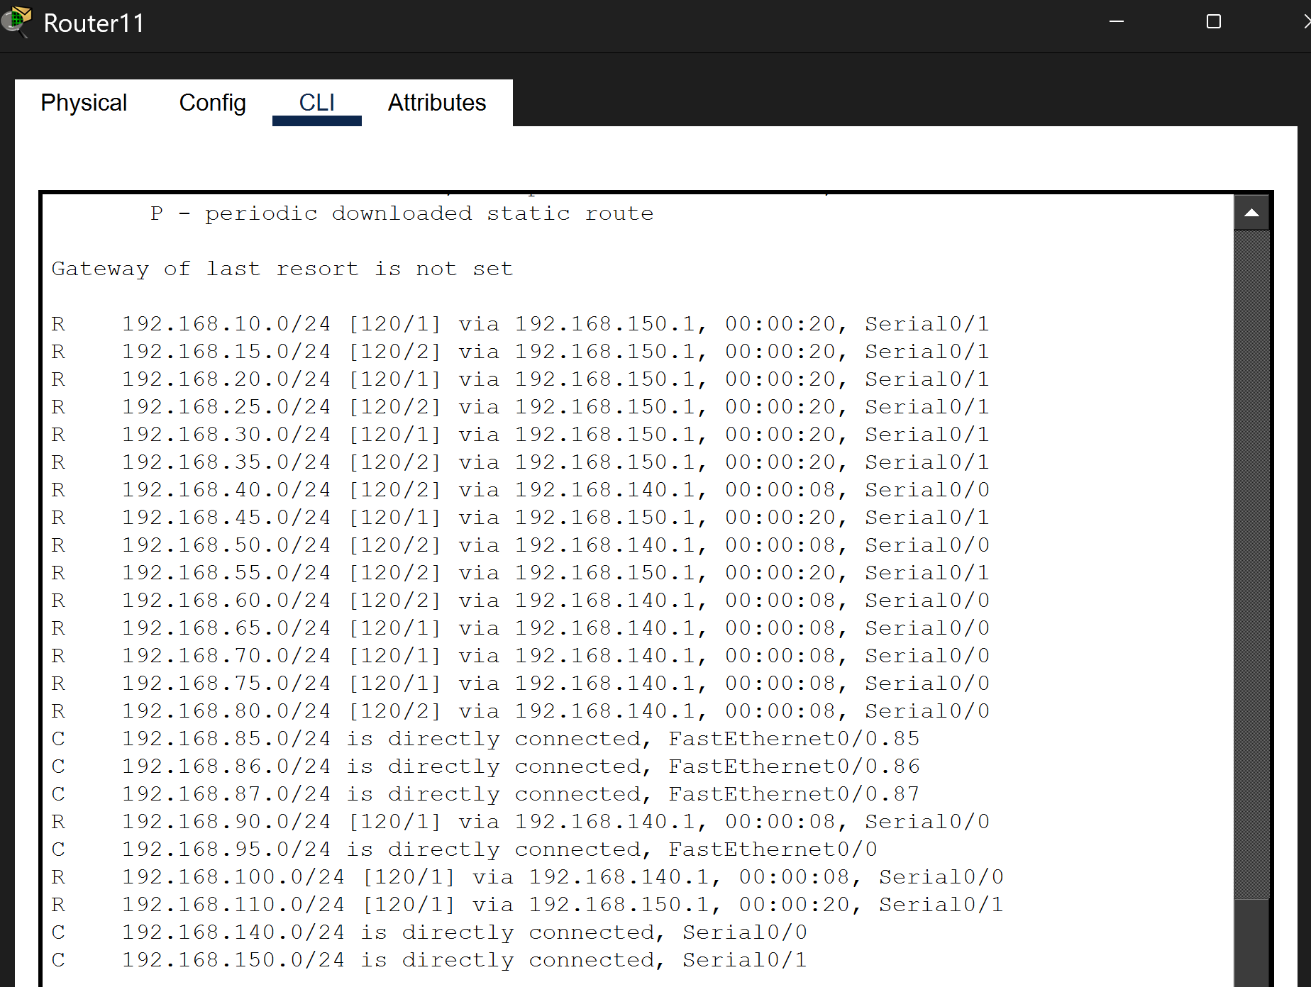
Bradford

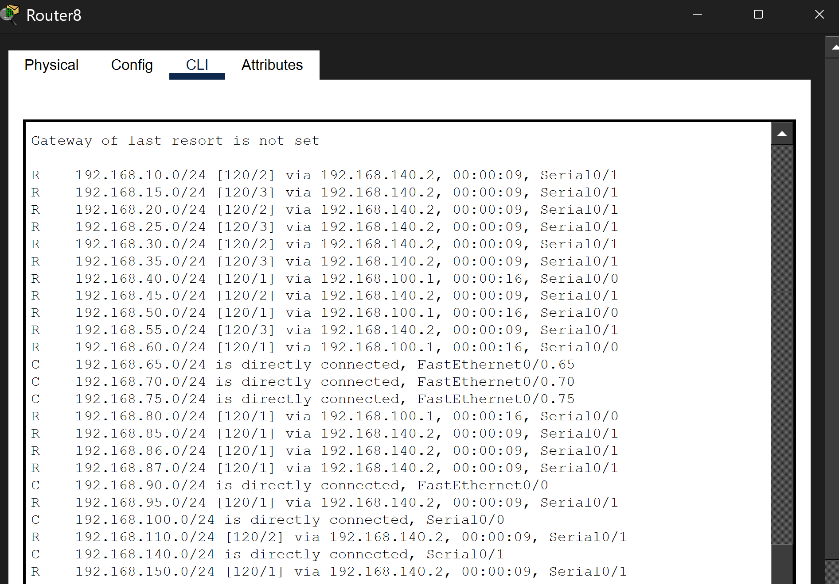
Liverpool

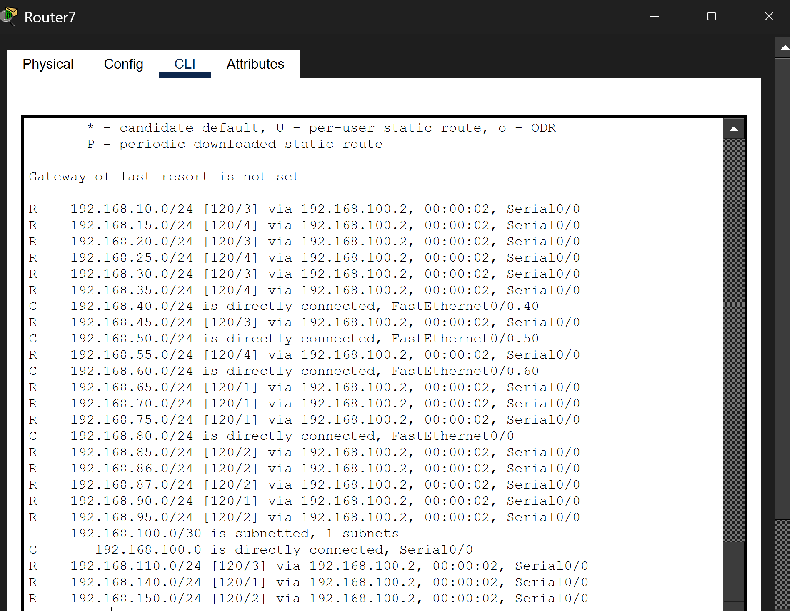
Newcastle

