# Simple Report – Multimodal Classifier with Google Teachable Machine

## 1. What I Trained

| Part | Classes & Sample Count | How We Collected Data |
| --- | --- | --- |
| **Image Model** | *Smartphones, Laptops, Bottles* (≈30 photos each) | Used webcam; showed each item from different angles. |
| **Audio Model** | *Queen, Hozier* (≈20 short clips each) | Played songs on laptop speaker; room had normal background noise. |
| **Combined Model** | Teachable Machine’s “Combine” block joins the two models | No extra data needed. |

## 2. How Training Went

* **Image accuracy:** about **96 %**
* **Audio accuracy:** about **93 %**
* Training took only a couple of minutes in the browser.

## 

## 3. Test Results

### 3.1 Image Model Confusion Matrix

*(Blue squares = correct guesses)*

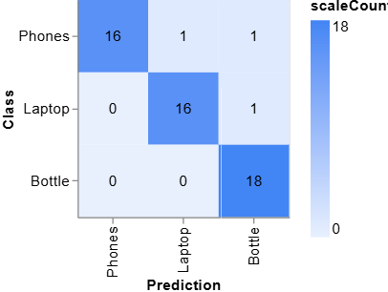

Confusion Matrix

*Out of 52 tests, 50 were right → ~96 %.*

### 3.2 Quick Audio Check

* Queen songs were usually tagged **Queen**.
* Hozier songs were usually tagged **Hozier**.
* During silent pauses the prediction sometimes flipped back and forth.

## 4. What Went Wrong (and Why)

| Mis-step | Likely Reason |  |
| --- | --- | --- |
| Holding the laptop **upright** looked like a phone. | Phones are tall and thin → model saw similar shape. |
| One laptop photo showed as **Bottle**. | Screen glare looked like a shiny bottle. |
| Audio model jumps between artists when there’s silence. | With no sound, the model isn’t sure. |  |

## 

## 5. Live Demo Highlights

1. Show bottle → says **Bottle** (fast).
2. Show laptop sideways → **Laptop** (correct).
3. Show laptop upright → **Phone** (mistake).
4. Play *Bohemian Rhapsody* → **Queen** almost all the time.
5. Short silent gap in Hozier song → guesses flicker.

## 6. Take-aways & Next Steps

* Even with a tiny dataset, Teachable Machine gives good accuracy.
* **More varied photos** (different angles, lighting) will cut down the image mistakes.
* **Smoothing audio output** (ignore silence) will steady the artist guesses.
* Future idea: export the trained model to a phone so shoppers can use it on-device.