# Board 1: Practice Board Report

This board was primarily a way to learn the full process of creating a new PCB from conceptualization to final testing. For this board, my first step was creating a Plan of Record for the board, so that I could define what functionality was required for my board to “work” in the end. The POR is added below.

1. A power plug to use an external 5 V AC to DC charger to power the board
2. A 555 Timer
3. Circuit to achieve an approximately 500 Hz and a duty cycle between 50% and 55% including a decoupling capacitor for the CONT Port
4. 4 same color LEDs and series resistors of: 10k, 1k, 300, and 50 Ohms.
5. Indicator lights, test points and isolation switches.
6. Design to measure the 5 V input rail, the 555 output voltage and the current through the 50 Ohm LED.

With this, I was able to create a sketch of what my circuit should look like in order to achieve these goals. This sketch is included below.

Based on the data sheet provided with the 555 timer I used, I calculated that the 1kΩ and 100kΩ resistor used with the 555 timer could achieve a 51% duty cycle and close to 500HZ. With this math done and the general circuit designed, I proceeded to create the full circuit desi gn in Altium, which is depicted below.

In Altium I also added several parts, like the led to indicate 5V power to the board and switched to isolate parts of the circuit, to the schematic to aid with debugging the circuit once constructed. Along with parts to aid with debugging the circuit, I also added several decoupling capacitors to reduce the switching noise from the 555 timer. From this point, I created the board layout itself, making sure to follow the best practices to avoid unwanted noise. The board design from Altium is included below.

Once I received the board, I learned how to properly solder a board so that the solder points are clean and make make full connections. The bare board and conscructed board are included below.

With a built board, my final task was to access whether the board met the expections set by my POR.

1. 5V AC to DC power supply requirement ment
2. 555 Timer requirement met
3. 500Hz and decoupling capacitor for the CONT port of the 555 timer met. Unfortunately, I didn’t meet the requirement for a near 50% duty cycle. My final board had a duty cycle of 66% with a 500Hz frequency. This error is due to the fact that I used a 1kΩ instead of a 100kΩ when creating my final board and the picture of the scope measurements are below.
4. Requirement for 4 LEDs and series resistors of: 10k, 1k, 300, and 50 Ohms met.
5. Indicator lights, test points, and isolation switches were all added.
6. Test points were able to measure the 5V rail and output of the 555 timer. While creating the board, I modified it to instead measure the voltage across the 1kΩ resistor instead of the 50Ω resistor.

The measurements below depict the output of the 555 Timer and the voltage across the 1kΩ resistor. The yellow shows the 555 Timer and is offset by about 9V to allow for easy distinction between the timer measurement and the resistor measurement, shown in green.

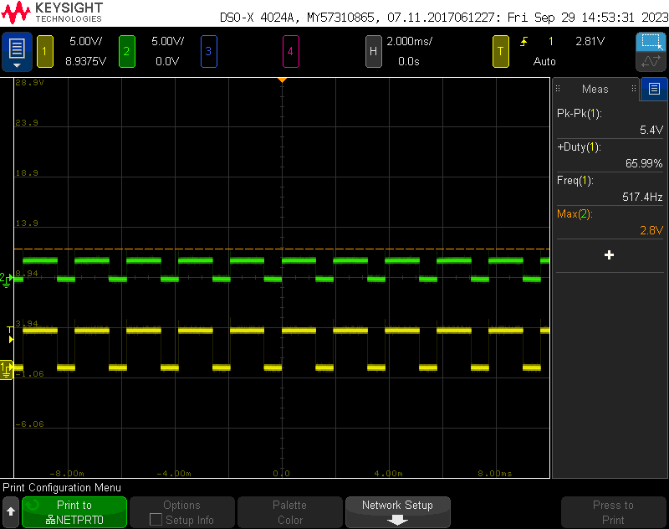

The design process of the project went very well and I hope to emulate that in future projects. The calculations I made for the resistors attached to the 555 Timer matched very closely with the measurements I collected from a prototype circuit on a solderless breadboard. Unfortunately, the construction of the boad went poorly. I made a mistake using the wrong resistor, which caused my board to fail the third point on my POR. I do not remember how or why I made this mistake, but in the future I must remember to double check all of the parts I solder onto my board with my PCB layout.