# Board 3: A Golden Arduino PCB

The purpose of this board was to get practice with the complete design flow of a PCB and integrating PCB design best practices into a more complex board. For this board, I made a POR to help guide the design and debugging of the board.

1. Convert 5 V in to 3.3 V.
2. Use an Atmega328 chip with a 16MHz resonator as the microcontroller for my arduino
3. Use a CH340g with a 12MHz resonator to allow for usb communication
4. Add a switch to choose between USB power or the power jack
5. Use indicator LEDs for the power jack, usb port, and board power.
6. Use leds to monitor the communication over the TX and RX lines.
7. Add isolation switches to isolate the CH340g and the Atmega328
8. Use decoupling capacitors where needed.
9. Add female header pins so that it has the same footprint as a standard arduino.
10. Follow PCB best practices by using a continues return plane with minimal cross unders and placing the decoupling capacitors as near the ICs they decouple.
11. Add a second row of header pins connected to ground to allow from spring probe testing of arduino pins.

Using this, I went on to create my schematic which I’ve included below.

Using that schematic I then made the pcb layout below.

During the design of the schematic, I chose to use net labels instead of long wires to connect many parts of the PCB together. This was helpful in that you no longer need to follow a line around the page in order to understand what a wire is, but instead you can read the name of the net label. This also allowed me to more easily separate the schematic to the various parts of the board.

For the layout design, I tried to keep the design more compact to make routing the traces easier and ideally avoid additional cross unders. While this did achieve its goal, it had the side effect of making it harder to solder many components onto the board, which makes it much more likely that I wouldn’t solder a component correctly due to the room constraints. In future designs, I will instead opt to scale the entire board to provide enough space that soldering wont be a concern.

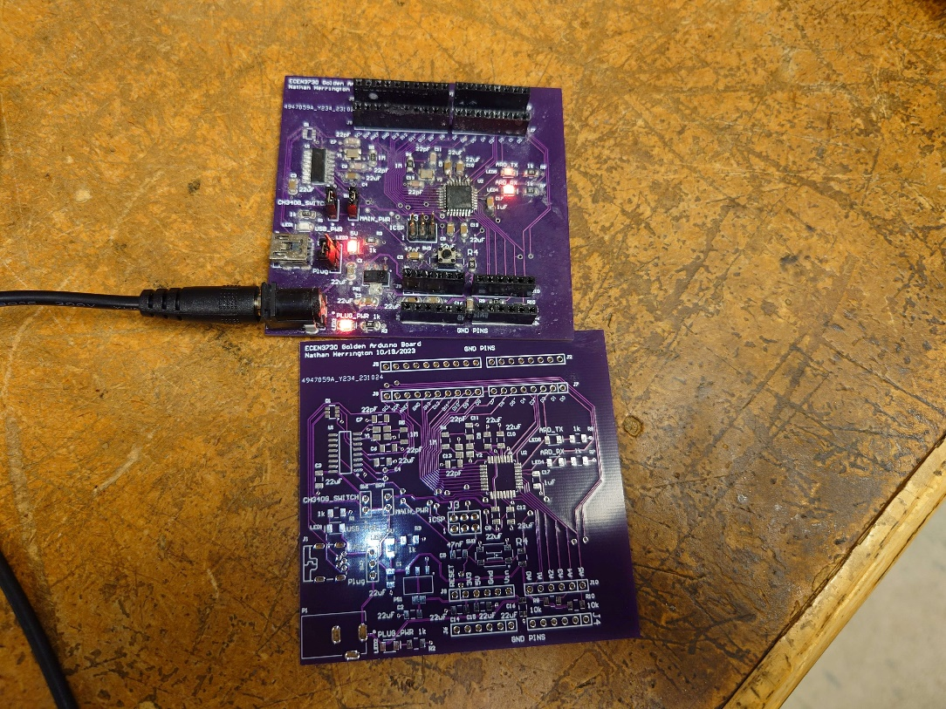Once I received my PCB, I brought up the board and prepared to boot load it. Using another arduino, I was able to bootload my board but I wasn’t able to push code to it. I believe this is because of the capacitors on my DTR line. I initially had issues bootloading my board, so I swapped the 47nF capacitor in series with the DTR line for a 1uF capacitor. This didn’t solve the bootloading problem, but I also never changed the capacitor back. This means that my DTR capacitor and my filter capacitor are the same and create an voltage divider that doesn’t allow for communication with the ATMega. Both my ATMega and CH340g had the correct power on their VCC pins and were both running as evidenced by the resonators providing the correct frequency. The measurements are included below.

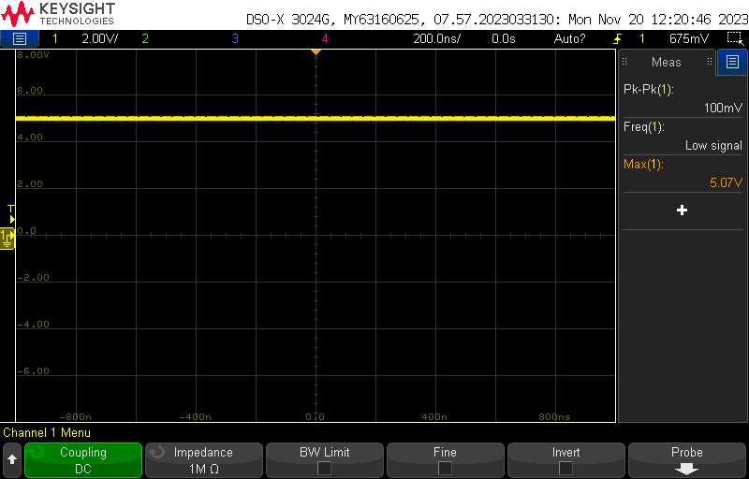

Figure : ATMega VCC Figure 2: CH340g VCC

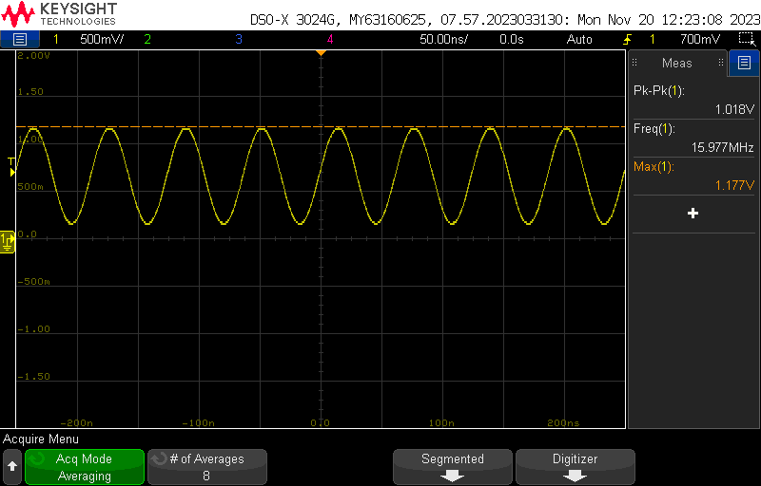

Figure 3: ATMega Resonator Figure 4: CH340g Resonator

Unfortunately, I couldn’t measure the difference between a custom board and a commercial board because I couldn’t get my board to run code and couldn’t get another board to use as reference.