# Lab 18 Report: Measuring a board’s current

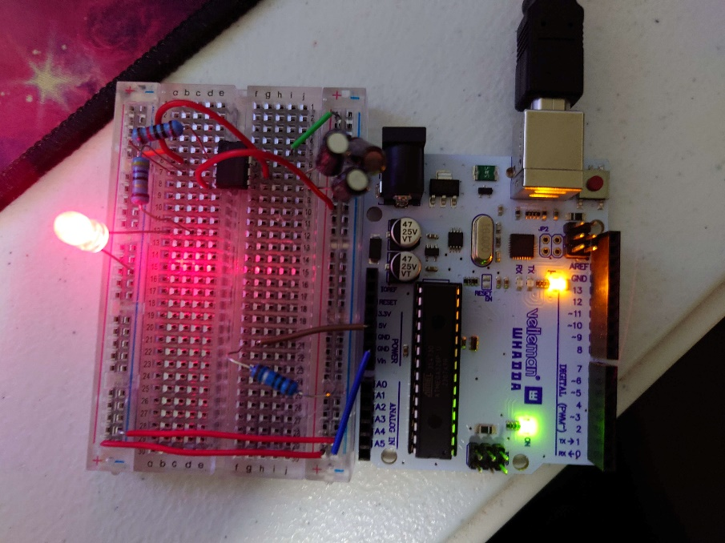 In this lab, I learned how to measure the current a board pulls, both at steady state and when the board initially receives power. To do this I used 2 single-ended scope probes with a current sense resistor and made a simple 555 timer circuit to draw current from my power source. The schematic and picture of circuit are included below.

To measure the power rail current, you simply divide the voltage drop across the current sense resistor by the voltage of that resistor. To find the voltage drop across the resistor, a standard single scope is unsafe because it will short the power on the board and damage the probe. As a result, it is safer to use 2 probes, 1 at the high side of the resistor and one at the low side of the resistor, and caclulate the difference between the 2 probes. A drawing of this test method is included to the right. Next, I needed to select a resistance for my current sense resistor so that it is large enough to have a measureable voltage drop while small enough to not significantly impact the power rail’s voltage. In order to estimate the voltage drop, I calculated the current through the resistor and LED. The voltage at the 555 Timer’s output is the blue line in the next image, and is about 3V at peak. The red LED had a a 1.6V drop, meaning that there 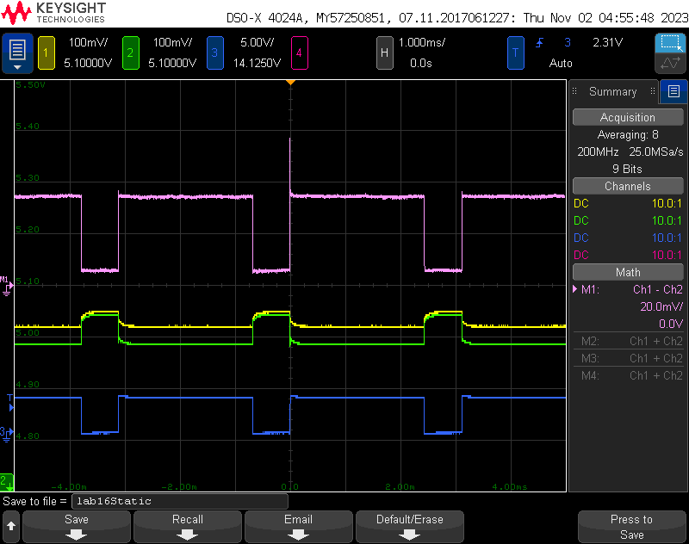was a 1.4V drop across the 49Ω resistor and the resulsting current draw is .028A. Using a 1Ω resistor would result in a .028V drop which is both measureable and minor enough to not impact the circuit. A 1Ω resistor also simplifies the calculations, meaning that the voltage and current are equal.

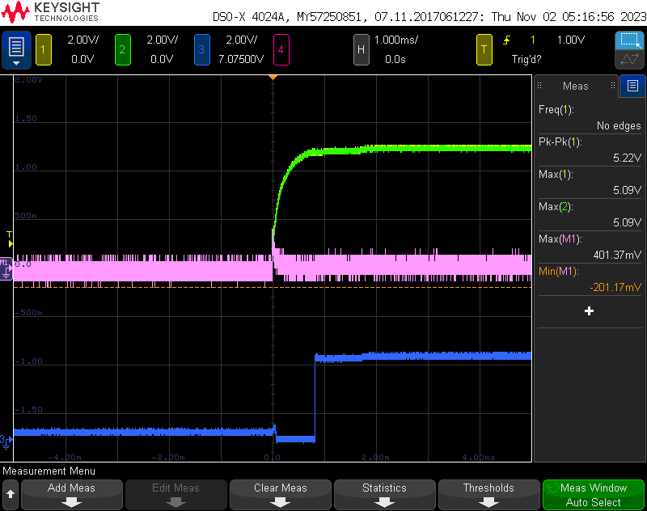 The image to the right shows the steady state voltages of the high side of the resistor, yellow, low side of the resistor, green, 555 timer output, blue, and the difference between the high and low sides, pink. While the LED was on, the current difference between the 2 sides of the sense resistor was about .038V, meaning the peak current draw is .038A.  
 I also measured the inrush current of my circuit, the current right as the circuit receives power. This current is expected to be greater due to the capacitors needing to initlally charge. My inrush voltage measurements are to the right. At its highest, the votlage drop across the current sensing resistor is about .4V, which results in a .4A current. This test used a 10uF, and I ran it again used a 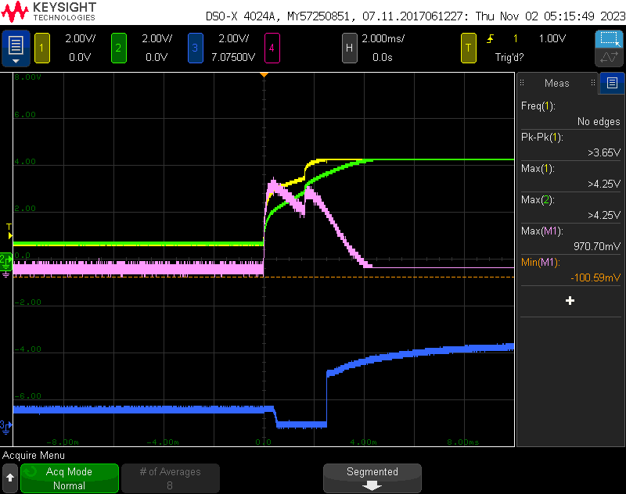1000uF capactior. The measurements I got are shown to the right. This time, there was a .97V drop across the resistor, resulting in a .97A current draw from the circuit.

Through this lab I learned a simple way to calculate the current draw of a circuit, and how to calculate a safe resistance to use to make that calculation. This is a useful tool to have for more in depth debugging in future PCBs, allowing me to monitor the current draw of the board and make sure it doesn’t differ from my expected draw too significantly. I also learned how large the transient current of a circuit can be right as it power on. A 1A draw could easily cause problems for the board, but it will likely be too short to be able to break many circuits, lasting about .4ms with my 10uF capacitor and 2 ms with my 1000uF capacitor.