# Lab 22 Report: Applications of Board 4 using the SBB version

For this lab, I tested several different VRMs to both confirm the functionality of my solderless breadboard version of my board 4, and, once confirmed, get a baseline of what I should be measuring when I make the same measurements with my PCB version of Board 4. For this, I used the test setup below:

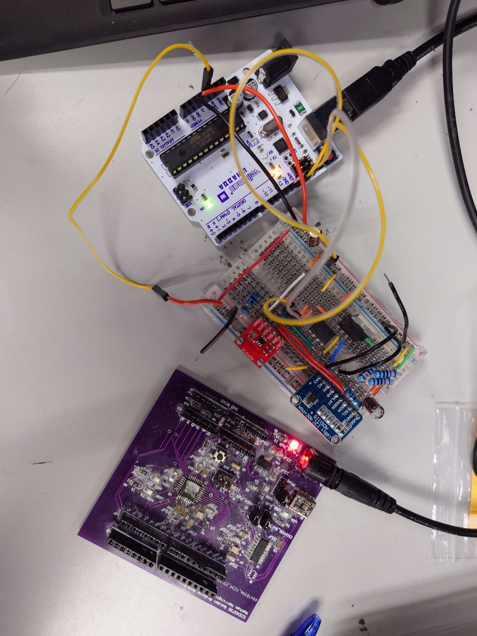

To make sure my setup was working, I initially tested a waveform generator with a known thevenin resistance of 50ohms and got the following measurements.

With the measured resistance at a stable 50ohms, matching the expected thevenin resistance for the waveform generator, I then measured a benchtop powersupply supplying 5V through a 10ohm resistor. The graph below shows my results.

This time I measured an average resistance of 17ohms, which is expected given the 10ohm resistor and already small resistance of the power supply. This confirms that my board is working and ready to test unknown VRMs.

First I tested a 5V and 9V wall wart. In order to get the power from the wall wart plug to my board, I used the jack from my Board 3 and the Vin pin. I also measured the 5V and 3.3V rail of my purchased arduino. All of the measurements are below.

The measurements of the 5V wall wart are a little unexpected, but that is likely due to the fact that the voltage drop was smaller than what my board could measure, so it measured a larger voltage drop than was present with the smaller current. Other than that, all of the other data matches expectations and provide baselines for what my Board 4 should expect to read.