# Lab 5 Report

During this lab I experimented with a slammer circuit to observe and learn about the effects of decoupling capacitors in a circuit. The slammer circuit tested the performance of a 9V power supply during a sudden load and allowed me to observe the power supply with and without a decoupling capacitor. The figures below show the performance of the 9V power supply with and without a decoupling capacitor.

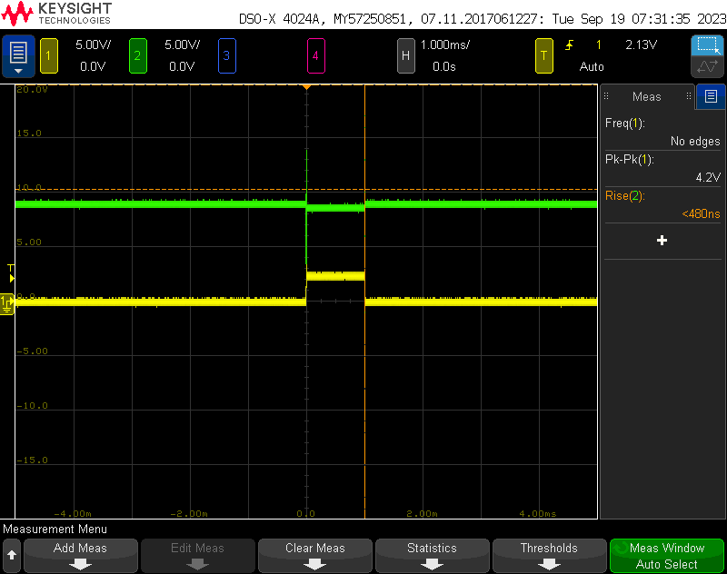

Figure : Voltage Slammer without Decoupling Capacitor Figure 2: Voltage Slammer with 1000µF Decoupling Capacitor

Based on these figures, it is easy to see a decrease in voltage while under a sudden load when no decoupling capacitor is present, while there is a very minor, almost unnoticeable, voltage drop with the capacitor present. This is because the capacitor can charge while no current flows through the circuit, then when there is a sudden load, it discharges to supplement the drop in voltage. This helps smooth that voltage drop that was present without the capacitor.

This circuit also let me test the effects of differing capacitance values on the voltage drop. I tested a 1µF and a 1000µF and found a very large difference in how well they were able to manage the voltage drop. From the figures below, larger capacitance values are better at minimizing the voltage drop.

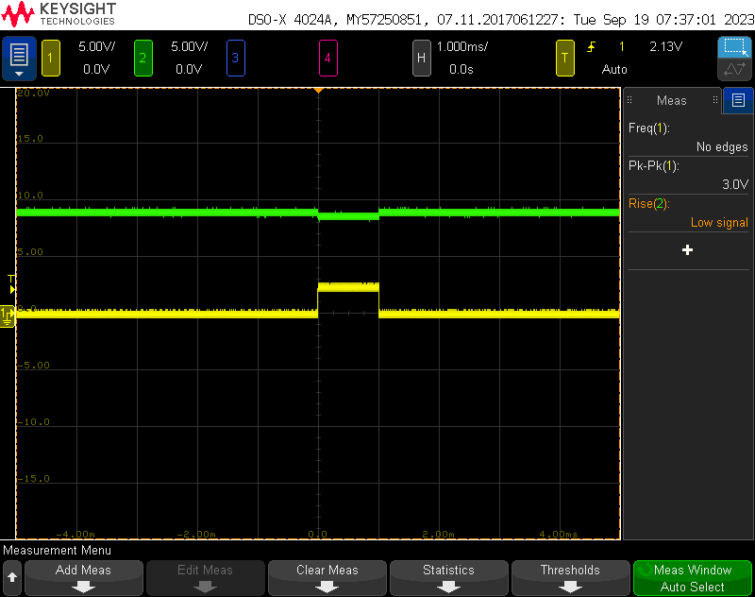

Figure 3: Voltage Slammer with 1µF Decoupling Capacitor Figure 4: Voltage Slammer with 1000 µF Decoupling Capacitor

Using this circuit, I was also able to calculate the Thevenin voltage and resistance of my power supply. I found that my power supply’s Thevenin voltage was about 9.5 V. Using this and the voltage drop across a 10Ω resistor, measured at 3.2V, I calculated a current of .32A, resulting in a Thevenin voltage of 20Ω. Unfortunately, I forgot to record a voltage drop across the interconnect between the voltage source and the mosfet drain, so I’m unable to calculate an equivalent inductance. My equivalent circuit drawing and built circuit are shown below.

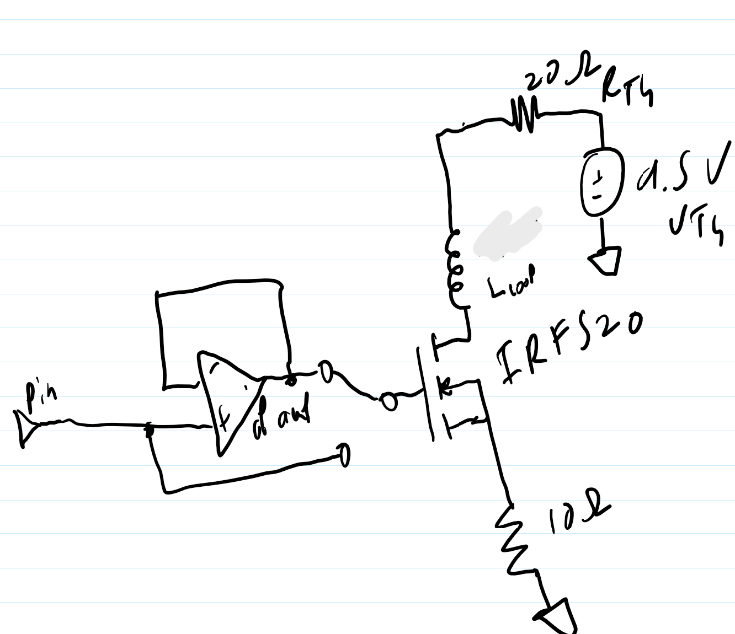

Figure 5: Equivalent Circuit Drawing Figure 6: Circuit built on a Solderless Breadboard