# Lab 9 Report

During this lab, I examined the effects of 3 different methods of designing a return on a the noise experienced in a victim line. The different methods are a continuous return plane, a separate return trace that isn’t shared and a separate return trace that is shared. To test this, I used a board provided to me by my professor that had a section with a return plane and another section without. The section without a return plane also had the ability to change whether or not the victim line shared a return trace or not. The board provided 5 header pins for an arduino to drive up to 5 aggressor loops. The noise is a switching noise, so that arduino would alternate the aggressor loops from high to low. I measured the voltage across the victim line, that was nearby in parallel, to understand what noise was generated. I also recorded the differnces between driving all 5 pins and only driving the pin nearest to the victim line to understand the importance of proximity when it comes to noise.

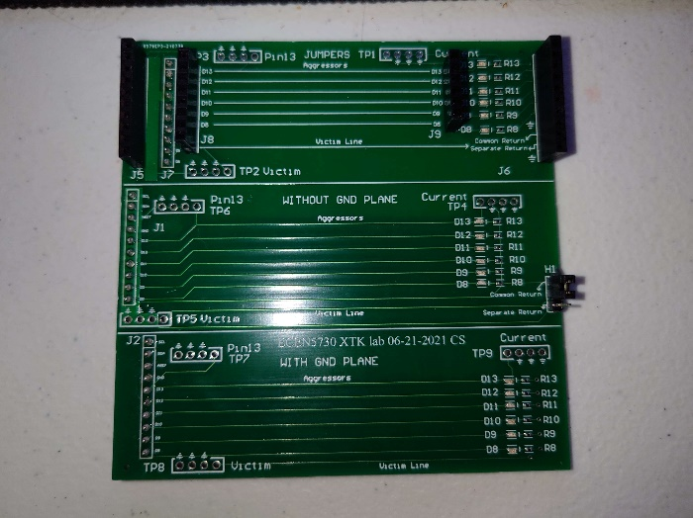

Figure : Front of Test Board Figure 2: Back of Test Board

The first return method I examined was when the aggresor loop or loops all used a return plane on a separate layer. This method had the least amount of noise present on the victim line. In the figure below, the green line below is the agressor signal which was used as a trigger to measure the noise on the victim line. The yellow line is that noise.

Figure 3: Ground plane noise from one pin Figure 4: Ground plane noise from five pins

It is clear here that the noise is very minor and will be, for a majority of circuits, negligible. This is due to the fact that a ground plane limits the ability of the aggressor and victim to generate noise through their mutual inductance.

Next I tested the noise when the aggressor and victim had no ground plane and didn’t share a return trace. This method had noticeably more noise than using a return plane. The figures follow the same coloring scheme as above.

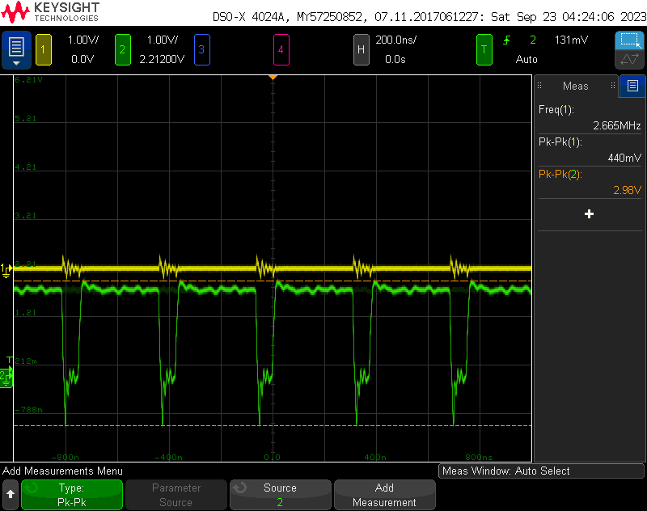

Figure 5: Separate return trace noise from one pin. Figure 6: Separate return trace noise from 5 pins.

While the noise present is still relatively small, it is now significant enough to cause errors in measurments and bugs in sensitive circuits. Now that the aggressor and victim have mutual inductance, the magnetic field generated from the aggressor switching will cause the victim line to experience an induced current, and thus a voltage.

The final method I tested was when the aggressor and victim both didn’t have a return plane and shared a return trace. This method had very significant noise, noise that was large enough that it could have caused bugs in many less sensitive circuits. It was so significant, that the voltage could spike and be larger than the aggressor circuit when all 5 pins were driving. The figures below follow the same color rules as above.

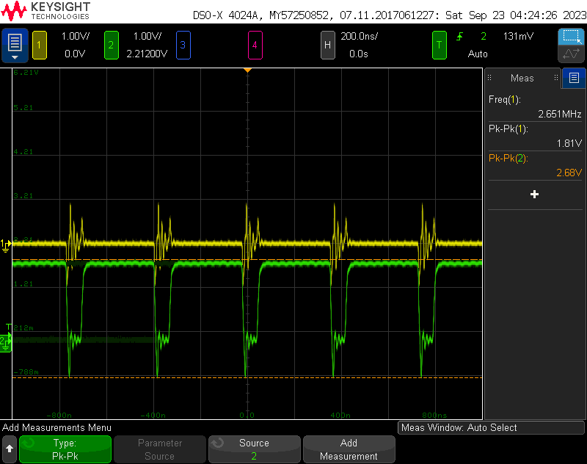

Figure 7: Common return trace noise from one pin. Figure 8: Common return trace noise from 5 pins.

This noise will, at the very least, be a problem when trying to perform any measurements, but can also impact the performance of of the circuit. Now both the mutual inductance and shared return are creating noise.

These tests show why a common return plane is the best practice because it plays a very large role in minimizing switching noise in a circuit. The return plane made it mostly negligible, while using a return trace made the noise large enough to start becoming problematic. This is why its important to keep any traces that must temporarily pass through the ground plane as short as possible. That small trace disrupts the ground plane, which is protecting the circuit from noise. In addition, its also important to provide separate returns so that extra noise isn’t generated from they victim and aggressor sharing a return path. Finally, if noise is predicted to be a problem, it is best to design the aggressor and victim as far apart as possible so that the noise from their mutual inductance, as shown by the fact that the nearest pin was the largest source of noise when there was no return plane.