LAB 1
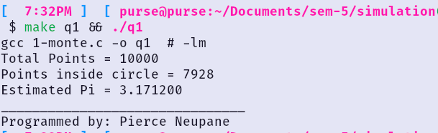
LAB 2
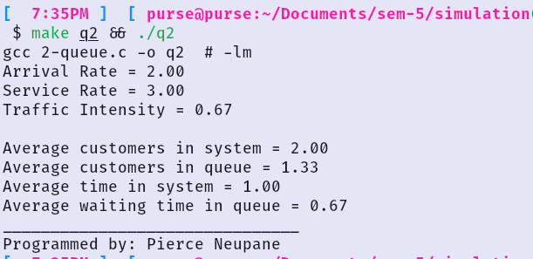
LAB 3
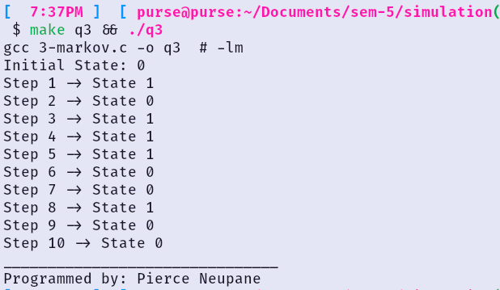
LAB 4
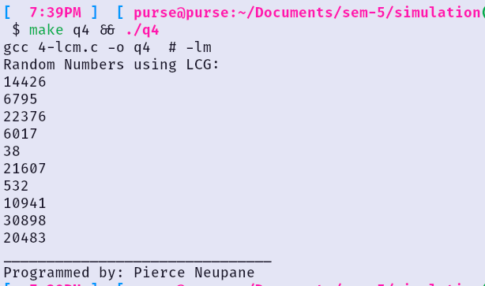
LAB 5
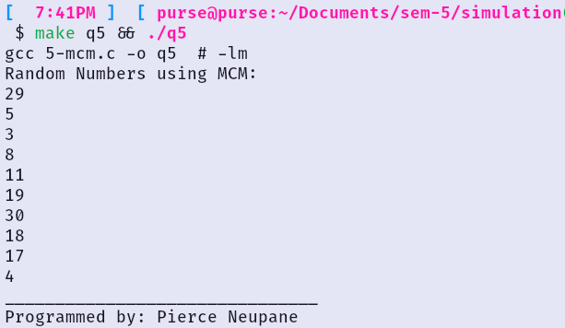
LAB 6
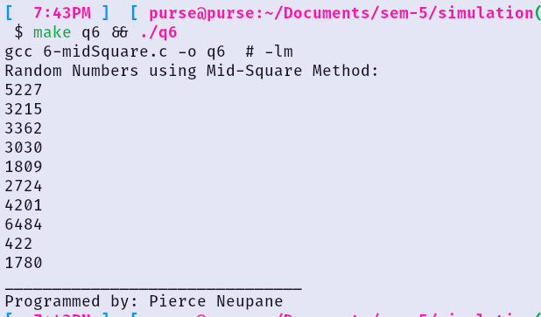
LAB 7
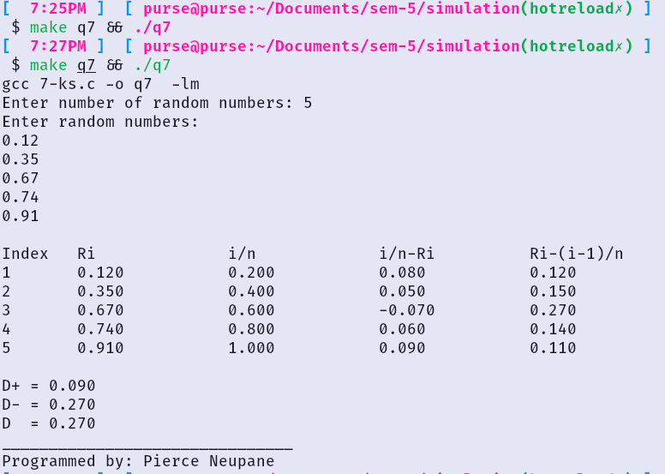
LAB 8
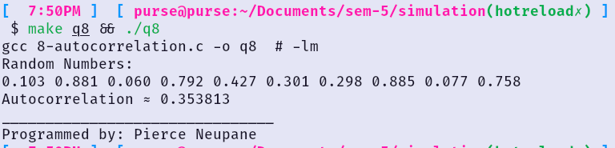
LAB 9
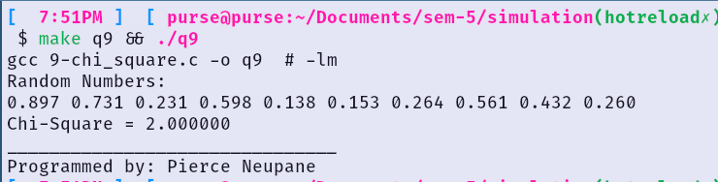
LAB 10
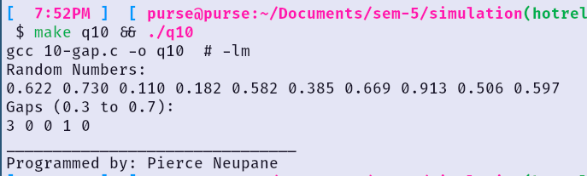

LAB 11
LAB 12
LAB 13
LAB 14
LAB 15
LAB 16

