THE IMPACT OF THE EURO ON EUROPEAN MARKETS
Prepared for:
Centre of Policy Research and Governance
Prepared by:
Purti Sadhwani

OCTOBER – NOVEMBER 2019

HISTORY AND INTRODUCTION OF THE EURO

Euro as a common currency was an ambition of The European Union since the 1960s, after a lot of deliberations and negotiations euro was launched on 1st January 1999. The coins and notes were launched on 1st January 2002, until then it was an ‘invisible currency’, only used for accounting and financial purposes.
The early ideas of establishment of economic and monetary union in Europe were raised against the background of increased economic division due to a number of new nation states in Europe after WWI. The first practical step to picturise the theme was between members of European Economic community with an initiative of European commission in 1969. The Prime Minister of Luxembourg Peirre Werner was assigned with the task to find ways to reduce exchange rate volatility. He proposed fixed parity and complete liberalization of movement of capital, and it was implemented in the European market. But, with the collapse of the Bretton Woods system in 1971,the fixed parity system failed. Post this, in 1972, a mechanism called ‘snake in the tunnel’ was created, it worked for around an year but even this wasn’t successful and had to be withdrawn in the year 1973.
In February, 1986, The Single European Act was signed at The Hague with an objective of establishing a single market by 31st December, 1992 within the European community. It came into effect on 1st July, 1987 under Delors commission.

The Delors Report under the then President of the European commission Jacques Delors set out a plan to introduce European Monetary Union (EMU) in 3 stages which consisted of creation of European system of central banks which would become responsible for formulating and implementing monetary policy.
The first stage began in 1990, with following features:
- Increased cooperation between central banks
- Free use of European currency units.

The second stage began in 1994 with creation of European Monetary Institute, succeeding EMCF under Maastricht. It was created as a forerunner to European Central Bank. During 1997, 11 countries which were a part of the eurozone were selected, the criteria for which was budget deficit less than 3% of GDP, debt ratio of less than 60% of GDP, low inflation and interest rates close to EU average.
In 1998 ECB succeeded EMI, and came into power in 1999. The third and final stage was launch of single currency Euro which further included irrevocable fixing of conversion rates, conduct of single monetary policy by European system of central banks, entry into effect Exchange rate mechanism II (ERM II) and the Stability and growth pact.

ASSESSING THE IMPACT OF THE EURO ON EUROPEAN MARKETS
1. FOREIGN EXCHANGE MARKETS

The introduction of Euro provided several economic benefits to the institutions and general public of euro area countries. One of the major benefits was the single exchange rate for the Eurozone countries. This led to a huge fall in the exchange rate risks associated with various national currencies, and hence benefitted the national banks, multinational companies and investors.
The European Central Bank holds the responsibility of monetary policy and Foreign Exchange risk management and has to balance the needs of all the member nations and therefore is more insulated from political pressure to inflate or manipulate the currency to meet any particular nation's needs.
A paper titled “The Impact of the Introduction of the Euro on Foreign Exchange Rate Risk Exposure” by Söhnke M. Bartram and George Andrew Karolyi found that The Euro led to a significant decrease in the volatility of trade-weighted exchange rates of European countries, stock return variances of nonfinancial firms increased after its introduction. However, the Euro was also accompanied by significant reductions in market risk exposures for nonfinancial firms in and outside of Europe. The report also shows that the reduction in market risk was not as a result of changes in financial leverage, and that it is concentrated in firms with a high fraction of foreign sales in Europe, a high fraction of total foreign sales and larger market capitalizations. In addition to its impact on market betas, the Euro has a positive effect on the incremental foreign exchange rate exposures, particularly for multinationals.
The other important finding is that the average change in foreign exchange exposure following the introduction of the Euro is positive . For example, among firms in the highest quartile of foreign Euro-area sales, the increase in exposure (δEuro) is 0.157 (and for those in the lowest quartile, it is 0.068. The fraction of significantly positive values of δEuro (around 4%, on average) far outnumbers those of significantly negative values (around 0.1%), which suggests that this finding of a positive shift in foreign exchange exposures is pervasive across the sample.
Overall, the results suggest that the stabilization of foreign exchange rates, as entailed by the introduction of the Euro, leads to lower risk of nonfinancial firms. In particular, market risk for firms within and outside of Europe is significantly reduced as foreign exchange rate risk decreases. Moreover, the Euro has a positive effect on incremental foreign exchange rate exposures. These results are in line with those reported by Bartov, Bodnar and Kaul (1996) who, using the trade weighted value of the U.S. dollar (in foreign currency per U.S. dollar, i.e. the inverse definition of our exchange rate variable), document a significant positive effect of the increase in exchange rate volatility after the breakdown of the Bretton Woods system (in contrast to the decrease of exchange rate volatility in our case) on the foreign exchange rate exposure of U.S. multinationals.
The research paper by Bartram and Karolyi confirms that the Euro does, in fact, lead to a substantial reduction in the volatility of trade-weighted exchange rates of European countries. It also show that, while stock return variances of nonfinancial firms increase during the sample period, the increase is significantly lower for firms with a higher fraction of foreign sales in the Euro area, in Europe or total foreign sales in general. The introduction of the Euro also leads to lower market risk exposures for firms in and outside of Europe. This finding suggests that foreign exchange rate risk is in part a source of non-diversifiable risk. The reduction in market risk is significantly larger for firms with high foreign sales in Europe, high total foreign sales and high market capitalization. In addition to its impact on market betas, the Euro has a positive effect on foreign exchange rate exposures, particularly for multinationals.
2. TRADE

Trade effects of Euro on European markets have been categorized into two major aspects that are how much or the magnitude of introduction of Euro and how has trade been affected.
There have been several studies focusing on Euro’s impact on trade, conducted before the introduction of Euro, so as to predict the impact, and have been continued since the introduction. The trends before 2007-08 have been evidently different and greater than the impact analyzed post the year because of the US Financial Crisis. Hence the analysis has been bifurcated into two of these periods, that is before and after 2007-08.
The perceived increase in intra-union trade that should occur when a country decides to become part of a single currency is captured by the Rose Effect. The adoption of a single currency removes any instability by eliminating foreign exchange risk and therefore this encourages countries to invest and trade with each other, eventually boosting intra union trade.
Currency unions have been of great interest in academia for almost 2 decades. In 2000, an article published by Rose depicted a very strong and positive effect of currency unions on bilateral trade, i.e. around 200%. Several researches have been conducted in order to observe the implication on European Monetary Union (EMU) with respect to Euro. The positive and large effect of a common currency on trade is very attractive to policy makers who aim to emphasize the benefits of currency unions. Nevertheless, estimates of this effect vary widely across studies and often have ambiguous results.
First research analysis by Rose and Stanley in 2005 was conducted to estimate the effect of currency unions on trade which resulted to be around 30% to 90%, this was the major attraction for transformation into single currency markets. And this was assumed to hold for the Eurozone as well.
Havernick (2010) considers separate effects of eurozone and other currency unions, his was the first meta analysis with pure focus on Eurozone. The results depicted that trade unions boost trade by approximately 60% but there is no such effect on the Eurozone, and that results are biased upwards because of Publication Bias. It stems from the motivation of research to be published, and results in a preference for statistically significant estimates over insignificant ones and for estimates that are in line with theoretical expectations over those that are not. Therefore in order to coordinate with the theoretical results of huge effects of currency unions on trade, a lot of reports have concluded the same for the Eurozone.
Baldwin and Taglioni (2007) also show that the results of Gravity model, in general are biased upwards as a result of estimation techniques used as well, their paper focuses on the mistakes made and possible errors of the Gravity Model, which has is used for estimating the impact on trade in all the reports.
Flam and Nordström (2007), have argued that the currency union reduced the transaction costs for trade and that this did not only cause an increase in trade within the currency union, but also between the currency union and outsider countries. The elimination of currency barriers within the currency union made each country in the union more attractive as a platform for exports to other countries. Increased exports from the currency union to outsider countries could be explained by increased crosscountry fragmentation of production made attractive by the currency union and thereby increased competitiveness of currency union countries on world markets

Glick and Rose (2015) find that the European Monetary Union (EMU) is different from other currency unions, the methodology is significantly important and ‘EMU has a mildly stimulating effect on trade at the best’. They conclude that “it is currently beyond our ability to estimate the effect of currency unions on aggregate trade with much confidence.” Later, Glick and Rose (2016) concluded that the “EMU has thus far boosted bilateral trade by around 50%.” This significant change in presented results and the papers as a whole might be a bit surprising since Rose co authored several studies on currency unions – not only on the euro area but also a meta-analysis of all currency unions (Rose and Stanley, 2005) as mentioned above.
This illustrates a clear example of the variations in various studies analyzing the impact of the Euro on trade. Petr Polak (2016) concludes that publication bias has reduced over time and that Euro had a positive impact of about 4% to 6% on bilateral trade, which might include the effect of Global Financial Crisis in the data set making it much smaller than the reports published in the past.
All euro estimates for 2002-2006 are higher than for 1999-2001, indicating that the euro has had a gradually increasing impact on trade and exports within the eurozone have been boosted considerably more than exports between the euro zone and outsider countries.

3. FINANCIAL MARKETS

The introduction of Euro contributed to a great extent eliminating the foreign exchange risk comprising with it the relaxation of technical, regulatory, and psychological constraints that led to segmentation of markets in the past. With the new possibilities opening up for borrowers and lenders in the region for diversification of financial strategies, markets have deepened and cross border activity has intensified.
The introduction of a single currency in Europe has led to both qualitative and quantitative improvements in the functioning of euro-area financial markets. The effects of enhanced competition have often occurred in sectors where they were maybe not so widely expected. For instance, the euro has acted as a catalyst for greater competition between sovereign issuers and markets within the region. Such a form of competition has great benefits if it leads to a convergence of national legal and regulatory environments toward the ‘best practice’ and the highest standards. Borrowers have benefited from easier access to a larger investor base across the euro area, widening their opportunities and investors from being able to allocate funds in a wider range of instruments and across borders with a wide range of options available. Banks and investors in fixed income markets have become more focused on the characteristics of individual borrowers rather than the nationality of the issuer. As a result, they have built up expertise to evaluate credit risk which is arguably more applicable across borders.
Lower market risk and a lower default risk has absolutely increased the contestability in pan-european markets which has further led to re-orientation of market strategies across borders. A more competitive environment has also contributed to the decline of rents derived from advantages created by the exploitation of the segmentation of markets. Another indication of the strength of the competitive environment is the multiplication of bond buy-backs and exchange auctions organised by European governments (Table 1)
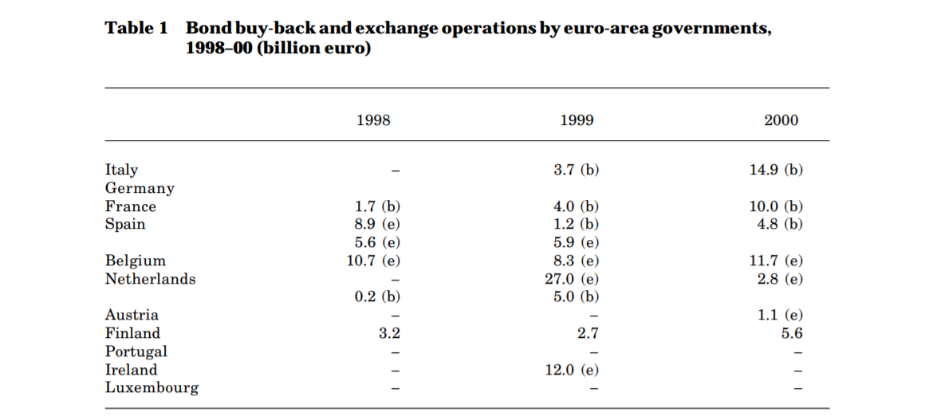
Moreover, prior to the introduction of the euro, borrowers in the legacy currency markets were considerably constrained in terms of the capital they could raise in domestic securities markets. Following the introduction of the euro, issuers have access to a broader and more diversified base of potential investors, which makes it possible to raise capital in much more favourable conditions than previously. An example of this point is the widespread comments, heard throughout 1999 and 2000, that many of the large mergers and acquisitions in the euro area would not have been possible if the purchasers had not been able to raise capital through the bond market.
The results of the research conducted by The European Central Bank titled THE IMPACT OF THE EURO ON FINANCIAL MARKETS suggests an overall increase in the integration of both equity and bond euro area markets since the introduction of the single currency. However, while the integration is very advanced for all euro area government bond markets, as for equity markets it seems to lag behind, and progress limited to large euro area economies. For bond markets, the research finds that the single currency was a major factor in fostering integration, which, unlike the equity markets, increases substantially in both small and large euro area economies.
4. COUNTRY WISE IMPACT
An empirical study by Alessandro Gasparotti und Matthias Kullas “20 Years of the Euro: Winners and Losers” discusses about the impact of euro on different Eurozone countries.

The problem of the divergent competitiveness of the Eurozone countries remains unsolved even after 20 years of launch. It arises from the fact that individual eurozone countries can no longer devalue their currency in order to remain internationally competitive; a method commonly used before the euro was introduced. Since introduction of the euro, an erosion of international competitiveness leads to lower economic growth, a rise in unemployment and falling tax revenues. Greece and Italy in particular are currently experiencing major difficulties due to the fact that they are unable to devalue their currency. In virtually every eurozone country, this trend has led to a discussion about the pros and cons of the single currency. Whilst the citizens of the troubled eurozone countries are lamenting low economic growth and high unemployment, other eurozone countries criticize that the intervention and the fact that financial assistance makes them liable for the problem countries. Twenty years after its introduction, the euro is therefore more controversial than ever.
For each of the examined eurozone countries, Table 2 indicates in euros how much higher or lower their per-capita GDP would have been, in 2017 (column 2) and overall (column 3), if they had not introduced the euro.
TABLE 2: Effects of the introduction of the euro on GDP in 2017
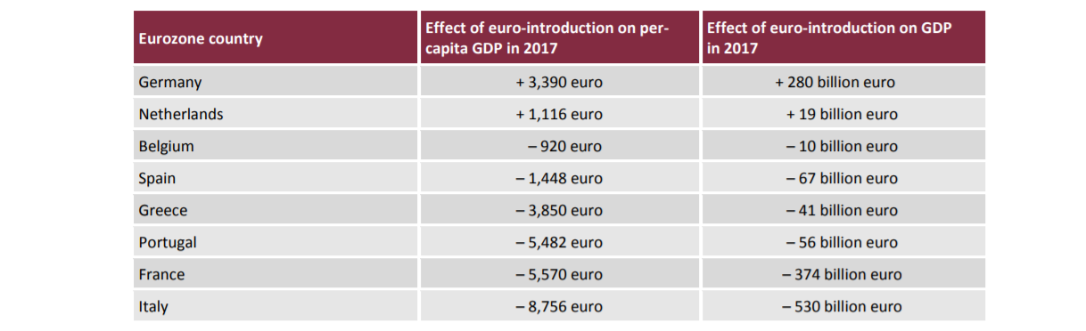
Source: cepStudy 20 Years of the Euro: Winners and Losers

The report also explains the results of introduction of Euro per country. The analysis on an overall basis concludes that Germany and the Netherlands are the only countries to have gained substantial benefits from the euro. Greece initially gained hugely from the euro but suffered enormous losses since 2011. In comparison to Germany's trillion-euro benefit, Greece could only book a €2 billion gain, which brought per capita gains to €190 per inhabitant over the 20-year life of the euro. One of the main reasons for the drop in prosperity was international competitiveness, according to the report. Before the introduction of the euro, countries were able to devalue their currencies to make their exports cheaper on the world market.This made them more competitive globally and was a tool used to pull countries out of economic difficulty.
"Greece and Italy in particular are currently experiencing major difficulties due to the fact that they are unable to devalue their currency."
The following two figures illustrate the analysis.

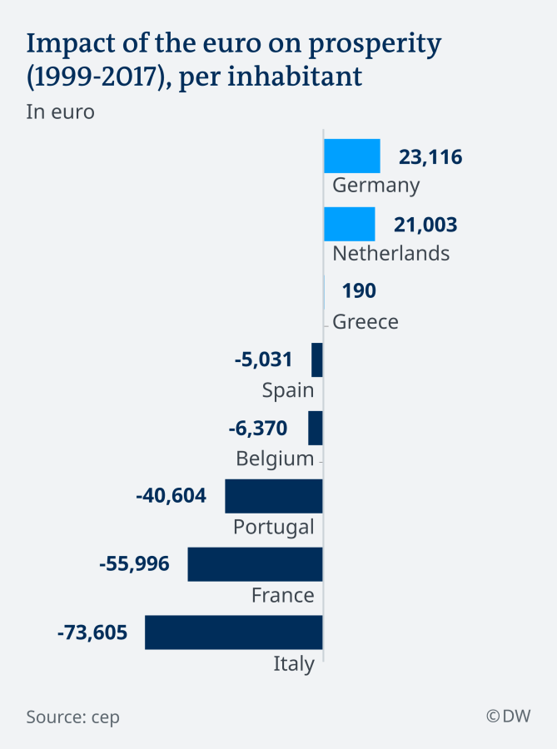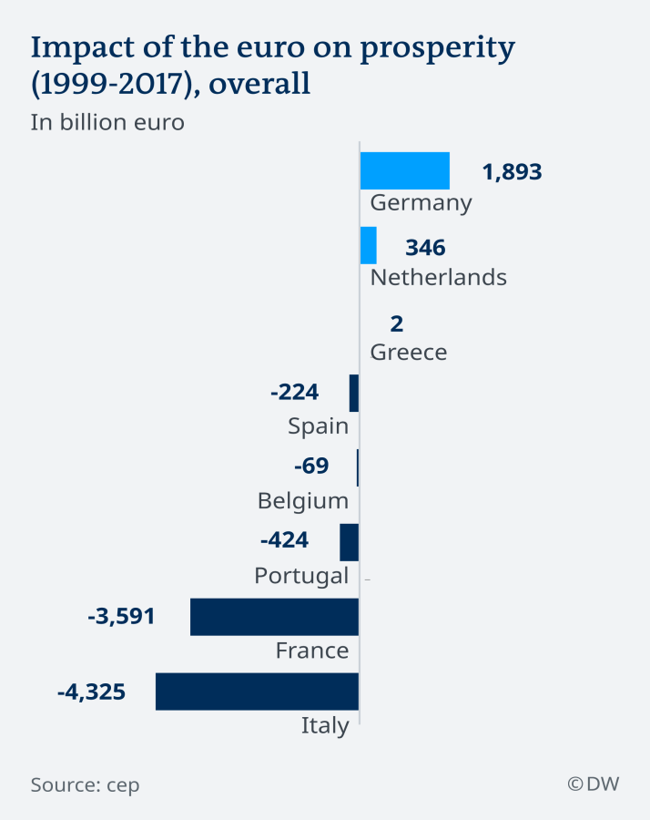

CONCLUSIONS

The main benefits of Euro include increase in trade and improved efficiency because the goods can be transferred without incurring transportation costs and various other country specific costs, the trade was more transparent and reliable because of the elimination of the currency risks, the forex markets saw a boom initially because of the increased trust in the currency. The currency also gained market confidence and helped the financial markets become one of the major gaining sectors of the integration.
On the other hand, there were issues like biases towards the stronger countries, more specifically, the countries with more established market structures and strong political foundations gained more than those with weaker markets and policies. One of the famous examples is Germany and Greece, the crisis in Greece was an indirect implication of the currency unification itself. The reason was rising fiscal deficits for a long period which later required bailouts. The situation could have been managed if monetary policy was in the hands of the nation. The major drawback of the euro comes from here, that is, the unification ripped off the countries with their monetary policy autonomy, there was no way that the countries could help an economic crisis through the route of changing interest rates.

References

- Effects of the Euro on Trade, Capital Markets and the International Monetary System by Ralf Zeppernick
- European Central Bank WORKING PAPER SERIES WORKING PAPER SERIES NO 598 / MARCH 2006 THE IMPACT OF THE EURO ON FINANCIAL MARKETS by Lorenzo Cappiello , Peter Hördahl , Arjan Kadareja and Simone Manganelli comments by Xavier Vives and Bruno Gerard
- BIS Working Papers No 100 The impact of the euro on Europe’s financial markets by Gabriele Galati and Kostas Tsatsaronis Monetary and Economic Department July 2001
- STUDY ON THE IMPACT OF THE EURO ON TRADE AND FOREIGN DIRECT INVESTMENT Richard Baldwin (Graduate Institute, Geneva), Virginia DiNino (Bank of Italy), Lionel Fontagné (Paris School of Economics and Université Paris I), Roberto A. De Santis and Daria Taglioni (ECB)* April 2008
- WORKING PAPER SERIES NO 941 / SEPTEMBER 2008 In 2008 all ECB publications feature a motif taken from the 10 banknote. THE EURO’S INFLUENCE UPON TRADE ROSE EFFECT VERSUS BORDER EFFECT 1 by Gianluca Cafiso
- The Impact of the Introduction of the Euro on Foreign Exchange Rate Risk Exposures Söhnke M. Bartram* and G. Andrew Karolyi
- The euro and trade: New evidence by Volker Nitsch, Mauro Pisu 15 July 2008
- cepStudy 20 Years of the Euro: Winners and Losers, Alessandro Gasparotti und Matthias Kullas, February 2019
- The Euro and Single Market impact on trade and FDI∗ Harry Flam Institute for International Economic Studies, Stockholm University, and CESifo Håkan Nordström Swedish National Board of Trade December 4, 2007
- How Has the Euro Changed the Foreign Exchange Market? Harald Hau, William Killeen, Michael Moore, Patrick Honohan, Julian Franks and Richard Portes

