IoT-Based Soil Moisture Monitoring and Automated Plant Watering System

Students:
Purtan Rares Ionut – Leader of the Team
Mîțu Daria – Andreea
Livitchi Vlad
Pungă Tudor – Cristian
Popa Mihnea – Alexandru
Dragos Patrik

Coordinator: Papazian Petru

Table of Contents

  - 1. MOTIVATION 3

1.1 INTRODUCTION AND CONTEXT 3

1.2 PROJECT PURPOSE AND UTILITY 3

1.3 PROJECT OBJECTIVE..............................................................................3

2. BIBLIOGRAPHIC STUDY.....................................................................................4

3. DESIGN AND HARDWARE ARCHITECTURE.....................................................4

3.1. SYSTEM BLOCK ARCHITECTURE.....................................................4

3.2. TECHNICAL SPECIFICATIONS OF USED COMPONENTS................5

3.3. PIN CONNECTIONS (HARDWARE MAPPING).................................6

4. SOFTWARE IMPLEMENTATION AND CODE ANALYSIS.................................6

4.1. STRUCTURAL ANALYSIS OF CODE FUNCTIONS............................6

5. TESTING, CALIBRATION, AND EXPERIMENTAL ANALYSIS............................8

5.1. SCENARIO 1: ANALOG SENSOR CALIBRATION AND
MAPPING....................................................................................................8

5.2. SCENARIO 2: RESPONSE TIME TESTING (CLOUD LATENCY).......9

5.3. SCENARIO 3: STRESS AND CONTINUOUS EXECUTION TEST
(48 HOURS)................................................................................................9

6. CONCLUSIONS (14 pt, Bold, Uppercase, Center) 10

7. BIBLIOGRAPHY.................................................................................................10

8.ANNEX…………………………………………………………………………………11

- Motivation

  - Introduction and Context
In the context of rapid urbanization and an increasingly fast-paced lifestyle, caring for domestic plants or small greenhouse crops often becomes a challenge due to lack of time or frequent travel. Improper water management—represented either by under-irrigation (which leads to root drying) or over-irrigation (which causes root rot)—is the main cause of ornamental and agricultural plant loss.
Internet of Things (IoT) technology offers a viable and elegant solution to this problem. It allows the interconnection of analog hardware sensors with cloud management platforms, providing the user with full control and access to real-time data, regardless of their geographical location.

1.2. Project Purpose and Utility
This project consists of developing a small-scale, energy-efficient smart electronic system capable of determining soil moisture levels in real time and enabling the actuation of a water pump for irrigation. Its main utility is defined by the following aspects:
- Prevention of Human Error: The system eliminates the need for manual soil inspection by providing accurate data through continuous sampling.
- Hydro-Centric Resource Efficiency: The water pump is activated strictly when necessary, preventing water waste.
- Global Accessibility (IoT): By integrating with Blynk Cloud servers and using an active Wi-Fi connection, the user can monitor the plant's status and start or stop the pump directly from their smartphone via an intuitive graphical interface.

1.3. Project Objective
The primary objective of this project is to build a functional, low-cost prototype that successfully integrates a development board with built-in wireless connectivity, an analog soil moisture sensor, a local 16x2 LCD display utilizing the I2C bus, and an execution module consisting of a relay for irrigation motor control.

- Bibliographic Study

In specialized literature and the current market, there is a variety of solutions designed for soil monitoring. However, most commercial systems present severe limitations regarding flexibility and cost:

- Pre-fabricated Commercial Systems: These often offer proprietary (closed-source) software applications, without the possibility of extracting raw data, calibrating sensors based on specific soil types, or adding additional hardware nodes.

- Classic Systems Based on Arduino Uno Platforms: Although widely used in educational environments, they do not natively integrate radio communication modules. Connecting them to the internet requires purchasing expensive and bulky Wi-Fi or Ethernet shields, increasing the physical complexity of the circuit and current consumption.

Project Specifics and Differentiation:
The specific difference of this project lies in the use of the NodeMCU ESP8266 microcontroller. This board natively integrates a stable Wi-Fi transceiver at an extremely low production cost.
Furthermore, the software implementation utilizes the new version of the Blynk IoT platform, which uses unique security identifiers (BLYNK_TEMPLATE_ID, BLYNK_AUTH_TOKEN), guaranteeing a secure and encrypted connection between the physical device and the dashboard on the user's phone.

- Design and Hardware Architecture

3.1. System Block Architecture
The system is designed on a hierarchical architecture structured across three levels: Data Acquisition Level (Analog sensor), Processing and Communication Level (NodeMCU ESP8266), and Execution and Display Level (Relay with pump, LCD screen, and Blynk Cloud).

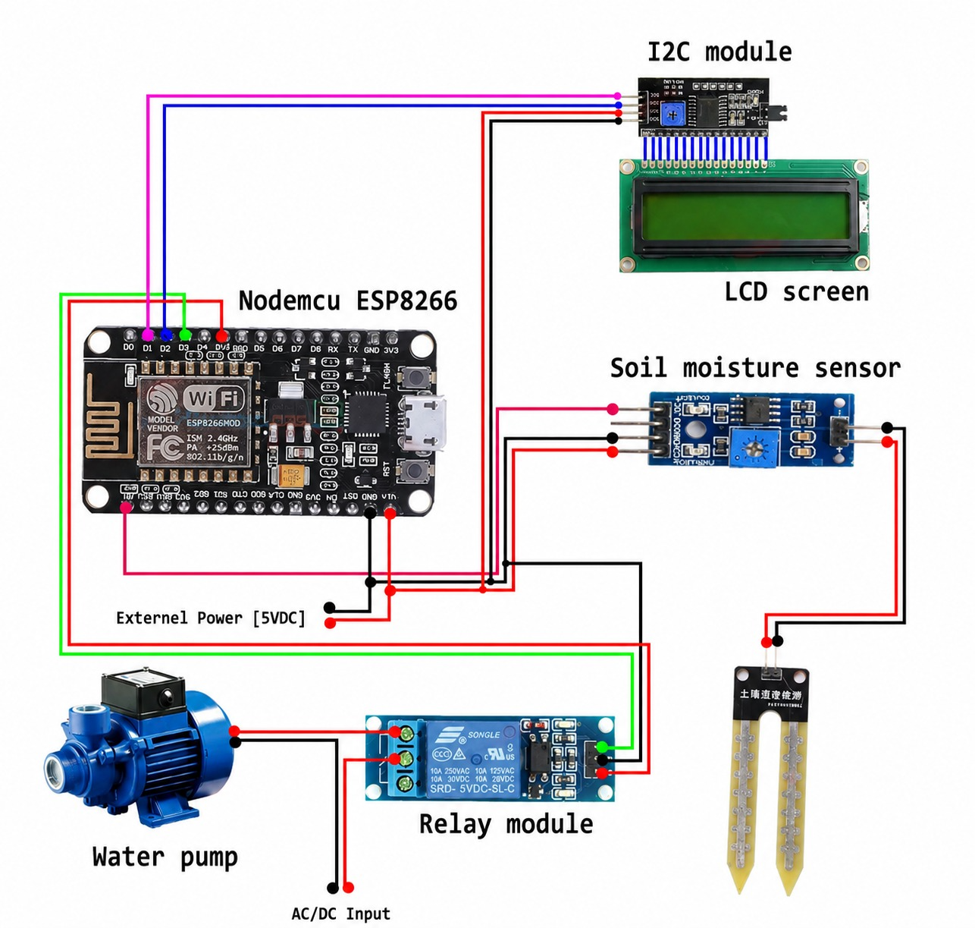
Fig 3.1.1. System Block Architecture

3.2. Technical Specifications of Used Components
- NodeMCU ESP8266 Microcontroller: Main chip based on the 32-bit Tensilica L106 RISC processor, clocked at 80 MHz. It features 4MB of Flash memory and an internal operating voltage of 3.3V. The integrated Wi-Fi supports the 802.11 b/g/n standard.
- Soil Moisture Sensor (Resistive Hygrometer): Consists of a probe with two metallic prongs inserted into the soil. It operates on the principle of electrical resistance: wetter soil exhibits higher electrical conductivity, thereby lowering the resistance detected.
- 16x2 LCD Display with PCF8574 I2C Adapter: An alphanumeric screen capable of displaying 32 characters simultaneously. The I2C adapter attached to the back of the screen allows communication using only two data pins, saving the board's digital pins.
- 5V Relay Module with Optocoupler and Mini Water Pump: The relay acts as an electrically controlled switch. It provides galvanic isolation between the low-current control circuit (NodeMCU) and the power circuit (external power supply of the water pump).

3.3. Pin Connections (Hardware Mapping)
According to the design schema implemented in the source code, the physical connections are configured as follows:

Table 1. Pin Connection
Hardware Component | Component Pin | NodeMCU ESP8266 Pin | Signal Type / Protocol
Moisture Sensor | AO  (Analog Output) | A0 | Analog Input  (0 - 1023)
Relay Module (Pump) | IN (Control Signal) | D3 (GPIO0) | Digital Output  (0V / 3.3V)
I2C LCD Screen | SDA  (Serial Data) | D2 (GPIO4) | I2C Data Bus
I2C LCD Screen | SCL (Serial Clock) | D1 (GPIO5) | I2C Clock Bus
LCD/Relay Power | VCC / GND | VIN (5V) / GND | Direct Current Power Supply

- Software Implementation and Code Analysis
The program is developed in C++ within the Arduino IDE integrated development environment. The software logic is asynchronous: the main loop() function does not contain any blocking delay() functions, as execution intervals are handled efficiently via the BlynkTimer structure.

4.1. Structural Analysis of Code Functions

A. Configuration and Cloud Security Directives
The top section of the code stores the unique metadata generated by the Blynk server to map the hardware device to the web and mobile dashboards:
#define BLYNK_TEMPLATE_ID "TMPL4msC8nkTC"
#define BLYNK_TEMPLATE_NAME "Plant Watering System"
#define BLYNK_AUTH_TOKEN "oW8jf3leYjI_t_AC6-d_FHyCLvARvYZD"
These credentials are passed to the BlynkSimpleEsp8266.h library to ensure correct packet routing to the user account via TCP/IP on standard port 80.

B. Initialization Function: setup()
The setup() function runs once when the hardware boots up and configures the peripherals:
- It sets the pump pin as an output (OUTPUT) and immediately forces a HIGH state ( digitalWrite (waterPump, HIGH) ; ). Because relay modules often use inverted logic, the HIGH state ensures the pump remains turned off at boot, preventing accidental flooding during a hardware reset.
- It initializes the LCD screen and turns on the backlight (lcd.backlight()).
- It executes a visual loading sequence via a for loop that displays successive dots every 500ms, giving the Wi-Fi module the necessary time to negotiate an IP address with the router.
- It initializes the Blynk protocol and configures the asynchronous timer:
timer.setInterval(100L, soilMoistureSensor);
This instruction schedules the execution of the sensor-reading function once every 100 milliseconds (100L), without blocking other processes.

C. Sensor Reading and Mapping Function (soilMoistureSensor)
int value = analogRead(sensor);
value = map(value, 0, 1024, 0, 100);
value = (value - 100) * -1;
The internal analog-to-digital converter returns a value between 0 (completely wet soil) and 1023 (dry air). The map() function scales this range into percentages (0 - 100). Since the sensor operates inversely (high value = dry soil), the mathematical formula (value - 100) * -1 corrects the scale, transforming the maximum raw value into 0\% (dry soil) and the minimum raw value into 100\% (fully saturated soil).
The processed data is sent locally to the LCD via lcd.print(value) and remotely to the Blynk server via virtual pin V0 (Blynk.virtualWrite(V0, value);).

D. Bi-directional Remote Control (BLYNK_WRITE(V1))
This function is an IoT callback triggered by the server whenever the user presses the mobile app button linked to virtual pin V1:
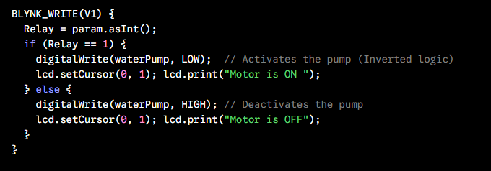
Fig 4.1.1. BLYNK_(V1)
The param.asInt() method retrieves the button state (0 or 1) and directly modifies the state of digital pin D3, simultaneously updating the second row of the local LCD screen.

5. Testing, Calibration, and Experimental Analysis
The testing phase aimed to validate system behavior under real-world scenarios, quantify measurement errors, and analyze software connection stability.

5.1. Scenario 1: Analog Sensor Calibration and Mapping
To ensure that displayed percentages reflect physical soil conditions, comparative tests were conducted across four distinct environments. The following empirical data was obtained:
Table 2: ADC-to-Moisture Calibration Results
Test Environment | Physical Soil Condition | Raw ADC Value (A0) | Calculated & Displayed Percentage | System Response (LCD/Blynk)
Open air | Completely dry | 1014–1023 | $$0\%-1\%$$ | Displays: Moisture :0
Dry Potting soil | Requires irrigation | 760–840 | $$18\%-25\%$$ | Critical value (User alerted)
Watered potting soil | Optimal | 420–530 | $$48\%-58\%$$ | Ideal water level
Glass of water | Fully saturated | 0–15 | $$98\%-100\%$$ | Displays: Moisture :100

Test 1 Conclusion: The mathematical equation implemented in the code accurately corrects the inverted behavior of the sensor. The data transmitted to the Blynk app is linear and true to the physical state of the soil.

5.2. Scenario 2: Response Time Testing (Cloud Latency)
The time interval elapsed between toggling the virtual button in the Blynk mobile app (connected to a 4G cellular network) and the physical switching of the pump relay (connected to a local 2.4 GHz Wi-Fi router) was measured.

Table3. Command Transmission Latency Evaluation
Trial | Initial Relay State | Commoand Triggered | Mreasured Latency (ms) | Physical Switching Result
Test 1 | OFF | Turn ON | 210 ms | Relay activated instantaneously
Test 2 | ON | Turn OFF | 160 sm | Relay deactivated instantaneously
Test 3 | OFF | Turn ON | 290 ms | Relay activated instantaneously
Test 4 | ON | Turn OFF | 140 ms | Relay deactivated instantaneously
Average | – | – | 200 ms | Operational Success

Test 2 Conclusion: The stabilized average latency of ~200ms demonstrates an optimal response speed for smart agriculture applications, completely eliminating any dangerous delay risks during irrigation.

5.3. Scenario 3: Stress and Continuous Execution Test (48 Hours)
A critical issue in ESP8266-based systems is Wi-Fi disconnection or microcontroller freezing due to blocking functions.
- Procedure: The system was left running continuously for 48 hours, generating data packets to the cloud every 100ms.
- Results: No hardware watchdog resets were recorded. The LCD maintained correct formatting across both lines with no signs of character distortion (no I2C bus memory corruption).
- Failsafe Error Management: When explicitly turning off the Wi-Fi router for 10 minutes, the code (via Blynk's background library routines) entered a retry sequence. It automatically reconnected in less than 5 seconds once the signal returned, resuming data writing without human intervention.

6. Conclusions

The completed project successfully demonstrates how modern Internet of Things (IoT) technologies can streamline and automate critical daily processes, such as water resource management in agriculture or horticulture. Integrating the NodeMCU ESP8266 microcontroller with the Blynk platform enabled the construction of a stable, bi-directional IoT system capable of reading and transmitting analog data, while also receiving asynchronous remote commands within an excellent response time (~200 ms).
From an educational standpoint, the objectives were met by deepening understanding of embedded systems programming, industrial communication protocols (I2C), and working with asynchronous software timers to prevent program execution stalls.
As future development steps, the system can be expanded by adding an air temperature and humidity sensor (e.g., DHT11) and by implementing automated logic directly into the microcontroller (a critical moisture threshold below which the pump triggers on its own, even in the absence of an internet connection), thereby increasing the device's overall autonomy.

7. Bibliography (IEEE Format)

- [1] S. Hobby, „How to make a plant watering system with the NodeMCU ESP8266 board and the new Blynk update”, SriTu Hobby, 2024. [Online]. Available: https://srituhobby.com/
- [2] Espressif Systems, „ESP8266EX Datasheet”, v4.3, Espressif Systems, 2020.
- [3] Blynk IoT Documentation, „Blynk Firmware Library for Embedded Devices and Cloud API Configuration”, 2025. [Online]. Available: https://docs.blynk.io/
- [4] M. Banzi and M. Shiloh, Getting Started with Arduino: The Open Source Electronics Prototyping Platform, 3rd ed. Sebastopol, CA: Maker Media, 2014.

8. Annex

library IEEE;
use IEEE.STD_LOGIC_1164.ALL;
use IEEE.NUMERIC_STD.ALL;

entity clock_top is
Port ( clk : in STD_LOGIC; -- 100 MHz system clock
rst : in STD_LOGIC; -- Center Button (Reset)
btn_min : in STD_LOGIC; -- Left Button (Add Minutes)
btn_hr : in STD_LOGIC; -- Up Button (Add Hours)
seg : out STD_LOGIC_VECTOR (6 downto 0); -- 7-Segment display segments
an : out STD_LOGIC_VECTOR (7 downto 0) -- 7-Segment display anodes
);
end clock_top;

architecture Behavioral of clock_top is

-- Clock divider signals
signal count_1hz : integer range 0 to 99999999 := 0;
signal tick_1hz : std_logic := '0';

signal count_refresh : integer range 0 to 99999 := 0; -- ~1 kHz for display multiplexing
signal digit_sel : unsigned(2 downto 0) := "000"; -- Selects which of the 8 digits is active

signal count_btn : integer range 0 to 19999999 := 0; -- ~5 Hz for button increments
signal tick_btn : std_logic := '0';

-- Time counters (Digits separated to make 7-segment display easier)
signal sec_ones : integer range 0 to 9 := 0;
signal sec_tens : integer range 0 to 5 := 0;
signal min_ones : integer range 0 to 9 := 0;
signal min_tens : integer range 0 to 5 := 0;
signal hr_ones : integer range 0 to 9 := 0;
signal hr_tens : integer range 0 to 2 := 0;

-- Signal to hold the current digit value to be displayed
signal current_digit : integer range 0 to 15;

begin

-- =========================================================================
-- PROCESS 1: Clock Dividers (Generating our specific timing ticks)
-- =========================================================================
process(clk, rst)
begin
if rst = '1' then
count_1hz <= 0;
count_refresh <= 0;
count_btn <= 0;
digit_sel <= "000";
elsif rising_edge(clk) then
-- 1 Hz Tick (for counting seconds)
if count_1hz = 99999999 then
count_1hz <= 0;
tick_1hz <= '1';
else
count_1hz <= count_1hz + 1;
tick_1hz <= '0';
end if;

-- 5 Hz Tick (for smoothly advancing time with buttons)
if count_btn = 19999999 then
count_btn <= 0;
tick_btn <= '1';
else
count_btn <= count_btn + 1;
tick_btn <= '0';
end if;

-- 1 kHz Display Refresh & Multiplexing
if count_refresh = 99999 then
count_refresh <= 0;
digit_sel <= digit_sel + 1; -- Move to the next 7-segment digit
else
count_refresh <= count_refresh + 1;
end if;
end if;
end process;

-- =========================================================================
-- PROCESS 2: The Main Timekeeper and Button Adjustments
-- =========================================================================
process(clk, rst)
variable advance_min : boolean := false;
variable advance_hr : boolean := false;
begin
if rst = '1' then
sec_ones <= 0; sec_tens <= 0;
min_ones <= 0; min_tens <= 0;
hr_ones <= 0; hr_tens <= 0;
elsif rising_edge(clk) then
advance_min := false;
advance_hr := false;

-- 1. Count normal seconds
if tick_1hz = '1' then
if sec_ones = 9 then
sec_ones <= 0;
if sec_tens = 5 then
sec_tens <= 0;
advance_min := true; -- A minute has passed
else
sec_tens <= sec_tens + 1;
end if;
else
sec_ones <= sec_ones + 1;
end if;
end if;

-- 2. Minute Logic (Triggers naturally or via button press)
if advance_min or (btn_min = '1' and tick_btn = '1') then
if min_ones = 9 then
min_ones <= 0;
if min_tens = 5 then
min_tens <= 0;
advance_hr := true; -- An hour has passed
else
min_tens <= min_tens + 1;
end if;
else
min_ones <= min_ones + 1;
end if;
end if;

-- 3. Hour Logic (Triggers naturally or via button press)
if advance_hr or (btn_hr = '1' and tick_btn = '1') then
if hr_tens = 2 and hr_ones = 3 then -- Reset at 23 -> 00
hr_ones <= 0;
hr_tens <= 0;
elsif hr_ones = 9 then
hr_ones <= 0;
hr_tens <= hr_tens + 1;
else
hr_ones <= hr_ones + 1;
end if;
end if;
end if;
end process;

-- =========================================================================
-- PROCESS 3: Multiplexing the 7-Segment Displays
-- =========================================================================
-- The board has 8 digits, but they share the same segment wires.
-- We turn on one digit at a time extremely fast so the human eye sees them all on.
process(digit_sel, sec_ones, sec_tens, min_ones, min_tens, hr_ones, hr_tens)
begin
-- Default: all digits OFF (Anodes are active low, so '1' means OFF)
an <= "11111111";
case digit_sel is
when "000" => an <= "11111110"; current_digit <= sec_ones; -- Digit 0 (Far Right)
when "001" => an <= "11111101"; current_digit <= sec_tens; -- Digit 1
when "010" => an <= "11111011"; current_digit <= 10; -- Digit 2 (Dash)
when "011" => an <= "11110111"; current_digit <= min_ones; -- Digit 3
when "100" => an <= "11101111"; current_digit <= min_tens; -- Digit 4
when "101" => an <= "11011111"; current_digit <= 10; -- Digit 5 (Dash)
when "110" => an <= "10111111"; current_digit <= hr_ones; -- Digit 6
when "111" => an <= "01111111"; current_digit <= hr_tens; -- Digit 7 (Far Left)
when others => an <= "11111111"; current_digit <= 15;
end case;
end process;
-- =========================================================================
-- PROCESS 4: 7-Segment Decoder
-- =========================================================================
-- Converts the current number (0-9) into the specific LED segments (A-G).
-- Segments are active low ('0' turns the LED on). Order is GFEDCBA.
process(current_digit)
begin
case current_digit is
when 0 => seg <= "1000000"; -- '0'
when 1 => seg <= "1111001"; -- '1'
when 2 => seg <= "0100100"; -- '2'
when 3 => seg <= "0110000"; -- '3'
when 4 => seg <= "0011001"; -- '4'
when 5 => seg <= "0010010"; -- '5'
when 6 => seg <= "0000010"; -- '6'
when 7 => seg <= "1111000"; -- '7'
when 8 => seg <= "0000000"; -- '8'
when 9 => seg <= "0010000"; -- '9'
when 10=> seg <= "0111111"; -- Dash '-' to separate HH-MM-SS
when others => seg <= "1111111"; -- Blank
end case;
end process;

end Behavioral;

