[GitHub Links](https://github.com/aishwaryanr/awesome-generative-ai-guide?tab=readme-ov-file" \l "book-list-of-free-genai-courses)

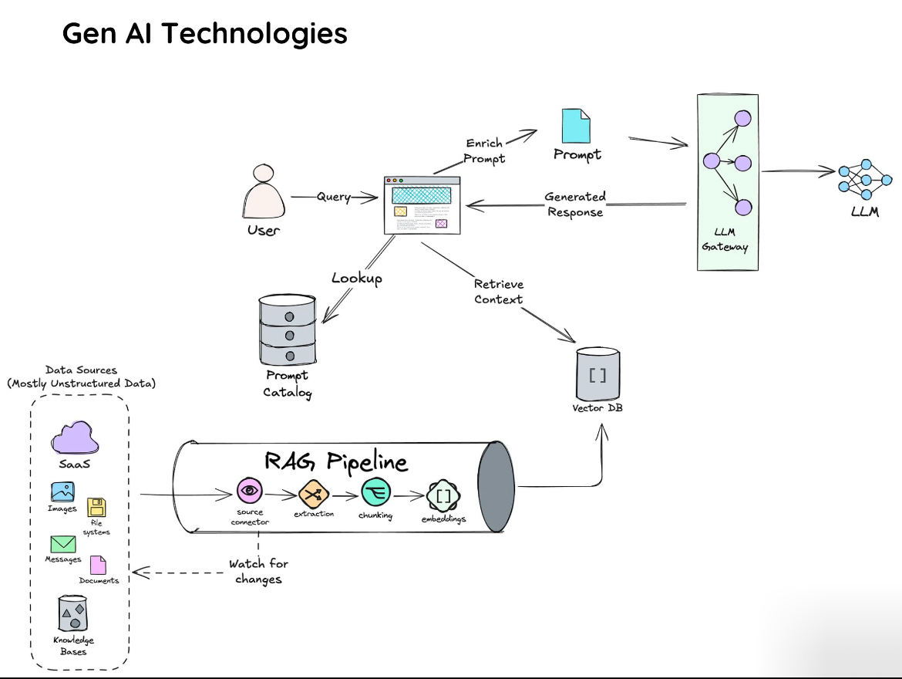

**Generative AI Architecture** illustrated in the image. We will go through each of the core components and explore the underlying technologies and methods that make them work efficiently in a real-world scenario.

This technical breakdown outlines the components, technologies, and processes that power each part of the Generative AI architecture. This architecture is designed for scalability, flexibility, and efficient querying, making it well-suited for complex, data-driven tasks such as customer support, document summarization, or healthcare queries.

**1. User Query**

* **Input Mechanism**: The user submits a query, often via a web interface, mobile app, or voice assistant. This input can be natural language text or voice converted to text.
* **Technology Stack**:
  + **Frontend Interface**: HTML, CSS, JavaScript (React, Angular, etc.) for web-based queries.
  + **Speech-to-Text**: Tools like Google Cloud Speech-to-Text or AWS Transcribe for voice input.

**2. Prompt Catalog**

* **Purpose**: The Prompt Catalog standardizes the queries to make them more actionable by the LLM. It ensures that complex user input is converted into a structured prompt that the LLM can process.
* **Technical Details**:
  + **Template-Based Prompting**: You can use **template matching** or **semantic parsing** to transform user queries into structured prompts.
  + **Natural Language Processing (NLP)**: Libraries like **spaCy** or **NLTK** can be used to parse and understand the intent behind user queries.
  + **Metadata Storage**: A database (SQL or NoSQL like MongoDB) stores the predefined prompts for efficient retrieval.
* **Example**:
  + Input Query: "What’s the weather in London?"
  + Prompt Template: "Provide the weather forecast for {City}."
  + Enriched Prompt: "Provide the weather forecast for London."

**3. RAG (Retrieval-Augmented Generation) Pipeline**

The RAG pipeline enhances the LLM’s responses by pulling data from various sources. It integrates retrieval-based mechanisms with the generation capabilities of the LLM.

* **Components**:

**a. Source Connector**

* + **Role**: The source connector allows the system to pull data from external sources like SaaS applications, internal databases, documents, and APIs.
  + **Technology Stack**:
    - **APIs**: REST or GraphQL APIs to pull real-time data from SaaS platforms, CRM systems, or third-party services.
    - **Custom Connectors**: Depending on the data sources (e.g., SQL databases, file systems), you might use custom-built connectors using **SQLAlchemy** (for databases), **PyFilesystem2** (for file systems), or cloud connectors (AWS S3, Google Cloud Storage).

**b. Extraction**

* + **Role**: This step extracts relevant information (data chunks) from the sources.
  + **Technology Stack**:
    - **Web Scraping**: Tools like **BeautifulSoup**, **Selenium**, or **Scrapy** for scraping web-based knowledge sources.
    - **Document Processing**: For structured documents (e.g., PDFs, Word files), **PyMuPDF**, **pdfminer**, or **Apache Tika** can be used.
    - **Data Parsing**: Parsing the content into a machine-readable format (e.g., extracting text from HTML tags).

**c. Chunking**

* + **Role**: It breaks down large data (documents, knowledge base entries) into smaller, meaningful chunks, improving relevance when retrieving context.
  + **Technology Stack**:
    - **Text Chunking**: NLP libraries like **spaCy** or **transformers** can be used to split text into sections, paragraphs, or sentences. Alternatively, **BERT-based models** can be used to identify contextually relevant chunks.

**d. Embeddings**

* + **Role**: Converts chunks of text into vector representations that capture semantic meaning, enabling efficient similarity-based retrieval.
  + **Technology Stack**:
    - **Embedding Models**: Pre-trained models like **BERT**, **GPT**, or domain-specific models like **BioBERT** (for healthcare) generate embeddings.
    - **Sentence Transformers**: The **sentence-transformers** library from Hugging Face provides embeddings for individual sentences or paragraphs, which can be used for similarity searches.
  + **Embedding Process**: Each chunk is passed through an embedding model to produce a dense vector representation that encodes the semantic meaning of the chunk.

**4. Vector Database**

* **Purpose**: The **Vector Database** stores the embeddings, making it possible to search through the chunks quickly and find the most relevant information based on cosine similarity or other distance measures.
* **Technology Stack**:
  + **Vector Storage**:
    - **FAISS (Facebook AI Similarity Search)** is a highly efficient vector search library that stores vectors in **HNSW (Hierarchical Navigable Small World)** graphs or **IVF (Inverted File Index)**, allowing fast retrieval of nearest neighbors.
    - **Pinecone** and **Weaviate** are cloud-based vector databases that offer managed services for storing and searching vectors.
    - **Milvus**: An open-source vector database that is optimized for high-performance similarity searches.
* **Retrieval Process**: When a query is made, the system generates the query embedding and compares it to the embeddings stored in the vector database. It retrieves the most semantically similar chunks.

**5. LLM Gateway**

* **Purpose**: The **LLM Gateway** acts as a middleware that interfaces between the LLM and the enriched prompt/context data. It also handles communication with the LLM's API or server.
* **Technology Stack**:
  + **API Management**: If using hosted LLMs (e.g., OpenAI GPT models, Cohere, or Anthropic's Claude), API calls are routed through the gateway.
  + **Load Balancing**: Tools like **Kong**, **NGINX**, or cloud-native solutions like **AWS API Gateway** handle API load balancing and rate limiting.
  + **Caching**: For commonly requested queries, the gateway can cache responses for faster retrieval. Tools like **Redis** can be used for caching.

**6. Generated Response**

* **Purpose**: The LLM processes the prompt and context and generates a human-like response.
* **Technology Stack**:
  + **LLM Models**:
    - **GPT (Generative Pre-trained Transformer)**, **T5**, **BERT**, and **PaLM** are commonly used models for text generation.
    - Models are typically hosted on cloud services or deployed on GPUs for scalability.
* **Generation Process**: The model takes the enriched prompt and the retrieved context, and it generates a response, which could be a direct answer, a summary, or a more detailed explanation depending on the query type.

**7. Monitoring and Updates**

* **Purpose**: Continuously monitors data sources for new content or updates, ensuring the vector database and RAG pipeline are always in sync with the latest information.
* **Technology Stack**:
  + **Change Detection**:
    - **Webhooks**: For real-time notifications about updates (e.g., from SaaS platforms or external services).
    - **Cron Jobs**: For periodic checks of document repositories or data sources to look for new data.
    - **ETL Pipelines**: Tools like **Apache Airflow**, **Apache Nifi**, or **Luigi** can be used to automate data extraction, transformation, and loading into the pipeline.

**Final Workflow Overview:**

1. **User Query** → **Prompt Catalog** → **RAG Pipeline** (Source Connector, Extraction, Chunking, Embeddings) → **Vector Database** → **LLM Gateway** → **Generated Response**.
2. Continuous updates from **Monitoring** ensure the data is fresh.

**Technology Stack** summary used in the **Generative AI Architecture**:

**1. User Query:**

* **Input Mechanism**:
  + **Web Frontend**: HTML, CSS, JavaScript (React, Angular).
  + **Voice Input**: Speech-to-text tools like Google Cloud Speech-to-Text or AWS Transcribe.

**2. Prompt Catalog:**

* **Purpose**: Transforms the user query into a structured prompt for processing by the LLM.
* **Technology**:
  + **NLP Libraries**: spaCy, NLTK for semantic understanding.
  + **Metadata Storage**: Databases like MongoDB or SQL for storing and retrieving predefined prompts.

**3. RAG Pipeline:**

* **Core Components**:
  + **Source Connector**: Pulls data from external sources.
    - **APIs**: REST or GraphQL for real-time data.
    - **Custom Connectors**: For databases (SQLAlchemy) and file systems (PyFilesystem2).
  + **Extraction**: Extracts relevant content from data sources.
    - **Web Scraping**: BeautifulSoup, Scrapy.
    - **Document Parsing**: PyMuPDF, pdfminer, Apache Tika for PDFs and other document types.
  + **Chunking**: Breaks data into smaller, contextually meaningful pieces.
    - **Text Chunking**: spaCy, transformers library for sentence/paragraph chunking.
  + **Embeddings**: Converts chunks into vector representations.
    - **Embedding Models**: BERT, GPT, Sentence Transformers for embedding generation.

**4. Vector Database:**

* **Purpose**: Stores the embeddings for efficient similarity-based retrieval.
* **Technology**:
  + **Vector Storage**: FAISS, Pinecone, Weaviate, Milvus for high-performance vector searches.
  + **Distance Measures**: Cosine similarity, Euclidean distance for querying semantic similarity.

**5. LLM Gateway:**

* **Purpose**: Mediates between the LLM and the enriched query/context.
* **Technology**:
  + **API Management**: Kong, NGINX, AWS API Gateway for routing and load balancing.
  + **Caching**: Redis for storing frequent responses to speed up queries.

**6. Generated Response:**

* **Purpose**: The LLM generates the final output based on the enriched prompt and context.
* **Technology**:
  + **LLM Models**: GPT (OpenAI), T5, BERT, PaLM for text generation and comprehension.

**7. Monitoring and Updates:**

* **Purpose**: Keeps data sources updated in real time to ensure the system responds with current information.
* **Technology**:
  + **Change Detection**: Webhooks for real-time notifications, Cron Jobs for periodic checks.
  + **ETL Pipelines**: Apache Airflow, Apache Nifi for automating data extraction, transformation, and loading.

**Overall Architecture Flow:**

1. **User Query** → **Prompt Catalog** → **RAG Pipeline** (Source Connector, Extraction, Chunking, Embeddings) → **Vector Database** → **LLM Gateway** → **Generated Response**.
2. **Continuous Monitoring** ensures data freshness and accuracy.

This stack combines **NLP**, **embedding-based retrieval**, **LLM generation**, and **real-time monitoring** to create a flexible and scalable AI system capable of handling complex user queries efficiently.

Here's a **comparison table** that summarizes the **key components** of the **Generative AI Technology Stack**:

| **Component** | **Purpose** | **Technology/Tools** | **Key Features** |
| --- | --- | --- | --- |
| **1. User Query** | User submits a query for processing. | Web Frontend: HTML, CSS, JavaScript (React, Angular)  Voice Input: Google Cloud Speech-to-Text, AWS Transcribe | Input via text or voice converted to text. |
| **2. Prompt Catalog** | Transforms the query into structured prompts. | NLP Libraries: spaCy, NLTK  Metadata Storage: MongoDB, SQL | Standardizes and enriches user input for LLM processing. |
| **3. RAG Pipeline** | Retrieves relevant data from sources to augment the response. | Source Connector: REST APIs, GraphQL  Extraction: BeautifulSoup, Scrapy  Chunking: spaCy, transformers  Embedding Models: BERT, GPT, Sentence Transformers | Combines data retrieval with LLM for enriched responses. |
| **4. Vector Database** | Stores and queries embeddings for fast retrieval. | FAISS, Pinecone, Weaviate, Milvus | Optimized for high-speed, semantic search. |
| **5. LLM Gateway** | Mediates between LLM and the enriched prompt/context. | API Management: Kong, NGINX, AWS API Gateway  Caching: Redis | Handles API routing, load balancing, and response caching. |
| **6. Generated Response** | Generates the final output from the LLM. | LLM Models: GPT (OpenAI), T5, BERT, PaLM | Generates human-like responses based on the enriched prompt and context. |
| **7. Monitoring and Updates** | Monitors data sources for freshness. | Change Detection: Webhooks  ETL Pipelines: Apache Airflow, Nifi  Cron Jobs | Ensures that data sources stay updated for accuracy. |

**Overview:**

* **Input and User Interaction**: User submits a query via **web interfaces** or **voice input**.
* **Prompt Processing**: The query is structured using **NLP tools** and stored in a **Prompt Catalog**.
* **Data Retrieval**: The **RAG pipeline** enhances the response by extracting and chunking data, which is stored as **embeddings** in a **vector database**.
* **LLM Gateway**: Interfaces with the **LLM**, and manages responses, ensuring optimal **API communication** and **response caching**.
* **Output Generation**: The LLM generates an enriched response based on context.
* **Continuous Monitoring**: Automated processes ensure data sources are continuously updated to keep the system fresh.