**Introduction**

TurfGuardian is a decentralized platform designed for booking football grounds using blockchain technology. By integrating blockchain and smart contracts, TurfGuardian aims to provide a seamless, secure, and transparent way for users to reserve football grounds. Traditional booking systems often suffer from issues such as lack of transparency, double bookings, and delayed payments. TurfGuardian addresses these challenges by utilizing blockchain's decentralized nature and smart contract functionality to automate and validate every transaction on the platform.

This documentation provides an overview of the platform's key features, guiding users through the processes of adding new turfs, booking slots, managing resources, and viewing bookings. It also explains the underlying technology, including the role of NFTs (Non-Fungible Tokens) in validating bookings, ensuring that both turf owners and users benefit from enhanced security, efficiency, and trust in the system. With TurfGuardian, booking a football ground becomes a streamlined experience that reduces the potential for human error and ensures that all parties involved can verify bookings in real-time.

**Overview of TurfGuardian Platform**

The TurfGuardian platform is a user-friendly, web-based solution that enables users to easily book football grounds (referred to as turfs), manage those bookings, and track the history of reservations. By leveraging blockchain technology, TurfGuardian aims to disrupt traditional booking models by providing an environment where bookings are secure, verifiable, and easy to manage.

The platform allows multiple users to add and list football turfs, set availability, and manage those resources seamlessly. It also provides users with the ability to book time slots for listed turfs, and all transactions are recorded transparently on the blockchain. TurfGuardian uses Non-Fungible Tokens (NFTs) to represent each booking. Once a user books a slot, an NFT is minted as a digital certificate that guarantees ownership of that time slot. This concept ensures that every booking is unique and verifiable, eliminating common booking issues such as double reservations or discrepancies in payment.

The platform's intuitive interface makes the process accessible even for users unfamiliar with blockchain. TurfGuardian provides a comprehensive dashboard where users can view available grounds, book them for specific time slots, and manage their reservations. Turf owners benefit from a secure and decentralized way to offer their facilities, reducing administrative overhead and providing a clear audit trail for every transaction. The combination of blockchain transparency and smart contracts also means that users can trust the accuracy and security of the bookings, fostering greater confidence in the platform.

**Application**

The following are the images used in the TurfGuardian application and where they are intended to be used:

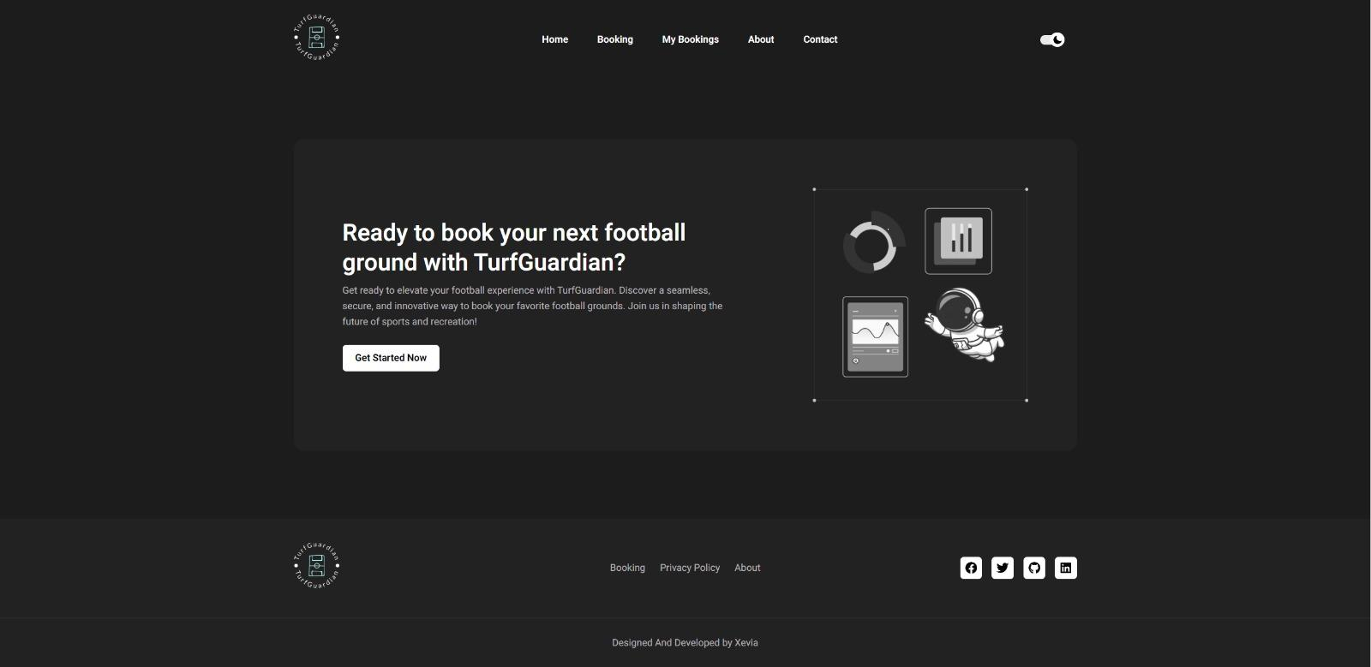

Main banner on the landing page, featuring a welcome message to prompt users to start booking football grounds.

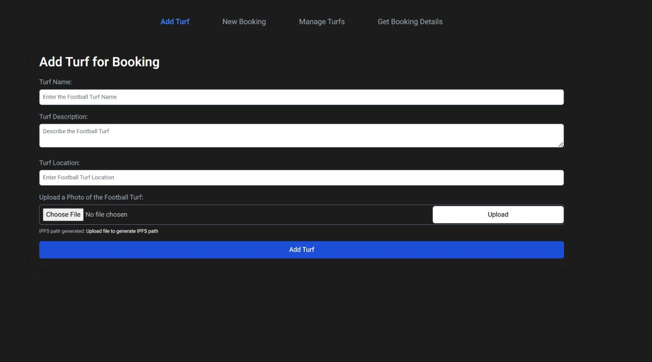

On the 'Add Turf' page, as an illustrative image next to form fields like Turf Name, Description, and Location.

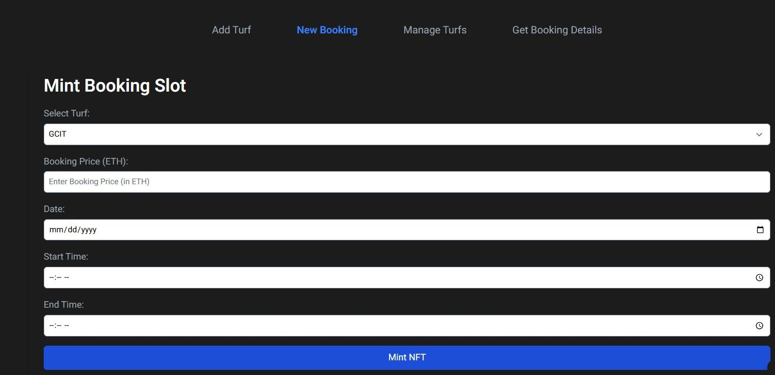

On the 'New Booking' page to visually support the booking process and guide users through the minting of booking slots.

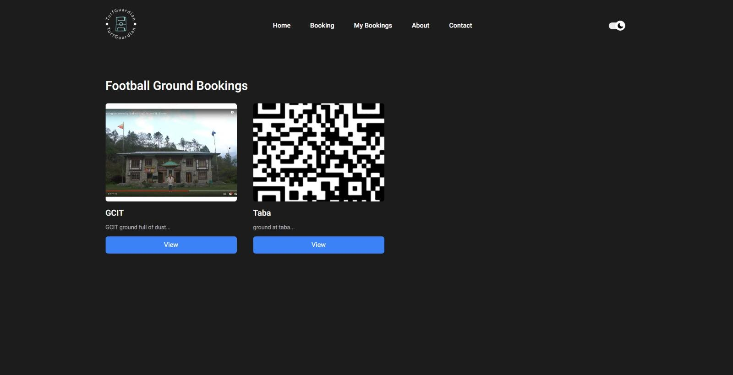

On the 'Manage Turfs' page, providing a visual representation of available grounds to help users manage turfs efficiently.

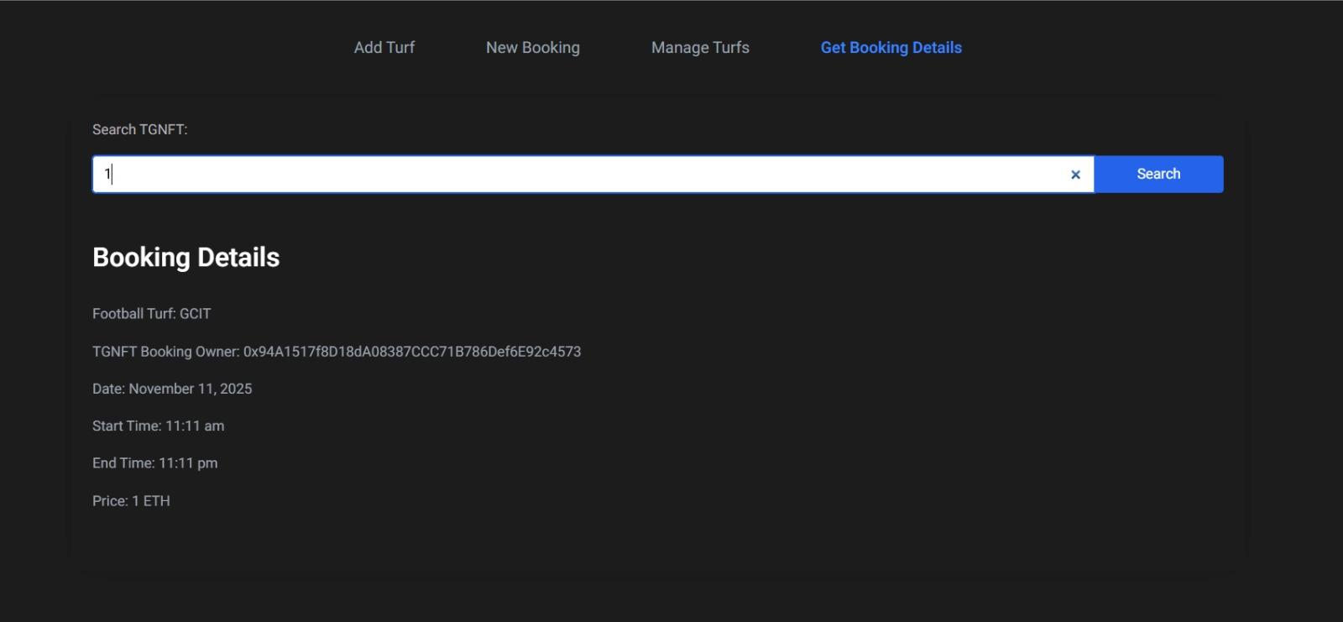

On the 'Get Booking Details' page, used as an icon or logo for booking search, helping users to quickly locate booking details.

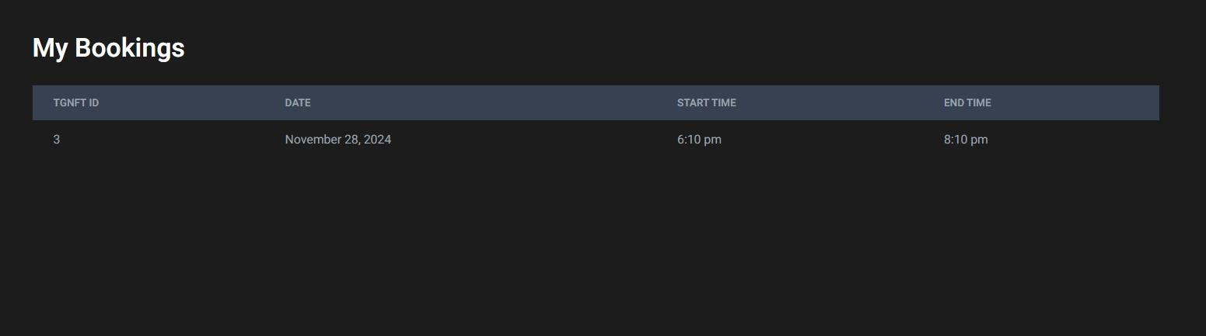

In the 'My Bookings' section, serving as a graphical header to distinguish user bookings and their booking history.

**TurfGuardian Smart Contract**

The core of the TurfGuardian platform is a Solidity-based smart contract that handles all booking functionalities. The TurfGuardian.sol file contains all the smart contract logic required to manage football ground bookings through NFTs.

**Main Components of the Smart Contract**

1. **Booking Struct**: The smart contract defines a Booking struct that holds details such as turfName, ownerAddress, date, startTime, endTime, and price. This struct is fundamental to storing booking information.
2. **Mappings**: The smart contract includes a mapping named bookings that stores booking details against unique TGNFT IDs, which helps in efficiently retrieving booking information and validating ownership.
3. **Functions**:
   * **addTurf()**: Used by admins to add new turfs. It accepts parameters such as the name, location, and description of the turf.
   * **mintBooking()**: Allows users to book a specific time slot for a turf. It mints an NFT representing the booking as proof of ownership and commitment.
   * **getBookingDetails()**: Allows users to retrieve information about a booking by providing the TGNFT ID. This function returns all relevant booking details.

**Steps to Use the Smart Contract**

To interact with the TurfGuardian smart contract, follow these steps after deploying the TurfGuardian.sol file to an Ethereum-compatible blockchain:

1. **Add a Turf**: Admins can add new turfs using the addTurf() function. Details like the turf name, location, and description must be provided, and only admins have permission to add turfs.
2. **Mint a Booking Slot**: Users can book a time slot by calling the mintBooking() function. Necessary details include turf name, date, and start and end times. Once confirmed, the booking results in the minting of an NFT that acts as proof of the reservation.
3. **Retrieve Booking Details**: To view booking information, users can use the getBookingDetails() function by providing the relevant TGNFT ID. This will return all associated details, including the booking date, time, and owner.

**Conclusion**

TurfGuardian offers a decentralized, secure, and efficient way to manage bookings for football grounds using blockchain technology. The platform's unique integration of smart contract-based booking management and NFT minting ensures that every booking is both verifiable and protected from double reservations or disputes. By employing blockchain technology, TurfGuardian addresses the inefficiencies present in traditional booking systems, allowing for a seamless and trustworthy experience for both turf owners and users.

The user-friendly interface of the platform enhances the accessibility of blockchain technology, making it possible for anyone to take advantage of decentralized bookings without needing in-depth technical knowledge. Images included throughout the application further help improve usability by visually guiding users through each process. TurfGuardian ultimately aims to create a transparent, efficient, and secure booking experience, reducing administrative tasks for turf owners and increasing booking confidence for users.

Refer to the smart contract deployment steps outlined above to get started with implementing the TurfGuardian platform and enjoy the benefits of a decentralized booking system.