CUSTOMER CHURN ANALYSIS
& RETENTION DASHBOARD
Telecom Industry — Predictive Analytics Project

Project Report
Prepared: September 23, 2026
IBM SkillsBuild Internship Project

Prepared by: Purujith Kadekar |
Dayananda Sagar College of Engineering

Dataset:
IBM Telco Customer Churn — Kaggle

Abstract
Customer churn — the rate at which subscribers discontinue service — is one of the most costly challenges in the telecommunications sector. This project presents a comprehensive end-to-end analytical solution built on the IBM Telco Customer Churn dataset (7,043 customers, 21 features). The analysis follows a structured flow from raw data facts to actionable business insights, risk identification, and strategic recommended actions.
The overall churn rate observed is 26.54%, representing 1,869 lost customers with a monthly revenue at risk of $139,130.85. Two machine learning models were trained and evaluated: Logistic Regression and Random Forest. The best-performing model (Random Forest) achieved a ROC-AUC of 0.8401, providing a useful ranking of customers by churn risk. The findings are surfaced through an interactive Streamlit dashboard with three pages: Executive Overview, Churn Drivers, and Risk & Actions.

1. Introduction & Problem Statement

1.1 Background
The telecommunications industry is characterised by intense competition, low switching barriers, and increasingly commoditised services. Retaining existing customers is generally considered more cost-effective than acquiring new ones, since acquisition typically requires marketing, sales and onboarding spend.

1.2 Problem Statement
A telecom company with 7,043 active subscribers is experiencing a churn rate of 26.54%, translating to 1,869 lost customers. With an average monthly charge of $64.76, this represents a significant and preventable revenue leak. The company needs answers to three critical questions:
• Why are customers leaving? Which service, demographic, and contract attributes are driving churn?
• Who is most at risk? Which specific customers have a high probability of churning in the near future?
• What should we do? Which targeted interventions will have the highest retention impact at lowest cost?

1.3 Solution Approach
This project addresses these questions through: (1) exploratory data analysis and feature-level churn rate computation, (2) machine learning model training and evaluation, and (3) an interactive Streamlit dashboard that enables business users to explore insights, identify at-risk customers, and execute data-driven retention strategies.

2. Objectives
• Compute and present key churn KPIs: churn rate, revenue at risk, average tenure, and model performance.
• Identify the top drivers of customer churn through systematic feature-level analysis.
• Train, compare, and select the best-performing classification model (Logistic Regression vs Random Forest).
• Build an interactive dashboard with three analytical pages.
• Generate a ranked list of high-risk customers with predicted churn probability.
• Provide quantified, actionable retention recommendations supported by the data.

3. Dataset Description

3.1 Overview
Property | Value
Name | WA_Fn-UseC_-Telco-Customer-Churn.csv
Source | IBM Sample Data / Kaggle
Total Rows | 7,043 customers
Total Columns | 21
Target Variable | Churn (Yes/No → 1/0)
Churned | 1,869 (26.54%)
Retained | 5,174 (73.46%)

3.2 Features
Column | Type | Description
customerID | ID | Unique customer identifier (dropped from modelling)
gender | Categorical | Male / Female
SeniorCitizen | Binary | 1 = Senior citizen, 0 = otherwise
Partner | Binary | Yes / No — has a partner
Dependents | Binary | Yes / No — has dependents
tenure | Numeric | Months with the company
PhoneService | Binary | Yes / No
MultipleLines | Categorical | Yes / No / No phone service
InternetService | Categorical | DSL / Fiber optic / No
OnlineSecurity | Categorical | Yes / No / No internet service
OnlineBackup | Categorical | Yes / No / No internet service
DeviceProtection | Categorical | Yes / No / No internet service
TechSupport | Categorical | Yes / No / No internet service
StreamingTV | Categorical | Yes / No / No internet service
StreamingMovies | Categorical | Yes / No / No internet service
Contract | Categorical | Month-to-month / One year / Two year
PaperlessBilling | Binary | Yes / No
PaymentMethod | Categorical | Electronic check / Mailed check / Bank transfer / Credit card
MonthlyCharges | Numeric | Current monthly charge amount ($)
TotalCharges | Numeric | Total amount charged (blank for new customers → filled 0)
Churn | Target | Yes / No → mapped to 1 / 0

3.3 Data Quality Notes
• 11 rows had blank TotalCharges values. All correspond to customers with tenure = 0 (new customers). These were filled with 0.0 — their total spend is genuinely zero. No rows were dropped.
• customerID was excluded from all modelling as it carries no predictive signal.
• SeniorCitizen was already encoded as 0/1 in the source data.
• All categorical columns were label-encoded for model training.

4. Methodology

4.1 Data Preparation
• Load CSV from the same directory as the script using a relative path.
• Convert TotalCharges to numeric, fill 11 blank values with 0.0 (tenure = 0 new customers).
• Map Churn Yes/No to 1/0 (integer binary target).
• Create TenureGroup bins: 0-12, 13-24, 25-48, 49-60, 61-72 months.
• Drop customerID and TenureGroup before model training.
• Label-encode all remaining categorical columns.

4.2 Exploratory Data Analysis
EDA was conducted across all 20 predictor variables. Churn rates were computed as mean(Churn) for each subgroup, enabling direct comparison without normalisation. Key dimensions analysed: contract type, internet service, payment method, tenure group, tech support, and senior citizen status.

4.3 Modelling
Two classification algorithms were trained and compared:
Model | Hyperparameters | Feature Scaling
Logistic Regression | max_iter=1000, class_weight=balanced, random_state=42 | StandardScaler (required)
Random Forest | n_estimators=200, max_depth=10, class_weight=balanced, random_state=42 | None (tree-based)

• Train/test split: 80/20, stratified by Churn to preserve class balance.
• class_weight='balanced' used in both models to address the 26.5% vs 73.5% class imbalance.
• Best model selected automatically by ROC-AUC on the held-out test set.
• All churn probabilities for the full dataset were generated by the best model for the risk table.

5. KPIs & Key Findings

5.1 KPI Dashboard
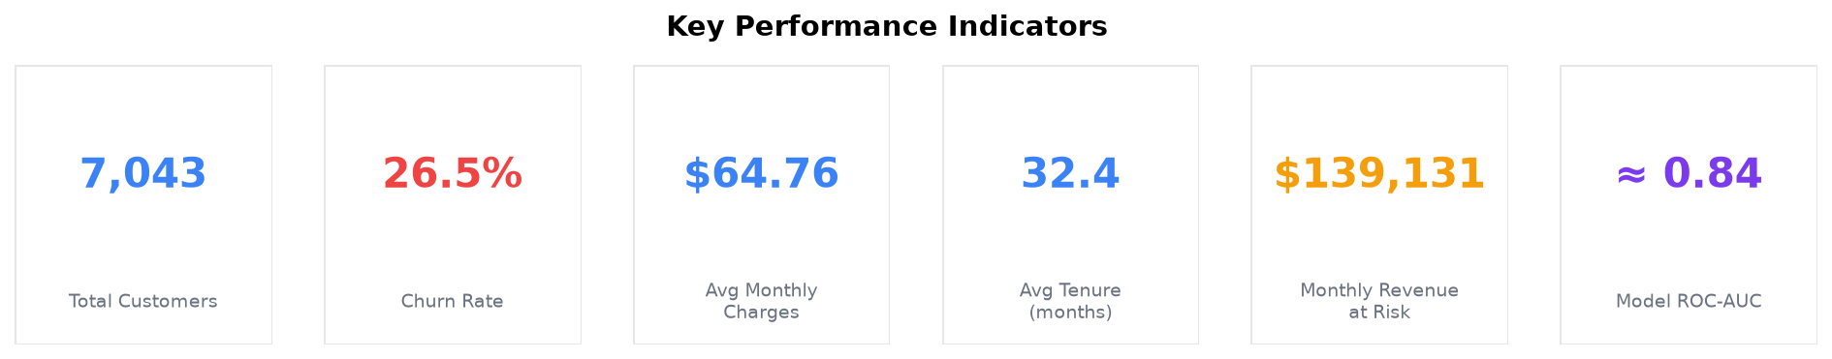
KPI | Value | Interpretation
Total Customers | 7,043 | Full dataset size
Churn Rate | 26.54% | ~1 in 4 customers churn
Avg Monthly Charges | $64.76 | Per-customer monthly revenue
Avg Tenure | 32.37 months | ~2.7 years average lifetime
Monthly Revenue at Risk | $139,130.85 | From churned customers only
Model ROC-AUC | 0.8401 | Random Forest on 20% test set

5.2 Churn vs Retained
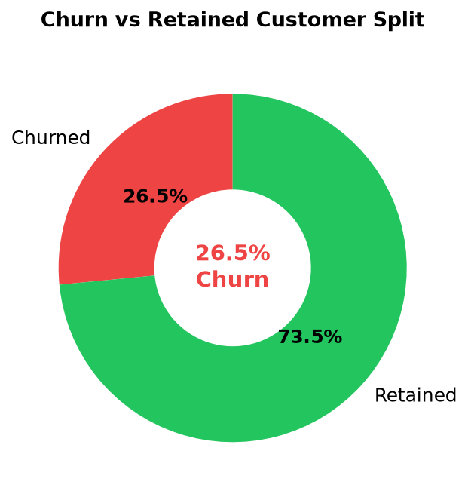
Out of 7,043 customers, 1,869 (26.54%) churned and 5,174 (73.46%) were retained.

5.3 Key Findings
• Month-to-month contract customers churn at ~42.7% vs 11.3% for one-year and 2.8% for two-year contracts.
• Fiber optic internet customers churn at ~41.9% — the highest of all service types.
• Electronic check payers churn at ~45.3% vs ~15% for automatic payment methods.
• Customers in their first 12 months churn at ~47.4% — the critical at-risk window.
• Customers without tech support churn at ~41.6% vs ~15.2% with support — a 26.5 pp gap.
• Senior citizens churn at ~41.7% vs ~23.6% for non-seniors.

6. Churn Drivers Analysis

6.1 Churn by Contract Type
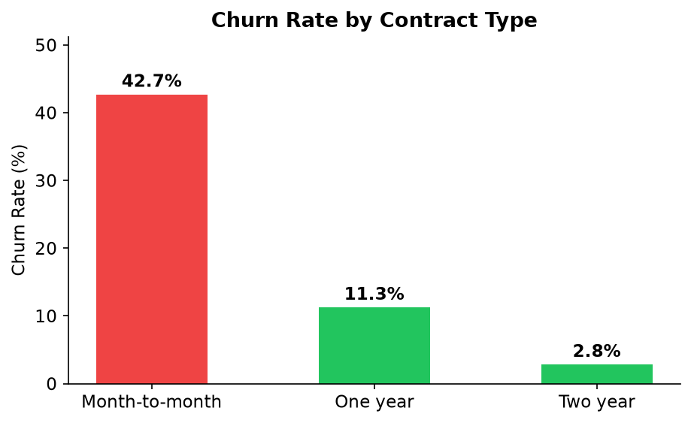
Month-to-month contracts have dramatically higher churn. With no lock-in period, dissatisfied customers can leave at the end of any billing cycle. This is the single most actionable churn driver.

6.2 Churn by Internet Service
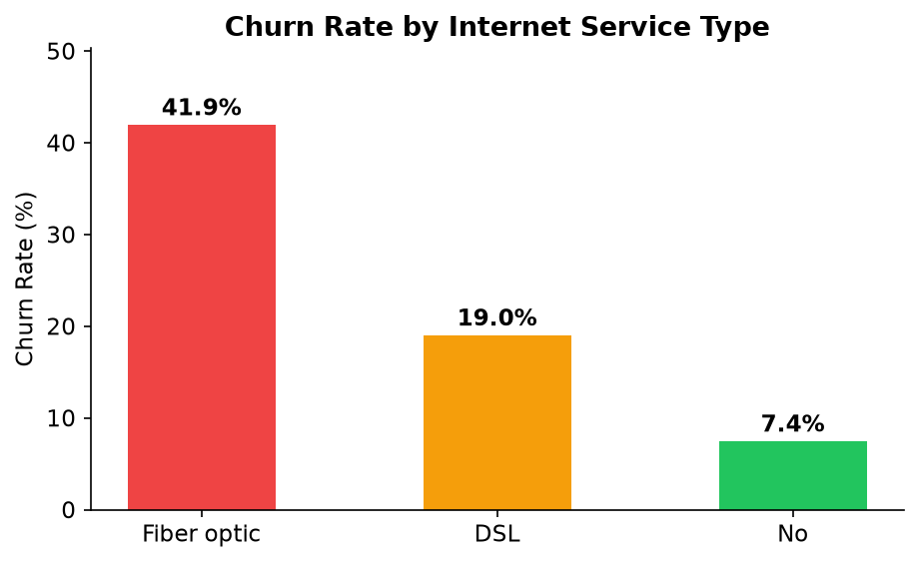
Fiber optic customers churn at ~42%, more than double the DSL rate (~19%). This likely reflects a combination of higher price points and unmet performance expectations. Customers with no internet service churn at only ~7%.

6.3 Churn by Payment Method
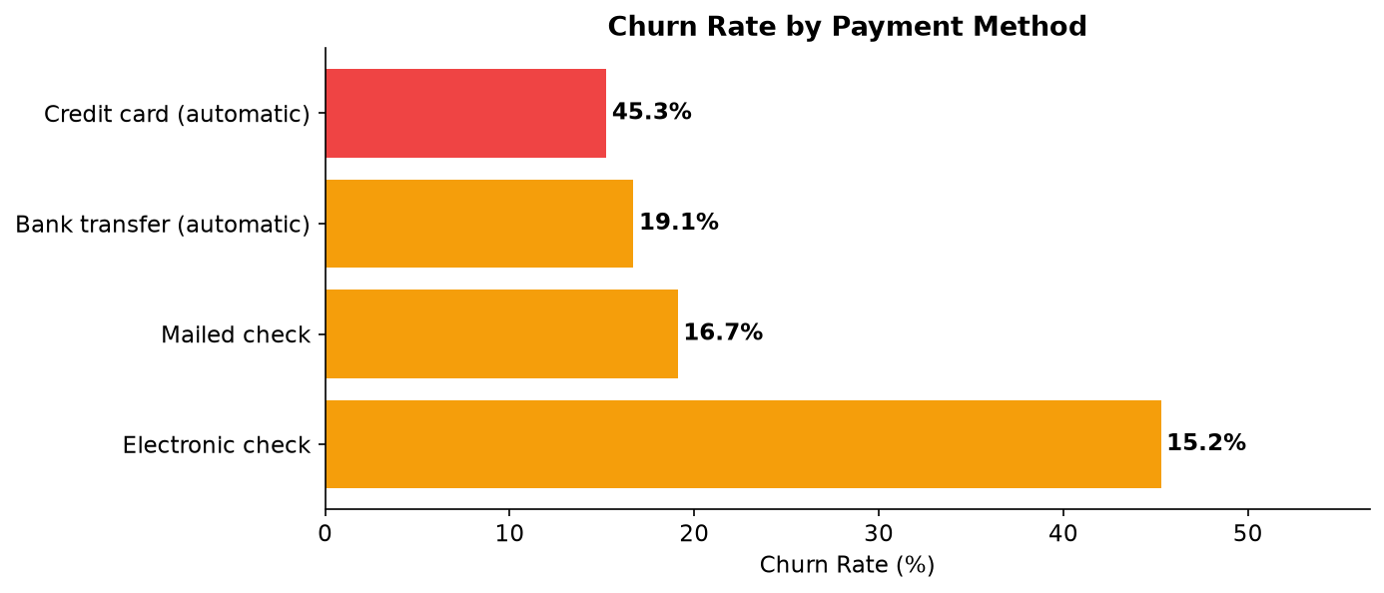
Electronic check payers exhibit the highest churn (~45%). Manual payment methods correlate with lower commitment — these customers are more likely to respond to competitor offers. Automatic payment customers (bank transfer or credit card) churn at ~15-17%.

6.4 Churn by Tenure Group
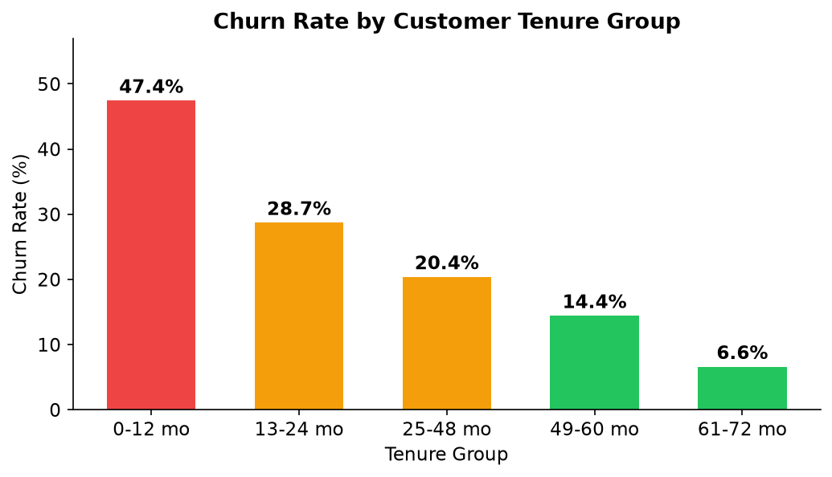
Churn is heavily concentrated in the first 12 months (~47.4%). After 24 months, churn rates drop significantly and continue declining. This confirms that early-lifecycle engagement is the highest-leverage intervention point.

6.5 Tech Support & Senior Citizen
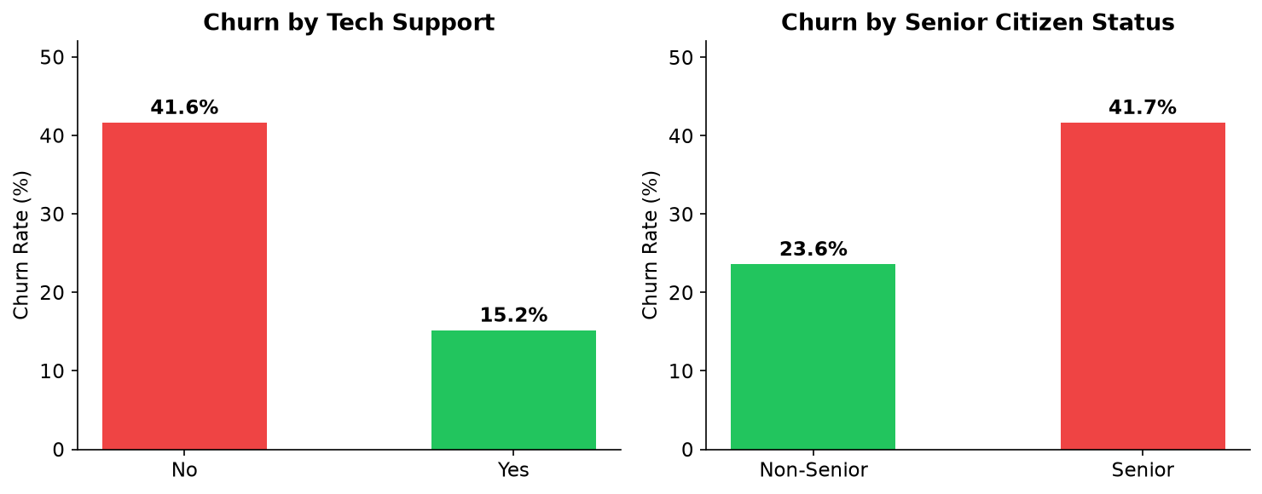
Customers without tech support churn at about 2.7x the rate of supported customers (41.6% vs 15.2%). Senior citizens churn at ~41.7% vs ~23.6% for non-seniors, suggesting price sensitivity and service complexity as key factors for this segment.

7. Model Results

7.1 Performance Metrics
Metric | Logistic Regression | Random Forest | Best
Accuracy | 0.7388 | 0.7608 | Random Forest
Precision | 0.5051 | 0.5352 | Random Forest
Recall | 0.7968 | 0.7513 | Logistic Regression
F1 Score | 0.6183 | 0.6251 | Random Forest
ROC-AUC | 0.8398 | 0.8401 | Random Forest

7.2 Model Comparison Chart
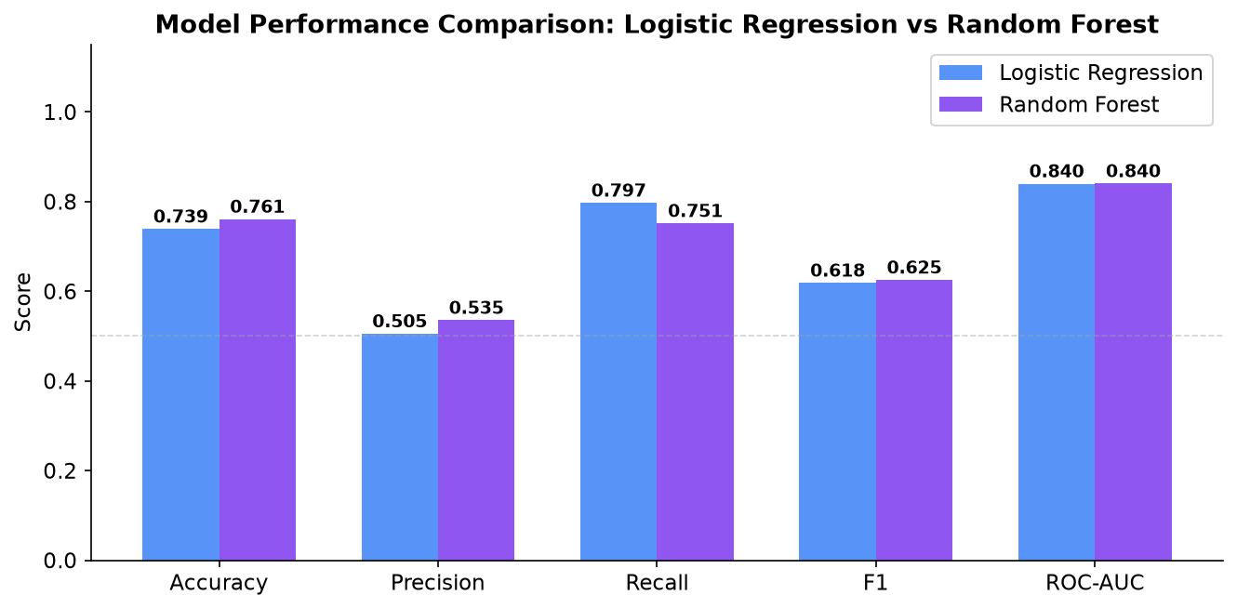
Random Forest was selected as the best model with a ROC-AUC of 0.8401. Both models benefit from class_weight='balanced' to handle the 73.5/26.5 class imbalance. While Logistic Regression achieves higher recall (0.7968), Random Forest provides a better overall discrimination score. The two models are effectively tied (ROC-AUC difference below 0.001), so the model the dashboard labels 'best' can change slightly with library versions; the figures in this report are from the run used to build it.

7.3 Confusion Matrix
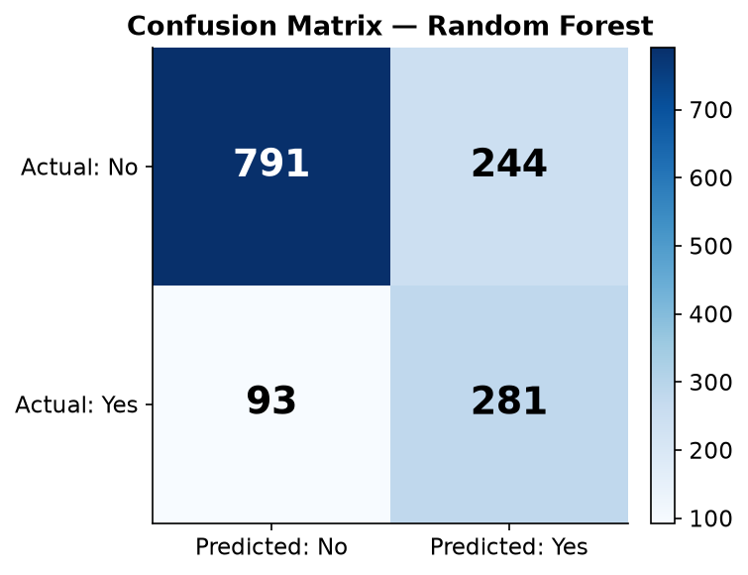

7.4 Feature Importances
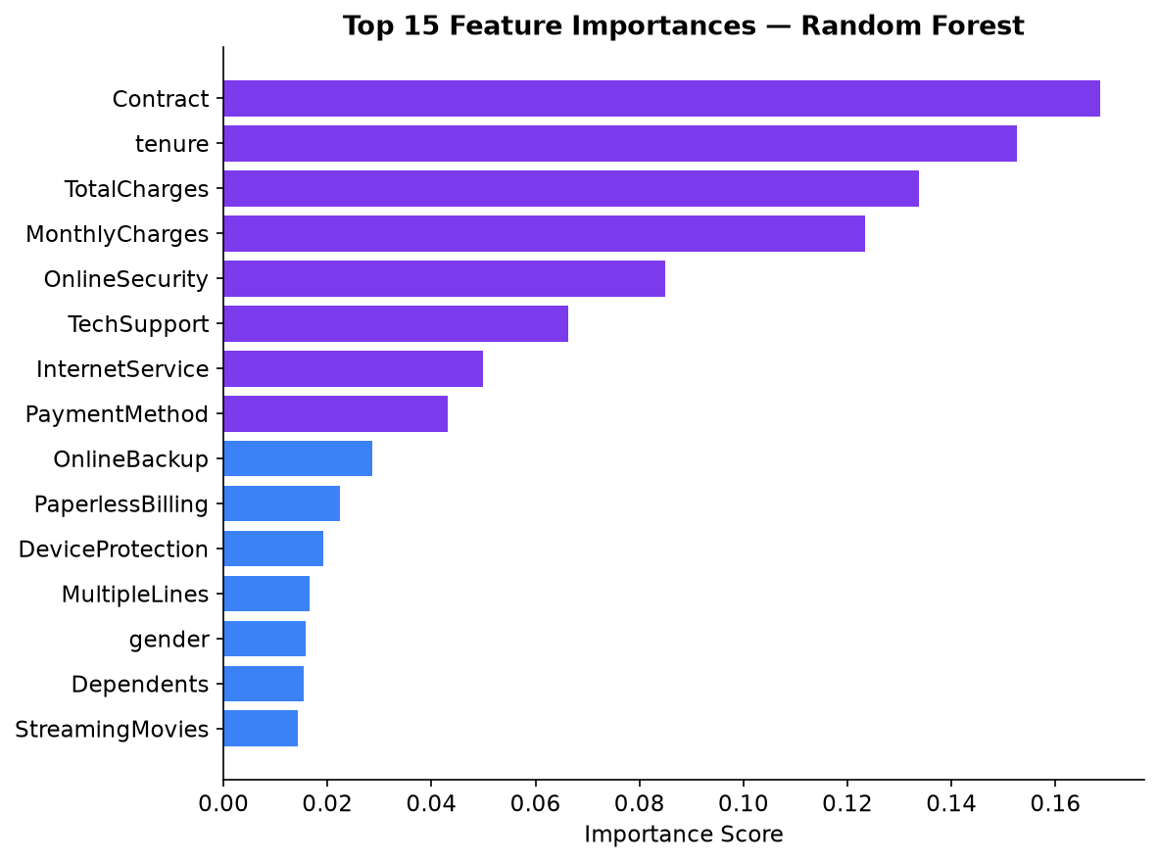
Contract type, tenure, TotalCharges and MonthlyCharges are the top four predictors. This is consistent with the EDA findings — how long a customer has been subscribed and what they pay are the strongest signals of churn risk.

7.5 ROC Curves
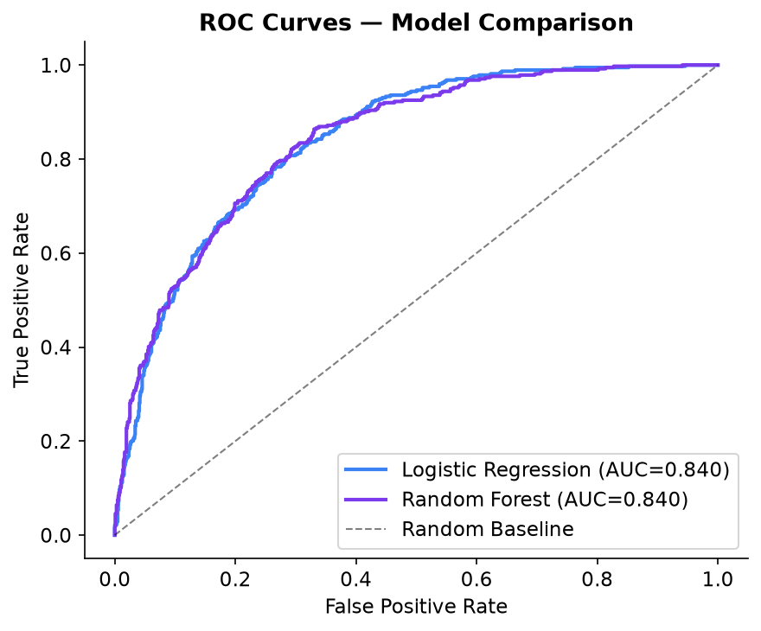

7.6 Churn Probability Distribution
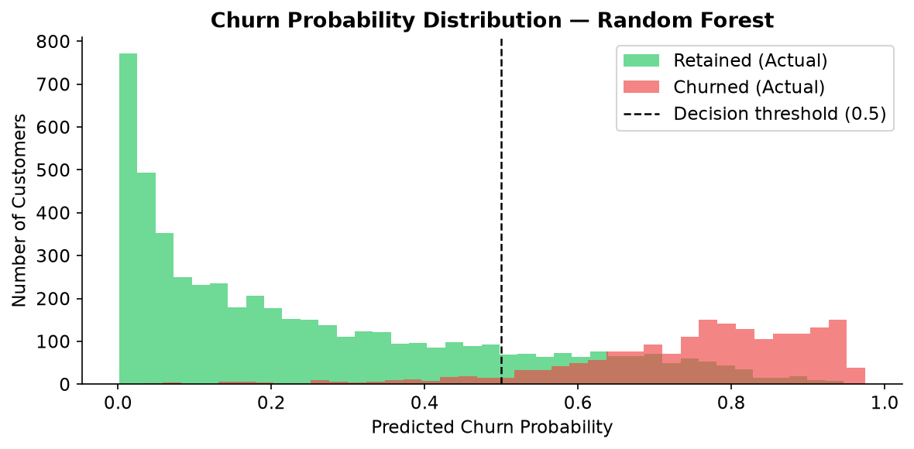
The probability distributions show reasonable separation between churned (red) and retained (green) customers. A threshold of 0.5 is used for binary classification; this can be adjusted based on the cost of false negatives vs false positives.

8. Risks, Opportunities & Recommended Actions

8.1 Risk Register
# | Risk | Evidence | Severity
1 | Month-to-month customer flight | ~42.7% churn rate on 3,875 flexible-contract customers | High
2 | Fiber optic dissatisfaction | ~41.9% churn rate — highest of all internet service types | High
3 | High-risk segment (M2M + fiber + first year) | 916 customers in this segment churn at 70.2% | Critical
4 | Senior citizen attrition | 1,142 senior customers at ~41.7% churn | High
5 | No tech support adoption | ~41.6% churn among customers without tech support | Medium
6 | Early-lifecycle drop-off | 47.4% churn in first 12 months — critical retention window | High

8.2 Opportunities
# | Opportunity | Potential Impact
1 | Convert M2M customers to annual contracts | Cutting M2M churn from 42.7% to 30% would retain ~490 customers, worth ~$36K/month
2 | Tech Support upsell to stable customers | 2,027 retained internet customers without tech support — upsell opportunity
3 | Loyal customer upgrade programme | 2,303 customers with 4+ years tenure — bundled upgrade candidates
4 | Senior-friendly simplified plan | Reduce senior churn from 41.7% toward 26.5% average
5 | Automatic payment migration | Moving electronic-check payers to auto-pay could reduce their 45% churn

8.3 Recommended Actions
Action 1 — Targeted Retention Offer for High-Value High-Risk M2M Customers
• Who: Active month-to-month customers with model-predicted churn probability >= 70%
• What: Proactive outreach offering 15-20% annual contract discount, or 3-month tech support trial
• Why: Month-to-month churners account for $120,847 of monthly revenue lost (87% of the total)
• Expected impact: every 10% of month-to-month churn prevented protects roughly $12,000/month
Action 2 — Fiber Optic Satisfaction Programme
• Who: 3,096 fiber optic customers (41.9% churn rate)
• What: Proactive service-quality calls, speed upgrade offers, and 'price-lock' promotion to 1-year plan
• Why: Fiber customers pay the highest monthly charges — retaining them has outsized revenue impact
Action 3 — New Customer Onboarding Programme
• Who: All customers in first 12 months (47.4% churn rate)
• What: Dedicated onboarding contact, 30/60/90-day automated check-ins, first-year loyalty discount
• Why: Early lifecycle is the highest-risk window; even a 10 pp improvement in this cohort is significant
Action 4 — Senior Citizen Simplified Plan
• Who: 1,142 senior customers (41.7% churn rate)
• What: 'Senior Simplified' plan — reduced complexity, lower price, priority support line
• Why: Senior customers are both high-churn and potentially high-CLV if retained
Action 5 — Tech Support Awareness Campaign
• Who: 3,473 customers without tech support (41.6% churn rate)
• What: In-app and email campaign highlighting support benefits; free first 3 months for at-risk customers
• Why: Customers with tech support churn ~26 pp less (15.2% vs 41.6%) — a low-cost retention lever

9. Conclusion
This project delivered a complete, end-to-end Customer Churn Analysis & Retention Dashboard for a telecom company. Starting from 7,043 customer records, the analysis identified a 26.54% overall churn rate and a monthly revenue at risk of $139,130.85.
Through systematic exploratory data analysis, five key churn drivers were identified: month-to-month contract type (~42.7% churn), fiber optic internet service (~41.9%), electronic check payment method (~45.3%), first-year tenure (~47.4%), and absence of tech support (~41.6%).
The Random Forest classifier achieved a ROC-AUC of 0.8401 on the held-out test set, providing a useful ranking of customers by churn risk. The top features driving model predictions — tenure, contract type, monthly charges — are fully consistent with the EDA findings, validating the model's business interpretability.
The interactive Streamlit dashboard translates all findings into business-ready pages: an Executive Overview with live KPIs, a Churn Drivers page with annotated charts, and a Risk & Actions page with a live at-risk table, single-customer prediction form, and structured strategic recommendations.

10. Future Scope
• Hyperparameter tuning (GridSearchCV / RandomizedSearchCV) for both models to improve ROC-AUC.
• Threshold optimisation: tune the classification threshold to minimise the cost of false negatives.
• Add XGBoost and CatBoost for comparison with tree ensemble baselines.
• SHAP (SHapley Additive exPlanations) for per-customer explainability in the Risk & Actions page.
• Time-series churn analysis: incorporate monthly snapshots to detect churn velocity trends.
• A/B test integration: track the impact of implemented retention actions directly in the dashboard.
• Real-time scoring pipeline: expose the trained model as a REST API for CRM integration.

11. References
[1] IBM Telco Customer Churn Dataset. Kaggle. https://www.kaggle.com/datasets/blastchar/telco-customer-churn
[2] Pedregosa et al. (2011). Scikit-learn: Machine Learning in Python. JMLR 12, 2825-2830.
[3] Streamlit Documentation. https://docs.streamlit.io
[4] Plotly Python Open Source Graphing Library. https://plotly.com/python/
[5] Breiman, L. (2001). Random Forests. Machine Learning, 45(1), 5-32.
[6] Cox, D.R. (1958). The Regression Analysis of Binary Sequences. JRSS-B 20(2), 215-232.
[7] Fawcett, T. (2006). An Introduction to ROC Analysis. Pattern Recognition Letters, 27(8), 861-874.

Appendix A. Dashboard Screenshots
Screenshots of the running Streamlit dashboard (streamlit run churn_retention_app.py).
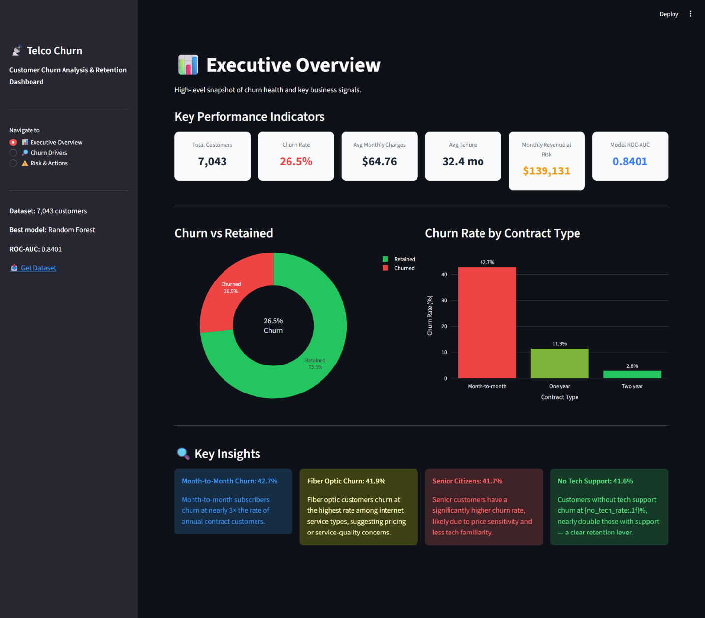
Figure A1 - Executive Overview page

Figure A2 - Churn Drivers page
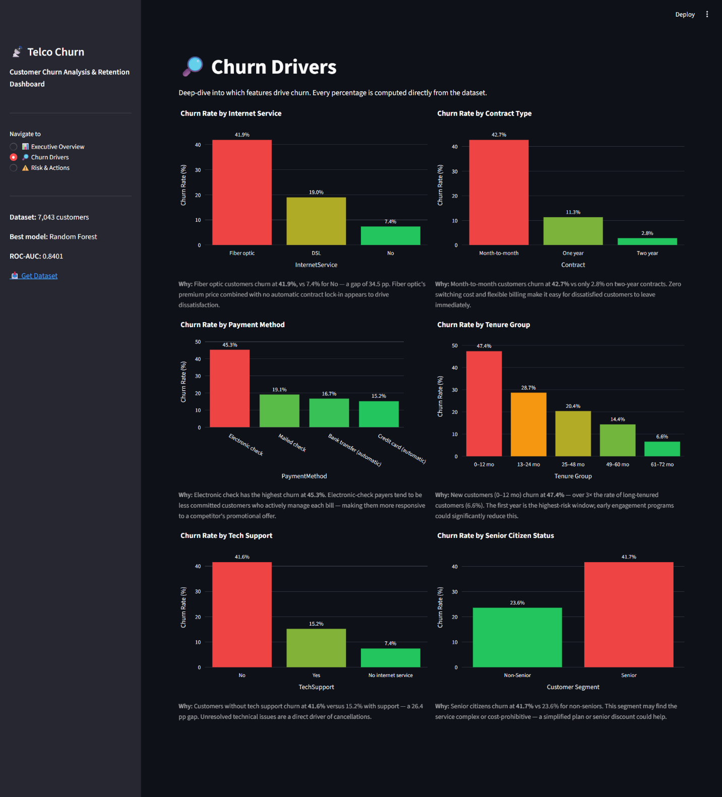
Figure A3 - Risk & Actions page
