**Responsive Portfolio**

**A PROJECT REPORT**

***Submitted by***

**Purum Manivardhan**

***Class Assessment 3 (CA3)***

***of***

**Semester-1**

**IN**

**B tech-CSE(Core)**



**Lovely Professional University, Punjab**

**ENROLLMENT NUMBER**

**12406683**

**Section: K24CT Roll No.:55 Date:25-10-2024**

**Table of Contents**

**Chapter Particulars Page No.**

**Chapter 1. Introduction……………………………………………………………………………………………..**

**Chapter 2. Technologies used…………………………………………………………………………………….**

**Chapter 3. Work Flow Diagram………………………………………………………...........................**

**Chapter 4. Working of Project……………………………………………………………………………………**

**Chapter 5. Snippets of Written Code…………………………………………………………………………**

**Chapter 6. Webpages Screenshot ……………………………………………………………………………**

**References……………………………………………………………………………………………………………………..**

**GitHub Repository link: https://github.com/Ankitj2024/Interactive-Portfolio/tree/main**

**Chapter 1: Introduction:**

The purpose of this interactive portfolio is to showcase my skills, projects, and accomplishments in a user-friendly, visually engaging way. The portfolio is designed with a modern, responsive layout that adjusts seamlessly across devices, enhancing accessibility and user experience. By integrating animations, smooth transitions, and dynamic content, this project aims to give users an immersive experience while navigating through my work. This portfolio reflects my technical skills and my commitment to creating meaningful digital experiences.

**Chapter 2: Technologies used:**

· **HTML**: For the basic structure of the website.

· **CSS**: For styling the website, including responsiveness, animations, and transitions.

· **JavaScript**: For interactivity, handling user input, and adding dynamic features such as smooth scrolling, modals, and hover effects.

**Chapter 3: The workflow diagram:**

* **Home Page**: Introduction, navigation links, and interactive elements to welcome users.
* **About Section**: Basic information about skills and a profile overview.
* **Projects Section**: Each project is clickable and opens to more details in a modal.
* **Contact Form**: Allows users to reach out, with fields for name, email, and message.

**Chapter 4: Working of project:**

* **Navigation**: A fixed header or sidebar allows users to easily switch between sections. JavaScript enables smooth scrolling and active link highlighting.
* **Home/Introduction Section**: This section includes a brief introduction. Buttons lead to other sections for easy navigation.
* **About Section**: Displays a summary of skills, tools, and experience with icons or progress bars.
* **Projects Section**: Each project card is clickable. When clicked, a modal opens with more detailed descriptions, images.
* **Contact Form**: The form captures user input (name, email, message) and is validated for errors. It may connect to an API for storing messages or sending emails directly.

**Chapter 5: Snippets of Written Code:**

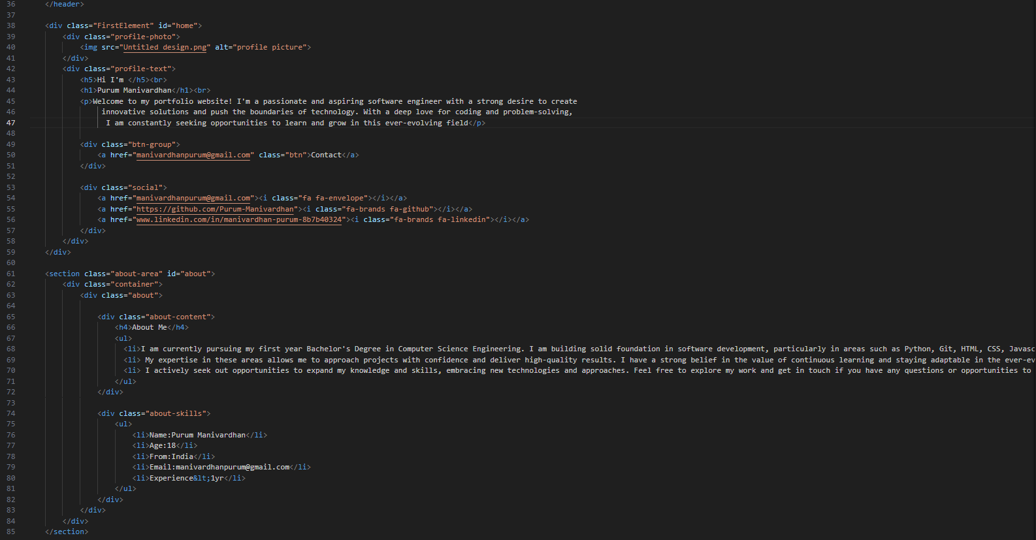

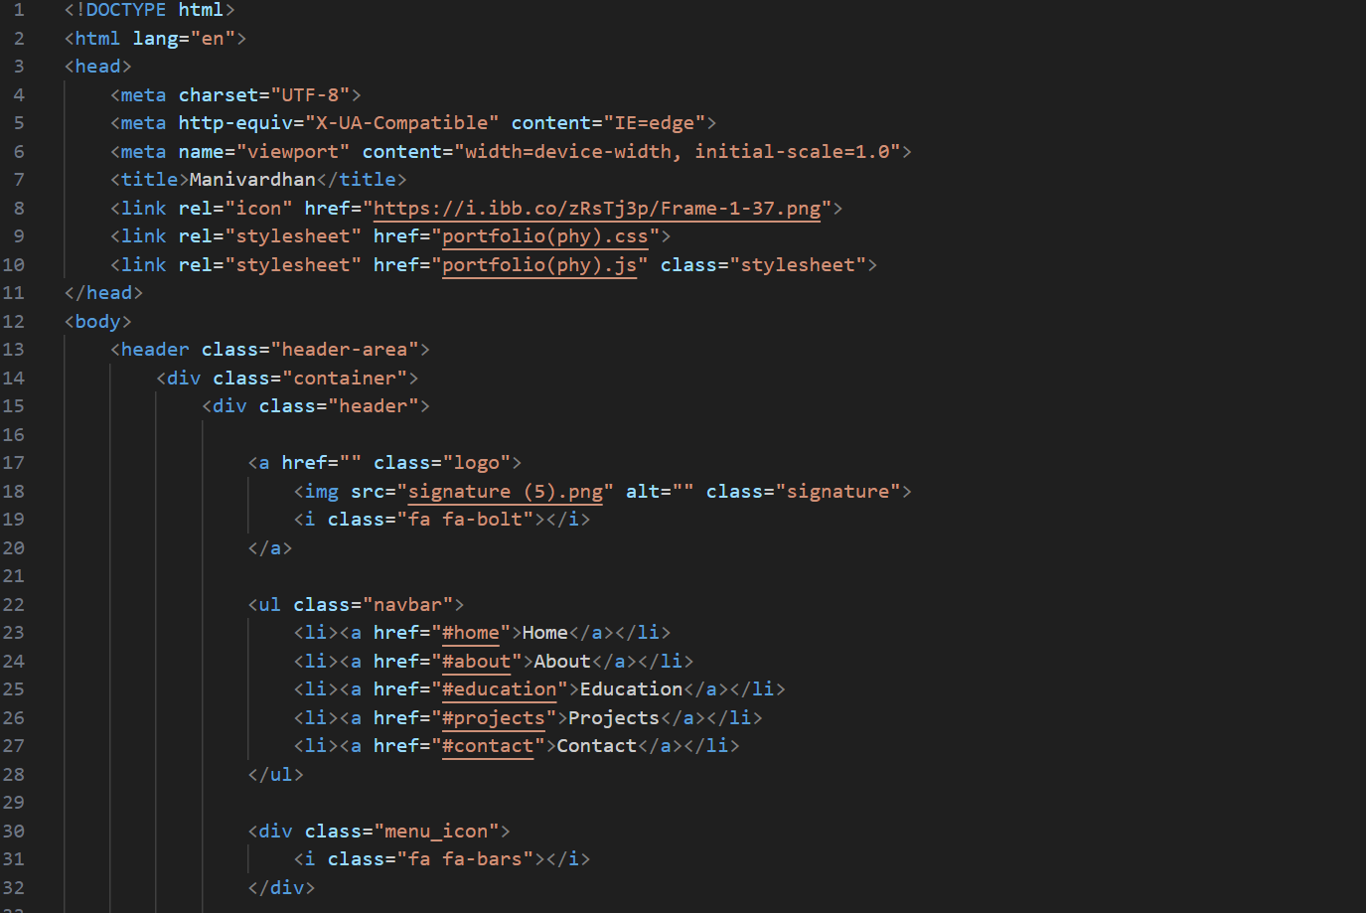

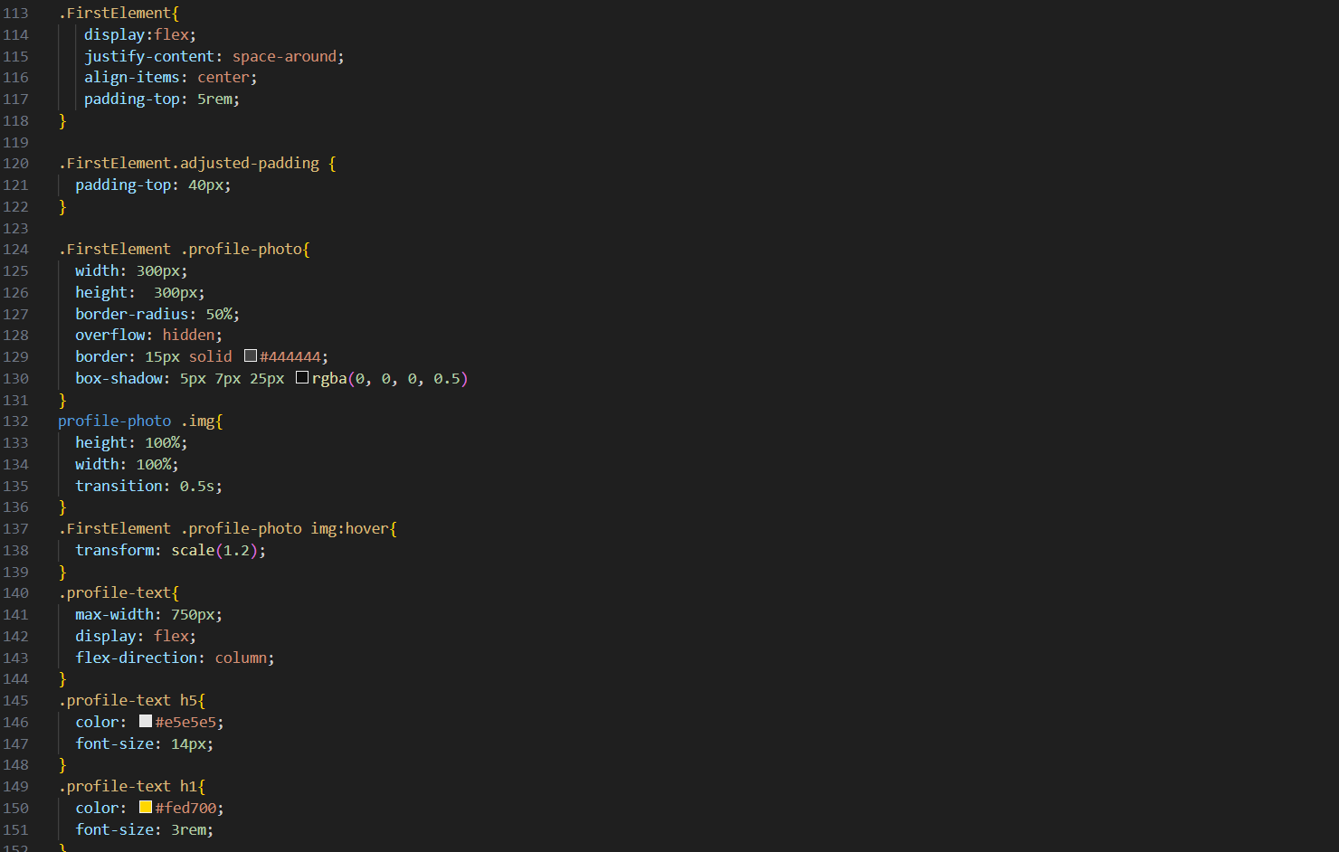

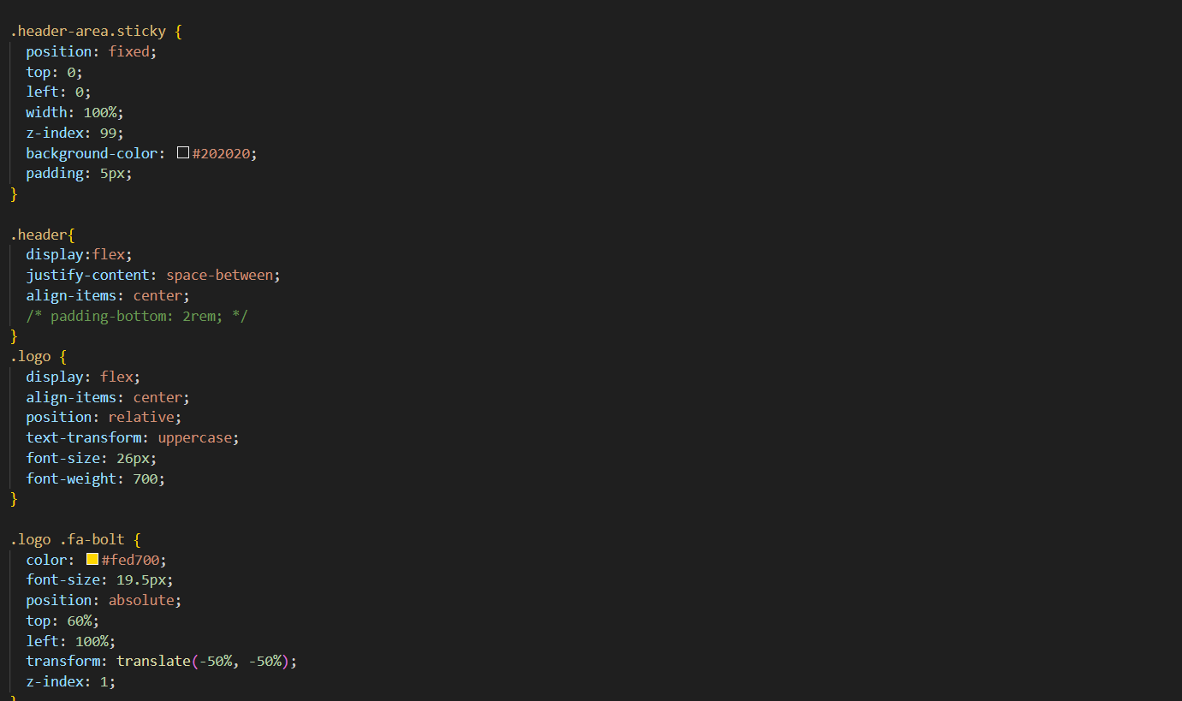

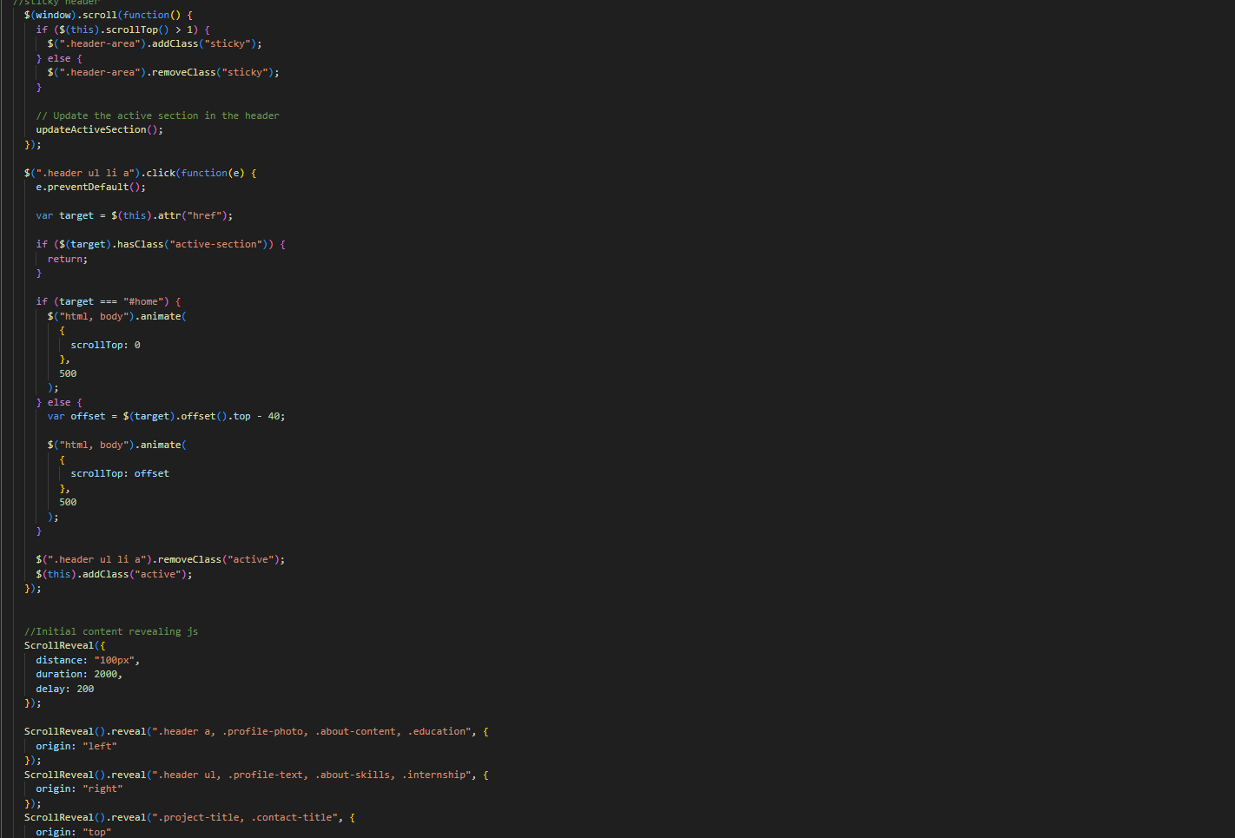

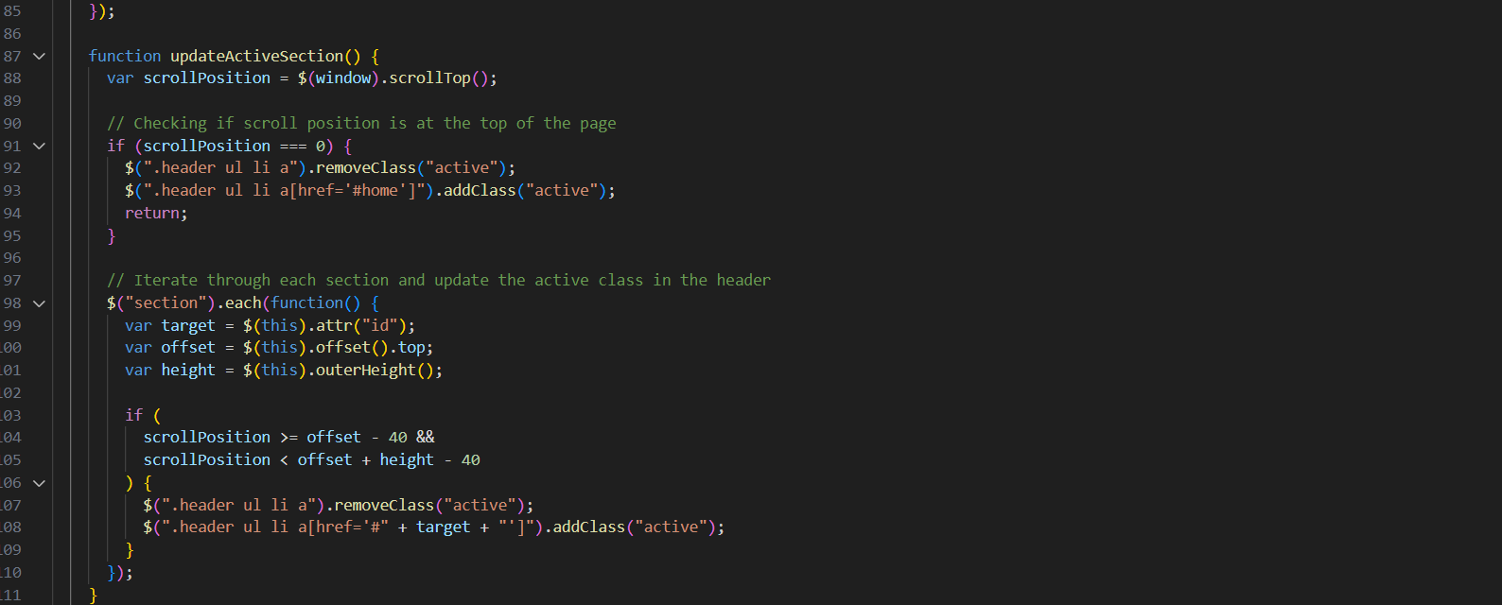

**Chapter 6: Webpages Screenshot:**

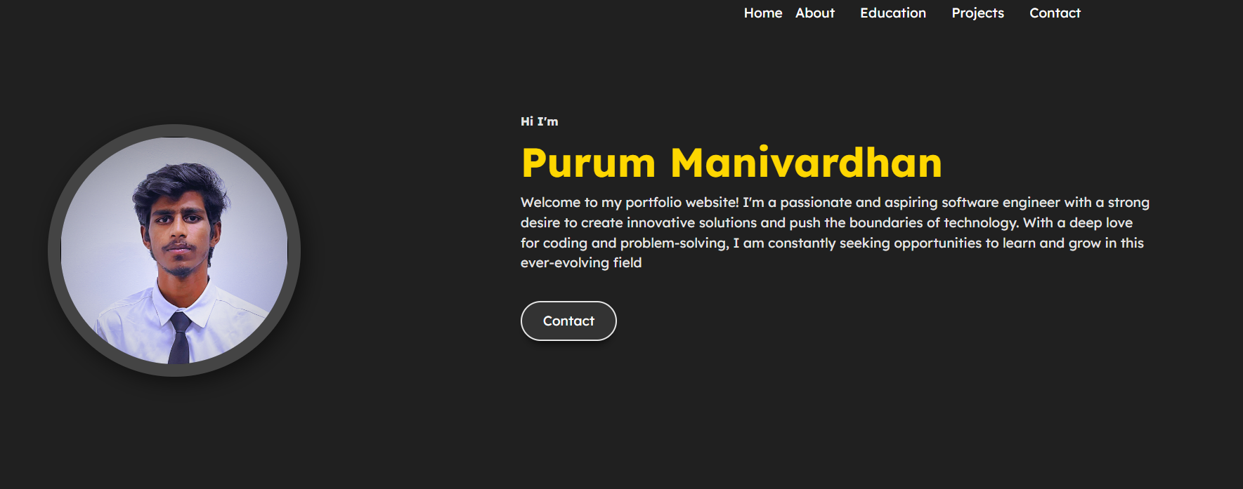

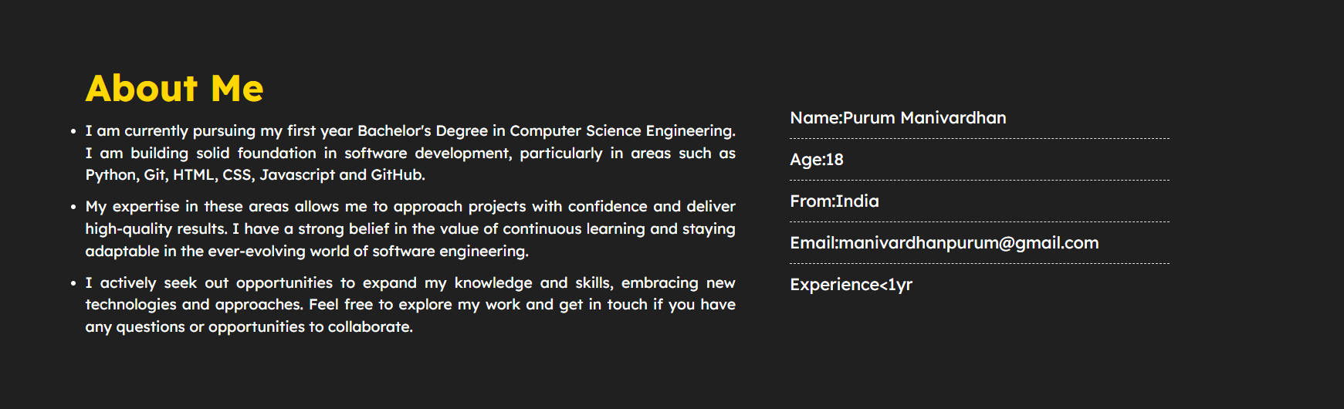

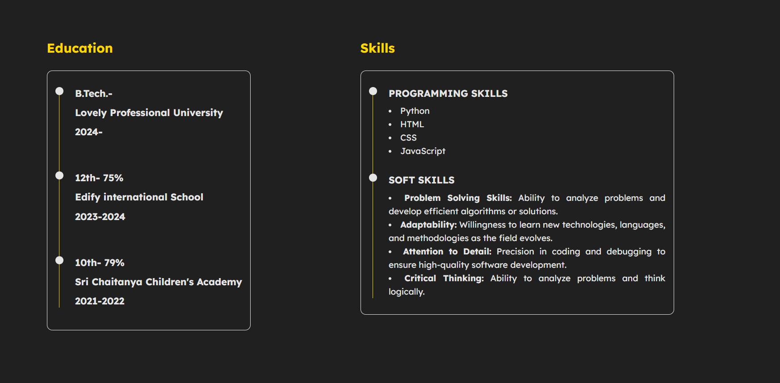

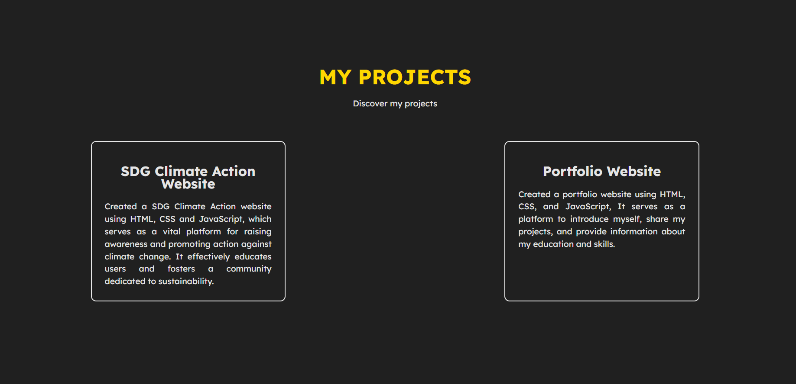

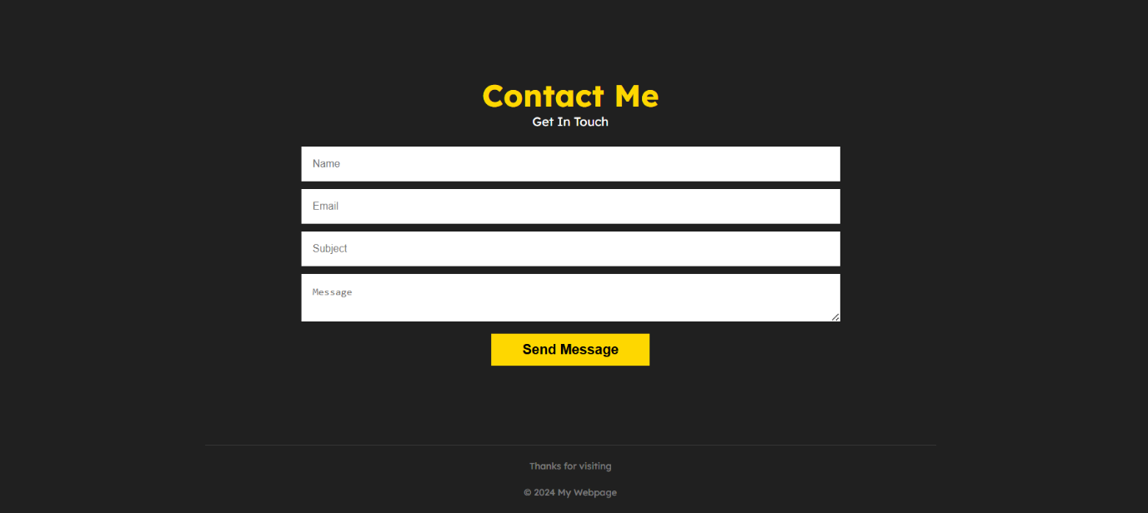

**References:**

Free code camp: <https://www.freecodecamp.org>

W3School: <https://www.w3schools.com>

Github: https://github.com