Question 1.

Which of the following represents voltage?

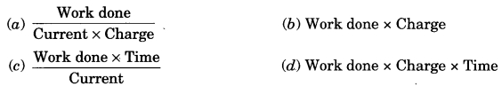

Answer: (a)

Question 2.

Unit of electric power may also be expressed as

(a) volt ampere

(b) kilowatt hour

(c) watt second

(d) Joule second

Answer: (a) volt ampere

Question 3.

Electrical resistivity of a given metallic wire depends upon

(a) its length

(b) its thickness

(c) its shape

(d) nature of the material

Answer: (d) nature of the material

Question 4.

A cell, a resistor, a key and ammeter are arranged as shown in the circuit diagrams of Figure (i), (ii) and (iii). The current recorded in the ammeter will be

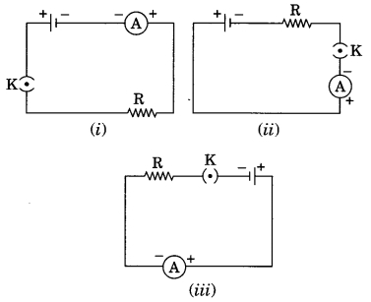

(a) maximum in (i)

(b) maximum in (ii)

(c) maximum in (iii)

(d) the same in all the cases

Answer: (d) the same in all the cases

Question 5.

The unit of e.m.f. of a cell is

(a) dyne

(b) volt

(c) ampere

(d) joule

Answer: (b) volt

Question 6.

Kilowatt hour is the unit of

(a) power

(b) energy

(c) impulse

(d) force

Answer: (b) energy

Question 7.

1 kWh is equal to

(a) 3.6 × 106 MJ

(b) 3.6 × 105 MJ

(c) 3.6 × 10² MJ

(d) 3.6 MJ

Answer: (d) 3.6 MJ

Question 8.

Materials which allow larger currents to flow through them are called

(a) insulators

(b) conductors

(c) semiconductors

(d) alloys

Answer: (b) conductors

Question 9.

Conventionally, the direction of the current is taken as

(a) the direction of flow of negative charge

(b) the direction of flow of atoms

(c) the direction of flow of molecules

(d) the direction of flow of positive charge

Answer: (d) the direction of flow of positive charge

Question 10.

The unit of specific resistance is

(a) ohm

(b) ohm

(c) ohm-metre

(d) ohm per metre

Answer: (c) ohm-metre

Question 11.

The slope of voltage (V) versus current (I) is called

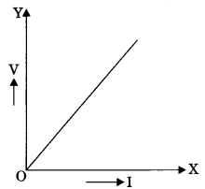

(a) resistance

(b) conductance

(c) resistivity

(d) conductivity

Answer: (a) resistance

Question 12.

The variable resistance is called

(a) resistor

(b) rheostat

(c) open switch

(d) none of these

Answer: (b) rheostat

Question 13.

The SI unit of resistance is

(a) ohm m

(b) ohm m1

(c) ohm

(d) (ohm)-1

Answer: (c) ohm

Question 14.

An electric iron draws a current 4 A when connected to a 220 V mains. Its resistance must be

(a) 1000 Ω

(b) 55 Ω

(c) 44 Ω

(d) None of these

Answer: (b) 55 Ω

Question 15.

The element used almost exclusively for filaments of incandescent lamps

(a) copper

(b) gold

(c) silver

(d) tungsten

Answer: (d) tungsten