Question 1.

A person cannot see distinctly objects kept beyond 2 m. This defect can be corrected by using lens of power

(a) +0.5 D

(b) -0.5 D

(c) +0.2 D

(d) -0.2 D

Answer: (b) -0.5 D

Question 2.

A student sitting on the last bench can read the letters written on the blackboard but is not able to read / the letters written in his textbook. Which of the following statements is correct?

(a) The near point of his eyes has receded away.

(b) The near point of his eyes has come closer to him.

(c) The far point of his eyes has come closer to him.

(d) The far point of his eyes has receded away.

Answer: (a) The near point of his eyes has receded away.

Question 3.

A prism ABC (with BC as base) is placed in different orientations. A narrow beam of white light is incident on the prism as shown in the Figures given below. In which of the following cases, after dispersion, the third colour from the top corresponds to the colour of the sky?

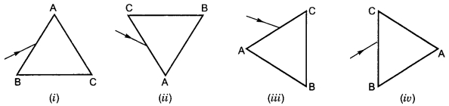

(a) (i)

(b) (ii)

(c) (iii)

(d) (iv)

Answer: (b) (ii)

Question 4.

At noon the sun appears white as

(a) light is least scattered.

(b) all the colours of the white light are scattered away.

(c) blue colour is scattered the most.

(d) red colour is scattered the most.

Answer: (a) light is least scattered.

Question 5.

Which of the following phenomena of light are involved in the formation of a rainbow?

(a) Reflection, refraction and dispersion

(b) Refraction, dispersion and total internal reflection

(c) Refraction, dispersion and internal reflection

(d) Dispersion, scattering and total internal reflection

Answer: (c) Refraction, dispersion and internal reflection

Question 6.

Twinkling of stars is due to atmospheric

(a) dispersion of light by water droplets

(b) refraction of light by different layers of varying refractive indices

(c) scattering of light by dust particles

(d) internal reflection of light by clouds

Answer: (b) refraction of light by different layers of varying refractive indices

Question 7.

The clear sky appears blue because

(а) blue light gets absorbed in the atmosphere.

(b) ultraviolet radiations are absorbed in the atmosphere.

(c) violet and blue lights get scattered more than lights of all other colours by the atmosphere.

(d) light of all other colours is scattered more than the violet and blue colour lights by the atmosphere.

Answer: (c) violet and blue lights get scattered more than lights of all other colours by the atmosphere.

Question 8.

Which of the following statements is correct regarding the propagation of light of different colours of white light in air?

(a) Red light moves fastest.

(b) Blue light moves faster than green light.

(c) All the colours of the white light move with the same speed.

(d) Yellow light moves with the mean speed as that of the red and the violet light.

Answer: (c) All the colours of the white light move with the same speed.

Question 9.

The danger signals installed at the top of tall buildings are red in colour. These can be easily seen from a distance because among all other colours, the red light

(a) is scattered the most by smoke or fog.

(b) is scattered the least by smoke or fog.

(c) is absorbed the most by smoke or fog.

(d) moves fastest in air.

Answer: (b) is scattered the least by smoke or fog.

Question 10.

Which of the following phenomena contributes significantly to the reddish appearance of the sun at sunrise or sunset?

(a) Dispersion of light

(b) Scattering of light

(c) Total internal reflection of light

(d) Reflection of light from the earth

Answer: (b) Scattering of light

Question 11.

The bluish colour of water in deep sea is due to

(a) the presence of algae and other plants found in water

(b) reflection of sky in water

(c) scattering of light

(d) absorption of light by the sea

Answer: (c) scattering of light

Question 12.

When light rays enter the eye, most of the refraction occurs at the

(a) crystalline lens

(b) outer surface of the cornea

(c) iris

(d) pupil

Answer: (b) outer surface of the cornea

Question 13.

The focal length of the eye lens increases when eye muscles

(a) are relaxed and lens becomes thinner

(b) contract and lens becomes thicker

(c) are relaxed and lens becomes thicker

(d) contract and lens becomes thinner

Answer: (a) are relaxed and lens becomes thinner

Question 14.

Which of the following statement is correct?

(a) A person with myopia can see distant objects clearly.

(b) A person with hypermetropia can see nearby objects clearly.

(c) A person with myopia can see nearby objects clearly.

(d) A person with hypermetropia cannot see distant objects clearly.

Answer: (c) A person with myopia can see nearby objects clearly.

Question 15.

A student traces the path of a ray through a glass prism for four different values of angle of incidence. On analysing the diagrams he is likely to conclude that the emergent ray

(a) is always parallel to the incident ray.

(b) is always perpendicular to the incident ray.

(c) is always parallel to the refracted ray.

(d) always bends at an angle to the direction of incident ray.

Answer: (d) always bends at an angle to the direction of incident ray.

Question 16.

A student is observing the diagram showing the path of a ray of light passing through a glass prism. He would find that for all angles of incidence the ray of light bends:

(а) towards the normal while entering into the prism and away from the normal while emerging out of the prism

(b) away from the normal while entering into the prism and towards the normal while emerging out of the prism.

(c) away from the normal while entering as well as while emerging out of the prism.

(d) towards the normal while entering as well as while emerging out of the prism.

Answer: (а) towards the normal while entering into the prism and away from the normal while emerging out of the prism

Question 17.

In the following diagram, the path of a ray of light passing through a glass prism is shown:

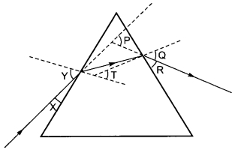

In this diagram the angle of incidence, the angle of emergence and the angle of deviation respectively are (select the correct option):

(a) X, R and T

(b) Y, Q and T

(c) X, Q and P

(d) Y, Q and P

Answer: (d) Y, Q and P

Question 18.

After tracing the path of a ray of light through a glass prism a student marked the angle of incidence (∠i), angle of refraction (∠r), angle of emergence (∠e) and the angle of deviation (∠D) as shown in the diagram. The correctly marked angles are:

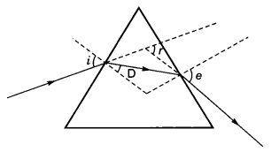

(a) ∠i and ∠r

(b) ∠i and ∠e

(c) ∠i, ∠e and ∠D

(d) ∠i, ∠r and ∠e

Answer: (b) ∠i and ∠e

Question 19.

The splitting of white light into its component colours is called

(a) refraction

(b) reflation

(c) dispersion

(d) tyndall effect

Answer: (c) dispersion

Question 20.

Reason behind advance sunrise and delayed sunset

(a) atmospheric refraction

(b) total internal reflection

(c) dispersion

(d) reflection

Answer: (a) atmospheric refraction

Question 21.

Type of lens used in correction of myopia

(a) convex lens

(b) concave lens

(c) reflecting lens

(d) bifocal lens

Answer: (b) concave lens

Question 22.

Type of lens used in correction of hypermetropia

(a) concave lens

(b) reflecting lens

(c) bifocal lens

(d) convex lens

Answer: (d) convex lens

Question 23.

Myopia may arise due to

(a) excessive curvature of the eye lens

(b) elongation of the eyeball

(c) both (a) and (b)

(d) none of these

Answer: (c) both (a) and (b)

Question 24.

In an experiment to trace the path of a ray of light through a glass prism for different values of angle of incidence a student would find that the emergent ray:

(a) is parallel to the incident ray

(b) is perpendicular to the incident ray

(c) is parallel to the refracted ray

(d) bends at an angle to the direction of incident ray

Answer: (d) bends at an angle to the direction of incident ray

Question 25.

While performing the experiment to trace the path of a ray of light passing through a glass prism, four students marked the incident ray and the emergent ray in their diagrams in the manner shown below.

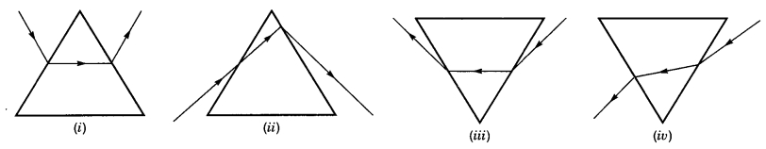

The correct path of the rays has been shown by:

(a) I

(b) II

(c) III

(d) IV

Answer: (c) III

Question 26.

A dark muscular membrane which controls size of pupil

(a) eye

(b) iris

(c) cornea

(d) retina

Answer: (b) iris

Question 27.

Least distance of distinct vision for normal eye is

(a) 25 cm

(b) 50 cm

(c) 75 cm

(d) infinity

Answer: (a) 25 cm

Question 28.

Farthest point of a normal eye is

(a) 25 cm

(b) 50 cm

(c) 75 cm

(d) infinity

Answer: (d) infinity

Question 29.

Crystalline lens of people at old age becomes milky and cloudy. This condition is called

(a) myopia

(b) lever

(c) cataract

(d) presbyopia

Answer: (c) cataract

Question 30.

The splitting of light into its component colours is called

(a) Spectrum

(b) Dispersion

(c) Tyndall effect

(d) Refraction

Answer: (b) Dispersion

Question 31.

Bifocal lens is used in

(a) myopia

(b) lever

(c) Cataract

(d) Presbyopia

Answer: (d) Presbyopia

Question 32.

Stars appears to be twinkling because of

(a) atmospheric refraction

(b) reflection

(c) Tyndall effect

(d) spectrum

Answer: (a) atmospheric refraction