Question 1.

Choose the incorrect statements from the following regarding magnetic lines of field.

(a) the direction of magnetic field at a point is taken to be the direction in which the north pole of a magnetic compass needle points

(b) magnetic field lines are closed curves

(c) if magnetic field lines are parallel and equidistant, they represent zero field strength

(d) relative strength of magnetic field is shown by the degree of closeness of the field lines.

Answer: (c) if magnetic field lines are parallel and equidistant, they represent zero field strength

Question 2.

If the key in the arrangement figure given below is taken out (the circuit is made open) and magnetic . field lines are drawn over the horizontal plane ABCD, the lines are

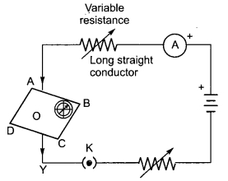

(a) concentric circles

(b) elliptical in shape

(c) straight lines parallel to each other (Due to earth’s magnetic field)

(d) concentric circles near the point O but of elliptical shapes as we go away from it.

Answer: (c) straight lines parallel to each other (Due to earth’s magnetic field)

Question 3.

A circular loop placed in a plane perpendicular to the plane of paper carries a current when the keys is ON. The current as seen from points A and B (in the plane of paper and on the axis of the coil) is anticlockwise and clockwise respectively. The magnetic field lines point from B to A. The N-pole of the resultant magnet is on the faces close to

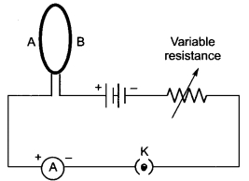

(a) A

(b) B

(c) A if the current is small, and B if the current is large

(d) B if the current is small and A if the current is large.

Answer: (a) A

Question 4.

For a current in a long straight solenoid, N- and S-poles are created at the two ends. Among the following statements, the incorrect statement is

(a) the field lines inside the solenoid are in the form of straight lines which indicates that the magnetic field is the same at all points inside the solenoid

(b) the strong magnetic field produced inside the solenoid can be used to magnetise a piece of magnetic material like soft iron, when placed inside the coil

(c) the pattern of the magnetic field associated with the solenoid is different from the pattern of the magnetic field around a bar magnet

(d) the N- and S-poles exchange position when the direction of current through the solenoid is reversed.

Answer: (c) the pattern of the magnetic field associated with the solenoid is different from the pattern of the magnetic field around a bar magnet

Question 5.

In the arrangement shown in the figure there are two coils wound on a non-conducting cylindrical rod. Initially the key is not inserted. Then the key is inserted and later removed. Then

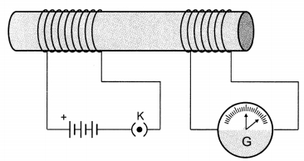

(a) the deflection in the galvanometer remains zero throughout.

(b) there is a momentary deflection in the galvanometer but it dies out shortly and there is no effect when the keys is removed.

(c) there are momentary galvanometer deflections that die out shortly; the deflections are in the same direction.

(d) there are momentary galvanometer deflections that die out shortly; the deflection are in opposite directions.

Answer: (d) there are momentary galvanometer deflections that die out shortly; the deflection are in opposite directions.

Question 6.

Choose the incorrect statement

(a) Fleming’s right-hand rule is a simple rule to know the direction of induced current.

(b) The right-hand thumb rule is used to find the direction of magnetic fields due to current carrying conductors.

(c) The difference between the direct and alternating currents is that the current always flows in one direction, whereas the alternating current reverses its direction periodically.

(d) In India, the AC changes direction after every 1/50 second.

Answer: (d) In India, the AC changes direction after every 1/50 second.

Question 7.

A constant current flows in a horizontal wire in the plane of the paper from east to west as shown in the figure. The direction of magnetic field at a point will be North to South

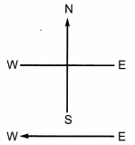

(a) directly above the wire

(b) directly below the wire

(c) at a point located in the plane of the paper, on the north side of the wire

(d) at a point located in the plane of the paper, on the south side of the wire.

Answer: (b) directly below the wire

Question 8.

The strength of magnetic field inside a long current carrying straight solenoid is

(a) more at the ends than at the centre

(b) minimum in the middle

(c) same at all points

(d) found to increase from one end to the other

Answer: (c) same at all points

Question 9.

The most important safety method used for protecting home appliances from short circuiting or overloading is by

(a) earthing

(b) use of fuse

(c) use of stabilizers

(d) use of electric meter.

Answer: (b) use of fuse

Question 10.

Select the incorrect statement

(а) Magnetic field lines are closed curves

(b) No two field lines can cross each other

(c) Field lines can cross each other

(d) The relative strength of the magnetic field is shown by degree of closeness of the field lines.

Answer: (c) Field lines can cross each other

Question 11.

Magnetic field lines around a straight conductor forms a pattern of

(a) concentric circles

(b) concentric ellipse

(c) straight line

(d) square shape.

Answer: (a) concentric circles

Question 12.

Electric motor is a device which converts

(a) mechanical energy to electrical energy

(b) electrical energy to mechanical energy

(c) chemical energy to mechanical energy

(d) mechanical energy to light energy.

Answer: (b) electrical energy to mechanical energy

Question 13.

The direction of induced current is given by

(a) Fleming’s right hand rule

(b) Fleming’s left hand rule

(c) Right hand thumb rule

(d) Left hand thumb rule.

Answer: (a) Fleming’s right hand rule

Question 14.

The insulation colour of earth wire is

(a) blue

(b) red

(c) green

(d) white.

Answer: (c) green

Question 15.

In India the potential difference between live wire and neutral wire is

(a) 240 V

(b) 250 V

(c) 280 V

(d) 220 V.

Answer: (d) 220 V.