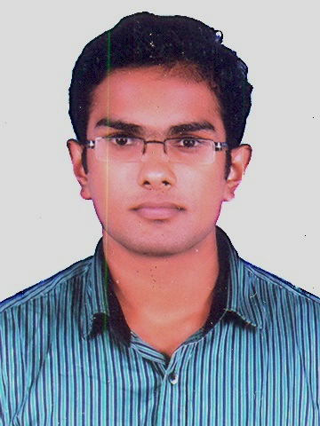 **VARGHESE SIMON**

iPhone / iPad Application Developer

Dreams PG, #56

8th Cross Maruthi Nagar,

Madiwala, Bangalore,

**E-mail:** varsim91@gmail.com Ph**: 9740309306**

**OBJECTIVE:**

To be part of an organization that utilizes my knowledge and skills to the core, where there is opportunity to learn more and in the process achieve my long-term goals.

**CAREER SUMMARY:**

* 1.3 years of experience in **iOS application development**
* Currently working in **Vmoksha Technology** from past 11 months (Nov-’13 to till date)
* Worked as an Intern in **Cerebtec Academy** for 4 months
* Proficient with **XCode, Objective-C, Cocoa Touch, iPhone SDK**
* Strong technical skills, knowledge about latest standards, trends and happenings
* Engaged in developing **3 iPhone apps**, of which **2 is in AppStore**.
* Engaged in fixing and releasing update of an iPhone app

**SKILLS:**

Languages : Objective C, Swift, C, C++.

Frameworks : UIKit Framework, Foundation , Mapkit

Technologies : In App Purchase, Push Notification, Core Bluetooth

Third Party Framework : AFNetworking, POP (Facebook), GPUImage, SWRevealViewController

Third Party Services : Parse Cloud service, CocoaPods, HockeyApp, Google Analytics, Flurry

Tools : Xcode IDE.

**RESPONSIBILITIES:**

* Involved in design, development of UI’s and coding in Objective C.
* Involved in implementation of efficient and performance oriented hierarchy of the application using Cocoa touch framework.
* Testing and debugging the application.
* Full understanding of an iOS application development life cycle
* Deployment of applications using AdHoc and to App Store

**EDUCATIONAL PROFILE:**

* **B.Tech** in **Electronics & Communication Engineering** (2009-2013) from Viswajyothi College of Engineering and Technology under **M G University**, Kottayam[**68%** aggregate].
* **HSC** from Nirmala Higher Secondary School, Muvattupuzha under State Board of Higher Secondary Examination, Kerala [**90%** aggregate].
* A **SSLC** from Nirmala Higher Secondary School, Muvattupuzha under State Board of Public Examination, Kerala [**94%** aggregate].

**PROJECTS**

**1) PROJECT : Quest For Bible Verses.**

**Category :** Reference

**Device :** iPhone and iPad

**Environment :** Objective-C, Xcode, User interface builder, Sqlite, XML parsing.

**Description :** This app shows a list of relevant Bible Verses about whatever you ask. Bible has solutions for all your problems. You just need to know where to look. This app helps you by searching for you. It search through the Bible and show what you need.

This app also includes

* Verse of the day
* Shares any verse you like with your family and friends
* More than 7500 topics covered

**Link:** https://itunes.apple.com/in/app/quest-for-bible-verses/id796303032?mt=8

**2) PROJECT : Insta Get Likes #UpLike**

**Category :** Social Network.

**Device :** iPhone

**Environment :**  Instagram APIs, Parse Cloud Services and In App Purchase

**Description :** This app will give user’s Instagram posts the attention they deserve. Implemented technology to get likes for Instagram posts. The app is having in app coins for spending on the user’s own posts that they want to get more likes. User will get coins when they like a post of other user. An easier way to get coin is through In App Purchase.

**Link:** https://itunes.apple.com/us/app/insta-get-likes-uplike-for/id927253101?ls=1&mt=8

**3) PROJECT : Chat That.** (Currently working on)

**Category :** Social Network.

**Device :** iPhone

**Environment :** Social Logins (Facebook and G+), Push Notification, Parse Cloud Services and Chat technology.

**Description :** This app will allow users to ask questions and share information with the world. Users will be able to ask questions, seek advice, get a review, or get insight on absolutely any person, place, thing, idea, or concept. Users can do this through chatting with other users, in real time, who have made themselves available to chat on a certain topic. This app will enable people to talk about anything with anybody in the world.

**PERSONAL PROFILE:**

**Name** : Varghese Simon

**Date of Birth** : 12 July 1991

**Father name** : A.V.Simon

**Mother name** : Susha Simon

**Nationality** : Indian

**Gender** : Male

**Marital Status** : Single

**Languages Known** : English, Malayalam and Hindi.

**Permanent Address** : Amabazhachalil House,

Puthuppady P.O, Muvattupuzha,

Ernakulam, Kerala,

Pin 686673

**DECLARATION:**

I hereby declare that the information furnished above is correct to the best of my knowledge.

Date: 20/10/2014

Place: Bangalore **VARGHESE SIMON**