Client engagement models
LexDesk / Advocate CRM — product design note
Phase: Design (pre-development). Audience: Product, design, leadership.

1. Purpose
This document captures agreed client-side engagement rules: how a client enters the platform, whom they connect with, and how matters and messaging behave for a pure solo advocate, for an advocate who practises independently on the platform while employed or affiliated with a firm, and for a firm-led model where assignment and reassignment of advocates is controlled by the firm.

2. Global product rules (fixed)
- Geography: India-wide framing; court and matter metadata must support all states even if integrations roll out incrementally.
- Messaging: chat is available only between linked clients and the appropriate advocate-side parties (no open messaging from directory).
- Dual-sided product: advocate CRM and client app are co-equal; permissions and matter context must be explicit in each flow.

3. Three client selection approaches

3.1 Path 1 — Pure individual advocate
The advocate operates as a solo practice on the platform. On the client app, the client discovers that advocate, sends a connection request, and after acceptance sees that same advocate as the face of every matter. There is no firm orchestration layer visible to the client.

3.2 Path 2 — Advocate who belongs to a firm but uses the platform independently
The advocate is part of a firm in real life (and may appear on a firm roster in CRM), but on the client experience they opt into being contactable as an individual. The client connects to that person; matters and updates are anchored to that advocate. The platform does not, for that relationship, apply firm-driven reassignment rules unless the product later migrates that client to Path 3 with consent.

3.3 Path 3 — Firm-led engagement
The client engages with the firm (or with a firm-designated lead such as a managing partner). The firm accepts the client, opens matters under the firm, and assigns a lead advocate per matter. The firm may change the assigned advocate later; the client app should show firm identity together with the current matter lead so expectations stay clear.

4. Client-side display summary
Path | Whom the client primarily sees | Who controls advocate assignment
1 — Pure individual | Single advocate only | N/A (same advocate)
2 — Firm member, independent on platform | The chosen advocate (person-first) | Effectively the advocate for that linked relationship; firm does not reassign on platform for that path
3 — Firm-led | Firm name plus lead advocate per matter | Firm (assignment and reassignment)

5. Flow diagrams
High-level flows for design and stakeholder review. Not a technical specification.

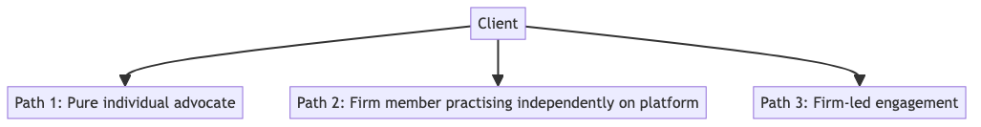
Figure 1 — Overview: three client entry paths

Figure 2 — Path 1: pure individual advocate

Figure 3 — Path 2: firm member, independent client relationship on platform

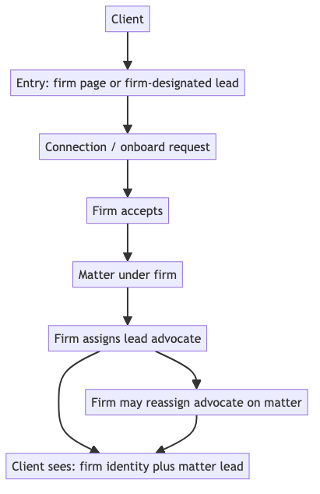
Figure 4 — Path 3: firm-led assignment and reassignment

6. Open design follow-ups (optional)
- Connection acceptance: whether Path 3 requests are accepted only by firm admin, only by matter lead, or by configurable firm policy.
- Migration: rules if a Path 2 client later moves under firm-led Path 3.
- Directory: whether firm-branded listings are required alongside advocate profiles.

