Schedule Management System
Architecture, Flows & Edge Cases — LexDesk Advocate CRM

April 2026 · Internal Design Document

1. The Core Model: Availability vs Appointments
Every scheduling system is built on two fundamentally different concepts that must never be confused:

Concept | Definition | Analogy
Availability | The advocate's potential time — when they could meet clients. | Hotel rooms open for booking.
Appointment | A confirmed booking occupying an availability slot. | A room that has been checked into by a guest.

The client never picks any random time — they only see what the advocate has explicitly made available. This keeps the advocate in full control of their calendar at all times.

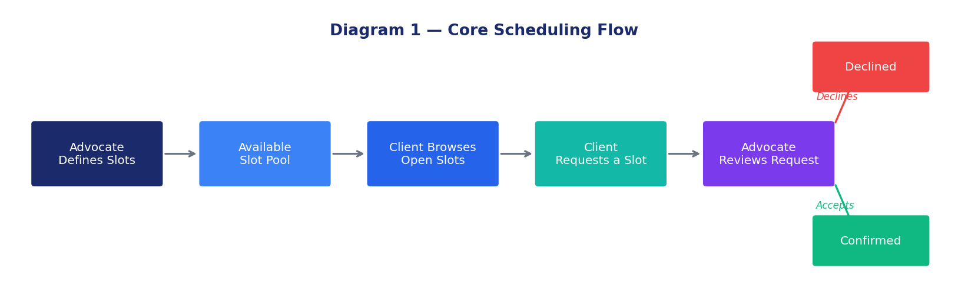
Diagram 1 — Core Scheduling Flow: from slot definition to confirmed appointment

2. How the Advocate Defines Their Availability
Availability is configured in four layers that stack on top of each other to produce the final set of bookable slots visible to the client:

- Layer 1 — Working Hours (Base): The advocate sets recurring weekly working hours per day. Example: Monday–Friday, 10:00 AM–1:00 PM and 3:00 PM–6:00 PM. These repeat every week automatically.
- Layer 2 — Exceptions & Blocked Dates: Specific dates or time ranges that override the base schedule. Examples: court hearing dates, public holidays, personal leave, travel days.
- Layer 3 — Slot Duration: How long each appointment slot should be. Common values: 30 minutes, 60 minutes, 90 minutes. A 60-minute slot duration within a 3-hour window produces 3 bookable slots.
- Layer 4 — Buffer Time Between Slots: A mandatory gap inserted between consecutive appointments. Example: 15-minute buffer after each 60-minute appointment allows the advocate to travel between rooms, make notes, or prepare for the next client.

Example configuration:
Working hours: Mon–Fri, 10 AM–1 PM and 3 PM–6 PM
Slot duration: 60 minutes
Buffer between slots: 15 minutes
Blocked: April 10 (court hearing), April 15–16 (holiday)
Result: The system auto-generates 5 bookable slots per day (10:00, 11:15, 12:30, 15:00, 16:15), excluding blocked dates.

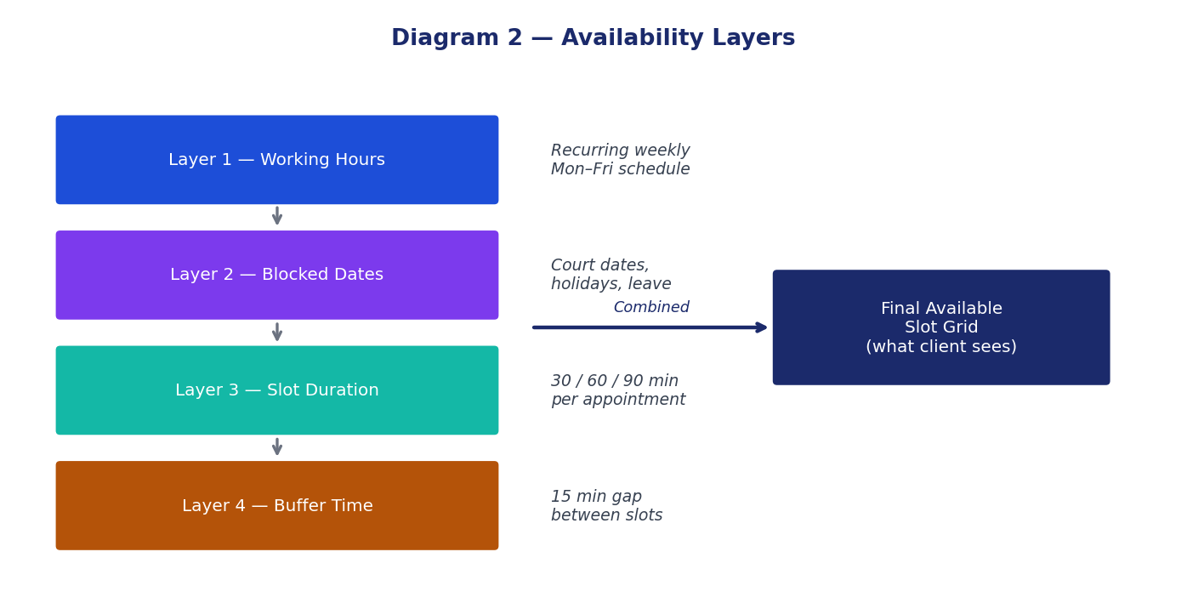
Diagram 2 — The four availability layers that combine to produce the final slot grid

3. The Full Appointment Lifecycle
Every appointment passes through a defined set of states. Understanding these states and the transitions between them is the core of any scheduling system.

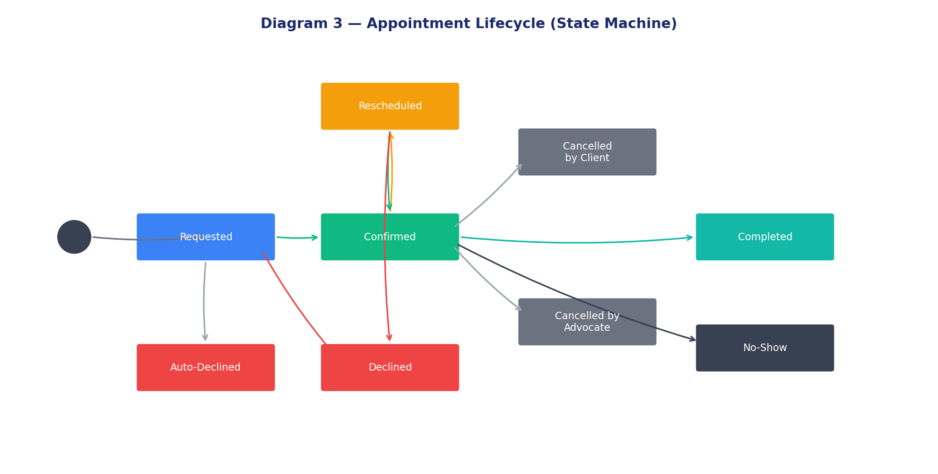
Diagram 3 — Appointment Lifecycle: every possible state and transition

State | Description
Requested | Client or advocate initiates an appointment. The slot is immediately locked to prevent double-booking.
Confirmed | The advocate accepts the request. Both parties are notified.
Declined | The advocate rejects the request. The slot is released. Client may request another slot.
Auto-Declined | No response from advocate within a configurable window (e.g., 24 hours). Client is notified.
Rescheduled | Either party proposes a new time. Existing appointment enters "pending reschedule" until the other party accepts.
Cancelled by Client | Client cancels a confirmed appointment. Slot is released. Late cancellations are flagged.
Cancelled by Advocate | Advocate cancels. Client is notified immediately and given priority to rebook.
Completed | The appointment time passes and it is marked complete, automatically or manually.
No-Show | Time passes and neither party attended. Tracked on the client profile.

4. How Clients Discover Availability
In a legal CRM, clients do not access a public calendar like Calendly. There are three possible booking models, each with different levels of control:

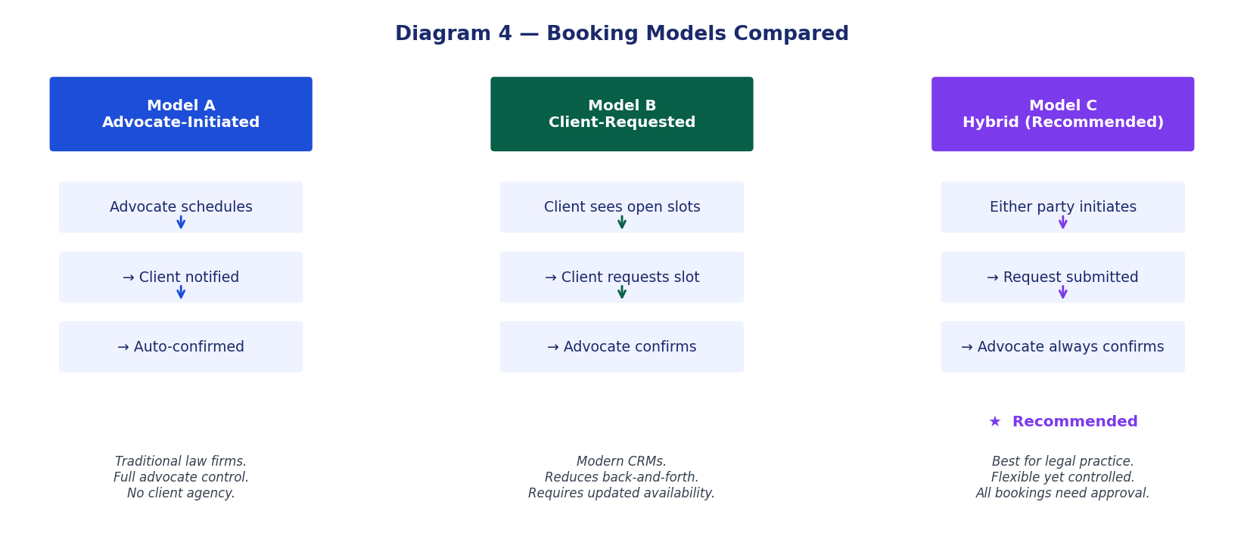
Diagram 4 — Three booking models compared; Hybrid is recommended for legal CRMs

Model | How it Works | Advantage | Drawback
Advocate-Initiated | Advocate schedules directly; client receives notification. | Full advocate control. | Client has no agency.
Client-Requested | Client browses open slots and sends a request; advocate confirms. | Reduces back-and-forth. | Requires advocate to keep availability updated.
Hybrid (Recommended) | Both parties can initiate; all bookings need advocate confirmation. | Flexible yet controlled. Best for legal practice. | Slightly more complex to build.

5. All Edge Cases — Explained
The following are every edge case that a scheduling system must handle. Ignoring even one can lead to double-bookings, confused clients, or advocate schedule conflicts.

A. Double-Booking
Scenario: Two clients simultaneously request the same slot.
Resolution: Slots must be locked the moment a request is submitted (like an e-commerce cart hold). The slot is released only if the request is declined or auto-expires. The second client who tries to book the same slot should see it as "Pending — already requested".
Implementation Note: Use a reservation lock with a timeout (e.g., hold for 10 minutes while the client fills the form). This is the most critical race condition to handle correctly.

B. Court Hearing Added After Slots Are Published
Scenario: A slot is already confirmed with a client, but the advocate then learns about a court hearing at the same time.
Resolution: The advocate must force-cancel the appointment with a mandatory reason and notification. The client must be given priority to rebook the next available slot.
Implementation Note: Blocked dates added after confirmation trigger a conflict resolution flow, not a silent deletion.

C. Advocate-Initiated Reschedule
Scenario: Advocate needs to move a confirmed appointment to a different time.
Resolution: 1. Advocate proposes a new time from available slots.
2. Client receives a notification: "Your appointment has been moved. Accept or Decline?"
3. If client declines, the appointment returns to Requested state.
4. If no response within X hours (configurable), the reschedule is auto-accepted.
Implementation Note: Both old and new times must be shown in the notification for clarity.

D. Client-Initiated Reschedule
Scenario: Client cannot make it to a confirmed appointment.
Resolution: 1. Client cancels their confirmed appointment.
2. The slot is released back to the available pool.
3. Client sees available slots and submits a new request.
4. Advocate confirms the new request.
Implementation Note: Cancellations within the late-cancellation window should be flagged on the client profile.

E. Late Cancellation
Scenario: Client or advocate cancels within a short window before the appointment (e.g., 2 hours prior).
Resolution: The system flags the cancellation as "Late". The slot reopens but is tagged. No financial penalty in the MVP, but it is tracked on the client profile for the advocate to review.
Implementation Note: Define a configurable "late cancellation threshold" (default: 24 hours) in Settings.

F. No-Show
Scenario: Appointment time passes and one or both parties do not attend.
Resolution: After the appointment end time passes, the status auto-transitions to Completed. The advocate can manually change it to No-Show. No-shows are tracked on the client profile.
Implementation Note: Do not auto-delete appointments — always retain history for audit purposes.

G. Same Client, Multiple Cases, Same Day
Scenario: A client requests two appointments for two different cases on the same day at different times.
Resolution: This is valid and must be allowed. Each appointment is linked to a specific case. The only constraint is that no two appointments overlap for the same advocate.
Implementation Note: Show clear case labels on all appointment cards so the client knows which is for which case.

H. Advocate on Leave — Client Needs Urgent Meeting
Scenario: The assigned advocate is on leave but the client has an urgent matter.
Resolution: A cover advocate can be designated by the admin. The client can then book with the cover advocate. For the MVP, the admin manually reassigns the appointment.
Implementation Note: Add a "delegation" or "cover advocate" field to the advocate leave entry.

I. Reminder Timing
Scenario: When and how many reminders should be sent?
Resolution: 24 hours before: reminder to both client and advocate.
1 hour before: final reminder.
If advocate has not confirmed 2 hours before: escalation alert to admin.
Implementation Note: All reminder timings should be configurable in Settings.

J. Time Zone Differences
Scenario: Advocate in Chennai, corporate client operates across multiple cities.
Resolution: All times stored in UTC internally. Displayed in IST for all users since this is an India-focused legal CRM. The timezone (IST) should appear on every appointment card.
Implementation Note: For future international expansion: store timezone with each user profile.

K. No Availability Published Yet
Scenario: Client tries to request an appointment, but the advocate has not set up availability.
Resolution: Client sees: "Your advocate has not set their availability yet. Please reach out via chat to schedule a meeting." The Request button is disabled.
Implementation Note: Advocate should receive an onboarding prompt to set up availability on first login.

L. Buffer Overflow — Running Over Time
Scenario: An appointment runs 20 minutes over its scheduled end time.
Resolution: The buffer time absorbs this. A 60-minute appointment at 10:00 AM with a 15-minute buffer means the next bookable slot is 11:15 AM, not 11:00 AM. This is calculated automatically.
Implementation Note: Encourage advocates to set realistic buffer times based on their typical meeting length.

M. Two Clients Request the Same Slot Simultaneously
Scenario: Two different clients request the same slot within seconds of each other.
Resolution: First-come-first-served with an instant reservation lock. The second client sees: "This slot is currently held by another request. Please choose another time."
Implementation Note: This is a backend concern — never handle race conditions on the UI alone.

N. Appointment Request for a Past Time
Scenario: A client or the system submits a request for a time that has already passed.
Resolution: The system validates that all appointment times must be strictly in the future (with a minimum lead time, e.g., at least 2 hours from now). Past requests are rejected.
Implementation Note: Add this as a backend validation rule — never rely on UI-side date pickers alone.

6. What Needs to Be Built — Feature Summary
Based on all the above, a complete scheduling system for LexDesk requires the following components:

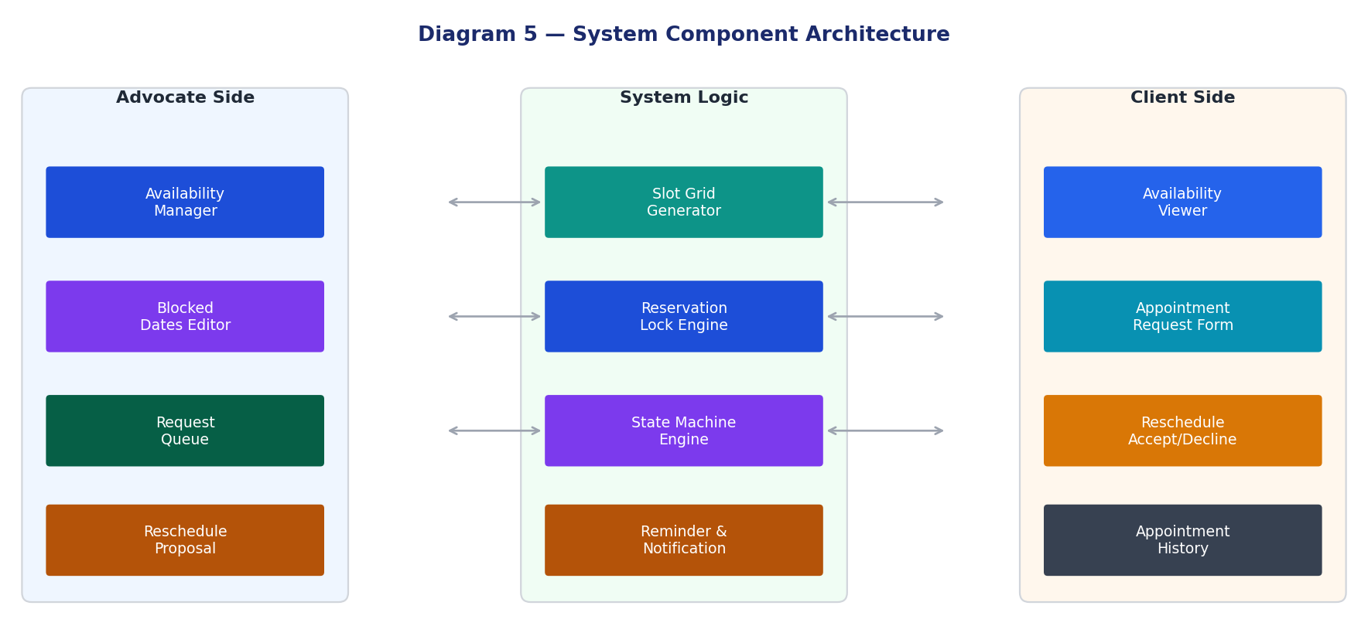
Diagram 5 — System component architecture split by Advocate Side, System Logic, and Client Side

Feature | Owner | Description
Availability Manager | Advocate | Set weekly recurring hours per day. Block specific dates or ranges. Configure slot duration and buffer time.
Slot Grid Generator | System | Auto-generate available slots from working hours minus blocked dates minus buffer. Refresh in real time as slots are booked or released.
Reservation Locking | System | Lock a slot the moment a request is submitted. Release on decline or timeout. Prevent race conditions.
Request Queue | Advocate | All pending appointment requests in one place. Accept, Decline, or Propose New Time.
Rescheduling Flow | Both | Advocate proposes new time → client notified → accepts or declines. Client cancels → picks new slot → advocate re-confirms.
Reminders & Notifications | System | 24-hour and 1-hour reminders for both parties. Late cancellation flagging. Escalation if advocate does not confirm.
Appointment History | Both | Full state history for every appointment. No-show and late cancellation tracking on client profile.
Client Availability View | Client | Client sees available slots for their assigned advocate only. Cannot see other clients or the reason for blocked dates.
Cover / Delegation | Admin | Admin assigns a cover advocate during leave. Appointments can be transferred.
Settings | Admin | Configurable: slot duration, buffer time, late-cancellation threshold, reminder timing, auto-decline timeout.

7. Recommended Implementation Approach for LexDesk
Given that this is a hybrid-initiated, advocate-controlled system suited to legal practice, the recommended implementation order is:

Phase | Name | Description
Phase 1 | Availability Setup | Advocate sets weekly hours, slot duration, buffer, and blocked dates.
Phase 2 | Slot Grid | System generates and displays available slots internally on the advocate dashboard.
Phase 3 | Request Flow | Client mobile app shows available slots. Client submits a booking request.
Phase 4 | Request Queue | Advocate web CRM shows pending requests. Advocate can Accept / Decline / Propose New Time.
Phase 5 | Rescheduling | Full reschedule flow for both advocate-initiated and client-initiated changes.
Phase 6 | Reminders | Automated 24-hour and 1-hour notifications to both parties.
Phase 7 | History & Audit | Complete appointment history, no-show tracking, late cancellation flags.
Phase 8 | Cover Advocate/Delegation | Admin can transfer appointments during advocate leave.

Key Principle: The advocate is always in control. Clients can request but never confirm their own appointments. Every booking requires explicit advocate acceptance. This is non-negotiable for a legal practice where confidentiality, time management, and professionalism are paramount.

