CIA-1

________________________________________________________

727721euit120

Purushothaman S

1.

CODEING:

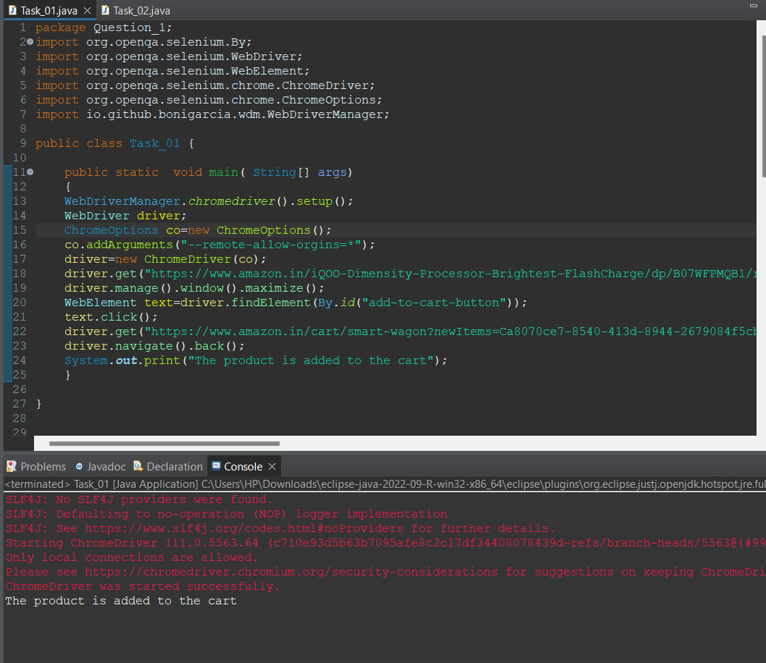

package Question_1;

import org.openqa.selenium.By;

import org.openqa.selenium.WebDriver;

import org.openqa.selenium.WebElement;

import org.openqa.selenium.chrome.ChromeDriver;

import org.openqa.selenium.chrome.ChromeOptions;

import io.github.bonigarcia.wdm.WebDriverManager;

public class Task_01 {

public static void main( String[] args)

{

WebDriverManager.*chromedriver*().setup();

WebDriver driver;

ChromeOptions co=new ChromeOptions();

co.addArguments("--remote-allow-orgins=*");

driver=new ChromeDriver(co);

driver.get("https://www.amazon.in/iQOO-Dimensity-Processor-Brightest-FlashCharge/dp/B07WFPMQB1/ref=sr_1_2?crid=3632HOPP93RLY&keywords=vivo%2Bv27%2Bpro%2B5g&qid=1681288375&sprefix=vivo%2Caps%2C769&sr=8-2&th=1");

driver.manage().window().maximize();

WebElement text=driver.findElement(By.*id*("add-to-cart-button"));

text.click();

driver.get("https://www.amazon.in/cart/smart-wagon?newItems=Ca8070ce7-8540-413d-8944-2679084f5cb3,1");

driver.navigate().back();

System.***out***.print("The product is added to the cart");

}

}

}

OUTPUT:

}

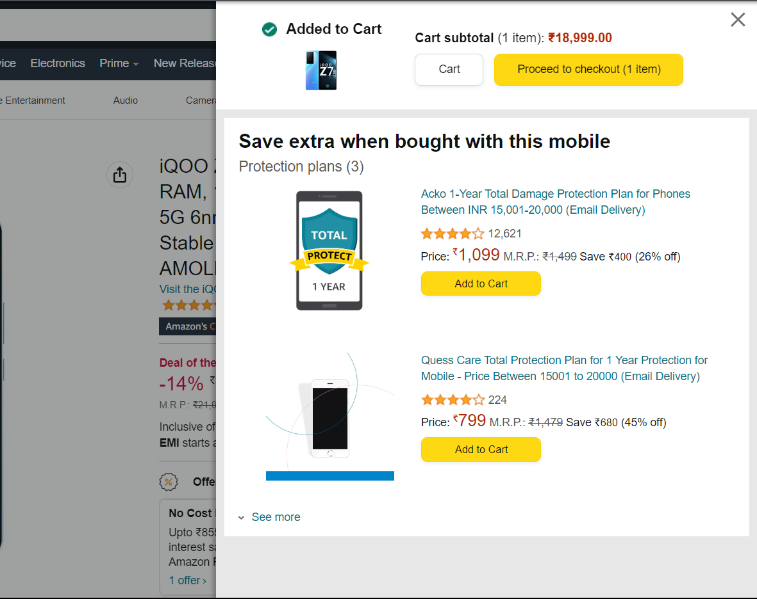

2.

_________________________________________________

CODEING:

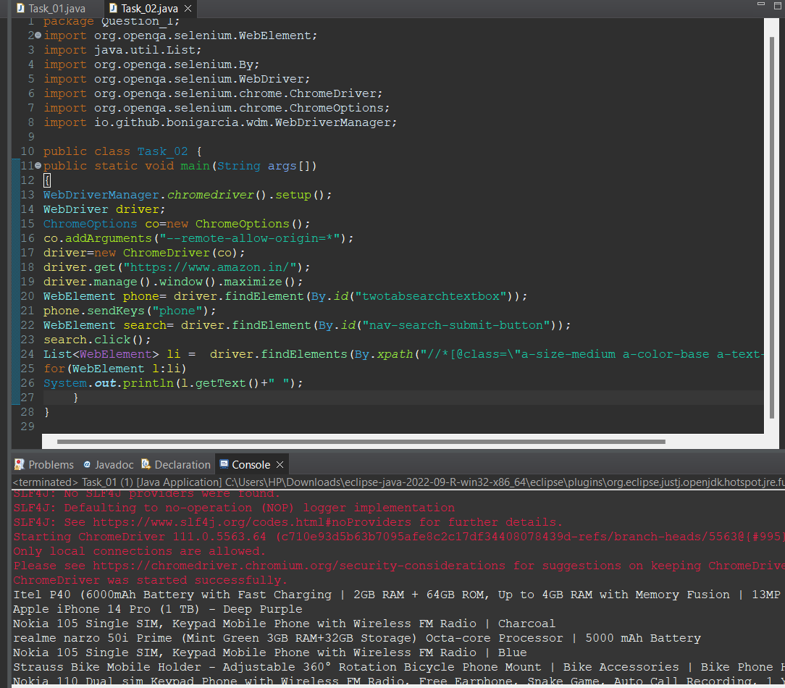

}

package Question_1;

import org.openqa.selenium.WebElement;

import java.util.List;

import org.openqa.selenium.By;

import org.openqa.selenium.WebDriver;

import org.openqa.selenium.chrome.ChromeDriver;

import org.openqa.selenium.chrome.ChromeOptions;

import io.github.bonigarcia.wdm.WebDriverManager;

public class Task_02 {

public static void main(String args[])

{

WebDriverManager.*chromedriver*().setup();

WebDriver driver;

ChromeOptions co=new ChromeOptions();

co.addArguments("--remote-allow-origin=*");

driver=new ChromeDriver(co);

driver.get("https://www.amazon.in/");

driver.manage().window().maximize();

WebElement phone= driver.findElement(By.*id*("twotabsearchtextbox"));

phone.sendKeys("phone");

WebElement search= driver.findElement(By.*id*("nav-search-submit-button"));

search.click();

List<WebElement> li = driver.findElements(By.*xpath*("//*[@class=\"a-size-medium a-color-base a-text-normal\"]"));

for(WebElement l:li)

System.***out***.println(l.getText()+" ");

}

}

Output:

