Name :- Purushottam Kumar

Roll - 2020178043

ID :- 2041

MCA I-Sem (Regular)

**Python LAB**

**26th-March-2021**

**Q-1. Write a python program to accept a string, count the number of vowels and consonants in the string and print the results.**

**1st End Semester Exam**

**PROGRAM**

vowel_count = 0;

const_count = 0;

String=input("Enter a string : ")

for i in range(len(String)):

# Checking whether a character is a vowel

if String[i] in ('a','e','i','o','u','A','E','I','O','U'):

vowel_count += 1;

elif ((String[i] >= 'a' and String[i] <= 'z')or(String[i] >= 'A' and String[i] <= 'Z')):

const_count += 1;

print("\nTotal number of Vowels : ",vowel_count)

print("\nTotal number of Consonents : ",const_count)



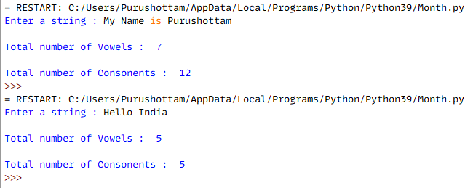

**Q-2. Write a python program that prompts the user to enter a number between 1 to 7, based on the input given display the corresponding day of the week.**

Week={1:"Sunday",2:"Monday",3:"Tuesday",4:"Wednesday",5:"Thursday",6:"Friday",7:"Saturday"}

def returnDay(N):

if (N>=1 and N<=7):

print("Day No-",N," = ",Week[N])

else:

print("\nInvalid Input ! Enter A Number Between 1 and 7")

N=int(input("\nEnter A Number Between 1 and 7 : "))

returnDay(N)

N=int(input("\nEnter A Number Between 1 and 7 : "))

returnDay(N)



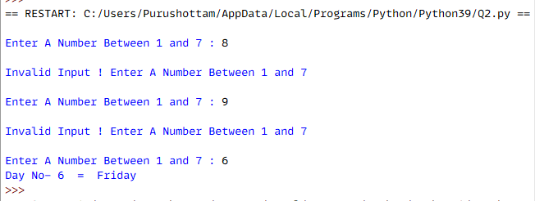

**Q-3. Imagine a Write a python program that uses functions to do the following :**

1. **Display the following menu**
2. Armstrong,
3. Palindrome,
4. Odd or even
5. Fibonacci and get the choice from the user
6. **Call the relevant function, receive the necessary input and display the output.**

# Armstrong Number...

**def Check_Armstrong(N):**

Total = 0

A = N

while A>0:

Rem = A % 10

Total += Rem ** 3

A //= 10

if N == Total:

print(N," is an Armstrong number.")

else:

print(N," is not an Armstrong number.")

# Palindrome..

**def Check_Palindrome(N):**

Total=0

Temp=N

while Temp>0:

Rem=Temp % 10

Total = Total*10+Rem

Temp//= 10

if(N==Total):

print(N," is a Palindrome Number.")

else:

print(N," is not a Palindrome Number.")

# Odd Even .....

**def Check_Odd_Even(Num):**

if(Num>0):

if Num % 2 == 0:

print(Num," is an even number")

else:

print(Num," is an odd number")

else:

print("\n You have entered Negative number !!\n")

# Fibonacci Series .....

**def fib(Num):**

if Num <= 1:

return Num

else:

return(fib(Num-1) + fib(Num-2))

**def Find_Fibonacci(Num):**

if Num > 0:

print("Fibonacci Series is : ",end='')

for i in range(Num):

print(fib(i), end=' ')

else:

print("Enter positive integer only.")

# Menu Driven Program Starts from Here....

while(True):

print("\n1.Check Armstrong \n2.Check Palindrome \n3.Check Odd/Even \n4.Fibonacci \n5.Exit")

Choice=int(input("Enter Your Choice : "))

if(Choice==1):

Num = int(input("\nEnter a positive Integer : "))

Check_Armstrong(Num)

elif(Choice==2):

Num = int(input("\nEnter a positive Integer : "))

Check_Palindrome(Num)

elif(Choice==3):

Num = int(input("\nEnter a positive Integer : "))

Check_Odd_Even(Num)

elif(Choice==4):

Num = int(input("\nEnter a positive Integer : "))

Find_Fibonacci(Num)

elif(Choice==5):

break

else:

print("\nInvalid Input ! Inter Valid Input \n")



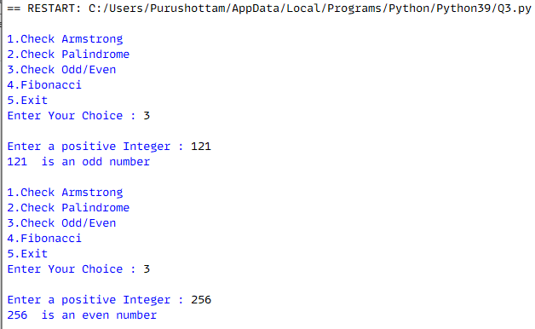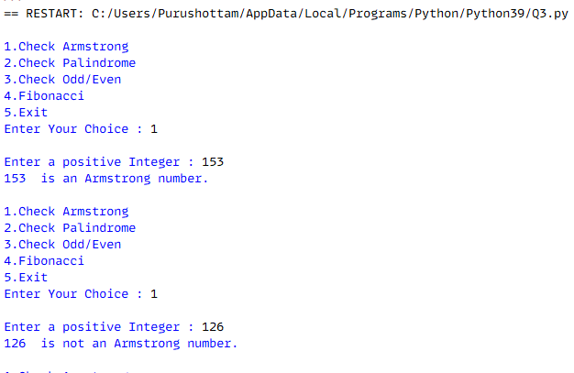

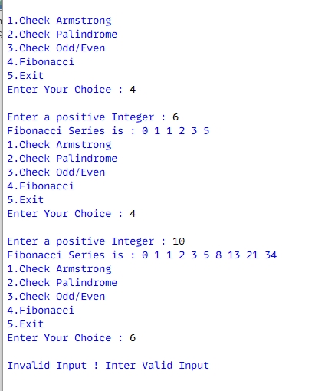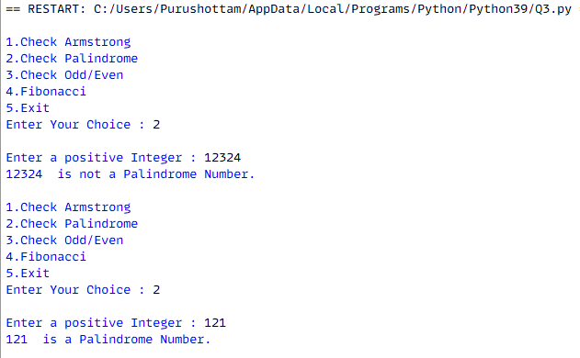

**Q-5.** Create a dictionary for student records and perform the following operations on the dictionary :

a) Add an item b) Modify an item c) Access an item

d) Delete an item e) Sort the item

S_record={"Purushottam":16,"Mukesh":17,"Rohan": 19,"Suresh":20}

def add():

key=input("Enter Student Name : ")

value=int(input("Enter the mark: "))

S_record[key]=value

print("The record added successfully..")

def update():

key=input("Enter the student name : ")

value=int(input("Enter the mark: "))

if key in S_record:

S_record[key]=value

print("The record updated successfully..")

else:

print("Name Not Found")

def access():

key=input("Enter Student Name : ")

print("Mark of the student : ",key," = ",S_record[key])

def removeitem():

key=input("Enter the student name : ")

if key in S_record.keys():

S_record.pop(key)

print(key , " is removed successfully")

else:

print("there is no student in record with the name ",key)

def sort():

temp=sorted(S_record.items())

S_record.clear()

S_record.update(temp)

def Main_Call():

print("Currently in the record: ",S_record)

choice=int(input("1) Add an item\n2) Modify an item\n3) Access an item\n4) Delete an item\n5) Sort the item\n other number to exit\nEnter your choice: "))

if choice==1:

add()

Main_Call()

elif choice==2:

update()

Main_Call()

elif choice==3:

access()

Main_Call()

elif choice==4:

removeitem()

Main_Call()

elif choice==5:

sort()

Main_Call()

else:

print("Exiting program: ")

Main_Call()

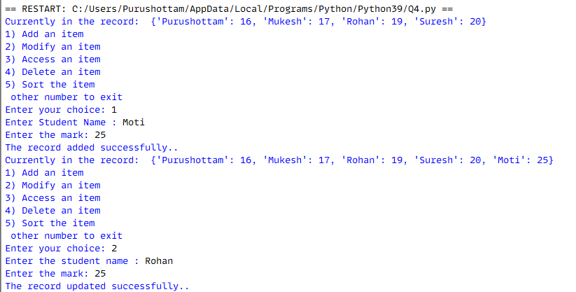**OUTPUT**

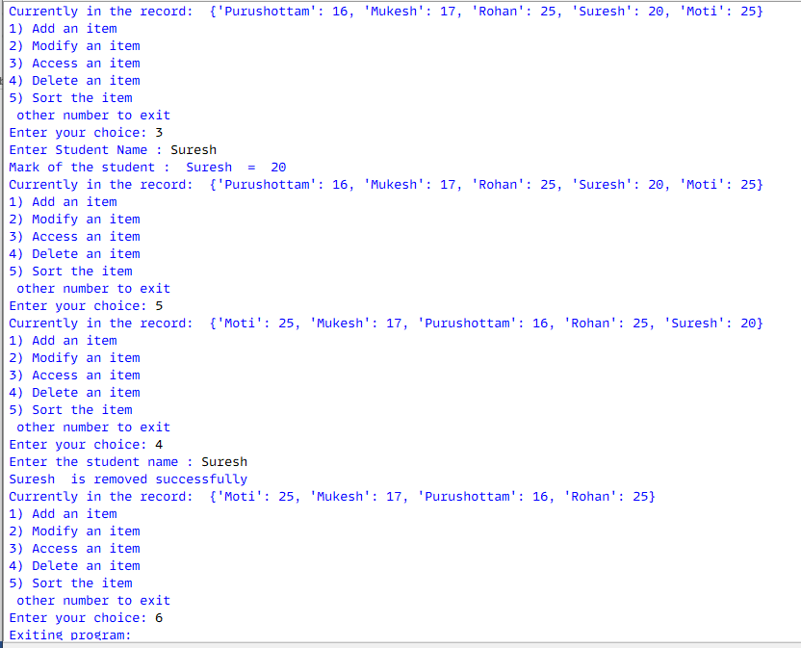

Q.4. Write a python program that does the following:(i) Create afile for “reading and appendingmode”(ii) Prompts the user to enter a string.(iii) Get analphabet/digit/symbol from the user and countsthe number of times that alphabet/digit/symbolappears in the file.

file = open("Question.txt", "a+")

line = input("Enter the string : ")

file.write(line)

file.flush()

file.seek(0)

read_c = file.read()

print (read_c)

file.close()

alphabets = digits = special = 0

for i in range(len(read_c)):

if (read_c[i].isalpha()):

alphabets += 1

elif (read_c[i].isdigit()):

digits += 1

else:

special += 1

print("\nTotal Number of Alphabets: : ", alphabets)

print("Total Number of Digits : ", digits)

print("Total Number of Special Characters: ", special)

**OUTPUT**

