Unit 3

**Associative Learning in Neural Networks**

**Definition:**  
Associative learning, in the context of neural networks, refers to the ability of a network to form connections between input and output patterns. This process mimics how biological neurons associate stimuli and responses. Neural networks learn these associations through training, where the weights between neurons are adjusted to strengthen the mapping between specific inputs and desired outputs.

**Biological Inspiration:**  
Inspired by Hebbian Learning, often summarized as:  
“Neurons that fire together, wire together.”  
When two neurons are activated simultaneously, the connection (synapse) between them becomes stronger, forming an association.

**Types of Associative Learning in Neural Networks:**

1. **Supervised Learning (Input-Output Association):**  
   The network learns to map inputs (features) to outputs (labels).  
   Commonly used in feedforward neural networks.  
   Example: A neural network learns to associate images of digits with their respective labels (0–9) using training data.
2. **Autoassociative Networks:**  
   Learns to recall entire patterns from partial or noisy inputs.  
   Example: Autoencoders – compress and reconstruct data, forming internal representations (associations).  
   Useful for denoising, compression, and anomaly detection.
3. **Heteroassociative Networks:**  
   Associates one set of patterns with another set.  
   Example: Hopfield Networks, Bidirectional Associative Memory (BAM).  
   Can retrieve an output pattern from a different but associated input pattern.

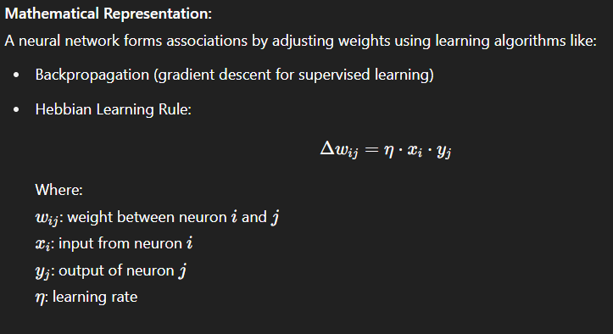

**Applications:**

* Pattern Recognition: Associating images with labels (image classification)
* Natural Language Processing (NLP): Word embeddings learn associations between words
* Recommendation Systems: Associating users with items they prefer
* Memory Simulation: Using Hopfield networks to simulate associative recall

**Example:**  
In a feedforward neural network trained on animal images:  
Input: Pixel values of an image of a cat  
Output: Label "Cat"  
The network learns to associate this pixel pattern with the label "Cat" by adjusting weights during training.

**Hopfield Network – In Depth**

A **Hopfield Network** is a type of **recurrent neural network** used for **associative memory**. Introduced by John Hopfield in 1982, it is capable of storing patterns and retrieving them when given incomplete or noisy input. It is mostly used in pattern recognition, optimization, and memory-related applications.

**2. Structure:**

* Composed of **binary neurons** with values +1 (active) or -1 (inactive).
* **Fully connected**: Each neuron is connected to every other neuron.
* **Symmetric weights**: The connection from neuron A to B is equal to B to A.
* No neuron is connected to itself (i.e., no self-loops).

**3. Pattern Storage (Learning Rule):**  
The network stores patterns using **Hebbian learning**, where the weights between neurons are calculated based on the training patterns.

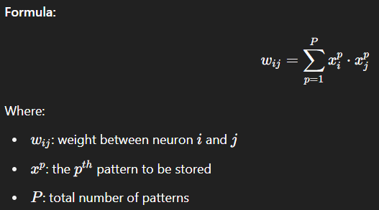

This rule strengthens connections between neurons that are active together.

**4. Pattern Recall (Working Mechanism):**  
When a noisy or partial input is given, the network updates each neuron one by one using input from other neurons. This process continues until the pattern becomes stable — this final pattern is the recalled memory.

**Update rule:**

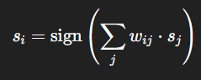

This means a neuron checks the signals from all other neurons and changes its state if needed.

**5. Energy Function (Stability Concept):**  
The Hopfield Network uses an **energy function** that always decreases with each update, ensuring the network reaches a stable state (like a ball rolling downhill).

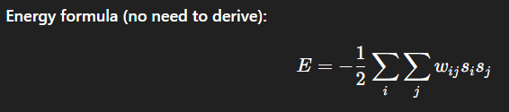

Lower energy means more stability, and the network stops updating when the energy is at its minimum.

**6. Applications:**

* **Pattern recognition** (e.g., recognizing characters even when partly erased)
* **Noise removal**
* **Associative memory** (like remembering a face from partial features)
* **Solving simple optimization problems**

**7. Advantages:**

* Can complete incomplete or distorted inputs.
* Converges to a stable state.
* Simple architecture and learning method.

**8. Limitations:**

* Can store only a limited number of patterns.
* Sometimes retrieves incorrect or mixed-up patterns (called spurious states).
* Works only with binary data (+1/-1).
* Not designed for sequential or time-series data.

### ****State Transition Diagram for Hopfield Neural Network****

A **State Transition Diagram** in the context of a **Hopfield Neural Network (HNN)** is a **graphical representation** that shows how the network moves (transitions) from one state (neuron activation pattern) to another during the process of updating neuron states, ultimately leading to a stable state (local energy minimum).

### ****What is a State in Hopfield Network?****

* A **state** is a combination of neuron activations.
* If there are nnn neurons, each taking values −1 or +1, there are 2^n possible states.
* Example for n=2:  
  States = {(+1, +1), (+1, -1), (-1, +1), (-1, -1)}

### ****What is a State Transition Diagram?****

* A **directed graph** where:
  + Each **node** represents a possible state of the network.
  + An **arrow** (edge) from state A to state B indicates that the network transitions from A to B after one asynchronous update.
  + **Stable states** (attractors) have no outgoing arrows.

### ****How to Derive the State Transition Diagram in Hopfield Model****

#### **Step 1: Define the Number of Neurons**

Let the network have n neurons → There will be 2^n possible states.

#### **Step 2: Compute Weight Matrix**

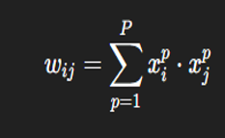

#### **Step 3: List All Possible States**

List all possible combinations of −1-1−1 and +1+1+1 for n neurons.

#### **Step 4: Apply the Update Rule**



#### **Step 5: Determine Transitions**

For each state:

* Apply the update rule to find the next state.
* Record which state transitions to which.

#### **Step 6: Draw the Diagram**

* Each state is a **node**.
* Draw **arrows** showing transitions.
* **Stable states** (no further transition) are shown with **loops or double circles**.

**Error Performance in Hopfield Networks**

Error performance in a Hopfield Network refers to its ability to correctly recall stored patterns and the likelihood of producing incorrect or unstable outputs. Since Hopfield Networks are used for associative memory, evaluating how often the network **fails to recall the correct pattern** or **converges to the wrong state** is essential for measuring its effectiveness.

**2. Factors Affecting Error Performance:**

* **Pattern Overlap:**  
  If the stored patterns are too similar to each other, the network may confuse them and converge to the wrong one.
* **Storage Capacity:**  
  A Hopfield Network can store approximately **0.15 × N** patterns reliably, where **N** is the number of neurons. Exceeding this limit increases the chance of errors.
* **Spurious States:**  
  These are false stable states that were not part of the original training patterns. The network might mistakenly settle into one of these, causing recall errors.
* **Noise in Input:**  
  If the input is too corrupted or incomplete, the network might not recover the correct pattern.

**3. Types of Errors:**

* **Recall Error:**  
  The network converges to a wrong stored pattern instead of the correct one.
* **Spurious Convergence:**  
  The network stabilizes on a pattern that was never trained (a spurious state).
* **Non-convergence:**  
  The network keeps changing without settling into any stable pattern (very rare due to energy minimization).

**4. Error Rate and Performance:**

* The error rate **increases** as more patterns are stored.
* For reliable performance, the number of stored patterns should be **well below the network’s capacity**.
* If **P** is the number of stored patterns and **N** is the number of neurons, then reliable storage is when:

P<0.15×NP < 0.15 \times NP<0.15×N

Beyond this, the **probability of error rises sharply**.

**5. Example:**  
If a Hopfield Network has 100 neurons, it can reliably store about 15 patterns. If 30 patterns are stored, the error rate will likely be high due to interference and overlap.

**6. Ways to Reduce Errors:**

* Store **fewer patterns** than the maximum capacity.
* Ensure stored patterns are **dissimilar** (orthogonal if possible).
* Use **asynchronous updates** (one neuron at a time), which reduce instability.
* Add **noise filtering** or preprocessing to input patterns.

**Simulated Annealing**

**Simulated Annealing (SA)** is a **probabilistic optimization algorithm** inspired by the physical process of annealing in metallurgy. In this process, a material is heated and then slowly cooled to remove defects, allowing atoms to settle into a low-energy, stable state. In computer science, SA mimics this by searching for a **global optimum** in a large solution space.

**2. Why Use Simulated Annealing?**  
In many complex problems, especially those with many local optima (like scheduling, routing, or assignment problems), traditional methods can get stuck in **local minima**. SA helps avoid this by allowing occasional “bad” moves, enabling the algorithm to explore a broader solution space.

**3. Basic Working of Simulated Annealing:**

* **Start** with an initial solution.
* **Evaluate** the cost (or energy) of the current solution.
* **Generate a new neighboring solution** by making a small change.
* **Calculate the change in cost (ΔE):**
  + If the new solution is better (ΔE < 0), accept it.
  + If it's worse (ΔE > 0), accept it **with a probability** based on a temperature parameter:

P=e−ΔE/T

* **Gradually reduce the temperature (T)** over time.
* Repeat the process until the system “freezes” (temperature is low and no changes occur).

**4. Key Components:**

* **Solution space**: All possible answers to the problem.
* **Energy or cost function**: Measures how good or bad a solution is.
* **Temperature (T)**: Controls the probability of accepting worse solutions. Higher temperature = more exploration.
* **Cooling schedule**: A rule for reducing temperature, such as:

T=T0×αk where T0​ is the initial temperature, α is the cooling rate (0 < α < 1), and k is the iteration number.

**5. Advantages:**

* Can escape local minima to find a global minimum.
* Simple and flexible.
* Works well on large, complex search spaces.

**6. Limitations:**

* Slower than some modern optimization techniques.
* Requires careful tuning of parameters (initial temperature, cooling rate, etc.).
* No guarantee of finding the exact global minimum, though it's often close.

**7. Applications:**

* **Traveling Salesman Problem (TSP)** &**Job scheduling**
* **VLSI design layout**
* **Neural network training**
* **Image processing**

**8. Example (Conceptual):**  
Imagine finding the shortest route to visit multiple cities (TSP). SA starts with a random path, then gradually modifies the order of cities. Even if a new path is longer, it may still be accepted if the temperature is high — allowing it to escape poor local paths and discover a better one later.

**Stochastic Network – In Depth**

A **Stochastic Network** is a type of neural network where randomness (or probability) is involved in how the network behaves. Unlike traditional deterministic neural networks, which produce the same output for a given input, stochastic networks can produce **different outputs** due to **random variables or probabilistic functions** within their structure.

They are widely used in modeling **uncertainty**, **learning probabilities**, and **sampling complex data distributions**.

**2. Meaning of “Stochastic”:**  
The word **stochastic** means **random or probabilistic**. In the context of neural networks, it means that the activation of neurons or weight updates may involve **random decisions**.

**3. Key Characteristics:**

* Neurons may be **activated based on probability**, not a fixed rule.
* The network’s output can **vary for the same input**, especially during training or sampling.
* Often used for **probabilistic inference** or **sampling-based optimization**.

**4. Types of Stochastic Networks:**

1. **Boltzmann Machines:**
   * A classic stochastic network with binary nodes and symmetric connections.
   * Uses a probabilistic learning rule.
   * Can learn hidden patterns from data.
2. **Restricted Boltzmann Machines (RBM):**
   * A simplified version with visible and hidden layers.
   * Often used in deep learning as building blocks for Deep Belief Networks (DBNs).
3. **Stochastic Neural Networks:**
   * General term for neural nets where units have random behavior.
   * May use **dropout** or **random noise** during training for regularization.
4. **Bayesian Neural Networks:**
   * Use probability distributions instead of fixed weights.
   * Provide a measure of **confidence or uncertainty** in predictions.

**5. Applications:**

**Probabilistic reasoning**, **Generative models, Dimensionality reduction,** **Recommendation systems.**

**6. Advantages:**

* Can **model uncertainty** and noise effectively.
* Useful for **generating** new data samples.
* Better generalization in some tasks due to randomness.

**7. Limitations:**

* Training is **computationally intensive**, especially for large networks.
* May require **sampling methods** like Gibbs Sampling or Contrastive Divergence.
* Harder to interpret and debug compared to deterministic networks.

**Boltzmann Machine**

A **Boltzmann Machine (BM)** is a type of **stochastic recurrent neural network** introduced by Geoffrey Hinton and Terry Sejnowski in 1985. It is designed to model complex probability distributions over binary patterns and is widely used for associative memory, optimization, and feature extraction. The network’s name comes from the **Boltzmann distribution** in statistical mechanics, which governs the probability of the network states.

**2. Structure:**

* The network consists of **binary neurons** (units) that can take values 0 or 1 (or sometimes -1 and 1).
* Neurons are **fully interconnected** with **symmetric weights** wij = wji meaning the connection strength from neuron i to j is equal to that from j to i.
* There are two main types of neurons:
  + **Visible units**: Represent the input data or observed variables.
  + **Hidden units**: Capture the underlying dependencies or features not directly observed in the data.
* The network is **recurrent and bidirectional**, with no restrictions on connections, allowing rich dynamics.

**3. Working Principle:**

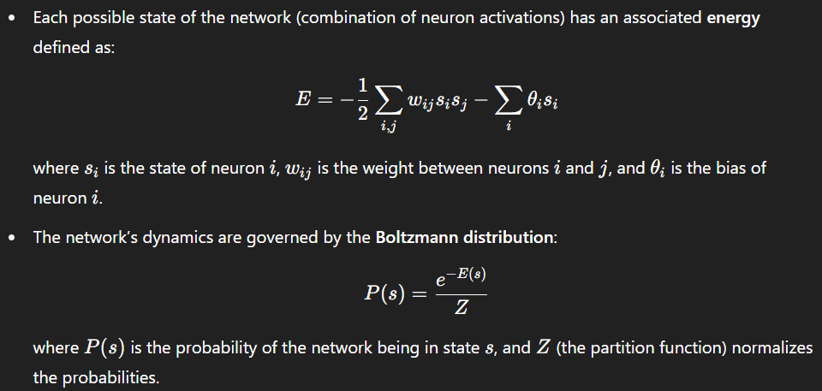

* Neurons update their states probabilistically based on their input, allowing the system to **explore the energy landscape**.
* The network tends to settle into **low-energy states**, which correspond to learned patterns or memories.

**4. Role of Temperature:**

* Inspired by physical annealing, a temperature parameter T controls the randomness in neuron activation:
  + At **high temperature**, neurons flip states more randomly, allowing exploration.
  + At **low temperature**, the network settles into stable states.
* Cooling the system slowly (simulated annealing) helps the network find **global minima** of the energy function.

**5. Applications:**

* **Associative memory:** Recall patterns from noisy or partial inputs.
* **Optimization:** Solve complex combinatorial problems by energy minimization.
* **Feature learning:** Extract hidden features from data distributions.
* **Pre-training layers** in deep learning models (e.g., using Restricted Boltzmann Machines).

**6. Limitations:**

* Training full Boltzmann Machines is **computationally expensive** due to recurrent connections and the need for extensive sampling.
* The presence of many hidden units makes exact computation of probabilities infeasible.
* Restricted Boltzmann Machines (RBMs) simplify the architecture for practical training.

**Boltzmann Learning**

**Boltzmann Learning** is the unsupervised learning algorithm designed to train Boltzmann Machines by adjusting the weights to make the model distribution approximate the data distribution. It aims to increase the probability of observed data patterns while decreasing the probability of others.

**2. Learning Objective:**  
The network learns by minimizing the difference between the **expected correlations** of neurons under the training data and under the model’s own distribution.

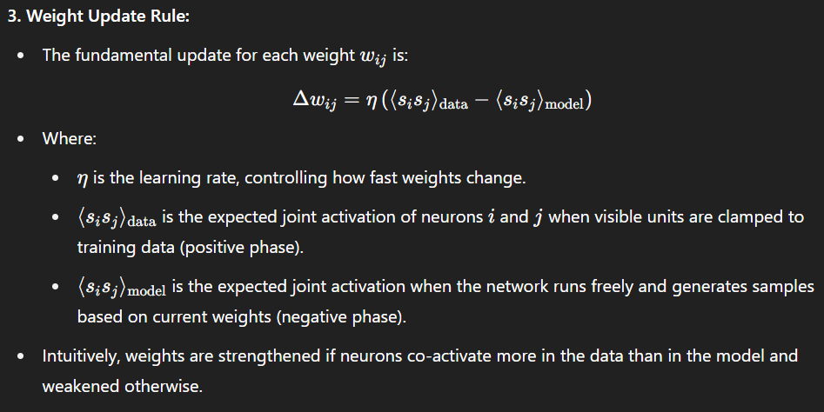 **4. Learning Process Steps:**

* **Positive phase:** Clamp visible units to data patterns, allow hidden units to update, measure correlations.
* **Negative phase:** Let the entire network run freely (no clamping), sample states, measure correlations.
* **Weight adjustment:** Use the difference in correlations to update weights.

**5. Challenges in Learning:**

* Computing the negative phase expectation is **expensive** because it requires sampling from the full joint distribution over all neurons.
* Training is slow due to the need for **many iterations** of sampling.

**6. Importance:**

* Boltzmann Learning allows the network to learn complex, multimodal distributions.
* It is a foundational method that inspired later developments in deep learning, including RBMs and Deep Belief Networks.

**Advantages of Boltzmann Machines**

* **Ability to Learn Complex Distributions:** BMs can model complex, multimodal probability distributions, making them powerful for unsupervised learning tasks.
* **Generative Model:** They can generate new samples similar to the training data, useful for tasks like image and speech synthesis.
* **Escape Local Minima:** Due to stochasticity and temperature-based exploration, BMs can escape local minima during training.
* **Flexibility:** Can be applied to a wide variety of problems, including optimization, classification, and feature learning.

**Limitations of Boltzmann Machines**

* **Computationally Expensive:** Training requires extensive sampling and running the network in both positive and negative phases, which is very slow for large networks.
* **Scaling Issues:** The fully connected structure leads to a large number of weights, making it impractical for large-scale problems.
* **Difficult to Train:** Weight updates rely on estimating expectations over the network’s distribution, which requires approximate methods like Gibbs sampling, making convergence slow.
* **Requires Careful Tuning:** The temperature schedule and learning rate must be carefully tuned for effective training.

**Architecture of Boltzmann Machine**

A **Boltzmann Machine (BM)** is a network of interconnected neurons arranged in a single layer or multiple layers, where every neuron is connected symmetrically to every other neuron except itself (i.e., no self-connections). The architecture can be described as follows:

1. **Units (Neurons):**
   * The network consists of binary neurons (also called units or nodes), each of which can be in one of two states: 0 or 1 (sometimes represented as -1 or +1).
   * Each neuron’s state is stochastic, meaning it is updated based on a probability that depends on the states of the neurons it connects to.
2. **Connectivity:**
   * The neurons are fully connected to each other via symmetric weights wij=wjiw
   * There are **no self-connections**, so wii=0 for all neurons.
   * This full connectivity means each neuron influences, and is influenced by, all others in the network.
3. **Visible and Hidden Units:**
   * In general, the neurons are divided into two sets:
     + **Visible units:** Represent observed data or inputs to the network.
     + **Hidden units:** Capture complex dependencies and features not directly observable in the data.
   * Both visible and hidden units interact through weighted connections.
4. **Symmetric Weights:**
   * The connection weights are symmetric, ensuring the network’s energy function is well-defined. This symmetry is important for the convergence properties of the network.
5. **Energy Function:**
   * The network associates an energy to every possible state configuration of the neurons:

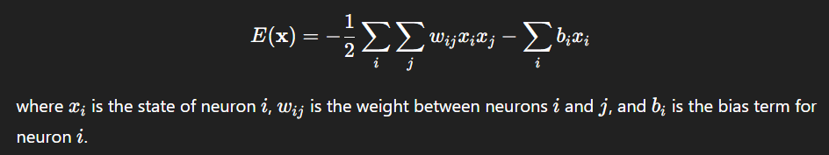

* + The network dynamics aim to reach states with minimum energy, which correspond to learned patterns.

1. **Stochastic Activation:**
   * Neurons update their states asynchronously using a probabilistic rule based on the weighted input sum and a temperature parameter.
   * This stochastic activation allows the network to explore multiple configurations, helping avoid local minima.

**State Transition Diagram**

A **State Transition Diagram** is a graphical representation of the dynamic behavior of a neural network, showing how the network moves from one state to another over time. Each **state** represents a particular pattern of activations of all neurons in the network.

* In networks like the **Hopfield network**, the network's state at any moment is a binary vector representing the activation (e.g., +1 or -1) of each neuron.
* The diagram consists of **nodes** and **directed edges**:
  + Each **node** corresponds to a possible network state (a specific activation pattern).
  + Each **edge** shows the transition from one state to the next after updating the neurons.
* The network starts in some initial state (often an input pattern) and updates neurons asynchronously or synchronously based on the activation rules.
* The network state changes at each step, moving through the state space along edges until it reaches a **stable state** (also called an attractor or fixed point), where no further changes occur.
* **Stable states** correspond to **memorized patterns** or stored memories.

**Importance:**

* The state transition diagram helps visualize how the network converges from any starting pattern to a stored memory.
* It shows the **energy landscape**, where transitions correspond to moves towards states with lower energy.

**False Minima Problem**

The **False Minima Problem** (also called **Spurious Minima** or **Local Minima Problem**) occurs when a neural network, such as a Hopfield network, converges to a stable state that is **not one of the desired stored patterns** but a **spurious or incorrect pattern**.

**Explanation:**

* In a Hopfield network, stored patterns correspond to **energy minima** in the energy landscape.
* However, because of the way weights are set and interactions between neurons, the network may develop **extra minima** in the energy function—these are not associated with any trained pattern.
* When the network state falls into such a false minimum, it will stay there indefinitely because it is a stable state, but it represents **incorrect or meaningless output**.

**Causes:**

* Storing too many patterns can lead to interference between them, increasing the number of false minima.
* Poorly chosen or highly correlated training patterns increase spurious states.

**Effects:**

* Degrades network performance by recalling wrong or meaningless patterns.
* Limits the capacity of the network to store patterns reliably.

**Ways to Mitigate:**

* Limit the number of stored patterns to below the network’s capacity (approximately 0.15 × number of neurons for Hopfield networks).
* Use learning rules that reduce spurious minima (e.g., pseudo-inverse method).
* Employ stochastic or probabilistic update methods (e.g., simulated annealing, Boltzmann machines) to escape local minima.

**Stochastic Update**

Stochastic update is a method where each neuron in a neural network updates its state based on probability rather than a fixed rule. Instead of always changing its state in a certain way, the neuron decides randomly whether to switch on or off, depending on the current inputs it receives.

**Why Use Stochastic Update?**

* **Avoid Local Minima:**  
  When neurons update deterministically, the network might get stuck in wrong stable states (called local minima). Stochastic updates help the network escape these by allowing occasional "random jumps" to different states.
* **Explore More States:**  
  Randomness lets the network explore a wider range of possible states, increasing the chance of finding the best overall solution.
* **Model Natural Noise:**  
  Biological neurons don’t always fire the same way every time; stochastic update mimics this natural randomness in brain function.

**How It Works**

* For each neuron, the network calculates how favorable it is for the neuron to be in a particular state based on other neurons’ signals.
* Instead of switching deterministically, the neuron switches state with a certain probability related to how favorable that state is.
* This means the neuron might sometimes switch even if it’s not the most “optimal” choice, allowing the system to avoid getting stuck.

**Applications**

* **Boltzmann Machines:**  
  Use stochastic updates to sample different states for learning complex patterns and probability distributions.
* **Simulated Annealing in Networks:**  
  Introduces controlled randomness to help networks gradually find better solutions by escaping false stable states.

**1. Pattern Association**

Pattern association is the process by which a neural network learns to link or associate an input pattern to a corresponding output pattern. This is useful when the goal is to recall a stored pattern from a noisy or incomplete input, or when associating one pattern with a related but different output pattern.

**Basic Functional Units and Working:**

* **Input Layer:**  
  The network receives an input vector representing the input pattern. This can be a binary, bipolar, or continuous-valued vector depending on the application.
* **Memory/Storage Mechanism:**  
  This is the core of the network where the associations between input-output pairs are stored. The network learns a weight matrix that encodes these associations.
* **Hidden/Intermediate Units (optional):**  
  Some associative networks have hidden layers to improve storage capacity or generalization.
* **Output Layer:**  
  Produces the output pattern corresponding to the input. The output could be the same as the input (autoassociation) or different (heteroassociation).

**Types of Pattern Association:**

* **Autoassociative Memory:**
  + Input and output patterns are the same or very similar.
  + The network recalls complete patterns when given partial or corrupted versions.
  + Example: Hopfield Network.
* **Heteroassociative Memory:**
  + Input and output patterns are different but related.
  + The network learns to map inputs to different output patterns.
  + Example: Bidirectional Associative Memory (BAM).

**Example Network:**

* **Hopfield Network:**  
  A recurrent network that stores patterns as stable states. When given a noisy input, the network settles into the closest stored pattern.

**Applications:**

* Recall of stored memories from partial cues.
* Error correction in noisy data.
* Pattern completion in signal processing.

**2. Pattern Classification**

Pattern classification is the process of assigning an input pattern to one of several predefined categories or classes. The ANN learns decision boundaries in the input space to separate different classes.

**Basic Functional Units and Working:**

* **Input Layer:**  
  Receives the feature vector of the input pattern. Features are numerical values representing the characteristics of the pattern.
* **Hidden Layers:**  
  One or more hidden layers process the input features to extract complex features and transform the input space for better class separation. Hidden neurons use nonlinear activation functions (e.g., sigmoid, ReLU) for flexibility.
* **Output Layer:**  
  The output layer has one neuron per class. The neuron with the highest activation (or output value) indicates the predicted class of the input.
* **Decision Function:**  
  The network applies a rule to classify the input, often selecting the class corresponding to the neuron with maximum output (winner-takes-all).

**Popular Architectures:**

* **Perceptron:**  
  A simple linear classifier for linearly separable data.
* **Multilayer Perceptron (MLP):**  
  Uses backpropagation to train multiple layers, capable of learning nonlinear decision boundaries.

**Training:**  
Supervised learning is used, where the network is trained with labeled examples of input-output pairs. The error between predicted and actual class labels guides the weight adjustments.

**Applications:**

* Handwritten digit recognition.
* Medical diagnosis (classifying disease conditions).
* Speech recognition.
* Image classification.

**3. Pattern Mapping**

Pattern mapping is a task where an ANN learns a direct mapping or transformation from input patterns to output patterns, which may be in different domains or of different sizes. This includes regression, function approximation, and sequence mapping.

**Basic Functional Units and Working:**

* **Input Layer:**  
  Receives the input vector or sequence to be mapped.
* **Hidden Layers:**  
  Extract features and learn intermediate representations to capture the underlying mapping function. Multiple layers can capture complex nonlinear transformations.
* **Output Layer:**  
  Produces the output vector or pattern, which may be continuous-valued or discrete, depending on the task.
* **Mapping Function:**  
  The network approximates a function f:X→Y where XXX is the input space and YYY is the output space.

**Common Architectures:**

* **Feedforward Neural Networks:**  
  Standard multilayer networks used for regression or general mapping tasks.
* **Encoder-Decoder Networks:**  
  Used for sequence-to-sequence mapping (e.g., language translation, speech synthesis).
* **Convolutional Neural Networks (CNNs):**  
  Often used for image-to-image mapping tasks (e.g., style transfer).

**Training:**  
Supervised learning with pairs of input-output patterns. The network minimizes a loss function measuring the difference between predicted outputs and actual outputs.

**Applications:**

* Time-series prediction (e.g., stock prices).
* Image enhancement or transformation.
* Language translation or speech recognition.

**b) Basic Functional Units of Artificial Neural Networks (ANN) for Pattern Recognition Tasks** [6 Marks]

The basic functional units of an Artificial Neural Network (ANN) used for pattern recognition include the following:

1. **Input Layer**
   * Receives the raw data or features for pattern recognition (e.g., pixel values in image recognition).
   * Each neuron corresponds to one feature or input attribute.
2. **Weights and Biases**
   * Weights represent the strength of the connection between neurons in different layers.
   * Bias allows shifting the activation function and helps the model fit data better.
3. **Summation Function**
   * Each neuron calculates the weighted sum of its inputs using the formula:  
     Net input=∑(wi⋅xi)+b where wi is weight, xi is input, and b is bias.
4. **Activation Function**
   * Introduces non-linearity into the model to handle complex patterns.
   * Common functions: Sigmoid, ReLU (Rectified Linear Unit), Tanh, Softmax.
5. **Hidden Layers**
   * Layers between input and output that extract and transform features.
   * Enable the network to learn intermediate representations or abstractions.
6. **Output Layer**
   * Produces the final output or classification result (e.g., class label).
   * Activation depends on the task: Softmax for multi-class classification, sigmoid for binary classification.

**Unit – 4**

**Competitive Learning Neural Network**

A Competitive Learning Neural Network is a type of unsupervised neural network where neurons compete among themselves to become active or “win” for a given input. Only one neuron (or a small group) wins the competition and updates its weights, while the others remain inactive.

**Key Characteristics**

* **Competition Among Neurons:**  
  Neurons compete to respond to the input pattern. The neuron whose weights are closest (or most similar) to the input wins the competition.
* **Winner-Takes-All:**  
  Only the winning neuron gets to learn by updating its weights, adapting to better represent the input pattern.
* **Unsupervised Learning:**  
  No labeled outputs are given. The network learns patterns or clusters from the input data itself.
* **Weight Update:**  
  The winner neuron adjusts its weights to become even closer to the input vector, reinforcing its specialization.

**How It Works**

1. **Input Presentation:**  
   An input vector is presented to all neurons simultaneously.
2. **Competition:**  
   Each neuron computes a similarity measure (like dot product or distance) between its weight vector and the input.
3. **Winning Neuron:**  
   The neuron with the highest similarity (closest weights) is declared the winner.
4. **Weight Adaptation:**  
   The winner neuron updates its weights slightly to move closer to the input pattern.
5. **Repeat:**  
   This process is repeated for many inputs, causing different neurons to specialize in different regions or clusters of the input space.

**Applications**

* **Clustering:**  
  Automatically grouping similar input patterns without supervision.
* **Vector Quantization:**  
  Reducing data dimensionality by representing clusters with prototype vectors.
* **Feature Extraction:**  
  Learning features or prototypes in image and signal processing.
* **Data Compression:**  
  Representing data using fewer neurons that capture important patterns.

**Examples**

* **Kohonen Self-Organizing Maps (SOM):**  
  An advanced competitive learning network that also preserves topological relationships between inputs.
* **Winner-Take-All Networks:**  
  Basic networks where only one neuron wins and updates at each step.

**Components of a Competitive Learning Neural Network and Their Contributions**

1. **Input Layer:**
   * **Description:** Consists of neurons that receive the input data vector. Each neuron corresponds to one feature or dimension of the input.
   * **Contribution:** Serves as the entry point for data into the network, presenting the raw input patterns for processing.
2. **Competitive (Output) Layer:**
   * **Description:** Contains neurons that compete to respond to the input pattern. Usually, only one neuron (or a small group) wins this competition and becomes active.
   * **Contribution:** Performs the selection of the neuron whose weight vector best matches the input, enabling the network to assign the input to a specific cluster or category.
3. **Weight Vectors (Synaptic Weights):**
   * **Description:** Each neuron in the competitive layer has an associated weight vector, representing a prototype or centroid in the input space.
   * **Contribution:** Encodes the learned representation of a cluster or feature pattern. During training, these weights are updated to better represent the input data assigned to that neuron.
4. **Competition Mechanism (Winner-Takes-All):**
   * **Description:** A process or rule where neurons compete, and only the neuron with the highest activation (closest match) wins.
   * **Contribution:** Ensures that only one neuron updates its weights per input, allowing specialization and avoiding interference among neurons.
5. **Learning Rule:**
   * **Description:** The algorithm that updates the winning neuron’s weights by moving them closer to the input vector, typically using a small learning rate.
   * **Contribution:** Enables adaptation and learning by refining neuron prototypes to better represent the input clusters over time.
6. **Normalization Unit (Optional):**
   * **Description:** A component that keeps the weight vectors normalized (e.g., unit length) for consistent distance or similarity measurement.
   * **Contribution:** Helps maintain stability and comparability of weights, improving the accuracy of competition and convergence.

**Example and Learning Algorithm of Competitive Learning Network**

**Example:**  
Imagine you have a dataset of different colors, and you want the network to group similar colors together without knowing their names beforehand. Each input to the network is a color represented by its RGB values (e.g., [255, 0, 0] for red). The network’s neurons will compete to represent groups of similar colors — one neuron might learn to represent shades of red, another blue, and so on.

**Learning Algorithm (Step-by-Step):**

1. **Initialize weights:**  
   Assign random weight vectors to each neuron in the competitive layer.
2. **Present input:**  
   Input a pattern (e.g., a color vector) to the network.
3. **Calculate similarity:**  
   Each neuron computes the distance (often Euclidean) between its weight vector and the input vector.
4. **Select winner:**  
   The neuron with the smallest distance (closest match) is the winner.
5. **Update weights:**  
   Adjust the winner’s weights to move closer to the input using:

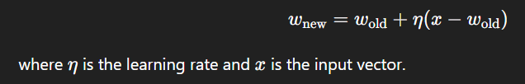

1. **Repeat:**  
   Repeat the process for many input patterns until weights stabilize.

**Result:**  
After training, each neuron’s weight vector represents a cluster center in the input space, allowing the network to classify or group new inputs by assigning them to the neuron with the closest weight.

**Pattern Clustering**

Pattern clustering is the process of organizing data into groups (clusters) such that patterns within the same group are more similar to each other than to those in other groups. It is a fundamental task in unsupervised learning used to discover hidden structures in data.

**Working Principle**

* **Input Data:**  
  The network receives multiple input vectors representing patterns.
* **Similarity Measure:**  
  To group patterns, the network computes a similarity or distance measure (e.g., Euclidean distance, cosine similarity) between input vectors and neuron weights.
* **Competition:**  
  Neurons compete to represent a pattern; the neuron with weights closest to the input vector wins.
* **Weight Adjustment:**  
  The winning neuron updates its weights to be even closer to the input vector, making it a better representative of that cluster.
* **Iteration:**  
  The process repeats for many input samples, gradually organizing neurons so that each represents a cluster of similar inputs.
* **Result:**  
  The network partitions the input space into distinct clusters, where each neuron represents one cluster center or prototype.

**Types of Pattern Clustering Networks**

* **Winner-Take-All Networks:**  
  Basic networks where the single winning neuron adapts to inputs.
* **Kohonen Networks (Self-Organizing Maps):**  
  Neurons compete and update in neighborhoods to preserve topological relationships (covered more in feature mapping).

**Advantages**

* No prior labeling required; suitable for exploratory data analysis.
* Can handle complex, high-dimensional data.
* Adaptive and dynamic with continuous learning.

**Challenges**

* Selecting the number of clusters or neurons can be difficult.
* Sensitivity to initial weight assignments.
* May produce clusters of varying size and shape.

**Applications**

* Customer segmentation in marketing.
* Grouping similar documents in text mining.
* Image segmentation and compression.
* Anomaly detection in network security.

**Feature Mapping Network**

Feature mapping networks organize and transform input data into a lower-dimensional space while preserving essential properties, such as similarity and neighborhood relationships, enabling easier analysis, visualization, or further processing.

**Working Principle**

* **Input Space to Map Space:**  
  High-dimensional input vectors are mapped onto nodes arranged typically in a 1D or 2D grid.
* **Best Matching Unit (BMU):**  
  For each input, the neuron whose weight vector is closest to the input is identified as the BMU.
* **Neighborhood Update:**  
  The BMU and its neighboring neurons update their weights to more closely resemble the input vector.
* **Topology Preservation:**  
  Because neighbors update together, similar inputs map to nearby neurons, preserving topological and metric relationships.
* **Learning Process:**  
  Over many iterations, the map organizes itself such that the input space structure is captured spatially on the grid.

**Important Concepts**

* **Neighborhood Function:**  
  Controls how much neighbors of the BMU get updated. It usually decreases over time and distance.
* **Learning Rate:**  
  Determines the magnitude of weight updates and also typically decreases over time to stabilize learning.

**Popular Feature Mapping Networks**

* **Kohonen Self-Organizing Map (SOM):**  
  The most widely used feature mapping network.
* **Growing Neural Gas:**  
  Adaptively adds neurons to better represent input data.

**Advantages**

* Reduces dimensionality without losing important data structure.
* Useful for visualization of high-dimensional data.
* Robust to noise in input data.

**Challenges**

* Requires careful tuning of parameters like neighborhood size and learning rate.
* Computationally intensive for large datasets.
* Interpretation of the resulting map requires domain knowledge.

**Applications**

* Visualization of complex data such as gene expression or market data.
* Feature extraction in speech and image processing.
* Pattern recognition and classification preprocessing.
* Robotics for sensor mapping and environment representation.

**Definition of ART Network**

Adaptive Resonance Theory (ART) is a neural network model designed for unsupervised learning that solves the stability-plasticity dilemma — enabling the network to learn new information without forgetting previously learned patterns. It clusters input patterns by dynamically creating or updating categories based on similarity and a vigilance parameter.

**Architecture of ART Network**

ART networks mainly consist of two layers:

* **F1 Layer (Input Layer):**  
  Processes and holds the input pattern. It acts as a comparison field for matching the input with learned categories.
* **F2 Layer (Category Layer):**  
  Contains neurons representing learned categories or clusters. Each neuron corresponds to a specific prototype pattern.
* **Gain Control and Reset Mechanisms:**  
  These regulate competition and help reset the search when no suitable category is found.
* **Vigilance Parameter:**  
  A threshold that controls how closely an input pattern must match a stored category for assignment.

**Working of ART Network**

1. **Input Presentation:**  
   An input pattern is presented to the F1 layer.
2. **Category Matching:**  
   The F2 layer neurons compete to find the best matching category based on similarity with the input.
3. **Vigilance Test:**  
   The winning neuron’s match is tested against the vigilance parameter.
   * If the match meets or exceeds the vigilance threshold, resonance occurs.
   * If the match is below the threshold, the winning neuron is inhibited, and the next best match is tested.
4. **Learning:**  
   When resonance occurs, weights are updated to reinforce the category, adapting it to better represent the input pattern.
5. **Category Creation:**  
   If no existing category passes the vigilance test, a new category neuron is recruited for the input pattern.

**Types of ART Networks**

* **ART1:**  
  Designed for binary input patterns (0s and 1s). It uses simple matching and learning rules suitable for discrete data.
* **ART2:**  
  Extends ART1 to handle continuous-valued input patterns, allowing for real-world analog data processing.
* **ART3:**  
  Incorporates more biologically inspired mechanisms such as neurotransmitter effects, adding complexity and biological realism.

**Features of ART Network**

1. **Stability-Plasticity Balance:**  
   The ART network can learn new patterns (plasticity) while preserving previously learned categories (stability), avoiding catastrophic forgetting.
2. **Vigilance Parameter:**  
   Controls the degree of similarity required to classify an input into an existing category, balancing generalization and specificity.
3. **Fast and Stable Learning:**  
   Learning occurs quickly through weight updates when resonance is achieved, and the network remains stable without constant retraining.
4. **Incremental Learning:**  
   Can continuously learn from new data without the need to retrain from scratch.
5. **Noise Tolerance:**  
   Robust to noisy or incomplete input patterns, as it can still correctly classify or create new categories.
6. **Unsupervised Learning:**  
   Does not require labeled data; it automatically clusters input patterns based on similarity.
7. **Dynamic Category Creation:**  
   Creates new categories as needed, allowing the network to adapt to novel inputs flexibly.

**Using ART for Character Recognition**

ART networks are well-suited for character recognition because they can learn to classify patterns (characters) without forgetting previously learned ones, even as new characters or variations are introduced.

**Step-by-step process:**

1. **Input Representation:**  
   Each character (such as a handwritten letter or digit) is converted into a suitable input format, often a binary or grayscale pixel matrix flattened into a vector. For example, a 28x28 pixel image becomes a 784-element input vector.
2. **Input to ART Network:**  
   The input vector is fed into the ART network’s input layer (F1).
3. **Category Matching:**  
   The ART network compares the input character vector to existing category prototypes stored in the recognition layer (F2). It measures similarity between the input and each learned pattern.
4. **Vigilance Test:**  
   The network checks if the best-matching category is similar enough based on the vigilance parameter. This controls whether the network recognizes the input as belonging to a known character or treats it as a new character.
5. **Learning and Classification:**
   * If a match passes the vigilance test, the network assigns the input to that character’s category and updates the prototype to better represent variations in handwriting or style.
   * If no match passes, the network creates a new category neuron to represent this novel character or style.
6. **Recognition Result:**  
   After training, when a new character is presented, the ART network quickly classifies it by matching it to the most similar stored category.

**Advantages of Using ART for Character Recognition**

* **Stable learning:** Learns new characters or styles without forgetting old ones.
* **Handles noisy inputs:** Can recognize characters even if the input is partially distorted or incomplete.
* **Unsupervised learning:** Does not require labeled data, useful for unsupervised clustering of character styles.
* **Adaptive:** Continuously adapts to new handwriting styles or fonts.

**Catastrophic Forgetting in Neural Networks**

**Catastrophic forgetting** (also known as **catastrophic interference**) is a phenomenon in **neural networks** where the model **forgets previously learned information** when trained on **new data**, especially in **sequential learning tasks**.

**What Happens in Catastrophic Forgetting?**

* When a neural network is trained on **Task A**, it learns patterns and stores them in its weights.
* If it is then trained on **Task B** (without access to Task A data), the **new learning updates the same weights**, causing the network to **forget Task A**.
* This is because the network overwrites the representations needed for the previous tasks.

**Why It Happens**

* Neural networks **do not inherently store past knowledge** separately.
* They adjust **shared weights** across all tasks.
* In **sequential (non-iid)** learning, there is no memory of past tasks unless explicitly added.

**E.g.: A** network is trained to recognize **digits (0–9)** → Task A.Later, it's trained to recognize **letters (A–Z)** → Task B.After training on letters, the network performs **poorly on digits**, even though it once did well.

**Self-Organizing Maps (SOM)**

Self-Organizing Map (SOM), developed by Teuvo Kohonen, is an unsupervised neural network used for **dimensionality reduction** and **data visualization**. It maps high-dimensional input data onto a usually two-dimensional grid of neurons, preserving the topological properties of the input space. This means similar input patterns activate neurons that are close together on the map.

**Key Features**

* **Unsupervised Learning:**  
  No target output labels are needed; the network learns the structure of input data by itself.
* **Topology Preservation:**  
  Maintains the spatial relationships of the input data, so points close in input space remain close in the output map.
* **Dimensionality Reduction:**  
  Converts complex, high-dimensional data into a simpler, interpretable two-dimensional map.

**Architecture**

* The SOM consists of neurons arranged in a 1D or 2D lattice (most commonly 2D).
* Each neuron has a weight vector of the same dimension as the input vectors.

**Working Principle**

1. **Initialization:**  
   Weights of all neurons are initialized randomly or sampled from the input data.
2. **Input Presentation:**  
   An input vector is presented to the network.
3. **Best Matching Unit (BMU) Identification:**  
   The neuron whose weight vector is most similar (closest) to the input vector is identified as the BMU.
4. **Weight Update:**  
   The BMU and its neighboring neurons update their weights to move closer to the input vector. The amount of adjustment depends on:
   * **Learning rate:** Decreases over time.
   * **Neighborhood function:** Determines how strongly neighboring neurons are updated; shrinks over time.
5. **Iteration:**  
   Steps 2–4 repeat for many input samples over several iterations, gradually organizing the map.

**Neighborhood Function**

* Controls how the BMU’s neighbors update their weights.
* Neighborhood radius decreases over time, causing the map to converge.

**Advantages**

* Effective for visualizing high-dimensional data.
* Reveals clusters and relationships between data points.
* Robust to noise and missing data.

**Limitations**

* Choosing parameters (learning rate, neighborhood size) requires experimentation.
* Training can be slow for very large datasets.
* Final map interpretation can be subjective.

**Applications**

* Market segmentation and customer profiling.
* Image and speech recognition.
* Gene expression analysis in bioinformatics.
* Robotics for sensor data mapping.

**Self-Organizing Map (SOM) Architecture**

* **Input Layer:**  
  Accepts the input vector of dimension *n*. Each input vector represents a pattern or data point in an n-dimensional space.
* **Map Layer (Output Layer):**  
  A two-dimensional grid (usually rectangular or hexagonal) of neurons arranged in rows and columns. Each neuron has an associated weight vector of the same dimension *n* as the input vector.
* **Weights:**  
  Each neuron’s weight vector acts as a prototype or representative of a particular region of the input space.
* **Topology:**  
  The spatial arrangement of neurons in the map preserves the input space topology, meaning neurons close on the grid respond to similar input patterns.

**Visual Summary of Architecture**

Input Vector (n dimensions) ---> Map Layer (2D grid of neurons with weight vectors)

**SOM Algorithm**

1. **Initialization:**
   * Assign initial random weight vectors to each neuron in the map.
   * Define initial learning rate and neighborhood radius.
2. **Input Presentation:**
   * Present an input vector *x* to the network.
3. **Best Matching Unit (BMU) Identification:**
   * Calculate the distance between the input vector and every neuron’s weight vector (usually Euclidean distance).
   * Find the neuron whose weight vector is closest to the input vector — this is the BMU.
4. **Weight Update:**
   * Update the weight vector of the BMU and its neighboring neurons to move closer to the input vector.
   * The amount of change decreases with time and with distance from the BMU.
   * The formula (conceptual) for updating weights:  
     *w(t+1) = w(t) + learning_rate(t) × neighborhood_function(distance) × (x - w(t))*
5. **Adjust Parameters:**
   * Decrease the learning rate and the neighborhood radius gradually over time.
6. **Repeat:**
   * Repeat steps 2 to 5 for many iterations (epochs) until the map stabilizes.

**Two Basic Feature Mapping Models**

Feature mapping models are used in machine learning and neural networks to transform input data into a space where patterns or classifications are easier to identify. The two basic feature mapping models are:

**1. Competitive Learning Model (Winner-Takes-All)**

**Definition:**

* In this model, multiple neurons compete to respond to a given input.
* Only **one neuron**, the **Best Matching Unit (BMU)**, is declared the **winner** and gets updated.

**Working:**

* The neuron with the **weight vector closest** to the input vector is selected as the winner.
* Only the winner’s weights are adjusted to become more like the input vector.
* This leads to **specialization** of neurons, where each learns to respond to different input patterns.

**Example:**

* Used in **Self-Organizing Maps (SOM)** and **Kohonen Networks**.

**Advantages:**

* Simple and fast.
* Useful for **clustering** and **pattern recognition**.

**2. Cooperative Learning Model**

**Definition:**

* In this model, **multiple neurons** (not just the winner) cooperate to learn from the input.
* The **winner** and its **neighboring neurons** are updated, typically based on a **neighborhood function**.

**Working:**

* The strength of weight update decreases with distance from the winner in the grid.
* This promotes **topological ordering**, preserving the structure of input data.

**Example:**

* Core concept in **Self-Organizing Maps (SOM)**, where both the BMU and its neighbors are updated.

**Advantages:**

* Helps in maintaining **smooth mapping** and **continuity** in the feature space.
* Produces more **organized and structured maps**.

**Properties of Feature Map**

1. **Topology Preservation**  
   The map maintains the spatial relationships of input data. Inputs that are close to each other in the original input space are mapped to nearby neurons on the feature map. This property helps in preserving neighborhood structures and meaningful similarity patterns.
2. **Dimensionality Reduction**  
   The feature map converts high-dimensional input data into a lower-dimensional representation (usually 2D), making it easier to visualize and analyze complex data.
3. **Continuity and Smoothness**  
   The feature map provides a smooth representation of input data, meaning gradual changes in input vectors correspond to gradual changes in neuron activation on the map.
4. **Topology Ordering**  
   Neurons are organized so that neighboring neurons in the map respond to similar input features, creating an ordered representation of the input space.
5. **Generalization**  
   The feature map generalizes input data by grouping similar inputs into clusters represented by the weights of neurons. This helps in recognizing patterns even with noisy or incomplete data.
6. **Competition and Cooperation**  
   Neurons compete to respond to an input pattern (competition), but once a winning neuron is selected, it cooperates with its neighbors by updating weights together (cooperation). This balance enables the formation of meaningful feature maps.
7. **Adaptability**  
   The feature map adapts to the input data distribution during training. The neurons’ weight vectors adjust to represent the input space effectively, allowing the map to model various data patterns dynamically.
8. **Robustness to Noise**  
   Because neurons represent clusters of similar inputs, the feature map is robust to noisy data, as small variations in input do not drastically change the activation pattern.

**Computer simulations** refer to the process of using software to imitate the behavior of neural networks and other computational models in order to study, analyze, and understand their functioning. It allows researchers and engineers to test theories, optimize architectures, and visualize learning processes without building physical systems.

**Key Aspects of Computer Simulations in Neural Networks**

**1. Model Testing and Validation**

* Simulations allow testing of neural network models (like feedforward, SOM, Hopfield, Boltzmann, etc.) with different datasets.
* Helps validate theoretical properties and understand how models behave in different conditions.

**2. Learning Behavior Observation**

* Simulations help track how weights change over time, how error decreases, and how neurons respond to inputs.
* Useful for analyzing convergence, stability, and learning speed.

**3. Visualization**

* Feature maps, activation patterns, and clustering can be visualized in 2D/3D plots.
* Important in Self-Organizing Maps (SOM) to observe how input data is mapped and organized.

**4. Parameter Tuning**

* Through simulations, hyperparameters like learning rate, number of neurons, epochs, and neighborhood radius can be adjusted and tested.
* Saves time and resources by avoiding physical trial-and-error.

**5. Experimentation with Data**

* Enables training on different types of input data (images, sounds, text, etc.).
* Simulations can incorporate noisy or incomplete data to test robustness.

**6. Performance Evaluation**

* Performance metrics like accuracy, error rate, convergence time, and memory usage can be evaluated through simulations.
* Results help in comparing different neural network architectures.

**Advantages of Computer Simulations**

* **Cost-Effective:** No need for expensive physical hardware setups.
* **Flexible:** Easy to modify models, datasets, and parameters.
* **Safe:** No physical risk while testing complex systems.
* **Repeatable:** Experiments can be rerun under the same or different conditions.
* **Scalable:** Can simulate small models or large-scale systems depending on computational power.

**Tools and Environments for Simulation**

* **MATLAB/Simulink:** Widely used in academia for neural network simulations.
* **Python Libraries:** TensorFlow, PyTorch, Keras, and scikit-learn support detailed simulations.
* **Java/Processing:** For visual simulations in educational contexts.
* **C/C++:** Used for performance-intensive, custom simulations.

**Applications**

* Testing Artificial Neural Networks (ANNs) for classification, recognition, and control tasks.
* Studying behavior of unsupervised networks like SOM or Hopfield models.
* Simulating biological neural behaviors in neuroscience research.
* Visualizing learning processes and clustering in data science.

**Learning Vector Quantization (LVQ)**

Learning Vector Quantization (LVQ) is a **supervised learning algorithm** that is used for **pattern classification**. It is based on prototype-based learning and uses labeled data to train a set of codebook vectors (also called prototypes or reference vectors) that represent different classes in the input space.

LVQ was developed by **Teuvo Kohonen**, the same person who developed the Self-Organizing Map (SOM).

**Key Characteristics of LVQ**

* **Supervised:** Unlike SOM, LVQ uses class labels during training.
* **Prototype-Based:** Each class is represented by one or more prototypes.
* **Simple and Intuitive:** Uses distance measures (typically Euclidean distance) to classify input vectors.

**LVQ Architecture**

* **Input Layer:** Takes input vectors (features).
* **Codebook Layer:** Contains a set of codebook vectors (also called weight vectors), each associated with a known class label.
* **Output Layer:** Determines the class of the input based on the closest codebook vector.

Each codebook vector is of the same dimension as the input and serves as a representative of a particular class.

**LVQ Algorithm (Basic Steps)**

1. **Initialization:**
   * Initialize a set of codebook vectors randomly or using examples from the training data.
   * Assign a class label to each codebook vector.
2. **Input Presentation:**
   * Present a labeled input vector to the network.
3. **Best Matching Unit (BMU):**
   * Find the codebook vector (BMU) that is closest to the input vector using a distance metric (usually Euclidean distance).
4. **Weight Update Rule:**
   * If the BMU has the **same class label** as the input vector:
     + Move the BMU **closer** to the input vector.
   * If the BMU has a **different class label**:
     + Move the BMU **away** from the input vector.
5. **Repeat:**
   * Repeat the process for many input vectors across several iterations (epochs), adjusting the learning rate over time.

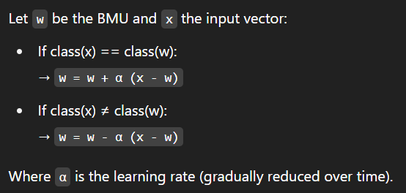

**Advantages of LVQ**

* Easy to implement and understand.
* Good for classification problems with labeled data.
* Performs well with small-to-medium-sized datasets.
* Offers a balance between interpretability and performance.

**Limitations of LVQ**

* Performance highly depends on the initial choice of codebook vectors.
* May not scale well to very large datasets.
* Sensitive to learning rate and training schedule.
* Doesn’t inherently handle overlapping class regions well unless extended.

**Applications**

* Speech and image recognition
* Medical diagnosis
* Bioinformatics (gene classification)
* Fault detection systems
* Pattern recognition tasks in general

**Adaptive Pattern Classification**

Adaptive Pattern Classification is the process by which a system—typically a neural network—**learns to classify input patterns** by adapting its internal structure (mainly weights and biases) based on training data. It can dynamically respond to new information, noise, or shifts in data patterns.

**Key Concepts**

* **Adaptiveness:** The system is capable of learning from data and refining its classification process over time.
* **Pattern Recognition:** Involves assigning an input to one of several predefined categories.
* **Learning Mechanism:** Most adaptive classifiers use training algorithms to adjust internal weights for minimizing classification errors.

**Types of Adaptive Pattern Classifiers**

* **Perceptron:**  
  A simple single-layer neural network that learns to classify linearly separable patterns by adjusting weights through a supervised learning rule.
* **Multilayer Perceptron (MLP):**  
  A more complex network with multiple layers of neurons. It uses **backpropagation** to learn from labeled data and can classify **non-linearly separable patterns**.
* **Self-Organizing Maps (SOM):**  
  An **unsupervised** learning model that clusters similar input data. Though not a classifier by default, it can be adapted for classification by labeling clusters.
* **Learning Vector Quantization (LVQ):**  
  A supervised extension of SOM that uses labeled data to **fine-tune prototypes** (reference vectors) for each class, improving classification accuracy.

**Architecture of Adaptive Classifier**

* **Input Layer:** Receives the raw input data (features).
* **Hidden Layer(s):** Processes and transforms the input through learned weights and activation functions.
* **Output Layer:** Produces the predicted class label.
* **Learning Module:** Adjusts the weights based on comparison between predicted and true outputs.

**Advantages**

* Learns from experience and improves with time.
* Adapts to changes in the input data distribution.
* Suitable for both linear and non-linear classification problems.
* Can handle noise and imperfect data.

**Disadvantages**

* Requires sufficient labeled data for supervised learning.
* Sensitive to learning rate, initialization, and other hyperparameters.
* May require significant computational resources for large datasets.

**Applications**

* Image and speech recognition
* Medical diagnosis systems
* Handwriting analysis
* Spam filtering

Unit 5

### Building blocks of CNNs: 1. Input Layer

* **Purpose**: Accepts the image as input.
* **Format**: 3D matrix → Height × Width × Channels  
  (e.g., 224×224×3 for RGB image)

**✅ 2. Convolutional Layer**

* **Purpose**: Extracts features like edges, textures, patterns.
* **Operation**: Applies filters (kernels) that slide over the image.
* **Output**: Feature Maps.

**✅ 3. Activation Function (ReLU)**

* **Purpose**: Adds non-linearity to the model.
* **Function**: ReLU(x) = max(0, x)
* **Effect**: Helps model learn complex patterns.

**✅ 4. Pooling Layer**

* **Purpose**: Reduces spatial dimensions (height, width).
* **Types**:
  + **Max Pooling**: Takes maximum value.
  + **Average Pooling**: Takes average value.
* **Benefits**:
  + Reduces computation.
  + Controls overfitting.
  + Adds translation invariance.

**✅ 5. Padding**

* **Purpose**: Preserves image size after convolution.
* **Types**:
  + **Valid Padding**: No padding, output shrinks.
  + **Same Padding**: Adds padding to keep size same.

**✅ 6. Stride**

* **Definition**: Step size of the filter as it moves.
* **Effect**:
  + **Stride = 1**: Normal scan.
  + **Stride > 1**: More aggressive reduction in size.

**✅ 7. Fully Connected (Dense) Layer**

* **Purpose**: Combines features and performs classification.
* **Structure**: Each neuron connects to all neurons in previous layer.

**✅ 8. Output Layer (Softmax)**

* **Purpose**: Converts outputs into probabilities.
* **Function**: Used for multi-class classification.
* **Example**: 10 units for classifying digits 0–9.

**✅ 9. Other Components**

* **Batch Normalization**: Normalizes layer inputs, improves training.
* **Dropout**: Randomly disables neurons during training to prevent overfitting.
* **Flatten Layer**: Converts 2D/3D feature maps into 1D vector before fully connected layer.

Input Image → Convolution → ReLU → Pooling → Convolution → ReLU → Pooling → Flatten → Fully Connected → Softmax Output

## **Architecture of a CNN**

A CNN is made up of multiple layers that work together to extract and learn features from images. Here's a step-by-step breakdown of a **typical CNN architecture**:

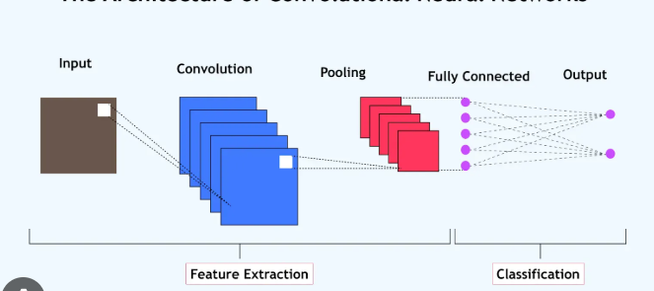

## **1. Input Layer**

* **Role**: The input layer takes in the raw pixel values of an image.
* **Structure**: The image is represented as a **3D matrix**:
  + **Height** × **Width** × **Channels**
  + Examples:
    - Grayscale image: 28×28×1
    - RGB image: 224×224×3
* This layer does **not learn** any parameters; it just passes the data to the next layer.

## 🔍 **2. Convolutional Layers**

* **Role**: Extract local patterns or features from the input image.
* **How It Works**:
  + Applies a set of **learnable filters (kernels)**.
  + Each filter slides (convolves) across the image.
  + Computes **dot products** between the filter and regions of the image.
  + Produces a **feature map** that indicates where a particular feature appears.
* **Filters** detect:
  + Low-level features: edges, corners
  + High-level features: textures, objects (in deeper layers)
* **Parameters learned**: weights of filters.

## ⚡ **3. Activation Function (ReLU)**

* **Role**: Introduce **non-linearity** into the network.
* **Why Needed**: Without non-linear activations, a CNN would be equivalent to a linear model.
* **ReLU (Rectified Linear Unit)**:

ReLU(x)=max⁡(0,x)

* + Converts all negative values to 0.
  + Keeps positive values unchanged.
* **Benefits**:
  + Faster computation
  + Avoids vanishing gradient issues (better than sigmoid/tanh)

## 🔽 **4. Pooling Layer**

* **Role**: Reduce spatial dimensions (height and width) of feature maps.
* **Common Types**:
  + **Max Pooling**: Takes the maximum value in a patch.
  + **Average Pooling**: Takes the average value.
* **Why It's Important**:
  + Reduces number of parameters and computations.
  + Makes features more robust to translation/rotation.
  + Prevents overfitting.
* **Typical Configurations**: Pool size = (2×2), Stride = 2

## 🧱 **5. Padding**

* **Role**: Add extra border (usually zeros) around the input matrix.
* **Why Use Padding?**
  + Prevents shrinking of output after each convolution.
  + Allows **filters to reach the edges** of the image.
* **Types**:
  + **Valid Padding**: No padding → output size reduces.
  + **Same Padding**: Padding added → output size stays the same.

## ↔️ **6. Stride**

* **Definition**: Number of pixels the filter moves at each step.
* **Effects**:
  + **Stride = 1**: Filters move one pixel at a time → high detail.
  + **Stride > 1**: Filters move faster → reduced output size.
* **Impact on Architecture**:
  + Larger strides = smaller outputs = less computation.

## 🧠 **7. Flatten Layer**

* **Role**: Converts multidimensional feature maps into a **1D vector**.
* This vector is then used as input to the Fully Connected Layer.
* **Why Needed?**:
  + Dense layers expect 1D input.
  + Bridges the transition from convolutional (spatial) to classification (vector) tasks.

## 🔗 **8. Fully Connected (Dense) Layer**

* **Role**: Learn **high-level features** and perform reasoning based on extracted features.
* **Structure**: Every neuron is connected to all neurons in the previous layer.
* **Output**: Feature vector for final decision-making.
* **Example**: In digit classification, 10 neurons for digits 0–9.

## 🧮 **9. Output Layer**

* **Role**: Generate the final prediction.
* **Common Activation Functions**:
  + **Softmax**: Multi-class classification (outputs probability for each class).

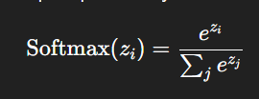

* + **Sigmoid**: Binary classification (outputs value between 0 and 1).

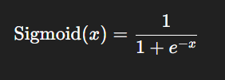

**1. Convolution Layer**

**Definition**:  
A **convolutional layer** is the fundamental building block of a CNN, designed to automatically and adaptively learn **spatial hierarchies of features** from input images.

**How it works**:

* It uses a **filter (kernel)** — a small matrix (e.g., 3×3 or 5×5) — which slides over the input image.
* At each position, it performs **element-wise multiplication** between the filter and the corresponding input patch, then sums the results to form a single number.
* This operation results in a new matrix called a **feature map** or **activation map**.

**Purpose**

* Detects low-level features (edges, corners) in initial layers and high-level features (shapes, textures) in deeper layers.
* Reduces the number of parameters compared to fully connected layers.

**Formula**: 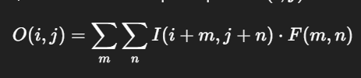

### ****2. Pooling Layers****

Pooling layers are used to **reduce the spatial dimensions** (height and width) of the feature maps, while **retaining important features**.

#### 🔸 A. **Max Pooling**

**Definition**:  
Selects the **maximum value** from each patch (e.g., 2×2) of the feature map.

**Purpose**:

* Preserves the most prominent feature in a region.
* Adds **translation invariance** (small shifts in input won’t affect output).
* Helps reduce overfitting and computational cost.

#### 🔸 B. **Average Pooling**

**Definition**:  
Computes the **average value** from each patch.

**Purpose**:

* Provides a smoother version of the feature map.
* Less aggressive than max pooling.
* Can be useful when presence of a feature is less important than its average strength.

#### 🔸 C. **Min Pooling**

Selects the **minimum value** from each patch.

**Purpose**:

* Captures the least-activated regions.
* Useful in specific tasks like anomaly or defect detection where the absence or weakness of a feature is meaningful.

**3. Padding**

Padding refers to the **addition of extra pixels** (usually zeros) around the border of the input image or feature map before applying convolution.

**Types**:

* **Same Padding**: Pads input so that output has **same spatial dimensions**.
* **Valid Padding**: **No padding**, resulting in reduced output size.

**Purpose**:

* Allows the network to preserve edge information.
* Ensures deeper networks do not excessively shrink spatial dimensions.
* Controls the size of the output feature maps.

**Padding Formula (Same:**

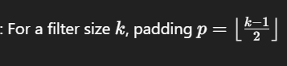

**🔹 4. Strided Convolutions**

Stride refers to the **number of pixels by which the filter moves** across the input image.

**How it affects output**:

* **Stride = 1**: Filter moves one pixel at a time — results in detailed feature maps.
* **Stride > 1**: Filter skips pixels — results in down sampling and faster computation.

**Purpose**:

* To control the spatial resolution of the output.
* Acts as a **learned down sampling technique**.
* Reduces the number of computations and parameters.

**Output Size Formula**: For input size N, filter size F, padding P, and stride S: 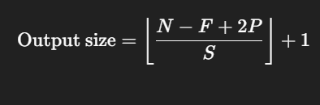**Convolutions over Volumes in CNNs**

In the context of **Convolutional Neural Networks (CNNs)**, **convolutions over volumes** refer to the process of applying convolutional operations not just to 2D images (height × width) but to 3D inputs — known as **volumes**. This 3D input can be represented as a matrix of **height × width × depth**, where **depth** typically refers to the number of **channels** in the image (for example, 3 channels for RGB images).

### 1. ****What is a Volume?****

A **volume** in CNNs is a 3D matrix (height × width × depth), where:

* **Height** refers to the vertical dimension of the input image.
* **Width** refers to the horizontal dimension of the input image.
* **Depth (Channels)** refers to the number of feature maps or channels. For example:
  + A **grayscale image** has only one channel (depth = 1).
  + A **RGB image** has three channels (depth = 3).
  + After applying convolution in earlier layers, depth might increase due to multiple feature maps.

### 2. ****Applying Convolution Over Volumes****

When we apply convolutions over volumes, each **filter** (or **kernel**) is designed to slide across the entire 3D volume, instead of just 2D images. This means that the filter also has a **depth dimension** (in addition to height and width), and it operates over a **3D region** in the input volume.

#### **How It Works:**

1. **Filter/Kernel Dimensions**:

For a volume, a filter will have a size such as **(f × f × d)**, where:

* + **f × f** is the spatial dimension (height × width) of the filter.
  + **d** is the depth of the filter, which must match the depth of the input volume (for an RGB image, this is 3).

1. **Sliding the Filter**:

The filter moves across the input volume both **horizontally** and **vertically**, considering the **depth** as well. At each position, a **3D dot product** is performed between the filter and the corresponding region of the input volume.

1. **Output Volume**:

The result is a **3D output volume** (feature map), where each depth slice represents a different feature detected by the filter. The depth of the output corresponds to the number of filters applied.

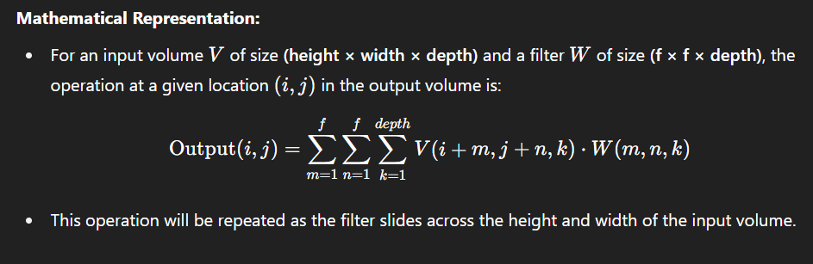

**Output from Convolutions Over Volumes**

After applying a set of filters, the output will be a **new feature map (3D volume)**. The number of channels in the output volume corresponds to the number of filters used.

* **Output Size**: The size of the output feature map depends on:
  + The **input size**.
  + The **filter size**.
  + The **stride**.
  + The **padding**.

Formula for the output volume size:

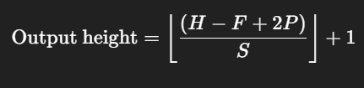

Where:

* H = Height of input volume
* F = Filter size
* P = Padding
* S = Stride

**Softmax Regression**  
Softmax regression, also known as **multinomial logistic regression**, is a generalization of logistic regression to multi-class classification problems. It is used to model the probability distribution of a list of potential outcomes.

**Working Mechanism:**

* **Normalization**: Softmax regression transforms the raw output scores (logits) from the neural network into probabilities by normalizing them. This is done through the **Softmax function**, which converts a vector of real numbers into a probability distribution.
* **Mathematical Formulation**:

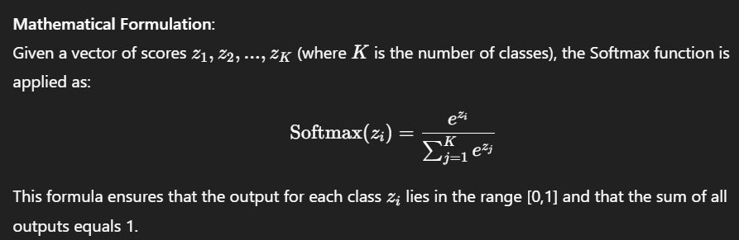​​

**Key Features:**

* **Multi-Class Classification**: Unlike binary logistic regression, which is used for two-class problems, **Softmax regression** can handle **multiple classes** (e.g., classifying an image as one of many categories like dog, cat, or bird).
* **Output**: The output of the Softmax function is a **probability distribution**, meaning that the predicted values will be between 0 and 1, and the sum of the probabilities across all classes will equal 1.

**Advantages:**

* **Multi-Class Capability**: Softmax regression avoids binary classification limitations and allows for classification problems with more than two classes.
* **Probabilistic Interpretation**: The output can be interpreted as the probability of the input belonging to each class, which is useful for applications like **multi-class classification** and **uncertainty estimation**.

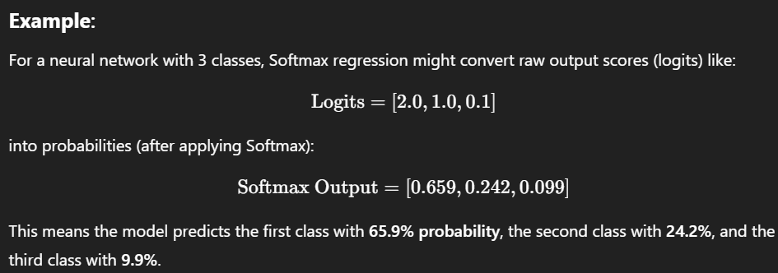

### ****Deep Learning Frameworks****

Deep learning frameworks are powerful tools that simplify the process of building, training, and deploying deep learning models. These frameworks provide high-level abstractions, optimized performance, and easy-to-use tools, which help researchers and developers implement complex neural networks. Some of the most popular deep learning frameworks include **TensorFlow**, **PyTorch**, **Keras**, and **Theano**.

**1. TensorFlow**

TensorFlow is an open-source deep learning framework developed by Google in 2015 for numerical computation and machine learning applications. It is one of the most popular frameworks, especially for production-level deep learning projects.

**Working**:  
TensorFlow uses a **dataflow graph** to define the structure of computation. It represents the computation in the form of a graph, where each node is a mathematical operation, and edges represent data (tensors). TensorFlow allows users to prepare a flowchart, where inputs (as tensors) are processed through these operations to generate outputs.

**Applications**:

* **Text-based Applications**: TensorFlow is widely used in natural language processing (NLP) tasks like **language detection** and **sentiment analysis**.
* **Image Recognition**: TensorFlow powers various image-related applications such as **motion detection**, **facial recognition**, and **photo clustering**.
* **Video Detection**: It is also used in **real-time object detection** from video feeds, enabling tracking and motion detection.

**2. PyTorch**

PyTorch is another popular deep learning framework, developed by Facebook’s AI Research Lab (FAIR). It is known for its dynamic computational graph and strong support for GPU acceleration.

**Working**:  
PyTorch uses a **dynamic computational graph**, which is built at runtime. This means you can change the graph structure on the fly, making it easier to debug and modify models. PyTorch also integrates with Python’s core programming concepts, including loops and conditional statements, which simplifies model building and training.

**Applications**:

* **Weather Forecasting**: PyTorch is used to predict weather patterns based on historical data and real-time inputs.
* **Text Auto-detection**: It powers **auto-suggestions** in search engines (like Google) and other **text-based prediction** tasks.
* **Fraud Detection**: PyTorch helps in detecting anomalies and frauds, such as **credit card fraud** by recognizing unusual patterns in transaction data.

**3. Keras**

Keras is a high-level neural network API, written in Python, designed to enable easy and fast prototyping. Initially developed as a standalone library, Keras now runs on top of other deep learning frameworks like TensorFlow and Theano.

**Working**:  
Keras provides an easy-to-use API for defining neural networks. It acts as a wrapper for low-level libraries (e.g., TensorFlow or Theano) to simplify model construction. Its modular approach allows for quick experimentation and testing of deep learning models, making it ideal for researchers and engineers who want to prototype quickly.

**Applications**:

* **Smartphone Applications**: Keras is used to develop machine learning models that power deep learning applications on smartphones.
* **Healthcare**: It is applied in the **prediction of heart diseases**, where models can alert healthcare providers about potential risks.
* **Face Mask Detection**: During the COVID-19 pandemic, Keras was used to develop models for detecting whether a person is wearing a mask in real-time.

**Training and testing on different distributions:**

Training and testing on different distributions refers to a situation where the data used to train a model and the data used to test or deploy the model come from different statistical distributions. This problem is also known as distribution shift or domain mismatch.

In machine learning, especially with CNNs, it is assumed that the model learns from data that is **representative** of what it will encounter during testing. When this assumption fails, model performance degrades because:

* The **features** learned during training may not match test data features.
* The model may not generalize well to new conditions.

## **Causes of Distribution Mismatch**

* Changes in **lighting, background, camera quality**.
* Different **data sources or environments** (e.g., lab vs real-world).
* Seasonal, geographical, or demographic differences.

## **4. Real-Life Example**

A CNN trained to detect animals in **zoo images** may perform poorly when tested on **wildlife camera footage**, because the surroundings, lighting, and animal behavior are different.

**Bias and Variance with mismatched data distributions,**

In machine learning and deep learning, the performance of a model is often measured in terms of **bias** and **variance**. These two are directly affected when **training and testing data distributions do not match**, a condition known as **distribution mismatch** or **domain shift**.

### 🔹 ****Bias****

* Bias is the **error due to overly simplistic assumptions** in the learning algorithm.
* High bias leads to **underfitting**, where the model cannot capture patterns from data.

### 🔹 ****Variance****

* Variance is the **error due to sensitivity to small fluctuations** in the training data.
* High variance leads to **overfitting**, where the model memorizes training data but fails to generalize.

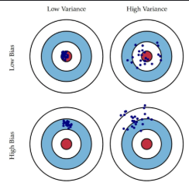

**3. Bias-Variance Trade-Off:**

* The **bias-variance trade-off** is the balance between **simplicity and flexibility** of a model.
* Goal: **Minimize total error (generalization error)** = Bias² + Variance + Irreducible error.

Noise in data (can't be removed by any model)

| **Model Complexity** | **Bias** | **Variance** | **Total Error** |
| --- | --- | --- | --- |
| Too Simple | High | Low | High |
| Too Complex | Low | High | High |
| **Optimal** | Balanced | Balanced | **Low** |

The trade-off aims to find the **“sweet spot”** where both bias and variance are low enough to ensure good performance on **both training and unseen data**.

## **What is Distribution Mismatch?**

* Occurs when the **statistical properties** of the training dataset differ from those of the testing or real-world dataset.
* Causes include: different lighting, camera quality, environments, or populations.

## **Impact on Bias and Variance**

| **Condition** | **Bias** | **Variance** | **Outcome** |
| --- | --- | --- | --- |
| Matched Distributions | Low | Low | Good generalization |
| Mismatched Distributions | High | High | Poor generalization |

## **Example**

A CNN trained on **passport photos** may perform poorly on **selfies** due to different angles, lighting, and noise, leading to:

* **High bias**: Fails to extract relevant features.
* **High variance**: Gives inconsistent outputs.

## **Solutions**

| **Technique** | **Purpose** |
| --- | --- |
| Data Augmentation | Adds variation to reduce bias and variance. |
| Domain Adaptation | Aligns feature distributions. |
| Transfer Learning | Uses pre-trained models on diverse datasets. |

**What Is Transfer Learning?**

**Transfer learning** is a technique in machine learning where a model developed for a specific task is reused or adapted to solve a related but different task. Instead of training a model from scratch, transfer learning leverages the knowledge gained by a pre-trained model on one task to improve generalization on a new task. Essentially, the model transfers learned features, weights, or patterns to a different, often smaller or more specialized, dataset or task.

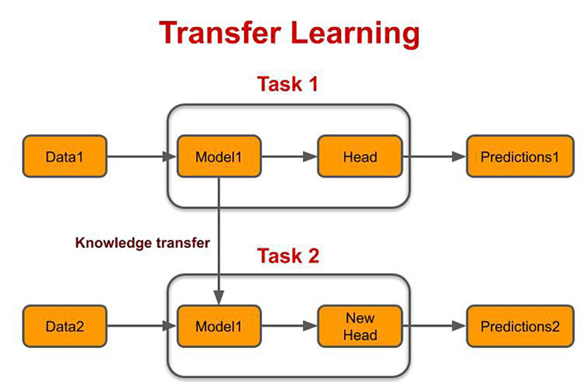

For example, if a model is trained to classify images of animals, the knowledge it gained about shapes, textures, and edges can be transferred to a new model that classifies medical images, even if the new dataset is smaller and lacks a large amount of labeled data.

**How Transfer Learning Works**

1. **Pre-trained Model**:
   * A model that has already been trained on a large dataset for a particular task is used as the starting point.
   * This model has learned a rich set of features (e.g., edges, shapes, textures for image tasks) that are generally applicable to many different tasks.
2. **Fine-tuning**:
   * Fine-tuning involves slightly adjusting the weights of the pre-trained model on the new dataset. This helps the model specialize in the new task without starting from scratch.
   * In some cases, the early layers (which learn generic features) are frozen (not updated during training), and only the later layers are trained for the new task.
3. **Feature Extraction**:
   * Instead of fine-tuning the entire model, the pre-trained model can also be used as a **feature extractor**. The features learned in the earlier layers are used as input to a new classifier or model tailored to the new task.

**Why Use Transfer Learning?**

1. **Saves Training Time**: Pre-trained models reduce training time significantly by already having learned general features, speeding up the process for new tasks.
2. **Reduces Need for Large Datasets**: Transfer learning allows the use of smaller datasets, as the model has already learned important features from the original task, minimizing the need for vast labeled data.
3. **Improves Performance**: The pre-trained model brings valuable knowledge, often improving performance on the new task, especially when data is limited.
4. **Applicability in Specialized Fields**: Transfer learning is useful in domains like NLP and Computer Vision, where labeled data is scarce, allowing general models to be adapted for specific tasks such as sentiment analysis or medical image analysis.

**Example 1: Image Classification**:

* You want to classify photos of dogs and cats, but you have a very small dataset (e.g., 100 images). Instead of training a neural network from scratch, you start with a model pre-trained on ImageNet (which has millions of images across thousands of classes) and fine-tune it on your small dataset.

**When to Use Transfer Learning**

1. **Lack of Training Data**: If there is insufficient labeled data for the task, transfer learning allows you to use a pre-trained model and fine-tune it with a smaller dataset.
2. **Existing Pre-trained Network**: If a pre-trained model exists for a similar task (e.g., image classification), you can reuse the learned features to speed up training and improve performance.
3. **Same Input Type**: Transfer learning works well when both tasks use the same type of input, such as images or text. For example, using an image classifier trained on one dataset and adapting it to another similar task.
4. **Task Similarity**: It’s most useful when the tasks are closely related. The model’s learned features from the source task are beneficial for the target task.
5. **Use of Open-Source Libraries**: If the pre-trained model is built using libraries like TensorFlow or PyTorch, you can easily load the **What is Multi-Task Learning?**

**Multi-Task Learning (MTL)** is a machine learning approach where a single model is trained to perform multiple tasks simultaneously. Instead of building separate models for each task, MTL leverages commonalities across tasks to improve learning efficiency and generalization..

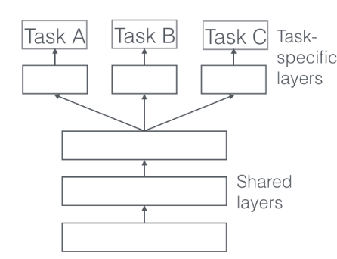

#### ⚙️ **How Does It Work?**

* **Shared Layers**: The model has shared hidden layers that learn general features from all tasks.
* **Task-Specific Layers**: On top of the shared layers, separate output layers are added for each task.
* **Joint Training**: The model is trained on multiple tasks together, using a combined loss function that considers all tasks.

**Example**:  
A neural network trained to do both object detection and image segmentation on the same input image. Shared layers learn visual features, while task-specific layers output bounding boxes or pixel-wise masks.

#### 📌 **When to Use Multi-Task Learning**

* When tasks are **related** (e.g., sentiment analysis + emotion detection).
* When you have **limited labeled data** for individual tasks but more combined data.
* When you want to **reduce training time** and computational cost by using one model for multiple purposes.
* When you aim for **better generalization** by leveraging signals from multiple learning objectives.

**Advantages of Multi-Task Learning**

1. **Improves Generalization**: By learning multiple related tasks at the same time, the model captures shared patterns, leading to better generalization across tasks.
2. **Efficient Learning**: Multi-task learning shares representations among tasks, reducing the need for separate models and making training more efficient.
3. **Reduces Overfitting**: Since the model learns from multiple tasks, it is less likely to overfit on a single task with limited data.
4. **Enables Transfer of Knowledge**: Learning one task can help improve performance on another related task by sharing useful information across tasks.

### ****End-to-End Deep Learning (E2E Learning)****

End-to-End Deep Learning is an approach where a deep neural network learns the **entire mapping from input to output** in a single model. Unlike traditional systems where different parts of the task (like feature extraction, classification, decision-making) are handled by separate modules, end-to-end models handle everything **automatically** through a unified architecture.

### 🔍 ****Detailed Working****

Let’s break down the process step-by-step:

#### 1. **Input Layer:**

The model receives **raw data** (e.g., pixel values of an image, audio waveform, or plain text). There is no need for manual pre-processing or hand-crafted feature extraction.

#### 2. **Hidden Layers:**

Multiple deep layers (CNNs, RNNs, LSTMs, Transformers, etc.) extract patterns, learn features, and abstract information at different levels:

* For images: Convolutional layers learn spatial hierarchies (e.g., edges, shapes, objects).
* For text/audio: Recurrent or attention-based models capture sequential dependencies.

#### 3. **Output Layer:**

The final layer directly produces the prediction or decision (e.g., object label, translated sentence, action in robotics, etc.).

#### 4. **Loss Function and Optimization:**

A loss function evaluates the difference between predicted output and actual output. Backpropagation updates weights across **all layers simultaneously**, optimizing the entire model end-to-end.

### 💡 ****Examples****

1. **Image Classification:**
   * Input: Raw image (e.g., 224x224 pixels).
   * Output: Predicted class (e.g., “cat” or “dog”).
2. **Speech Recognition:**
   * Input: Raw audio waveform.
   * Output: Transcribed text.

**Introduction to CNN models: LeNet – 5, AlexNet, VGG – 16, Residual Networks**

## **LeNet-5: A CNN Model for Handwritten Digit Recognition**

**LeNet-5** is one of the earliest convolutional neural network (CNN) architectures, proposed by **Yann LeCun in 1998**. It was developed to recognize handwritten characters, particularly for digit recognition tasks such as reading ZIP codes and digits from bank cheques.

### ****Key Concepts Behind LeNet-5****

* **Hierarchical Feature Extraction**: LeNet-5 uses multiple layers to automatically extract increasingly complex features from input images.
* **Parameter Sharing**: Convolutional layers use shared weights, reducing the number of parameters and improving generalization.
* **Local Receptive Fields**: Each neuron in the convolutional layer only connects to a small region of the input, capturing spatial hierarchies.
* **Subsampling (Pooling)**: Reduces the spatial dimensions, controls overfitting, and improves model efficiency.
* **Fully Connected Layers**: Learn non-linear combinations of the features for final classification.

## **LeNet-5 Architecture Description**

The LeNet-5 architecture consists of **7 layers** (excluding input), with **trainable parameters**, and includes a combination of **convolutional**, **subsampling (pooling)**, and **fully connected layers**.

### 1. ****Input Layer****

* Size: **32×32** pixels grayscale image
* Note: Although datasets like MNIST have 28×28 images, they are padded to 32×32 for this architecture.

### 2. ****C1 – Convolutional Layer****

* **6 filters** of size 5×5 are applied
* Output size: **28×28×6**
* Each filter computes a feature map using local receptive fields
* Activation: **tanh**

### 3. ****S2 – Subsampling Layer (Average Pooling)****

* Pooling window: 2×2, stride 2
* Output size: **14×14×6**
* Each 2×2 region is averaged to reduce spatial resolution
* Activation: **tanh**
* Helps in translation invariance and reduces computation

### 4. ****C3 – Convolutional Layer****

* 16 filters of size 5×5
* Output size: **10×10×16**
* **Selective connectivity**: Not all filters connect to all previous maps, providing diversity in learned features
* Activation: **tanh**

### 5. ****S4 – Subsampling Layer****

* Pooling window: 2×2, stride 2
* Output size: **5×5×16**
* Performs average pooling
* Activation: **tanh**

### 6. ****C5 – Convolutional Layer****

* 120 filters of size 5×5
* Fully connected to all 5×5×16 inputs
* Output size: **1×1×120**
* Acts like a **fully connected layer in convolutional form**
* Activation: **tanh**

### 7. ****F6 – Fully Connected Layer****

* 120 inputs → 84 neurons
* Fully connected with **tanh** activation

### 8. ****Output Layer****

* 84 inputs → **10 output units** (for 10 digit classes)
* Uses **softmax activation** to output class probabilities

## 🔍 **Features of LeNet-5**

* **Simplicity**: Uses basic CNN components that form the foundation of modern networks.
* **Efficiency**: Fewer parameters compared to deep networks like VGG or ResNet.
* **Effectiveness**: Performed extremely well on early datasets such as MNIST.
* **Pioneering Model**: Inspired the development of deeper and more powerful CNNs.

## **AlexNet: A Deep CNN for Image Classification**

**AlexNet** is a deep convolutional neural network that marked a significant breakthrough in the field of computer vision. It was developed by **Alex Krizhevsky, Ilya Sutskever, and Geoffrey Hinton**, and **won the ImageNet Large Scale Visual Recognition Challenge (ILSVRC) in 2012**, outperforming traditional machine learning models by a large margin.

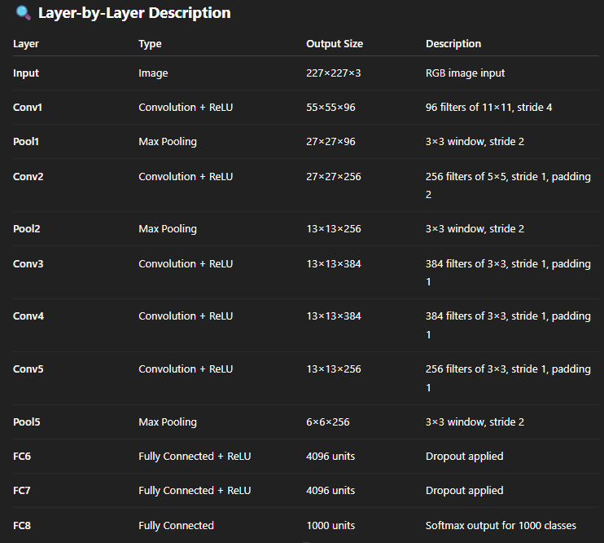

• **Introduction**:

* AlexNet is a deep Convolutional Neural Network (CNN) developed by **Alex Krizhevsky**, **Ilya Sutskever**, and **Geoffrey Hinton**.
* Won the **ImageNet Large Scale Visual Recognition Challenge (ILSVRC) 2012**, reducing the top-5 error rate to **15.3%**.

• **Input and Dataset**:

* Trained on the **ImageNet** dataset with over **1.2 million images** and **1000 classes**.
* Input image size: **227×227×3** (RGB).

• **Architecture Overview**:

* **8 learnable layers**: 5 Convolutional Layers + 3 Fully Connected Layers.
* Uses **ReLU activation**, **max pooling**, **dropout**, and **softmax** output.

• **Innovative Features**:

* **ReLU** (Rectified Linear Unit) used instead of tanh/sigmoid → faster training.
* **Overlapping max pooling** → better feature retention.
* **Dropout** → reduces overfitting in fully connected layers.
* **Data augmentation** (flipping, cropping, color variation) improves generalization.
* **GPU parallelism** → trained on two GPUs to handle large model size.

• **Output Layer**:

* Final layer is a fully connected layer with **1000 neurons** using **softmax** to classify images into 1000 categories.

**VGG-16** is a **deep convolutional neural network** developed by researchers at the **Visual Geometry Group (VGG)** from the **University of Oxford**. It was proposed by **Karen Simonyan** and **Andrew Zisserman** in their 2014 paper:

• **Introduction**:

* Proposed in **2014** for the **ImageNet Large Scale Visual Recognition Challenge (ILSVRC)**.
* Achieved **second place** in classification and **first in localization**.

• **Input and Dataset**:

* Input image size: **224×224×3** (RGB).
* Trained on **ImageNet** dataset (1.2M images, 1000 classes).

• **Architecture**:

* **16 layers** with learnable weights:
  + **13 convolutional layers**
  + **3 fully connected layers**
* Uses only **3×3 convolution filters** and **2×2 max pooling** layers.
* All convolution layers use **ReLU activation**.

• **Key Features**:

* Uniform architecture with **3×3 filters** and **stride 1**, padding 1.
* **Depth** enables better learning of complex patterns.
* **Fully connected layers**: two layers with 4096 units, one with 1000 (for output).
* Final classification done with **softmax**.

• **Advantages**:

* Simpler and more uniform design than predecessors.
* Good **transfer learning capabilities** for other vision tasks (object detection, segmentation).
* High accuracy and generalization despite large size.

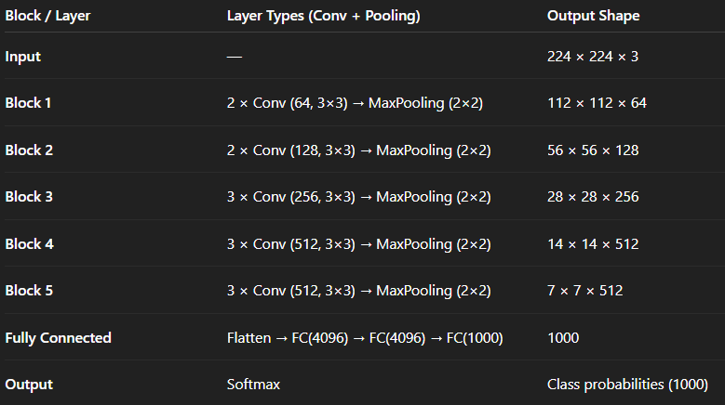

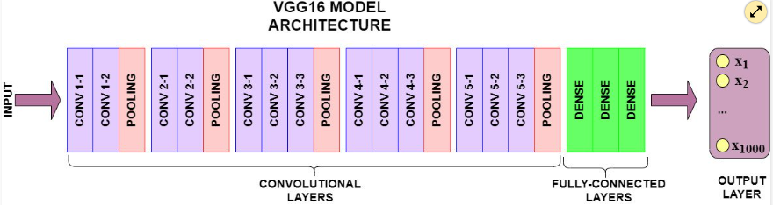

## **ResNet – Residual Neural Network**

* **ResNet** (Residual Network) was introduced by **Kaiming He.** in **2015**.
* It **won** the **ImageNet 2015 Challenge** with an **error rate of 3.57%**, outperforming all previous models.
* Solves the **vanishing gradient** and **degradation** problems in deep neural networks.

## 🧱 Key Concept: **Residual Learning**

* In deep networks, as layers are added, accuracy can **decrease** due to difficulty in training.
* ResNet introduces **“shortcut connections”** that allow the network to **skip layers** and **directly pass information** to deeper layers.
* **Skip/Residual connection** helps in training deeper networks by allowing gradient flow.
* •**ResNet-50** = 1 conv + 16 bottleneck blocks = **50 layers.**

### ✅ ****Residual Block****:

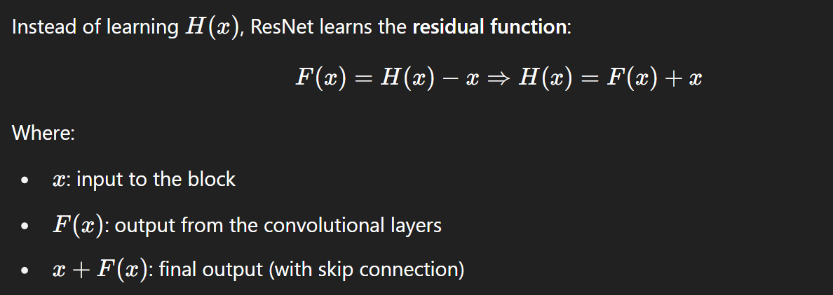

This helps gradients flow backward easily through **identity connections**, avoiding vanishing gradients.

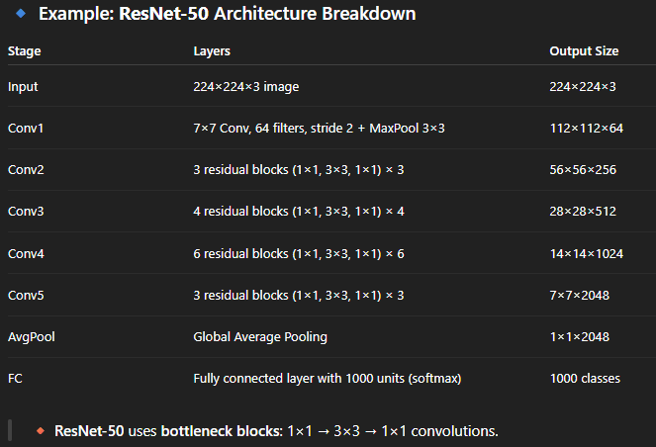

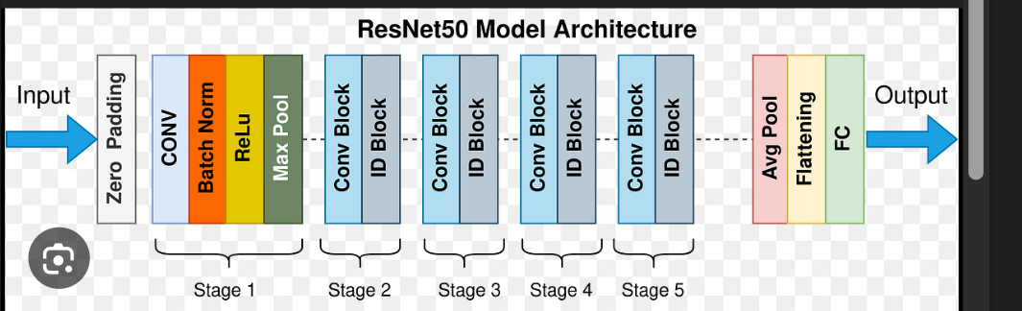 Key Features

1. **Skip Connections**:
   * Enable direct gradient flow and stabilize deep network training.
2. **Very Deep**:
   * Networks with **50, 101, or even 152 layers** can be trained successfully.
3. **Improved Accuracy**:
   * Outperforms VGG, AlexNet, and traditional CNNs in image classification.
4. **Parameter Efficiency**:
   * Bottleneck blocks reduce number of parameters while maintaining depth.

**Unit 6:**

**Pattern Classification & Recognition Systems**

**Classification: Recognition of Olympic Games Symbols**

**Pattern Recognition** is the process of identifying regularities and structures in data and classifying them into categories based on learned patterns. It is widely used in image analysis, biometric systems, speech processing, and text recognition.

In this context, the **recognition of Olympic Games symbols** is a visual pattern recognition task where pictograms representing different sports are identified from images.

The **Olympic Games symbols** include internationally recognized logos and pictograms that represent various sports (e.g., swimming, gymnastics, running). These symbols:

* Are designed to be language-independent.
* Have distinct shapes and patterns for each sport.
* Must be correctly recognized for applications such as automatic sports classification, mobile applications, broadcasting, and accessibility services.

### ****Application to Recognition of Olympic Games Symbols****

#### **Steps Involved**:

1. **Image Preprocessing**:
   * Input Olympic symbol image is normalized, resized, and converted to grayscale or binary if needed.
   * Noise reduction and edge detection may also be applied.
2. **Feature Extraction**:
   * Features such as shape, boundary, and texture are extracted.
   * Alternatively, raw pixel data may be used directly if deep neural networks are employed.
3. **Training the ANN**:
   * A dataset of labeled Olympic symbols is used.
   * The ANN is trained to map input images to their correct categories (e.g., swimming, boxing, archery).
4. **Classification**:
   * When a new symbol image is input, the ANN predicts the class with the highest probability.

**📄 2. Recognition of Printed Characters (OCR)**

Artificial Neural Networks (ANNs) are powerful tools inspired by the structure and functioning of the human brain. They are widely used in pattern recognition tasks, especially for image-based data such as **printed character recognition**. ANNs can effectively learn and classify patterns, making them ideal for Optical Character Recognition (OCR) systems.

### ****Working of ANN in Printed Character Recognition****

#### **1. Input Layer**

* The printed character image is converted into a grid of pixels (e.g., 28x28 pixels).
* Each pixel's intensity is used as an input neuron.
* For example, a 28x28 image will have 784 input neurons.

#### **2. Preprocessing**

* Convert the character image to grayscale or binary.
* Normalize the size and remove noise.
* Flatten the image into a 1D input vector for the ANN.

#### **3. Hidden Layers**

* One or more hidden layers process the input using **weights, biases**, and **activation functions**.
* These layers extract meaningful features such as:
  + Curves
  + Lines
  + Dots
  + Edge patterns

#### **4. Output Layer**

* Each output neuron represents one possible character (e.g., 26 for A-Z or 36 for A-Z and 0-9).
* The neuron with the highest output value represents the predicted character.

### ****Training the ANN****

* The ANN is trained using a labeled dataset (e.g., MNIST for digits or EMNIST for letters).
* The **backpropagation algorithm** adjusts weights based on the error between predicted and actual output.
* After multiple epochs of training, the ANN learns to generalize and accurately classify new character inputs.

### ****Example****

If the input is a printed character 'B':

* The image is fed to the ANN.
* After processing, the network activates the output neuron corresponding to 'B'.
* The ANN outputs **"B"** with high confidence.

**Real-World Use Cases:**

* Bank cheque reading.
* Automated data entry.
* Reading utility bills and receipts.

### ****Neocognitron Neural Network****

The **Neocognitron** is a **hierarchical, multilayered artificial neural network** developed by **Kunihiko Fukushima in 1979**.Particularly useful in the **recognition of handwritten characters**.

The architecture of the Neocognitron was **inspired by the human visual system**, especially the structure and function of **neurons in the primary visual cortex (V1 area)**. It laid the foundation for **modern convolutional neural networks (CNNs)**, which are widely used in today’s image recognition systems.

### ****Architecture of Neocognitron****

The Neocognitron consists of multiple layers of two main types of neuron modules:

#### 🔹 **S-cells (Simple cells)**

* Function: Detect **specific local features** such as edges, lines, curves, etc.
* Each S-cell receives input from a small, localized region of the previous layer.
* Feature-selective: Only responds to specific shapes or patterns.

#### 🔹 **C-cells (Complex cells)**

* Function: Provide **positional tolerance** (shift-invariance).
* Each C-cell combines outputs from a group of S-cells (called a receptive field).
* Helps the system recognize features regardless of their **exact position** in the input.

#### 🔹 **Hierarchy of Layers:**

Input → S1 → C1 → S2 → C2 → ... → Sn → Cn → Output Layer

#### 🔹 **Output Layer:**

* The final output layer performs **pattern classification**.
* Each output unit represents a **character class** (e.g., ‘A’, ‘B’, ‘1’, ‘2’, etc.).
* The unit with the strongest response indicates the **recognized character**.

### ****How Neocognitron is Trained****

#### 🔸 **A. Unsupervised Learning (Feature Extraction Layers)**

The initial layers (S and C layers) **learn feature detectors** automatically without labeled data:

* **Self-organization** based on Hebbian learning principles.
* S-cells become sensitive to basic features (lines, corners, curves).
* The network adapts to extract features that are **frequently occurring patterns** in input data.
* C-cells aggregate S-cell outputs, improving robustness to position.

#### 🔸 **B. Supervised Learning (Classification Layer)**

The final output layer is trained **supervised**, using labeled examples:

* During training, **each input is associated with a known class** (e.g., image of digit “3” labeled as class 3).
* The final layer uses **winner-takes-all or backpropagation** mechanisms to adjust connections.
* After training, the network can classify unseen inputs based on the learned hierarchical features.

### ****Significance in Handwritten Character Recognition:****

* **Tolerant to Variations:** Neocognitron can tolerate differences in writing styles, sizes, and positions.
* **Automatic Feature Learning:** It learns to extract relevant features without manually engineering them.
* **No Need for Perfect Alignment:** Unlike some traditional OCR methods, the input does not need to be perfectly centered.
* **Effective for Noisy Input:** It can handle partially distorted or noisy handwritten inputs.

## **Q: You have been asked to develop a model for recognizing handwritten digits. What are the chosen steps for the activity? Explain each with detail.**

To develop a **handwritten digit recognition model**, a systematic approach using **Machine Learning / Deep Learning** techniques is followed. Below are the **key steps** involved:

### 🔹 ****1. Data Collection****

* Collect a dataset of labeled handwritten digits.
* Most commonly used: **MNIST dataset** (Modified National Institute of Standards and Technology), which contains:
  + 60,000 training images
  + 10,000 test images
* Each image is 28x28 pixels in grayscale, labeled 0–9.

### 🔹 ****2. Data Preprocessing****

* **Normalization**: Scale pixel values to the range [0, 1] or [-1, 1] for faster convergence.
* **Reshaping**: Flatten 28x28 images to 784-dimensional vectors (for ANN) or retain 2D shape for CNNs.
* **Noise Removal**: Remove unwanted marks or smudges using filters.
* **Augmentation** (optional): Rotate, scale, or flip images to improve generalization.

### 🔹 ****3. Model Selection****

Choose an appropriate model:

* **Artificial Neural Network (ANN)**: Basic feed-forward network
* **Convolutional Neural Network (CNN)**: Best suited for image data due to spatial feature extraction.
  + Consists of layers like convolution, pooling, and fully connected layers.

### 🔹 ****4. Model Training****

* Use the **training dataset** to train the model.
* Feed input images to the network and adjust weights using:
  + **Forward propagation**
  + **Loss calculation** (e.g., cross-entropy)
  + **Backpropagation**
  + **Optimizer** (e.g., Adam, SGD)

### 🔹 ****5. Model Evaluation****

* Evaluate the model on the **test dataset**.
* Use performance metrics:
  + **Accuracy**
  + **Confusion Matrix**
  + **Precision/Recall**
* Helps check for overfitting or underfitting.

### 🔹 ****6. Model Optimization****

* Fine-tune the model to improve performance:
  + Adjust learning rate, batch size, number of layers.
  + Add dropout layers to prevent overfitting.
  + Apply regularization techniques (L1/L2).

### 🔹 ****7. Deployment****

* Convert the trained model into a deployable format.
* Integrate into applications like:
  + Banking check scanners
  + Postal address readers
  + Mobile OCR apps
* Deploy using platforms like TensorFlow Lite, ONNX, etc.

## Q-**Device That Recognizes a Pattern of Handwritten or Printed Characters**

### The device is known as an ****OCR (Optical Character Recognition) System****.

**OCR (Optical Character Recognition)** is an advanced computer vision technology used to **automatically identify and convert text—either printed or handwritten—into machine-readable digital form**.

It is widely used in:

* Document digitization (e.g., scanning books or printed forms)
* Mobile applications (e.g., scanning receipts, IDs)
* Bank cheque processing
* Passport and ID card reading
* License plate recognition systems

## **Working of OCR System**

OCR works by using a combination of **image processing**, **pattern recognition**, and **machine learning** techniques. Below is the in-depth explanation:

### ✅ ****1. Image Acquisition****

* **Input**: The source document (printed or handwritten) is captured as a digital image using:Flatbed scanner,Mobile camera, Document camera.
* **Image Format**: The image is usually stored in formats such as .jpg, .png, or .pdf.

🧠 **Goal**: Obtain a clear and readable image for further processing.

### ✅ ****2. Preprocessing****

Preprocessing improves the quality of the image so that character recognition becomes easier and more accurate.

* **Noise Removal**: Cleans the image by removing dots, lines, or stains that could interfere with recognition.
* **Binarization**: Converts the image to black (foreground text) and white (background). This simplifies the image to focus only on text.
* **Normalization**: Adjusts the scale, rotation, and alignment of characters to maintain uniformity across the image.
* **Skew Correction**: Rotates the image if it is tilted or slanted.
* **Thinning**: Reduces the width of character strokes to a single pixel-wide skeleton, enhancing shape recognition.

🧠 **Goal**: Make the image clearer and more consistent for analysis.

### ✅ ****3. Character Segmentation****

Segmentation is one of the most crucial steps in OCR, especially for handwritten text.

* The image is split into:
  + **Lines**
  + **Words**
  + **Individual characters**
* Each character is isolated so it can be analyzed separately.

🧠 **Goal**: Identify the boundaries of each character accurately.

### ✅ ****4. Feature Extraction****

This is the process of identifying the most important characteristics of each character.

* Features can include:
  + **Edges**
  + **Corners**
  + **Loops** (e.g., in letters like 'a', 'o', 'e')
  + **Junctions** (where lines intersect, like in 'k' or 'x')
  + **Stroke direction and length**

These features are converted into a **numerical vector** representing the character.

🧠 **Goal**: Transform visual character shapes into a form understandable by recognition algorithms.

### ✅ ****5. Character Recognition (Using ML/ANN)****

At this stage, the extracted features are input into a **trained recognition model**.

There are two major approaches:

#### 🔹 **A. Template Matching (Old Method)**

* Compares the character against stored templates.
* Limited accuracy and fails on varied fonts or handwriting.

#### 🔹 **B. Machine Learning / Artificial Neural Networks (Modern Method)**

* **Supervised learning** is used to train a model with thousands of character images.
* **Artificial Neural Networks (ANN)** or **Convolutional Neural Networks (CNNs)** are used.
  + CNNs are powerful in recognizing **handwritten characters** by learning spatial features.
* **Output**: The model gives a **probability score** for each character class and selects the one with the highest probability.

🧠 **Goal**: Accurately classify each character using learned patterns.

### ✅ ****6. Output Generation****

Finally, the recognized characters are **converted into a usable digital format**:

* **Text files (.txt)**
* **Word processing files (.doc, .docx)**
* **Searchable PDFs**
* **Database entries** for further processing (e.g., forms, IDs)

Users can **edit, search, or store** the text just like any other digital data.

## **What is NETtalk?**

**NETtalk** is a **neural network-based model** developed to **convert English text into speech sounds**. It simulates how humans learn to pronounce written text by using **artificial neural networks (ANNs)** to map **graphemes (letters)** to **phonemes (speech sounds)**.

## **Purpose of NETtalk:**

NETtalk was developed as a **speech synthesis system** to show that a neural network can learn **complex language patterns** such as:

* English pronunciation rules
* Handling of irregular words and phonetic inconsistencies

It is often cited as one of the **first successful applications of ANN** in **natural language processing**.

## **How NETtalk Works:**

### 1. ****Input Layer:****

* Takes a **sliding window** of letters from a sentence (typically 7 letters at a time).
* Each letter is encoded as a **binary vector**.

### 2. ****Hidden Layer:****

* Learns the internal representation of pronunciation patterns.
* Adjusts weights during training to reduce pronunciation error.

### 3. ****Output Layer:****

* Produces a **phoneme** (a basic sound unit of speech) for the **central letter** in the input window.
* These phonemes are then converted to sound using a speech synthesizer.

## **Q-Explain Automatic Language Translation with Its Three Basic Rules**

**Automatic Language Translation** is the process of using **computer software or algorithms** to convert text or speech from one language (source language) into another language (target language) **without human intervention**.

This technique is widely used in:

* Translation apps (Google Translate)
* Multilingual websites
* International communication tools

### 🧠 ****Three Basic Rules / Approaches of Language Translation****

Automatic translation is typically based on three major approaches (or rules):

### 1. ****Syntactic Rule-Based Translation (Rule-Based Machine Translation – RBMT):****

* Uses **grammar rules** and a **bilingual dictionary**.
* Translates by analyzing **syntax and grammar structure**.
* Example: Subject–Verb–Object order is converted from one language to another based on grammar rules.

✅ Pros: Suitable for grammatically strict languages  
❌ Cons: Poor handling of exceptions, idioms, and informal language

### 2. ****Statistical Rule-Based Translation (Statistical Machine Translation – SMT):****

* Uses **probabilities/statistics** based on large bilingual corpora/document set.
* Learns likely word mappings from **frequency of usage**.
* Example: If "hello" frequently matches with "hola" in English-Spanish text pairs, the model learns this translation.

✅ Pros: Learns from real-world data  
❌ Cons: Requires large datasets; errors in rare or complex sentences

### 3. ****Neural Network-Based Translation (Neural Machine Translation – NMT):****

* Uses **deep learning and neural networks** (especially LSTM or Transformer models).
* Understands **context**, not just word-to-word translation.
* Translates entire sentences more naturally and fluently.

✅ Pros: High-quality, context-aware translations  
❌ Cons: Computationally expensive; requires lots of training data.

### ****Translation Process****

1. Text is input in Source Language.
2. Tokenization and analysis of structure.
3. Translated using one of the rules above.
4. Output is generated in Target Language.

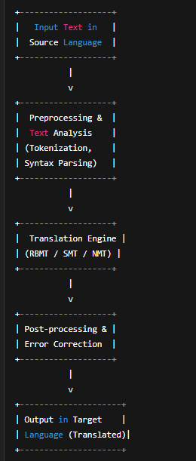

## **Q-What is Automatic Translation? How Does It Work? What Are Its Benefits?**

**Automatic Translation**, also known as **Machine Translation (MT)**, is a subfield of computational linguistics that focuses on **automatically converting text or speech** from one language into another using **software or AI models**, without human intervention.

Example: Translating "Good Morning" in English to "Bonjour" in French using Google Translate.

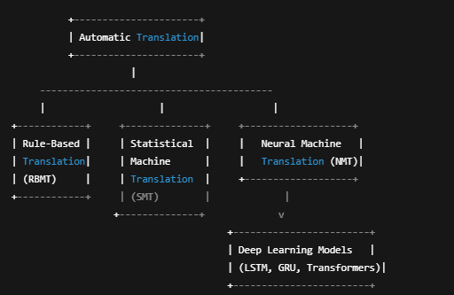

Automatic translation involves the following steps:

#### 1. **Input Analysis:**

* The sentence is tokenized (split into words).
* Grammar, structure, and meaning are analyzed.

#### 2. **Translation Engine:**

Uses one of the following approaches:

* **Rule-Based (RBMT)**: Uses dictionaries and grammar rules.
* **Statistical (SMT)**: Translates using statistical word mappings.
* **Neural (NMT)**: Uses deep learning to understand and translate full sentences contextually.

#### 3. **Target Language Generation:**

* Produces translated text with appropriate grammar and word order.
* May apply post-editing to improve fluency.

#### 4. **Output Display:**

* The translated text is presented to the user.

## **Q-Recognition of Consonant-Vowel (CV) Segments using Artificial Neural Networks (ANN)**

### 🔹 ****What are CV Segments?****

* **CV segments** refer to basic **speech sound units** formed by the combination of a **consonant followed by a vowel**, e.g., /ka/, /ba/, /ma/, etc.
* These are **phonetic building blocks** of spoken language and are crucial for **speech recognition and synthesis**.

### 🔹 ****Why Recognize CV Segments?****

* Important for **automatic speech recognition (ASR)** systems.
* Enhances performance in **language translation**, **voice assistants**, and **speech-to-text** applications.
* Useful in **phoneme-level modeling**, especially for children’s speech, speech therapy, and accent recognition.

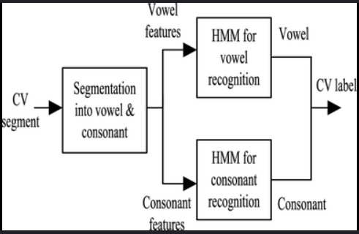

## 🔹 **Application of ANN in CV Segment Recognition**

### 1. ****Feature Extraction****

* Extract features from the speech signal using:
  + **MFCC (Mel Frequency Cepstral Coefficients)**
  + **Linear Predictive Coding (LPC)**
  + **Spectrograms**
* These features represent important acoustic characteristics of the CV sounds.

### 2. ****Input to ANN****

* The extracted features are input to the **Artificial Neural Network**.
* The input layer corresponds to the number of extracted features (e.g., 13 MFCCs).

### 3. ****Neural Network Architecture****

* Typically a **Multi-Layer Perceptron (MLP)** or **Recurrent Neural Network (RNN)** is used.
* Structure:
  + **Input layer**: Feature vectors
  + **Hidden layers**: Neurons learn complex acoustic patterns
  + **Output layer**: CV classes (e.g., 20–40 CV segment classes)

### 4. ****Training the ANN****

* Supervised learning: Provide labeled CV audio samples.
* Use **Backpropagation** and **Gradient Descent** to minimize loss.
* ANN learns to distinguish between different CV combinations.

### 5. ****Testing and Recognition****

* New, unseen audio is fed to the trained ANN.
* The network predicts the most likely CV segment.

## **Benefits of Using ANN for CV Recognition**

* **Non-linear mapping** ability allows modeling complex acoustic patterns.
* **High accuracy** in recognizing subtle differences between similar sounds.
* **Noise tolerance**, especially with properly trained deep networks.
* Works well with **limited datasets** using transfer learning or data augmentation.

## **Q-**Texture Classification and Segmentation

Texture classification and segmentation are key tasks in **image processing** and **computer vision**, where the goal is to **understand visual patterns** in images.

### What is Texture?

* **Texture** refers to the visual surface characteristics and patterns of objects in an image.
* Examples: grass, brick walls, fabric, wood grain, sand, etc.
* It is defined by the **spatial distribution of pixel intensities**.

## Texture Classification

Texture classification is the process of **assigning a texture label** (such as “rough”, “smooth”, “repetitive”) to an **image or region** based on its visual patterns.

### Steps in Texture Classification:

1. **Preprocessing**
   * Convert the image to grayscale.
   * Apply filters to enhance texture (e.g., Gaussian, Laplacian).
2. **Feature Extraction**  
   Extract meaningful descriptors like:
   * **GLCM** (Gray-Level Co-occurrence Matrix)
   * **LBP** (Local Binary Pattern)
   * **Gabor Filters**
   * **Wavelet Transforms**
3. **Classification using ANN**
   * Feed extracted features into a **trained classifier** like:
     + Artificial Neural Network (ANN)
     + Convolutional Neural Network (CNN)
     + Support Vector Machine (SVM)
   * The model assigns a **label** to the texture (e.g., “grass”, “fabric”).

### Applications:

* **Industrial Inspection** (e.g., detecting defects on surfaces)
* **Remote Sensing** (e.g., classifying land-use types from satellite images)
* **Face and fingerprint recognition**

## Texture Segmentation

Texture segmentation is the process of **partitioning an image** into multiple **regions with distinct textures**.

### Steps in Texture Segmentation:

1. **Texture Feature Computation**
   * Calculate texture descriptors (LBP, Gabor filters) for each pixel or patch.
2. **Segmentation Process**  
   Use:
   * **Clustering Algorithms** (like k-means) to group similar texture regions.
   * **Neural Networks** or **Self-Organizing Maps (SOMs)** for unsupervised segmentation.
3. **Post-processing**
   * Smooth segmented regions to remove noise.
   * Apply morphological operations to enhance boundaries.

### 🔸 Applications:

* **Medical Imaging** (e.g., tumor vs. healthy tissue)
* **Object Detection**
* **Geographical Image Analysis**

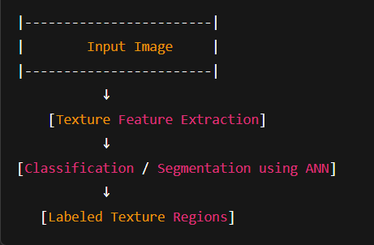

## **Q-Texture Classification using Convolutional Neural Networks (CNNs)** [5 Marks]

Texture classification is the process of identifying and labeling textures (e.g., smooth, rough, dotted, woven) in an image using computational methods.

### 🔹 Why Use CNNs?

Convolutional Neural Networks (CNNs) are ideal for texture classification because they automatically **extract spatial features** like edges, patterns, and shapes that define texture, without manual feature engineering.

### ✅ ****Steps in Texture Classification Using CNN:****

### ****Input Image****

* + Raw image or patches containing textures are given as input to the CNN.
  + Images may be grayscale or RGB.

### ****Convolution Layers****

* + CNN applies **filters (kernels)** that detect low-level texture features:
    - Lines
    - Dots
    - Repeated patterns
  + These filters slide across the image and create **feature maps**.

### ****Activation & Pooling****

* + **ReLU** activation is applied to add non-linearity.
  + **Max Pooling** reduces the size of feature maps while preserving important features.
  + Helps to reduce computation and focus on dominant texture features.

### ****Fully Connected Layers****

* + The high-level features are flattened and passed through **dense layers** to make decisions about texture class.

### ****Output Layer****

* + A **Softmax classifier** predicts the probability of each texture class.
  + The highest probability class is the output (e.g., fabric, sand, wood).

### 🔹 Advantages of Using CNN:

* Learns complex patterns automatically.
* Works well even on **large and diverse texture datasets**.
* Outperforms traditional hand-crafted methods.

### 🔹 Applications:

* Material surface inspection
* Terrain classification in remote sensing
* Medical image texture analysis (e.g., MRI scans)

