Unit 3:

**Virtualization**  
Virtualization is a technology that allows a single physical computer to share its hardware resources with multiple digitally separated environments. These environments operate as independent virtual systems, each with its own allocated memory, CPU, and storage. This enables multiple operating systems and applications to run simultaneously on the same physical hardware, improving hardware utilization, flexibility, and performance.

#### ****Adopting Virtualization:****

Organizations adopt virtualization to:

* Increase the efficiency of hardware usage.
* Lower operational and maintenance costs.
* Reduce energy consumption.
* Simplify IT infrastructure.  
  Virtualization allows companies to run different operating systems and applications on a single server without rebooting, making it ideal for cloud computing, server consolidation, and disaster recovery.

#### ****3. Importance of Virtualization:****

Consider a company that needs three different servers:

* One for secure email storage,
* One for a customer-facing application,
* One for internal business processes.

#### ****Key Concepts in Virtualization:****

* **Virtual Machine (VM):** A software-based emulation of a physical computer. It runs its own operating system and applications, acting as an independent guest machine on a host system.
* **Hypervisor:** A software layer that manages multiple VMs on a single physical machine. It ensures that resources are properly distributed among VMs without interference, maintaining system stability and isolation.

#### ****Types of Virtualization:****

* **Server Virtualization:** Dividing a physical server into multiple VMs, each serving different purposes.
* **Storage Virtualization:** Pooling physical storage from multiple devices into a single, manageable virtual storage unit.
* **Network Virtualization:** Abstracting physical network resources to create multiple virtual networks.
* **Desktop Virtualization:** Hosting desktop environments on a central server and delivering them to end users over a network.
* **Application Virtualization:** Running applications in a virtual environment without installing them on the local device.

### **Advantages of Virtualization:**

1. **Efficient Resource Utilization:**
   * Virtualization allows multiple virtual machines to run on a single physical machine, improving the use of available hardware resources.
2. **Cost Reduction:**
   * Reduces the need for purchasing and maintaining multiple physical servers, thereby lowering hardware and maintenance costs.
3. **Energy Savings:**
   * Fewer physical machines result in lower power consumption and cooling requirements in data centers.
4. **Flexibility and Scalability:**
   * Virtual machines can be easily created, modified, or deleted as needed, making it easy to scale up or down.
5. **Isolation:**
   * Each virtual machine operates independently, so a crash or security breach in one VM does not affect others.
6. **Support for Legacy Systems:**
   * Virtualization allows older operating systems and applications to run on modern hardware without compatibility issues.
7. **Disaster Recovery and Backup:**
   * Virtual machines can be easily backed up, cloned, or restored, which enhances disaster recovery capabilities.

### **Disadvantages of Virtualization:**

1. **Initial Setup Cost:**
   * Though it saves costs in the long run, the initial cost of setting up virtualization infrastructure and licenses can be high.
2. **Performance Overhead:**
   * Virtual machines may not perform as efficiently as physical machines due to the extra layer of the hypervisor.
3. **Security Risks:**
   * If not properly configured, a vulnerability in the hypervisor could affect multiple virtual machines.
4. **Complex Management:**
   * Managing virtual environments, especially in large-scale deployments, can be complex and may require specialized skills.
5. **Resource Contention:**
   * If too many VMs are hosted on a single physical machine, they may compete for resources, leading to performance issues.
6. **Licensing Issues:**
   * Software licensing in virtual environments can be more complicated and may incur additional costs.

### **Virtual Clustering:**

**Virtual clustering** in cloud computing refers to the technique of grouping multiple **virtual machines (VMs)** to work together as a **single logical unit or cluster**. These clusters can provide high availability, load balancing, and efficient resource utilization without relying on physical proximity or hardware.

### **Key Concepts:**

1. **Virtual Machines (VMs)**
2. **Cluster**
3. **Virtual Clustering**

### **Advantages of Virtual Clustering:**

1. **High Availability:**
   * If one VM fails, another in the cluster can take over, ensuring continuity.
2. **Load Balancing:**
   * Workload is distributed across VMs to prevent any single VM from being overloaded.
3. **Scalability:**
   * New VMs can be added to the cluster dynamically to handle more workload.
4. **Cost Efficiency:**
   * Reduces the need for physical infrastructure by using virtualized environments.
5. **Flexibility and Isolation:**
   * Different applications or services can run on separate VMs while still being part of the same cluster.

### **Architecture Components:**

1. **Physical Servers (Host Machines):**
   * These are actual hardware systems that run multiple virtual machines.
   * Each host uses a **hypervisor** to create and manage VMs.
2. **Hypervisor (Virtual Machine Monitor):**
   * Software that sits between the hardware and the virtual machines.
   * It allocates resources (CPU, memory, storage) to each VM and ensures isolation.
3. **Virtual Machines (VMs):**
   * Software-based computers that act as nodes in the cluster.
   * Each VM can run its own OS and specific applications.
4. **Virtual Cluster Manager:**
   * Software or service that manages the coordination and communication between VMs in the cluster.
   * Examples: Kubernetes, Apache Mesos, Windows Failover Cluster.
5. **Shared Storage System:**
   * Centralized storage accessible by all VMs in the cluster.
   * Ensures data availability and synchronization.
6. **Network Infrastructure:**
   * Enables communication between virtual machines within the cluster.
   * Includes virtual switches, routers, and firewalls.

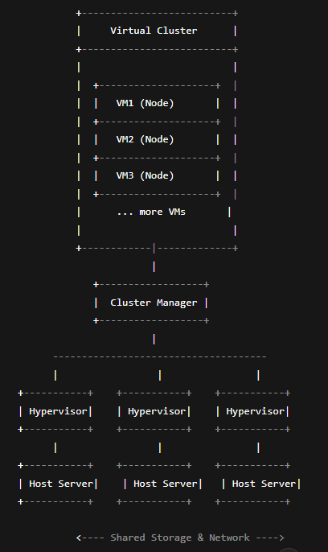

#### ****Virtualization Architecture:****

Virtualization architecture is the framework that allows multiple virtual machines (VMs) to run on a single physical machine using a software layer known as the **hypervisor**. It enables efficient resource sharing, isolation, and management of hardware resources such as CPU, memory, and storage.

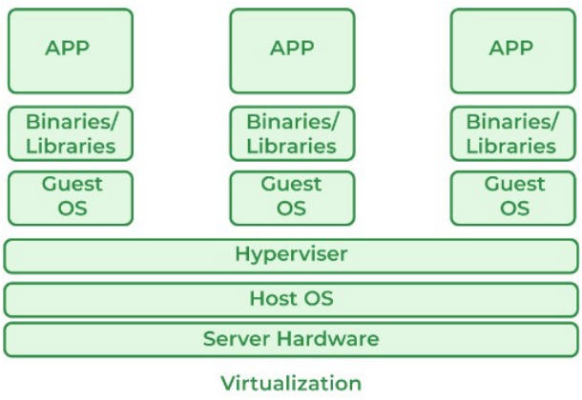

### **1. Physical Hardware Layer:**

* This is the **foundation layer** of the virtualization architecture.
* It includes **physical servers**, **storage devices**, **CPUs**, **memory (RAM)**, **disk drives**, and **network adapters**.
* All virtualization processes are ultimately dependent on this physical infrastructure.

### **2. Hypervisor Layer (Virtual Machine Monitor - VMM):**

* The **hypervisor** is a critical component that sits **directly on top of the hardware**.
* It is responsible for:
  + Creating and managing **multiple virtual machines**.
  + **Partitioning physical resources** (CPU, memory, storage) into logical units.
  + Ensuring that **each VM operates independently** and securely without interference.
* There are two types of hypervisors:
  + **Type 1 (Bare-metal):** Runs directly on hardware (e.g., VMware ESXi, Microsoft Hyper-V).
  + **Type 2 (Hosted):** Runs over a host OS (e.g., VirtualBox, VMware Workstation).

### **3. Virtualization Management Layer:**

* This layer **provides the tools and interfaces** required to manage virtual resources.
* Administrators can:
  + **Create, configure, and monitor VMs**.
  + Manage **virtual networks** and **virtual storage devices**.
* Examples of virtualization management tools include **VMware vCenter**, **Red Hat Virtualization Manager**, etc.

### **4. Guest Operating System Layer:**

* Each **virtual machine** hosts its own **guest operating system** (e.g., Windows, Linux).
* These OSes function as if they were installed on physical hardware.
* The guest OS interacts with virtualized hardware provided by the hypervisor and allows applications to run.

### **5. Application Layer:**

* This is the **topmost layer**, where **applications and workloads** execute inside the virtual machines.
* Each virtual machine can run **multiple applications** based on the resources assigned to it.
* Applications in different VMs remain **isolated**, providing better **security**, **flexibility**, and **resource management**.

### **Virtualization Software Examples:**

| **Category** | **Software Tools** |
| --- | --- |
| **Type-1 Hypervisors** | VMware ESXi, Microsoft Hyper-V, XenServer |
| **Type-2 Hypervisors** | Oracle VirtualBox, VMware Workstation |
| **Cloud Virtualization** | KVM, OpenStack, Proxmox, AWS EC2 (based on Xen/KVM) |
| **Management Tools** | VMware vSphere, Red Hat Virtualization Manager |

### **Selection Criteria for Best Virtualization Software:**

1. **Core Functionality**:
   * **Resource Management**: Efficient use of CPU and memory without overloading the host.
   * **Scalability**: Ability to handle growth across single or multiple VMs.
   * **Security**: Must include encryption, authentication, and access control.
2. **Key Features**:
   * **Hardware Compatibility**: Should support diverse hardware and processor architectures.
   * **System Management**: Easy configuration, simulation, and data collection.
   * **Consolidation**: Efficient multitasking, VM migration, and replication within a host.
3. **Usability**:
   * User-friendly interface with centralized control over the virtual environment.
   * Good documentation and beginner-friendly guides.
4. **Integrations**:
   * Broad support for various guest operating systems.
   * Flexibility to test different applications and services within VMs.

## **Applications of Virtualization in Cloud Computing**

Virtualization plays a crucial role in enabling the delivery of flexible, scalable, and efficient cloud computing services. Below are some key applications of virtualization within cloud environments:

### **1. Resource Pooling and On-Demand Provisioning**

Virtualization allows cloud service providers to **pool physical resources** such as CPU, memory, and storage from multiple servers. These resources can be **provisioned on-demand** to users through virtual machines (VMs), ensuring optimal resource utilization and scalability based on current workload demands.

### **2. Multi-Tenancy**

Through virtualization, multiple users (tenants) can securely share the same physical hardware. Each tenant operates in an **isolated virtual environment**, ensuring **data security, privacy, and efficient use** of infrastructure without interference from other tenants.

### **3. Infrastructure as a Service (IaaS)**

In IaaS cloud models, virtualization is the backbone for providing **virtualized compute, storage, and networking** resources. Users can deploy and manage these virtual components independently, without needing to handle or maintain physical hardware.

### **4. Disaster Recovery and Business Continuity**

Virtualization simplifies disaster recovery processes by enabling **live migration** of VMs between physical hosts or data centers. This capability ensures **minimal downtime** during failures and maintains **business continuity** by restoring services quickly.

### **5. Cloud Bursting**

With virtualization, organizations can extend their **on-premises infrastructure to the cloud** during peak demand periods. This technique, known as **cloud bursting**, enables dynamic deployment of virtual machines to manage temporary spikes in workload, improving performance and cost-efficiency.

### **6. Platform as a Service (PaaS)**

Virtualization supports PaaS platforms by offering **pre-configured environments** for application development and deployment. Developers can use virtualized instances for **coding, testing, and production**, without needing to manage the physical infrastructure.

## **Pitfalls of Virtualization in Cloud Computing**

Although virtualization enhances flexibility and resource utilization in cloud computing, it also introduces several challenges and limitations. The key pitfalls include:

### **1. Performance Overhead**

Virtualization introduces a **performance penalty** due to the presence of the **hypervisor layer**, which sits between the physical hardware and virtual machines. This can lead to **reduced application performance**, particularly for resource-intensive workloads, as the hypervisor consumes CPU, memory, and other resources.

### **2. Resource Contention**

In a **multi-tenant cloud environment**, multiple virtual machines often share the same physical infrastructure. Without proper management, this can lead to **resource contention**, where virtual machines compete for limited CPU, memory, or storage, resulting in **slower response times and degraded performance** during peak periods.

### **3. Security Vulnerabilities**

Virtualization can increase the **attack surface** in cloud environments. A flaw in the **hypervisor** or **misconfigured virtual machines** could allow unauthorized access to other VMs on the same host, leading to potential **data breaches**. Strong isolation mechanisms and security practices are essential to mitigate such risks.

### **4. Management Complexity**

While virtualization simplifies physical hardware utilization, it introduces **complexity in managing virtual infrastructure**. Administrators must handle tasks like VM provisioning, configuration, live migration, load balancing, and performance monitoring. Managing large-scale virtual environments requires advanced tools and expertise.

### **5. Licensing and Compliance Challenges**

Virtualized environments may face **licensing conflicts**, especially when traditional software licensing models are based on physical hardware. Organizations must ensure that their **licensing agreements** and **compliance requirements** are met even in dynamically changing cloud environments.

### **6. Risk of Over-Provisioning**

Although cloud platforms allow **on-demand scalability**, there's a tendency to **over-provision virtual resources**. Allocating more virtual CPUs, memory, or storage than necessary can result in **wasted resources and increased operational costs**, particularly if those resources are underutilized.

## **Virtualization in Grid Computing – Explained**

**Virtualization in Grid Computing** refers to the abstraction and dynamic management of physical computing resources across a distributed grid environment. It allows multiple virtual machines (VMs) to be deployed on physical servers located in different places, effectively pooling resources to function as a unified computing system.

### 🔹 **Key Features and Role of Virtualization in Grid Computing**

1. **Abstracts Physical Infrastructure**  
   Virtualization separates the hardware from the applications by creating virtual environments. This enables the **deployment of VMs across geographically distributed servers**, making the grid more flexible and efficient.
2. **Efficient Resource Pooling and Allocation**  
   It facilitates **sharing and dynamic allocation** of CPU, memory, and storage based on workload demands. Virtual machines can be **scaled up, scaled down, or migrated** to different nodes in the grid as required.
3. **Improved Scalability and Flexibility**  
   As workloads increase, more VMs can be added without needing additional physical servers. This makes grid computing highly **scalable** and **adaptive** to user and application requirements.
4. **Fault Tolerance and High Availability**  
   Virtual machines operate in **isolated environments**, so a failure in one VM doesn't affect others. In case of hardware or software failures, VMs can be **migrated to another host**, ensuring **minimal downtime** and continuous service availability.
5. **Security and Isolation**  
   Virtualization provides **isolation between VMs**, improving security. Applications run independently, and data leakage or faults in one VM do not impact others.
6. **Application in Scientific and High-Performance Computing**  
   Grid computing often supports **scientific simulations, big data analysis, and HPC tasks**. Virtualization helps by **scaling resources on demand** and supporting **heterogeneous applications** in a seamless manner.

### ✅ Advantages:

1. **Efficient Resource Utilization** – Maximizes use of physical hardware by running multiple VMs.
2. **Scalability** – Easily scale resources up or down based on demand.
3. **Fault Tolerance** – Supports VM migration to maintain availability during failures.
4. **Security and Isolation** – Keeps workloads isolated, reducing risk of system-wide failures.

### ❌ Disadvantages:

1. **Performance Overhead** – Virtualization adds extra layers, reducing efficiency.
2. **Resource Contention** – Multiple VMs may compete for limited resources.
3. **Management Complexity** – Requires advanced tools and expertise to manage VMs.
4. **Security Risks in Hypervisor** – Vulnerabilities at the hypervisor level can affect all VMs.

### **Virtualization in Cloud Computing – Short Note**

Virtualization is a core technology in cloud computing that enables the creation of virtual versions of physical resources such as servers, storage, networks, and operating systems. It allows a single physical system to run multiple independent **virtual machines (VMs)**, each acting as an isolated environment.

In cloud environments, virtualization helps optimize hardware utilization, reduce infrastructure costs, and deliver scalable, flexible services. Cloud providers use virtualization to dynamically allocate computing resources based on user needs, allowing users to deploy applications without managing physical hardware.

#### ****Types of Virtualization in Cloud Computing:****

* **Server Virtualization:** Splits a physical server into multiple VMs.
* **Storage Virtualization:** Combines physical storage into a unified virtual pool.
* **Network Virtualization:** Creates virtual networks independent of physical infrastructure.
* **Desktop Virtualization:** Allows remote access to virtual desktops from any device.

Virtualization also ensures **isolation** between VMs, enhancing security and system stability. It is essential in delivering major cloud service models:

* **Infrastructure as a Service (IaaS):** e.g., AWS EC2 – provides virtual machines to users.
* **Platform as a Service (PaaS):** Offers platforms on virtual infrastructure for application development.
* **Software as a Service (SaaS):** Hosts software in virtual environments accessible over the internet.

In summary, virtualization powers cloud computing by enabling **on-demand resource provisioning**, **cost-effectiveness**, **rapid deployment**, and **high availability**.

### **Hypervisor**

A **hypervisor** is a type of software that allows you to **create and run multiple virtual machines (VMs)** on a **single physical computer**. Each VM operates like a separate computer with its own operating system and applications.

#### ****Key Functions:****

* Allocates **CPU, memory, storage**, and other hardware resources to each virtual machine.
* Acts as a **middle layer** between the physical hardware (host) and the virtual machines (guests).
* Enables **virtualization**, which is the foundation of **cloud computing**.

### **Why is a Hypervisor Important?**

* **Efficient Use of Resources**: Multiple VMs share the same hardware, reducing the need for multiple physical servers.
* **Cost Savings**: Reduces hardware and energy costs by running many virtual systems on fewer machines.
* **Scalability**: Easily scale up or down computing power by adding or removing VMs.
* **Portability**: Easily move virtual machines between different physical servers.

### **Type 1 Hypervisor (Bare-Metal Hypervisor):**

A **Type 1 hypervisor** is installed **directly on the physical hardware** of a computer. It does **not require an operating system** beneath it. Because it interacts directly with the hardware, it is called a **bare-metal hypervisor**.

#### ****Key Characteristics:****

* Runs directly on the server hardware.
* Provides **better performance and efficiency**.
* Offers **high security** since there is no underlying host OS.
* Commonly used in **data centers** and for **enterprise-level virtualization**.

#### ****Examples:****

* VMware ESXi
* Microsoft Hyper-V
* Citrix XenServer

### **Type 2 Hypervisor (Hosted Hypervisor):**

A **Type 2 hypervisor** runs **on top of an existing operating system** like Windows, Linux, or macOS. It functions like an **application** on the host OS and uses the host’s resources to run virtual machines.

#### ****Key Characteristics:****

* Installed **as software on an existing OS**.
* Easier to install and use.
* Generally used for **personal or development use**, like testing applications or running multiple OSes.
* **Lower performance and security** compared to Type 1 due to the added layer of the host OS.

#### ****Examples:****

* VMware Workstation
* Oracle VirtualBox
* Parallels Desktop

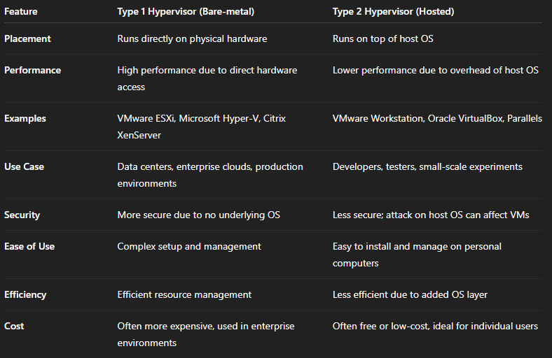

### **1. Server Virtualization**

#### ****Definition:****

Server virtualization is the process of dividing a **physical server** into multiple **virtual servers (Virtual Machines or VMs)**. Each VM can run its own operating system (OS) and applications independently, even though they all share the same physical hardware.

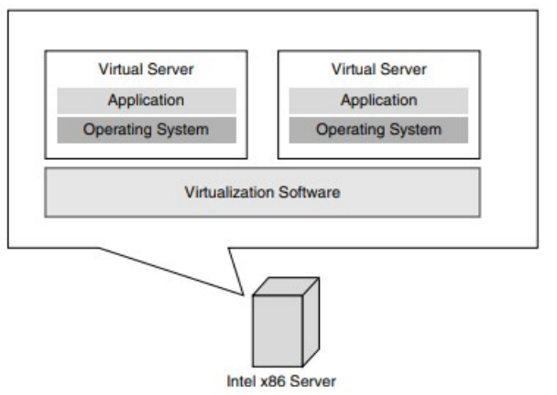

#### ****How It Works:****

A **hypervisor** (either Type 1 or Type 2) is installed to manage the physical hardware and allocate resources like CPU, RAM, and storage to each VM. Each VM operates in isolation, meaning a failure in one does not affect others.

#### ****Uses and Benefits:****

* Reduces the number of physical servers needed (hardware consolidation).
* Lowers hardware and maintenance costs.
* Improves **resource utilization** and system efficiency.
* Simplifies server deployment and management in cloud environments.
* Enables **load balancing**, quick provisioning, and fault isolation.

### **2. Network Virtualization**

#### ****Definition:****

Network virtualization abstracts physical network infrastructure into multiple **virtual networks**. These virtual networks can operate independently while sharing the same underlying physical hardware.

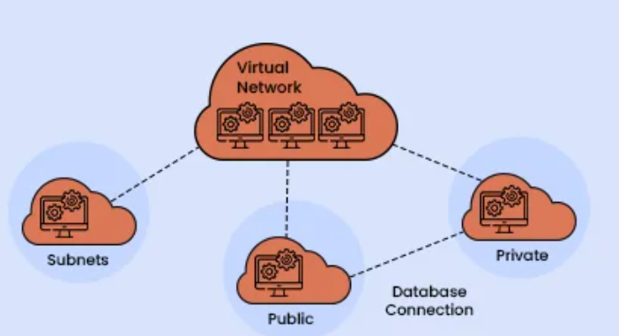

#### ****How It Works:****

Using technologies like **Software-Defined Networking (SDN)** or **Network Functions Virtualization (NFV)**, network virtualization separates the **control plane** (network rules and logic) from the **data plane** (actual packet forwarding). It allows administrators to create, configure, and manage virtual networks dynamically.

#### ****Uses and Benefits:****

* **Improves scalability** and agility by enabling rapid network provisioning.
* Simplifies network management and **reduces configuration errors**.
* Allows for **customized network topologies** for each cloud tenant.
* Enhances **security** by segmenting network traffic.
* Enables **on-demand resource allocation** for different services or tenants.

### **3. Storage Virtualization**

#### ****Definition:****

Storage virtualization combines **multiple physical storage devices** into a single, logical pool of storage that appears as one unit to users and applications.

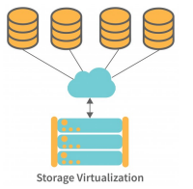

#### ****How It Works:****

A **virtual storage layer** or controller abstracts the physical disks and presents them as a unified storage system. It dynamically manages data distribution, redundancy, and storage space, making it easier for virtual machines to access and utilize storage.

#### ****Uses and Benefits:****

* Simplifies **data management** and backup operations.
* Improves **storage utilization and efficiency**.
* Enhances **fault tolerance and data availability**.
* Allows for **non-disruptive upgrades** and maintenance.
* Supports **scalable cloud storage systems** where storage can be added or reallocated without downtime.

### **4. Application Virtualization**

#### ****Definition:****

Application virtualization allows an application to run **independently of the underlying OS**. This means the app can function on different devices and operating systems without being installed locally.

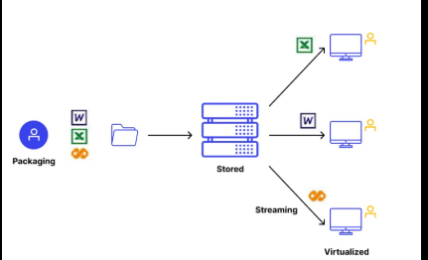

#### ****How It Works:****

Applications are packaged into a **virtual environment** that contains all necessary dependencies. This virtual app can then be streamed or run on a remote server, and accessed by users over the network or cloud.

#### ****Uses and Benefits:****

* Centralized application management: easy to **update or patch** applications.
* Avoids **software conflicts** by isolating applications from each other and from the OS.
* Provides **device and OS independence**, enabling applications to run on various platforms (e.g., Windows apps on Mac).
* Enhances **mobility and remote access** for users in cloud environments.

### **5. Data Virtualization**

#### ****Definition:****

Data virtualization enables real-time access to data across **multiple disparate sources** without physically copying or moving the data.

#### ****How It Works:****

A **virtual data layer** sits between the data sources and the users/applications. It integrates data from multiple systems (e.g., databases, cloud storage, APIs) and presents it as a **unified view**. Users can query this virtual layer as if it were a single database.

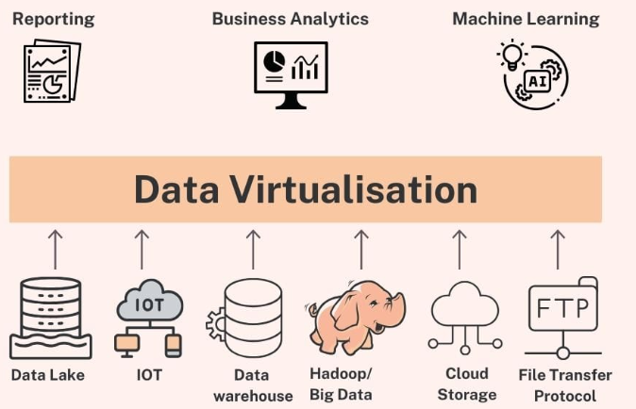

#### ****Uses and Benefits:****

* **Speeds up data access** and analysis without the need for complex ETL (Extract, Transform, Load) processes.
* Facilitates **real-time decision-making** by providing up-to-date data from all sources.
* Reduces **data duplication** and storage costs.
* Simplifies **data integration and reporting**.
* Ideal for **cloud environments** where data resides in multiple systems or services.

## **6. CPU Virtualization**

### **Definition**

CPU virtualization allows **multiple virtual CPUs (vCPUs)** to be created from a single physical CPU. It enables each virtual machine to **think** it has its own dedicated CPU, while the actual processing is shared among many VMs.

### **Working**

* The **hypervisor** intercepts and manages CPU instructions from VMs.
* It **schedules** the execution of virtual CPUs on available physical CPU cores.
* Advanced CPUs now come with **hardware-assisted virtualization features** (e.g., Intel VT-x, AMD-V) that support efficient virtualization directly in the CPU.

### **Use**

* Allows efficient **multi-tenant usage** of CPU resources in cloud computing.
* Helps in **load balancing** and optimizing resource allocation.
* Essential for **running multiple operating systems** or containers concurrently.
* Used in **virtual desktop infrastructure (VDI)** and **cloud platforms** to support CPU-intensive applications.

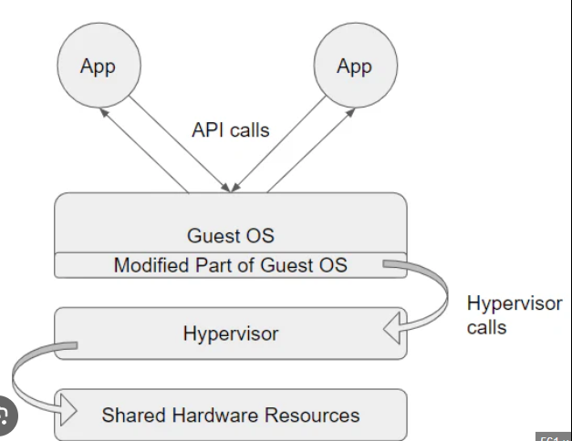

## **Anatomy of Cloud**

The anatomy of cloud computing involves the **core components** that make up a cloud environment. These components work together to deliver **computing resources as services** over the internet.

### 🔧 **1. Cloud Infrastructure**

Cloud infrastructure refers to the **physical and virtual components** required to support cloud computing. It forms the backbone of cloud services (IaaS, PaaS, SaaS).

#### 💡 ****Key Components:****

#### a) ****Compute Resources:****

* Virtual Machines (VMs) or containers that execute applications and services.
* These are hosted on physical servers located in data centers.

#### b) ****Storage Systems:****

* Scalable storage (block, file, object) for storing data and backups.
* Examples: Amazon S3, Google Cloud Storage.

#### c) ****Networking:****

* Physical and virtual networks for data transfer between services and users.
* Includes routers, switches, load balancers, firewalls, and VPNs.

#### d) ****Hypervisor:****

* Software that enables **virtualization** of compute and storage resources.
* Manages multiple virtual machines on a single physical machine.
* Types: Type 1 (bare-metal), Type 2 (hosted).

#### e) ****Data Centers:****

* Physical locations housing servers, storage, and network equipment.
* Managed by cloud providers like AWS, Azure, and Google Cloud.

#### f) ****Cloud Management Software:****

* Tools for provisioning, automation, orchestration, and monitoring.
* Examples: OpenStack, Kubernetes (for containers), VMware vSphere.

### 🖥️ **2. Virtual Infrastructure**

Virtual infrastructure is the **software-defined version** of physical infrastructure. It uses virtualization to abstract and manage hardware resources.

#### 💡 ****Core Elements:****

#### a) ****Virtual Machines (VMs):****

* Software emulations of physical computers.
* Run their own OS and apps in isolation on shared physical hardware.

#### b) ****Virtual Network:****

* Logical networks created using **network virtualization**.
* Enables secure and scalable communication between VMs.

#### c) ****Virtual Storage:****

* Combines multiple storage devices into a unified pool.
* Managed by storage virtualization to allocate space to VMs efficiently.

#### d) ****Virtual Desktop Infrastructure (VDI):****

* Provides desktop environments to users via virtual machines.
* Centralized, secure, and easy to manage.

#### e) ****Virtualization Layer:****

* The **hypervisor** forms this layer and manages all virtual resources.
* Ensures resource isolation, allocation, and security.

## **Virtual Machine (VM) Migration Technique**

### **Definition:**

Virtual Machine Migration is the process of **moving a running virtual machine** from one physical host to another without interrupting its services. This ensures continuous system availability, load balancing, fault tolerance, and better resource utilization in cloud computing environments.

### **Types of VM Migration:**

1. **Live Migration:**
   * In this method, the VM is transferred while it is still running.
   * Minimal or no downtime is observed.
   * Used in scenarios like load balancing and server maintenance.
2. **Cold Migration:**
   * The VM is first powered off, then moved to the target host.
   * It causes complete downtime.
   * Suitable for scheduled maintenance or offline VMs.
3. **Warm Migration:**
   * The VM is suspended, transferred, and then resumed.
   * Downtime is less than cold migration but more than live migration.

### **Steps in Live VM Migration (Pre-copy approach):**

1. **Pre-Migration:**
   * Source and destination hosts are selected.
   * Resources like CPU and memory are checked.
2. **Memory Transfer:**
   * The VM continues running on the source.
   * Memory pages are copied to the destination host.
3. **Iterative Copying:**
   * Modified memory pages are tracked and repeatedly copied until few pages remain.
4. **Stop-and-Copy:**
   * VM execution is paused briefly.
   * Final memory pages and CPU state are transferred.
5. **VM Activation:**
   * The VM resumes on the destination.
   * Source VM instance is deleted.

### **Advantages:**

* Ensures **high availability** of services.
* Facilitates **load balancing** and **server maintenance**.
* Helps in **energy saving** by consolidating VMs and turning off idle servers.

### **Applications:**

* Cloud data center management
* Disaster recovery
* Dynamic resource allocation
* Minimizing downtime during upgrades