**UNIT 1**

**Cloud Computing: Definition, Importance, Advantages, and Disadvantages**

**Definition of Cloud Computing**

Cloud computing is an internet-based technology that enables users to store, manage, and process data on remote servers instead of local computers or physical servers. It provides access to computing resources such as storage, servers, databases, networking, software, and artificial intelligence through third-party cloud service providers. Cloud computing follows a pay-as-you-go model, allowing businesses and individuals to use resources as needed without maintaining costly infrastructure.

**Importance of Cloud Computing**

* Cloud computing plays a crucial role in modern IT infrastructure, offering numerous benefits:
* Cost Efficiency: Reduces expenses by eliminating the need for expensive hardware and maintenance.
* Scalability and Flexibility: Resources can be scaled up or down based on demand.
* Remote Accessibility: Enables users to access data and applications from anywhere with an internet connection.
* Business Continuity: Provides backup and disaster recovery solutions to prevent data loss.
* Faster Innovation: Supports AI, analytics, and software development for businesses.
* Security and Compliance: Cloud providers implement strict security measures to protect data.
* Collaboration and Productivity: Teams can work together on shared applications and documents.
* IT Modernization: Helps businesses transition from traditional infrastructure to advanced cloud-based solutions.

**Advantages of Cloud Computing**

* Scalability: Cloud computing allows businesses to scale resources up or down based on their needs.
* Security: Leading cloud providers implement strong security measures to protect data and infrastructure.
* Cost Efficiency: Eliminates the need for purchasing and maintaining expensive hardware and software.
* Reliability: Cloud services ensure high uptime, backup, and disaster recovery solutions.
* Accessibility: Users can access cloud resources from any location with an internet connection.
* Rapid Development: Developers can quickly deploy, test, and update applications on the cloud.

**Disadvantages of Cloud Computing**

* Downtime: Cloud services may experience outages, affecting business operations.
* Security Concerns: Data stored in the cloud may be vulnerable to cyber threats.
* Compliance Challenges: Some industries have strict regulations on cloud data storage and security.
* Limited Control: Users rely on third-party providers for infrastructure management.
* Vendor Lock-in: Migrating data and services between cloud providers can be complex and costly.
* Cost Management: Improper resource allocation may lead to unexpected cloud expenses.

**Characteristics of Cloud Computing**

* **On-Demand Self-Services**

Cloud computing services do not require human administrators for provisioning.

Users can independently **provision, monitor, and manage computing resources** as needed.

* **Broad Network Access**

Cloud services are accessible over **standard networks** (such as the internet).

Users can access services using **various heterogeneous devices** (laptops, smartphones, tablets, etc.).

* **Rapid Elasticity**

IT resources can **scale in and out quickly** based on demand.

Services are provided whenever needed and released when demand decreases, ensuring efficient resource utilization.

* **Resource Pooling**

Cloud providers use a **multi-tenant model**, where multiple customers share resources.

IT resources like **servers, storage, and applications** are dynamically assigned and reassigned according to user demand.

* **Measured Service**

Resource utilization is **tracked and monitored** for each user and application.

Helps in **billing, cost management, and efficient resource allocation**.

* **Multi-Tenancy**

A single set of shared resources supports **multiple tenants (users or organizations)**.

Ensures cost efficiency and resource optimization.

* **Virtualization**

Cloud computing leverages **virtualization technology** to abstract physical hardware.

Users access **virtualized instances** of computing resources rather than direct physical infrastructure.

* **Resilient Computing**

Cloud services are designed with **redundancy and fault tolerance** to ensure **high availability**.

Failover mechanisms help maintain service continuity even in case of hardware or network failures.

### **Essential Characteristics of Cloud Computing (NIST Definition)**

The **National Institute of Standards and Technology (NIST)** defines cloud computing as a model that enables **on-demand network access** to shared computing resources. NIST identifies **five essential characteristics** of cloud computing:

### **1. On-Demand Self-Service**

* Users can **provision computing resources automatically** without requiring human intervention.
* Resources like **storage, processing power, and networking** can be allocated or released as needed.
* **Example:** A developer can instantly deploy a virtual machine in **AWS EC2** without contacting the cloud provider.

### **2. Broad Network Access**

* Cloud services are accessible **over the internet** via standard devices like **laptops, smartphones, and tablets**.
* Ensures **ubiquitous access** from anywhere with an internet connection.
* **Example:** A user can access **Google Drive** or **Dropbox** from any device, anywhere.

### **3. Resource Pooling**

* Computing resources (such as servers, storage, and applications) are **shared across multiple users** in a multi-tenant model.
* Resources are dynamically assigned and reassigned based on demand.
* **Example:** In **Microsoft Azure**, multiple users share the same physical server infrastructure but have isolated virtual environments.

### **4. Rapid Elasticity**

* Cloud resources **scale up or down automatically** based on demand.
* Users get resources when needed and release them when they are no longer required.
* **Example:** An **e-commerce website** automatically scales up its servers during a flash sale and scales down after traffic reduces.

### **5. Measured Service**

* Cloud platforms **monitor, control, and optimize resource usage** automatically.
* Users are billed **only for the resources they consume** (pay-as-you-go model).
* **Example:** In **Amazon Web Services (AWS)**, billing is based on the exact amount of storage, processing power, or bandwidth used.

**Migrating into the Cloud**

Cloud migration is the process of moving digital assets—including applications, data, and workloads—from on-premises infrastructure to a cloud environment. It helps businesses achieve scalability, cost efficiency, and better performance. When a company moves some or all of its data centre capabilities into the cloud, usually to run on the cloud-based infrastructure provided by a cloud service provider such as AWS, Google Cloud, or Azure.

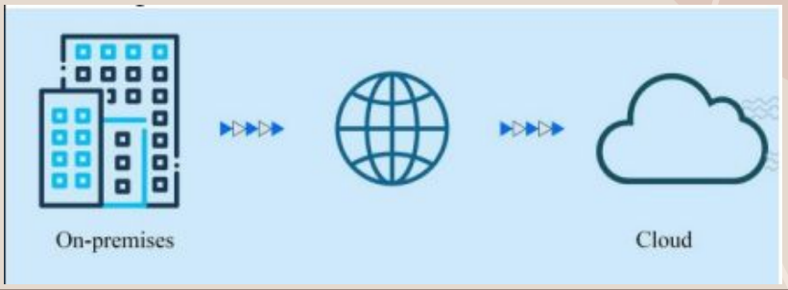

## **1. Benefits of Cloud Migration**

Migrating to the cloud offers several advantages:

* **Scalability** – Cloud resources can be scaled up or down based on demand, allowing businesses to handle traffic spikes efficiently.
* **Cost** – Reduces capital expenses (CapEx) on physical hardware and shifts to an operational expense (OpEx) model where businesses pay only for what they use.
* **Performance** – Cloud services optimize application and system performance with high-speed computing and distributed data centers.
* **Flexibility** – Enables access to applications and data from anywhere, supporting remote work and business continuity.

## **2. Challenges in Cloud Migration**

While cloud migration provides many benefits, it also comes with potential difficulties:

* **Migrating Large Databases** – Transferring large amounts of data to the cloud can be complex, requiring careful planning and execution to avoid downtime.
* **Data Integrity** – Ensuring that data is not lost, corrupted, or altered during migration is crucial.
* **Continued Operation** – Businesses need to ensure minimal disruption during migration to avoid affecting users and services.
* **Security** – Data security and compliance issues arise as organizations move sensitive data to the cloud, requiring robust encryption and access controls.

**Gartner’s 5R, AWS 6R, and AWS 7R Migration Strategies**

Cloud migration strategies help organizations move their applications to the cloud while optimizing cost, performance, and security. Below are the key migration strategies, starting with **Gartner’s 5R**, followed by **AWS 6R** and **AWS 7R** strategies?

**Gartner’s 5R Migration Strategy**

Gartner originally introduced the **5R approach** to help businesses select the best method for cloud migration.

**1. Rehost ("Lift and Shift")**

* Moves applications to the cloud **without modifying** their architecture.
* Uses **IaaS (Infrastructure-as-a-Service)** for quick migration.
* Suitable for businesses seeking **fast and cost-effective migration**.
* **Example:** Moving an on-premise database server to **AWS EC2** without modifications.

**2. Refactor ("Replatform")**

* Makes **small modifications** to optimize applications for the cloud.
* Uses **PaaS (Platform-as-a-Service)** to reduce infrastructure management.
* Improves **performance, scalability, and cost-efficiency**.
* **Example:** Moving an application to **AWS Elastic Beanstalk** for better management.

**3. Revise**

* **Partially modifies** an application before migration.
* After revision, the application is **either rehosted or refactored**.
* Suitable for applications needing **some modernization** without a full rebuild.
* **Example:** Adding microservices to a monolithic application before cloud migration.

**4. Rebuild**

* **Completely rewrites** and re-architects an application from scratch.
* Takes full advantage of **modern cloud-native technologies**.
* Time-consuming but **improves scalability, resilience, and cost savings**.
* **Example:** Rewriting a legacy application using **AWS Lambda (serverless computing)**.

**5. Replace**

* **Replaces an application** with a SaaS (Software-as-a-Service) solution.
* Eliminates the need for **maintaining infrastructure and custom applications**.
* Best for businesses that **do not require custom-built applications**.
* **Example:** Moving from an on-premise CRM to **Salesforce** or from a local email server to **Microsoft 365**.

**AWS 6R Migration Strategy**

AWS expanded **Gartner’s 5Rs** by adding **one more strategy**, creating the **6Rs of Cloud Migration**.

**1. Rehost ("Lift and Shift")**

* Moves applications to **AWS** without modifications.
* **Fastest method** but does not use cloud-native features.
* **Example:** Migrating a **VM from on-premise to AWS EC2**.

**2. Replatform ("Lift, Tinker, and Shift")**

* Makes **small optimizations** during migration to enhance efficiency.
* **Example:** Moving a database from on-premise to **Amazon RDS** instead of a self-managed **EC2 instance**.

**3. Repurchase ("Replace")**

* Replaces existing applications with **SaaS solutions**.
* Reduces management overhead but may include licensing costs.
* **Example:** Moving from an on-premise **ERP system** to **SAP on AWS**.

**4. Refactor ("Re-architect")**

* **Completely modifies the application architecture** to take advantage of cloud features.
* **Example:** Converting a monolithic application into microservices using **AWS Lambda** and **Kubernetes (EKS)**.

**5. Retire**

* Identifies and **decommissions applications** that are no longer needed.
* Reduces costs and simplifies cloud migration.
* **Example:** Shutting down an outdated reporting system.

**6. Retain**

* Keeps certain applications **on-premise** due to compliance, security, or business reasons.
* **Example:** A government agency keeping sensitive data in a private cloud.

**AWS 7R Migration Strategy**

AWS further refined the **6R strategy** by adding **one more approach**, making it the **7Rs of Cloud Migration**.

**1. Rehost ("Lift and Shift")**

* Moves applications to **AWS** without modification.
* Suitable for businesses needing **quick migration** with minimal effort.

**2. Replatform ("Lift, Tinker, and Shift")**

* Makes **minor optimizations** during migration for better cloud performance.

**3. Repurchase ("Replace")**

* Replaces **on-premise software** with **SaaS solutions**.

**4. Refactor ("Re-architect")**

* **Redesigns applications** to take full advantage of **AWS cloud-native services**.

**5. Retire**

* **Shuts down outdated or redundant applications** to reduce costs.

**6. Retain ("Revisit")**

* Keeps some applications **on-premise** for compliance, security, or cost reasons.

**7. Relocate**

* **Moves entire datacenters** or workloads to the cloud without buying new hardware.
* **Example:** Using **VMware Cloud on AWS** to migrate workloads without modifications.

**Seven-Step Model of Cloud Migration**

The **Seven-Step Model of Cloud Migration** provides a structured approach to successfully moving applications and data to the cloud. Here’s a breakdown of each step:

### **1. Assessment Step**

* The first step is to **evaluate and select the right cloud provider** (AWS, Azure, Google Cloud, etc.).
* Organizations need to analyze **business requirements, cost factors, and security policies** before migration.

### **2. Isolation Step**

* This step involves **preparing data for migration**.
* Identify **which data and applications** will be moved to the cloud and ensure they are structured properly.
* Data cleansing and optimization are also done in this phase.

### **3. Mapping Step**

* Organizations **select the cloud storage and computing resources** that will be used.
* This step determines the most suitable cloud storage types (Object Storage, Block Storage, etc.).
* It ensures **data mapping is aligned with business needs**.

### **4. Re-architect Step**

* The IT team **sets up cloud computing resources**, ensuring the infrastructure is properly designed.
* This includes **configuring virtual machines, databases, networking, and security policies**.
* Applications might be modified to fit cloud environments (refactoring).

### **5. Augmentation Step**

* This step focuses on **scaling and optimizing cloud resources** to enhance enterprise operations.
* Additional cloud services (e.g., AI, big data, analytics) may be integrated for better performance.

### **6. Test Your Model**

* Testing is performed to **ensure applications and services function correctly** after migration.
* This includes **load testing, security testing, and performance monitoring**.
* If issues are found, adjustments are made before full deployment.

### **7. Monitor and Maintain Your Model**

* Continuous monitoring ensures the cloud environment remains **secure, updated, and optimized**.
* Regular **updates, security patches, and performance tuning** are applied.
* Businesses ensure **cost efficiency and compliance** with cloud policies.

**Trends in CC**

**1. Virtualization**

Virtualization involves the abstraction of physical resources to create multiple virtual instances, improving resource utilization and scalability. It plays a crucial role in cloud computing and IT modernization.

Key Points:

Types of Virtualization: Includes infrastructure, server, desktop, storage, network, and hardware virtualization.

On-Demand Power Supply: Virtualization enables businesses to allocate extra resources when needed, enhancing flexibility.

Environmental Benefits: Reduces hardware dependency and power consumption, supporting Green IT initiatives.

Cost Efficiency: Lowers operational costs by maximizing resource utilization and minimizing the need for physical infrastructure.

Easy Migration: Small and medium-sized businesses (SMBs) can quickly migrate workloads to virtual environments, improving business continuity.

**2. Data Growth**

The exponential increase in data, especially unstructured data, presents challenges in storage, security, and compliance. Effective data management strategies are essential for businesses to handle this rapid growth.

Key Points:

Massive Data Increase: Data volumes are expected to grow significantly in the next five years, with 80% remaining unstructured.

Increased IT Complexity: More data leads to complex IT environments, requiring efficient storage and retrieval methods.

Virtualized Storage Solutions: Companies must adopt technologies like thin provisioning, deduplication, automated tiering, and virtual tapes for better storage management.

Security and Compliance Challenges: The rise in data access demands improved backup, audit, and security measures to ensure data integrity.

Segmentation and Prioritization: Businesses must categorize data based on importance and usage to optimize storage and retrieval processes.

**3. Energy and Green IT**

Green IT focuses on minimizing energy consumption and environmental impact while maintaining high performance and efficiency in computing systems.

Key Points:

Energy-Efficient Computing: Companies adopt low-power hardware, efficient cooling systems, and renewable energy to reduce carbon footprints.

Corporate Social Responsibility (CSR): Organizations are increasingly prioritizing sustainability in IT operations to meet environmental regulations.

Eco-Friendly Data Centers: Cloud providers and enterprises are designing data centers with efficient cooling and power management to minimize energy waste.

Performance vs. Power Efficiency: Businesses must balance high performance with minimal power usage through innovative technologies.

Incentives for Green IT: Governments and organizations are offering incentives and policies to encourage the adoption of sustainable IT practices.

**4. Complex Resource Tracking**

Complex resource tracking involves monitoring and managing energy and computing resources dynamically to enhance efficiency and sustainability.

Key Points:

Automated Optimization: Workloads are dynamically adjusted to optimize energy consumption and resource utilization.

Integration with IoT & AI: IoT sensors and AI-driven analytics help track and optimize power usage in data centers and IT infrastructure.

KPI-Based Management: Organizations use Knowledge Power Infrastructure (KPI) metrics to measure and manage energy efficiency.

Demand for New Skills: As resource tracking becomes more complex, businesses require specialized professionals to handle smart energy management systems.

Vendor Growth: The need for advanced tracking solutions is increasing, leading to new market opportunities for technology providers.

**5. Consumerization and Social Software**

The rise of social media and collaborative software is reshaping business strategies, user engagement, and digital marketing.

Key Points:

Social Collaboration Tools: Platforms like wikis, blogs, Facebook, and Twitter drive business engagement and knowledge sharing.

Content Aggregation: Businesses leverage social media for content sharing, marketing, and customer engagement.

Social Validation: User-generated content, such as ratings and reviews, plays a crucial role in decision-making for consumers and businesses.

Early Pattern Detection: AI and analytics help companies identify emerging trends through real-time social media monitoring.

Collective Intelligence: Organizations harness collective input from users to improve products, services, and customer satisfaction.

**Cloud Service Models: SaaS, PaaS, IaaS, Storage.**

**1. Software as a Service (SaaS) - Detailed Explanation**

**Introduction to SaaS**

Software as a Service (SaaS) is a cloud computing model where software applications are delivered over the internet instead of being installed on local devices. The entire software infrastructure, including servers, storage, networking, middleware, and databases, is managed by the SaaS provider. This eliminates the need for businesses and individuals to install, update, or maintain software on their own systems.

SaaS applications are typically accessed via a web browser, making them easy to use on any device with an internet connection. Many everyday applications, including email, social media platforms, and cloud file storage services, operate on the SaaS model.

**How SaaS Works**

**Software is Hosted Remotely** – The SaaS provider hosts the software on their servers, meaning users don’t need to install or maintain it on their own devices.

**Access via the Internet** – Users log in to the application through a web browser, eliminating the need for local installations.

**Pay-as-You-Go Model** – Most SaaS providers offer subscription-based pricing, allowing businesses to pay only for what they use.

**Automatic Updates** – The SaaS provider handles software updates, security patches, and maintenance, ensuring users always have the latest version.

**Scalability** – Businesses can increase or decrease their usage based on demand, making SaaS a flexible and cost-effective solution.

**Characteristics of SaaS**

Remote Hosting – The software and its infrastructure are hosted on cloud servers rather than being stored on local machines.

Web-Based Access – Users can access the application from any device with an internet connection and a web browser.

No Local Installation Required – Most SaaS applications do not require installation on the user’s device, though some may need browser plugins.

Multi-Tenant Model – SaaS providers use a one-to-many model, meaning a single instance of the software serves multiple users simultaneously.

Centralized Management – Updates, security patches, and maintenance are managed by the provider, ensuring smooth operation without user intervention.

**Examples of SaaS**

**Personal SaaS Applications:**

Gmail, Yahoo Mail, Outlook.com – Cloud-based email services.

Google Drive, Dropbox, OneDrive – Cloud storage solutions.

Netflix, Spotify, YouTube – Streaming services for video and music.

**Enterprise SaaS Applications:**

Salesforce – Customer Relationship Management (CRM) software.

HubSpot – Marketing automation and customer engagement.

Trello & Asana – Project management and collaboration tools.

Slack & Microsoft Teams – Communication and team collaboration platforms.

Adobe Creative Cloud – Cloud-based design and editing software.

**Advantages of SaaS**

Cost-Effective – Businesses pay only for what they use, avoiding high upfront costs for software and infrastructure.

Quick Deployment & Reduced Setup Time – Users can start using SaaS applications immediately without needing to install complex software.

Accessibility – SaaS applications can be accessed from anywhere with an internet connection, promoting remote work and collaboration.

Automatic Updates & Maintenance – Software updates and security patches are handled by the provider, ensuring users always have the latest features.

Scalability – Businesses can scale resources up or down as needed, making SaaS a flexible solution for growth.

**Disadvantages of SaaS**

Limited Customization – Unlike on-premise software, SaaS applications may not be as flexible or customizable for specific business needs.

Dependence on Internet Connectivity – A stable internet connection is required to access SaaS applications, which can be a problem in areas with poor connectivity.

Security Concerns – Since data is stored on external servers, businesses must trust the SaaS provider with data security and privacy.

Limited Control Over Data – Organizations relying on SaaS providers for storage and management may have concerns over data ownership and regulatory compliance.

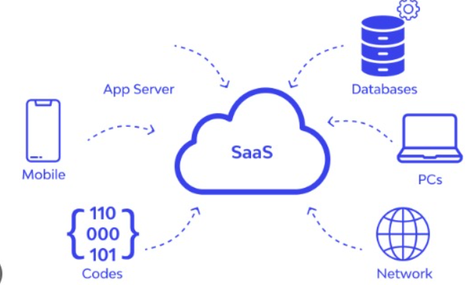

**2.Platform as a Service (PaaS) – A Detailed Explanation**

Platform as a Service (PaaS) is a cloud computing model that provides a platform for developers to build, deploy, and manage applications over the internet. It offers an environment with pre-configured computing resources such as servers, storage, networking, and databases, allowing developers to focus solely on writing code and developing applications instead of managing infrastructure.

A PaaS provider hosts the required hardware and software on its infrastructure, eliminating the need for users to install and maintain in-house hardware or software. This allows organizations to develop and deploy applications efficiently without worrying about managing servers or other IT infrastructure.

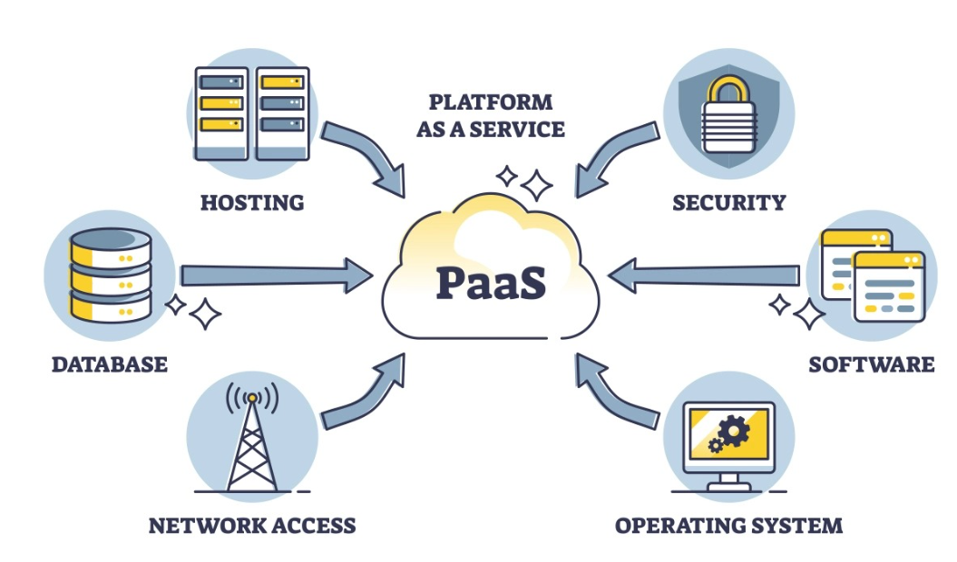

**Working of PaaS (Platform as a Service)**

**User Accesses PaaS Platform**

Developers access the cloud-based platform via a web interface, CLI (Command Line Interface), or APIs.

Example: Logging into Google App Engine.

**Development and Coding**

Developers write applications using pre-configured environments with supported programming languages and frameworks.

Example: Coding a Node.js application on Heroku.

**Application Deployment**

Developers push the code to the PaaS platform, which automatically compiles, tests, and deploys it.

Example: Deploying a Django web app on AWS Elastic Beanstalk.

**Auto-Scaling and Resource Management**

The platform automatically scales based on traffic and resource needs.

Example: A website scales up on Microsoft Azure App Services during peak hours.

**Monitoring and Maintenance**

The PaaS provider handles security patches, updates, and infrastructure monitoring.

Example: Automatic updates for a Spring Boot application on IBM Cloud Foundry.

**Database and Storage Management**

PaaS offers integrated database solutions like SQL and NoSQL databases.

Example: Using Google Firebase for real-time data storage.

**Characteristics of PaaS**

**Built on Virtualization Technology**

PaaS relies on virtualization, allowing resources to be scaled up or down automatically based on demand.

Example: AWS Elastic Beanstalk automatically adjusts computing resources depending on traffic.

**Supports Multiple Programming Languages & Frameworks**

PaaS platforms support various languages such as Python, Java, .NET, PHP, Node.js, making it easy for developers to use their preferred tools.

Example: Google App Engine allows applications to be built using multiple languages.

**Integrates with Web Services & Databases**

PaaS enables developers to seamlessly connect applications with databases and external APIs.

Example: Microsoft Azure SQL Database provides managed database services that can be integrated into applications.

**Advantages of PaaS**

**Simple and Convenient for Users**

PaaS provides pre-configured development environments, allowing developers to focus on coding without worrying about server management.

Example: Heroku allows developers to deploy apps with just a few commands, reducing infrastructure setup time.

**Cost-Effective**

Organizations pay only for what they use, reducing the need to invest in expensive on-premises infrastructure.

Example: Google App Engine offers a pay-as-you-go pricing model.

**Efficient Management of the Application Lifecycle**

PaaS supports the entire application lifecycle, including building, testing, deploying, managing, and updating applications.

Example: AWS Elastic Beanstalk simplifies application deployment with built-in lifecycle management tools.

**Improved Development Efficiency**

PaaS provides built-in development tools, automation, and templates, reducing coding complexity and improving developer productivity.

Example: Salesforce App Cloud allows businesses to create custom applications using minimal coding.\

**Disadvantages of PaaS**

**Limited Control Over Infrastructure**

Since PaaS providers manage the underlying infrastructure, users have limited control over configurations, updates, and system performance.

Example: Developers using Google App Engine may not have the ability to modify underlying server settings.

**Dependence on the Provider**

Organizations rely on PaaS providers for availability, security, and scalability. If the provider experiences downtime, applications may become unavailable.

Example: If Heroku faces an outage, all hosted applications will be affected.

**Limited Flexibility**

PaaS platforms may not support all types of applications or may lack compatibility with legacy systems.

Example: Some enterprise applications with highly customized configurations may not run efficiently on PaaS.

**Examples of PaaS Providers**

Some well-known PaaS providers include:

AWS Elastic Beanstalk (Amazon) – Deploy and manage applications with minimal configuration.

Google App Engine – A fully managed PaaS that supports multiple languages.

Microsoft Azure App Services – A platform for developing web apps and APIs.

Heroku – A cloud platform for deploying, managing, and scaling applications.

Salesforce App Cloud – A cloud-based platform for building business applications.

**3.Infrastructure as a Service (IaaS)**

Infrastructure as a Service (IaaS) is a cloud computing model that provides on-demand access to computing resources such as servers, storage, networking, and virtualization over the internet. Instead of purchasing and maintaining physical hardware, organizations can rent infrastructure from a cloud provider and scale it as needed.

In an IaaS model, the cloud provider manages the physical infrastructure, including data centers, networking equipment, and storage, while the customer is responsible for managing the operating system, applications, and data.

This model allows businesses to focus on their core operations without worrying about hardware maintenance, upgrades, or security patches for the underlying infrastructure.

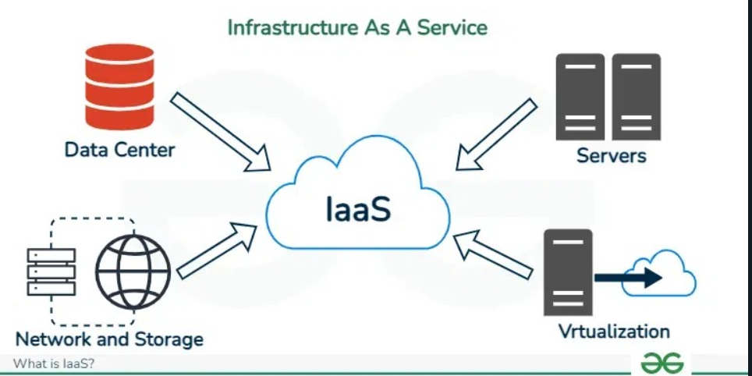

**Working of IaaS (Infrastructure as a Service)**

**User Selects and Configures Infrastructure**

Users choose virtual machines (VMs), storage, and networking resources from the IaaS provider’s dashboard.

Example: Selecting a Linux VM on AWS EC2.

**Provisioning and Deployment**

The IaaS provider allocates computing resources in a data center based on the user’s selections.

Example: Deploying a Windows Server on Microsoft Azure VMs.

**Operating System and Application Installation**

Users install OS, software, and security tools on their virtual machines.

Example: Installing Apache Web Server on a Google Cloud Compute Engine VM.

**Network Configuration**

Users set up firewalls, VPNs, and load balancers for security and performance optimization.

Example: Configuring AWS VPC (Virtual Private Cloud) for network isolation.

**Scaling and Auto-Healing**

Resources scale up/down dynamically, and faulty instances are restarted automatically.

Example: Google Cloud’s auto-scaling feature adjusts server instances based on demand.

**Monitoring and Security Management**

Users track performance via cloud monitoring tools, while security measures are applied for data protection.

Example: Using IBM Cloud Monitoring for real-time resource tracking.

**Characteristics of IaaS**

**Resources are Available as a Service**

Computing resources such as servers, storage, and networking are provided on-demand over the internet, eliminating the need for physical infrastructure.

Example: AWS EC2 instances allow users to create and configure virtual machines as needed.

**Highly Scalable Services**

Businesses can scale up or down their resources based on demand. This is especially useful for companies with fluctuating workloads.

Example: Microsoft Azure Virtual Machines automatically scale based on traffic.

**Dynamic and Flexible Cloud Service Model**

IaaS offers flexibility in choosing the operating system, applications, and configurations according to business needs.

Example: Google Cloud Compute Engine allows users to install their own OS and software stacks.

**GUI and API-based Access**

Users can manage and configure resources through a graphical user interface (GUI) or Application Programming Interface (API) for automation.

Example: AWS Management Console provides a GUI, while AWS CLI (Command Line Interface) allows for automated management.

**Automation of Administrative Tasks**

IaaS automates tasks such as provisioning, scaling, and monitoring to reduce manual effort.

Example: IBM Cloud Orchestrator automates cloud infrastructure deployment.

**Advantages of IaaS**

IaaS provides numerous benefits that make it a popular choice for businesses:

**Cost-Effective**

No upfront investment in expensive hardware.

Organizations pay only for what they use (hourly, weekly, or monthly).

Example: Google Cloud Compute Engine charges based on usage, reducing unnecessary expenses.

**Website Hosting**

Running websites on IaaS is often cheaper than using traditional hosting services.

Example: AWS Lightsail provides an affordable option for hosting websites and applications.

**Improved Security**

Cloud providers implement strong security measures such as firewalls, encryption, and DDoS protection.

Example: Microsoft Azure Security Center helps monitor and protect cloud infrastructure.

**Reduced Maintenance Effort**

The IaaS provider manages hardware, networking, and system upgrades, reducing the burden on IT teams.

Example: IBM Cloud Infrastructure takes care of software updates and infrastructure maintenance.

**Disadvantages of IaaS**

**Limited Control Over Infrastructure**

Since the provider manages the infrastructure, businesses have less control over system configurations and updates.

Example: Some organizations prefer on-premises servers to maintain full control over their IT environment.

**Security Concerns**

While the cloud provider secures the infrastructure, customers are responsible for securing their applications and data.

This requires proper security policies and encryption.

Example: If a business does not properly configure security settings, it may expose sensitive data to cyber threats.

**Limited Access in Some Regions**

Cloud computing services may be restricted in some countries due to legal and regulatory issues.

Example: Some cloud services may not be available in certain regions due to data sovereignty laws.

**Examples of IaaS Providers**

Amazon Web Services (AWS) EC2 – Provides scalable virtual machines and storage solutions.

Google Cloud Compute Engine – Allows businesses to run virtual machines with customizable configurations.

Microsoft Azure Virtual Machines – Offers cloud-based computing resources with flexible pricing.

IBM Cloud Infrastructure – Delivers cloud computing services with high security and automation.

**Difference between SAAS IAAS PASS**

`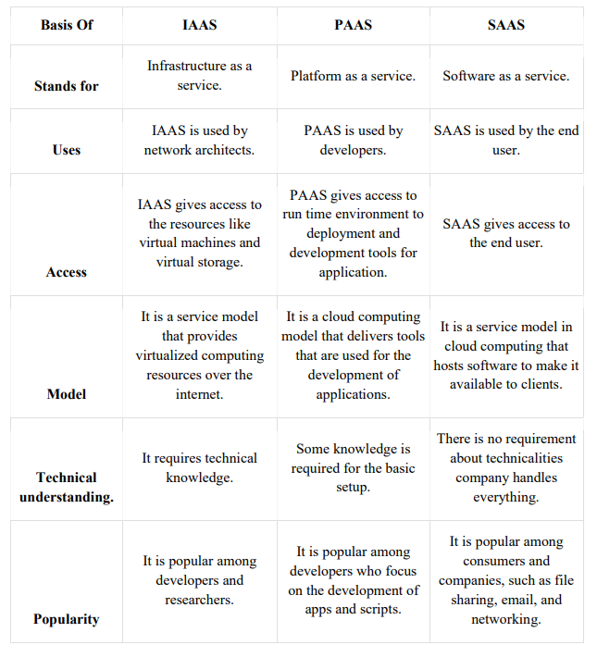

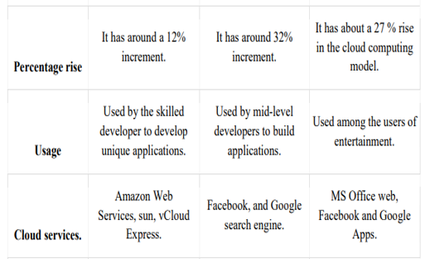

**Cloud Computing Logical Architecture**

Cloud computing is a distributed computing model that enables users to access computing resources (such as servers, storage, applications, and networking) on demand via the Internet. The cloud system architecture is designed to efficiently provide these resources while ensuring scalability, security, and performance

**Front End (Client-Side):**

The client uses the front end, which contains a client-side interface and application. Both of these components are important to access the Cloud computing platform. The front end includes web servers (Chrome, Firefox, Opera, etc.), clients, and mobile devices.

**Back End (Cloud Service Provider-Side)**

The backend part helps you manage all the resources needed to provide Cloud computing services. This Cloud architecture part includes a security mechanism, a large amount of data storage, servers, virtual machines, traffic control mechanisms, etc.

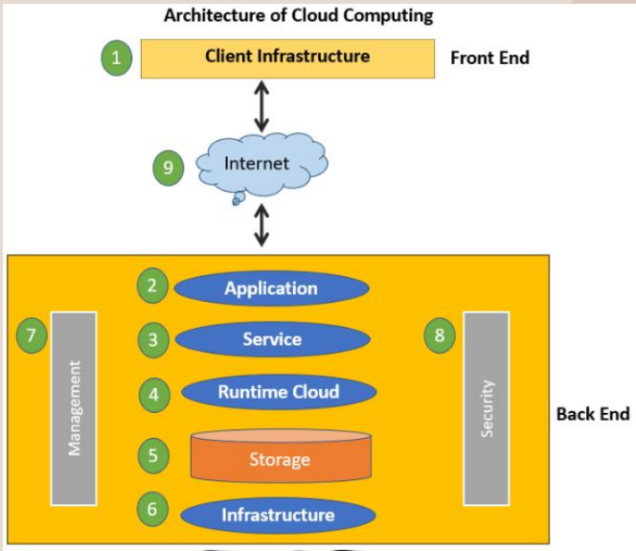

**2. Key Components of Cloud Computing Architecture**

1. Client Infrastructure

It is a front-end component that provides a Graphical User Interface (GUI).

It helps users interact with cloud applications through web browsers, mobile apps, or APIs.

Example: When accessing Microsoft OneDrive, users interact with a user-friendly interface via the browser or app.

2. Application

Cloud applications allow users to perform tasks without installing software locally.

Cloud-based software runs on remote servers and provides results via the Internet.

Example: Google Docs runs entirely on the cloud, allowing users to edit documents in real-time without local installations.

3. Cloud Services

Cloud computing services are categorized into three main types:

Software as a Service (SaaS): Provides ready-to-use applications (e.g., Google Workspace, Microsoft 365).

Platform as a Service (PaaS): Offers a development environment for application deployment (e.g., Google App Engine, AWS Elastic Beanstalk).

Infrastructure as a Service (IaaS): Provides virtual machines, storage, and networking resources (e.g., AWS EC2, Microsoft Azure Virtual Machines).

Example: Netflix uses AWS cloud infrastructure to deliver streaming content globally.

4. Runtime Cloud

Provides an execution environment for virtual machines (VMs).

Ensures that cloud applications and software run smoothly and efficiently.

Example: Java Runtime Environment (JRE) allows Java applications to run within cloud platforms.

5. Storage

Cloud storage provides scalable storage capacity to store and manage data securely.

Different types of cloud storage include:

Object Storage (e.g., Amazon S3, Google Cloud Storage)

Block Storage (e.g., Azure Managed Disks)

File Storage (e.g., Google Drive, Dropbox)

Example: Google Photos automatically stores and manages user images in cloud storage.

6. Cloud Infrastructure

Consists of hardware and software needed for cloud computing.

Includes servers, networking devices, virtualization software, and data centers.

Example: Google Cloud uses global data centers to power services like Gmail, YouTube, and Google Drive.

7. Cloud Management

Responsible for resource allocation, monitoring, and cloud service optimization.

Ensures smooth operation and security of cloud services.

Example: AWS CloudWatch monitors CPU usage, memory, and performance of cloud applications.

8. Cloud Security

Security measures include firewalls, encryption, authentication protocols, and access control mechanisms.

Helps protect data, applications, and infrastructure from cyber threats.

Example: Microsoft Azure Security Center provides threat protection for cloud applications.

9. Internet (Network Layer)

Acts as a medium for communication between the front-end and back-end cloud infrastructure.

Enables users to access cloud services remotely from anywhere.

Example: A student accesses Google Classroom via an internet connection from a laptop.

**4. Advantages of Cloud System Architecture**

✅ Cost Efficiency: Reduces IT infrastructure costs as resources are provided on a pay-as-you-go basis.

✅ Scalability: Cloud services automatically scale up/down based on demand.

✅ Accessibility: Cloud applications and data are accessible from anywhere with an Internet connection.

✅ Security: Cloud providers implement robust security measures to protect data.

✅ Automatic Updates: Cloud platforms handle software updates and maintenance automatically.

**5. Challenges of Cloud System Architecture**

⚠ Latency Issues: Cloud performance depends on Internet speed and connectivity.

⚠ Data Privacy Risks: Sensitive data is stored on third-party servers, which may pose security concerns.

⚠ Limited Control: Users have less control over the underlying cloud infrastructure.

⚠ Legal Compliance: Data regulations vary by region, impacting cloud adoption.

### **Cloud Deployment Model**

Cloud deployment models define the **location and management** of cloud infrastructure. These models specify the **ownership, scale, access, and purpose** of a cloud environment. The choice of a deployment model determines how cloud resources are managed, who controls them, and what level of customization users can have. Additionally, they define the relationship between the **infrastructure and users**.

## **Public Cloud**

The **public cloud** allows **anyone** to access systems and services over the **internet**. However, it may be **less secure** since it is open to the general public or major industry groups.

* In a **public cloud**, infrastructure is owned and managed by a **third-party cloud service provider**, not the consumer.
* It is commonly used for **cloud hosting**, allowing customers to easily access services.
* Cloud providers **offer services to multiple customers** in a shared environment.
* Examples include **Google App Engine**, **Amazon Web Services (AWS)**, and **Microsoft Azure**.

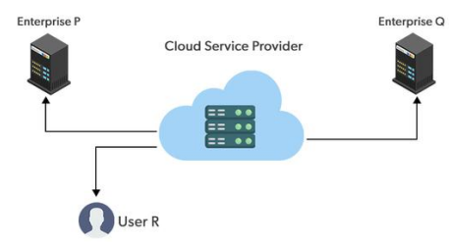

### **Advantages of the Public Cloud Model**

✅ **Minimal Investment**

Uses a **pay-per-use** model with no upfront fees, making it cost-effective.

✅ **No Setup Cost**

Infrastructure is fully managed by the **cloud provider**, eliminating setup costs.

✅ **Infrastructure Management Not Required**

Users do not need to handle infrastructure maintenance.

### **Disadvantages of the Public Cloud Model**

### **Less secure: Public cloud is less secure as resources are public so there is no guarantee of high-level security.**

### **Low customization: It is accessed by many public so it can’t be customized according to personal requirements.**

### **Private Cloud**

The **private cloud deployment model** is the opposite of the **public cloud model**. It provides a **dedicated environment** for a **single user or organization**, ensuring **higher security, privacy, and control** over resources. Unlike the public cloud, private cloud users **do not share** hardware, storage, or networks with other users.

* It is also known as the **"internal cloud"** since it operates exclusively within an organization.
* Private clouds can be **hosted on-premise** (within the organization’s data center) or **externally** by a third-party cloud provider.
* A **secure cloud environment** with **firewalls and strict access controls** ensures protection.
* Commonly used by **government agencies, financial institutions, and large enterprises** with **strict compliance requirements**.

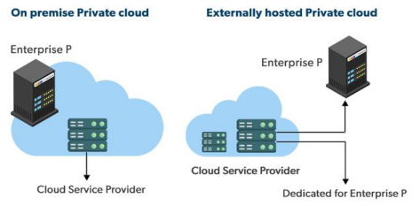

### **Advantages of the Private Cloud Model**

✅ **Better Control**

The organization has **full control** over IT infrastructure, security policies, and user access.

✅ **Data Security and Privacy**

Suitable for **sensitive data storage** where **only authorized personnel** can access the cloud.

**Stronger security measures** (firewalls, encryption, and authentication) protect critical data.

✅ **Supports Legacy Systems**

Designed to work with **legacy applications** that may not be supported by the **public cloud**.

✅ **Customization**

Unlike public clouds, private clouds allow **customization** to meet specific business needs.

### **Disadvantages of the Private Cloud Model**

🚫 **Less Scalable**

* Private clouds have limited scalability as they cater to a smaller number of users.

💰 **Costly**

* Higher costs due to dedicated resources and **personalized facilities**.

### **Hybrid Cloud**

The **hybrid cloud** model combines the **best of both private and public clouds** by allowing organizations to balance **security** and **cost-efficiency**.

* Businesses can **store sensitive data** in a **private cloud** while leveraging **public cloud services** for scalability.
* Data and applications can be **moved between cloud environments** as needed.
* **Flexible cloud deployment** suited for dynamic workloads.

### **Advantages of the Hybrid Cloud Model**

**Flexibility & Control**

Businesses can **customize** their cloud setup for **optimized performance and security**.

**Cost-Effectiveness**

Only pay for **extra cloud capacity** when needed.

**Enhanced Security**

Sensitive data remains **protected** in a private cloud, **reducing cyber threats**.

### **Disadvantages of the Hybrid Cloud Model**

**Difficult to Manage**

Managing **both private and public clouds** increases complexity.

**Slow Data Transmission**

**Latency issues** may arise when transferring data between cloud environments.

**Community Cloud**

It allows systems and services to be accessible by a group of organizations. It is a distributed system that is created by integrating the services of different clouds to address the specific needs of a community, industry, or business. The infrastructure of the community could be shared between the organization which has shared concerns or tasks. It is generally managed by a third party or by the combination of one or more organizations in the community.

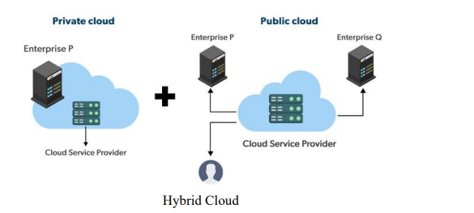

**Advantages of the Community Cloud Model**

• Cost Effective: It is cost-effective because the cloud is shared by multiple organizations or communities.

• Security: Community cloud provides better security.

• Shared resources: It allows you to share resources, infrastructure, etc. with multiple organizations.

• Collaboration and data sharing: It is suitable for both collaboration and data sharing.

**Disadvantages of the Community Cloud Model**

• Limited Scalability: Community cloud is relatively less scalable as many organizations share the same resources according to their collaborative interests.

• Rigid in customization: As the data and resources are shared among different organizations according to their mutual interests if an organization wants some changes according to their needs they cannot do so because it will have an impact on other organizations.

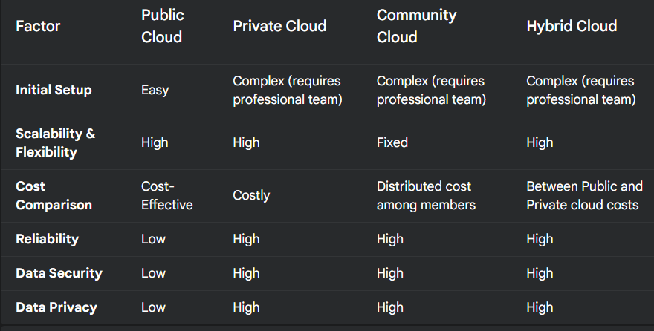

**UNIT 2**

### **Enterprise Storage and Its Subsystems**

Enterprise storage is a centralized system that manages, protects, and shares business-critical data efficiently. It is designed to handle massive workloads, scaling from terabytes to petabytes without excessive cabling or complex subsystems. Key features of enterprise storage include scalability, unlimited connectivity, and multi-platform support.

To build an effective storage system, understanding storage architectures is crucial for achieving cost efficiency, high performance, and ease of management. The main types of storage subsystems are:

1. **Direct Attached Storage (DAS)** – The most basic storage system, directly connected to a computer or server. It serves as the foundation for other storage architectures.
2. **Storage Area Network (SAN)** – A dedicated high-speed network that connects storage devices, offering better performance and centralized storage management compared to DAS.
3. **Network Attached Storage (NAS)** – A storage solution connected to a network, providing file-based data access to multiple users and devices. NAS is built on top of SAN and DAS, making it the most advanced storage layer.

### **Direct Attached Storage (DAS) Subsystem**

Direct-Attached Storage (DAS) refers to storage devices (HDDs or SSDs) that are directly connected to a computer or server without a network interface. Unlike Storage Area Networks (SAN) and Network-Attached Storage (NAS), DAS is not shared over a network, making it a localized storage solution.

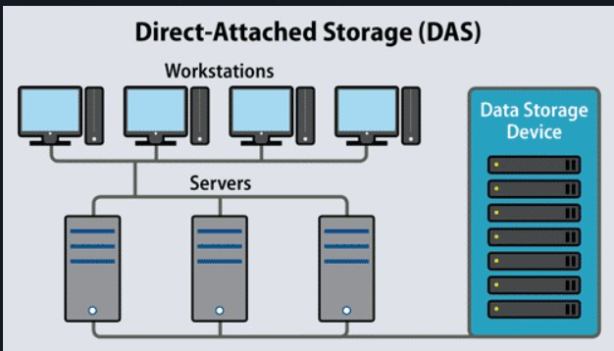

#### **Characteristics of DAS**

* **Direct Connection**: Storage devices are physically connected to a server or PC using internal ports (e.g., SATA, NVMe) or external cables (e.g., USB, Thunderbolt).
* **Limited Access**: The storage device is accessible only to the connected system, unlike network-based storage.
* **Fast Data Access**: Provides low-latency access as data does not travel over a network.
* **Limited Scalability**: Can only scale up to the number of available ports on the computer.

#### **Types of DAS**

1. **Internal DAS**
   * Storage devices are installed inside the computer/server chassis.
   * Uses a Host Bus Adapter (HBA) for high-speed data transfer over a short distance.
   * Example: An SSD connected via an M.2 slot or an HDD connected via SATA.
2. **External DAS**
   * Storage devices are housed in an external enclosure and connected via cables.
   * Common interface protocols: Fibre Channel Protocol (FCP) and Small Computer System Interface (SCSI).
   * Example: USB external hard drives or RAID enclosures connected via Thunderbolt.

#### **Advantages of DAS**

* **Cost-Effective**: Lower initial cost compared to SAN or NAS.
* **High Speed**: Faster data access since no network congestion affects performance.
* **Easy Management**: Simple setup without complex configurations.
* **Ideal for Localized Use**: Works well for single-server environments.

#### **Disadvantages of DAS**

* **Limited Scalability**: Cannot scale beyond the system’s available ports.
* **Lack of Shared Access**: Only accessible by the directly connected system.
* **Risk of Downtime**: If the host system fails, the DAS device becomes inaccessible.
* **Inefficient Resource Utilization**: Unused storage space on one DAS device cannot be shared with other servers.

### **Storage Area Network (SAN) with Diagram**

A Storage Area Network (SAN) is a high-speed, dedicated storage network that provides block-level storage access to multiple servers. It enables centralized storage management and high-performance data transfer.

#### **Characteristics of SAN**

* **High-Speed Connectivity**: Uses Fibre Channel (FC) or iSCSI for fast data transfer.
* **Block-Level Storage**: Appears as local storage to connected servers.
* **Highly Scalable**: Can expand by adding storage devices and network components.
* **Centralized Storage Management**: Simplifies administration and enhances data availability.

#### **Components of SAN**

1. **Storage Arrays**: High-capacity storage devices forming the core of SAN.
2. **Host Bus Adapters (HBAs)**: Interface cards in servers that connect them to the SAN.
3. **SAN Switches**: Used for managing data traffic between storage and servers.
4. **Protocols**:
   * **Fibre Channel (FC)**: High-speed, low-latency protocol.
   * **iSCSI**: Uses standard IP networks for storage communication.

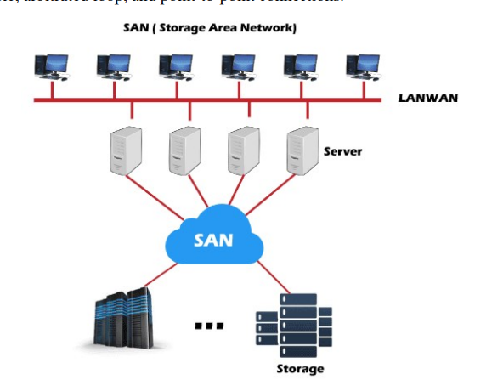

#### **Advantages of SAN**

* **High Performance**: Provides low-latency, high-speed access to data.
* **Scalability**: Storage capacity can be increased without affecting performance.
* **Centralized Management**: Easier to manage compared to decentralized storage solutions.
* **Data Protection**: Built-in features like RAID, snapshots, and replication enhance reliability.

#### **Disadvantages of SAN**

* **High Cost**: Expensive due to specialized hardware and management software.
* **Complexity**: Requires expertise for setup and maintenance.
* **Network Dependency**: Performance can be affected by network failures.

### **Network Attached Storage (NAS) with Diagram**

Network-Attached Storage (NAS) is a file-based storage system that connects to a network, allowing multiple users and devices to access data over a LAN. It operates as a standalone storage server with its own operating system and management software.

#### **Characteristics of NAS**

* **Connected to Network**: Uses Ethernet to share storage across multiple devices.
* **File-Level Storage**: Supports file access protocols such as NFS (Unix), SMB (Windows), and AFP (Mac).
* **Centralized Storage**: Enables file sharing among multiple users.
* **Scalability**: Can expand by adding more NAS devices or increasing disk capacity.

#### **Components of NAS**

1. **Physical Storage Drives**: Multiple HDDs or SSDs arranged in RAID for redundancy.
2. **CPU & Operating System**: Manages file access and network communication.
3. **Networking Interface**: Ethernet or Wi-Fi for connectivity.
4. **Protocols**: NFS, SMB, AFP for cross-platform access.

#### **Diagram of a NAS Architecture**

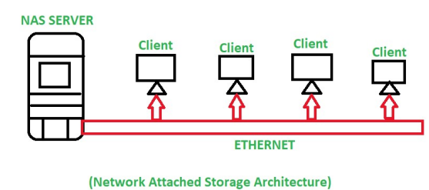

#### **Storage Methods in NAS**

1. **File Storage**: Organizes data in a hierarchical structure using directories and subdirectories.
2. **Block Storage**: Stores data in fixed-sized blocks for efficient access.
3. **Object Storage**: Uses unique identifiers and metadata for large-scale, unstructured data.

#### **Advantages of NAS**

* **Easy File Sharing**: Enables multi-user access with built-in access controls.
* **Cost-Effective**: More affordable than SAN while providing centralized storage.
* **Cross-Platform Support**: Works with Windows, Unix, and MacOS.
* **Scalable**: Capacity can be increased without major infrastructure changes.

#### **Disadvantages of NAS**

* **Lower Performance than SAN**: Slower due to network-based access.
* **Network Dependency**: Performance may degrade with high network traffic.
* **Security Concerns**: Vulnerable to network-based threats.

| **Feature** | **SAN** | **NAS** | **DAS** |
| --- | --- | --- | --- |
| **Type of storage** | Blocks | Shared files | Sectors |
| **Transmission of data** | Fiber Channel | Ethernet, TCP/IP | IDE/SCSI |
| **Speed** | 5-10 ms | 20-50 ms | 5-10 ms |
| **Complexity** | High | Moderate | Easy |
| **Mode of Access** | Servers | Clients or Servers | Clients or Servers |
| **Capacity** | > 10¹² bytes | 10⁹ - 10¹² bytes | 10⁹ bytes |
| **Usage** | Application data | Unstructured, Shared data | OS |

### **Data Storage Management Process**

Data storage management involves the monitoring of software and hardware assets, such as storage arrays, physical servers, and cloud storage services. Data storage management can involve resolving performance issues like potential bottlenecks and analyzing real-time storage capacity to help improve the end-user experience. With this information, admins can reallocate storage resources to fulfill business storage needs. The data storage management process involves policies and procedures to effectively manage storage infrastructure. The key areas of this process are:

#### **a. Change Management**

* It refers to the process of requesting, scheduling, implementing, and evaluating changes in the storage infrastructure.
* It ensures the integrity and availability of data while managing configuration and provisioning of storage resources.
* Processes like data migration and storage space allocation are documented under change management.

#### **b. Performance and Capacity Planning**

* It involves measuring system performance in terms of storage utilization.
* Performance analysis helps in identifying bottlenecks and planning future storage requirements.
* It ensures that organizations make informed decisions on storage purchases and upgrades.

#### **c. Tiering (Tiered Storage)**

* It refers to the practice of using multiple storage technologies to balance cost and performance.
* High-performance data is stored on expensive, fast-access storage (e.g., Fibre Channel), while less critical data is stored on cost-effective solutions like DAS or SAS.

### **2. Challenges in Data Storage Management**

Storage administrators face several challenges in managing data efficiently:

#### **a. Massive Data Demand**

* The amount of digital data is increasing rapidly, making storage expansion a necessity.
* With data expected to reach zettabyte levels, scalable solutions are required.

#### **b. Performance Barrier**

* Large-scale databases and applications demand faster disk access.
* Traditional storage systems struggle with slow query response times, requiring optimized storage solutions.

#### **c. Power Consumption and Cost**

* Expanding storage requires significant power, cooling, licensing, and maintenance costs.
* IT organizations must balance performance with cost efficiency.

### **3. Functions of Data Storage Management**

The main functionalities of data storage management include:

#### **a. Performance and Reliability**

* Ensures quick access to business-critical data, improving operational efficiency.
* Uses tiered storage strategies to optimize performance.

#### **b. Security and Data Protection**

* Implements data backup solutions and encryption for protection.
* Uses multifactor authentication to prevent unauthorized access.

#### **c. Control and Compliance**

* Implements storage tiering for better data organization.
* Ensures compliance with industry regulations for data security and accessibility.

### **4. Data Storage Management Tools**

Storage administrators use various tools to monitor and manage storage efficiently:

#### **a. Configuration Tools**

* Helps in setting up and organizing RAID devices.
* Allows defining storage groups, levels, and spare drive assignments.

#### **b. Provisioning Tools**

* Manages access control for storage resources.
* Prevents unauthorized users from accessing other users' storage.

#### **c. Measurement Tools**

* Analyzes storage performance and utilization patterns.
* Helps in capacity planning and upgrading storage systems as needed.

**File Systems**

File system is an interface between secondary storage device like hard disk and user application. Hard disk is a block oriented device. The purpose of file systems is to maintain a consistent view of storage so that we can effectively manage it. This is done in a way that allows the users to create files and directories as well as delete, open, close read, write and/or extend the files on the device. File systems also maintain security over the files by using access control lists for a file. A file system is a structure used in computer to store data on a hard disk. When we install a new hard disk, we need to partition and format it using a file system before storing data. There are three file systems in use in Windows OS; they are NTFS, FAT32 and rarely-used FAT.

**FAT File System**

File Allocation Table (FAT) file system is a simple file system originally designed for small disks and simple folder structures. FAT was planned for systems with very small RAM and small disks. It required much less system resources compared to other file systems like UNIX. It is also found on in flash memory, digital cameras and portable devices. It is used to store file information and extend the life of a hard drive. Essentially, the FAT system has made a comeback. Thumb or flash drives have become very common and have smaller size that makes the FAT system useful. The smaller sizes are even formatted in FAT16. Usually the file system operates blocks, not sector. File system blocks are groups of sectors that optimize storage addressing. Modern file systems generally use block sizes from 1 upto 128 sectors. 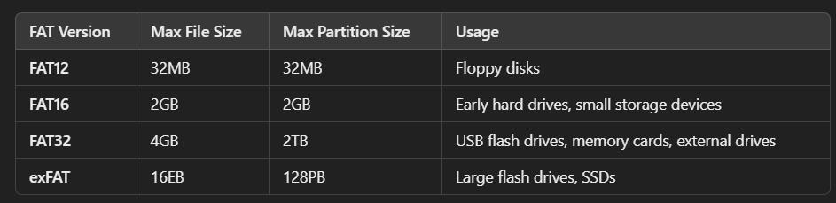

### **4. Advantages of FAT**

✅ **Simple & Lightweight** – Requires minimal system resources, making it ideal for **embedded systems** and **low-power devices**.  
✅ **Broad Compatibility** – Works on Windows, macOS, Linux, and even gaming consoles, making it an industry-standard for **removable storage**.  
✅ **Fast Read/Write Speeds** – Suitable for devices where **speed is prioritized over complex file permissions** (e.g., USB drives).

### **5. Limitations of FAT**

❌ **Lack of Security** – No built-in file permissions or encryption, making it **less secure** than NTFS or ext4.  
❌ **Poor Fault Tolerance** – If the **File Allocation Table gets corrupted**, data loss is **likely** because there is **no journaling mechanism**.  
❌ **Fragmentation Issues** – Files get scattered across the disk over time, leading to **slower performance**.  
❌ **File Size Limitations** – FAT16 and FAT32 **cannot handle large files**, making them impractical for modern applications

### **NTFS (New Technology File System) - Detailed Explanation**

The **New Technology File System (NTFS)** is a file system introduced by Microsoft with the **Windows NT** operating system. It is designed to efficiently **store, organize, and manage files** on modern hard drives while offering advanced **security, reliability, and performance** features.

**Developed in the 1990s** – Microsoft created NTFS to overcome limitations of **FAT (File Allocation Table)** and **HPFS (High-Performance File System)** used in DOS-based Windows.

**First introduced in Windows NT 3.1 (1993)** – Replaced FAT and HPFS as the primary file system for Windows NT-based systems.

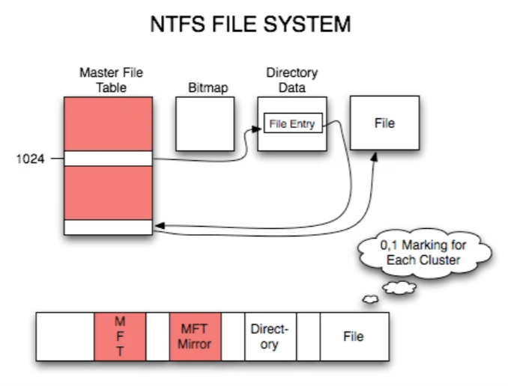

### **. Key Features of NTFS**

🔹 **Performance & File Compression**

* NTFS supports **file compression**, which **reduces disk space usage** and improves performance.

🔹 **Security & Access Control**

* Uses **Access Control Lists (ACLs)** to manage user permissions.
* Supports **encryption (EFS - Encrypting File System)** for data protection.

🔹 **Reliability & Fault Tolerance**

* NTFS uses **journaling (Master File Table - MFT)** to **track file changes** and maintain consistency

🔹 **Efficient Disk Space Utilization**

* Supports **disk quotas**, which allow administrators to **limit disk usage** for users.

🔹 **File System Journaling**

* Maintains a **log of file operations**, helping with **data auditing** and recovery.

### **3. Advantages of NTFS**

✅ **High Security** – Allows **encryption, user permissions, and ACLs** to protect sensitive files.  
✅ **Fault Tolerance** – Uses **journaling (MFT)** to recover from crashes and power failures.  
✅ **Supports Large Files & Partitions** – Unlike FAT32 (which has a 4GB file size limit), NTFS can store **huge files (up to 16TB) and partitions (up to 8PB)**.  
✅ **Efficient Storage Management** – **Compression, disk quotas, and smaller cluster sizes** help optimize space usage.  
✅ **Better Performance** – Less fragmentation, **faster file access, and indexing support** improve performance.

### **4. Disadvantages of NTFS**

❌ **Not Ideal for Small Storage Devices** – NTFS is **not suitable for USB drives or memory cards** due to high overhead.  
❌ **Limited Compatibility** – NTFS is mainly supported by **Windows**. macOS and Linux can read NTFS but may have **limited write support**.  
❌ **Higher Resource Consumption** – NTFS **requires more CPU and RAM** compared to FAT, making it unsuitable for embedded systems.  
❌ **Overhead for Small Files** – NTFS has **higher metadata storage requirements**, which may **reduce efficiency** for small files. 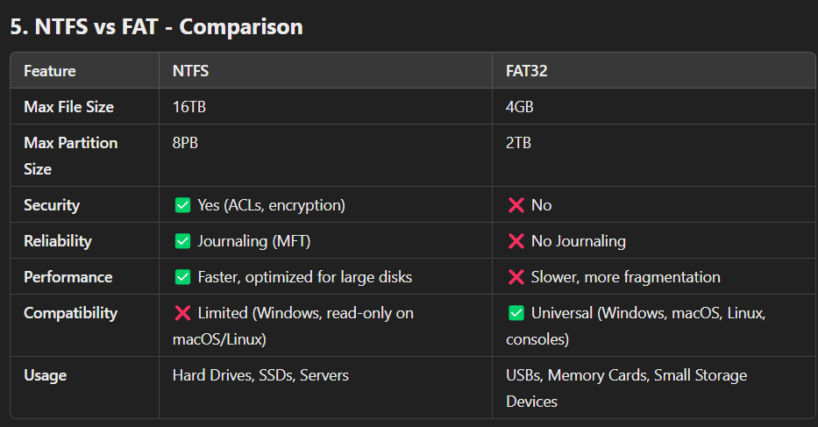**Cloud File System (10 Marks Answer)**

A Cloud File System (CFS) is a distributed file system that allows users and organizations to store, access, and manage files over the internet using cloud infrastructure. It follows a hub-and-spoke architecture:

Hub: The central storage located in a public cloud provider (e.g., AWS, Azure, Google Cloud).

Spokes: Local storage appliances that act as caches to improve performance at remote offices or data centers.

**Key Considerations of Cloud File Systems:**

Basic File System Functionality: Supports file operations (create, read, write, delete).

Open Source: Should be open-source for customization and flexibility.

Data Reliability: Must be trustworthy for users to store important data.

Shared Network Access: Should allow multiple users and systems to access files over a network.

Parallel Scalability: Must support multiple nodes and high workloads efficiently.

Data Protection: Should offer security and error detection even on basic hardware.

**1. Google File System (GFS)**

**Google File System (GFS) is a distributed file system developed by Google to handle large-scale data processing across multiple nodes. It is optimized for storing and managing massive datasets, primarily used in Google’s internal infrastructure.**

**Characteristics:**

**✔ Scalability: Supports petabytes of data and thousands of machines.**

**✔ Fault Tolerance: Uses replication to ensure data availability even if a node fails.**

**✔ Chunk-based Storage: Files are divided into 64 MB chunks, managed by a central Master Server.**

**✔ High Throughput: Designed for high bandwidth and efficient data access.**

**✔ Optimized for Large Files: Works best for large sequential reads/writes rather than small random accesses.**

**Advantages:**

**✅ Highly Scalable – Handles large amounts of data efficiently.**

**✅ Fault-Tolerant – Uses replication (3 copies per chunk) to prevent data loss.**

**✅ Efficient Data Access – Supports parallel processing for big data applications.**

**✅ Automatic Load Balancing – Distributes workload evenly across machines.**

**Disadvantages:**

**❌ Single Point of Failure – The Master Server is a bottleneck and can crash.**

**❌ Not Suitable for Small Files – Optimized for large sequential data, not random access.**

**❌ Limited Open Source Availability – GFS is not publicly available, but Apache Hadoop’s HDFS is inspired by it.**

**2. Gluster File System (GlusterFS):**

**GlusterFS is an open-source, distributed file system developed by Red Hat. It aggregates multiple storage devices into a single storage pool, offering scalability and redundancy.**

**Characteristics:**

**✔ Scalable Architecture: Supports horizontal scaling by adding new storage nodes.**

**✔ Distributed Storage: Uses multiple nodes to store data efficiently.**

**✔ Replication & High Availability: Ensures data redundancy across multiple servers.**

**✔ POSIX Compliance: Works like a traditional file system, supporting Linux-based environments.**

**✔ No Centralized Metadata Server: Avoids a single point of failure.**

**Advantages:**

**✅ Highly Scalable – Can handle petabytes of data across many servers.**

**✅ Open Source – Free to use and modify.**

**✅ Fault Tolerant – Data replication ensures high availability.**

**✅ Compatible with Cloud Storage – Works well with AWS, Azure, Google Cloud.**

**Disadvantages:**

**❌ High Latency for Small Files – Works best for large files.**

**❌ Complex Setup & Management – Requires expertise to configure and maintain.**

**❌ Performance Overhead – Distributed nature can slow down performance in certain cases.**

**3. Ghost File System (GFS):**

**Ghost File System (GFS) is a hypothetical or conceptual file system that focuses on security, anonymity, and temporary storage, often associated with encrypted and ephemeral file storage. It is not a widely known or officially recognized file system like Google File System or GlusterFS.**

**Characteristics:**

**✔ Ephemeral Storage: Files exist only temporarily before being automatically deleted.**

**✔ High Security & Encryption: Uses end-to-end encryption to protect user data.**

**✔ Decentralized & Anonymous: Often used in dark web applications or secure communication platforms.**

**✔ Minimal Metadata Storage: Limits tracking and logging of stored files.**

**Advantages:**

**✅ Strong Security – Protects against unauthorized access and surveillance.**

**✅ Temporary Storage – Reduces long-term digital footprints.**

**✅ Ideal for Privacy-Conscious Users – Helps in anonymous communication.**

**Disadvantages:**

**❌ Limited Use Cases – Not designed for mainstream file storage.**

**❌ No Data Persistence – Files may be lost permanently after expiration.**

**❌ Potential Misuse – Can be exploited for illegal activities due to its anonymous nature.**

## **4.Hadoop Distributed File System (HDFS)/** Hadoop File System:

Hadoop Distributed File System (HDFS) is a scalable, fault-tolerant, and distributed file system designed to run on commodity hardware. It is a core component of the Hadoop ecosystem, allowing efficient storage and processing of large datasets. HDFS is modeled after the **Google File System (GFS)** and is optimized for handling large files with sequential access patterns.

### **HDFS Architecture**

1. **NameNode (Master Node)**
   * Manages the metadata (file structure, replication info, permissions).
   * Stores the file system namespace and keeps track of file locations.
   * Receives heartbeat signals from DataNodes.
2. **DataNode (Worker Nodes)**
   * Stores actual data in the form of **blocks** (default size: 128MB or 64MB).
   * Responds to read and write requests from clients.
   * Periodically sends heartbeat signals to the NameNode.
3. **Secondary NameNode (Checkpoint Node)**
   * Not a backup of the NameNode, but helps in periodic checkpointing of metadata.
   * Helps in merging the Edit Logs with the FsImage to prevent excessive log sizes.

### **How HDFS Works?**

* When a file is stored in HDFS, it is **split into blocks** (e.g., 128MB each).
* These blocks are **replicated** across multiple DataNodes (default replication factor: 3).
* The **NameNode** maintains metadata but does not store actual data.
* When a user requests data, the NameNode provides the block locations, and the DataNodes directly serve the requested file blocks.

### **Features of HDFS**

1. **Scalability** – Can store petabytes of data across multiple nodes.
2. **Fault Tolerance** – Data is replicated to prevent data loss.
3. **High Throughput** – Optimized for batch processing and sequential reads.
4. **Data Locality** – Hadoop moves computation closer to the data to reduce network congesti

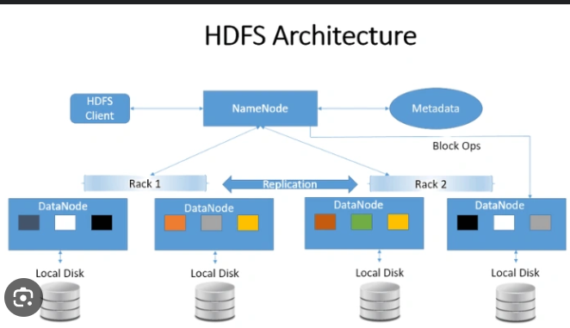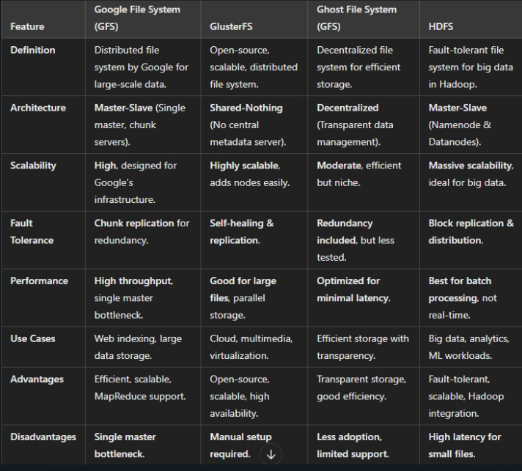

### **Cloud Data Stores**

A **Cloud Data Store** is a **digital repository** used for storing, managing, and distributing data across systems. It can be **network-connected storage, distributed cloud storage, physical hard drives, or virtual storage**.

#### **Types of Data Stored:**

* **Structured Data** (e.g., tables in databases)
* **Unstructured Data** (e.g., emails, images, videos)

#### **Purpose of Data Stores:**

✔ **Data Retention** – Stores and safeguards business data.  
✔ **Data Sharing** – Enables access across different business units.  
✔ **Data Management** – Organizes and processes information efficiently.

#### **Types of Data Stores:**

1. **Relational Databases** – MySQL, PostgreSQL, SQL Server, Oracle.
2. **Object-Oriented Databases** – Stores data as objects.
3. **Operational Data Stores** – Provides real-time data access.
4. **Schema-less Data Stores** – Example: Apache Cassandra, DynamoDB.
5. **Paper Files** – Traditional method for storing physical records.
6. **Data Files** – Includes spreadsheets, flat files, etc.

Cloud data stores play a crucial role in **modern data storage solutions,** offering **scalability, accessibility, and efficiency.**

**What is Grid Computing?**

Grid Computing is a distributed computing model where multiple computers, servers, or nodes work together to perform a large computational task. It involves a network of interconnected computers that share resources like processing power, storage, and data to solve complex problems efficiently.

Instead of relying on a single supercomputer, grid computing connects multiple machines to act as a single powerful system. These computers can be located in different geographic locations and are linked via a network, typically the internet or a private network.

**Characteristics of Grid Computing:**

✔ Distributed Architecture – Uses multiple machines instead of a centralized system.

✔ Resource Sharing – Computers share their CPU, memory, and storage for computation.

✔ Parallel Processing – Tasks are broken into smaller parts and executed simultaneously.

✔ Scalability – Can handle increasing workloads by adding more nodes.

✔ Heterogeneous Systems – Supports different hardware and operating systems.

**How Grids are Used in Cloud Computing?**

In Cloud Computing, grid computing plays a crucial role in optimizing resources and enhancing performance. Here’s how:

High-Performance Computing (HPC):

* Cloud providers use grid computing for scientific simulations, weather forecasting, and big data analytics.
* Example: NASA and research institutions use grid computing for space simulations.

Scalable Resource Allocation:

* Cloud platforms distribute workloads across multiple grid nodes, ensuring efficient load balancing.
* This helps in handling sudden traffic spikes in cloud-based applications.

Cost Efficiency:

* Grid computing allows cloud providers to use idle resources from different machines, reducing wasted computational power.

Disaster Recovery & Backup:

* Data replication across a grid infrastructure ensures business continuity in case of hardware failure.

Cloud-Based Virtual Grids:

* Companies use virtual machines (VMs) on cloud grids to perform large-scale parallel processing.
* Example: Google Cloud, AWS, and Azure use grid-based processing to handle AI/ML workloads.

**How Cloud Data Management Works?**

Cloud Data Management (CDM) is the process of collecting, storing, protecting, and processing data in cloud environments, ensuring efficient access, security, and compliance. It eliminates the need for physical storage by utilizing cloud-based infrastructure for data operations.

**Working of Cloud Data Management**

1. Data Acquisition & Storage

* Data is collected from multiple sources (IoT, applications, databases) and stored in cloud storage systems like data warehouses or lakes.
* The SNIA SIRDM model (Storage Industry Resource Domain Model) provides a standardized cloud storage approach using Cloud Data Management Interface (CDMI) for simplicity.

2. Metadata Management

The SIRDM model uses three types of metadata for efficient cloud storage:

* User Metadata: Helps in locating data objects and containers.
* Storage System Metadata: Manages storage functions like assigning space and controlling access.
* Data System Metadata: Provides data services and controls operations based on user needs.

3. Data Protection & Compliance

* Encryption and access control secure data from breaches.
* Compliance with GDPR, CCPA ensures legal data handling and privacy.
* Automated backups and disaster recovery prevent data loss.

4. Data Processing & Accessibility

* Centralized Data Management removes data silos, improving collaboration.
* Real-time processing and AI analytics extract valuable insights.
* Scalability ensures cloud systems adapt to workload demands.

**Benefits of Cloud Data Management**

✅ Optimized Business Decisions – Data insights improve efficiency and revenue.

✅ Eliminates Data Silos – Ensures consistency and better collaboration.

✅ Regulatory Compliance – Meets privacy laws like GDPR & CCPA.

✅ Scalability & Cost Savings – Cloud resources adjust dynamically without extra hardware costs.

✅ Disaster Recovery & High Availability – Data remains safe with redundancy and backups.

**Cloud Storage Provisioning: A Detailed Explanation**

1. Definition of Cloud Provisioning

Cloud provisioning is the process of allocating and managing cloud resources (such as computing power, storage, networking, and applications) for businesses and users. This enables organizations to access cloud services on demand without the need for expensive on-premises infrastructure.

Cloud provisioning is a key feature of cloud computing and ensures that users can access the right resources efficiently, securely, and cost-effectively. It includes setting up virtual machines, databases, software services, and security controls in cloud environments like Amazon Web Services (AWS), Microsoft Azure, and Google Cloud Platform (GCP).

**Cloud provisioning supports three primary cloud service models:**

Infrastructure-as-a-Service (IaaS) – Provides virtualized computing resources like virtual machines, storage, and networking.

Platform-as-a-Service (PaaS) – Offers a complete development and deployment environment in the cloud.

Software-as-a-Service (SaaS) – Delivers cloud-hosted software applications accessible via the internet.

Cloud provisioning allows organizations to be more flexible, scalable, and efficient by optimizing IT resource utilization.

**2. Benefits of Cloud Provisioning**

Cloud provisioning provides several advantages over traditional IT infrastructure:

1. Scalability

Businesses can increase or decrease resources based on demand without needing to purchase physical infrastructure.

Supports multi-tenancy, meaning multiple users can share resources while maintaining isolation.

2. Cost Savings

Organizations only pay for the resources they use (pay-as-you-go model), reducing unnecessary expenses.

Fewer IT employees are needed, as cloud service providers handle infrastructure maintenance.

3. Efficiency and Speed

Cloud provisioning enables rapid deployment of IT resources.

Organizations can launch applications and services within minutes instead of weeks.

4. Flexibility

Businesses can choose from public, private, and hybrid cloud models based on their needs.

Supports remote access, allowing employees to work from anywhere.

5. Enhanced Security and Compliance

Cloud providers implement firewalls, encryption, and authentication to protect data.

Meets industry regulations like GDPR, HIPAA, and CCPA for data security.

Supports automated backups and disaster recovery solutions.

6. Improved Resource Management

IT administrators can monitor and optimize resource usage efficiently.

**3. Challenges of Cloud Provisioning**

1. Complex Management and Monitoring

Businesses often use multiple cloud platforms (AWS, Azure, Google Cloud), making it difficult to manage resources centrally.

Requires specialized IT skills to configure and maintain cloud environments properly.

2. Service Enforcement Issues

If self-service provisioning is not properly managed, users may deploy resources they don’t need, increasing costs.

Strict governance policies are required to control access and prevent unauthorized provisioning.

3. Resource Dependencies

Cloud workloads often depend on multiple cloud services (compute, storage, networking, databases).

Unexpected dependencies can lead to performance bottlenecks and increased costs.

4. Cost Control Challenges

Without proper monitoring, businesses may exceed their cloud budget due to unmonitored resource usage.

Automated alerts for cost overages may be delayed, leading to unexpected expenses.

5. Security and Compliance Risks

Organizations need to ensure that sensitive data is stored securely and meets compliance standards.

Poor access control can result in data breaches and security vulnerabilities.

**4. Types of Cloud Provisioning**

Cloud provisioning is categorized into five main types based on how resources and services are allocated:

1. Server Provisioning

Assigns computing resources (CPU, RAM, storage) to physical or virtual servers.

Servers are provisioned based on their intended workload (e.g., web hosting, database management).

Example: Setting up virtual machines (VMs) in AWS EC2 or Azure Virtual Machines.

2. Cloud Provisioning

Sets up the fundamental cloud infrastructure, including storage, networking, and computing power.

Includes configuring load balancers, virtual networks, and cloud databases.

Example: Deploying a full-stack cloud environment on Google Cloud Platform (GCP).

3. User Provisioning

Manages identity and access control by granting users the appropriate permissions to access cloud resources.

Controls authentication and authorization for email, databases, and SaaS applications.

Example: Assigning specific access roles to employees in Microsoft Azure Active Directory (Azure AD).

4. Network Provisioning

Configures firewalls, routers, IP addresses, and VPNs for secure communication between cloud resources.

Ensures network traffic is optimized for performance and security.

Example: Setting up a Virtual Private Cloud (VPC) in AWS or configuring a content delivery network (CDN).

5. Service Provisioning

Grants users access to cloud-based services, such as SaaS applications, databases, and storage solutions.

Controls who can use specific services and what permissions they have.

Example: Assigning a Google Workspace account to a new employee or providing access to Salesforce CRM.

**Data-intensive Technologies**:

Cloud computing has transformed data storage, processing, and management. **Data-intensive technologies** play a crucial role in handling **large-scale datasets** efficiently. These technologies ensure **scalability, high availability, fault tolerance, and real-time processing**.

## **1. Hadoop Ecosystem**

Hadoop is an **open-source framework** designed for **distributed storage and parallel processing** of large datasets. It is widely used for **Big Data analytics** in cloud environments.

### 🔹 **Key Components of Hadoop:**

✔ **Hadoop Distributed File System (HDFS)** – Stores large data across multiple machines in a fault-tolerant manner.  
✔ **MapReduce** – A programming model that splits tasks into smaller ones, processes them in parallel, and aggregates the results.  
✔ **Yet Another Resource Negotiator (YARN)** – Manages resources for job scheduling and execution.  
✅ **Advantages:**

* **Scalability:** Handles petabytes of data across multiple nodes.
* **Fault Tolerance:** Automatically recovers from node failures.
* **Cost-Effective:** Uses low-cost commodity hardware.

### ❌ **Disadvantages:**

* **High Latency:** Not ideal for real-time processing.
* **Complex Configuration:** Requires expertise to manage Hadoop clusters.

## **2. HPCC (High-Performance Computing Cluster)**

HPCC is a **data-intensive computing platform** that provides **high-speed data processing** and analytics. It is an alternative to Hadoop and is developed by **LexisNexis Risk Solutions**.

### 🔹 **Key Components of HPCC:**

✔ **Thor Cluster:** Used for batch data processing and transformations.  
✔ **Roxie Cluster:** Optimized for real-time data analytics and querying.  
✔ **Enterprise Control Language (ECL):** A high-level programming language used in HPCC for data manipulation.

### ✅ **Advantages:**

* **Faster Processing:** Offers better performance than Hadoop for some workloads.
* **Real-Time Querying:** Supports real-time data analysis with Roxie Cluster.
* **Optimized for Large-Scale Data:** Handles structured and unstructured data efficiently.

### ❌ **Disadvantages:**

* **Limited Adoption:** Less widely used compared to Hadoop.
* **Learning Curve:** ECL is different from traditional programming languages.

## **3. NoSQL Databases**

NoSQL databases are designed for **storing and managing large volumes of unstructured and semi-structured data** in cloud environments. They are optimized for **high availability, scalability, and performance**.

### 🔹 **Types of NoSQL Databases:**

✔ **Key-Value Stores** – Redis, Amazon DynamoDB (fast read/write operations).  
✔ **Document Stores** – MongoDB, CouchDB (flexible schema).  
✔ **Column-Family Stores** – Apache Cassandra, HBase (optimized for distributed storage).  
✔ **Graph Databases** – Neo4j (ideal for relationship-based data).

### ✅ **Advantages:**

* **Scalability:** Easily scales horizontally.
* **Flexible Schema:** Adapts to different data types.
* **Fast Performance:** Optimized for cloud-based applications.

### ❌ **Disadvantages:**

* **Less ACID Compliance:** Not ideal for traditional transactional applications.
* **Data Consistency Issues:** Uses eventual consistency instead of strict consistency.

## **4. Apache Spark**

Apache Spark is a **real-time big data processing framework** that improves upon Hadoop’s **batch processing** limitations. It provides **in-memory processing** for faster analytics.

### 🔹 **Key Features of Apache Spark:**

✔ **In-Memory Computing:** Stores intermediate data in memory for faster execution.  
✔ **Supports Multiple Languages:** Works with Java, Scala, Python, and R.  
✔ **Machine Learning Library (MLlib):** Provides built-in machine learning capabilities.  
✔ **Graph Processing (GraphX):** Handles graph-based data structures efficiently.

### ✅ **Advantages:**

* **Lightning-Fast Processing:** 100x faster than Hadoop for some tasks.
* **Real-Time Analytics:** Supports streaming data with Spark Streaming.
* **Flexible Data Processing:** Handles batch, streaming, and machine learning workloads.

### ❌ **Disadvantages:**

* **High Memory Usage:** Requires a large amount of RAM.
* **Complexity:** Requires tuning for optimal performance.

## **5. Cloud-Based Data Warehousing**

Cloud-based data warehouses store **large datasets for business intelligence and analytics**. These platforms **scale dynamically** and provide **real-time querying capabilities**.

### 🔹 **Popular Cloud Data Warehouses:**

✔ **Amazon Redshift** – Scalable cloud data warehouse with high-speed analytics.  
✔ **Google BigQuery** – Serverless, real-time data warehouse.  
✔ **Snowflake** – Supports multi-cloud environments with auto-scaling features.

### ✅ **Advantages:**

* **Scalable & Cost-Effective:** Pay-as-you-go pricing model.
* **Fast Query Processing:** Optimized for analytical queries.
* **Seamless Integration:** Connects with cloud storage services like AWS S3 and Google Cloud Storage.

### ❌ **Disadvantages:**

* **High Costs for Large Queries:** Running complex queries can be expensive.
* **Vendor Lock-in:** Migration to another platform can be difficult.

**Distributed Cloud Storage**

**Amazon DynamoDB**

Amazon DynamoDB is a fully managed NoSQL database service provided by AWS. It allows users to create and manage database tables that can store and retrieve any amount of data. It automatically handles data distribution across multiple servers while maintaining high performance and scalability.

**Working of DynamoDB:**

Data Storage & Management:\

DynamoDB stores data in tables, where each table consists of items (rows) and attributes (columns).

It supports both key-value and document-based data models.

Automatic Scaling:

* The database automatically scales up or down based on the read/write workload without downtime.

High Availability & Replication:

* Data is replicated across at least three different AWS availability zones for fault tolerance.

Performance Optimization:

* Uses request routing algorithms for efficient data retrieval.

Backup & Recovery:

* Provides on-demand backups for long-term retention and disaster recovery.

**Advantages of DynamoDB:**

✅ Fully Managed: No need to handle database administration tasks like setup, scaling, and maintenance.

✅ Highly Scalable: Can handle large workloads by dynamically adjusting resources.

✅ Low Latency: Provides fast data access even as the dataset grows.

✅ High Availability: Ensures uptime with automatic replication across multiple locations.

✅ Flexible Schema: Supports dynamic tables with varying attributes per item.

✅ Cost-Effective: Pay only for the resources used, reducing unnecessary expenses.

**Disadvantages of DynamoDB:**

❌ Limited Query Capabilities: Does not support complex queries like SQL joins.

❌ Eventual Consistency: Some read operations may return stale data.

❌ Pricing Complexity: Costs can increase with high read/write requests.

❌ Strict Partitioning: Poor partition key design can lead to uneven data distribution.

**Use Cases of DynamoDB:**

🔹 Web & Mobile Applications: Stores user data for real-time apps like gaming leaderboards, social media, and e-commerce.

🔹 IoT Applications: Handles massive streams of sensor data efficiently.

🔹 Big Data & Analytics: Supports machine learning and recommendation systems.

🔹 Serverless Computing: Works well with AWS Lambda for event-driven applications.

**Apache CouchDB**

Apache CouchDB is an open-source NoSQL document-oriented database that stores data in JSON-based document formats. It provides a schema-free data model, making it flexible for use across multiple platforms such as computers, mobile devices, and web applications. Unlike relational databases, it does not use tables and schemas but instead organizes data as documents with unique fields and metadata.

**Working of CouchDB:**

Document Storage & JSON Format:

* CouchDB stores data as JSON documents, where each document contains fields with unique names and varying data types like text, numbers, Booleans, and lists.

Data Retrieval & Querying:

* Uses MapReduce as a query language, enabling efficient data retrieval and transformation.Supports full-text search for easy data access.

ACID Compliance & Data Integrity:

* CouchDB follows ACID (Atomicity, Consistency, Isolation, Durability) properties, ensuring data reliability even during failures.

Replication & Offline Access:

* Provides distributed replication, allowing one server to update another even if it was offline.

Security & Authentication:

* Offers database-level security, where users are divided into readers (who can read and write data) and admins (who manage database configurations).

Eventual Consistency:

* Guarantees eventual consistency, meaning data remains available even during network partitions while ensuring synchronization over time.

HTTP API for Communication:

* Every document has a unique URI exposed via an HTTP-based API.
* Uses standard HTTP methods like POST, GET, PUT, DELETE for CRUD (Create, Read, Update, Delete) operations.

**Advantages of CouchDB:**

✅ HTTP API for Easy Communication: Simplifies integration with web applications.

✅ Flexible Data Storage: Supports various data types without schema constraints.

✅ Efficient MapReduce System: Helps optimize data processing and retrieval.

✅ Simple Structure: Easy to understand and implement.

✅ Fast Indexing & Retrieval: Provides quick data access through efficient indexing.

**Disadvantages of CouchDB:**

❌ Large Overhead Space Usage: Requires more storage compared to other databases.

❌ Expensive Arbitrary Queries: Complex queries take more resources and time.

❌ Extra Storage Overhead: Consumes more space due to document-based structure.

❌ Slow Temporary Views on Large Datasets: Performance degrades for ad-hoc queries.

❌ No Transaction Support: Lacks full ACID transaction capabilities.

❌ Replication Limitations: Struggles with large-scale database replication.

**Use Cases of CouchDB:**

🔹 Mobile & Offline Applications: Best for apps that require offline access and synchronization.

🔹 Web & Cloud-based Applications: Ideal for applications that use HTTP APIs for data exchange.

🔹 Big Data & Analytics: Useful for managing and analyzing unstructured data.

🔹 Distributed Systems: Ensures seamless data synchronization across multiple devices and servers.

**ThruDB**

ThruDB is an open-source database built on Apache's Thrift framework that provides a set of simple, scalable services such as indexing, partitioning, storage, caching, and replication to manage modern web data layers efficiently. It offers flexible, fast, and easy-to-use tools that simplify web data management, making it ideal for developers who need robust backend services.

**Working of ThruDB:**

Built on Apache Thrift:

* Uses Thrift as a cross-language framework for data serialization, remote procedure calls (RPC), and server programming.
* Developers define data types and service interfaces in a single language-neutral document, which generates all necessary code for RPC clients and servers.

Core Services of ThruDB:

* Thrucene: A service for indexing using the Lucene search engine.
* Throxy: A load-balancing and partitioning service to distribute traffic efficiently.
* Thrudoc: A document storage service for managing structured and unstructured data.
* Thruqueue: A persistent message queue service for asynchronous task handling.
* Thrift: Provides cross-language service compatibility.

Multi-Master Replication:

* ThruDB supports multi-master replication, meaning multiple database nodes can handle read/write operations simultaneously, improving availability and fault tolerance.

Scalability & Backup:

* Designed for horizontal scaling, meaning new servers can be added without performance degradation.
* Supports incremental backups and redo logging to maintain data consistency and recovery.

**Advantages of ThruDB:**

✅ Multi-Master Replication: Ensures high availability and fault tolerance.

✅ Highly Scalable: Designed for horizontal scalability, making it suitable for web-scale applications.

✅ Efficient Data Management: Supports indexing, caching, partitioning, and replication in a unified system.

✅ Flexible Storage: Supports multiple storage backends and custom data formats.

✅ Strong Search Capabilities: Offers a Lucene-based search engine (Thrucene) for fast and accurate indexing.

✅ Cross-Language Compatibility: Built on Thrift, enabling API access across multiple programming languages.

**Disadvantages of ThruDB:**

❌ Still an Emerging Technology: Not as widely adopted or documented as DynamoDB, CouchDB, or SimpleDB.

❌ Complex Setup: Requires Thrift-based infrastructure and integration.

❌ Performance Overhead: Multi-master replication can lead to increased processing demands.

❌ Limited Community Support: Fewer resources and community contributions compared to mainstream NoSQL databases.

❌ No Built-in Query Language: Unlike SQL-based databases, querying requires using custom APIs.

**Use Cases of ThruDB:**

🔹 Web-Scale Applications: Ideal for handling large-scale web data operations with indexing, caching, and replication.

🔹 Search & Indexing Services: Thrucene provides fast indexing and retrieval, making it useful for search engines.

🔹 Distributed Storage Systems: Thrudoc enables document storage across multiple nodes.

🔹 High-Performance API Services: Thrift-based APIs allow seamless integration across different programming languages.

🔹 Real-Time Data Processing: Thruqueue enables message queuing, useful for handling real-time tasks.

**Types of Data Stores**

With the rise of social computing and data analysis applications, IT organizations have adopted advanced technologies to manage large-scale data. Two prominent distributed storage systems are BigTable and Dynamo, each designed to handle massive amounts of data efficiently.

1. **BigTable**

BigTable is a high-performance, proprietary distributed storage system developed by Google. It is built on Google File System (GFS) and is designed to handle large-scale structured data, supporting billions of rows and thousands of columns. It is used in various Google services such as Google Maps, Google Earth, YouTube, and Gmail.

**Working of BigTable**

BigTable is structured as a sparse, distributed, persistent multidimensional sorted map, where:

Rows are indexed using a row key.

Columns are grouped into column families.

Timestamps are used to store multiple versions of data.

**The system is built using the following key components:**

**Row Key**

Each row has a unique key and is sorted lexicographically.

All data under a single row key is atomic, meaning operations either fully succeed or fail.

Tablet (row range): The table is partitioned into smaller segments called tablets, which are distributed across multiple storage nodes.

**Column Key**

Column keys are organized into column families, which define access control and storage properties.

A column family must be created first before storing data.

**Data Storage & Replication**

Data is stored in Google File System (GFS).

Google’s Chubby lock service is used for tablet management and consistency.

A master server handles tablet assignment, load balancing, and schema changes.

**Advantages of BigTable**

✅ Highly Scalable: Can handle petabytes of data across thousands of servers.

✅ High Performance: Supports low-latency reads and writes.

✅ Efficient Storage: Uses compression techniques to reduce data storage costs.

✅ Automatic Load Balancing: Easily distributes workloads across multiple nodes.

✅ Supports MapReduce: Works well with big data processing frameworks.

**Disadvantages of BigTable**

❌ Proprietary: Not open-source, making it less flexible compared to open-source alternatives.

❌ Complex Setup: Requires Google Cloud services and is not easy to self-host.

❌ Limited Querying: Lacks traditional SQL support, making queries less intuitive.

❌ Expensive: Due to its cloud-based nature, costs can be high.

**2. Dynamo: A Distributed Storage System**

Amazon Dynamo is a highly available, decentralized NoSQL storage system designed to handle key-value pairs. It is primarily used in Amazon Web Services (AWS), including Amazon S3, Amazon EC2, and shopping cart services. Dynamo provides eventual consistency and is optimized for high availability.

**Working of Dynamo**

Dynamo follows a peer-to-peer (P2P) architecture with a focus on availability and fault tolerance.

**Partitioning & Consistent Hashing**

Dynamo uses consistent hashing to distribute data across multiple nodes.

The hash function generates a 128-bit identifier that determines which node stores the data.

**Replication & Fault Tolerance**

Data is replicated across multiple nodes to ensure durability.

If a node fails, other nodes take over, preventing data loss.

**Version Control & Conflict Resolution**

Dynamo does not reject updates even if network partitions exist.

It uses vector clocks to track changes and resolve conflicts.

Users must manually merge conflicting updates if required.

**Read & Write Operations**

Dynamo supports two primary operations:

PUT(key, object) → Stores a key-value object.

GET(key) → Retrieves the value associated with a key.

Data can be read from multiple replicas, improving availability.

**Advantages of Dynamo**

✅ High Availability: Designed to be always available, even in case of failures.

✅ Decentralized: No single point of failure; nodes can join and leave dynamically.

✅ Scalable: Can dynamically adjust the number of nodes to handle increased traffic.

✅ Eventual Consistency: Ensures that all replicas will eventually have the same data.

✅ Simple API: Uses only get() and put() operations for easy data retrieval.

**Disadvantages of Dynamo**

❌ No SQL Support: Only supports key-value operations, making complex queries difficult.

❌ Conflict Resolution: Requires manual reconciliation of conflicting versions.

❌ Data Consistency Issues: Provides eventual consistency rather than strong consistency.

❌ Replication Overhead: Maintaining multiple copies of data can consume extra storage space.

❌ High Complexity: Requires deep technical knowledge for efficient deployment.