**Introduction**

Cyber security is the practice of safeguarding systems, networks, and data from threats, vulnerabilities, and unauthorized access. As digital technology evolves, securing information has become a priority to prevent data breaches, financial losses, and cyber-attacks. A well-structured security framework consists of multiple components, each with its own security requirements.

### **Elements of Information System**

1. **Hardware**
   * Restricts access to physical devices to prevent unauthorized use.
   * Data is often more valuable than the hardware itself, such as laptops or servers.
   * Physical security measures like biometric authentication, smart cards, and restricted access areas enhance protection.
   * Hardware security modules (HSMs) are used for cryptographic key management.
2. **Software**
   * Software contains vulnerabilities, bugs, and loopholes that attackers can exploit.
   * Regular security patches and updates help protect against malware, ransomware, and other cyber threats.
   * Secure coding practices help in reducing software vulnerabilities.
   * Firewalls, antivirus programs, and endpoint security tools help in protecting software assets.
3. **Data**
   * Data must be securely stored, processed, and transmitted to prevent leaks and unauthorized access.
   * Ensuring **Confidentiality** (restricting access to authorized users), **Integrity** (preventing unauthorized changes), and **Availability** (ensuring accessibility when needed) is crucial.
   * Data backups and disaster recovery plans ensure continuity in case of data loss or breaches.
4. **Procedures**
   * Security policies and best practices define the framework for safeguarding information.
   * Procedures include guidelines for password management, access control, authentication mechanisms, and system monitoring.
   * Organizations implement **Incident Response Plans (IRP)** and **Disaster Recovery Plans (DRP)** to mitigate the impact of security breaches.
   * Regular audits and compliance checks ensure adherence to security standards like ISO 27001, GDPR, and HIPAA.
5. **People**
   * People are the weakest link in security due to human errors, negligence, or lack of awareness.
   * Social engineering attacks, such as phishing, pretexting, and baiting, target individuals to gain unauthorized access.
   * Employee training and awareness programs help prevent security breaches caused by human factors.
   * Multi-factor authentication (MFA) and role-based access control (RBAC) limit access based on user roles.
6. **Networks**
   * Networks face evolving security challenges due to hacking attempts, unauthorized access, and malware propagation.
   * Security measures include **firewalls, intrusion detection/prevention systems (IDS/IPS), virtual private networks (VPNs), and network segmentation**.
   * Secure protocols such as HTTPS, TLS, and SSH encrypt data to prevent eavesdropping and MITM attacks.
   * Regular network monitoring and penetration testing help identify vulnerabilities before exploitation.

## **Security Policy**

A security policy in information security is a formal document that outlines an organization's approach to protecting its information assets. It serves as a set of guidelines and rules that define the security requirements, responsibilities, and procedures to be followed by individuals, systems, and processes within the organization.

### **Importance of Security Policy**

A security policy is crucial for organizations to establish a secure environment for their data, systems, and users. The key reasons highlighting the need for security policies include:

* **Protecting Information Assets:** Prevents unauthorized access and data breaches.
* **Mitigating Security Risks:** Helps in identifying and addressing vulnerabilities, fraud, and misuse.
* **Establishing a Security Culture:** Encourages employees to follow secure practices.
* **Ensuring Business Continuity:** Reduces downtime due to security incidents.
* **Protecting Reputation and Trust:** Prevents financial and reputational losses.
* **Regulatory Compliance:** Ensures adherence to legal and industry-specific regulations.

## **Categories of Security Policies**

Security policies can be classified into three main categories:

1. **Regulatory Policies**
   * Ensures compliance with industry regulations and legal requirements.
   * Example: Data protection laws (GDPR, HIPAA, PCI-DSS compliance).
2. **Advisory Policies**
   * Provides guidelines on security best practices for employees.
   * Not mandatory but strongly recommended to avoid security risks.
   * Example: Rules on using personal devices in the workplace (BYOD policy).
3. **User Policies (Informative Policies)**
   * Educates employees or external stakeholders about security protocols.
   * No strict enforcement but provides awareness about security measures.
   * Example: Password change policies or acceptable internet usage policies.

## **Steps for Creating a Security Policy**

1. **Identify the Need:** Define the purpose and scope of the policy.
2. **Management Approval:** Obtain approval from leadership and key stakeholders.
3. **Risk Assessment:** Identify vulnerabilities and prioritize risks.
4. **Draft the Policy:** Create a detailed policy draft and seek feedback.
5. **Employee Training:** Educate staff on security policy requirements.
6. **Publication and Implementation:** Share the policy with relevant parties.
7. **Review and Update:** Continuously monitor and improve security measures.

**A Security Policy Contains :**

* **Communicates clear ,**
* **Realistic.**
* **Defines scope and applicability,**
* **Consistent with higher level policy & guidance.**
* **Open to change based on new risk.**
* **Identifies the areas of responsibility for user, administrators, and management.**
* **Provides sufficient guidance for developing specific procedures.**

## **Common Security Techniques**

Security techniques help protect an organization's information assets and prevent unauthorized access, data breaches, and cyber threats. The commonly used security techniques include:

### **1. Firewalls**

Firewalls are crucial for **network security** because they **monitor, filter, and control** traffic between trusted and untrusted networks.

* **Network Firewalls:** Control and monitor incoming and outgoing network traffic based on predetermined security rules.
* **Host-based Firewalls:** Protect individual devices by monitoring and controlling network traffic at the device level.

### **2. Encryption**

**Encryption** is the process of converting data into a **coded format** so that only authorized parties can access it. It protects sensitive information from hackers, cybercriminals, and unauthorized users.

* **Data Encryption:** Converts sensitive data into a secure format, ensuring that only authorized users can access it.
* **Communication Encryption:** Uses protocols like HTTPS, TLS, or VPNs to secure data transmission over networks.

### **3. Intrusion Detection and Prevention Systems (IDPS)**

**Intrusion Detection and Prevention Systems (IDPS)** are cybersecurity tools that **monitor, detect, and prevent** unauthorized activities in a network or system.

* **Intrusion Detection (IDS):** Monitors system activities and alerts administrators about potential threats.
* **Intrusion Prevention (IPS):** Blocks or mitigates malicious activities before they cause damage.

### **4. Data Loss Prevention (Backup and Recovery)**

**Data Loss Prevention (DLP)** is a cybersecurity strategy and technology used to **detect, monitor, and prevent unauthorized access, sharing, or leakage of sensitive data**.

* **Regular Backups:** Ensures that critical data is backed up periodically to avoid loss due to cyber-attacks or system failures.
* **Disaster Recovery Plan:** Provides strategies to restore data and maintain operations after a security incident.

### **5. Antivirus and Anti-Malware Software**

**Antivirus and Anti-Malware Software** are security programs designed to **detect, prevent, and remove malicious software** (malware) from computers and networks.

* **Real-time Threat Detection:** Identifies and removes malware such as viruses, worms, and Trojans.
* **Regular Updates:** Ensures that antivirus definitions are updated to protect against the latest threats.

### **6. Security Policies (Training and Awareness)**

* **User Awareness Programs:** Educates employees on recognizing phishing attacks, social engineering, and password management.
* **Security Best Practices:** Promotes secure behaviors such as multi-factor authentication (MFA) and strong password policies.

**Operational Model of Network Security**

### Introduction to Network Security

Network security refers to the strategies, policies, and measures implemented to protect network infrastructure, data, and communications from unauthorized access, cyber threats, and data breaches. It ensures the confidentiality, integrity, and availability of data in transit and at rest. The **Operational Model of Network Security** provides a structured approach to safeguarding network resources.

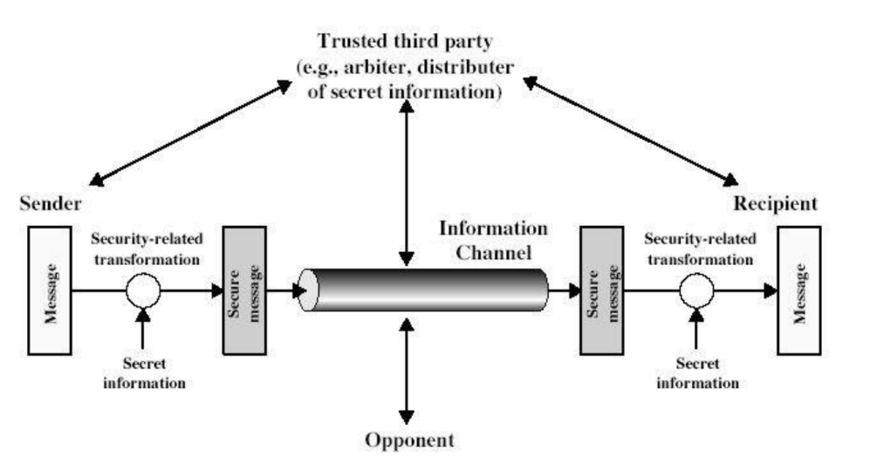

### **Key Components of the Operational Model of Network Security**

The operational model of network security is structured around several essential elements that work together to create a robust security framework. These include:

#### ****1. Security Policies and Procedures****

* Define the security requirements, guidelines, and standards.
* Establish rules for data access, authentication, and authorization.
* Enforce policies for secure remote access, password management, and data classification.

#### ****2. Identification, Authentication, and Access Control****

* **Identification:** Assign unique identifiers to users, devices, and processes.
* **Authentication:** Use credentials such as passwords, biometrics, or multi-factor authentication (MFA) to verify identity.
* **Access Control:** Implement Role-Based Access Control (RBAC) and Principle of Least Privilege (PoLP) to limit user access.

#### ****3. Network Perimeter Security****

* **Firewalls:** Control incoming and outgoing traffic based on security rules.
* **Intrusion Detection and Prevention Systems (IDPS):** Monitor network traffic for suspicious activity.
* **Virtual Private Networks (VPNs):** Encrypt data in transit to ensure secure remote access.

#### ****4. Data Encryption and Secure Communications****

* Encrypt sensitive data using protocols like **SSL/TLS** and **AES** encryption.
* Implement **End-to-End Encryption (E2EE)** to secure messages and files.
* Use **Public Key Infrastructure (PKI)** for digital signatures and certificates.

#### ****5. Endpoint Security****

* Install **Antivirus and Anti-Malware** software on all devices.
* Enable **Endpoint Detection and Response (EDR)** solutions to detect threats.
* Implement **patch management** to keep software updated and secure.

#### ****6. Monitoring, Logging, and Incident Response****

* Use **Security Information and Event Management (SIEM)** to collect and analyze logs.
* Implement **Real-time Monitoring** tools to detect and mitigate threats.
* Develop an **Incident Response Plan (IRP)** to handle security breaches efficiently.

#### ****7. Security Awareness and Training****

* Conduct regular cybersecurity awareness programs for employees.
* Educate users about **phishing attacks, social engineering, and insider threats**.
* Simulate cyber-attack scenarios to enhance preparedness.

#### ****8. Business Continuity and Disaster Recovery****

* Regularly **backup** critical data and maintain an offsite backup.
* Establish a **Disaster Recovery Plan (DRP)** to restore services quickly.
* Perform **periodic security audits** and penetration testing.

### **Steps to Implement the Operational Model of Network Security**

1. **Assess the Network Infrastructure**: Identify assets, vulnerabilities, and threats.
2. **Develop and Enforce Security Policies**: Define security measures and access controls.
3. **Implement Security Controls**: Deploy firewalls, IDS/IPS, encryption, and endpoint protection.
4. **Monitor and Detect Threats**: Use SIEM and threat intelligence tools.
5. **Respond to Incidents**: Follow the incident response plan to mitigate security breaches.
6. **Review and Improve Security Posture**: Conduct security audits and update policies regularly.

The **Operational Model of Network Security** provides a comprehensive framework to safeguard an organization’s network infrastructure. By implementing a layered security approach, enforcing policies, and continuously monitoring threats, organizations can minimize risks and ensure a secure computing environment. Regular training and updates are crucial to adapting to evolving cyber threats and maintaining robust network security.

# **Basic Terminologies in Network Security (Detailed Explanation)**

Network security involves various concepts and terminologies essential for understanding and implementing security measures. Below are eight key terminologies explained in detail:

### **1. Firewall**

A **firewall** is a network security device or software that monitors and controls incoming and outgoing traffic based on predefined security rules. It acts as a barrier between a trusted internal network and untrusted external networks (e.g., the Internet).

#### ****Types of Firewalls:****

* **Packet Filtering Firewall:** Filters packets based on IP addresses, protocols, and ports.
* **Stateful Inspection Firewall:** Monitors active connections and determines which network packets should be allowed.
* **Proxy Firewall:** Acts as an intermediary between users and resources, filtering traffic at the application level.
* **Next-Generation Firewall (NGFW):** Combines traditional firewalls with additional features like Intrusion Prevention Systems (IPS) and deep packet inspection.

**Example:** If a firewall blocks all incoming traffic except for web traffic (HTTP/HTTPS), it prevents unauthorized access to network resources.

### **2. Intrusion Detection System (IDS) and Intrusion Prevention System (IPS)**

Both IDS and IPS monitor network traffic for malicious activities but differ in their response mechanisms:

* **IDS (Intrusion Detection System):**
  + Detects and alerts security personnel about suspicious activities but does not prevent them.
  + Example: Snort (an open-source IDS tool).
* **IPS (Intrusion Prevention System):**
  + Actively blocks or prevents identified threats from affecting the system.
  + Example: Cisco IPS.

### **3. Virtual Private Network (VPN)**

A **VPN** is a technology that establishes a secure and encrypted connection over an insecure network like the Internet. It ensures confidentiality and security of data transmission.

#### ****Types of VPNs:****

1. **Remote Access VPN:** Used by remote users to securely access an organization's network.
2. **Site-to-Site VPN:** Connects multiple offices of an organization over the internet securely.

**Example:** Employees working from home use a VPN to securely access company resources without exposing data to hackers.

### **4. Phishing**

Phishing is a cyber-attack in which attackers impersonate a trusted entity to trick users into revealing sensitive information, such as usernames, passwords, and credit card details.

#### ****Types of Phishing Attacks:****

* **Email Phishing:** Fake emails pretending to be from legitimate sources.
* **Spear Phishing:** Targeted phishing attacks aimed at specific individuals.

**Example:** An email appearing to be from a bank asking users to update their passwords through a fake login page.

### **5. Ransomware**

Ransomware is a type of **malware** that encrypts a victim’s data and demands payment (ransom) to restore access.

#### ****Stages of a Ransomware Attack:****

1. **Infection:** Delivered via phishing emails, malicious links, or exploits.
2. **Encryption:** Files are encrypted, making them inaccessible.
3. **Ransom Demand:** Attackers demand payment (usually in cryptocurrency) to decrypt files.

#### ****Common Ransomware Examples:****

* **WannaCry:** A global ransomware attack affecting thousands of systems.
* **Ryuk:** Targeted ransomware affecting large enterprises.

**Prevention Tips:**

* Keep backups of important data.
* Avoid clicking on unknown links or attachments.
* Use strong endpoint security solutions.

### **6. Denial of Service (DoS) and Distributed Denial of Service (DDoS) Attacks**

* **DoS Attack:** An attack that floods a network or system with excessive traffic, making it unavailable to legitimate users.
* **DDoS Attack:** A more powerful form of DoS where multiple compromised computers (botnets) attack a target simultaneously.

**Example:** A website going offline due to a flood of fake traffic from multiple sources (DDoS using botnets).

**Prevention Measures:**

* Use a **Web Application Firewall (WAF)** to filter unwanted traffic.
* Employ **Rate Limiting** to prevent excessive requests.
* Deploy **DDoS Protection Services** (e.g., Cloudflare, Akamai).

### **7. Encryption and Decryption**

**Encryption** is the process of converting plaintext into ciphertext (unreadable format) to prevent unauthorized access. **Decryption** is the process of converting ciphertext back into plaintext.

#### ****Types of Encryption:****

1. **Symmetric Encryption (Private Key):**
   * Uses the same key for encryption and decryption.
   * Example: AES, DES.
2. **Asymmetric Encryption (Public Key):**
   * Uses two keys: public (encryption) and private (decryption).
   * Example: RSA, ECC.

#### ****Encryption Use Cases:****

* **HTTPS:** Encrypts web communication.
* **End-to-End Encryption (E2EE):** Used in messaging apps like WhatsApp.
* **Email Encryption:** Secure email communication (PGP encryption).

### **8. Multi-Factor Authentication (MFA)**

MFA is a security mechanism that requires users to verify their identity using multiple factors before granting access.

#### ****Types of Authentication Factors:****

1. **Something You Know:** Passwords, PINs.
2. **Something You Have:** Smart cards, OTPs, authentication apps.
3. **Something You Are:** Biometrics (fingerprint, retina scan).

**Example:** Online banking login requiring a password (something you know) and an OTP sent to your phone (something you have).

#### ****Benefits of MFA:****

* Reduces the risk of unauthorized access.
* Protects against password-based attacks.
* Strengthens security for sensitive accounts and transactions.

## **Threats and Vulnerability in Network Security**

### **1. Threat**

A **threat** is any potential danger or event that can exploit weaknesses in a system, causing harm to an organization, network, or individual. Threats can be intentional (e.g., hacking) or unintentional (e.g., natural disasters).

#### ****Types of Threats:****

1. **Malware:** Includes viruses, worms, ransomware, and spyware that damage or disrupt systems.
2. **Phishing Attacks:** Deceptive emails or messages used to steal sensitive information.
3. **Denial-of-Service (DoS) Attacks:** Overloading a system or network to make it unavailable.
4. **Man-in-the-Middle (MITM) Attacks:** Attackers intercept communication between two parties.
5. **Insider Threats:** Employees or partners misusing their access to harm the organization.
6. **Social Engineering:** Manipulating people into revealing confidential data.
7. **Zero-Day Attacks:** Exploiting unknown vulnerabilities before they are patched.

### **2. Vulnerability**

A **vulnerability** is a weakness or flaw in a system, software, or network that can be exploited by a threat to cause harm. Vulnerabilities can arise due to misconfigurations, outdated software, weak passwords, or design flaws.

#### ****Types of Vulnerabilities:****

1. **Software Vulnerabilities:** Bugs or security flaws in applications (e.g., buffer overflow).
2. **Hardware Vulnerabilities:** Flaws in physical devices (e.g., Spectre & Meltdown CPU flaws).
3. **Network Vulnerabilities:** Weak encryption, open ports, or lack of firewalls.
4. **Human Vulnerabilities:** Poor security practices like weak passwords or phishing susceptibility.

### **Key Difference Between Threat and Vulnerability:**

| **Factor** | **Threat** | **Vulnerability** |
| --- | --- | --- |
| **Definition** | A potential event or entity that can cause harm to a system. | A weakness in a system that can be exploited by a threat. |
| **Nature** | External (hackers, malware) or internal (insider threats). | Internal weaknesses within a system or software. |
| **Example** | A hacker attempting to gain unauthorized access. | An outdated operating system with security flaws. |
| **Impact** | Leads to data breaches, financial loss, or system downtime. | Provides an entry point for threats to exploit. |
| **Control Methods** | Firewalls, IDS/IPS, threat intelligence, and security awareness. | Regular software updates, strong passwords, and vulnerability assessments. |

## **Difference Between Security and Privacy**

| **Aspect** | **Security** | **Privacy** |
| --- | --- | --- |
| **Definition** | Protection of data, networks, and systems from unauthorized access or threats. | Protection of personal or sensitive information from unauthorized access, sharing, or misuse. |
| **Focus Area** | Confidentiality, integrity, and availability of data. | Controlling how personal data is collected, stored, and used. |
| **Goal** | Prevent cyberattacks, data breaches, and system failures. | Prevent unauthorized access, tracking, and data exposure. |
| **Threats** | Hackers, malware, DoS attacks, phishing, and insider threats. | Data leaks, identity theft, government surveillance, and unauthorized tracking. |
| **Protection Methods** | Firewalls, encryption, multi-factor authentication (MFA), antivirus software. | Data anonymization, privacy policies, user consent, GDPR compliance. |
| **Regulations** | Covered under cybersecurity laws (e.g., NIST, ISO 27001). | Protected by data privacy laws (e.g., GDPR, CCPA). |
| **User Control** | Mostly handled by security professionals and IT teams. | Users have direct control over their privacy settings and data-sharing permissions. |
| **Example** | A company encrypting its internal databases to prevent hacking. | A social media platform allowing users to restrict who can see their profile. |
|  |  |  |
| **Real-World Example** | Using an anti-virus to prevent malware infections. | Websites asking for cookie consent before tracking user activities. |

### **Comparison Table: Active vs. Passive Attacks**

| **Aspect** | **Active Attack** | **Passive Attack** |
| --- | --- | --- |
| **Definition** | An attack where the attacker actively modifies, disrupts, or damages the system or data. | An attack where the attacker secretly monitors or intercepts data without making changes. |
| **Objective** | To alter, damage, or disrupt data and system operations. | To gather information stealthily without detection. |
| **Modification of Data** | Yes, data is modified, deleted, or corrupted. | No, data is only observed or captured. |
| **Detection** | Easier to detect as system behavior changes. | Harder to detect because no modifications are made. |
| **Example Attacks** | Man-in-the-Middle (MITM), Denial of Service (DoS), Ransomware, SQL Injection. | Eavesdropping, Traffic Analysis, Keylogging, Passive Wiretapping. |
| **Impact on System** | Causes immediate damage, service disruption, or data corruption. | Does not cause immediate harm but compromises confidentiality. |
| **Attacker's Goal** | To cause harm, steal data, or manipulate system behaviour. | To secretly gather sensitive information for later use. |
| **System Response** | System often crashes, slows down, or behaves abnormally. | System continues to function normally. |
| **Countermeasures** | Firewalls, Intrusion Detection Systems (IDS), encryption, authentication. | Strong encryption, VPNs, secure communication channels. |
| **Real-World Example** | A hacker injecting malware into a website to steal user credentials. | A hacker passively monitoring a Wi-Fi network to capture login credentials. |

### **What is CIA Triad? Explain with Diagram/Elements of Information Security.**

The **CIA Triad** is a fundamental model in information security that focuses on three core principles: **Confidentiality, Integrity, and Availability**. These principles help ensure the protection and security of data in an organization.

#### ****Components of CIA Triad:****

1. **Confidentiality:**
   * Ensures that sensitive information is only accessible to authorized users.
   * Prevents unauthorized access using encryption, authentication, and access controls.
   * **Example:** Encrypting customer data to protect it from hackers.
2. **Integrity:**
   * Ensures that data remains accurate, consistent, and unaltered by unauthorized users.
   * Uses hashing, checksums, and digital signatures to prevent tampering.
   * **Example:** A banking system ensuring that transaction records are not modified by attackers.
3. **Availability:**
   * Ensures that data and systems are available when needed by authorized users.
   * Prevents disruptions using backups, redundancy, and disaster recovery plans.
   * **Example:** A cloud service using load balancing to handle traffic surges without downtime.

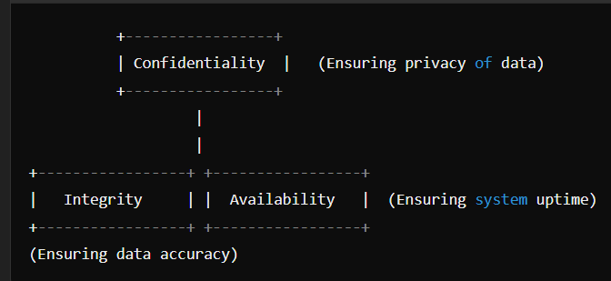

### **What is Security Service? Explain Different Security Services in Detail.**

A **Security Service** is a mechanism used to protect data, systems, and networks from security threats. It ensures secure communication, data integrity, and access control.

#### ****Types of Security Services:****

1. **Authentication:**
   * Confirms the identity of a user or system before granting access.
   * Uses passwords, biometrics, and two-factor authentication (2FA).
   * **Example:** Logging into a bank account using OTP verification.
2. **Access Control:**
   * Restricts unauthorized users from accessing data or systems.
   * Uses role-based access control (RBAC) and permission settings.
   * **Example:** Only managers can access financial reports in a company.
3. **Data Integrity:**
   * Ensures that data is not altered, corrupted, or tampered with.
   * Uses hashing techniques like SHA-256.
   * **Example:** Ensuring a file download is not modified by hackers.
4. **Confidentiality:**
   * Protects sensitive data from being disclosed to unauthorized users.
   * Uses encryption (AES, RSA).
   * **Example:** Encrypting emails to prevent unauthorized access.
5. **Non-Repudiation:**
   * Prevents users from denying their actions.
   * Uses digital signatures and audit logs.
   * **Example:** A sender signing an email digitally to prove they sent it.
6. **Availability:**
   * Ensures data and services are available when needed.
   * Uses load balancing, backups, and DDoS protection.
   * **Example:** A website using Cloud flare to prevent downtime due to attacks.

### **Explain the Types of Security Mechanisms**

Security mechanisms are techniques used to implement security policies and services to protect systems and data from cyber threats.

#### ****Types of Security Mechanisms:****

1. **Encryption:**
   * Converts data into an unreadable format to protect it from unauthorized access.
   * **Example:** SSL/TLS securing online transactions.
2. **Firewall:**
   * Monitors and filters network traffic to block malicious activities.
   * **Example:** A company firewall blocking suspicious IP addresses.
3. **Intrusion Detection and Prevention Systems (IDS/IPS):**
   * IDS detects unauthorized activities, while IPS prevents attacks.
   * **Example:** Detecting and blocking brute-force login attempts.
4. **Access Control Mechanisms:**
   * Restricts access to resources based on permissions.
   * **Example:** Employees accessing only their department’s files.
5. **Authentication and Authorization:**
   * Confirms user identity and assigns appropriate access rights.
   * **Example:** Using multi-factor authentication (MFA) for secure logins.
6. **Data Backup and Recovery:**
   * Protects against data loss due to cyberattacks or system failures.
   * **Example:** Cloud storage services keeping regular backups.
7. **Security Audit and Monitoring:**
   * Continuously monitors and logs activities to detect threats.
   * **Example:** Analysing system logs to find suspicious behaviour.
8. **Anti-Malware and Antivirus:**
   * Detects and removes malicious software from systems.
   * **Example:** Windows Defender scanning files for viruses.

**UNIT 2**

**Data Encryption Techniques & Standards**

**Introduction:**

Data encryption is a fundamental aspect of cybersecurity used to protect sensitive information from unauthorized access. Encryption techniques transform readable data into an unreadable format, ensuring confidentiality and integrity.

Encryption is widely used in secure communication, financial transactions, password protection, and safeguarding confidential files. Over time, various encryption techniques and standards have been developed to strengthen data security against cyber threats.

# **Symmetric Encryption**

Symmetric encryption is a cryptographic technique where the **same key** is used for both **encryption** and **decryption** of data. It is widely used due to its **speed and efficiency**, making it ideal for securing large amounts of data.

## **Components of Symmetric Encryption**

A symmetric encryption system consists of **five main components**:

1. **Plaintext** – The original message before encryption.
2. **Encryption Algorithm** – A mathematical function that converts plaintext into ciphertext using the secret key.
3. **Secret Key** – A private key that must be kept confidential, as it is used for both encryption and decryption.
4. **Ciphertext** – The encrypted, unreadable version of the plaintext.
5. **Decryption Algorithm** – A function that converts ciphertext back to plaintext using the same secret key.

### **Encryption Process**

1. **Plaintext** is provided as input.
2. **Encryption algorithm** processes the plaintext using a **secret key**.
3. The **output** is **ciphertext**, which looks like random data.
4. The **ciphertext is sent** to the receiver.
5. The receiver uses the **same secret key** and a **decryption algorithm** to convert the ciphertext back to **plaintext**.

## **Advantages of Symmetric Encryption**

✔ **Fast and Efficient** – High-speed encryption, making it ideal for large datasets.  
✔ **Shorter Keys** – Requires less computational power compared to asymmetric encryption.  
✔ **Flexible Usage** – Can be used for data encryption, authentication, and pseudorandom number generation.  
✔ **Can Be Strengthened** – Combining multiple symmetric ciphers can enhance security.

## **Disadvantages of Symmetric Encryption**

✖ **Key Management Complexity** – In large networks, securely managing keys for multiple users is challenging.  
✖ **Key Exchange Problem** – Securely sharing the secret key with the recipient is difficult.  
✖ **Frequent Key Changes Required** – To maintain security, secret keys must be updated periodically.

## **Real-World Applications of Symmetric Encryption**

* **Wi-Fi Security** – Used in WPA2 for encrypting wireless networks.
* **VPNs (Virtual Private Networks)** – Secures private communications over public networks.
* **Database Encryption** – Protects sensitive user data in databases.
* **File and Disk Encryption** – Tools like BitLocker and VeraCrypt use AES encryption.
* **Secure Messaging Apps** – Many chat applications encrypt messages using symmetric encryption. 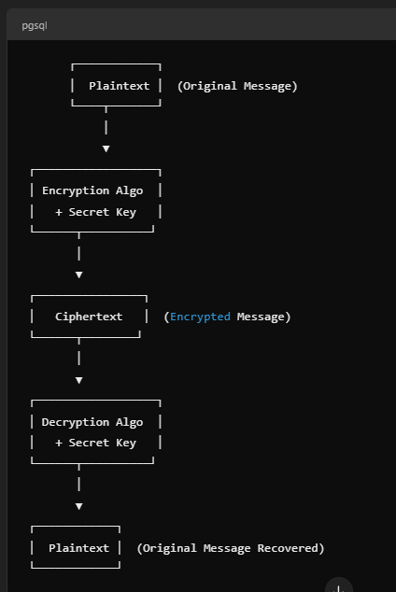

# **Asymmetric Encryption**

## **Definition**

Asymmetric encryption, also known as **public-key cryptography**, uses **two different keys** for encryption and decryption:

1. **Public Key** – Used for encryption, can be shared openly.
2. **Private Key** – Used for decryption, must be kept secret.

This method ensures **confidentiality, integrity, authentication, and non-repudiation** in secure communications.

## **Components of Asymmetric Encryption**

A typical asymmetric encryption system consists of the following components:

1. **Plaintext** – The original message to be encrypted.
2. **Public Key** – Used for encrypting the plaintext message.
3. **Encryption Algorithm** – Converts plaintext into ciphertext using the public key.
4. **Ciphertext** – The encrypted message that is transmitted securely.
5. **Private Key** – Used for decrypting the ciphertext back into plaintext.
6. **Decryption Algorithm** – Uses the private key to transform ciphertext back to plaintext.

## **Encryption Process**

1. **Plaintext** is given as input.
2. **Public key** encrypts the plaintext using an **encryption algorithm**.
3. The **output** is **ciphertext**, which is transmitted securely.
4. The **ciphertext is received** by the intended recipient.
5. The **recipient uses their private key** to decrypt the ciphertext back into **plaintext**.

## **Advantages of Asymmetric Encryption**

✔ **Better Security** – Private keys are kept secret, making attacks harder.  
✔ **No Key Distribution Problem** – Users generate their own key pairs.  
✔ **Scalability** – Works well even for large networks.  
✔ **Supports Digital Signatures** – Ensures integrity, authentication, and non-repudiation.  
✔ **Used for Secure Web Communications** – Essential for HTTPS, digital certificates, and email security.

## **Disadvantages of Asymmetric Encryption**

✖ **Slower Than Symmetric Encryption** – More computationally intensive.  
✖ **Complex Key Management** – Public and private keys must be properly managed.  
✖ **Not Ideal for Large Data Encryption** – Often used to encrypt session keys instead.

## **Real-World Applications of Asymmetric Encryption**

* **Secure Web Browsing (HTTPS, SSL/TLS)** – Used to encrypt web traffic.
* **Email Security (PGP, S/MIME)** – Ensures confidential communication.
* **Digital Signatures** – Used for authentication and non-repudiation.
* **Blockchain & Cryptocurrency** – Secures transactions in Bitcoin and Ethereum.
* **SSH Authentication** – Used in secure remote logins.

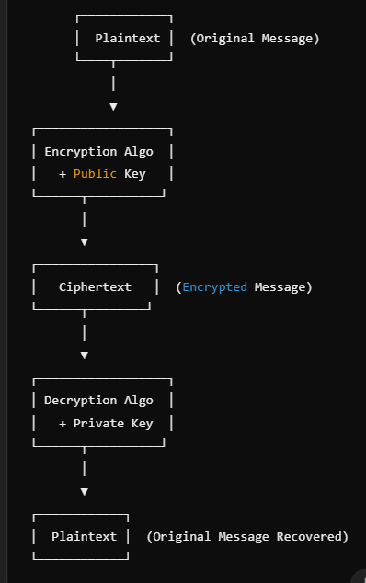

### **Cryptography: An Overview**

Cryptography is the **practice and study of techniques** used to secure communication in the presence of third parties (adversaries). It is an ancient art of **writing in secret codes** to protect sensitive information from unauthorized access.

Cryptography ensures **confidentiality, integrity, authentication, and non-repudiation** in digital communication. It protects data from **theft, alteration, or unauthorized access** and plays a crucial role in cybersecurity.

### **Types of Cryptographic Schemes**

There are three main types of cryptographic techniques:

1. **Secret Key Cryptography (Symmetric Encryption)**
   * Uses a **single shared key** for both encryption and decryption.
   * Common algorithms: **AES, DES, 3DES, Blowfish, RC4**.
   * Used for **fast encryption of large data** but requires secure key exchange.
2. **Public-Key Cryptography (Asymmetric Encryption)**
   * Uses **two keys**: a **public key** (for encryption) and a **private key** (for decryption).
   * Common algorithms: **RSA, ECC, Diffie-Hellman, DSA**.
   * Provides **secure key exchange and digital signatures**.
3. **Hash Functions**
   * Converts data into a **fixed-length hash value** (irreversible).
   * Used for **data integrity verification** (e.g., in passwords and digital signatures).
   * Common algorithms: **SHA-256, MD5, SHA-3**.

Cryptography is essential for **secure online transactions, data protection, digital signatures, and user authentication** in modern digital systems.

## **1. Substitution Ciphers**

### **Definition**

A **Substitution Cipher** is a method of encryption where each letter in the plaintext is replaced with another letter, number, or symbol. The **positions of the characters remain the same**, but their identity is changed based on a fixed system or key.

### **Types of Substitution Ciphers**

#### ****A. Monoalphabetic Substitution Cipher****

* Each letter in the plaintext is replaced by **a fixed letter** from the ciphertext alphabet.
* The mapping remains **constant throughout the message**.
* Example: **Caesar Cipher, Atbash Cipher, Simple Substitution Cipher**.

#### ****B. Polyalphabetic Substitution Cipher****

* Multiple substitution alphabets are used to encrypt the text.
* The same letter can be substituted differently depending on its position in the text.
* Example: **Vigenère Cipher, Playfair Cipher, Hill Cipher**

### **Advantages of Substitution Ciphers**

✔ **Easy to implement**  
✔ **Can be made stronger using multiple alphabets**  
✔ **Used in classical cryptography and basic security applications**

### **Disadvantages of Substitution Ciphers**

✖ **Prone to frequency analysis attacks**  
✖ **Easily breakable if the key is short (e.g., in Vigenère Cipher)**  
✖ **Simple ciphers (like Caesar) are weak against brute force attacks**

## **2. Transposition Ciphers**

### **Definition**

A **Transposition Cipher** is a type of encryption where **the positions of the characters in the plaintext are rearranged** to form the ciphertext, but the characters themselves remain unchanged.

### **Types of Transposition Ciphers**

#### ****A. Rail Fence Cipher (Simple Columnar Transposition)****

* The plaintext is written in a **zig-zag pattern** and then read row-wise to create ciphertext.

#### ****B. Columnar Transposition Cipher****

* The plaintext is written in a **grid format**, and the letters are rearranged based on a secret key.

### **Advantages of Transposition Ciphers**

✔ **Stronger than substitution ciphers against frequency analysis**  
✔ **Can be combined with substitution ciphers for stronger encryption**

### **Disadvantages of Transposition Ciphers**

✖ **Still vulnerable to pattern detection**  
✖ **Not effective against modern cryptanalysis techniques**

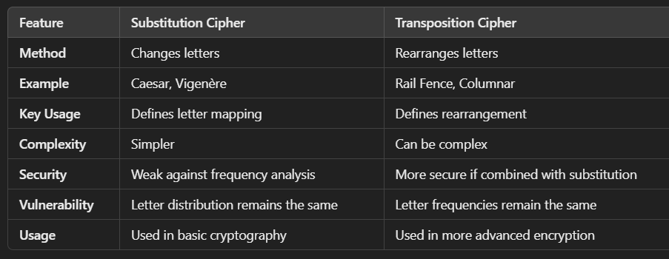

# **Steganography: Overview, Applications, and Limitations**

**Steganography** is the practice of **hiding secret information** within non-secret digital files, such as images, audio, video, or text, to conceal its existence. Unlike cryptography, which **encrypts data** to make it unreadable, steganography **hides the data** so that it remains undetectable.

### **Key Features of Steganography:**

✔ **Hides existence** of the message.  
✔ **Does not alter the overall appearance** of the cover medium.  
✔ **Difficult to detect** without knowing the embedding method.  
✔ Often combined with **encryption** for added security.

## **Types of Steganography**

### **1. Text Steganography**

Hiding messages within text files using techniques like:

* **Whitespace Manipulation**: Adding extra spaces/tabs that encode binary data.
* **Letter Substitution**: Changing font sizes or types to hide data.
* **Context-Based**: Using synonyms or grammatical patterns to encode information.

### **2. Image Steganography**

Hiding data inside images by modifying **pixel values** without visible distortion.

**Methods:**

* **Least Significant Bit (LSB) Encoding**: Replacing the **least important bit** of each pixel with secret data.
* **Palette-Based Encoding**: Modifying color palettes in indexed images.
* **DCT (Discrete Cosine Transform) Steganography**: Hiding data in frequency coefficients of **JPEG images**.

### **3. Audio Steganography**

Embedding secret data into audio files by modifying **frequency or amplitude**.

**Methods:**

* **LSB Encoding**: Altering the least significant bits in digital audio samples.
* **Echo Hiding**: Adding slight echoes that encode information.
* **Phase Coding**: Modifying audio phase differences to store data.

### **4. Video Steganography**

Hiding data inside video files by altering **frames, colors, or motion vectors**.

**Methods:**

* **Frame Manipulation**: Embedding data in selected frames.
* **Bitplane Complexity Segmentation (BPCS)**: Altering complex regions of frames.
* **Motion Vector Encoding**: Modifying motion data in video compression.

### **5. Network Steganography**

Hiding data within network protocols, such as **TCP/IP headers, packet timing, or covert channels**.

**Methods:**

* **Protocol Steganography**: Manipulating header fields in TCP, IP, or UDP packets.
* **Timing Steganography**: Deliberately adjusting packet timing to encode information.

## **Applications of Steganography**

### **1. Secure Communication**

* Used to **covertly transmit** sensitive information over **insecure networks**.
* Protects against **interception by adversaries**.

### **2. Digital Watermarking**

* Embedding **copyright information** in images, videos, or audio to prevent piracy.
* Used in **broadcast monitoring, fingerprinting, and intellectual property protection**.

### **3. Cybersecurity and Intelligence**

* Governments and military organizations use it for **covert operations and spying**.
* **Steganographic malware** can hide malicious code within harmless-looking files.

### **4. Digital Forensics**

* Detecting hidden messages in **criminal investigations**.
* Used in **anti-counterfeiting** and document verification.

### **5. Protecting Journalists & Whistleblowers**

* Activists use steganography to **bypass censorship and surveillance**.
* Helps in transmitting confidential information in **repressive environments**.

## **Limitations of Steganography**

### **1. Vulnerable to Steganalysis**

* **Steganalysis** is the science of detecting steganography.
* Modern tools can **analyze statistical anomalies** in media files to uncover hidden messages.

### **2. Requires a Large Cover Medium**

* A **high-resolution image** or **large audio file** is needed to store a significant amount of secret data.
* If too much data is embedded, the **cover file becomes suspicious**.

### **3. Low Redundancy and Robustness**

* If the **carrier file is compressed, resized, or modified**, the hidden data might be **lost or corrupted**.
* **JPEG compression** and **image scaling** can remove embedded information.

### **4. Detection Can Lead to Legal Consequences**

* Some **governments and organizations ban steganography** because of its use in illegal activities (e.g., cybercrime, terrorism).
* **Hidden data in digital media** might be **seized or investigated**.

### **5. Not a Replacement for Encryption**

* Steganography **only hides the presence** of data; it does **not encrypt it**.
* **If detected, hidden data can be extracted unless it is also encrypted**.

# **DES (Data Encryption Standard) Algorithm**

## **Introduction**

The **Data Encryption Standard (DES)** is a symmetric-key block cipher that was widely used for data encryption. It was developed in the 1970s by IBM and later adopted as a federal standard by the U.S. National Institute of Standards and Technology (NIST) in 1977.

### **Key Features of DES**

* **Block Cipher:** Encrypts data in 64-bit blocks.
* **Key Size:** Uses a 56-bit key (plus 8 parity bits, making it 64-bit).
* **Symmetric Key:** The same key is used for encryption and decryption.
* **Rounds:** DES consists of 16 rounds of encryption, each applying permutations and substitutions.

### **Working of DES**

1. **Initial Permutation (IP):** The 64-bit plaintext is shuffled according to a fixed table.
2. **16 Rounds of Encryption:**
   * The 64-bit block is divided into two 32-bit halves: **Left (L) and Right (R)**.
   * A **Feistel Function (F)** is applied to the right half using a round key.
   * The result is XORed with the left half.
   * Swap the halves (except in the final round).
   * A different subkey is used for each round (generated from the main key).
3. **Final Permutation (FP):** After 16 rounds, another fixed permutation is applied to the combined halves to produce the ciphertext.

### **Feistel Function (F) in Each Round**

Each round consists of:

1. **Expansion (E-Box):** Expands 32-bit R to 48-bit using a fixed expansion table.
2. **Key Mixing:** XORs the expanded R with a 48-bit round key.
3. **Substitution (S-Boxes):** Breaks the 48-bit result into 8 blocks of 6 bits each. Each block is substituted using a fixed **S-Box**, reducing it back to 4 bits (total 32 bits).
4. **Permutation (P-Box):** Rearranges the 32-bit output.
5. **XOR with Left Half:** The output is XORed with L, then L and R are swapped.

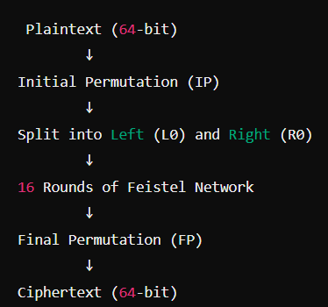

## **Example of DES Encryption**

### **Example Plaintext Conversion**

* Suppose we want to encrypt the **message** "HI"
* **ASCII Binary Representation**:
  + H → 01001000
  + I → 01001001
* Combined into a **64-bit block** (with padding if needed).

### **Step 1: Initial Permutation**

* The 64-bit plaintext is **shuffled** based on the **IP table**.

### **Step 2: Key Expansion**

* Example **Key**: 133457799BBCDFF1 (Hex)
* Convert to **binary**, apply **PC-1**, and generate **16 subkeys (K1–K16)**.

### **Step 3: 16 Rounds of Feistel Network**

* Each round involves **expansion, XOR, substitution, and permutation** using subkeys.

### **Step 4: Final Permutation**

* The **ciphertext** is obtained after applying the **FP table**.

## **Advantages of DES**

✔ **Easy to implement** in hardware and software.  
✔ **Uses Feistel structure**, which allows decryption with the same algorithm.  
✔ **Well-studied encryption technique**, making it useful for educational purposes.

## **Disadvantages of DES**

❌ **Weak Key Size (56-bit)** → Vulnerable to **brute-force attacks**.  
❌ **Not Secure for Modern Use** → Replaced by **AES and 3DES**.  
❌ **Vulnerable to cryptanalysis**, including **differential and linear attacks**.

# **Detailed Explanation of 3DES (Triple DES) Algorithm**

## **Introduction**

🔐 **Triple Data Encryption Standard (3DES)** is an enhancement of the **Data Encryption Standard (DES)** to overcome its security weaknesses. It applies the DES algorithm **three times** to each data block, making it significantly more secure than standard DES.

### **Why 3DES Was Developed?**

* DES uses a **56-bit key**, which is vulnerable to **brute-force attacks** due to modern computing power.
* **3DES increases the key length** to **168 bits (in the strongest variant)** by applying DES encryption three times.
* 3DES is still used in some legacy systems but is **being phased out in favor of AES** due to better security and performance.

## **Key Features of 3DES**

* **Block Size**: 64-bit (same as DES)
* **Key Size**: 112-bit (two-key variant) or **168-bit (three-key variant)**
* **Rounds**: 48 (16 rounds per DES operation, executed 3 times)
* **Type**: Symmetric key block cipher
* **Structure**: **Feistel Network (same as DES)**

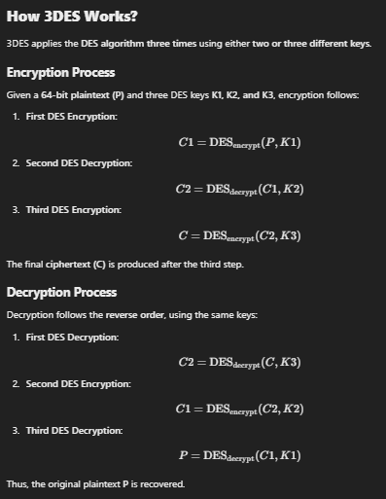

## **Encryption:**

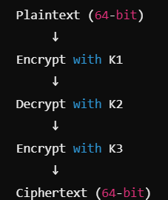

## **Decryption**

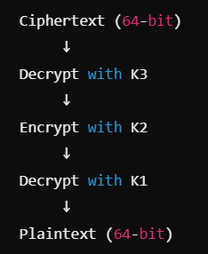

## **Example of 3DES Encryption**

### **Step 1: Convert Plaintext to Binary**

* Suppose the plaintext message is "HI".
* **ASCII to Binary Conversion**:
  + H → 01001000
  + I → 01001001
* Padding is added to form a **64-bit block**.

### **Step 2: Apply 3DES Encryption**

Using three keys:

* **K1 = AABB09182736CCDD**
* **K2 = 1122334455667788**
* **K3 = AABB09182736CCDD**

1. **Encrypt plaintext with K1** using DES.
2. **Decrypt the result with K2** using DES.
3. **Encrypt the result with K3** using DES.

The final cipher text is obtained after the third step.

### **Step 3: Decryption (Reverse the Process)**

1. **Decrypt with K3**.
2. **Encrypt with K2**.
3. **Decrypt with K1** to recover the plaintext.

## **Advantages of 3DES**

✔ **More Secure Than DES**: Increases security by applying DES three times.  
✔ **Backward Compatible with DES**: Can interoperate with legacy systems.  
✔ **Used in Banking & Financial Systems**: Despite AES adoption, some systems still use 3DES.

## **Disadvantages of 3DES**

❌ **Slow Compared to AES**: Requires **three DES operations**, making it inefficient for large data.  
❌ **Not Future-Proof**: Being **phased out** by NIST; AES is recommended instead.  
❌ **Key Length Still Limited**: **112-bit security (2-key) is vulnerable to modern attacks**.

# **Advanced Encryption Standard (AES)**

**Advanced Encryption Standard (AES)** is a **symmetric-key block cipher** used worldwide for secure data encryption. It was developed by **Vincent Rijmen and Joan Daemen** and adopted by **NIST (National Institute of Standards and Technology) in 2001** to replace the insecure **DES and 3DES algorithms**.

AES is widely used in **banking, military, government communications, and online transactions** due to its **high security and efficiency**.

## **Key Features of AES**

* **Block Size**: 128 bits
* **Key Sizes**: 128-bit, 192-bit, or 256-bit
* **Rounds**:
  + **10 rounds** for **128-bit keys**
  + **12 rounds** for **192-bit keys**
  + **14 rounds** for **256-bit keys**
* **Encryption Type**: Symmetric (same key is used for encryption and decryption)
* **Structure**: **Substitution-Permutation Network (SPN)** instead of the Feistel structure used in DES

## **How AES Works?**

AES processes **128-bit blocks** of data in **a series of rounds**, where each round consists of several transformations to **confuse and diffuse** the data.

### **AES Encryption Process**

AES encryption consists of the following steps:

### **1. Key Expansion**

* The **original key** is expanded into **multiple round keys** using the **Rijndael key schedule**.
* A total of **11, 13, or 15 round keys** are generated (depending on key size).

### **2. Initial Round (AddRoundKey)**

* The first **128-bit block of plaintext** is XORed with the **first round key**.

### **3. Main Rounds (Repeat 9, 11, or 13 times)**

Each round consists of **four transformations**:

1️**SubBytes (Byte Substitution using S-Box)**

* Each byte in the block is replaced using a fixed **S-Box (Substitution Box)**.
* This introduces **non-linearity** and strengthens security.

2️**ShiftRows (Row Shifting in Matrix Form)**

* The **first row remains unchanged**.
* The **second row is shifted left by 1 position**.
* The **third row is shifted left by 2 positions**.
* The **fourth row is shifted left by 3 positions**.
* This ensures diffusion by mixing data across rows.

3️**MixColumns (Mixing in Galois Field GF(2⁸))**

* A mathematical transformation is applied on each column using **matrix multiplication**.
* This step provides further diffusion by mixing data across bytes.
* **Note:** This step is **skipped in the final round**.

4 **AddRoundKey (XOR with Round Key)**

* The output is XORed with the **round key** generated from the key expansion process.

### **4. Ciphertext Output**

* After all rounds, the **final 128-bit encrypted block** is obtained as the **ciphertext**.

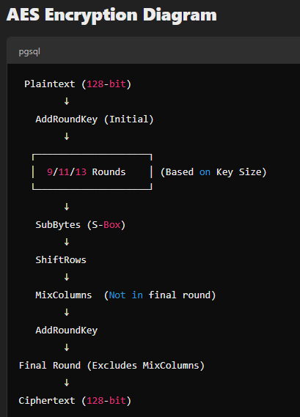**Decryption is the reverse process**, applying inverse operations in reverse order.

## **Example of AES Encryption**

### **Step 1: Convert Plaintext to Binary**

Suppose we encrypt "HELLO123" using AES-128.

* ASCII to **Hexadecimal**: "48 45 4C 4C 4F 31 32 33"
* Converted to **128-bit binary block**.

### **Step 2: Key Expansion**

* Example key: 2B7E151628AED2A6ABF7158809CF4F3C
* Expand to generate **11 round keys**.

### **Step 3: AES Rounds**

* **Apply AddRoundKey** (XOR plaintext with first round key).
* **Perform 9 main rounds** (SubBytes, ShiftRows, MixColumns, AddRoundKey).
* **Perform the final round** (excluding MixColumns).
* **Ciphertext is obtained**.

## **AES Decryption Process**

**Decryption follows the reverse process**, using inverse transformations:

1. **Inverse ShiftRows**
2. **Inverse SubBytes**
3. **AddRoundKey**
4. **Inverse MixColumns (except in the final round)**

This restores the **original plaintext**.

## **Advantages of AES**

✔ **Highly Secure**: Resistant to **brute-force, differential, and linear cryptanalysis**.  
✔ **Efficient**: Faster than DES and 3DES due to fewer computational steps.  
✔ **Scalable Key Sizes**: Supports **128, 192, and 256-bit** keys.  
✔ **Used in Modern Security Protocols**: **TLS, SSL, VPNs, Wi-Fi encryption (WPA2), banking security**.

## **Disadvantages of AES**

❌ **Complex Key Expansion**: More difficult to implement than DES.  
❌ **Slower for Small Data**: Not ideal for encrypting very small amounts of data (e.g., short messages).  
❌ **Vulnerable to Side-Channel Attacks**: If improperly implemented in hardware, attackers can exploit **power consumption or timing leaks**.

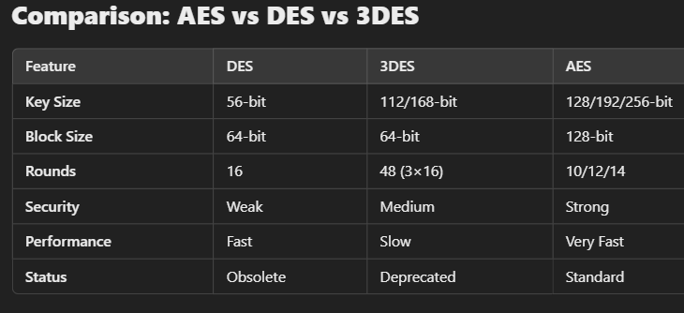

# **Weak Keys in DES Algorithm**

The **Data Encryption Standard (DES)** is a symmetric-key block cipher that encrypts data using **16 rounds of Feistel structure**. However, certain **keys** in DES create **weaknesses** that make the encryption vulnerable.

**Weak keys** in DES are specific **64-bit keys** that **fail to provide strong encryption**, making them **vulnerable to cryptanalysis**. These keys cause **identical subkeys** to be generated in each round, reducing the overall security of DES.

## **Types of Weak Keys in DES**

### **1. Completely Weak Keys**

🔹 These keys **generate the same subkey for all 16 rounds**, meaning encryption and decryption produce the same result.  
🔹 There are **4 completely weak keys** in DES:

| **Hexadecimal Representation** |
| --- |
| 0000000000000000 |
| FFFFFFFFFFFFFFFF |
| 1F1F1F1F0E0E0E0E |
| E0E0E0E0F1F1F1F1 |

📌 **Why are these weak?**

* Since the **same subkey** is used in every round, the encryption process **does not change** the data effectively.
* If a user encrypts plaintext with one of these weak keys, **decryption with the same key gives back the original plaintext immediately**.

### **2. Semi-Weak Keys**

🔹 There are **6 pairs of semi-weak keys** (12 keys total).  
🔹 When **one key is used for encryption, its pair key decrypts the ciphertext**, effectively **undoing encryption**.

| **Hexadecimal Representation (Pairs of Semi-Weak Keys)** |
| --- |
| 01FE01FE01FE01FE & FE01FE01FE01FE01 |
| 1FE01FE00EF10EF1 & E01FE01FF10EF10E |
| 011F011F010E010E & 1F011F010E010E01 |
| E0FEE0FEF1EEF1EE & FEE0FEE0EEF1EEF1 |
| FE1FFE1FEEF1EEF1 & 1FFE1FFEFEF1FEF1 |
| E0E0E0E0F1F1F1F1 & F1F1F1F1E0E0E0E0 |

**Why are these semi-weak?**

* If K1 is used to encrypt a message, **K2 can decrypt the ciphertext**, and vice versa.
* This reduces the number of possible key choices, making **brute-force attacks easier**.

### **3. Possibly Weak Keys**

🔹 These keys **generate a limited number of unique subkeys**, reducing the complexity of encryption.  
🔹 There are **48 possibly weak keys** in DES, making them **less secure than strong keys** but not as weak as completely weak keys.

## **How Weak Keys Affect Security**

**Weak keys in DES make the encryption highly predictable and vulnerable to attacks.**

* **If an attacker identifies that a weak key is used**, they can easily decrypt the data.
* Since **DES has only 2⁵⁶ possible keys**, a **brute-force attack** is feasible with modern computing.
* **Triple DES (3DES) and AES** were introduced to solve these security issues.

## **Example of Weak Key Behavior**

Imagine encrypting the plaintext "HELLO" using a **completely weak key (0000000000000000)**:

1. The **same subkey** is generated for all **16 rounds**.
2. The **ciphertext remains unchanged** after decryption.
3. This means **encryption does nothing**, making the key useless.

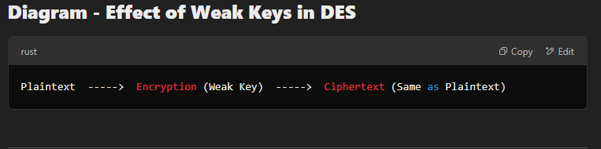

## **Advantages and Disadvantages of DES Weak Keys**

### ✅ **Advantages**

✔ Helps identify vulnerabilities in DES.  
✔ Used for testing and cryptanalysis in security research.

### ❌ **Disadvantages**

❌ Makes encryption weaker and predictable.  
❌ Allows attackers to easily decrypt messages.  
❌ Reduces key strength, making **brute-force attacks feasible**.

## **How to Avoid Weak Keys?**

✔ **Use a key generator that avoids weak and semi-weak keys.**  
✔ **Upgrade from DES to AES (Advanced Encryption Standard).**  
✔ **Use Triple DES (3DES) for added security** (though AES is preferred).

REMAINING POINTS

Block Cipher

Stream Cipher

Counter mode of block cipher

Columnar Cipher

Improved Columnar Cipher

Play Fair cipher

Caesar Cipher

Monoalphabetic Cipher

Hill Cipher

Polyalphabetic Substitution

One Time Pad.

Feistel Cipher.

Comparison between Monoalphabetic and Polyalphabetic Cipher