**Unit 3**

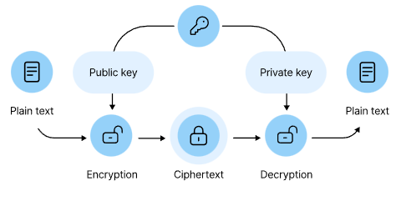

**Public Key Cryptography**, also known as **asymmetric cryptography**, is a cryptographic system that uses a pair of keys: a **public key**, which is openly shared, and a **private key**, which is kept secret by the owner. The public key is used to **encrypt** data or verify digital signatures, while the private key is used to **decrypt** data or create digital signatures. This method allows secure communication between parties without the need to share a secret key beforehand, addressing a major limitation of symmetric key cryptography.

**Key Features:**

* Enables **secure communication** without needing to share a secret key in advance
* Supports **digital signatures** (authentication and integrity)
* Used in **SSL/TLS**, email encryption, blockchain, and more

# **RSA Algorithm**

**RSA** (named after its inventors **Rivest**, **Shamir**, and **Adleman**) is one of the most widely used **public key cryptographic algorithms**. It enables secure **data encryption**, **digital signatures**, and **key exchange** in a public-key infrastructure (PKI).

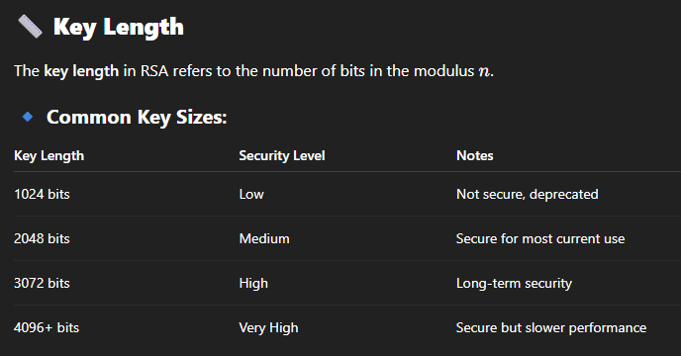

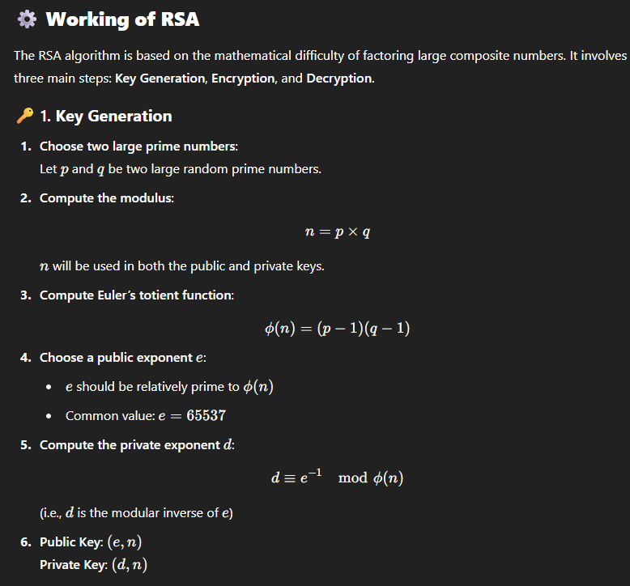

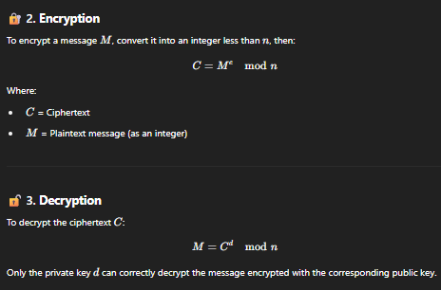

**Security in RSA**

**Based on Integer Factorization**

* Security relies on difficulty of factoring n=p×q

**No Efficient Classical Algorithm**

* Factoring large semi primes is hard with current computers.

**Key Size Matters**

* Use at least **2048-bit** keys for strong security.

**Main Vulnerabilities**:

* Poor prime generation
* Small key sizes
* Side-channel attacks (e.g., timing attacks)

**Quantum Threat**

* **Shor’s Algorithm** can break RSA on quantum computers.

**Mitigation**

* Use strong keys, proper padding (e.g., OAEP), and secure implementation.

# **Key Distribution in RSA**

### ****In Symmetric Cryptography:****

* **Secret key** must be shared securely between both parties before communication.
* The same **key** is used for both encryption and decryption.

### ****In RSA/Public Key Cryptography:****

* **Public key** can be **freely distributed** to anyone.
* The **private key** remains **confidential** and is kept only by the key owner.
* **Encryption** is done using the **public key**, and only the **private key holder** can decrypt the message.

### ****Public Key Infrastructure (PKI):****

* Public keys are distributed through **digital certificates** (e.g., X.509).
* **Certificates** are issued by trusted **Certificate Authorities (CAs)** to verify authenticity.
* Commonly used in **HTTPS**, **email encryption**, **digital signatures**, and more.

# **Diffie-Hellman Key Exchange**

**Diffie-Hellman** is one of the earliest and most famous algorithms for securely exchanging cryptographic keys over an insecure channel. It allows two parties to establish a **shared secret key** that can be used for **symmetric encryption**, without needing to directly exchange the key itself.

## ⚙️ **Working of Diffie-Hellman Key Exchange**

1. **Public Parameters**:
   * Both parties agree on a **large prime number** ppp and a **base (primitive root)** ggg. These values are public and can be shared openly.
2. **Private Keys**:
   * Each party generates a **private key**:
     + Let **Alice's private key** be aaa
     + Let **Bob's private key** be bbb
     + These private keys are **kept secret** and never exchanged.
3. **Public Key Generation**:
   * Each party computes their **public key** by using the public parameters and their private key:
     + **Alice's public key**: A=g^amod  p
     + **Bob's public key**: B=g^bmod  p
     + The public keys A and A are then exchanged between Alice and Bob.

## 🔄 **Key Exchange Process**

1. **Exchange Public Keys**:

• Alice sends her public key A to Bob.

• Bob sends his public key B to Alice.

1. **Key Computation**:
   * Now, both Alice and Bob can independently compute the shared secret key using their own private key and the other party's public key:
     + **Alice's computation**:  
       S=B ^ a mod  p
     + **Bob's computation**:  
       S=A^ b mod  p
   * Both calculations yield the same shared secret key SSS, because of the mathematical property:

(g^b)^a mod p=(g^a)^b mod p

This results in the same value for both Alice and Bob.

1. **Resulting Shared Secret**:
   * Alice and Bob now share the same secret key S, which can be used for symmetric encryption to communicate securely.

**Elliptic Curve Cryptography (ECC)** is a powerful and efficient method used in modern cryptographic systems. It relies on the algebraic structure of elliptic curves over finite fields. Below is a detailed breakdown of the concepts you've mentioned:

### 1. ****Elliptic Curve Arithmetic****

Elliptic curves are equations of the form:

y^2=x^3+ax+b

Where:

* a and b are constants.
* The curve has distinct properties, such as symmetry about the x-axis, which is useful in cryptographic operations.

In elliptic curve cryptography (ECC), we work with points on these curves. The most significant operation is **point addition** (combining two points on the curve to get another point), and **point doubling** (doubling a point on the curve). This allows the construction of a **group** in which elliptic curve operations can be performed.

Elliptic curve arithmetic is used in two key ways:

* **Scalar multiplication**: Multiplying a point on the curve by an integer (i.e., repeatedly adding the point to itself).
* **Point addition**: Adding two points on the elliptic curve.

The difficulty of solving the **Elliptic Curve Discrete Logarithm Problem** (ECDLP) — the task of figuring out the integer k such that P=k, where P and Q are points on the curve — is computationally hard. This is what ensures the security of ECC-based systems.

### ****Elliptic Curve Cryptography (ECC)****

ECC is a form of public key cryptography based on the algebraic structure of elliptic curves. ECC offers the same level of security as traditional cryptosystems like RSA, but with smaller key sizes. This makes ECC highly efficient in terms of computational resources and bandwidth.

* **Key generation**: ECC uses pairs of keys (public and private) for encryption and digital signatures. The private key is a randomly chosen integer, and the public key is derived by multiplying the private key with a predefined point on the elliptic curve.
* **Elliptic Curve Diffie-Hellman (ECDH)**: A method used to securely exchange cryptographic keys over a public channel. This method allows two parties to independently generate a shared secret key, which can be used for symmetric encryption.
* **Elliptic Curve Digital Signature Algorithm (ECDSA)**: A widely used algorithm for digital signatures. It uses elliptic curve arithmetic to generate a signature that can be used to authenticate the identity of the sender of a message.

### 3. ****Cryptography****

Cryptography is the science of securing communication and information through encoding and decoding. There are two main types:

* **Symmetric Key Cryptography**: The same key is used for both encryption and decryption (e.g., AES).
* **Asymmetric Key Cryptography**: Uses a pair of keys — one for encryption (public key) and one for decryption (private key) (e.g., RSA, ECC).

Elliptic Curve Cryptography falls under the category of asymmetric key cryptography.

**Security**

The security of elliptic curve cryptography is based on the **Elliptic Curve Discrete Logarithm Problem (ECDLP)**, which is computationally hard to solve. In other words, even though the operations on elliptic curves are easy to perform (like point addition and scalar multiplication), reversing them (i.e., finding the integer from a given point) is extremely difficult. This difficulty underpins the strength of ECC.

Authentication Methods:  
 Authentication is the process of verifying the identity of a user, device, or service.   
Common methods include:   
Password-based authentication: Verifying users with passwords.   
Biometric authentication: Using physical attributes like fingerprints or facial recognition.   
Cryptographic authentication: Using cryptographic methods like digital signatures or certificates.

### ****Message Digest****

A **message digest** (also called a hash) is a fixed-size numerical representation of data (like a message or file). The purpose of a message digest is to ensure data integrity. Even a small change in the original data will result in a drastically different digest. developed by **Ronald Rivest** in 1991, is a widely used **cryptographic hash function**. It takes an input of any length and produces a fixed-size **128-bit (16-byte)** hash value called a **message digest**.

* **SHA (Secure Hash Algorithm)**: A family of cryptographic hash functions that produce a message digest. SHA-256 is commonly used in modern cryptography and is widely used in ECC-based systems.
* **Hashing with ECC**: Often, a hash is used in combination with elliptic curve algorithms, especially in digital signatures. The hash of a message is signed by a private key, ensuring both the integrity and authenticity of the message.

## **Step-by-Step Operation of MD5 Algorithm**

### ****Step 1: Padding the Message****

* The original message is padded to ensure its length is **448 mod 512** (i.e., 64 bits short of a multiple of 512).
* Padding is done by:
  + Appending a **‘1’ bit**.
  + Appending **‘0’ bits** until the length condition is met.

🔹 Purpose: Ensures message can be divided into 512-bit blocks with space for length info.

### ****Step 2: Append Message Length****

* A **64-bit representation** of the original message length (before padding) is appended to the message.
* Now the total message length is a **multiple of 512 bits**.

🔹 Example: If original message length = 1000 bits → append 64-bit binary of 1000.

### ****Step 3: Initialize MD5 Buffers****

Four **32-bit registers** are initialized to fixed constants:

A = 0x67452301

B = 0xefcdab89

C = 0x98badcfe

D = 0x10325476

🔹 These registers will store the intermediate and final digest values.

### ****Step 4: Process the Message in 512-bit Blocks****

Each 512-bit block is divided into **16 words (M[0] to M[15])** of 32 bits each.

MD5 then performs **64 operations** (grouped into 4 rounds of 16 operations) using one of four **non-linear functions** per round:

| **Round** | **Function** | **Logic** |
| --- | --- | --- |
| 1 | F | (B AND C) OR ((NOT B) AND D) |
| 2 | G | (B AND D) OR (C AND (NOT D)) |
| 3 | H | B XOR C XOR D |
| 4 | I | C XOR (B OR (NOT D)) |

Each operation includes:

* A constant derived from the **sine function**.
* A **left circular rotation**.
* A message word from M[0] to M[15].

🔹 The result updates the values of A, B, C, D for each operation.

### ****Step 5: Add Result to Current Hash****

After processing each 512-bit block:

A = A + AA

B = B + BB

C = C + CC

D = D + DD

(Where AA, BB, CC, DD are temporary values calculated from the block)

🔹 This helps carry over the effect of one block to the next.

### ****Step 6: Output the Final Digest****

* After all blocks are processed, the final output is the **concatenation of A, B, C, D**.
* The result is a **128-bit (16-byte)** digest usually shown as a **32-character hexadecimal** string.

🔹 Example:  
MD5("abc") = 900150983cd24fb0d6963f7d28e17f72

### ****What is Kerberos?****

Kerberos is a **network authentication protocol** designed to provide **secure user authentication** over an insecure network. It uses **symmetric key cryptography** and a **trusted third party** to authenticate users and services.

Kerberos was developed at **MIT** and is based on the concept of **“tickets”** to allow nodes to prove their identity securely.

### 📘 ****Key Components in Kerberos****

1. **Client** – The user who wants to access a service.
2. **Authentication Server (AS)** – Authenticates users and issues Ticket Granting Tickets (TGTs).
3. **Ticket Granting Server (TGS)** – Issues service tickets based on TGT.
4. **Service Server (SS)** – Provides the actual service requested (e.g., mail server).
5. **Key Distribution Center (KDC)** – A trusted authority that includes both AS and TGS.

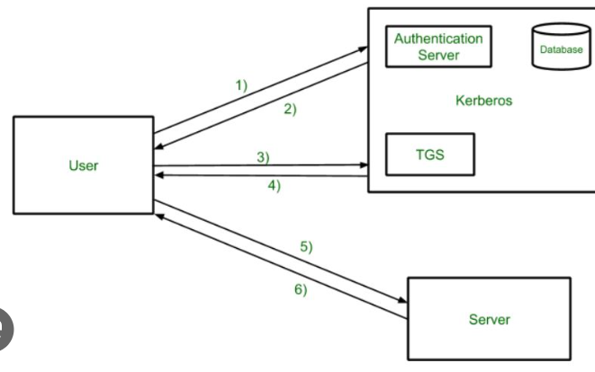

### ****Step-by-Step Kerberos Operation****

#### ✅ Step 1: Authentication Request

* Client sends a request to the **Authentication Server (AS)**:

#### ✅ Step 2: Authentication Response

* AS responds with:
  + **Session key** (encrypted using client’s password-derived key).
  + **TGT (Ticket Granting Ticket)** encrypted with TGS's secret key.

#### ✅ Step 3: Service Ticket Request

* Client uses the TGT to request access from the **TGS(Ticket Granting Server)** for a specific service:

#### ✅ Step 4: Service Ticket Response

* TGS verifies the TGT and sends a **service ticket**, encrypted using the service server's key.

#### ✅ Step 5: Access to Service

* Client sends the **service ticket and authenticator** to the **Service Server (SS)**.
* SS validates the ticket and allows access.

### ****X.509 Authentication Service****

**X.509** is a standard that defines the format of public key certificates, which are used in public key infrastructure (PKI). These certificates authenticate the identity of entities (such as users or websites) and bind their identities to cryptographic keys.

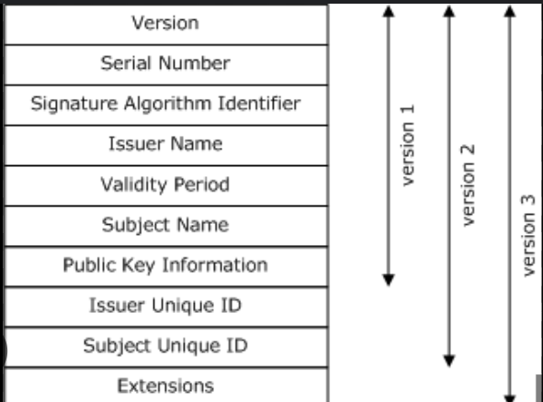

### ****Working of X.509 Authentication Process****

#### Step 1: **Certificate Generation**

* Entity generates a **key pair** (public and private key).
* Entity sends a **Certificate Signing Request (CSR)** to the CA.
* CA verifies identity and issues an **X.509 certificate** signed with CA’s private key.

#### Step 2: **Authentication**

* When Entity A wants to communicate with Entity B:
  + A sends its X.509 certificate.
  + B uses the CA's **public key** to verify A’s certificate.
  + Once verified, B trusts A’s public key and uses it for secure communication.

#### Step 3: **Secure Communication**

Parties exchange **encrypted data**, sign messages, or verify signatures using verified public keys from the certificates.

| **Feature / Basis** | **Kerberos** | **X.509 Authentication Service** |
| --- | --- | --- |
| **Type of Cryptography** | Symmetric key cryptography | Asymmetric (Public Key Infrastructure - PKI) |
| **Authentication Mechanism** | Uses **tickets** and a **trusted third party** (KDC) | Uses **digital certificates** and **public keys** |
| **Trusted Authority** | **Key Distribution Center (KDC)** | **Certificate Authority (CA)** |
| **Scalability** | Limited; not well-suited for large-scale networks | Highly scalable and suitable for global systems |
| **Authentication Method** | Mutual authentication using **session keys** | Authentication via **certificate verification** |
| **Password Dependency** | Client's password is used to decrypt session key | No password dependency; |
| **Replay Attack Prevention** | Uses **timestamps** and **authenticators** | Uses **nonces**, **timestamps**, and **signatures** |
| **Use Case** | Intranet, corporate networks | Internet, browsers, digital signatures, SSL/TLS |
| **Example** | Windows AD login systems | HTTPS, Email certificates, Code signing |

## What is a Digital Signature?

The Digital Signature Standard (DSS) is a federal standard (FIPS PUB 186) developed by NIST (National Institute of Standards and Technology) for generating and verifying digital signatures. Developed in 1994.A **digital signature** is a cryptographic mechanism used to:

* Prove the **authenticity** of a message or document.
* Ensure the **integrity** of the message (it hasn’t been tampered with).
* Provide **non-repudiation** (the sender cannot deny having sent the message).

## 🔄 **How Digital Signatures Work**

### 🔹 1. ****Signing Process****

* A message is hashed using a cryptographic **hash function** (e.g., SHA-256).
* The **sender** uses their **private key** to sign the hash.
* The resulting **digital signature** is sent along with the message.

### 🔹 2. ****Verification Process****

* The **receiver** computes the hash of the received message.
* They use the **sender's public key** to verify the signature.
* If the verification succeeds, the message is:
  + **Authentic** (from the claimed sender)
  + **Unaltered** (no modification in transit)

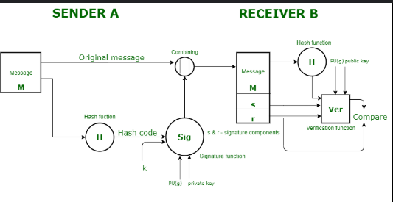

**Digital Signature Algorithms**

Digital Signature Algorithms are **cryptographic techniques** that allow a sender to prove they created and sent a message, and that the message was **not altered** during transmission. The algorithm defines **how signatures are created and verified**.

**Key Components of a Digital Signature Algorithm**

1. **Key Generation Algorithm**
   * Generates a **private-public key pair**.
2. **Signing Algorithm**
   * Uses the **private key** to sign a **hashed** version of the message.
3. **Verification Algorithm**
   * Uses the **public key** to verify the signature by comparing it with the message hash.

### ****1. RSA Digital Signature****

* Uses the **RSA algorithm** for both encryption and digital signatures.
* Signature: S = M^d mod n, Verified by M = S^e mod n.
* Still widely used in **SSL/TLS**, **email security**, and **code signing**.

### 📝 ****2. ECDSA****

* A compact, faster version of DSA using **Elliptic Curve Cryptography (ECC)**.
* Offers equivalent security with **smaller key sizes** (e.g., 256-bit ECC = 3072-bit RSA).
* Used in **Bitcoin**, **TLS**, **smart cards**, and **IoT**.

### 📝 ****3. ElGamal Signature****

* Early digital signature algorithm based on the **Discrete Logarithm Problem**.
* Not commonly used today due to performance limitations.

## Authentication Protocols Using Digital Signatures

**Digital signatures** play a crucial role in many authentication protocols. They ensure **data integrity**, **authenticity**, and sometimes **confidentiality** in digital communication.

Here are some key protocols that use digital signatures:

### 1. ****SSL/TLS (Secure Sockets Layer / Transport Layer Security)****

**Used for:** Secure web communication (HTTPS)

* The **server** presents a **digital certificate** (signed by a Certificate Authority - CA).
* The **client** verifies this certificate using the **CA’s public key**.
* This confirms the **server’s identity** and helps establish an **encrypted connection**.

✅ Ensures **server authentication**, **data confidentiality**, and **integrity**.

### 2. ****IPSec (Internet Protocol Security)****

**Used for:** Securing IP-level communications (e.g., VPNs)

* During the **IKE (Internet Key Exchange)** process, digital signatures authenticate the **endpoints**.
* Each party signs identity information to prove who they are.

✅ Provides **mutual authentication**, protects against spoofing.

### 3. ****S/MIME (Secure/Multipurpose Internet Mail Extensions)****

**Used for:** Securing email communication

* Emails are **digitally signed** to verify the sender.
* Also used for **encryption** to keep email content private.
* The recipient verifies the signature using the **sender’s public key**.

✅ Ensures **sender authenticity** and **message integrity**.

### 4. ****PGP (Pretty Good Privacy) / GPG (GNU Privacy Guard)****

**Used for:** Email security and file encryption

* Messages are **signed** with the sender’s private key.
* Recipients use the **sender’s public key** to verify authenticity.
* Can also be used to **encrypt** messages.

✅ Guarantees **non-repudiation** and **content integrity**.

### 5. ****OAuth 2.0 and OpenID Connect****

**Used for:** Authorization and identity verification in web apps and APIs

* Use **JWTs (JSON Web Tokens)**, often signed using algorithms like **RS256 (RSA)** or **ES256 (Elliptic Curve)**.
* The **signature** proves the token was issued by a trusted authority and hasn’t been tampered with.

✅ Enables **secure token validation** and **identity assurance**.

**Unit 4**

### ****Introduction to IP Security****

**IPSec (Internet Protocol Security)** is a framework of protocols that ensures **secure communication** over IP networks, especially the internet.

#### Security Goals:

1. **Confidentiality** – Data should be hidden from unauthorized access (achieved via encryption).
2. **Integrity** – Data should not be modified during transmission.
3. **Authentication** – The source of the data should be verified.
4. **Anti-replay** – Prevent the reuse of packets by attackers.

#### Why Needed in Cybersecurity?

* Traditional IP (especially IPv4) **lacks built-in security features**.
* Sensitive data (passwords, personal info) needs protection against **eavesdropping, tampering**, and **spoofing**.
* IPSec is commonly used in **VPNs** to create secure tunnels.

## **IPSec Architecture**

IPSec (Internet Protocol Security) is a framework of protocols that operates at the **network layer (Layer 3)** of the **OSI model**, providing **secure communication** across IP networks.

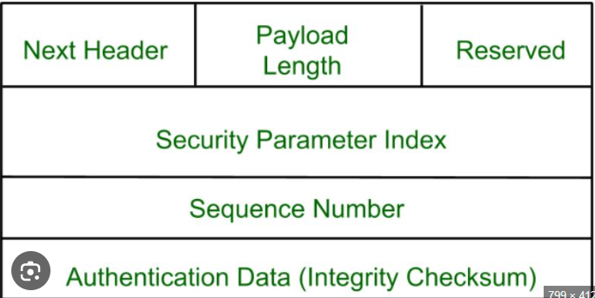

### ****Key Components of IPSec****

### 1. ****Next Header****

* Identifies the type of the next header following the AH (e.g., TCP = 6, UDP = 17).
* Helps the receiver know how to interpret the rest of the packet.

### 2. ****Payload Length****

* Indicates the length of the AH in **32-bit words**, **excluding** the first two 32-bit words.
* Helps in determining where the payload starts.

### 3. ****Reserved****

* Reserved for future use.
* Always set to **zero** to ensure proper alignment and forward compatibility.

### 4. ****Security Parameter Index (SPI)****

* A **32-bit unique identifier** for the **Security Association (SA)**.
* The SA defines the security settings (e.g., encryption/authentication algorithms and keys).

### 5. ****Sequence Number****

* A **monotonically increasing number** assigned to each packet.
* Used to **prevent replay attacks** by ensuring uniqueness of packets.

### 6. ****Authentication Data****

* Contains the **Integrity Check Value (ICV)**, a cryptographic hash (e.g., HMAC-SHA1, HMAC-SHA256).
* Used for **verifying packet integrity** and **authenticity**.
* Covers immutable parts of the IP header and entire payload.

### ****Modes of Operation****

### 🔸 ****1. Transport Mode****

* **Encrypts only the payload** (actual data) of the IP packet.
* The original **IP header remains unchanged**.
* Used for **end-to-end communication**, e.g., between two hosts.

**Example:**

[ IP Header ][ Encrypted Payload ]

### 🔸 ****2. Tunnel Mode****

* **Encrypts the entire original IP packet**, including its header.
* A **new IP header** is added.
* Commonly used in **VPNs**, where gateways or routers protect traffic.

**Example:**

[ New IP Header ][ Encrypted Original IP Header + Payload ]

| **Protocol** | **Function** |
| --- | --- |
| **AH** | Provides integrity, authentication (no encryption). |

**IPSec Security Services (Short Notes)**

1. **Confidentiality**
   * Protects data from unauthorized access.
   * Achieved using encryption (via **ESP**).
2. **Authentication**
   * Verifies the identity of the sender.
   * Provided by **AH** and optionally **ESP**.
3. **Integrity**
   * Ensures data is not altered in transit.
   * Provided by **AH** and **ESP**.
4. **Anti-Replay Protection**
   * Blocks duplicate/replayed packets.
   * Uses sequence numbers.
5. **Access Control**
   * Enforces security policies to allow or deny traffic.

**IPv4 (Internet Protocol Version 4)**

* **32-bit address** system (about 4.3 billion addresses).
* Still the most widely used protocol today.

#### 🔹 Security Features:

* **No built-in security** mechanisms.
* **IPSec is optional** and must be manually configured.
* Relies on **external protocols/tools** for encryption and authentication (e.g., VPNs, firewalls).

#### 🔹 Limitations in Security:

* Vulnerable to:
  + **IP spoofing**
  + **Man-in-the-Middle (MitM) attacks**
  + **Eavesdropping**
  + **Denial of Service (DoS)** attacks
* NAT (Network Address Translation) is used to manage IP exhaustion, but it complicates **end-to-end security**.

### ****IPv6 (Internet Protocol Version 6)****

#### 🔹 Overview:

* **128-bit address** system (virtually unlimited addresses).
* Designed to **replace IPv4** and support modern internet growth.

#### 🔹 Security Features:

* **IPSec is mandatory** for IPv6 compliance (though not always enforced).
* Supports:
  + **Authentication**
  + **Confidentiality (Encryption)**
  + **Data integrity**
* Simplified packet structure helps improve **security processing** and performance.
* **No need for NAT**, promoting **true end-to-end communication** and security.

## **IPSec Protocols**

### ****Modes of Operation Explain in short.****

**1.Authentication Header (AH):**

The **Authentication Header (AH)** protocol is one of the two core protocols used in the **IPSec** suite. It is designed to provide **connectionless integrity**, **data origin authentication**, and **protection against replay attacks**, but it does **not provide confidentiality** (i.e., it does not encrypt the data).

#### 🔹 Features of AH:

1. **Integrity Protection**: Ensures that the contents of the packet have not been tampered with during transmission.
2. **Origin Authentication**: Verifies the identity of the sender.
3. **Replay Protection**: Uses a sequence number to detect and prevent packet replay attacks.

#### 🔹 Working of AH:

* AH adds a header to the IP packet between the original IP header and the payload.
* It uses **hashing algorithms** like **HMAC-SHA1** or **HMAC-MD5** to compute a **Message Authentication Code (MAC)**.
* AH also includes parts of the IP header in the authentication to prevent spoofing.

#### 🔹 AH Header Format:

| **Field** | **Description** |
| --- | --- |
| **Next Header** | Protocol type of the payload (e.g., TCP, UDP) |
| **Payload Length** | Length of the AH header |
| **Reserved** | Reserved for future use |
| **SPI** | Security Parameters Index (identifies SA) |
| **Sequence Number** | Prevents replay attacks |
| **Authentication Data** | MAC for integrity check |

#### Modes of AH:

* **Transport Mode**
* **Tunnel Mode**

#### 🔹 Limitations:

* AH does **not encrypt data**, so it doesn’t ensure confidentiality.
* Because it authenticates parts of the IP header, it may face issues with NAT (Network Address Translation).

#### 🔹 Applications:

* Used in environments where **data integrity and source authentication** are essential, and **data confidentiality is not required**.

**2. Encapsulating Security Payload (ESP):**

The **Encapsulating Security Payload (ESP)** is a key protocol in the **IPSec** suite, designed to provide **data confidentiality** through encryption. In addition, it can also offer **integrity**, **authentication**, and **anti-replay protection**.

#### 🔹 Features of ESP:

1. **Confidentiality**: Encrypts the payload using algorithms like **AES**, **3DES**, etc.
2. **Integrity & Authentication**: Uses hashing (HMAC) to ensure data integrity and authenticate the sender.
3. **Replay Protection**: Uses a sequence number field to prevent replay attacks.

#### 🔹 ESP Header Format:

| **Field** | **Description** |
| --- | --- |
| **SPI** | Security Parameters Index |
| **Sequence Number** | Used for replay protection |
| **Payload Data** | Encrypted data (TCP, UDP, etc.) |
| **Padding** | Used to align data |
| **Pad Length** | Indicates the size of padding |
| **Next Header** | Type of protocol in payload |
| **Authentication Data (Optional)** | Integrity check value |

#### Modes of ESP:

* **Transport Mode**
* **Tunnel Mode**

#### 🔹 Advantages of ESP:

* Ensures **confidentiality**, **integrity**, and **authentication**.
* More widely used than AH because it includes encryption.
* Flexible and supports both encryption and optional authentication.

#### 🔹 Applications:

* **Virtual Private Networks (VPNs)**
* Secure **remote access**
* **Site-to-site tunneling** between organizations

3. **Internet Security Association and Key Management Protocol (ISAKMP):**

The **Internet Security Association and Key Management Protocol (ISAKMP)** is a framework used for **establishing, negotiating, modifying, and deleting Security Associations (SAs)** and cryptographic keys in a secure manner. ISAKMP operates independently of the key exchange protocol but is most commonly used with **IKE (Internet Key Exchange)**.

#### 🔹 Features of ISAKMP:

1. **SA Management**: Defines how Security Associations are created and managed.
2. **Key Management Framework**: Works with protocols like IKE for exchanging cryptographic keys.
3. **Authentication Support**: Supports various authentication methods (e.g., digital signatures, pre-shared keys).
4. **Modular Design**: Allows plug-in of different encryption and hashing algorithms.

#### 🔹 Components of ISAKMP:

* **Security Association (SA)**: Defines parameters like encryption algorithm, hashing method, and keys.
* **Payloads**: Structured data exchanged between peers during negotiation (e.g., key data, identities, certificates).
* **Messages**: Exchanged in a specific sequence to perform negotiation.

#### 🔹 Working Phases:

ISAKMP works through the **IKE protocol**, which has two main phases:

1. **IKE Phase 1**:
   * Establishes a secure, authenticated channel between peers.
   * Negotiates ISAKMP SA.
   * Modes: **Main Mode** (secure but slower), **Aggressive Mode** (faster but less secure).
2. **IKE Phase 2**:
   * Uses the secure channel to negotiate **IPSec SAs** for ESP or AH.
   * Mode: **Quick Mode**.

#### 🔹 ISAKMP Message Exchange:

| **Message** | **Purpose** |
| --- | --- |
| SA Payload | Proposes security policies |
| Key Exchange Payload | Exchanges cryptographic keys |
| Identification Payload | Identifies the peers |
| Certificate Payload | Exchanges digital certificates |

#### 🔹 Benefits:

* Provides a **unified framework** for key and SA management.
* Enhances **interoperability** between different security systems.

A **VPN (Virtual Private Network)** is a technology that creates a **secure and encrypted connection** over a less secure network, such as the Internet. It enables users to securely access a private network and share data remotely through public networks as if they were directly connected to the private network.

### ****1. Purpose of a VPN:****

* To provide **confidentiality**, **integrity**, and **authenticity** of data during communication over public networks.
* To protect **sensitive data** from eavesdropping and unauthorized access.
* To ensure **secure remote access** to enterprise or personal networks.

**VPN Components:**

### ****1. VPN Client****

* The **VPN Client** is a software application installed on the user’s device (e.g., PC, smartphone).
* It is responsible for:
  + Initiating the VPN connection and starting the tunneling protocol.
  + Encrypting outgoing data before it is sent over the internet.
  + Authenticating the user with the VPN server using credentials or digital certificates.
* **Examples**: OpenVPN Client, Cisco AnyConnect, NordVPN, ExpressVPN apps.

### ****2. VPN Server****

* The **VPN Server** is a remote system that receives encrypted traffic from the VPN client.
* It performs:
  + **Decryption** of received data.
  + **Forwarding** of data to its final destination (websites, internal resources).
  + **Encryption** of the response back to the client.
* Also handles:
  + User authentication
  + Access control policies
  + Traffic routing and logging

### ****3. Tunneling Protocols****

* A **secure, encrypted communication path** between the client and the server.
* Define how data is **encapsulated and securely transmitted**.
* Form the backbone of the VPN tunnel.
* **Common tunneling protocols**:
  + **L2TP/IPSec** – Combines Layer 2 Tunneling Protocol and IP Security for encryption.
  + **OpenVPN** – Open-source, secure, and highly configurable.
  + **IKEv2/IPSec** – Ideal for mobile devices; provides fast reconnection.
  + **WireGuard** – Lightweight, modern, and high-performance.

### ****4. Encryption****

* Converts plaintext data into **ciphertext** to prevent unauthorized access.
* Ensures **data confidentiality and integrity** during transmission.
* **Common algorithms**:
  + **AES-256** – Highly secure and widely used in modern VPNs.
  + **RSA** – For secure key exchange.
  + **SHA** – Generates hash values to check data integrity.

### ****5. Authentication****

* Verifies the **identity of users and devices** before establishing a VPN connection.
* Ensures that only **authorized users** can access the VPN.
* **Methods**:
  + Username and password
  + Digital certificates
  + Multi-Factor Authentication (MFA)
  + Pre-Shared Keys (PSK) for site-to-site VPNs

### ****3. Security Requirements in VPN:****

**a. Confidentiality (Encryption)**

* Encrypts data using AES to prevent unauthorized access and eavesdropping.

🔹 **b. Authentication**

* Verifies user/device identity using passwords, certificates, or MFA.

🔹 **c. Data Integrity**

* Ensures data isn't altered using hash functions like HMAC-SHA1/MD5.

🔹 **d. Tunnelling and Encapsulation**

* Hides original data using protocols like IPSec, L2TP, or GRE.

🔹 **e. Replay Protection**

* Prevents reuse of packets using sequence numbers and timestamps.

🔹 **f. Key Management**

* Uses ISAKMP/IKE for secure key exchange and timely renewal.

### 🔹 1. ****Remote Access VPN****

Allows **individual users** to securely connect to a private network (such as a company network) from a remote location using the internet.

**How it works**:

* The user installs a VPN client or uses built-in support on their device.
* A secure **encrypted tunnel** is created between the user’s device and the organization’s network.
* Data travels securely as if the user is physically present inside the organization.

**Use Case**:  
Employees working from home accessing internal resources like file servers, emails, databases, etc.

**Protocols Used**:  
PPTP, L2TP/IPSec, SSL, IKEv2.

### 🔹 2. ****Site-to-Site VPN****

Connects **two or more entire networks** (e.g., head office and branch office) over the internet securely.

**How it works**:

* VPN gateways (routers or firewalls) are set up at each site.
* These gateways handle the encryption and decryption of all traffic.
* Users at both locations can communicate securely **without using VPN software individually**.

**Use Case**:  
Organizations linking branch offices to the central office for resource sharing.

**Types**:

* **Intranet VPN** – Within a single organization.
* **Extranet VPN** – Between different organizations (e.g., a business partner).

**Protocols Used**:  
IPSec, GRE (Generic Routing Encapsulation).

### 🔹 3. ****SSL VPN (Secure Sockets Layer VPN)****

Allows users to securely access **web-based applications** using a standard web browser.

**How it works**:

* User logs in through a browser via an HTTPS connection.
* No need to install client software.
* Access is usually limited to specific applications (not the entire network).

**Use Case**:  
Temporary access for partners or employees to company portals, email, or CRM tools.

**Benefits**:

* Simple to use
* No special software required
* Uses **SSL/TLS encryption** (same as used in HTTPS websites)

**What is Web Security?**

Web security refers to the collective measures, practices, and protocols that are implemented to **protect web applications, websites, and online data** from cyber threats and attacks. Its primary goal is to ensure that user data and system resources are not compromised during online communication and interaction.

**🔹 Importance of Web Security:**

1. **Protection of Sensitive Data:**
   * Prevents unauthorized access to passwords, credit card details, and personal records.
2. **Maintains User Trust:**
   * Users feel safe interacting with secure websites (HTTPS), improving engagement and reputation.
3. **Compliance with Legal Standards:**
   * Organizations must adhere to regulations like **GDPR**, **HIPAA**, and **PCI DSS**.
4. **Business Continuity:**
   * Prevents service disruptions due to attacks like DDoS, maintaining consistent service availability.
5. **Avoids Financial Losses:**
   * Reduces risk of fraud and financial penalties due to data breaches.

**🔹 Key Security Goals:**

1. **Confidentiality:**
   * Ensures that data is accessible only to authorized users (e.g., via encryption like SSL/TLS).
2. **Integrity:**
   * Protects data from being altered or tampered during transmission (e.g., using hash functions).
3. **Authentication:**
   * Verifies the identity of users and servers to prevent impersonation.
4. **Non-repudiation:**
   * Ensures that a party cannot deny sending or receiving a message (e.g., using digital signatures).
5. **Availability:**
   * Ensures web services remain accessible to users without interruption (e.g., using load balancers, backups).

**🔹 Common Threats:**

* Phishing attacks
* SQL injection
* Cross-site scripting (XSS)
* Denial of service (DoS)
* Man-in-the-middle (MITM) attacks

**Secure Socket Layer (SSL):**

Secure Socket Layer (SSL) is a **cryptographic protocol** that provides **secure communication over the internet** by encrypting data between a web client (browser) and a web server. SSL ensures **confidentiality**, **integrity**, and **authentication** during data transmission.

Although SSL has been replaced by the more secure **Transport Layer Security (TLS)**, the term "SSL" is still widely used in practice and documentation.

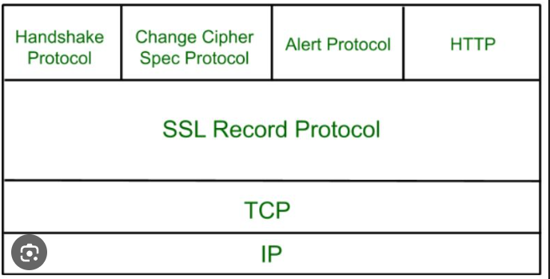

### 🔹 ****Objectives of SSL:****

1. **Data Encryption:**
   * Ensures that data exchanged between the client and server is encrypted and unreadable to attackers.
2. **Server Authentication:**
   * Verifies the identity of the server using digital certificates.
3. **Message Integrity:**
   * Ensures that data has not been altered during transit by using hash functions.

### 🔹 ****Working Process of SSL :****

• **Client Hello**

* The client (browser) sends a request to the server to establish a secure connection.
* It includes supported SSL versions, cipher suites, and a randomly generated number.

• **Server Hello**

* The server responds with its selected SSL version, chosen cipher suite, and its **digital certificate** (includes the server’s public key).
* The certificate is issued by a **trusted Certificate Authority (CA)**.

• **Certificate Verification**

* The client checks the **authenticity** of the server’s certificate.
* If trusted, the process continues. If not, a warning is shown.

• **Session Key Generation**

* The client generates a **pre-master secret**, encrypts it with the server’s **public key**, and sends it to the server.
* Both sides use this to compute the **same session key** using algorithms.

• **Symmetric Encryption Setup**

* Both client and server now share a **symmetric session key**.
* All communication is encrypted using this key for speed and security.

• **Secure Data Transmission**

* Now, the **encrypted session begins**.
* Data is exchanged securely using the shared session key.

### 🔹 ****Components of SSL Protocol Suite:****

**SSL Record Protocol**

**Handshake Protocol**

**Change Cipher Spec Protocol**

**Alert Protocol**

### 🔹 ****Advantages of SSL:****

* Protects sensitive data like login credentials, banking information.
* Builds trust through HTTPS-enabled websites.
* Prevents session hijacking and MITM (Man-in-the-Middle) attacks.

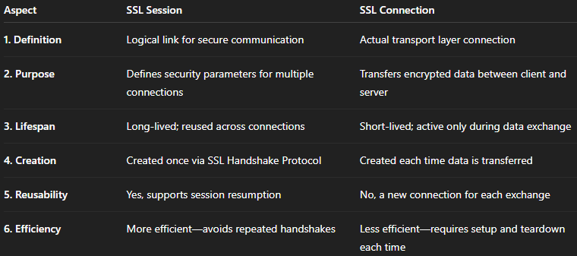

### ****1. SSL Record Protocol****

* **Definition**: The foundation protocol of SSL that provides secure transmission of data over the network.
* **Functions**:
  + Fragmentation: Divides data into manageable blocks.
  + Compression (optional): Reduces data size before encryption.
  + MAC (Message Authentication Code): Adds integrity protection by verifying that the data has not been altered.
  + Encryption: Encrypts the data using the negotiated cipher.
* **Importance**: Ensures **confidentiality** and **data integrity** for upper-layer protocols like HTTP, SMTP, etc.
* **Use Case**: Encrypts application data such as web pages or emails.

### ****2. Change Cipher Spec Protocol****

* **Definition**: A simple protocol that signals both client and server to switch to the newly negotiated cipher suite.
* **Structure**: Contains only a single byte with the value 0x01.
* **Timing**:
  + Sent by both parties after the handshake is complete.
  + Precedes secure data transfer using the new encryption keys.
* **Importance**: Marks the **transition from unsecured to secured communication** using agreed session parameters.
* **Use Case**: Initiates encryption using the final shared secret key after key exchange.

### ****3. Alert Protocol****

* **Definition**: Manages communication of SSL-related errors or status notifications between client and server.
* **Structure**:
  + Alert messages consist of two bytes: **alert level** and **alert description**.
  + Levels: Warning or Fatal.
* **Common Alerts**:
  + unexpected_message
  + bad_record_mac
  + handshake_failure
  + close_notify (used to terminate the session securely)
* **Importance**: Enables **error reporting**, **warning notifications**, and **secure session termination**.
* **Use Case**: Alerts the user or system to issues like invalid certificates or handshake failure.

### ****4. Handshake Protocol****

* **Definition**: A crucial protocol used to negotiate session settings and authenticate the client and server.
* **Steps Involved**:
  1. **ClientHello** – Initiates communication with supported cipher suites and random value.
  2. **ServerHello** – Server responds with selected cipher suite and session details.
  3. **Server Certificate** – Sent to authenticate the server (and optionally the client).
  4. **Key Exchange** – Exchange of key material (e.g., via RSA or Diffie-Hellman).
  5. **Finished Messages** – Both parties verify successful setup.
* **Importance**: Establishes **authentication**, **key exchange**, and **session creation**.
* **Use Case**: Starts every SSL session and defines how secure communication will proceed.

**Electronic Mail Security**

Electronic Mail (E-mail) is one of the most widely used services on the internet for communication between individuals, organizations, and businesses. Despite its popularity, standard email protocols such as **SMTP (Simple Mail Transfer Protocol)**, **POP3 (Post Office Protocol)**, and **IMAP (Internet Message Access Protocol)** lack robust security features. These protocols transmit data in plain text, which exposes email communication to various **security threats**, including:

* **Eavesdropping:** Unauthorized interception of email content during transmission.
* **Spoofing:** Forging the sender's identity to deceive the recipient.
* **Message Alteration:** Tampering with the contents of an email before delivery.
* **Phishing Attacks:** Deceiving users into providing sensitive information.
* **Unauthorized Access:** Gaining access to email accounts without permission.

**Need for E-mail Security:**

Due to these vulnerabilities, there is a strong need to implement security mechanisms in email communication. The main objectives are:

* **Confidentiality:** Ensures that only the intended recipient can read the email content, typically achieved through encryption.
* **Authentication:** Verifies the sender’s identity to prevent impersonation.
* **Message Integrity:** Guarantees that the message has not been altered during transmission.
* **Non-repudiation:** Prevents the sender from denying the act of sending a particular message.

**Security Mechanisms Used:**

To achieve the above objectives, the following security techniques are used:

1. **Encryption:**
   * Converts the original message into an unreadable format.
   * Protects the confidentiality of email content during transmission.
   * Common techniques include **symmetric** and **asymmetric encryption**.
2. **Digital Signatures:**
   * Used to authenticate the sender.
   * Ensures message integrity and provides non-repudiation.
   * Created using the sender’s private key and verified using the public key.
3. **Hash Functions:**
   * Generate a fixed-size hash value from the email content.
   * Any change in the message results in a different hash, thus ensuring integrity.
4. **Certificates and Public Key Infrastructure (PKI):**
   * Digital certificates issued by trusted Certificate Authorities (CAs) bind public keys to user identities.
   * PKI supports secure key distribution and management.

**Pretty Good Privacy (PGP)**

**Pretty Good Privacy (PGP)** is a data encryption and decryption program developed by **Phil Zimmermann** in **1991**. It is used primarily for **securing email communication**, ensuring:

* **Confidentiality** (only the intended recipient can read the message),
* **Integrity** (ensuring the message has not been altered),
* **Authentication** (verifying the sender’s identity).

PGP uses a **hybrid cryptographic approach**—combining the **speed of symmetric encryption** with the **security of asymmetric encryption**, making it both efficient and secure.

**Working of PGP (Simplified):**

1. **Compression:**
   * The email message is first **compressed** to reduce size and improve security.
2. **Symmetric Encryption:**
   * A **random session key** is generated.
   * This session key is used to **encrypt the compressed message** using a fast symmetric algorithm like **AES**.
3. **Asymmetric Encryption of Session Key:**
   * The **session key** is encrypted using the **recipient’s public key** (e.g., RSA), ensuring only the recipient can decrypt it.
4. **Digital Signature:**
   * A **hash** of the original message is created.
   * The hash is **encrypted with the sender’s private key** to generate a **digital signature**, ensuring authenticity and integrity.
5. **Transmission:**
   * The final email contains:
     + The **encrypted message**,
     + The **encrypted session key**, and
     + The **digital signature**.
6. **Decryption by Receiver:**
   * The receiver **decrypts the session key** with their private key.
   * Then uses that key to **decrypt the message**.
   * Finally, verifies the **digital signature** using the sender’s public key.

**Features of PGP:**

* ✅ **Hybrid Encryption:**
  + Combines the speed of **symmetric encryption** with the security of **asymmetric encryption**.
* ✅ **Digital Signatures:**
  + Provides **authentication**, **data integrity**, and **non-repudiation**.
* ✅ **Web of Trust:**
  + Unlike centralized **Certificate Authorities (CAs)**, PGP uses a **decentralized trust model** called the **Web of Trust**.
  + Users manually **sign and verify each other’s keys**, building a trusted network.
* ✅ **Cross-Platform Support:**
  + Available on many platforms and email clients, making it **widely accessible**.

**MIME (Multipurpose Internet Mail Extensions)**

**MIME (Multipurpose Internet Mail Extensions)** is a standard that **extends the functionality of traditional email protocols** like **SMTP (Simple Mail Transfer Protocol)**. Introduced in the early 1990s, MIME enables email to support **multimedia content** and attachments such as:

* Text in different character sets (e.g., UTF-8),
* Images,
* Audio and video files,
* Application files (e.g., PDFs, Word docs).

MIME transforms internet email from simple **plain text messages** to rich and diverse **multimedia messages**.

**🔹 Functions of MIME:**

1. **Content-Type Declaration:**
   * MIME uses **Content-Type headers** to define the type of content being sent.
   * Examples include:
     + text/plain – Plain text
     + text/html – HTML content
     + image/jpeg – Image files
     + audio/mpeg – Audio files
     + application/pdf – PDF documents
2. **Content-Transfer-Encoding:**
   * Since SMTP only supports **7-bit ASCII text**, MIME uses encoding schemes like:
     + **Base64** and **Quoted-Printable**
   * These convert **binary files** (e.g., images) into ASCII format for transmission.
3. **Multipart Messages:**
   * MIME supports **multiple parts** in a single message using multipart/* content types.
   * Examples:
     + multipart/mixed – Text with file attachments
     + multipart/alternative – Same message in plain text and HTML
     + multipart/related – HTML message with embedded images
4. **File Attachments:**
   * MIME allows users to attach files of any type to emails.
   * Attachments are encoded and included as separate parts of a **MIME message body**.
5. **Character Set Support:**
   * MIME supports different character sets (e.g., UTF-8, ISO-8859-1), enabling **international language** support in emails.

**Limitations of MIME:**

* **No Built-in Security:**
  + MIME **does not provide** security features like **encryption, digital signatures, or message integrity**.
  + This makes MIME messages **vulnerable to eavesdropping or tampering**.
* **Relies on Other Protocols for Security:**
  + To overcome these security gaps, **S/MIME (Secure/MIME)** was developed, which adds **encryption and digital signature capabilities** using public-key cryptography.

**S/MIME (Secure/Multipurpose Internet Mail Extensions)**

**S/MIME** is a standard for **secure email communication** that builds on **MIME (Multipurpose Internet Mail Extensions)** by adding **encryption and digital signatures**. It ensures **confidentiality, message integrity, authentication, and non-repudiation**.

**Key Features:**

1. **Confidentiality:**
   * Ensures only the intended recipient can read the email by using **encryption**.
2. **Authentication:**
   * Uses **digital signatures** to verify the identity of the sender.
3. **Message Integrity:**
   * Detects if the message was altered during transmission.
4. **Non-Repudiation:**
   * The sender cannot deny having sent the message if it is digitally signed.
5. **Public Key Infrastructure (PKI):**
   * Utilizes **X.509 digital certificates** issued by **Certificate Authorities (CAs)** to manage public keys.

**How S/MIME Works:**

1. **Digital Signature Creation:**
   * The sender creates a **hash** (digest) of the message content.
   * This hash is **encrypted using the sender’s private key** to form a **digital signature**.
2. **Message Encryption:**
   * A **random symmetric key** (called a session key) is generated.
   * The message is **encrypted using this symmetric key** (e.g., AES).
3. **Key Encryption:**
   * The session key is **encrypted with the recipient’s public key** (asymmetric encryption, e.g., RSA).
4. **Transmission:**
   * The final S/MIME message includes:
     + Encrypted message
     + Encrypted session key
     + Sender’s digital signature
     + Sender’s digital certificate
5. **Decryption by Receiver:**
   * The recipient:
     + Decrypts the session key using their **private key**,
     + Decrypts the message using the **symmetric session key**,
     + Verifies the **digital signature** using the sender’s **public key** (from the certificate).

**Advantages:**

* **Strong Security:**
  + Uses a combination of **asymmetric and symmetric encryption** to ensure data protection.
* **Standards-Based:**
  + Based on widely accepted standards like **X.509** and **PKCS**.
* **Email Client Support:**
  + Integrated into most modern email clients without the need for third-party tools.

**Disadvantages:**

* ❌ **Certificate Management Complexity:**
  + Users must **obtain, install, and manage digital certificates**, which can be technically challenging.
* ❌ **Centralized Trust Model:**
  + Relies on **Certificate Authorities (CAs)**. If a CA is compromised, trust in the system is affected.
* ❌ **Cost and Accessibility:**
  + Certificates from trusted CAs may require **payment or subscriptions**.

### ****Secure Electronic Transaction (SET)****

**Secure Electronic Transaction (SET)** is a **security protocol** developed by **Visa and MasterCard** to ensure the **safety of online credit card transactions**. It provides a **secure environment** for **electronic payment s**, particularly over open networks like the Internet, by ensuring the **authentication, confidentiality, and integrity** of payment data.

### ****Goals of SET:****

1. **Authentication:**  
   To verify the identities of the **cardholder** and **merchant** using **digital certificates**.
2. **Confidentiality:**  
   To protect sensitive information (like the card number) through **encryption**, ensuring that only authorized parties can access it.
3. **Message_Integrity:**  
   To ensure that data is not **altered or tampered with** during transmission.
4. **Fraud_Prevention:**  
   To prevent **unauthorized access, card misuse**, and **data breaches** during e-commerce transactions.

### ****Key Components of SET:****

1. **Cardholder:**  
   The customer who owns a credit card and initiates a purchase online.
2. **Merchant:**  
   The seller or e-commerce platform that accepts credit card payments.
3. **Payment_Gateway:**  
   A secure server that connects the merchant to the financial institutions for processing payments.
4. **Certificate_Authority(CA):**  
   Issues **digital certificates** to both merchants and cardholders to prove their identities securely.

### ****How SET Works:****

#### 1. **Registration:**

* Both the **cardholder** and the **merchant** register with a **Certificate Authority (CA)**.
* They receive **digital certificates** that bind their identities to their public keys.

#### 2. **Initiation of Transaction:**

* The **cardholder** selects items to purchase and proceeds to payment.

#### 3. **Order and Payment Information:**

* The cardholder sends:
  + **Order Information (OI)** to the **merchant**
  + **Payment Information (PI)** to the **payment gateway**
* Both OI and PI are encrypted separately to maintain **privacy** (dual encryption mechanism).

#### 4. **Digital Signatures:**

* The cardholder **digitally signs** both OI and PI to guarantee **message integrity and authenticity**.

#### 5. **Authentication:**

* The **merchant** and **payment gateway** authenticate the cardholder’s certificate.
* Similarly, the cardholder can authenticate the merchant’s certificate.

#### 6. **Authorization:**

* The **payment gateway** validates the **card details** with the issuing bank.
* On approval, the **authorization message** is sent back to the merchant.

#### 7. **Order Confirmation:**

* The merchant sends a confirmation to the cardholder.
* The order is then processed and delivered.

### ****Advantages of SET:****

✅ **Dual Encryption:**

* Payment and order information are encrypted separately, ensuring **enhanced privacy**.

✅ **Authentication:**

* Digital certificates confirm the **legitimacy** of both parties.

✅ **Data Confidentiality:**

* Credit card numbers are **not revealed** to the merchant, reducing the risk of theft.

✅ **End-to-End Security:**

* Ensures **confidential, authenticated, and tamper-proof** communication.

### ****Limitations of SET:****

**Complex Implementation:**

* Requires **specialized software** and **infrastructure** for cardholders, merchants, and banks.

**Certificate Management:**

* Issuing, managing, and verifying digital certificates adds **overhead**.

**Low Adoption:**

* Despite its strong security, SET was **not widely adopted** due to its **complexity**.

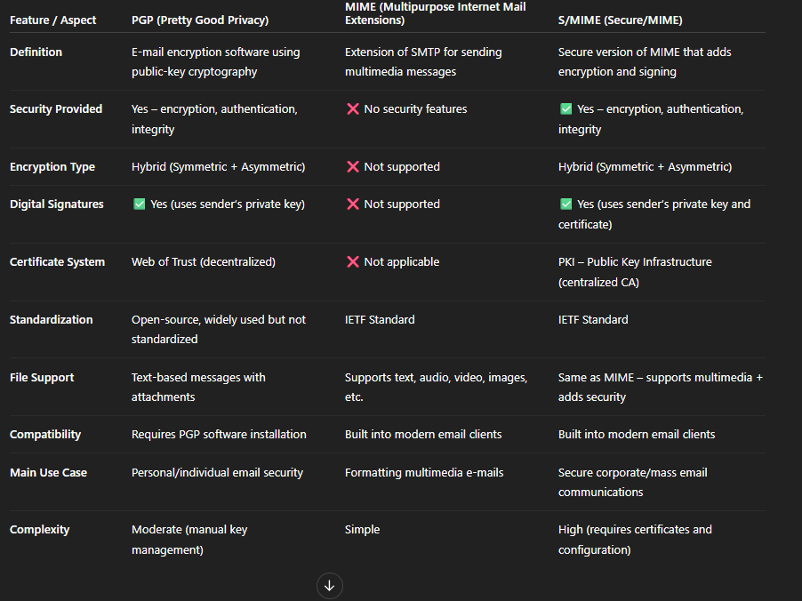

**Unit 5**

**Computer Intrusions**

**Definition:**  
Computer intrusion is the unauthorized access, use, or disruption of a computer system or network. It is often carried out by hackers or malicious software (malware) to steal data, damage systems, or gain control of resources.

**Types of Computer Intrusions:**

1. **Hacking:**  
   Gaining unauthorized access to computer systems by bypassing security mechanisms.
2. **Malware Infections:**  
   Use of malicious software such as viruses, worms, trojans, or ransomware to disrupt or damage systems.
3. **Phishing Attacks:**  
   Trick users into revealing sensitive information like usernames, passwords, or credit card details via fake emails or websites.
4. **Denial of Service (DoS) Attacks:**  
   Overloading a system or network to make it unavailable to legitimate users.
5. **Man-in-the-Middle Attacks (MITM):**  
   Intercepting communications between two parties to steal or manipulate data.

**Consequences of Computer Intrusions:**

* **Data Theft:** Confidential information such as personal data, banking details, or intellectual property can be stolen.
* **System Damage:** Files or operating systems may be corrupted or deleted.
* **Financial Loss:** Organizations may lose money through fraud, ransom payments, or downtime.
* **Reputation Damage:** Affected companies may lose customer trust.
* **Legal Issues:** Failure to secure data can lead to legal penalties.

**Prevention Techniques:**

* Use of **strong passwords** and **multi-factor authentication**
* **Firewalls** and **antivirus software**
* **Regular software updates** and **patching vulnerabilities**
* **Employee training** on recognizing phishing and other threats
* **Network monitoring** and **intrusion detection systems (IDS)**

**🔒 1. Firewall – Introduction (10 Marks)**

**Introduction:**

A **firewall** is a security system that monitors and controls incoming and outgoing network traffic based on predefined security rules. It acts as a barrier between a trusted internal network and untrusted external networks (like the Internet), allowing or blocking traffic based on rules.

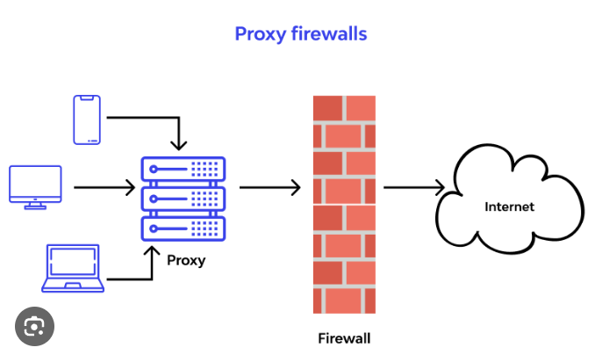

**Purpose:**

* Prevent unauthorized access.
* Monitor and filter network traffic.
* Provide a line of defense against cyber threats.

**Working:**

Firewalls inspect packets of data traveling to/from a network. Based on set rules (like IP address, port number, protocol), they decide whether to allow or block traffic.

**🔍 2. Characteristics and Types of Firewalls (10 Marks)**

**Characteristics of Firewalls:**

* **Traffic Control:** Filters traffic based on IP, protocol, ports, etc.
* **Access Rules:** Implements security policies using allow/deny rules.
* **Logging and Alerts:** Keeps logs of traffic and alerts on suspicious activity.
* **Stateful Inspection:** Monitors the state of active connections.
* **Application Awareness:** Some modern firewalls understand application-level traffic.

**Types of Firewalls:**

1. **Packet-Filtering Firewall:**
   * Works at network layer.
   * Checks IP addresses, port numbers, and protocols.
   * Fast but limited in filtering capabilities.
2. **Stateful Inspection Firewall:**
   * Tracks active connections.
   * More secure than packet filtering.
   * Blocks unwanted traffic based on session state.
3. **Application-Level Firewall (Proxy Firewall):**
   * Works at application layer.
   * Filters specific application traffic like HTTP, FTP.
   * Slower but more secure.
4. **Next-Generation Firewall (NGFW):**
   * Combines traditional firewall with intrusion prevention, application awareness, and deep packet inspection.
   * Uses AI/ML for threat detection.
5. **Software vs. Hardware Firewall:**
   * **Software Firewall** is installed on individual devices.
   * **Hardware Firewall** is a standalone device protecting networks.

**✅ 3. Benefits of Firewalls (10 Marks)**

**Benefits:**

1. **Prevents Unauthorized Access:**
   * Blocks intrusions and hackers from accessing internal networks.
2. **Monitors Network Traffic:**
   * Keeps track of all inbound and outbound traffic.
3. **Protects Against Malware:**
   * Stops malicious data packets from entering the system.
4. **Enforces Security Policies:**
   * Helps organizations control what type of traffic is allowed.
5. **Reduces Risk of Attacks:**
   * Prevents attacks like DoS, brute-force, and port scanning.
6. **Content Filtering:**
   * Blocks access to unwanted or harmful websites.
7. **Customizable Rules:**
   * Rules can be configured to meet specific needs of an organization.
8. **Improves Network Performance:**
   * Can detect and stop bandwidth-hogging applications.

**⚠️ 4. Limitations of Firewalls (10 Marks)**

**Limitations:**

1. **Cannot Prevent Insider Threats:**
   * Firewalls don't detect attacks from within the network (e.g., disgruntled employees).
2. **Ineffective Against Social Engineering:**
   * Phishing, baiting, etc., bypass firewalls as they manipulate users directly.
3. **No Protection Against Encrypted Threats:**
   * Firewalls struggle with inspecting encrypted traffic unless equipped with SSL inspection.
4. **Can Be Misconfigured:**
   * Poorly set rules can lead to security holes or blocked legitimate traffic.
5. **Not a Standalone Solution:**
   * Needs to be part of a larger security framework (antivirus, IDS, training, etc.)
6. **Performance Overhead:**
   * Especially for application-level or NGFWs, performance may degrade if resources are limited.
7. **Limited Deep Inspection (in basic firewalls):**
   * Cannot analyze content within packets in basic models.

**Trusted System - Key Points (12 Marks)**

* A trusted system is a secure computing environment that strictly enforces security policies to protect data confidentiality, integrity, and availability.
* These systems are designed to prevent unauthorized access, malicious attacks, and data breaches while maintaining system reliability.

2. Core Security Principles

* Confidentiality: Ensures sensitive data is only accessible to authorized users (e.g., Bell-LaPadula model).
* Integrity: Protects data from unauthorized modification (e.g., Biba model).
* Availability: Guarantees authorized users can access systems when needed.
* Accountability: Tracks and logs all security-relevant activities for auditing.

3. Essential Components

* Multilevel Security (MLS): Implements hierarchical access control (e.g., Top Secret → Secret → Confidential).
* Reference Monitor: Acts as a security kernel that validates every access request against security policies.
* Trusted Computing Base (TCB): Includes all hardware, software, and firmware components critical for enforcing security.
* Security Models: Formal frameworks like Bell-LaPadula, Biba, and Clark-Wilson that define access rules.

**4. Implementation Examples**

* Operating Systems:
* Hardware Security:
* Certifications:
* Military Services:
* Naval Services:
* Banking Services:

**5. Challenges & Limitations**

* Complexity: Difficult to design, implement, and verify mathematically.
* Performance Impact: Security checks can slow down system operations.
* High Costs: Expensive to develop and certify for compliance.
* Emerging Threats: Vulnerable to advanced attacks like zero-day exploits.

**🔐 2. Access Control (10 Marks)**

**Access control** is a security technique that regulates who or what can view or use resources in a computing environment.

**Types of Access Control:**

1. **Discretionary Access Control (DAC):**
   * Users can grant access to their own files.
   * Example: File sharing permissions in Windows.
2. **Mandatory Access Control (MAC):**
   * Access is based on fixed policies set by the system (e.g., classified information access).
3. **Role-Based Access Control (RBAC):**
   * Access is based on user roles within the organization (e.g., admin, employee).
4. **Attribute-Based Access Control (ABAC):**
   * Uses attributes like user location, time, and device to grant access.

**Components:**

* **Subjects:** Users or processes requesting access.
* **Objects:** Files, databases, or systems being accessed.
* **Access Rights:** Permissions like read, write, execute.

**Benefits:**

* Prevents unauthorized access.
* Enhances security and data protection.
* Ensures accountability through user-specific controls.

**Challenges:**

* Complexity in large systems.
* Risk of privilege escalation if not managed properly.

**🛡️ 3. Intrusion Detection (10 Marks)**

**Intrusion Detection** is the process of monitoring computer systems and networks for suspicious or malicious activities that could indicate a security breach or attack.

**Types of Intrusion Detection Systems (IDS):**

1. **Network-based IDS (NIDS):**
   * Monitors traffic across the network for threats.
2. **Host-based IDS (HIDS):**
   * Monitors a specific computer or server for signs of intrusion.

**Detection Methods:**

1. **Signature-Based Detection:**
   * Detects known threats using a database of signatures (like antivirus).
2. **Anomaly-Based Detection:**
   * Detects unusual behavior that deviates from the normal pattern.

**Components:**

* **Sensors:** Collect data from systems or network traffic.
* **Analyzers:** Evaluate data to detect intrusions.
* **User Interface:** Allows administrators to view alerts and reports.

**Benefits:**

* Early detection of attacks.
* Helps identify both external and internal threats.
* Logs and reports aid in forensic analysis.

**Limitations:**

* May generate false positives.
* Signature-based IDS can't detect new threats (zero-day).
* Requires skilled staff for management and interpretation.

**1. Need for Intrusion Detection Systems (IDS)**

Modern networks are exposed to a wide range of cyber threats such as hacking, malware, insider attacks, and data breaches. Traditional security tools like firewalls cannot detect all types of threats—especially **internal attacks or sophisticated intrusion attempts**. That’s where an **Intrusion Detection System (IDS)** is essential.

**Key Reasons for Needing IDS:**

1. **Detection of Known and Unknown Attacks**
   * IDS can identify both **signature-based threats** (known patterns) and **anomalous behaviours** (sudden deviations).
   * Example: A brute force attack on login credentials or unusual login times.
2. **Continuous Network and Host Monitoring**
   * Monitors **24/7 activity** in real-time to detect suspicious patterns.
   * Provides visibility into user behaviour, system calls, and network traffic.
3. **Internal Threat Detection**
   * Firewalls mainly protect from external threats.
   * IDS helps in detecting **insider threats**, such as a disgruntled employee accessing sensitive data.
4. **Support for Incident Response**
   * Triggers alerts and logs details of suspicious activities.
   * Helps security teams investigate and respond **quickly to threats**.
5. **Forensic and Legal Evidence**
   * IDS logs can be used to **analyse breaches**, identify entry points, and support legal actions.
6. **Compliance and Regulatory Requirements**
   * Many standards like **ISO 27001, PCI-DSS, HIPAA, and GDPR** require intrusion detection as part of security monitoring.
7. **Integration with Security Ecosystem**
   * Can be integrated with **SIEM (Security Information and Event Management)** and **firewalls** for better coordination and automation.

**🧠 2. Methods of Intrusion Detection**

**1. Signature-Based Detection (Misuse Detection)**

**Working:**

Signature-based detection identifies intrusions by comparing system activities, files, or network traffic to a database of known attack patterns, known as signatures. These signatures can represent known malware behavior, specific commands, or predefined traffic patterns associated with malicious actions.

When the IDS observes an activity that matches a stored signature, it generates an alert indicating a potential intrusion.

**Example:**

A worm that always sends a specific command to a particular network port can be easily detected by a signature-based IDS if that command is part of its signature database.

**Advantages:**

* Very accurate for known threats.
* Produces low false positives since it looks for exact matches.

**Disadvantages:**

* Unable to detect new, unknown (zero-day) attacks because no signature exists for them.
* Requires constant updates to the signature database to stay effective against newly discovered threats.
* Not effective against slightly modified versions of known attacks unless signatures are also updated for those variants.

Best Use Cases:

* Environments with well-understood threats.
* Systems requiring low false alarms.
* Detecting widespread malware and common exploits.

**2. Anomaly-Based Detection**

Anomaly-based detection focuses on identifying deviations from normal system or user behaviour. It works by first creating a baseline of what is considered "normal" activity within a system or network. This baseline can include typical login times, average data usage, or usual patterns of application behaviour.

Once this baseline is established, the IDS monitors real-time activities. Any deviation from the normal baseline is flagged as potentially malicious.

This method often uses statistical techniques, artificial intelligence, or machine learning algorithms to build models of normal behaviour.

Example:

If a user who usually accesses files during business hours suddenly begins downloading large amounts of data late at night, the system may detect this as abnormal behaviour and raise an alert.

Advantages:

* Capable of detecting new and unknown threats, including zero-day attacks.
* Effective against insider threats, data leaks, and unusual user activities.
* Does not depend on prior knowledge of specific attack signatures.

Disadvantages:

* Higher rate of false positives, especially during the initial learning phase or when normal usage patterns change.
* Requires time to learn what constitutes normal behavior.
* Needs regular updates to the behavior model to remain accurate over time.

Best Use Cases:

* Detecting sophisticated attacks not covered by known signatures.
* Identifying insider threats or compromised accounts.
* Monitoring critical systems for unusual behavior patterns.

**Comparison Table**

| **Feature** | **Signature-Based Detection** | **Anomaly-Based Detection** |
| --- | --- | --- |
| Detection Type | Known attack patterns | Deviations from normal behavior |
| Ability to Detect Zero-Day | No | Yes |
| False Positive Rate | Low | High |
| Maintenance Requirements | Frequent signature updates | Regular model retraining |
| Adaptability | Limited to known threats | Can adapt to new and unknown threats |
| Initial Setup Time | Fast | Longer (requires training) |
| Best Use Cases | Detecting common malware | Insider threats and unknown attacks |

**Types of Intrusion Detection Systems (IDS)**

**1. Network-based Intrusion Detection System (NIDS)**

A Network-based IDS (NIDS) is a security solution that monitors and analyzes traffic flowing across a network in real-time. It inspects data packets traveling through the network and attempts to detect suspicious patterns that may indicate an attack or intrusion.

**How it Works:**

* NIDS is usually placed at strategic points within the network, such as near routers, switches, or firewalls.
* It passively analyzes traffic by capturing packets directly from the network
* It examines packet headers, payloads, and overall traffic patterns for known attack signatures or unusual behavior.

**Detection Methods:**

* Signature-based Detection: Compares network traffic to a database of known attack signatures (like virus definitions).
* Anomaly-based Detection: Learns normal network behavior and flags anything that deviates from this baseline.

Use Cases:

* Detecting Denial of Service (DoS) or Distributed Denial of Service (DDoS) attacks.
* Identifying port scans or unauthorized attempts to access network services.
* Monitoring internal traffic for lateral movement of malware.

**Advantages:**

* Covers the entire network segment; one NIDS can monitor many devices.
* No need to install software on individual hosts.
* Useful for detecting large-scale network attacks.

**Disadvantages:**

* Cannot see encrypted traffic (like HTTPS) unless placed behind a decryption device.
* May miss attacks that happen only on a single host (especially internal compromise).
* Can be overwhelmed by high traffic volumes, leading to missed alerts or false negatives.

Examples:

* Snort – An open-source NIDS that supports both signature and anomaly-based detection.

**2. Host-based Intrusion Detection System (HIDS)**

A Host-based IDS (HIDS) is installed on individual computers or servers. It monitors the internal operations of a system, such as system calls, application logs, file integrity, and user activity, to detect malicious activity.

**How it Works:**

* HIDS software runs on each host and analyzes system-level data like:
  + Operating system logs
  + Application logs
  + Configuration files
  + File system changes
  + Active processes

**Detection Methods:**

* Signature-based: Recognizes known malicious behavior patterns or file changes.
* Anomaly-based: Learns normal user and system behavior and flags deviations.
* File Integrity Monitoring (FIM): Detects unauthorized modifications to files.

**Use Cases:**

* Detecting privilege escalation attempts or unauthorized root/admin access.
* Monitoring sensitive files and configuration changes.
* Detecting malware or rootkits that do not generate network traffic.

**Advantages:**

* Can detect attacks that do not generate any network activity.
* Provides a detailed view of what is happening on a specific system.
* Useful for detecting insider threats or compromised accounts.

**Disadvantages:**

* Needs to be installed and managed on each individual host.
* Can be disabled by a sophisticated attacker if the system is compromised.
* Limited visibility into broader network context.

Examples:

* OSSEC – An open-source HIDS that supports log analysis, file integrity checking, and alerting.
* Tripwire – A tool for monitoring file integrity and alerting on changes.
* AIDE (Advanced Intrusion Detection Environment) – Another file integrity checker used in Unix-like systems.

Comparison Table:

| Feature | NIDS | HIDS |
| --- | --- | --- |
| Monitoring Scope | Network traffic | Specific host system |
| Deployment | On network perimeter or tap | On each machine (endpoint) |
| Can Detect | Network-based attacks, port scans | File tampering, privilege escalation |
| Resource Usage | Low on hosts; processing on network | High CPU/Memory usage on host system |
| Visibility | Broad network-level visibility | Deep host-level visibility |
| Encrypted Traffic | Cannot inspect (unless decrypted) | Can inspect if decrypted on host |
| Example Tools | Snort, Suricata, Zeek | OSSEC, Tripwire, AIDE |

**🔐 Password Management – 12 Marks**

Passwords are the **first line of defense** for most systems and user accounts. Proper password management ensures that **authentication is secure**, reducing the risk of unauthorized access and data breaches.

**🔹 1. Password Management Practices:**

**✅ a. Strong Password Policies**

* Enforce minimum length (e.g., 8–12 characters).
* Require a mix of **uppercase, lowercase, numbers, and symbols**.
* Avoid using dictionary words or personal information.

**✅ b. Password Expiry and Rotation**

* Users are forced to change passwords **periodically** (e.g., every 90 days).
* Prevents continued use of compromised passwords.

**✅ c. Account Lockouts and Login Attempts**

* Lock accounts temporarily after a set number of failed attempts.
* Prevents **brute-force attacks**.

**✅ d. Multi-Factor Authentication (MFA)**

* Combines passwords with other authentication factors like **OTP, biometrics, or smart cards**.
* Adds an extra layer of security.

**✅ e. Password Hashing and Storage**

* Passwords should never be stored in plain text.
* Use strong **hashing algorithms** (e.g., bcrypt, SHA-256 with salt) to protect stored passwords.

**✅ f. Password Managers**

* Secure applications that store and autofill strong, unique passwords for each site.
* Examples: **Bitwarden, LastPass, KeePass**.

**Limitations and Challenges of IDS (5 Points × 3 Lines)**

**1. False Positives**

IDS may generate alerts for legitimate activity that resembles malicious behavior.  
This leads to unnecessary alarms, wasting time and resources.  
Frequent false positives can cause administrators to ignore real threats.

**2. Cannot Prevent Attacks**

An IDS only **detects** intrusions; it doesn’t **block** or stop them.  
By the time an alert is raised, the system might already be compromised.  
It must be paired with prevention systems (like firewalls or IPS).

**3. Encrypted Traffic Limitations**

IDS struggles to inspect encrypted data (e.g., HTTPS traffic).  
Attackers can hide malicious payloads inside encrypted packets.  
Decrypting traffic adds complexity and may violate privacy policies.

**4. Skilled Attackers Can Evade IDS**

Attackers may use stealthy techniques like **fragmented packets or obfuscation**.  
Some IDS may not reconstruct such traffic correctly, missing the threat.  
This makes it harder to detect advanced persistent threats.

**5. Requires Constant Tuning and Expertise**

IDS systems need **regular updates, rule tuning, and monitoring**.  
Improperly configured IDS can become noisy or ineffective.  
Security teams need expertise to analyze alerts and maintain the system.

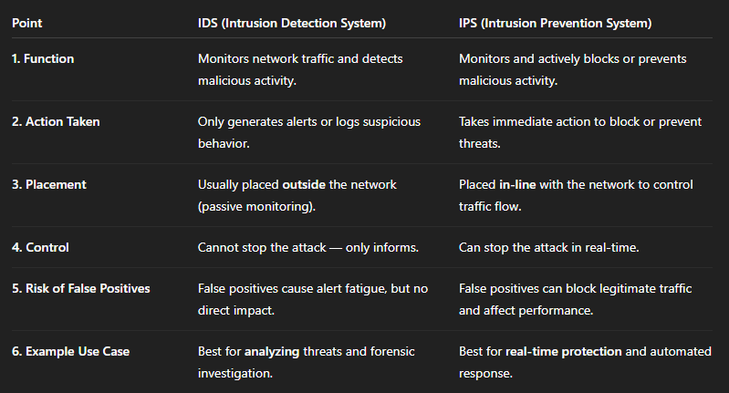

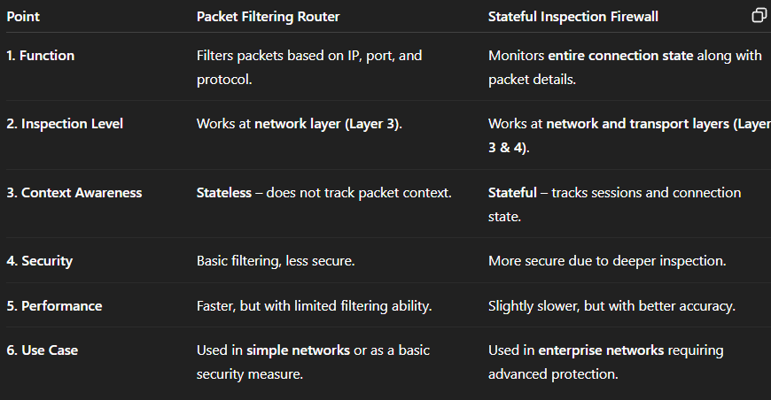

### ****Screened Subnet Firewall Architecture****

A **Screened Subnet Firewall Architecture** (also known as **DMZ Architecture**) adds an additional layer of security by placing **a demilitarized zone (DMZ)** between the internal and external networks using **two firewalls or a three-interface firewall**.

### 🔹 ****Key Components****:

1. **External Firewall (or Router):**  
   Filters traffic between the **internet and DMZ**.
2. **DMZ (Demilitarized Zone):**  
   Contains public-facing servers like web, mail, and DNS servers.
3. **Internal Firewall (or Router):**  
   Filters traffic between the **DMZ and internal network**.
4. **Internal Network:**  
   Hosts sensitive data and systems, protected by multiple layers.

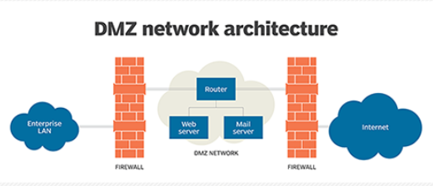

### ****Operations of Packet Filtering Firewall (In-Depth)****

**Layer of Operation:**

Packet filtering firewalls operate at the **Network Layer (Layer 3)** and sometimes at the **Transport Layer (Layer 4)** of the OSI model. They inspect the **header** of each packet and make decisions based on the information found there.

1. **Inspecting Packet Headers**  
   The firewall examines the header of every incoming and outgoing packet. It analyzes crucial fields such as the source IP address, destination IP address, source port number, destination port number, and the protocol used (TCP, UDP, ICMP). This information helps determine whether the packet should be allowed through the network or not.
2. **Applying Filtering Rules**  
   Once the packet header is analyzed, the firewall checks it against a predefined set of rules configured by the network administrator. These rules determine the action (allow or deny) for various combinations of IP addresses, ports, and protocols. For example, a rule might block all traffic from a specific IP address or deny access to port 23 (Telnet).
3. **Allowing or Denying Packets**  
   Based on the evaluation of the rules, the firewall either **allows** the packet to pass through to its destination or **blocks** (drops or rejects) it. Allowing means the packet continues its path in the network, while denying means the packet is discarded, and possibly a log or alert is generated.
4. **Protocol-Based Filtering**  
   The firewall can enforce rules based on the protocol used in the communication. For instance, it can allow HTTP (port 80) and HTTPS (port 443) traffic while blocking others like FTP or Telnet. This helps reduce attack surfaces by limiting the types of allowed communications.
5. **Stateless Packet Inspection**  
   Most packet filtering firewalls are **stateless**, meaning they do not track the state or context of a connection. Each packet is evaluated in isolation, without knowledge of previous packets. This operation ensures speed and efficiency, though it limits the firewall's ability to detect complex threats or connection-based attacks.

**Unit 6**

**Personally Identifiable Information (PII)**

Personally Identifiable Information (PII) refers to any data that can be used to identify, locate, or contact a specific individual either directly or indirectly. It is sensitive information that, if disclosed or misused, can lead to identity theft, financial fraud, or personal harm.

**Types of PII:**

1. **Direct Identifiers:**  
   These can uniquely identify an individual on their own.
   * Examples: Full name, Aadhaar number, passport number, mobile number, email address, etc.
2. **Indirect Identifiers:**  
   These may not uniquely identify an individual alone but can do so when combined with other data.
   * Examples: Gender, age, date of birth, zip code, IP address, etc.

**Importance of PII Protection:**

* **Privacy Maintenance:** Prevents unauthorized access to personal life.
* **Security:** Avoids identity theft, cyberstalking, and fraud.
* **Legal Compliance:** Organizations must protect PII to comply with data protection laws like the DPDP Act in India or GDPR in Europe.
* **Trust Building:** Users are more likely to share information if they trust that it will be protected.

**Risks Associated with PII Exposure:**

* Identity theft and impersonation.
* Financial fraud through banking data misuse.
* Phishing attacks and spam.
* Reputational damage or blackmail.

**Safeguards to Protect PII:**

1. **Data Encryption:** Ensures that even if data is accessed, it cannot be read without a decryption key.
2. **Access Controls:** Only authorized personnel should have access to PII.
3. **Regular Audits:** Periodic security checks to identify and fix vulnerabilities.
4. **User Awareness:** Educating individuals on phishing and secure practices.
5. **Anonymization:** Removing or masking personal identifiers in datasets.

**Legal Framework in India:**

* **Information Technology Act, 2000:**  
  Covers penalties for failure to protect sensitive personal data.
* **Digital Personal Data Protection (DPDP) Act, 2023:**
  + Emphasizes user consent for data processing.
  + Introduces principles like data minimization, accuracy, and security safeguards.
  + Establishes a Data Protection Board for enforcement.

## **1. Cyber Stalking** (8 Marks Answer)

Cyber stalking refers to the use of the internet, social media, email, or other forms of digital communication to harass, threaten, or stalk an individual repeatedly. It is a form of online harassment that causes emotional distress, fear, or mental trauma to the victim.

### ****Common Forms of Cyber Stalking:****

1. **Email Threats or Harassment:**  
   Sending threatening, abusive, or vulgar emails continuously.
2. **Social Media Abuse:**  
   Posting offensive comments, tagging victims in inappropriate content, or spreading rumors.
3. **Monitoring and Surveillance:**  
   Tracking someone's online activity, GPS location, or browsing history.
4. **Impersonation:**  
   Creating fake profiles using the victim’s name and photo to defame them.
5. **Sending Malware or Spyware:**  
   Using malicious software to gain access to private information or control over devices.

### ****Impact on Victims:****

* **Emotional Distress:** Fear, anxiety, depression, or trauma.
* **Reputation Damage:** Public shaming or humiliation.
* **Privacy Invasion:** Unauthorized access to personal data or photographs.
* **Physical Threats:** Sometimes it escalates to offline stalking or threats.

### ****Laws in India Against Cyber Stalking:****

* **Section 354D of the IPC:**  
  Defines stalking and makes cyberstalking a punishable offense.
* **IT Act 2000 (Amended):**  
  Provides provisions for punishment under Section 66E and 67 for violating privacy and transmitting obscene material.

### ****Prevention and Safety Tips:****

* Keep social media accounts private and block/report unknown users.
* Do not share personal information publicly.
* Use strong passwords and enable two-factor authentication.
* Install antivirus and avoid clicking on unknown links.
* Immediately report to cybercrime portals or local police.

## **2. Cybercrime** (8 Marks Answer)

Cybercrime refers to any criminal activity that involves a computer, network, or digital device. These crimes can target individuals, organizations, or governments and are typically committed over the internet.

### ****Types of Cybercrime:****

1. **Hacking:**  
   Unauthorized access to or control of a system, server, or data.
2. **Phishing:**  
   Tricking users into providing sensitive information like passwords or credit card details through fake emails or websites.
3. **Identity Theft:**  
   Stealing personal data to impersonate someone, usually for fraud.
4. **Ransomware Attacks:**  
   Malicious software locks access to a system and demands payment to unlock it.
5. **Cyber Terrorism:**  
   Attacks on critical infrastructure like banking or government sites for political motives.
6. **Online Harassment & Defamation:**  
   Using digital platforms to insult, abuse, or spread false information.

### ****Impact of Cybercrime:****

* **Financial Losses:** Online fraud, unauthorized transactions, and scams.
* **Data Breaches:** Leakage of sensitive data affecting privacy and security.
* **Loss of Trust:** Users lose faith in digital platforms and services.
* **National Security Threats:** Attacks on defense, energy, or communication systems.

### ****Legal Framework in India:****

* **Information Technology Act, 2000:**  
  Provides the legal foundation for electronic governance and penalizes cybercrimes.
  + **Section 43:** Compensation for unauthorized access and data theft.
  + **Section 66:** Punishment for hacking and identity theft.
  + **Section 66F:** Covers cyber terrorism.
* **Indian Penal Code (IPC):**  
  Includes sections on defamation, stalking, and criminal intimidation online.

### ****Cybercrime Prevention Measures:****

* Use updated antivirus and firewalls.
* Avoid clicking on unknown links or downloading files from suspicious sources.
* Report suspicious emails or messages.
* Use strong, unique passwords and enable two-factor authentication.
* Raise awareness through education and digital literacy.

## **PII Confidentiality Safeguards** (8 Marks Answer)

### ****Introduction:****

**Personally Identifiable Information (PII)** includes any data that can identify an individual, such as name, address, phone number, Aadhaar number, email ID, etc. Ensuring the **confidentiality** of PII is critical to prevent identity theft, data breaches, and cybercrime

### ****Objectives of PII Confidentiality Safeguards:****

* To protect individual privacy.
* To prevent unauthorized access or misuse.
* To ensure data is used only for legitimate and consented purposes.
* To maintain compliance with data protection laws and regulations.

### ****Key Safeguards for Protecting PII:****

#### **1. Data Encryption:**

* Encrypt data both **in transit** and **at rest**.
* Ensures that even if data is intercepted or stolen, it cannot be read without a decryption key.

#### **2. Access Control:**

* Restrict access to PII to **authorized personnel** only.
* Use **role-based access control (RBAC)** to limit exposure.
* Employ strong user authentication methods like passwords, biometrics, and OTPs.

#### **3. Anonymization and Masking:**

* Replace or hide personal identifiers in datasets to prevent identity exposure.
* Useful in data analytics, testing, and reporting where actual identity isn’t required.

#### **4. Secure Storage and Disposal:**

* Store data in **secure servers or databases** with up-to-date security protocols.
* **Shred** physical documents and **permanently delete** digital records when no longer needed.

#### **5. Regular Security Audits:**

* Conduct **periodic audits and vulnerability assessments**.
* Helps detect and address security loopholes before they can be exploited.

#### **6. Employee Training and Awareness:**

* Educate staff and users on **data privacy policies**, phishing risks, and safe handling practices.
* Promotes a culture of privacy and security in the organization.

#### **7. Use of Firewalls and Antivirus:**

* Protect systems from **malware, ransomware, and external attacks**.
* Keeps unauthorized intrusions in check.

### ****Legal Safeguards (Indian Context):****

* **IT Act 2000 – Section 43A:** Mandates compensation if companies fail to protect sensitive personal data.
* **Digital Personal Data Protection (DPDP) Act 2023:**
  + Requires user consent before data collection.
  + Mandates organizations to implement safeguards and notify breaches.
  + Grants users rights like data access, correction, and erasure.

## **Information Protection Law: Indian Perspective** (8 Marks Answer)

With the rapid growth of digital technologies and increasing data breaches, protecting personal and sensitive information has become a priority. India has introduced various **legal frameworks** to ensure the confidentiality, integrity, and lawful use of data, especially **Personally Identifiable Information (PII)**.

### ****Key Information Protection Laws in India:****

### ****1. Information Technology (IT) Act, 2000:****

* India’s primary law for cybercrime and electronic commerce.
* Recognizes **electronic records** and **digital signatures**.
* Includes provisions for securing sensitive personal data.

**Important Sections:**

* **Section 43A:**  
  Compensation for failure to protect personal data by body corporates.
* **Section 72:**  
  Penalty for breach of confidentiality and privacy by accessing data without consent.
* **Section 66E:**  
  Punishment for violation of privacy through capturing or transmitting private images.

### ****2. Digital Personal Data Protection (DPDP) Act, 2023:****

A modern data protection law enacted to ensure the privacy of individuals’ personal data.

**Key Features:**

* **Consent-based Data Processing:**  
  Data can only be collected and processed with the individual’s consent.
* **Data Principal Rights:**  
  Includes rights to access, correct, delete personal data, and file complaints.
* **Obligations of Data Fiduciaries:**  
  Organizations must ensure transparency, security, and lawful processing of data.
* **Establishment of Data Protection Board:**  
  A regulatory body to address data breaches and enforce penalties.
* **Cross-border Data Transfer:**  
  Allows transfer of personal data to certain trusted countries.

### ****3. Indian Penal Code (IPC) Provisions:****

Some IPC sections also support information protection indirectly:

* **Section 403:** Dishonest misappropriation of property (applicable to data theft).
* **Section 408 & 409:** Breach of trust by employees and public servants.
* **Section 499 & 500:** Defamation including online defamation.

### ****4. Sector-specific Regulations:****

* **RBI Guidelines:** For banking and financial institutions on customer data security.
* **SEBI Guidelines:** For securities and investment firms to secure investor data.
* **TRAI Regulations:** For telecom companies to protect user data.

### ****Challenges in Enforcement:****

* Low awareness among users.
* Jurisdictional issues in cross-border data crimes.
* Rapid evolution of technology vs. slow law-making.

### ****Advantages of Cyber Law [5 Marks]****

1. **Protection Against Cybercrimes**  
   Cyber laws help detect, prevent, and punish cybercrimes like hacking, identity theft, cyberstalking, and data breaches.
2. **Legal Framework for E-Commerce**  
   Cyber law supports online transactions by providing legal recognition to digital signatures, e-contracts, and electronic records.
3. **Data Privacy and Security**  
   It enforces rules for protecting sensitive personal and corporate data, promoting trust in digital platforms.
4. **Intellectual Property Protection**  
   Cyber law helps protect digital intellectual property such as software, websites, trademarks, and copyrights from unauthorized use.
5. **Regulation of Social Media and Online Content**  
   It prevents misuse of social media and monitors illegal content like fake news, hate speech, and cyberbullying.
6. **Support for Digital India Initiatives**  
   Cyber laws provide a secure environment for digital governance, cashless transactions, and e-services

### ****1. Remote Connectivity Hacking**** (8 Marks Answer)

Remote connectivity hacking refers to the unauthorized access of computer systems or networks using remote access technologies such as **RDP (Remote Desktop Protocol)**, **VPN**, **TeamViewer**, or other remote control tools.

**How It Works:**

* Attackers use phishing, brute force, or leaked credentials to access a remote system.
* Once inside, they can steal data, install malware, or gain persistent access.

**Examples:**

* Gaining unauthorized access to a company server via RDP using weak admin passwords.
* Using a compromised VPN connection to infiltrate internal systems.

**Impact:**

* Data breaches
* Financial loss
* System downtime
* Reputation damage

**Preventive Measures:**

* Use **multi-factor authentication (MFA)**.
* Keep remote access software up to date.
* Limit remote access to **known IP addresses**.
* Monitor logs and use intrusion detection systems.

### ****2. VoIP Hacking**** (8 Marks Answer)

VoIP (Voice over Internet Protocol) Hacking is the act of attacking internet-based telephony systems to intercept calls, manipulate voice data, or cause service disruption.

**How It Works:**

* VoIP data packets can be intercepted or redirected.
* Hackers exploit vulnerabilities in SIP (Session Initiation Protocol) or RTP (Real-Time Transport Protocol).

**Types of Attacks:**

* **Eavesdropping:** Listening to calls without authorization.
* **Call Hijacking:** Redirecting calls to malicious destinations.
* **Toll Fraud:** Using VoIP systems to make international calls without the owner’s knowledge.
* **Denial of Service (DoS):** Overloading the VoIP system to shut it down.

**Examples:**

* A hacker reroutes a company’s support line to their own number.
* Intercepting confidential VoIP calls using a packet sniffer.

**Impact:**

* Leakage of sensitive conversations.
* Financial fraud via toll misuse.
* Damage to brand trust and services.

**Preventive Measures:**

* Use **SRTP (Secure RTP)** for encryption.
* Employ **VoIP-specific firewalls and IDS**.
* Disable unnecessary services and ports.

### ****3. Wireless Hacking**** (8 Marks Answer)

Wireless hacking involves breaking into **Wi-Fi networks** to intercept, manipulate, or steal data transmitted over the air.

**How It Works:**

* Hackers use tools to find and crack weak wireless security protocols like WEP or WPA.
* Fake access points are also used to deceive users.

**Types of Attacks:**

* **Wardriving:** Scanning for unsecured networks while moving.
* **Evil Twin Attack:** Creating a fake Wi-Fi access point.
* **WPA/WEP Cracking:** Breaking encryption to gain access.
* **De-authentication Attack:** Forcing users off a network to intercept reconnections.

**Examples:**

* Connecting to a coffee shop’s fake Wi-Fi and stealing users’ credentials.
* Hacking into a home router using the default admin password.

**Impact:**

* Data theft and session hijacking.
* Network misuse for illegal activities.
* Compromise of connected devices.

**Preventive Measures:**

* Use **WPA3** encryption.
* Change default router settings and passwords.
* Disable SSID broadcasting and use MAC filtering.

### ****4. Mobile Hacking**** (8 Marks Answer)

Mobile hacking refers to unauthorized access or control over smartphones or tablets to exploit personal information, apps, or device resources.

**How It Works:**

* Hackers use malicious apps, phishing links, or OS vulnerabilities to gain access.
* Attack vectors include SMS (smishing), Bluetooth, and rogue applications.

**Types of Mobile Attacks:**

* **Smishing:** Phishing via SMS.
* **Spyware/Malware:** Monitoring user activity.
* **Rooting/Jailbreaking Exploits:** Gaining administrative access.
* **Bluetooth Exploits:** Connecting silently to devices.

**Examples:**

* A user unknowingly installs a fake banking app that steals login details.
* Bluetooth connection exploited in a public area to access contacts and files.

**Impact:**

* Identity theft.
* Financial fraud.
* Surveillance and privacy violation.

**Preventive Measures:**

* Install apps only from trusted sources.
* Regularly update OS and apps.
* Enable app permissions cautiously.
* Use mobile antivirus and security tools.

### ****5. Countermeasures**** (8 Marks Answer)

Countermeasures refer to strategies and technologies implemented to **prevent**, **detect**, and **respond** to hacking attacks across different platforms.

### ****General Countermeasures for All Hacking Types:****

#### **1. Strong Authentication:**

* Use of **multi-factor authentication (MFA)**.
* Strong passwords with regular updates.

#### **2. Encryption:**

* Encrypt sensitive data **at rest and in transit**.
* Use **VPNs** for secure connections.

#### **3. Firewalls and IDS/IPS:**

* Network firewalls block unauthorized access.
* **Intrusion Detection and Prevention Systems** detect and respond to attacks.

#### **4. Security Patching and Updates:**

* Keep all devices, applications, and firmware updated.
* Apply patches to fix known vulnerabilities.

#### **5. User Awareness:**

* Conduct cybersecurity training and phishing simulations.
* Encourage safe browsing and app installation practices.

#### **6. Endpoint Security:**

* Use antivirus and anti-malware tools.
* Enable device lock screens and remote wipe features.

#### **7. Regular Audits and Monitoring:**

* Conduct **vulnerability assessments** and **penetration testing**.
* Monitor system logs for suspicious activity.

### ✅ ****Life Cycle of Cyber Forensics [6 Marks]****

The **Cyber Forensics Life Cycle** is a structured process used to identify, preserve, analyze, and present digital evidence in a legally admissible way. It typically involves the following key phases:

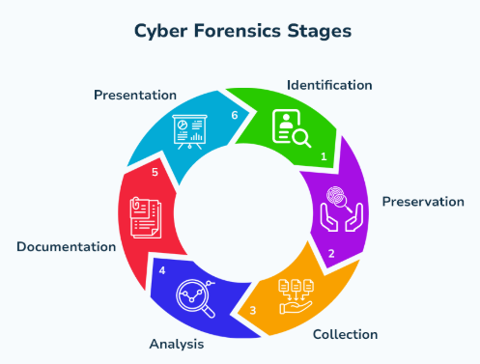

### 🔹 1. ****Identification****

* Determine the scope and nature of the cyber incident.
* Identify the devices, users, or networks involved.
* Recognize the type of data that may contain digital evidence.

### 🔹 2. ****Preservation****

* Secure the crime scene (digital environment) to prevent evidence tampering.
* Isolate the affected system to prevent further damage or alteration.
* Create forensic copies (bit-by-bit images) of digital media for examination.

### 🔹 3. ****Collection****

* Collect digital evidence from sources like hard disks, mobile devices, logs, email, cloud storage, etc.
* Maintain a chain of custody to prove that evidence has not been altered.
* Ensure proper documentation of tools, procedures, and personnel involved.

### 🔹 4. ****Examination****

* Use forensic tools to examine the collected data.
* Extract relevant information such as deleted files, internet activity, or timestamps.
* Focus on specific data types based on the case (emails, logs, etc.).

### 🔹 5. ****Analysis****

* Analyze evidence to understand what happened, how, when, and who was involved.
* Reconstruct the timeline of events.
* Correlate data from various sources for a clear picture of the incident.

### 🔹 6. ****Documentation and Reporting****

* Prepare a detailed report containing findings, methods used, and conclusions.
* Reports must be clear, precise, and suitable for presentation in a court of law.
* Include visual aids like timelines, screenshots, and logs if needed.

### 🔹 7. ****Presentation****

* Present the evidence and report to legal authorities, management, or court.
* The forensic expert may testify as a witness to explain technical findings.
* The integrity and admissibility of the evidence are crucial in this phase.

### ****Who are Cyber Criminals?****

Cyber criminals are individuals or groups who use technology and the internet to commit illegal activities targeting systems, networks, or data for personal, financial, or political gain.

They can be:

* **Hackers** (black-hat)
* **Insiders** (disgruntled employees)
* **Script kiddies** (amateur attackers using tools)
* **Cyber terrorists**
* **Organized crime syndicates**

### 🔹 ****Types of Cyber Crimes:****

| **Type** | **Description** |
| --- | --- |
| 1. **Hacking** | Unauthorized access to or control over computer systems or networks. |
| 2. **Phishing** | Fraudulent attempts to acquire sensitive information by pretending to be legitimate sources. |
| 3. **Identity Theft** | Stealing someone's personal information to commit fraud. |
| 4. **Cyberstalking** | Harassing or threatening someone using digital communication. |
| 5. **Online Fraud and Scams** | Deceptive schemes like fake online shopping websites, lottery scams, etc. |
| 6. **Denial of Service (DoS)** | Attacks that overload a system to make it unavailable to users. |
| 7. **Data Breach** | Unauthorized access to sensitive, confidential, or protected data. |
| 8. **Cyber Espionage** | Stealing confidential information from governments or corporations. |
| 9. **Ransomware Attacks** | Locking or encrypting data and demanding a ransom to release it. |
| 10. **Child Pornography** | Distribution or access to child sexual abuse content through the internet. |

### ****What is a Botnet?****

A **botnet** (short for “robot network”) is a network of infected computers or IoT devices (called **bots** or **zombies**) that are remotely controlled by a **cybercriminal** or **botmaster** without the users’ knowledge.

These infected devices are used to perform malicious activities such as:

* **Sending spam emails**
* **Launching DDoS attacks**
* **Spreading malware**
* **Stealing data**
* **Mining cryptocurrency**

### 🔒 ****How to Protect from Botnets:****

1. **Use Antivirus and Anti-malware Software**
   * Regularly scan and update your security software to detect bot infections.
2. **Keep Software Updated**
   * Apply security patches to your OS, browsers, apps, and firmware to fix known vulnerabilities.
3. **Enable Firewalls**
   * Use both hardware and software firewalls to block unauthorized connections.
4. **Avoid Suspicious Links and Downloads**
   * Don’t click unknown links or open attachments in unsolicited emails.
5. **Use Strong, Unique Passwords**
   * Change default credentials on routers, IoT devices, and other endpoints.
6. **Monitor Network Traffic**
   * Unusual outbound traffic may indicate botnet activity.
7. **Disable Unused Services**
   * Turn off remote access or unnecessary ports to reduce attack surface.
8. **Educate Users**
   * Train employees or users about phishing, fake updates, and botnet risks.

**i) Virus:**  
A virus is a malicious program that attaches itself to files or programs and spreads when the infected file is executed. It can corrupt, delete, or steal data from a system.

**ii) Phishing:**  
Phishing is a cyber attack where attackers trick users into revealing sensitive information (like passwords or credit card numbers) by pretending to be legitimate entities, usually via fake emails or websites.

**iii) Spoofing:**  
Spoofing is an attack in which a cybercriminal disguises as a trusted source (such as IP address, email, or website) to gain access to data or systems.

**iv) Phone Phishing (Vishing):**  
Phone phishing involves using phone calls to trick people into revealing personal or financial information. The attacker usually poses as a bank officer or government representative.

**v) Internet Pharming:**  
Pharming redirects users from a legitimate website to a fake one without their knowledge, often to steal login credentials or financial information.

**vi) Cyber Forensic:**  
Cyber forensic is the process of collecting, preserving, analyzing, and presenting digital evidence from electronic devices, often used in legal investigations.