**1. Basics and Need of Data Science**

**1.1 What is Data Science?**

Data Science is an interdisciplinary field that combines statistical analysis, machine learning, data engineering, and domain expertise to extract meaningful insights and knowledge from structured and unstructured data. It involves the use of scientific methods, algorithms, and systems to solve complex problems and make data-driven decisions.

**1.2 Why is Data Science Important?**

* **Decision Making:** Data Science enables organizations to make informed decisions by analyzing historical and real-time data.
* **Predictive Analytics:** It allows businesses to predict future trends and behaviors, helping them to stay ahead of the competition.
* **Automation:** Data Science can automate repetitive tasks, improving efficiency and reducing human error.
* **Personalization:** Companies can use Data Science to offer personalized experiences to customers, enhancing customer satisfaction and loyalty.
* **Innovation:** Data Science drives innovation by uncovering hidden patterns and insights that can lead to new products, services, and business models.

**2. Applications of Data Science**

**2.1 Healthcare**

* **Predictive Diagnostics:** Using machine learning models to predict diseases based on patient data.
* **Drug Discovery:** Accelerating the process of drug discovery by analyzing biological data.
* **Personalized Medicine:** Tailoring medical treatments to individual patients based on their genetic makeup.

**2.2 Finance**

* **Fraud Detection:** Identifying fraudulent transactions using anomaly detection algorithms.
* **Algorithmic Trading:** Using predictive models to make high-frequency trading decisions.
* **Risk Management:** Assessing and mitigating financial risks through data analysis.

**2.3 Retail**

* **Customer Segmentation:** Grouping customers based on purchasing behavior to target marketing efforts.
* **Inventory Management:** Optimizing inventory levels using demand forecasting models.
* **Recommendation Systems:** Suggesting products to customers based on their browsing and purchase history.

**2.4 Transportation**

* **Route Optimization:** Finding the most efficient routes for delivery and transportation.
* **Autonomous Vehicles:** Using sensor data and machine learning to enable self-driving cars.
* **Traffic Prediction:** Predicting traffic patterns to reduce congestion and improve urban planning.

**2.5 Social Media**

* **Sentiment Analysis:** Analyzing social media posts to gauge public opinion.
* **Content Recommendation:** Suggesting content to users based on their interests and behavior.
* **Network Analysis:** Understanding social networks and influence patterns.

**Relationship Between Data Science and Information Science**

Data Science and Information Science are two closely related fields that often overlap but have distinct focuses and methodologies. Understanding their relationship is crucial for appreciating how they complement each other in the broader context of data-driven decision-making and knowledge management.

**1. Definitions and Core Focus**

**1.1 Data Science**

* **Definition:** Data Science is an interdisciplinary field that uses scientific methods, algorithms, and systems to extract knowledge and insights from structured and unstructured data.
* **Core Focus:**
  + Analyzing data to uncover patterns, trends, and insights.
  + Building predictive models using machine learning and statistical techniques.
  + Solving complex problems through data-driven approaches.
  + Handling both structured (e.g., databases) and unstructured data (e.g., text, images, videos).

**1.2 Information Science**

* **Definition:** Information Science is the study of the collection, classification, manipulation, storage, retrieval, and dissemination of information.
* **Core Focus:**
  + Managing and organizing information for efficient retrieval and use.
  + Designing information systems (e.g., databases, libraries, archives).
  + Ensuring the accessibility, reliability, and usability of information.
  + Primarily deals with structured data and information systems.

**2. Key Similarities**

* **Data as a Central Resource:** Both fields rely on data as a primary resource for generating insights or managing information.
* **Interdisciplinary Nature:** Both fields draw from computer science, mathematics, statistics, and domain-specific knowledge.
* **Goal of Enhancing Decision-Making:** Both aim to improve decision-making processes, whether through insights derived from data (Data Science) or efficient information retrieval and management (Information Science).
* **Use of Technology:** Both fields leverage advanced technologies, such as databases, machine learning, and data visualization tools.

**3. Key Differences**

| **Aspect** | **Data Science** | **Information Science** |
| --- | --- | --- |
| **Primary Focus** | Extracting insights and knowledge from data. | Managing and organizing information for efficient retrieval and use. |
| **Data Types** | Structured and unstructured data (e.g., text, images, videos). | Primarily structured data (e.g., databases, documents). |
| **Techniques** | Machine learning, statistical modeling, predictive analytics, data visualization. | Information retrieval, database management, knowledge organization systems. |
| **Output** | Predictive models, actionable insights, and data-driven decisions. | Organized information systems, databases, and knowledge repositories. |
| **Time Orientation** | Forward-looking (predictive and prescriptive analytics). | Backward-looking (descriptive and historical information management). |

**5. Real-World Examples of Their Relationship**

**5.1 Digital Libraries**

* **Information Science Role:** Designing the library's database system, cataloging resources, and ensuring efficient information retrieval.
* **Data Science Role:** Analyzing user behavior to recommend books, predicting trends in resource usage, and optimizing search algorithms.

**5.2 Healthcare Systems**

* **Information Science Role:** Managing electronic health records (EHRs) and ensuring secure, efficient access to patient data.
* **Data Science Role:** Analyzing patient data to predict disease outbreaks, personalize treatments, and improve healthcare outcomes.

**5.3 E-Commerce Platforms**

* **Information Science Role:** Organizing product catalogs, managing inventory databases, and ensuring smooth transaction processing.
* **Data Science Role:** Using customer data to build recommendation systems, predict sales trends, and optimize pricing strategies.

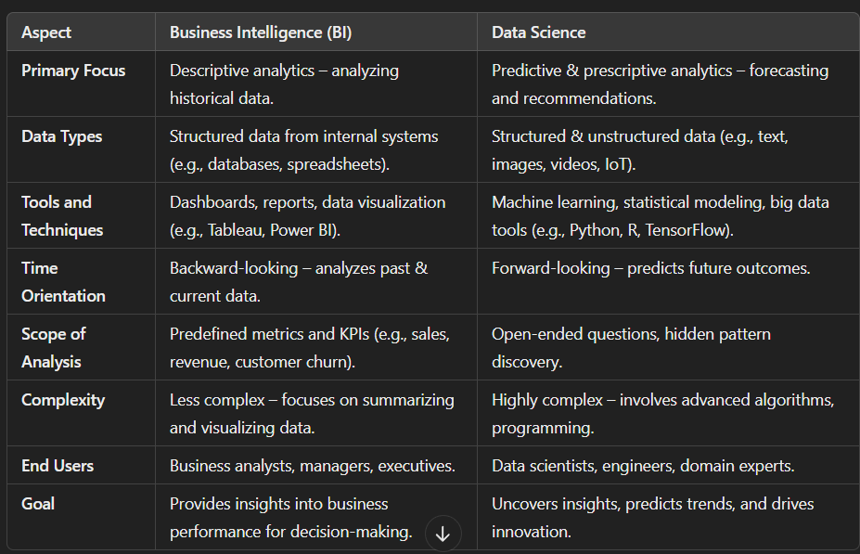

**Data: Data Types and Data Collection**

Data is the foundation of Data Science, Business Intelligence, and Information Science. Understanding the types of data and the methods of collecting it is crucial for effective analysis and decision-making. Below is a detailed explanation of **data types** and **data collection methods**.

**1. Data Types**

Data can be categorized into three main types based on its structure and format:

**1.1 Structured Data**

* **Definition:** Data that is organized in a predefined format, typically stored in relational databases or spreadsheets.
* **Characteristics:**
  + Organized in rows and columns (e.g., tables in SQL databases).
  + Easily searchable and analyzable using query languages like SQL.
  + Examples: Sales records, customer information, financial transactions.
* **Use Cases:**
  + Business reporting (e.g., sales dashboards).
  + Transactional systems (e.g., banking, e-commerce).

**1.2 Unstructured Data**

* **Definition:** Data that does not have a predefined structure or format.
* **Characteristics:**
  + Cannot be easily stored in traditional relational databases.
  + Requires advanced techniques for processing and analysis.
  + Examples: Text documents, emails, social media posts, images, videos, audio files.
* **Use Cases:**
  + Sentiment analysis (e.g., analyzing customer reviews).
  + Image recognition (e.g., facial recognition in photos).
  + Natural language processing (e.g., chatbots).

**1.3 Semi-Structured Data**

* **Definition:** Data that does not fit into a rigid structure but has some organizational properties.
* **Characteristics:**
  + Contains tags or markers to separate elements (e.g., JSON, XML).
  + More flexible than structured data but easier to process than unstructured data.
  + Examples: JSON files, XML files, NoSQL databases.
* **Use Cases:**
  + Web data (e.g., data from APIs).
  + Log files (e.g., server logs, application logs).

**2. Data Collection Methods**

Data collection is the process of gathering information from various sources for analysis. The method of collection depends on the type of data and the purpose of the analysis.

**2.1 Primary Data Collection**

* **Definition:** Data collected directly from original sources for a specific purpose.
* **Methods:**
  + **Surveys and Questionnaires:** Collecting data through structured questions (e.g., customer satisfaction surveys).
  + **Interviews:** Conducting one-on-one or group interviews to gather qualitative data.
  + **Experiments:** Conducting controlled experiments to test hypotheses (e.g., A/B testing in marketing).
  + **Observations:** Collecting data by observing behavior or events (e.g., tracking user interactions on a website).

**2.2 Secondary Data Collection**

* **Definition:** Data collected from existing sources that were originally gathered for another purpose.
* **Methods:**
  + **Public Databases:** Accessing data from government or public organizations (e.g., census data, weather data).
  + **Published Reports:** Using data from industry reports, research papers, or whitepapers.
  + **Web Scraping:** Extracting data from websites using automated tools (e.g., scraping product prices from e-commerce sites).
  + **APIs:** Retrieving data from third-party services via Application Programming Interfaces (e.g., Twitter API for social media data).

**2.3 Automated Data Collection**

* **Definition:** Data collected automatically using sensors, devices, or software.
* **Methods:**
  + **Sensors and IoT Devices:** Collecting real-time data from sensors (e.g., temperature sensors, fitness trackers).
  + **Transactional Systems:** Capturing data from business transactions (e.g., point-of-sale systems, online payment systems).
  + **Logs:** Recording events in systems or applications (e.g., server logs, application logs).

**2.4 Social Media Data Collection**

* **Definition:** Data collected from social media platforms.
* **Methods:**
  + **Social Media APIs:** Accessing data from platforms like Twitter, Facebook, or Instagram.
  + **Web Scraping:** Extracting public posts, comments, or reviews from social media sites.
  + **Sentiment Analysis Tools:** Analyzing user-generated content to gauge public opinion.

**2.5 Big Data Collection**

* **Definition:** Collecting large volumes of data from diverse sources.
* **Methods:**
  + **Data Lakes:** Storing raw, unstructured data in a centralized repository (e.g., Hadoop, AWS S3).
  + **Streaming Data:** Collecting real-time data streams (e.g., stock market data, IoT sensor data).
  + **Cloud Platforms:** Using cloud-based tools to collect and store data (e.g., Google BigQuery, Azure Data Lake).

**3. Importance of Data Collection**

* **Accuracy:** High-quality data collection ensures accurate and reliable analysis.
* **Completeness:** Collecting data from multiple sources provides a comprehensive view of the problem.
* **Relevance:** Data collection methods should align with the objectives of the analysis.
* **Timeliness:** Real-time or near-real-time data collection enables timely decision-making.

**4. Challenges in Data Collection**

* **Data Quality:** Ensuring the data is accurate, complete, and free from errors.
* **Data Privacy:** Complying with regulations (e.g., GDPR) when collecting personal data.
* **Data Volume:** Managing and storing large volumes of data efficiently.
* **Data Integration:** Combining data from diverse sources into a unified format.

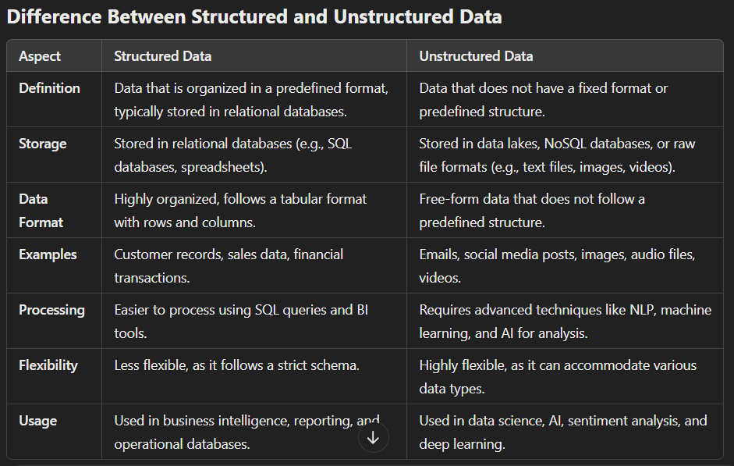**Need for Data Wrangling (Data Cleaning & Preparation) in Detail**

**What is Data Wrangling?**

Data wrangling is the process of cleaning, transforming, and organizing raw data into a structured format suitable for analysis. It ensures data quality, consistency, and usability for business intelligence (BI), machine learning (ML), and data science applications.

**Why is Data Wrangling Needed?**

**1️ Improves Data Quality & Accuracy**

* Raw data is often messy, containing errors, missing values, and inconsistencies.
* Cleaning data (removing duplicates, correcting errors) ensures accurate insights and reliable decision-making.

**2️⃣ Handles Missing & Inconsistent Data**

* Datasets often contain missing values (e.g., blank fields in surveys, unrecorded sales).
* Data wrangling helps impute missing values or remove incomplete records to prevent biased results.

**3️⃣ Eliminates Duplicates & Redundant Data**

* Duplicate records lead to incorrect calculations and misinterpretations.
* De-duplication ensures a single, accurate source of truth.

**4️⃣ Standardizes Data Formats & Units**

* Data comes from multiple sources in different formats (e.g., dates as DD/MM/YYYY vs. YYYY-MM-DD).
* Wrangling converts data into a uniform format, ensuring compatibility across systems.

**5️⃣ Enables Better Data Integration**

* Data from different sources (databases, APIs, spreadsheets) may have varied structures.
* Wrangling aligns different datasets into a common structure for seamless integration.

**6️⃣ Enhances Data Usability for Machine Learning & BI**

* Raw data is rarely ready for immediate use in ML models or BI dashboards.
* Data transformation (e.g., feature scaling, encoding categorical variables) is essential for model accuracy and meaningful analysis.

**7️⃣ Detects & Removes Outliers**

* Extreme values (outliers) can distort statistical analysis and ML predictions.
* Wrangling identifies and removes these anomalies or transforms them appropriately.

**8️⃣ Optimizes Data for Faster Processing**

* Large datasets may have unnecessary columns, increasing storage and processing time.
* Wrangling reduces data complexity, improving query performance and computational efficiency.

**Data Wrangling Methods: Detailed Explanation**

Data wrangling is the process of cleaning, transforming, and organizing raw data into a usable format for analysis. It is a critical step in the data science workflow, as raw data is often messy, incomplete, or inconsistent. Below is a **detailed explanation** of the five key data wrangling methods: **Data Cleaning, Data Integration, Data Reduction, Data Transformation, and Data Discretization**. Each method is explained with its **advantages, disadvantages, and examples** to help you write a detailed 5-mark answer.

**1. Data Cleaning**

**Definition:**

Data cleaning is the process of identifying and correcting errors, inconsistencies, and inaccuracies in a dataset. It ensures that the data is accurate, complete, and ready for analysis.

**Steps Involved:**

1. **Handling Missing Values:**
   * Fill missing values using mean, median, or mode.
   * Remove records with missing values if they are insignificant.
2. **Removing Duplicates:**
   * Identify and eliminate duplicate records to avoid redundancy.
3. **Correcting Errors:**
   * Fix typos, incorrect data entries, and inconsistencies (e.g., "New Yrok" → "New York").
4. **Standardizing Formats:**
   * Ensure consistent formats for dates, currencies, and other fields.

**Advantages:**

1. **Improved Data Quality:** Clean data is free from errors and inconsistencies, leading to more reliable analysis.
2. **Better Decision-Making:** Accurate data ensures that insights and decisions are based on correct information.
3. **Enhanced Efficiency:** Clean data reduces the time and effort required for analysis.

**Disadvantages:**

1. **Time-Consuming:** Cleaning large datasets can be labor-intensive and time-consuming.
2. **Subjectivity:** Deciding how to handle missing or inconsistent data can be subjective.
3. **Risk of Data Loss:** Incorrect cleaning methods may result in the loss of valuable information.

**Example:**

* A dataset contains customer information with missing age values. The missing values are filled using the average age of the dataset.
* Duplicate records in a sales dataset are identified and removed to ensure accurate analysis.

**2. Data Integration**

**Definition:**

Data integration combines data from multiple sources into a unified view, often stored in a data warehouse or data lake. It ensures that data from different systems can be analyzed together.

**Steps Involved:**

1. **Extract:** Collect data from various sources (e.g., databases, APIs, spreadsheets).
2. **Transform:** Convert data into a consistent format (e.g., standardizing date formats, currency units).
3. **Load:** Load the transformed data into a centralized repository (e.g., data warehouse).

**Advantages:**

1. **Unified View:** Provides a single source of truth by merging data from different systems.
2. **Enhanced Analysis:** Enables cross-functional analysis by combining diverse datasets.
3. **Improved Efficiency:** Reduces the need to switch between multiple systems for data access.

**Disadvantages:**

1. **Complexity:** Integrating data from disparate sources can be technically challenging.
2. **Data Quality Issues:** Inconsistent formats or standards across sources can lead to errors.
3. **Costly:** Requires significant resources for tools, infrastructure, and expertise.

**Example:**

* Combining sales data from an e-commerce platform with customer data from a CRM system to analyze customer purchasing behavior.
* Integrating weather data with transportation logs to study the impact of weather on delivery times.

**3. Data Reduction**

**Definition:**

Data reduction reduces the volume of data while maintaining its integrity and usefulness. It is often achieved through dimensionality reduction, sampling, or aggregation.

**Steps Involved:**

1. **Dimensionality Reduction:**
   * Reduce the number of features (variables) using techniques like Principal Component Analysis (PCA).
2. **Sampling:**
   * Select a subset of data for analysis instead of the entire dataset.
3. **Aggregation:**
   * Summarize data at a higher level (e.g., daily sales data aggregated to monthly sales).

**Advantages:**

1. **Efficiency:** Reduces storage and computational requirements.
2. **Faster Processing:** Smaller datasets are quicker to analyze.
3. **Improved Focus:** Eliminates irrelevant or redundant data, focusing on key variables.

**Disadvantages:**

1. **Loss of Detail:** Reducing data may result in the loss of important information.
2. **Complexity:** Choosing the right reduction technique requires expertise.
3. **Risk of Bias:** Improper sampling or reduction methods can introduce bias.

**Example:**

* Using PCA to reduce the number of features in a dataset from 50 to 10 while retaining 95% of the variance.
* Sampling 10% of a large dataset for preliminary analysis to save time and resources.

**4. Data Transformation**

**Definition:**

Data transformation converts data from one format or structure into another to make it suitable for analysis. It ensures that data is compatible with analytical tools and algorithms.

**Steps Involved:**

1. **Normalization:**
   * Scale numerical data to a standard range (e.g., 0 to 1).
2. **Encoding:**
   * Convert categorical data into numerical format using techniques like one-hot encoding or label encoding.
3. **Aggregation:**
   * Summarize data at a higher level (e.g., daily sales data aggregated to monthly sales).

**Advantages:**

1. **Standardization:** Ensures data is in a consistent format for analysis.
2. **Compatibility:** Makes data compatible with analytical tools and algorithms.
3. **Enhanced Insights:** Transformed data can reveal patterns that were not visible in the raw format.

**Disadvantages:**

1. **Complexity:** Transformation processes can be technically challenging.
2. **Time-Consuming:** Large datasets may require significant processing time.
3. **Risk of Errors:** Incorrect transformations can lead to inaccurate results.

**Example:**

* Normalizing numerical data to a range of 0 to 1 for machine learning models.
* Converting categorical data (e.g., "Male," "Female") into numerical format using one-hot encoding.

**5. Data Discretization**

**Definition:**

Data discretization is the process of converting continuous numerical data into discrete categories or bins. It is commonly used in machine learning and data preprocessing to simplify complex datasets and improve model interpretability.

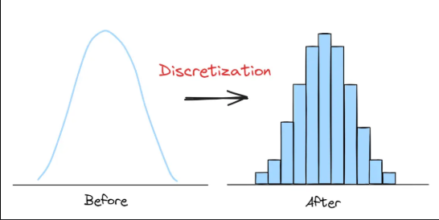

**Steps Involved:**

1. **Binning:**
   * Divide continuous data into a set of bins or intervals (e.g., age groups: 0-18, 19-35, 36-50, 51+).
2. **Clustering:**
   * Group similar data points into clusters and assign them to discrete categories.
3. **Histogram Analysis:**
   * Use histograms to identify natural breaks in the data for discretization.

**Advantages:**

1. **Simplification:** Reduces the complexity of continuous data.
2. **Improved Analysis:** Enables the use of categorical analysis techniques.
3. **Noise Reduction:** Minimizes the impact of minor fluctuations in data.

**Disadvantages:**

1. **Loss of Precision:** Discretization may result in the loss of detailed information.
2. **Subjectivity:** Choosing the right bin size or intervals can be subjective.
3. **Potential Bias:** Improper binning can introduce bias into the analysis.

**Example:**

* Grouping ages into categories (e.g., 0-18, 19-35, 36-50, 51+).
* Discretizing temperature data into ranges (e.g., low: 0-10°C, medium: 11-20°C, high: 21-30°C).

### ****What is Data Normalization in Data Science?****

Data normalization is a preprocessing technique used in data science to scale numerical data into a specific range, making it easier to compare and analyze. It helps in improving the performance of machine learning models by ensuring that no particular feature dominates due to its scale.

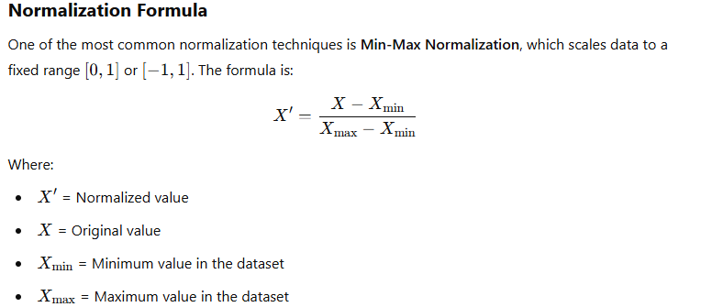

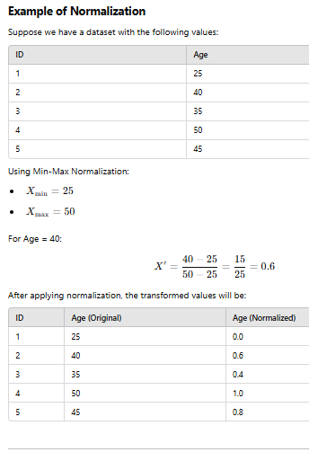

**Note on Normalization**

* Normalization is essential when features have different ranges, ensuring that no single feature dominates others in distance-based models (e.g., KNN, K-Means).
* It is particularly useful for algorithms that rely on gradient descent, like Neural Networks.
* Alternative techniques include **Z-score Standardization**, which scales data based on mean and standard deviation.

## **Data Reduction Techniques in Data Science**

Data reduction is the process of minimizing the volume of data while maintaining its integrity and significance. It helps improve computational efficiency and reduces storage requirements.

## **1. Dimensionality Reduction**

Removes irrelevant or redundant features while preserving the most important information.

### ****(a) Principal Component Analysis (PCA)****

* Converts correlated features into a smaller set of uncorrelated features called **principal components**.
* Reduces high-dimensional data while retaining maximum variance.

✅ **Example:**  
A dataset with 100 features is reduced to 10 principal components while maintaining 95% of the original data variance.

### ****(b) Linear Discriminant Analysis (LDA)****

* Similar to PCA but focuses on maximizing class separability.
* Used in classification problems.

✅ **Example:**  
In a dataset with 10 features for disease prediction, LDA selects the most significant ones for better classification.

### ****(c) t-SNE (t-Distributed Stochastic Neighbor Embedding)****

* Reduces high-dimensional data into 2D or 3D for visualization.
* Preserves local structures in the data.

✅ **Example:**  
Reducing a 50-feature dataset to a 2D scatter plot for clustering visualization.

## **2. Data Compression**

Reduces data storage requirements while preserving information.

### ****(a) Lossless Compression****

* Data can be perfectly reconstructed.
* Techniques: Run-Length Encoding (RLE), Huffman Encoding, Lempel-Ziv-Welch (LZW).

✅ **Example:**  
A CSV file is compressed using **GZIP** to reduce its size without losing information.

### ****(b) Lossy Compression****

* Reduces data by removing less important information.
* Used in image, audio, and video processing.

✅ **Example:**  
JPEG compression reduces image size while slightly affecting quality.

## **3. Numerosity Reduction**

Stores data in a more compact form.

### ****(a) Parametric Methods****

* Data is represented using mathematical models.
* Example: Regression models.

✅ **Example:**  
Instead of storing 1 million data points, a **linear regression model** summarizes the trend.

### ****(b) Non-Parametric Methods****

* Uses clustering, sampling, and histograms.

✅ **Example:**  
A large dataset is summarized using **k-means clustering**, grouping similar data points together.

## **4. Data Cube Aggregation**

* Groups data and presents it at different levels of granularity.
* Used in **OLAP (Online Analytical Processing)** for summarizing data.

✅ **Example:**  
Sales data is aggregated:

* Daily → Monthly → Quarterly → Yearly

## **5. Data Sampling**

* Selects a subset of data that represents the whole dataset.
* Reduces processing time while keeping accuracy.

### ****(a) Simple Random Sampling****

Each record has an equal chance of selection.

✅ **Example:**  
From a population of 1 million customers, 10,000 are randomly selected.

### ****(b) Stratified Sampling****

Divides the data into groups (strata) and samples from each.

✅ **Example:**  
Dividing a customer dataset into age groups and selecting samples from each.

**UNIT 2**

**Statistics in Data Science**

### ****Need of Statistics in Data Science****

Statistics is a fundamental component of Data Science, providing the tools and techniques to analyze and interpret data effectively. It helps transform raw data into meaningful insights, guiding decision-making processes in various domains such as business, healthcare, finance, and technology. Below are the key reasons why statistics is essential in Data Science:

#### ****a) Data Collection and Summarization****

Statistics helps in designing experiments and surveys to collect data efficiently. It also provides methods such as descriptive statistics (mean, median, mode, standard deviation) to summarize and present data meaningfully.

**Example:** A retail store collects customer purchase data and uses statistics to summarize the average spending, most frequent purchases, and customer demographics.

#### ****b) Identifying Patterns and Trends****

Statistical techniques help identify underlying patterns, correlations, and trends in large datasets. This is crucial for predictive analytics and decision-making.

**Example:** A social media company uses statistical analysis to understand user engagement trends, such as peak activity hours and popular content types.

#### ****c) Probability and Predictive Analytics****

Probability theory, a branch of statistics, helps in making predictions based on historical data. It forms the foundation of machine learning models and risk assessment.

**Example:** An insurance company uses probability models to predict the likelihood of a customer filing a claim, which helps in pricing insurance premiums.

#### ****d) Hypothesis Testing and Decision Making****

Hypothesis testing is used to validate assumptions and make data-driven decisions. It ensures that business strategies and scientific experiments are backed by statistical evidence.

**Example:** A pharmaceutical company conducts hypothesis tests to determine if a new drug is more effective than an existing one before launching it in the market.

#### ****e) Reducing Bias and Variability****

Statistical methods help reduce errors and biases in data analysis. Techniques such as sampling, standardization, and normalization ensure data accuracy and reliability.

**Example:** A polling agency uses statistical sampling to predict election outcomes while minimizing biases due to non-representative samples.

#### ****f) Machine Learning and Model Evaluation****

Many machine learning algorithms are built on statistical concepts, such as linear regression, decision trees, and Bayesian networks. Statistics also provides metrics to evaluate model performance (e.g., accuracy, precision, recall, F1-score).

**Example:** A recommendation system in an e-commerce platform uses statistical models to analyze past purchases and predict future customer preferences.

### ****Basics and Need of Hypothesis and Hypothesis Testing****

#### ****a) Basics of Hypothesis****

A hypothesis is a statement or assumption about a population parameter that can be tested using statistical methods. Hypothesis testing helps determine whether there is enough statistical evidence to support a claim.

There are two main types of hypotheses:

1. **Null Hypothesis (H₀)**: Assumes that there is no significant difference or effect.
2. **Alternative Hypothesis (H₁ or Ha)**: Assumes that there is a significant difference or effect.

#### ****b) Need for Hypothesis Testing****

Hypothesis testing is essential for:

* Making informed decisions based on data.
* Validating research findings and scientific experiments.
* Testing business strategies before implementation.
* Ensuring statistical evidence su+pports conclusions.

#### ****c) Steps in Hypothesis Testing****

1. **Define the Null and Alternative Hypothesis:**
   * Example: A company claims that the average lifespan of its batteries is 500 hours.
     + H₀: The mean lifespan = 500 hours.
     + H₁: The mean lifespan ≠ 500 hours.
2. **Select a Significance Level (α):**
   * Common values are 0.05 (5%) or 0.01 (1%).
3. **Choose a Statistical Test:**
   * t-test, z-test, chi-square test, etc., depending on the data type and distribution.
4. **Compute the Test Statistic and P-value:**
   * The test statistic measures how far the sample data deviates from the null hypothesis.
   * The p-value indicates the probability of obtaining the observed results if H₀ is true.
5. **Make a Decision:**

**If p-value < α** → Reject **H₀** (the null hypothesis), meaning there is **enough evidence** to support the alternative hypothesis (**H₁**), indicating a **statistically significant difference**.

#### **If p-value ≥ α** → Fail to reject **H₀**, meaning there is **not enough evidence** to support **H₁**, so we conclude that there is **no statistically significant difference** based on the given data.****d) Example of Hypothesis Testing****

A school wants to test if a new teaching method improves student performance. They compare test scores of two groups: one using the new method and one using the traditional method.

* **H₀:** The new method has no effect on student scores.
* **H₁:** The new method improves student scores.
* Conduct a t-test to compare the means.
* If p-value < 0.05, the school concludes the new method is effective.

**Q-With the suitable example, Comment on the statement "The range is influence by outliers"**

The **range** is the difference between the maximum and minimum values in a dataset:

Range=Max Value−Min Value

Since the range depends only on the extreme values, it is highly **sensitive to outliers**. Even a single extreme value can significantly increase or decrease the range, making it **less reliable** as a measure of dispersion when outliers are present.

**Example:**

Consider two sets of student test scores:

* **Set A (No Outliers):** 45, 50, 55, 60, 65
  + Range = 65−45=20
* **Set B (With an Outlier):** 45, 50, 55, 60, 100
  + Range = 100−45=55

Here, the presence of **100** as an extreme value (outlier) in **Set B** significantly increases the range from **20 to 55**, demonstrating how the range is **greatly influenced by outliers**.

**Q-Difference Between Null and Alternative Hypothesis (with Example)**

| **Feature** | **Null Hypothesis (H₀)** | **Alternative Hypothesis (H₁ or Ha)** |
| --- | --- | --- |
| **Definition** | Assumes no effect, difference, or relationship. | Assumes a significant effect, difference, or relationship. |
| **Decision if True** | We fail to reject H₀ (no change or effect). | We reject H₀ (indicating significant findings). |
| **Example in Medicine** | "A new drug has no effect on blood pressure." | "A new drug lowers blood pressure." |
| **Example in Business** | "Customer satisfaction is not affected by price changes." | "Customer satisfaction decreases when prices increase." |

**Example: Hypothesis in a Manufacturing Process**

A factory produces light bulbs, and the manager claims that the average lifespan of bulbs is **1,000 hours**.

* **Null Hypothesis (H₀):** The average lifespan = 1,000 hours.
* **Alternative Hypothesis (H₁):** The average lifespan ≠ 1,000 hours (bulbs last either more or less).

If a sample is tested and the results show a significant difference, we may **reject H₀** and accept **H₁**, concluding that the actual lifespan differs from 1,000 hours.

**Q-A researcher has exam results for a sample of students who took a training course for a national exam. The researcher wants to know if trained students score abovethe national average of 850.**

* 1. **Define Null Hypothesis and Alternative Hypothesis.**
  2. **ii) Is it one tail or two tail hypothesis?**
  3. **Comment on your answer**

A researcher wants to determine whether students who took a training course score above the national average of **850**.

#### ****i) Null and Alternative Hypothesis****

* **Null Hypothesis (H₀):** The mean score of trained students is **less than or equal to 850**.H0:μ≤850H₀: \mu \leq 850H0​:μ≤850
* **Alternative Hypothesis (H₁):** The mean score of trained students is **greater than 850**.H1:μ>850H₁: \mu > 850H1​:μ>850

#### ****ii) One-Tailed or Two-Tailed Hypothesis?****

This is a **one-tailed (right-tailed) test** because the researcher is only interested in whether trained students score **higher** than 850.

**Comment:**

* **One-tailed tests** check for an increase or decrease in one specific direction.
* **Two-tailed tests** check for any significant difference (higher or lower).
* Here, since we are only testing if trained students score **higher**, the test is **one-tailed**.

### ****Pearson Correlation Coefficient****

#### ****Q-What is Pearson’s Correlation Coefficient?****

The **Pearson correlation coefficient (r)** is a statistical measure that quantifies the **strength and direction of the linear relationship** between two variables. It is widely used to determine how two continuous variables are related.

The **Pearson’s r** value ranges from **-1 to +1**:

* **+1** → Perfect positive correlation (as one variable increases, the other also increases).
* **0** → No correlation (no relationship between the variables).
* **-1** → Perfect negative correlation (as one variable increases, the other decreases).

#### 

### ****Q-What Does Pearson’s Correlation Coefficient Test Do?****

Pearson’s correlation test determines the **degree to which two variables are linearly related**. If two variables show a strong correlation, we can predict one variable’s behavior based on the other.

## 

## 

## **1. t-Test**

### ****What is a t-Test?****

A **t-test** is a statistical method used to determine whether there is a **significant difference** between the means of two groups. It is particularly useful when dealing with **small sample sizes**.

### ****When to Use a t-Test?****

* When comparing the **means of two independent groups**.
* When comparing the **mean of one group before and after treatment** (paired t-test).
* When the data follows a **normal distribution** and the variance is **equal** between groups.

### ****Types of t-Tests****

1. **Independent t-Test (Unpaired t-Test)**
   * Compares the means of **two separate groups**.
   * Example: Comparing **exam scores** of two groups taught using **different teaching methods**.
2. **Paired t-Test (Dependent t-Test)**
   * Compares the means of **the same group** before and after a treatment.
   * Example: Measuring the **blood pressure** of patients **before and after** taking medication.

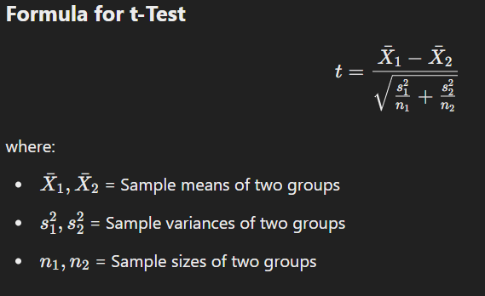

### ****Example: t-Test on Student Exam Scores****

A researcher wants to test whether two different teaching methods affect student performance.

* **Group A**: 10 students taught with **Method 1** (average score = 80).
* **Group B**: 10 students taught with **Method 2** (average score = 85).

Using a **t-test**, we can determine whether the **difference in scores is statistically significant** or just due to random variation.

## **2. Chi-Square Test**

### ****What is a Chi-Square Test?****

The **Chi-Square test** is used to determine whether there is a **significant association between two categorical variables**. It is useful for analyzing **survey data, medical studies, and market research**.

### ****Types of Chi-Square Tests****

### ****1. Chi-Square Test for Independence****

* Tests whether **two categorical variables** are related.
* Example: **Is there a relationship between gender and preference for a new product?**

### 

#### ****Example: Gender vs Product Preference****

A survey is conducted to check whether gender affects preference for a **new smartphone model**.

| **Gender** | **Likes Phone** | **Dislikes Phone** | **Total** |
| --- | --- | --- | --- |
| Male | 40 | 20 | 60 |
| Female | 50 | 10 | 60 |
| **Total** | **90** | **30** | **120** |

Using the **Chi-Square test**, we check whether the difference in preference is **statistically significant**.

### ****2. Chi-Square Goodness-of-Fit Test****

* Determines **whether observed categorical data matches expected data**.
* Example: **Do dice rolls match the expected fair distribution (1/6 probability for each face)?**

### ****Hypothesis Testing****

Hypothesis testing is a **statistical method** used to make decisions or inferences about a **population based on sample data**. It helps determine whether a claim about a population parameter (e.g., mean, proportion) is **statistically significant** or if it occurred by chance.

#### ****Steps in Hypothesis Testing****

1. **State the Null and Alternative Hypotheses**
   * **Null Hypothesis (H₀)**: Assumes no effect or no difference.
   * **Alternative Hypothesis (H₁ or Ha)**: Assumes a significant effect or difference.
2. **Select a Significance Level (α)**
   * Common values: **0.05 (5%) or 0.01 (1%)**.
   * If the probability of observing the data under H₀ is **less than α**, reject H₀.
3. **Choose the Appropriate Statistical Test**
   * **t-Test** (comparing means)
   * **Chi-Square Test** (categorical data relationships)
   * **ANOVA** (comparing multiple group means)
4. **Compute the Test Statistic and P-Value**
   * The **test statistic** measures the difference between sample data and H₀.
   * The **p-value** indicates the probability of obtaining the observed result under H₀.
5. **Make a Decision**
   * If **p-value ≤ α**, reject H₀ (evidence supports H₁).
   * If **p-value > α**, fail to reject H₀ (not enough evidence for H₁).

### ****Example: Hypothesis Testing in Exam Scores****

A researcher wants to test whether students who take a **training course** score higher than the national average of **850 points**.

#### ****Step 1: Define Hypotheses****

* **Null Hypothesis (H₀):** The average score of trained students = 850.
* **Alternative Hypothesis (H₁):** The average score of trained students **> 850**.

#### ****Step 2: Choose α-Level****

* Let **α = 0.05** (5% significance level).

#### ****Step 3: Perform a t-Test****

* Collect sample data of **n = 30 students** who took the course.
* Compute **mean and standard deviation** of their scores.

#### ****Step 4: Interpret Results****

* If the **p-value < 0.05**, we **reject H₀** and conclude that trained students **score significantly higher** than 850.
* If **p-value > 0.05**, we **fail to reject H₀**, meaning we **don’t have enough evidence** to support that trained students score higher.

### ****Bayes' Theorem****

#### ****Introduction****

Bayes' Theorem is a fundamental

Concept in probability theory and statistics. It describes how to update the probability of a hypothesis based on new evidence. It is widely used in machine learning, medical diagnosis, spam filtering, and decision-making under uncertainty.

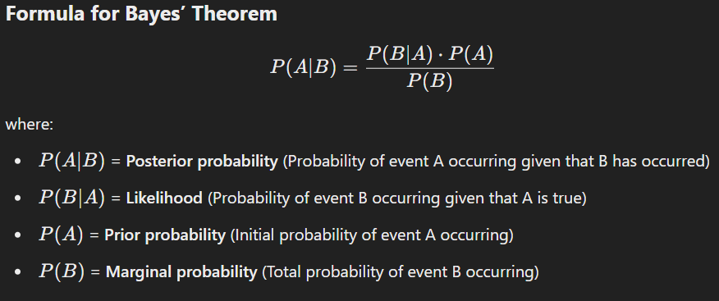

### ****Applications of Bayes' Theorem****

1. **Medical Diagnosis:** Predicts the probability of diseases based on test results.
2. **Spam Filtering:** Identifies spam emails based on word frequency patterns.
3. **Machine Learning:** Used in Bayesian classifiers and probabilistic models.
4. **Weather Prediction:** Updates forecasts based on new data.

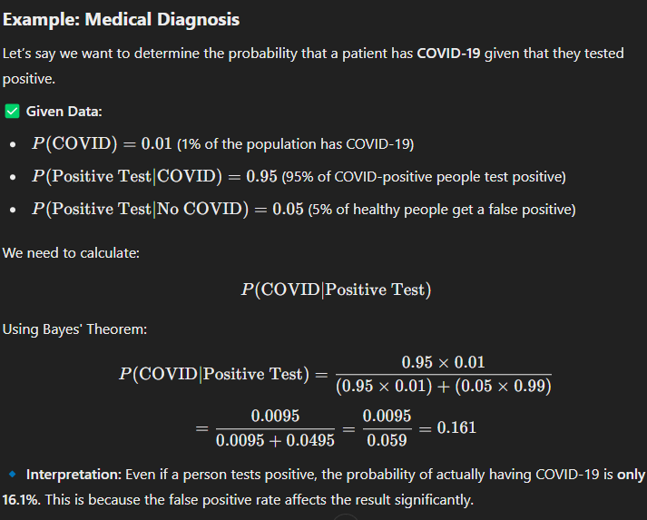

**Comment on the Statement: "Variance of the particular feature is zero."**

If the variance of a particular feature is **zero**, it means that **all the values in that feature (column) are the same** across all data points. This has important implications in data science and machine learning:

**Implications of Zero Variance:**

1. **No Information Gain**
   * A feature with zero variance **does not contribute any useful information** because all its values are identical.
   * Such a feature **cannot help in classification, regression, or clustering**.
2. **Redundant Feature**
   * Since all values are the same, this feature **does not help in distinguishing between data points**.
   * It is often **removed during feature selection** to avoid unnecessary computation.
3. **Effect on Machine Learning Models**
   * Many models, especially those relying on **distance-based calculations** (e.g., KNN, SVM, K-Means), are **affected by zero-variance features**.
   * Such features can **bias the model** and increase computation without improving performance.

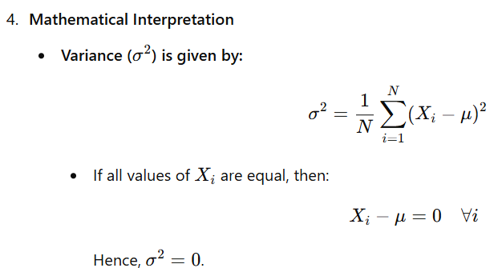

**Example:**

Consider a dataset with a feature Temperature:

| **ID** | **Temperature (°C)** |
| --- | --- |
| 1 | 30 |
| 2 | 30 |
| 3 | 30 |
| 4 | 30 |
| 5 | 30 |

* Since all values are **30**, the variance is **0**.
* This feature **does not provide any variability** and can be **dropped**.

## **Conventional Methods to Handle Missing Data**

Missing data is a common issue in datasets that can impact analysis and machine learning models. Here are four conventional methods to handle missing data:

### ****1. Deletion Methods****

#### ****(a) Listwise Deletion (Complete Case Analysis)****

* Removes entire rows where **any** value is missing.
* Useful when missing data is **random** and occurs in a **small percentage** of the dataset.

✅ **Example:**  
If a dataset has 1000 records and only **5% of them** have missing values, we can remove those rows.

🚫 **Drawback:**

* May lead to data loss if many records are removed.
* Not ideal for large-scale missing data.

#### ****(b) Pairwise Deletion****

* Uses **only available values** for each analysis.
* Keeps as much data as possible instead of removing entire rows.

✅ **Example:**  
In a correlation matrix, if a value is missing in one variable, calculations proceed with the available data.

🚫 **Drawback:**

* Results may vary depending on which data points are available.

### ****2. Mean, Median, or Mode Imputation****

* **Numerical data**: Replace missing values with the **mean** or **median** of the column.
* **Categorical data**: Replace missing values with the **mode** (most frequent value).

✅ **Example:**

| **ID** | **Age** | **Salary** | **Gender** |
| --- | --- | --- | --- |
| 1 | 25 | 50,000 | Male |
| 2 | 30 | 55,000 | Female |
| 3 | 28 | **NaN** | Male |
| 4 | 40 | 70,000 | **NaN** |

* **Mean Salary** = (50,000 + 55,000 + 70,000) / 3 = **58,333**
* **Mode Gender** = **Male**
* Fill missing values:
  + Salary → 58,333
  + Gender → Male

🚫 **Drawback:**

* Can **distort variance** in the data.
* May **reduce the effectiveness** of predictive models.

### ****3. Regression Imputation****

* Predicts missing values using regression models based on other available features.
* More **accurate than mean imputation**, as it considers relationships between variables.

✅ **Example:**  
If **salary** is missing, use a regression model based on **age, education, and job position** to predict the salary.

🚫 **Drawback:**

* Can introduce **bias** if the model is not well-trained.
* Assumes a **linear relationship** between variables.

### ****4. K-Nearest Neighbors (KNN) Imputation****

* Fills missing values based on the **nearest neighbors** in the dataset.
* More accurate as it considers similarities between data points.

✅ **Example:**  
If a person’s **age is missing**, KNN finds similar records (based on other features like income and education) and fills the missing value with the **average age of the nearest neighbors**.

🚫 **Drawback:**

* Computationally **expensive** for large datasets.
* Sensitive to the choice of **K (number of neighbors).**