**1. Basics and Need of Data Science**

**1.1 What is Data Science?**

Data Science is an interdisciplinary field that combines statistical analysis, machine learning, data engineering, and domain expertise to extract meaningful insights and knowledge from structured and unstructured data. It involves the use of scientific methods, algorithms, and systems to solve complex problems and make data-driven decisions.

**1.2 Why is Data Science Important?**

* **Decision Making:** Data Science enables organizations to make informed decisions by analyzing historical and real-time data.
* **Predictive Analytics:** It allows businesses to predict future trends and behaviors, helping them to stay ahead of the competition.
* **Automation:** Data Science can automate repetitive tasks, improving efficiency and reducing human error.
* **Personalization:** Companies can use Data Science to offer personalized experiences to customers, enhancing customer satisfaction and loyalty.
* **Innovation:** Data Science drives innovation by uncovering hidden patterns and insights that can lead to new products, services, and business models.

**2. Applications of Data Science**

**2.1 Healthcare**

* **Predictive Diagnostics:** Using machine learning models to predict diseases based on patient data.
* **Drug Discovery:** Accelerating the process of drug discovery by analyzing biological data.
* **Personalized Medicine:** Tailoring medical treatments to individual patients based on their genetic makeup.

**2.2 Finance**

* **Fraud Detection:** Identifying fraudulent transactions using anomaly detection algorithms.
* **Algorithmic Trading:** Using predictive models to make high-frequency trading decisions.
* **Risk Management:** Assessing and mitigating financial risks through data analysis.

**2.3 Retail**

* **Customer Segmentation:** Grouping customers based on purchasing behavior to target marketing efforts.
* **Inventory Management:** Optimizing inventory levels using demand forecasting models.
* **Recommendation Systems:** Suggesting products to customers based on their browsing and purchase history.

**2.4 Transportation**

* **Route Optimization:** Finding the most efficient routes for delivery and transportation.
* **Autonomous Vehicles:** Using sensor data and machine learning to enable self-driving cars.
* **Traffic Prediction:** Predicting traffic patterns to reduce congestion and improve urban planning.

**2.5 Social Media**

* **Sentiment Analysis:** Analyzing social media posts to gauge public opinion.
* **Content Recommendation:** Suggesting content to users based on their interests and behavior.
* **Network Analysis:** Understanding social networks and influence patterns.

**Relationship Between Data Science and Information Science**

Data Science and Information Science are two closely related fields that often overlap but have distinct focuses and methodologies. Understanding their relationship is crucial for appreciating how they complement each other in the broader context of data-driven decision-making and knowledge management.

**1. Definitions and Core Focus**

**1.1 Data Science**

* **Definition:** Data Science is an interdisciplinary field that uses scientific methods, algorithms, and systems to extract knowledge and insights from structured and unstructured data.
* **Core Focus:**
  + Analyzing data to uncover patterns, trends, and insights.
  + Building predictive models using machine learning and statistical techniques.
  + Solving complex problems through data-driven approaches.
  + Handling both structured (e.g., databases) and unstructured data (e.g., text, images, videos).

**1.2 Information Science**

* **Definition:** Information Science is the study of the collection, classification, manipulation, storage, retrieval, and dissemination of information.
* **Core Focus:**
  + Managing and organizing information for efficient retrieval and use.
  + Designing information systems (e.g., databases, libraries, archives).
  + Ensuring the accessibility, reliability, and usability of information.
  + Primarily deals with structured data and information systems.

**2. Key Similarities**

* **Data as a Central Resource:** Both fields rely on data as a primary resource for generating insights or managing information.
* **Interdisciplinary Nature:** Both fields draw from computer science, mathematics, statistics, and domain-specific knowledge.
* **Goal of Enhancing Decision-Making:** Both aim to improve decision-making processes, whether through insights derived from data (Data Science) or efficient information retrieval and management (Information Science).
* **Use of Technology:** Both fields leverage advanced technologies, such as databases, machine learning, and data visualization tools.

**3. Key Differences**

| **Aspect** | **Data Science** | **Information Science** |
| --- | --- | --- |
| **Primary Focus** | Extracting insights and knowledge from data. | Managing and organizing information for efficient retrieval and use. |
| **Data Types** | Structured and unstructured data (e.g., text, images, videos). | Primarily structured data (e.g., databases, documents). |
| **Techniques** | Machine learning, statistical modeling, predictive analytics, data visualization. | Information retrieval, database management, knowledge organization systems. |
| **Output** | Predictive models, actionable insights, and data-driven decisions. | Organized information systems, databases, and knowledge repositories. |
| **Time Orientation** | Forward-looking (predictive and prescriptive analytics). | Backward-looking (descriptive and historical information management). |

**4. How They Complement Each Other**

**4.1 Data Science Relies on Information Science**

* **Data Storage and Retrieval:** Data Science depends on Information Science for efficient data storage, retrieval, and management. Databases and information systems designed by Information Science professionals provide the infrastructure for Data Science workflows.
* **Data Organization:** Information Science ensures that data is well-organized, indexed, and accessible, which is critical for Data Science projects.
* **Metadata Management:** Information Science provides metadata (data about data), which helps Data Scientists understand the context and structure of datasets.

**4.2 Information Science Benefits from Data Science**

* **Advanced Analytics:** Data Science techniques, such as machine learning and natural language processing, can enhance information retrieval systems by enabling smarter search algorithms and personalized recommendations.
* **Unstructured Data Handling:** Information Science traditionally focuses on structured data, but Data Science techniques allow for the analysis and organization of unstructured data (e.g., text, images).
* **Insight Generation:** Data Science can uncover patterns and trends in large datasets, which can inform the design of better information systems.

**5. Real-World Examples of Their Relationship**

**5.1 Digital Libraries**

* **Information Science Role:** Designing the library's database system, cataloging resources, and ensuring efficient information retrieval.
* **Data Science Role:** Analyzing user behavior to recommend books, predicting trends in resource usage, and optimizing search algorithms.

**5.2 Healthcare Systems**

* **Information Science Role:** Managing electronic health records (EHRs) and ensuring secure, efficient access to patient data.
* **Data Science Role:** Analyzing patient data to predict disease outbreaks, personalize treatments, and improve healthcare outcomes.

**5.3 E-Commerce Platforms**

* **Information Science Role:** Organizing product catalogs, managing inventory databases, and ensuring smooth transaction processing.
* **Data Science Role:** Using customer data to build recommendation systems, predict sales trends, and optimize pricing strategies.

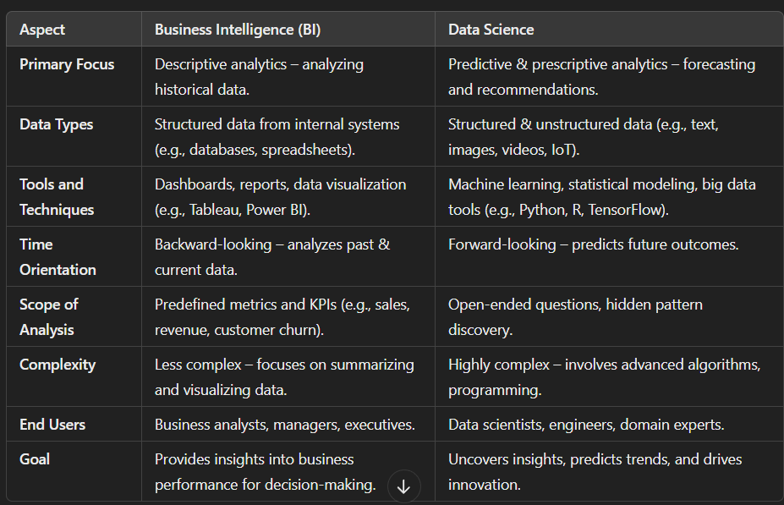

**Data: Data Types and Data Collection**

Data is the foundation of Data Science, Business Intelligence, and Information Science. Understanding the types of data and the methods of collecting it is crucial for effective analysis and decision-making. Below is a detailed explanation of **data types** and **data collection methods**.

**1. Data Types**

Data can be categorized into three main types based on its structure and format:

**1.1 Structured Data**

* **Definition:** Data that is organized in a predefined format, typically stored in relational databases or spreadsheets.
* **Characteristics:**
  + Organized in rows and columns (e.g., tables in SQL databases).
  + Easily searchable and analyzable using query languages like SQL.
  + Examples: Sales records, customer information, financial transactions.
* **Use Cases:**
  + Business reporting (e.g., sales dashboards).
  + Transactional systems (e.g., banking, e-commerce).

**1.2 Unstructured Data**

* **Definition:** Data that does not have a predefined structure or format.
* **Characteristics:**
  + Cannot be easily stored in traditional relational databases.
  + Requires advanced techniques for processing and analysis.
  + Examples: Text documents, emails, social media posts, images, videos, audio files.
* **Use Cases:**
  + Sentiment analysis (e.g., analyzing customer reviews).
  + Image recognition (e.g., facial recognition in photos).
  + Natural language processing (e.g., chatbots).

**1.3 Semi-Structured Data**

* **Definition:** Data that does not fit into a rigid structure but has some organizational properties.
* **Characteristics:**
  + Contains tags or markers to separate elements (e.g., JSON, XML).
  + More flexible than structured data but easier to process than unstructured data.
  + Examples: JSON files, XML files, NoSQL databases.
* **Use Cases:**
  + Web data (e.g., data from APIs).
  + Log files (e.g., server logs, application logs).

**2. Data Collection Methods**

Data collection is the process of gathering information from various sources for analysis. The method of collection depends on the type of data and the purpose of the analysis.

**2.1 Primary Data Collection**

* **Definition:** Data collected directly from original sources for a specific purpose.
* **Methods:**
  + **Surveys and Questionnaires:** Collecting data through structured questions (e.g., customer satisfaction surveys).
  + **Interviews:** Conducting one-on-one or group interviews to gather qualitative data.
  + **Experiments:** Conducting controlled experiments to test hypotheses (e.g., A/B testing in marketing).
  + **Observations:** Collecting data by observing behavior or events (e.g., tracking user interactions on a website).

**2.2 Secondary Data Collection**

* **Definition:** Data collected from existing sources that were originally gathered for another purpose.
* **Methods:**
  + **Public Databases:** Accessing data from government or public organizations (e.g., census data, weather data).
  + **Published Reports:** Using data from industry reports, research papers, or whitepapers.
  + **Web Scraping:** Extracting data from websites using automated tools (e.g., scraping product prices from e-commerce sites).
  + **APIs:** Retrieving data from third-party services via Application Programming Interfaces (e.g., Twitter API for social media data).

**2.3 Automated Data Collection**

* **Definition:** Data collected automatically using sensors, devices, or software.
* **Methods:**
  + **Sensors and IoT Devices:** Collecting real-time data from sensors (e.g., temperature sensors, fitness trackers).
  + **Transactional Systems:** Capturing data from business transactions (e.g., point-of-sale systems, online payment systems).
  + **Logs:** Recording events in systems or applications (e.g., server logs, application logs).

**2.4 Social Media Data Collection**

* **Definition:** Data collected from social media platforms.
* **Methods:**
  + **Social Media APIs:** Accessing data from platforms like Twitter, Facebook, or Instagram.
  + **Web Scraping:** Extracting public posts, comments, or reviews from social media sites.
  + **Sentiment Analysis Tools:** Analyzing user-generated content to gauge public opinion.

**2.5 Big Data Collection**

* **Definition:** Collecting large volumes of data from diverse sources.
* **Methods:**
  + **Data Lakes:** Storing raw, unstructured data in a centralized repository (e.g., Hadoop, AWS S3).
  + **Streaming Data:** Collecting real-time data streams (e.g., stock market data, IoT sensor data).
  + **Cloud Platforms:** Using cloud-based tools to collect and store data (e.g., Google BigQuery, Azure Data Lake).

**3. Importance of Data Collection**

* **Accuracy:** High-quality data collection ensures accurate and reliable analysis.
* **Completeness:** Collecting data from multiple sources provides a comprehensive view of the problem.
* **Relevance:** Data collection methods should align with the objectives of the analysis.
* **Timeliness:** Real-time or near-real-time data collection enables timely decision-making.

**4. Challenges in Data Collection**

* **Data Quality:** Ensuring the data is accurate, complete, and free from errors.
* **Data Privacy:** Complying with regulations (e.g., GDPR) when collecting personal data.
* **Data Volume:** Managing and storing large volumes of data efficiently.
* **Data Integration:** Combining data from diverse sources into a unified format.

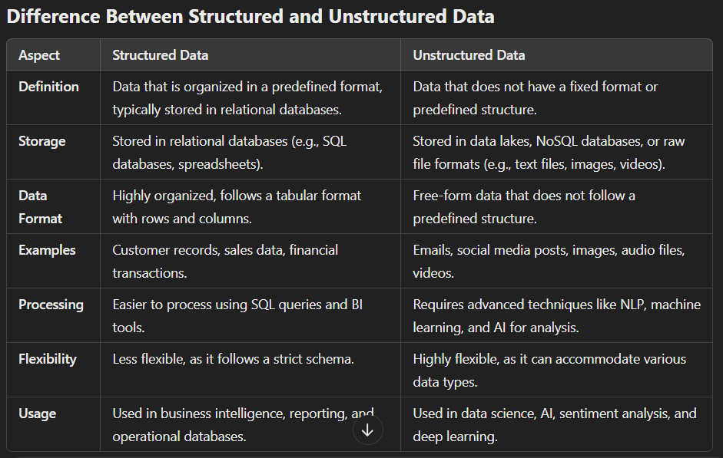**Need for Data Wrangling (Data Cleaning & Preparation) in Detail**

**What is Data Wrangling?**

Data wrangling is the process of cleaning, transforming, and organizing raw data into a structured format suitable for analysis. It ensures data quality, consistency, and usability for business intelligence (BI), machine learning (ML), and data science applications.

**Why is Data Wrangling Needed?**

**1️ Improves Data Quality & Accuracy**

* Raw data is often messy, containing errors, missing values, and inconsistencies.
* Cleaning data (removing duplicates, correcting errors) ensures accurate insights and reliable decision-making.

**2️⃣ Handles Missing & Inconsistent Data**

* Datasets often contain missing values (e.g., blank fields in surveys, unrecorded sales).
* Data wrangling helps impute missing values or remove incomplete records to prevent biased results.

**3️⃣ Eliminates Duplicates & Redundant Data**

* Duplicate records lead to incorrect calculations and misinterpretations.
* De-duplication ensures a single, accurate source of truth.

**4️⃣ Standardizes Data Formats & Units**

* Data comes from multiple sources in different formats (e.g., dates as DD/MM/YYYY vs. YYYY-MM-DD).
* Wrangling converts data into a uniform format, ensuring compatibility across systems.

**5️⃣ Enables Better Data Integration**

* Data from different sources (databases, APIs, spreadsheets) may have varied structures.
* Wrangling aligns different datasets into a common structure for seamless integration.

**6️⃣ Enhances Data Usability for Machine Learning & BI**

* Raw data is rarely ready for immediate use in ML models or BI dashboards.
* Data transformation (e.g., feature scaling, encoding categorical variables) is essential for model accuracy and meaningful analysis.

**7️⃣ Detects & Removes Outliers**

* Extreme values (outliers) can distort statistical analysis and ML predictions.
* Wrangling identifies and removes these anomalies or transforms them appropriately.

**8️⃣ Optimizes Data for Faster Processing**

* Large datasets may have unnecessary columns, increasing storage and processing time.
* Wrangling reduces data complexity, improving query performance and computational efficiency.

**Data Wrangling Methods: Detailed Explanation**

Data wrangling is the process of cleaning, transforming, and organizing raw data into a usable format for analysis. It is a critical step in the data science workflow, as raw data is often messy, incomplete, or inconsistent. Below is a **detailed explanation** of the five key data wrangling methods: **Data Cleaning, Data Integration, Data Reduction, Data Transformation, and Data Discretization**. Each method is explained with its **advantages, disadvantages, and examples** to help you write a detailed 5-mark answer.

**1. Data Cleaning**

**Definition:**

Data cleaning is the process of identifying and correcting errors, inconsistencies, and inaccuracies in a dataset. It ensures that the data is accurate, complete, and ready for analysis.

**Steps Involved:**

1. **Handling Missing Values:**
   * Fill missing values using mean, median, or mode.
   * Remove records with missing values if they are insignificant.
2. **Removing Duplicates:**
   * Identify and eliminate duplicate records to avoid redundancy.
3. **Correcting Errors:**
   * Fix typos, incorrect data entries, and inconsistencies (e.g., "New Yrok" → "New York").
4. **Standardizing Formats:**
   * Ensure consistent formats for dates, currencies, and other fields.

**Advantages:**

1. **Improved Data Quality:** Clean data is free from errors and inconsistencies, leading to more reliable analysis.
2. **Better Decision-Making:** Accurate data ensures that insights and decisions are based on correct information.
3. **Enhanced Efficiency:** Clean data reduces the time and effort required for analysis.

**Disadvantages:**

1. **Time-Consuming:** Cleaning large datasets can be labor-intensive and time-consuming.
2. **Subjectivity:** Deciding how to handle missing or inconsistent data can be subjective.
3. **Risk of Data Loss:** Incorrect cleaning methods may result in the loss of valuable information.

**Example:**

* A dataset contains customer information with missing age values. The missing values are filled using the average age of the dataset.
* Duplicate records in a sales dataset are identified and removed to ensure accurate analysis.

**2. Data Integration**

**Definition:**

Data integration combines data from multiple sources into a unified view, often stored in a data warehouse or data lake. It ensures that data from different systems can be analyzed together.

**Steps Involved:**

1. **Extract:** Collect data from various sources (e.g., databases, APIs, spreadsheets).
2. **Transform:** Convert data into a consistent format (e.g., standardizing date formats, currency units).
3. **Load:** Load the transformed data into a centralized repository (e.g., data warehouse).

**Advantages:**

1. **Unified View:** Provides a single source of truth by merging data from different systems.
2. **Enhanced Analysis:** Enables cross-functional analysis by combining diverse datasets.
3. **Improved Efficiency:** Reduces the need to switch between multiple systems for data access.

**Disadvantages:**

1. **Complexity:** Integrating data from disparate sources can be technically challenging.
2. **Data Quality Issues:** Inconsistent formats or standards across sources can lead to errors.
3. **Costly:** Requires significant resources for tools, infrastructure, and expertise.

**Example:**

* Combining sales data from an e-commerce platform with customer data from a CRM system to analyze customer purchasing behavior.
* Integrating weather data with transportation logs to study the impact of weather on delivery times.

**3. Data Reduction**

**Definition:**

Data reduction reduces the volume of data while maintaining its integrity and usefulness. It is often achieved through dimensionality reduction, sampling, or aggregation.

**Steps Involved:**

1. **Dimensionality Reduction:**
   * Reduce the number of features (variables) using techniques like Principal Component Analysis (PCA).
2. **Sampling:**
   * Select a subset of data for analysis instead of the entire dataset.
3. **Aggregation:**
   * Summarize data at a higher level (e.g., daily sales data aggregated to monthly sales).

**Advantages:**

1. **Efficiency:** Reduces storage and computational requirements.
2. **Faster Processing:** Smaller datasets are quicker to analyze.
3. **Improved Focus:** Eliminates irrelevant or redundant data, focusing on key variables.

**Disadvantages:**

1. **Loss of Detail:** Reducing data may result in the loss of important information.
2. **Complexity:** Choosing the right reduction technique requires expertise.
3. **Risk of Bias:** Improper sampling or reduction methods can introduce bias.

**Example:**

* Using PCA to reduce the number of features in a dataset from 50 to 10 while retaining 95% of the variance.
* Sampling 10% of a large dataset for preliminary analysis to save time and resources.

**4. Data Transformation**

**Definition:**

Data transformation converts data from one format or structure into another to make it suitable for analysis. It ensures that data is compatible with analytical tools and algorithms.

**Steps Involved:**

1. **Normalization:**
   * Scale numerical data to a standard range (e.g., 0 to 1).
2. **Encoding:**
   * Convert categorical data into numerical format using techniques like one-hot encoding or label encoding.
3. **Aggregation:**
   * Summarize data at a higher level (e.g., daily sales data aggregated to monthly sales).

**Advantages:**

1. **Standardization:** Ensures data is in a consistent format for analysis.
2. **Compatibility:** Makes data compatible with analytical tools and algorithms.
3. **Enhanced Insights:** Transformed data can reveal patterns that were not visible in the raw format.

**Disadvantages:**

1. **Complexity:** Transformation processes can be technically challenging.
2. **Time-Consuming:** Large datasets may require significant processing time.
3. **Risk of Errors:** Incorrect transformations can lead to inaccurate results.

**Example:**

* Normalizing numerical data to a range of 0 to 1 for machine learning models.
* Converting categorical data (e.g., "Male," "Female") into numerical format using one-hot encoding.

**5. Data Discretization**

**Definition:**

Data discretization converts continuous data into discrete intervals or bins, making it easier to analyze.

**Steps Involved:**

1. **Binning:**
   * Divide continuous data into a set of bins or intervals (e.g., age groups: 0-18, 19-35, 36-50, 51+).
2. **Clustering:**
   * Group similar data points into clusters and assign them to discrete categories.
3. **Histogram Analysis:**
   * Use histograms to identify natural breaks in the data for discretization.

**Advantages:**

1. **Simplification:** Reduces the complexity of continuous data.
2. **Improved Analysis:** Enables the use of categorical analysis techniques.
3. **Noise Reduction:** Minimizes the impact of minor fluctuations in data.

**Disadvantages:**

1. **Loss of Precision:** Discretization may result in the loss of detailed information.
2. **Subjectivity:** Choosing the right bin size or intervals can be subjective.
3. **Potential Bias:** Improper binning can introduce bias into the analysis.

**Example:**

* Grouping ages into categories (e.g., 0-18, 19-35, 36-50, 51+).
* Discretizing temperature data into ranges (e.g., low: 0-10°C, medium: 11-20°C, high: 21-30°C).