**Name: Purushottam Mahajan**

**Roll No: TE A 74.**

**Seminar Title: Lane Detection Using Artificial Intelligence.**

**Abstract:**

Lane discovery plays a crucial part in erecting I ntelligent business system. How to ameliorate the delicacy of lane recognition and the capability of wind discovery has always been the focus of exploration. Aiming at the discovery of unheroic and white lane lines and angles in complex surroundings, this paper introduces a new lane line discovery system grounded on machine vision, which combines the unheroic lane line reused in HSV space with the white lane line reused in grayscale space. Through canny edge discovery, inverse perspective metamorphosis and sliding window polynomial befitting system to achieve real- time lane discovery. The trial shows that the algorithm can directly descry the wind and the lane line under the light changing circumstances, and can calculate the vehicle's divagation distance according to the lane line discovery results. At the same time, the algorithm shows good trustability and robustness under multiple working conditions. The Concern regarding the nature of accidents has grown as the frequence of business incidents has increased. It happens constantly as a result of mortal mistake. In order to help motorists, lane discovery systems are presently being created with the primary end of relating lanes and advising motorists about implicit lane departures. There are multiple ways for detecting lanes, with numerous fastening on straight lanes. This paper's main thing is to examine the downsides of colorful lane detecting algorithms and suggest a result that does down with them. This work uses artificial intelligence to fete lanes using OpenCV, NumPy, and digital image processing( noise junking, edge discovery, and Hough metamorphosis).

**Objective:**

The ideal of this work is to develop a dependable lane discovery system using machine vision and artificial intelligence that can directly descry both unheroic and white lane lines, including angles, in complex surroundings. By combining HSV and grayscale processing, edge discovery, and polynomial befitting, the system aims to enhance lane recognition delicacy and help motorists in safe lane changes. The system will also calculate vehicle divagation from lanes to help reduce accidents caused by indecorous lane departures.

**Motivation:**

As the number of increasing accidents, many of those happen due to changing lanes in wrong way. This can lead to many loss of lives. To prevent this from happening, smart lane detector can be installed in vehicles which will help them to change lanes in more efficient way.

**Flow Diagram/Architecture:**

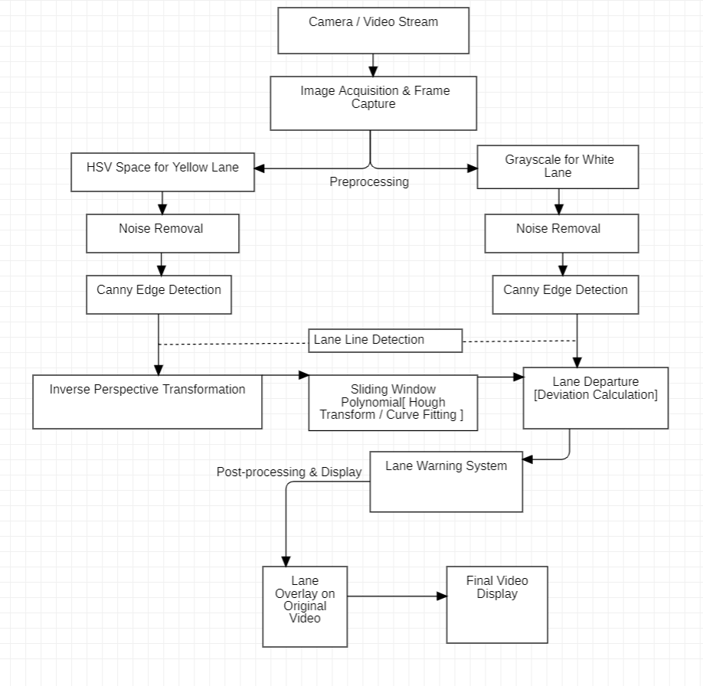

**1. Camera / Video Stream**

* The system starts with a real-time video feed or image frames from a camera mounted on the vehicle. This serves as the input to the lane detection system.

**2. Image Acquisition & Frame Capture**

* Each frame from the video stream is captured for further processing.

**3. Pre-processing**

* **Yellow Lane Detection:**
  + **HSV Space for Yellow Lane**: The system uses the HSV (Hue, Saturation, Value) color space to better differentiate yellow lane markings from the rest of the road.
* **White Lane Detection:**
  + **Grayscale for White Lane**: The system converts the image to grayscale to simplify the detection of white lane markings.
* **Noise Removal**: Similar to the yellow lane detection process, noise is removed to improve accuracy.
* **Canny Edge Detection**: The system applies edge detection to highlight the white lane lines.

**4. Lane Line Detection**

* After pre-processing, the system works to detect lane lines. This step uses:
  + **Sliding Window**: A method where windows are placed across the image to locate the lane lines.
  + **Polynomial Fitting / Hough Transform / Curve Fitting**: These are mathematical techniques used to fit a curve or line to the detected lane markings, helping to ensure the lines are smooth and continuous.

**5. Inverse Perspective Transformation**

* The transformation makes the lane lines appear straight, helping the system to better predict the road’s path.

**6. Lane Departure & Deviation Calculation**

* The system calculates the vehicle's position relative to the detected lane lines. If it detects that the vehicle is deviating from the centre of the lane, it flags a potential lane departure.

**7. Lane Warning System**

* Based on the deviation from the lane, the system may trigger warnings to alert the driver of an impending lane departure or suggest corrective action to maintain the vehicle’s position within the lane.

**8. Post-processing & Display**

The detected lane lines are overlaid on the original video stream, providing a visual guide to the driver or system.

**Conclusion:**

This paper presents a robust lane detection algorithm that effectively identifies lanes, including curves, in real-time under varying lighting conditions. By integrating machine vision techniques such as edge detection, inverse perspective transformation, and sliding window polynomial fitting, the system ensures reliable and accurate lane detection.