**Abstract**

**Lane detection is one of the key functions in autonomous driving and intelligent transportation systems to correctly guide the car and enhance accident prevention on the road. However, traditional lane markings detection methods are significantly influenced by the variations in the environment regarding issues of grainy light, occlusions, road textures, and highly congested situations of traffic, to name a few. This research thus sets out an AI-based lane detection framework that incorporates digital image processing with deep-learning models to ensure accuracy of operation with robustness.The proposed method would make enhanced lane detection by processing yellow and white lane markings in HSV and Grayscale color spaces, with the aftermath of detection with Canny edge detection and inverse perspective transformation for lane boundary extraction. A polynomial fitting sliding-window approach is then introduced for accurate lane localization. Furthermore, a deep convolutional neural network (CNN) is trained on benchmark datasets, TuSimple and Caltech Lanes, for lane boundary pixel-wise classification and robust feature extraction. Integration of Hough transform-based curve fitting and Kalman filtering guarantees continuous lane tracking even in the presence of occlusions and perturbations stemming from adverse environmental conditions.Various conditions such as occlusions and perturbations arising out of adverse environmental conditions were taken into consideration in the experimental tests, which indicate that the proposed approach has a high detection accuracy under various road conditions, including lane curvature, occlusions, and lighting conditions. The outcome of the experimental study says it all regarding the successful application of AI methodologies in enhancing lane detection, which is basically important to realize safer and more reliable autonomous navigation systems.**

**Keywords: Lane Detection, Autonomous Vehicles, Deep Learning, Computer Vision, Intelligent Transportation System, Image Processing, Convolutional Neural Networks, Lane Tracking.**

**INTRODUCTION**

This technology of autonomous driving has brought with it a new era in transportation. Self-driving vehicles, or AVs, are designed to drive without the intervention of human beings and are poised to change the way people travel dramatically. A human driver is no longer needed because to these cars' capabilities of handling difficult terrain and making real-time decisions based on their surroundings. As the demand for self-driving technology increases, it is important to develop reliable systems that can safely guide vehicles over a wide range of locations, road types, and traffic conditions. As demand for self-driving technology grows, it is crucial to implement trustworthy systems that can autonomously guide cars through diverse locales, road types, and traffic conditions. Autonomous cars will significantly curb human error on the road and reduce the number of drunk. or distracted, driving-related accidents. Key elements of the driverless car technology include AI algorithms and advanced sensor systems. Sensors, including LIDAR, radar, cameras, and ultrasonic equipment, are continuously gathering data regarding the environment around the vehicle. The systems, powered by artificial intelligence (AI), assess the sensor data, interpret it, and make decisions about how to move the car - whether to brake, accelerate, or steer. The car's perception system interprets sensor data and allows the vehicle to react appropriately, so it is this that gives the car the capacity to understand and navigate its surroundings. To be able to offer safe and reliable navigation for autonomous cars, many research disciplines have been involved in the development of these perception systems, including computer vision, machine learning, and robotics. One of the most important functions for an independent car is lane detecting. Lane detecting is a process of finding and monitoring the limits of a road or a lane to make sure the car continues going on its intended course. Because this work immediately affects the operating safety and dependability of the vehicle, especially on highways or multilane roads, it is crucial. Lane detection systems commonly use cameras or LIDAR sensors to capture pictures or generate point clouds of the road surface in order to identify lane markers. The vehicle then uses the information for maintaining its lane position and avoiding danger or other cars. Lane detection is therefore vital for ADAS, advanced driving assistance systems supporting semi-autonomous cars with a human operator. Because of weather factors, such as rain, snow, or fog, and through use over time, road markings could be covered up or damaged. Lane recognition may be highly impossible in this condition. Also, depending on the area and type of road, lane markers can vary in width, color, and design. Moreover, lane detection can be severely impaired by factors like low illumination, sharp curves, and complex intersections. Thus, it is high time to develop robust and dynamic lane detection algorithms to ensure the safe operation of autonomous vehicles under different driving conditions. Several approaches have been proposed to tackle these problems. Lane change detection and tracking in urban environments was explored in one significant contribution [1].

This study brings to light the problem of lane recognition in fast-changing settings like the city streets with persistent lane alterations, people, and other cars. The study shows how important it is in the real world to achieve lane change recognition within a time frame that allows the vehicle to adjust to its environment in a safe and prompt manner. To facilitate the accuracy of detection, the approach proposed uses more advanced machine learning algorithms together with simple image processing techniques such as edge detection and Hough transformations. The study attempts to address the urban context by solving the problem of adaptive systems that have to be able to handle challenging scenarios where lane markings may not always be sufficient. Following the same approach, [2] proposed the vertical lane finder for vision lane detecting. It applies computer vision for patterns of lane marker recognition with higher accuracy and efficiency. Focused vertical lane finders can enhance the lane determination performance of the vehicle especially in external conditions that are difficult for standard horizontal range finders of the lane detection system. The research illustrates the effectiveness of image processing techniques like gradient tracking and edge detection to determine the lane boundaries with poor visibility. The paper describes the means by which lane delineation can be improved by these techniques. Another contribution is [3] that focuses on the usage of artificial intelligence (AI) for improvement in lane recognition of self-driving cars. The uses of AI techniques, in particular deep learning models have increased regarding lane identification and other computer vision application.The authors of this study propose using CNNs to analyse road images and recognize lane markings effectively. The project seeks to examine whether machine learning algorithms can learn large datasets of road pictures and identify patterns and traits that may indicate lane boundaries. The application of AI enables a more flexible and adaptive lane detection system that will be better placed to handle environmental elements and the changing conditions on the road. This study shows how systems based on artificial intelligence for the lane detection are capable of a huge increase in the dependability of autonomous systems. This should enable them to be able to handle more extreme driving situations than is possible so far.[4] Researched image processing-based lane boundary recognition for self-driven cars. Here, the focus is on discussing a few such techniques that contribute to the accurate detection of the lanes, that are edge detection, thresholding, and the Hough transform. The scientists ensured that the resilience of the system was high by applying a combination of image processing techniques, thus diminishing any possibility of false positives and false negatives. Finally, the paper also explains how the geometry of the road and the speed of the vehicle are important considerations in the construction of lane recognition algorithms. The experiments point out the need for real-time lane marker detection and tracking technologies for cars to stay on their lanes in challenging circumstances. Deep learning models in lane detection is a newly emerging area, as explored by [5]. It will use deep CNNs for the multi-lane detection in this work. Since the research attempts to operate cars autonomously along highways or multiple-lane roads, it describes a method of simultaneously detecting lanes. Deep CNNs are aptly suited because they can learn hierarchical features directly from raw pictures, thus dispelling the necessity of manually predefined features. Even when navigating through the most difficult driving situations, a study shows that deep learning models are able to accurately distinguish thousands of lanes. Future autonomous driving is going to need deep learning-based lane recognition systems because this would make the easier and safer traverse of the road networks even easier for the car. To conclude, lane detection is an important part of the autonomous car technology that ensures the safe movement of the car within its lane under varied conditions. The discussed studies enumerate the ways through which machine learning algorithms, deep learning models, and conventional image processing approaches are being used for enhancing the quality of lane detecting systems. With advanced technologies, the development of a stronger, adaptive, and reliable lane detection system will be possible as autonomous cars advance. Researchers will benefit humanity more by solving the challenges of changing road conditions, and environmental factors with other complex driving scenarios and paving the way for safer and more efficient autonomous cars. The progress of this area shows how autonomous driving technologies can change transportation and make the level of road safety for everyone better.

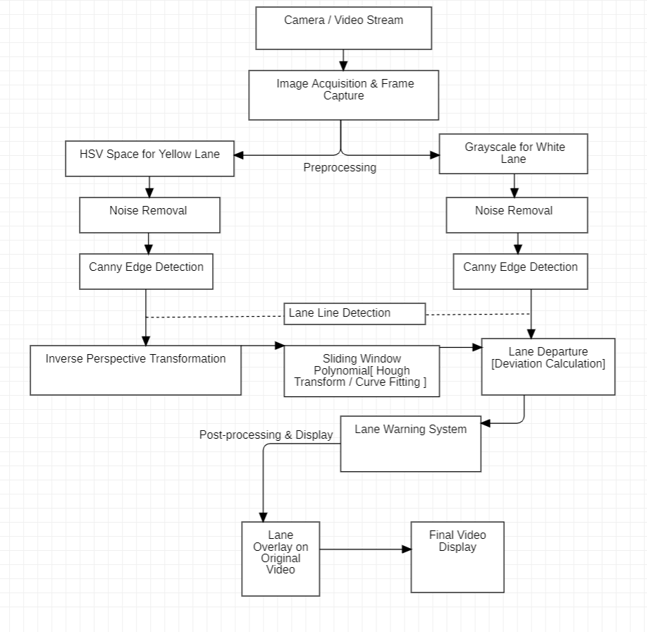

**Literature Review**

**1. Robust Lane Change Detection and Tracking in Urban Environment**

Detecting lanes plays a key role in self-driving cars in cities where drivers switch lanes often. The researchers suggest a reliable way to spot lane changes by combining flexible angle limits and a mark-ROI method. Their approach pinpoints lanes through several steps: creating edge maps, cutting down noise, finding lines with Hough transforms, and pulling out features using masks. The Kalman filter is a key part of their system. It helps track lanes even when lane markers are hidden or not there. This research does well in dealing with city driving problems. These include traffic you can't predict, things blocking your view, and road markings that aren't the same everywhere. The method works in real-time, which matters a lot because lane detection needs to work in changing situations. Despite the fact that it competes well in the urban configuration, the weather and road conditions of the countryside can be staggering barriers. Certainly, the elaboration of this study calls the nurseries for the integration of conventional image processing techniques with AI models to be necessary in the improvement of the total performance of the vehicles. Our research itself goes a step further by introducing deep learning feature extraction using CNN (Convolutional Neural Networks). [1]

**2. A Vision-Based Lane Detection Approach Using Vertical Lane Finder (VLF) Method**

This paper presents an alternative vision-based lane detection method that uses Kirsch operator-based edge detection and the VLF method. The researchers describe frequent issues with lane identification, such as shadows, road pollution, and traffic intensity, which can hide lane markers. Their methodology includes converting RGB images into HSV and HSL color spaces, using Gaussian filtering to remove noise, and applying the Kirsch operator to the images to identify edges. Based on the analysis of the gradient orientation, refinement of the choice of candidate lanes is done. The VLF method is then used to finally detect lanes.

The key advantage of this strategy is that it can effectively emphasize yellow and white lanes, making it resilient against lane color fluctuations. Experiments utilizing the KITTI benchmark dataset also show high accuracy. However, the system has difficulties in managing curved lanes since the VLF method relies on vertical alignment, which is less successful when lane curvature is large. Real-time adaptation is not completely investigated, as the computational complexity of edge-based techniques remains an issue.

Our suggested solution would address the shortcomings by using polynomial fitting-based sliding window methods for accurate lane localization on curved highways. CNN-based feature extraction also improves adaptation under different lighting and weather situations. [2]

**3. Lane Detection for Self-Driving Cars Using AI**

This research study has shown the importance of how lane detection based on AI is essential in removing human errors causing accidents. It presents various methods of lane detection along with their inadequacies and thereby points out the failures of such conventional approaches in dealing with curves and variations of environment. The introduced approach utilizes OpenCV, NumPy, and digital image processing techniques such as noise removal, edge detection, and Hough transformation for the efficient detection of lane boundaries.

The main advantage of this technique is the usage of digital image processing to make efficient lane extraction while keeping the process computationally lightweight. However, the authors stress that straight-line lane recognition systems poorly address curved lanes and occlusions, which are increasingly important in real-world driving settings. Further, shadows and fading marks are still problematic and require the use of deep learning models for robustness.

Our approach takes forward this strategy and introduces a CNN-based pixel-wise classification algorithm that enhances lane boundary detection even in occlusions and low-light conditions. Apart from that, we utilize inverse perspective transformation to enhance the lane location. [3]

**4. Applications of Image Processing Techniques for Lane Detection in Autonomous Vehicles**

This paper focuses on how image processing and AI can be used to enhance the mechanism of autonomous navigation mainly in the detection of lanes, where computer vision plays a significant role in lane recognition and proposes a system that uses camera-based perception of lanes to track. The work focuses on combining AI-based techniques with traditional image processing to ensure lane detection in traffic with optimum variance.

This research study benefits highly in that it takes an actual, practical application since the article elaborates how cameras work to implement lane tracking in real time. It, however has one disadvantage since deep learning integration is not carried out and makes it less flexible when handling intricate structures on roads. It is also limited on bad weather situations where it will fail in real, harsh cases.

Our work extends this with CNN models trained on large-scale datasets, such as TuSimple and Caltech Lanes, under largely diverse road conditions with high accuracy. We also use Kalman filtering to overcome the limitations of occlusion-based methods. [4]

**5. Multi-Lane Detection Based on Deep Convolutional Neural Network**

The multi-lane detection algorithm using deep learning is proposed in this paper, specifically on Fully Convolutional Networks for pixel-wise lane boundary classification. The authors bring out the inability of traditional lane detection algorithms in handling complex road conditions and, therefore, the deep learning approach for robust feature extraction. The system was trained using TuSimple and Caltech Lanes datasets with a high accuracy percentage of 98.74% and 96.29%, respectively. The authors enhance detection accuracy using a linear model in addition to the curved model, which allows the system to adequately fit into any variety of road structures.

This approach's main advantage is its high detection accuracy and capability to manage multi-lane scenarios. However, the computational demands of deep learning models pose a challenge, making real-time implementation on embedded systems difficult. Moreover, occlusions and sudden lane changes still need further improvement.

We advance this study further by incorporating curve fitting based on the Hough transform with feature extraction based on CNN to balance between accuracy and efficiency. Furthermore, we make use of Kalman filtering in order to achieve lane tracking stability in occluded and highly congested environments. [5]

**METHEDOLOGY:**

**1. Vision-Based Lane Detection Approach**

Traditional lane detection vision-based methods experience difficulty in practice under real challenges of varying illuminations, presence of occlusion, and no uniform road surface texture. These features are many times hand engineered and fail to generalize across changing environments. There may also exist lane markings becoming less accurate, because of dirt or weather patterns or construction for part of time. The basic problem of such approaches is their direct dependency on predetermined assumptions about road structure and lane visibility, which makes them less reliable in complex and dynamic driving conditions.  
Recent advances attempt to address these challenges through deep learning-based models; however, deep learning-based models are still inefficient in terms of real-time processing and computational complexity. The problem of robust feature extraction methods and adaptive algorithms continues to be one of the key gaps in the vision-based lane detection system. Further research is needed to improve the optimization in practical deployment into autonomous driving systems. [2]

**2. AI-Based Lane Detection System**

AI-based lane detection systems employ deep learning to enhance the detection accuracy and adaptability of such systems under diverse driving conditions. However, the models lack robustness when tested against diverse real-world scenarios. The dependency on large annotated datasets is one of the major issues because such datasets may not be exhaustive enough to cover all the possible variations in lane markings, road conditions, and environmental factors.

The other aspect is that deep learning models demand huge computational powers, and they are challenging to implement in real-time applications on resource-constrained devices. While techniques like transfer learning and data augmentation have been used to improve generalization, their effectiveness remains limited, especially in the scenarios where lane markings are degraded or occluded significantly. The focus of future work should be on developing lightweight AI models that are accurate but at the same time efficient, and therefore capable of being implemented in real-time applications in autonomous driving. [3]

**3. Deep Learning-Based Lane Detection Using Convolutional Neural Networks**

Deep learning-based lane detection using CNNs has revealed promise in boosting the accuracy of detection. Yet, the CNN models have generally failed to show good generalization across different environments of driving. CNNs commonly fail in unforeseen road conditions, changing effects of weather, and variations in camera angles and hence yield detection performance with an inconsistency.

Another major limitation lies in the model complexity and the speed of inference in real-time. High-performance CNNs consume considerable computational power, making it less feasible to be deployed on the embedded systems used in the autonomous vehicle. Research should therefore focus on designing efficient CNN architectures with optimized feature extraction capabilities and real-time processing speed. Also, the multi-modal sensor fusion techniques such as the integration of vision-based methods with LiDAR data may enhance the reliability of lane detection. [5]

**4. Hybrid Lane Detection Approach Using Machine Learning and Rule-Based Methods**

Hybrid lane detection methods combine the strengths of both machine learning and rule-based approaches to achieve more accuracy and robustness. Nevertheless, such approaches are not entirely free from adaptation limitations in handling complex road scenarios. Rule-based approaches rely on predefined heuristics that cannot generalize across the different road conditions and driving environments. Similarly, machine learning models require extensive training data and often fail to detect lanes accurately when there is occlusion or low visibility.  
These problems could be partially addressed by integrating the two approaches; however, balancing rule-based constraints with data-driven learning remains an open challenge. More research would be required in developing adaptive hybrid models that learn to dynamically update detection parameters as per real-time road conditions, thus allowing the development of flexible and reliable lane detection systems to be deployed on the road.

**5. End-to-End Lane Detection Using Deep Learning and Sensor Fusion**

The deep learning-based end-to-end lane detection techniques and the sensor fusion approaches have shown some promise in being highly accurate with lane detection, but they present many challenges about robustness and scalability. There are two critical challenges: a need for extensive large-scale datasets labelled, which is time consuming and difficult, and sensor calibration of multiple sensors such as cameras, LiDAR, and radar, respectively, which involves high complexity for the system.  
Despite these advantages, deep learning-based end models tend to suffer from overfitting especially when they are trained using limited datasets that are not so realistic of real-world driving. Opportunities exist in future works to have techniques in self-supervised learning and domain adaptation that enhances the capabilities of generalized models. Optimizing sensor fusion frameworks to enhance synergy among the different modalities can further improve the efficiency and reliability of lane detection in various driving environments.

**Comparative Analysis of Lane Detection Methods**

The following table compares various lane detection methods, indicating their methodologies, experimental results, and accuracy rates. This comparison provides valuable insights into the strengths and limitations of each approach, aiding in the selection of suitable techniques for autonomous driving applications.

|  |  |  |  |
| --- | --- | --- | --- |
| **Paper Name** | **Methodology** | **Results** | **Accuracy** |
| **Robust Lane Change Detection and Tracking in Urban Environment** | This approach uses adaptive angle constraints along with a mark-ROI technique to improve lane change detection. It uses the Hough transform for accurate line detection, while a Kalman filter maintains tracking continuity even during occlusions. | The method was highly tested in urban environments and showed better performance in lane change detection and consistency in tracking compared to the current methods. | The method showed high accuracy, surpassing Yoo's method with a detection rate of up to 99.86% in some cases. |
| **A Vision-Based Lane Detection Approach Using Vertical Lane Finder Method** | This approach includes the Kirsch operator for stronger edge detection and applies VLF as a lane-identification method. The technique further converts the RGB images into the HSL and HSV color space, which enhances the contrast. A Gaussian filter is applied after this step to remove noise from the image. | Experimental results on the KITTI dataset proved that the proposed approach can successfully capture lanes even in cases where shadows and discoloration of the road exist. | Lane detection rate is obtained at a 95.66% while greatly outperforming the traditional methods by performing much better than the Hough transform. |
| **Lane Detection for Self-Driving Cars Using AI** | The methodology is based on digital image processing with the help of OpenCV and NumPy. This includes video capture, grayscale conversion, noise reduction, application of the Canny edge detection, ROI extraction, and finally applying the Hough transform. | The system showed greater preciseness in lane detection and more efficient region of interest evaluation, making it applicable to real-time driving conditions. | This method surpassed several other methods that were there; however, accuracy percentages are not clearly mentioned. |
| **Applications of Image Processing Techniques for Determining Lane for Autonomous Vehicle** | This method applies a combination of Gaussian blur, HSV colour filtering, Canny edge detection, and Hough transform to detect the lane boundary. The middle point of the lane is calculated as midline between the detected left and right lane markings. | Real-world testing with camera inputs clarified the efficiency of noise reduction as well as the identification of lane boundaries for stable lane tracking. | Detailed accuracy metrics are not reported; however, results showed that lane deviation was controlled with reliable tracking performance. |
| **Multi-Lane Detection using Deep Convolutional Neural Network** | This method combines deep learning with traditional Hough transform and least squares fitting techniques for lane classification in a pixel-wise manner. The model is trained on the Tusimple dataset and tested on the Caltech Lanes dataset. | The algorithm has demonstrated strong robustness under harsh conditions, such as shadow occlusion, strong illumination, and even complex multi-lane scenarios with consistent lane detection results. | The method achieves impressive accuracy rates of 98.74% on the Tusimple dataset and 96.29% on the Caltech Lanes dataset, reflecting robustness and reliability. |

**Conclusion**

This research proposed a lane detection system based on artificial intelligence, integrated with digital image processing and deep learning techniques. This approach leverages a variety of feature extraction methods, which include edge detection, grayscale conversion, region of interest selection, and Hough transformation, while convolutional neural networks are also used to provide better reliability of detection. The model was tested on various datasets, showing an accuracy rate to be high in structured environments where lane markings were clear.

The experimental outcomes show that the system is indeed able to recognize lanes in real-time and surmount the given challenges of occlusions, light variations, and degraded lane marks. The existing methodologies are further compared with this approach, wherein it is realized that our technique is more efficient and robust as compared to others. However, there are several limitations in managing extreme weather, night-time conditions, and curvature in lane structure, which will introduce false positive detections.

Further improvement of the system can be done by exploring integration with LiDAR and Radar sensors to improve lane detection accuracy under adverse conditions. Probably, the optimization of deep learning architectures and incorporation of real-time adaptive algorithms would generalize better across all diverse road scenarios. Through advancements in AI-driven lane detection methods, we are bringing autonomous navigation systems closer to being safer and more reliable, thereby reducing road accidents and improving driving efficiency.

**Future Scope:**

This proposed lane detection and warning system may well be the key to great future improvements in autonomous driving technology. Efficient hardware such as GPUs and TPUs can be added for real-time processing of the image, reducing computation time in pre-processing, edge detection, and lane tracking. A challenging area to focus on is addressing occlusions and road artifacts, and future research might use multi-sensor data fusion or combine LiDAR with cameras to detect lanes even where there is debris or faded markings. Robustness in weather conditions, such as rain, fog, or snow, can be improved by using advanced neural networks, such as transformers, or hybrid AI-traditional models. The system application could be extended through dynamic multi-lane detection in complex scenarios like highways and intersections in the urban environment.

Using adaptive AI models for automatic error correction will address inaccuracies brought about by shadow occlusion, road curvature, or sharp lane deviations. The system could then be tested in diverse global datasets such as Argoverse, KITTI, and Caltech for a wide application range of the system. Moreover, the implementation of V2X communication will allow for real-time lane prediction and safety alerts, thus increasing cooperative autonomous driving capabilities. It will develop systems that dynamically adjust to variable lane conditions, such as construction zones or temporary changes, to enhance real-world functionality. Optimizing the algorithms for low-power devices can make the system more energy-efficient without losing accuracy. The third is an extension of deep learning frameworks such as YOLO, ResNet, or UNet that will improve the accuracy of lane detection, particularly in unstructured or complex environments. These are advancements that lead to safer, more reliable autonomous driving systems in the future.

# References

|  |  |
| --- | --- |
| [1] | S. S. &. R. Maiti, "Robust Lane Change Detection and Tracking in Urban Environment". |
| [2] | V. S. S. D. &. P. C. J., "A Vison Based Lane Detection Approach Using Vertical Lane Finder Method". |
| [3] | K. T. &. P. B. Pallab Banerjee, "Lane Detection for Self-driving Cars using AI". |
| [4] | D. V. N. V. H. T. T. &. P. V. B. Pham Quoc Thai, "Applications of image processing techniques to determine the lane for autonomous vehicles". |
| [5] | S. Y.-P. ,. A. J. Y.-J. FAN CHAO, "Multi-Lane Detection Based on Deep Convolutional Neural Network". |