**MLU1**

**1. What is Machine Learning? (10 Marks)**

Machine Learning (ML) is a branch of Artificial Intelligence (AI) that allows computers to **learn from data** and improve their performance on a task **without being explicitly programmed**.

* Traditional programming involves writing code with specific instructions to perform a task.
* In contrast, machine learning relies on feeding **large datasets** to **mathematical algorithms** that identify patterns and make decisions.
* The model generalizes from the training data and can make predictions or classifications on new, unseen data.

**Types of Machine Learning:**

1. **Supervised Learning** – The model learns from labelled data.  
   *Example*: Predicting house prices from historical price data.
2. **Unsupervised Learning** – The model identifies patterns in data without labels.  
   *Example*: Customer segmentation based on behavior.
3. **Reinforcement Learning** – The model learns through trial-and-error interactions with an environment.  
   *Example*: Game-playing agents like AlphaGo.

**Key Components:**

* **Data** – Foundation for learning.
* **Features** – Relevant variables in the dataset.
* **Algorithms** – Mathematical models like Decision Trees, SVM, Neural Networks.
* **Model** – The trained system that makes predictions.

**Goal:**

To **minimize error** and **maximize accuracy** when predicting outcomes.

**2. Real-life Applications of Machine Learning (10 Marks)**

**A. Healthcare**

* **Diagnosis**: ML models detect diseases like cancer or heart conditions from X-rays, MRIs, or symptoms.
* **Personalized Medicine**: Tailors treatments based on genetic data.
* **Predictive Analysis**: Forecasts outbreaks or patient deterioration.

**B. Finance**

* **Fraud Detection**: Detects unusual transactions or hacking patterns.
* **Algorithmic Trading**: ML helps make stock predictions and trades.
* **Credit Risk Assessment**: Lends money based on risk models trained on customer data.

**C. E-Commerce**

* **Recommendation Engines**: Suggest products based on user behavior (Amazon, Netflix).
* **Churn Prediction**: Predicts if a customer is likely to leave.
* **Dynamic Pricing**: Sets prices based on demand, season, competition.

**D. Transportation**

* **Autonomous Vehicles**: ML processes sensor and vision data for lane detection, pedestrian identification, etc.
* **Route Optimization**: Apps like Uber or Google Maps predict traffic and suggest best routes.

**E. Agriculture**

* **Disease Detection**: Uses images of crops to identify diseases.
* **Yield Estimation**: ML models predict how much crop a farmer will produce.

**F. Daily Use Cases**

* **Spam Filters**
* **Face Unlock**
* **Voice Assistants**
* **OCR (Optical Character Recognition)**

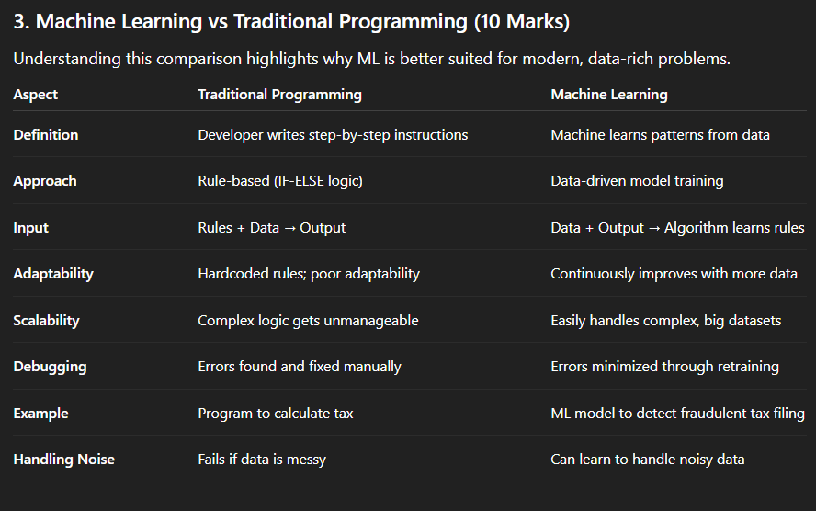

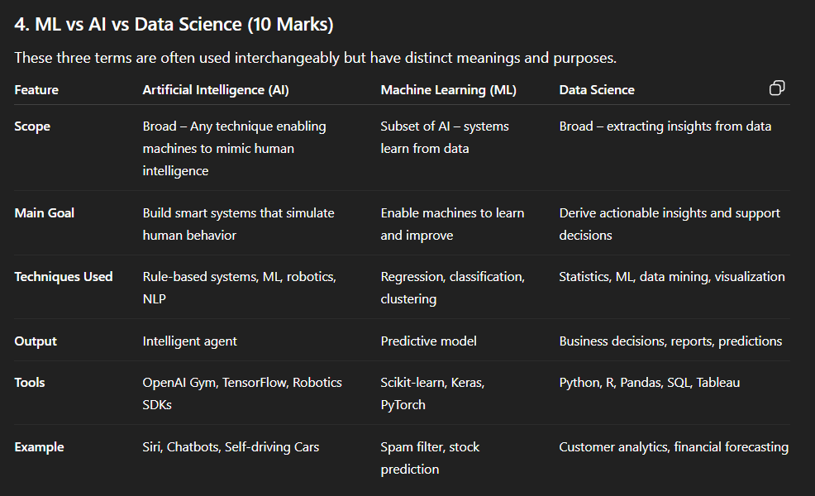

**Learning Paradigms in Machine Learning**

Machine learning involves different **paradigms** based on how the system learns from data. These paradigms are determined by the **type of data available (labeled or unlabeled)**, the **goal of learning (prediction or pattern discovery)**, and the **form of feedback (direct or indirect)** received during training.

**Learning Tasks**

**✅ 1. Descriptive Tasks**

* Descriptive tasks are used when the objective is to **analyze and understand the structure, patterns, or distribution** of data without making predictions.
* These tasks are useful in **exploratory data analysis**, where we want to group similar data points, reduce dimensions, or find relationships between variables.
* For example, in a retail business, descriptive tasks can help identify **customer segments** based on purchasing behavior using clustering techniques like K-Means.

**✅ 2. Predictive Tasks**

* Predictive tasks aim to **forecast unknown values or outcomes** using historical or labeled data.
* These tasks are the most common in real-world applications and are used to make decisions based on predictions.
* For example, predicting **whether a loan applicant will default**, based on their financial data, is a predictive task solved using supervised learning.

**Learning Paradigms**

**✅ 1. Supervised Learning**

* In supervised learning, the algorithm is trained on a **labeled dataset**, which means each input comes with a corresponding correct output.
* The goal is for the model to **learn a function** that maps inputs to outputs and generalizes well to unseen data.
* Supervised learning is divided into two main categories:
  + **Classification**: Predicts discrete labels (e.g., spam or not spam).
  + **Regression**: Predicts continuous values (e.g., predicting housing prices).
* A common real-life example is **email spam detection**, where the model learns from emails labeled as “spam” or “not spam”.

**✅ 2. Unsupervised Learning**

* Unsupervised learning works with **unlabeled data**, meaning the system has to learn patterns and structures in the data on its own.
* The main goal is to **discover hidden relationships or groupings** in the data without any guidance.
* Common tasks in unsupervised learning include:
  + **Clustering**: Grouping similar data points together (e.g., market segmentation).
  + **Dimensionality Reduction**: Reducing the number of input variables (e.g., PCA – Principal Component Analysis).
* A practical example is **customer segmentation**, where a business wants to divide customers into different categories based on their purchasing behavior without predefined labels.

**✅ 3. Semi-Supervised Learning**

* Semi-supervised learning is a middle ground between supervised and unsupervised learning. It uses a **small amount of labeled data** along with a **large amount of unlabeled data**.
* Since labeling data is often expensive and time-consuming, semi-supervised learning tries to **maximize the use of available data**.
* The model first learns from the labeled data and then applies what it has learned to understand and label the rest of the data.
* For example, in **medical imaging**, only a few scans might be labeled by a doctor. Semi-supervised learning can help the model learn from those few labeled images and apply the knowledge to classify a larger dataset.

**✅ 4. Reinforcement Learning**

* Reinforcement learning is a unique learning paradigm where an **agent interacts with an environment** and learns by receiving **rewards or penalties** based on its actions.
* The agent aims to **maximize the total reward over time** by learning the best strategy (called a **policy**).
* Key components in reinforcement learning include:
  + **Agent**: The decision-maker.
  + **Environment**: The world the agent interacts with.
  + **Action**: The moves or decisions the agent can take.
  + **Reward**: Feedback received after performing an action.
* This paradigm is used in complex tasks where **sequential decision-making** is required.
* Examples include **training robots to walk**, **autonomous driving**, or **game-playing agents** like DeepMind’s AlphaGo, which beat human champions at Go.

**Models of Machine Learning**

Machine learning models can be categorized based on their underlying principles and methodologies. Below is an in-depth explanation of each type.

**1. Geometric Models**

**Geometric models** rely on spatial relationships and distance metrics to make predictions. These models interpret data points in a geometric space where distances and angles determine classification or regression.

**Key Concepts**

* **Distance Metrics**: Euclidean, Manhattan, and Minkowski distances measure similarity between data points.
* **Decision Boundaries**: Models like SVM (Support Vector Machines) find hyperplanes that best separate different classes.
* **K-Nearest Neighbors (KNN)**: Classifies data based on the majority class of its nearest neighbors.
* **Clustering (K-Means)**: Groups data into clusters based on distance from centroids.

**Advantages**

* Intuitive interpretation of data in multi-dimensional space.
* Effective for both classification and clustering tasks.

**Limitations**

* Sensitive to the **curse of dimensionality**.
* Performance degrades with irrelevant features.

**Applications**

* Image recognition, recommendation systems, anomaly detection.

**2. Probabilistic Models**

**Probabilistic models** use probability theory to model uncertainty in data. They estimate likelihoods and make predictions based on probability distributions.

**Key Concepts**

* **Bayesian Networks**: Represent dependencies between variables using directed acyclic graphs.
* **Naïve Bayes**: Assumes feature independence and applies Bayes' theorem for classification.
* **Gaussian Mixture Models (GMM)**: Models data as a combination of Gaussian distributions.
* **Hidden Markov Models (HMM)**: Used for sequential data like speech recognition.

**Advantages**

* Handles uncertainty effectively.
* Provides probabilistic confidence scores.

**Limitations**

* Strong assumptions (e.g., Naïve Bayes assumes feature independence).
* Computationally expensive for large datasets.

**Applications**

* Spam detection, medical diagnosis, natural language processing.

**3. Logical Models**

**Logical models** use rule-based systems and symbolic reasoning for decision-making. They rely on if-then rules and Boolean logic.

**Key Concepts**

* **Decision Trees**: Split data based on feature thresholds (e.g., ID3, C4.5).
* **Random Forests**: Ensemble of decision trees for improved accuracy.
* **Rule-Based Systems**: Expert systems that apply predefined rules.
* **Inductive Logic Programming (ILP)**: Combines logic programming with machine learning.

**Advantages**

* Highly interpretable (**white-box models**).
* No need for feature scaling.

**Limitations**

* Prone to **overfitting** if not pruned properly.
* Struggles with continuous data.

**Applications**

* Fraud detection, medical diagnosis, credit scoring.

**4. Grouping and Grading Models**

These models focus on clustering (grouping) and ranking (grading) data points based on similarity or importance.

**Key Concepts**

* **Clustering (K-Means, DBSCAN, Hierarchical)**: Groups similar data points.
* **Dimensionality Reduction (PCA, t-SNE)**: Reduces features while preserving structure.
* **Learning to Rank (LTR)**: Ranks items based on relevance (used in search engines).

**Advantages**

* **Unsupervised learning** (no labels needed for clustering).
* Helps in exploratory data analysis.

**Limitations**

* Choosing the right number of clusters can be challenging.
* Sensitive to outliers.

**Applications**

* Customer segmentation, search engines, recommendation systems.

**Feature Transformation: Dimensionality Reduction Techniques – PCA and LDA**

Feature transformation means converting the original features of a dataset into a new set of features. One key purpose of this is dimensionality reduction, which means reducing the number of features while preserving the most important information. This helps models perform better, reduces overfitting, and makes data easier to visualize.

Two widely used techniques for dimensionality reduction are Principal Component Analysis (PCA) and Linear Discriminant Analysis (LDA).

1. Principal Component Analysis (PCA)

PCA is an unsupervised technique, so it does not use any class or label information. Its goal is to capture the maximum variance in the data.

It creates new features called principal components, which are directions in the data along which the variation is highest. These components are independent of each other (uncorrelated).

By selecting only the top principal components, we can reduce the number of features while keeping most of the important patterns in the data.

PCA is useful when dealing with many features and is commonly applied in areas like image processing, text mining, and data preparation for machine learning.

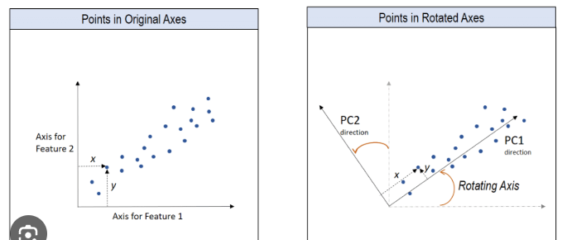

**2. Linear Discriminant Analysis (LDA)**

LDA is a supervised technique, meaning it uses class or label information.

Unlike PCA, which focuses on variance across all data, LDA aims to maximize the separation between different classes.

It finds new axes called linear discriminants that best distinguish the classes by maximizing the distance between class centers and minimizing the spread within each class. This helps in clearly separating the classes in fewer dimensions.

LDA is particularly useful for classification problems, helping to reduce features while retaining information important for distinguishing classes. It is often used in applications such as face recognition, speech recognition, and medical diagnosis.

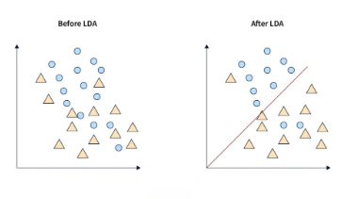

**Parametric and Non-Parametric Models in Machine Learning**

**1. Parametric Models**

* **Definition:**  
  Parametric models assume a specific functional form for the mapping between input and output and are characterized by a **fixed number of parameters** that do not grow with the size of data.
* **Working:**
  + The model first assumes a distribution (e.g., linear, logistic, Gaussian).
  + Learning = estimating the parameters of this distribution (e.g., slope and intercept in linear regression).
  + Once parameters are estimated, predictions are made using the fixed function.
* **Examples:** Linear Regression, Logistic Regression, Naïve Bayes, Perceptron, Neural Networks (fixed architecture).
* **Advantages:**
  + Simple and easy to understand.
  + Training is faster as only a few parameters are learned.
  + Works well with smaller datasets.
* **Limitations:**
  + Limited flexibility; cannot capture very complex patterns if the assumed function is wrong.
  + Strong assumptions about data distribution.

**2. Non-Parametric Models**

* **Definition:**  
  Non-parametric models do **not assume a fixed functional form**. The number of parameters (or complexity) grows with the amount of training data.
* **Working:**
  + The model adapts itself based on data instead of predefining a function.
  + Learning is more flexible and data-driven.
* **Examples:** k-Nearest Neighbors (kNN), Decision Trees, Random Forests, Support Vector Machines (with kernels).
* **Advantages:**
  + Highly flexible, can model complex and irregular patterns.
  + Makes fewer assumptions about data distribution.
* **Limitations:**
  + Computationally expensive (slower training and prediction).
  + Requires larger datasets to avoid overfitting.

