Fundamentals of Distributed Computing
Distributed computing refers to a computing system in which multiple independent computers work together as a single system to achieve a common goal. These computers communicate with each other through a network and coordinate their actions by passing messages.
In a distributed system, resources such as data, processing power, storage, and applications are shared among many machines located in different geographical locations.
A Distributed System is a collection of autonomous computers connected through a network that appears to users as a single coherent system.

Characteristics of Distributed Systems

1. Resource Sharing
Resources such as hardware, software, files, and services are shared among multiple users and systems. Example: Shared printers or cloud storage.

2. Concurrency
Multiple processes run simultaneously across different machines and interact with each other. Example: Multiple users accessing a database at the same time.

3. Scalability
The system can expand easily by adding more machines without affecting performance.
Example: Adding more servers to handle increased website traffic.

4. Fault Tolerance
If one component fails, the system continues to function using other components.
Example: Cloud servers automatically shifting workload to other nodes.

5. Transparency
The distributed system hides its complexity from users and appears as a single system.

6. Heterogeneity
Distributed systems support different hardware, operating systems, and programming languages. Example: Windows, Linux, and macOS machines working together.

Issues in Distributed Systems

1. Network Latency
Communication between machines over a network can be slower than local communication.

2. Security
Ensuring secure communication, authentication, and data protection is challenging.

3. Synchronization
Coordinating processes running on different machines requires complex synchronization techniques.

4. Data Consistency
Maintaining consistent data across multiple machines is difficult.

5. Fault Handling
Detecting and recovering from system failures requires special mechanisms.

6. Scalability Issues
Managing performance when the number of users or nodes increases.

Goals of Distributed Systems

1. Resource Sharing
Allow users to share hardware, data, and services across multiple systems.

2. Transparency
Hide the complexity of distributed operations and present the system as a single unified system.

3. Openness
Distributed systems should support standard interfaces and protocols for easy integration.

4. Scalability
The system should grow easily by adding more nodes without significant changes.

5. Reliability and Fault Tolerance
The system should continue functioning even if some components fail.

6. Performance Improvement
Tasks can be distributed among multiple machines to increase processing speed.

Types of Distributed Systems

1. Client–Server Systems
- Clients request services.
- Servers provide services.
Example:
- Web applications
- Database systems
Architecture:
Client → Request → Server → Response

2. Peer-to-Peer (P2P) Systems
All nodes act as both clients and servers. Each computer shares resources directly with others.
Example: Blockchain networks
Advantages:
- No central server
- Highly scalable

3. Cluster Computing
A cluster is a group of closely connected computers working together as a single system.
Characteristics:
- Same network
- Same operating system
- High performance computing
Example:
Scientific simulations and research computing.

4. Grid Computing
Grid computing connects computers from different organizations and locations to solve large computational problems.
Example:
Scientific research projects such as climate modeling.

Distributed System Models

1. Physical Model
Describes the hardware organization of the system such as computers, networks, and communication links.
Example:
Network topology like star, ring, or mesh.

2. Architectural Model
Defines the structure of the distributed system and how components interact.
Examples:
- Client–Server Architecture
- Peer-to-Peer Architecture
- Multi-tier Architecture
Introduction to Artificial Intelligence and Data Science in Distributed Computing
Artificial Intelligence and Data Science require processing large datasets and complex computations that a single computer cannot efficiently handle. Distributed computing divides tasks among multiple machines to process data in parallel. This enables faster computation, scalability, and efficient handling of big data for AI applications like machine learning and analytics.

Distributing Computational Tasks
tasks refers to the process of dividing a large computational problem into smaller subtasks and assigning them to multiple nodes in a distributed system. This helps in reducing execution time, improving performance, and utilizing system resources efficiently.
1. Task Partitioning
- A large problem is divided into smaller independent or interdependent tasks.
- Partitioning can be:
  - Static Partitioning – tasks are divided before execution.
  - Dynamic Partitioning – tasks are divided during runtime based on system load and resource availability.
2. Task Assignment and Scheduling
- Tasks are allocated to different nodes depending on node capacity, workload, and availability.
- Efficient scheduling ensures proper load balancing, preventing some nodes from being overloaded while others remain idle.
3. Execution and Result Aggregation
- Each node executes its assigned task independently or cooperatively.
- The results from all nodes are collected and combined to produce the final output.
- This method improves scalability and reduces overall computation time.

Applications
- Distributed machine learning model training (e.g., TensorFlow, Spark).
- Big data analytics.

Handling Large Volumes of Data in Distributed Computing
refers to the ability of a distributed system to store, process, and manage massive datasets by distributing them across multiple machines (nodes). This approach enables efficient data processing, scalability, and improved performance for AI and Data Science applications.
1. Distributed Data Storage
- Large datasets are divided into smaller chunks and stored across multiple nodes in a distributed system.
- This allows systems to store data beyond the capacity of a single machine.
- Technologies like distributed file systems are commonly used.
2. Parallel Data Processing
- Multiple nodes process different parts of the dataset simultaneously.
- Parallel processing significantly reduces data processing time and improves system efficiency.
3. Data Replication and Availability
- Data is often replicated across multiple nodes to ensure reliability and fault tolerance.
- If one node fails, the data can be retrieved from another node, ensuring continuous system operation.

Applications
- Big data analytics systems Hadoop and Spark.
- Machine learning and deep learning
- Cloud-based storage and data processing platforms.

Communication Overhead in Distributed Computing
refers to the additional time and resources required for nodes to exchange information in a distributed system. It arises due to network communication, synchronization, and coordination between nodes.
1. Causes of Communication Overhead
- Data transfer between nodes over the network.
- Synchronization messages used to coordinate distributed tasks.
- Data replication and consistency updates required to maintain accurate data across nodes.
2. Impact on Performance
- High communication overhead can reduce the efficiency of parallel processing.
- Excessive data transfer increases latency and slows down distributed AI and data science tasks such as model training.
3. Minimization Strategies
- Reduce data transfer by performing computations locally whenever possible.
- Use efficient communication protocols and data compression techniques.
- Optimize task allocation to reduce communication between nodes.

Applications
- Distributed machine learning where model parameters are shared between nodes.
- Big data processing systems such as Hadoop and Spark, where intermediate data is exchanged between nodes.

Leveraging Parallel Processing Capabilities in Distributed Computing
refers to the use of multiple processors or computing nodes to perform many computations simultaneously in a distributed system. This approach improves processing speed, efficiency, and performance, especially for AI and Data Science tasks.
1. Task Parallelism
- Large computational tasks are divided into smaller independent tasks.
- These tasks are executed simultaneously on multiple processors or nodes.
- This significantly reduces execution time.
2. Data Parallelism
- Large datasets are split into smaller portions, and each node processes a portion of the data at the same time.
- Commonly used in machine learning and deep learning training.
3. Improved System Performance
- Parallel processing allows systems to handle complex computations efficiently.
- It increases scalability, throughput, and overall system performance.

Applications
- Training deep learning and machine learning models on large datasets.
- Big data processing frameworks such as Hadoop and Spark.
Issues Related to Data Storage and Retrieval
1. Data Volume (Large-scale Data)
AI and Data Science applications generate huge amounts of data from sources like IoT, sensors, and social media. Distributed storage systems such as HDFS are required to store and retrieve this data efficiently.
2. Data Variety (Heterogeneous Data Formats)
Data exists in different formats such as structured, semi-structured, and unstructured data. Managing and retrieving these different formats requires preprocessing and specialized storage systems like NoSQL databases.
3. Data Velocity (Speed of Data Generation)
Data in AI systems is generated continuously in real time from sources like transactions and sensors. Distributed systems must process and retrieve this data quickly to support real-time analytics.
4. Data Quality (Incomplete or Noisy Data)
Data may contain missing values, errors, or duplicate records that affect AI model accuracy. Proper data cleaning and validation are required before storing and retrieving data.
5. Data Consistency (Maintaining Accurate Updates)
Distributed systems store multiple copies of data across different nodes for reliability. Maintaining consistency between these copies during updates is a major challenge.
6. Data Security and Privacy
AI systems often handle sensitive data such as personal or financial information. Strong security mechanisms like encryption and access control are required to protect stored and retrieval.

Data Consistency in Distributed Computing
refers to the property that all nodes in a distributed system see the same and updated data at the same time. It ensures that data remains accurate and reliable across multiple machines.
1. Multiple Data Copies
- In distributed systems, data is often replicated across different nodes to improve reliability and availability.
2. Concurrent Updates
- Multiple users or processes may update the same data simultaneously.
- This can lead to conflicts and inconsistencies if not properly managed.
3. Consistency Models
- Systems use different consistency models such as strong consistency and eventual consistency.
- These models define how quickly updates become visible across nodes.

Applications
- Distributed databases
- Cloud storage systems
- Financial transaction systems

Synchronization in Distributed Computing
Synchronization is the process of coordinating multiple processes or nodes so that they access shared resources in a controlled and orderly manner.
1. Coordination of Processes
- Distributed systems run many processes simultaneously on different machines.
- Synchronization ensures these processes operate in the correct sequence.
2. Avoiding Data Conflicts
- Without synchronization, multiple nodes may access or modify the same data at the same time, causing errors.
- Techniques like locks, semaphores, and timestamps help manage access.
3. Maintaining System Stability
- Proper synchronization ensures correct program execution and data integrity.
- It is important for distributed databases and parallel computing systems.

Applications
- Distributed databases
- Parallel computing systems
- Real-time collaborative applications

Fault Tolerance in Distributed Computing
is the ability of a distributed system to continue functioning even when some components or nodes fail.
1. Node Failures
- In large distributed systems, failures such as hardware crashes, network failures, or software errors are common.
- The system must detect and handle such failures.
2. Data Replication
- Important data is replicated across multiple nodes to prevent data loss.
- If one node fails, another node can provide the same data.
3. Recovery Mechanisms
- Systems use techniques like checkpointing, backups, and automatic recovery.
- These mechanisms help restore the system and continue processing.

Applications
- Cloud computing platforms
- Distributed databases
- Large-scale AI and big data systems
Use Cases and Applications of Integrating AI and Data Science in Distributed Systems
1. Predictive Maintenance
- Uses AI and machine learning to predict equipment failures before they occur.
- Distributed systems process sensor and IoT data from machines in real time.
- Helps reduce downtime, maintenance cost, and equipment damage.
2. Fraud Detection
- AI analyzes large volumes of financial transactions to detect suspicious activities.
- Distributed systems enable real-time monitoring and analysis of transaction data.
- Used in banking, e-commerce, and insurance systems to prevent fraud.
3. Intelligent Transportation Systems
- AI analyzes traffic data, GPS signals, and sensor data to manage transportation.
- Distributed computing processes large-scale real-time traffic information.
- Improves traffic flow, route planning, and accident detection.
4. Supply Chain Optimization
- AI helps in demand forecasting, inventory management, and logistics planning.
- Distributed systems process data from suppliers, warehouses, and retailers.
- Improves delivery efficiency and reduces operational costs.
5. Energy Management
- AI analyzes energy consumption patterns from smart meters and sensors.
- Distributed systems manage large energy data from power grids and renewable sources.
- Helps in energy optimization, load balancing, and reducing power wastage.
6. Healthcare and Medical Diagnostics
- AI models analyze medical records, images, and patient data to assist diagnosis.
- Distributed systems enable large-scale healthcare data storage and processing.
- Used for disease prediction, medical imaging analysis, and patient monitoring.
7. Customer Behavior Analysis
- AI analyzes customer interactions, purchase history, and browsing data.
- Distributed systems process large datasets from websites and mobile applications.
- Helps businesses in personalized recommendations and targeted marketing.
8. Natural Language Processing (NLP)
- AI processes and understands human language from text and speech data.
- Distributed systems handle large text datasets from social media, emails, and documents.
- Applications include chatbots, sentiment analysis, and language translation.

Predictive Maintenance using AI and Data Science

1. Data Collection and Preprocessing
- Machines are equipped with IoT sensors to collect data such as temperature, vibration, pressure, and usage statistics.
- Collected data is cleaned, normalized, and processed to remove noise and missing values.
- Data Science tools (Python, R, SQL) are used for feature extraction and data transformation.

2. Predictive Modeling using AI
- Machine Learning algorithms like Random Forest, SVM, and Neural Networks are used to predict equipment failures.
- Models are trained using historical data, maintenance records, and operational logs.
- Techniques like classification, regression, and anomaly detection identify early failure signs.

3. Decision Making and Optimization
- AI systems provide maintenance recommendations and failure alerts.
- Maintenance schedules are optimized to reduce downtime and improve efficiency.
- Helps in better resource planning and operational management.

Applications of Predictive Maintenance
1. Manufacturing Industry
2. Automotive and Transportation
3. Energy and Utilities
4. Aviation and Aerospace
5. Oil and Gas Industry
6. Healthcare Equipment

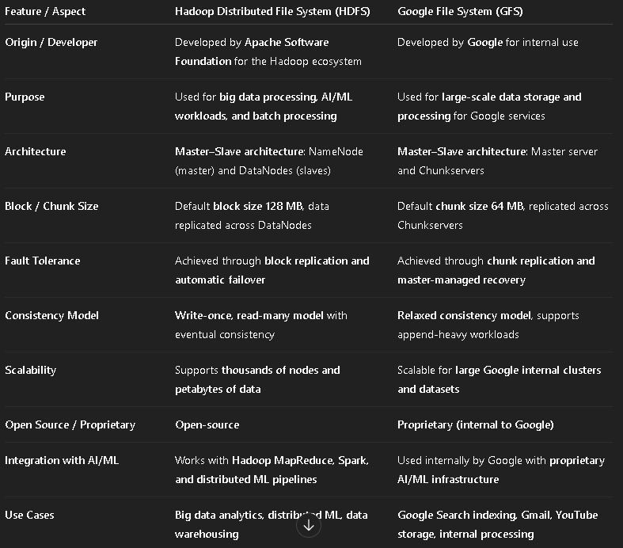

Cluster Computing
Cluster computing is a computing approach where multiple interconnected computers (nodes) work together as a single system to perform complex tasks. It improves performance, scalability, and reliability by distributing workloads across multiple machines.
- Nodes in a cluster share computing resources and workloads.
- Provides high performance and fault tolerance.
- Widely used in big data processing, AI/ML workloads, and cloud computing.

Cloud Platforms Used for Cluster Computing

1. Amazon Web Services (AWS)
- AWS is a cloud computing platform provided by Amazon.
- Offers services such as EC2 (Elastic Compute Cloud), S3 storage, and EMR for big data processing.
- Used for scalable distributed computing, machine learning, and data analytics.

2. Microsoft Azure
- Azure is a cloud computing platform developed by Microsoft.
- Provides services like Virtual Machines, Azure AI, Azure Storage, and Azure Kubernetes Service.
- Supports enterprise applications, AI solutions, and distributed data processing.

3. Google Cloud Platform (GCP)
- GCP is a cloud computing service provided by Google.
- Offers services like Compute Engine, BigQuery, Kubernetes Engine, and AI/ML tools.
- Designed for large-scale data analytics, machine learning, and distributed computing
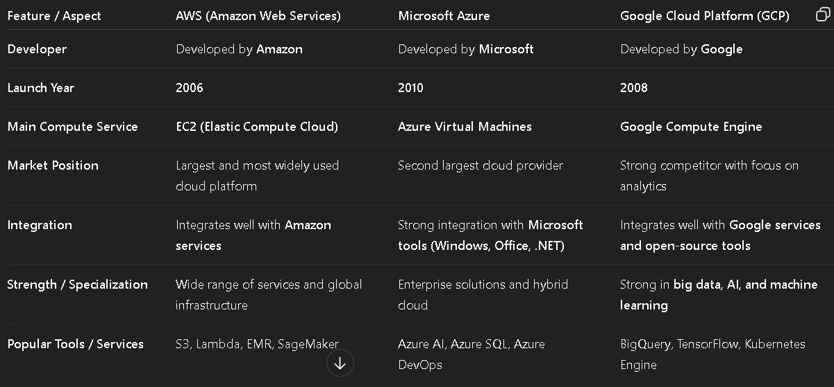
1. Message Brokers
A Message Broker is a software system that enables communication between different applications or services by sending, receiving, and managing messages in a distributed system.
1. Message Communication
- Message brokers allow applications to exchange information through messages without direct connection.
- They act as an intermediary between producers (senders) and consumers (receivers).
2. Asynchronous Processing
- Messages are stored in queues or topics, allowing systems to process data independently and asynchronously.
- This improves system flexibility and scalability.
3. Reliability and Fault Tolerance
- Message brokers ensure reliable delivery of messages even if some components fail.
- They support message persistence, retries, and acknowledgements.
Examples
- Apache Kafka
- RabbitMQ
- ActiveMQ
Applications
- Microservices communication
- Event-driven systems
- Distributed data processing
2. Stream Processing
Stream processing is a technique used to process continuous streams of real-time data as soon as it is generated, instead of storing it first for batch processing.
1. Real-Time Data Processing
- Data is processed immediately as it arrives from sources such as sensors, logs, or transactions.
- Enables instant insights and faster decision-making.
2. Continuous Data Streams
- Systems handle unbounded streams of data generated continuously from devices or applications.
- Suitable for high-speed and large-scale data environments.
3. Scalable Distributed Processing
- Stream processing systems use distributed architectures to process large volumes of data efficiently.
- Supports fault tolerance and scalability.
Examples
- Apache Kafka Streams
- Apache Flink
- Apache Spark Streaming
Applications
- Real-time fraud detection
- IoT data analysis
- Online recommendation systems

Edge Computing
Edge computing is a distributed computing approach where data processing is performed near the data source (devices or sensors) instead of sending it to a centralized cloud server. This helps in reducing latency and improving system performance.
1. Processing Near Data Source
- Data is processed closer to devices such as IoT sensors, smartphones, or local servers.
- Reduces the need to send large amounts of data to distant cloud data centers.
2. Reduced Latency and Faster Response
- Since processing happens near the data source, response time is faster.
- This is important for real-time applications like autonomous vehicles and smart devices.
3. Reduced Network Bandwidth
- Only important data is sent to the cloud while the rest is processed locally.
- This reduces network traffic and bandwidth usage.

Applications
- Internet of Things (IoT) devices
- Smart cities and smart homes
- Autonomous vehicles
- Industrial automation systems

Advantages
- Faster data processing
- Improved system efficiency
- Reduced network load
- Better real-time decision making.
1. Eager Replication
Eager replication (also called synchronous replication) is a replication technique where data updates are immediately applied to all replicas before the transaction is completed.
- All replicas are updated simultaneously to maintain consistency.
- Ensures strong consistency across all nodes.
- Requires high communication between nodes, which may increase latency.
- Commonly used in financial systems and critical databases.
2. Lazy Replication
Lazy replication (also called asynchronous replication) updates the primary node first and propagates the updates to other replicas later.
- Updates are eventually sent to other replicas after the main transaction.
- Provides better performance and lower latency than eager replication.
- Temporary data inconsistencies may occur between replicas.
- Used in large-scale distributed systems and cloud storage.
3. Quorum-Based Replication
Quorum-based replication ensures consistency by requiring a minimum number of nodes (quorum) to agree on read and write operations.
- Uses read quorum (R) and write quorum (W) values.
- Ensures data consistency by requiring majority agreement.
- Improves fault tolerance and reliability.
- Commonly used in distributed databases like Cassandra.
4. Consensus-Based Replication
Consensus-based replication ensures that all nodes agree on the same data updates before committing a transaction.
- Nodes use consensus algorithms to agree on updates.
- Examples include Paxos and Raft algorithms.
- Ensures strong consistency and reliability.
- Used in distributed systems like blockchain and distributed databases.
5. Selective Replication
Selective replication is a method where only specific data or frequently accessed data is replicated across selected nodes.
- Not all data is replicated across every node.
- Reduces storage and network overhead.
- Improves performance for frequently accessed data.
- Used in content delivery networks and distributed databases.
Consistency Model
A Consistency Model defines the rules that determine how and when updates to data become visible to all nodes in a distributed system. It ensures that multiple users accessing replicated data see correct and predictable results.
Consistency models help maintain data reliability, correctness, and synchronization across distributed databases.
Types of Consistency Models
1. Strong Consistency
- Ensures that all nodes always return the most recent updated data.
- After a write operation, any read will immediately return the latest value.
- Provides high accuracy but may increase latency.
2. Eventual Consistency
- Guarantees that all replicas will eventually become consistent over time if no new updates occur.
- Temporary inconsistencies may exist between nodes.
- Provides high availability and scalability.
3. Read-Your-Writes Consistency
- Ensures that a user always reads their own latest updates after performing a write operation.
- Prevents users from seeing outdated versions of their own data.
- Commonly used in web and social media applications.
4. Consistent Prefix Consistency
- Ensures that updates are seen in the correct order without missing earlier updates.
- If a process observes a sequence of updates, it will see them in the same order.
- Useful in log systems and distributed event processing.
5. Causal Consistency
- Ensures that causally related operations are observed in the same order by all nodes.
- Maintains cause-and-effect relationships between operations.
- Independent operations may appear in different orders across nodes.
1. Distributed Hash Tables (DHTs)
A Distributed Hash Table (DHT) is a decentralized system that stores key–value pairs across multiple nodes in a distributed network, allowing efficient data lookup.
- Uses hash functions to assign data to specific nodes.
- Enables fast data retrieval using a unique key.
- Provides scalability and fault tolerance in distributed systems.
- Commonly used in peer-to-peer networks like BitTorrent and Chord.
2. Distributed Inverted Indexing
Distributed inverted indexing is a technique used to store and search large text datasets across multiple nodes using an inverted index structure.
- Maps keywords or terms to their document locations.
- Data is distributed across multiple servers for scalability.
- Enables fast search and retrieval of documents.
- Widely used in search engines like Google and Elasticsearch.
3. Range-based Partitioning
Range-based partitioning distributes data across nodes based on specific value ranges of a key attribute.
- Each node stores data within a specific range of values.
- Improves efficiency for range queries and ordered data retrieval.
- Helps balance data storage across distributed nodes.
- Common in distributed databases and big data systems.
4. Content-based Indexing
Content-based indexing retrieves data based on the actual content or features of the data rather than simple identifiers.
- Uses data attributes, metadata, or extracted features for indexing.
- Suitable for multimedia data such as images, videos, and audio.
- Enables advanced search based on similarity or patterns.
- Used in image recognition and multimedia retrieval systems.
5. Peer-to-Peer (P2P) Indexing
Peer-to-peer indexing is a decentralized indexing method where each node in the network stores and manages part of the index.
- No central server, nodes act as both clients and servers.
- Improves scalability and fault tolerance.
- Nodes cooperate to locate and retrieve data efficiently.
- Used in file-sharing systems and decentralized networks.
6. Hybrid Approaches
Hybrid indexing approaches combine multiple indexing techniques to improve efficiency, scalability, and reliability in distributed systems.
- Combines methods such as DHT, range partitioning, and inverted indexing.
- Provides better performance and flexible data retrieval.
- Handles different data types and query requirements.
- Used in large-scale distributed databases and search systems.

