5.1) Input Parameters for **make escher**:

Generations = 500,000

Population Size = 24

Mutation Rate = 0.03

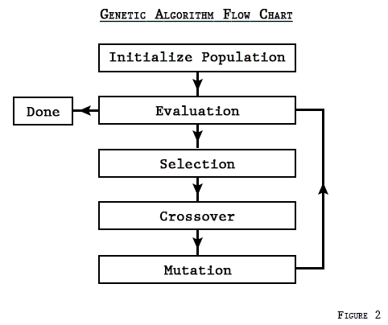5.2) The basic process for any GLA is:

In the case of running this program and taking snapshots of the population at different generations what we primarily observe is the iterative process that is crossover, and mutation. This is quite noticeable especially in a video format because we get to see how the colors that were not there initially there are introduced and how the colors that are accurate to the goal image begin to make a lasting impression on the sample. The transition from the first generation to the last shows how the colors and pixels begin to form shapes by defining boundaries with color. This phenomenon is quite remarkable as those considerations to form those boundaries are made solely because there was a group of individuals with high fitness and those individuals passed on enough useful data to the children that they were able to maintain this structure. This highlighting of shapes defines the work of crossover; however, another important function is mutation. Mutating the population provides the pool with just enough variety and randomness that the population can find a way to evolve out of a particularly ineffective set of genes. Which is also what contributes to the image being able to transition from the initial to the final since if it were stuck with the base genes it would have no way to improve.