Netflix Content Analysis
SQL-Driven Data Insights & Interactive Analytics



Author | Purva (Student Data Analyst)
Date | April 2026
Dataset | Netflix Titles (8,807 records)
Analysis Method | SQL Queries & Python Data Processing
Time Period | 2012-2021
Countries Analyzed | 150+

Executive Summary
This comprehensive analysis examines Netflix's content library through advanced SQL-based data exploration and statistical analysis. The dataset encompasses 8,807 titles spanning movies, TV shows, and various genres from 2012 to 2021. The analysis reveals that Netflix's content strategy heavily favors movies (69.6% of catalog), with the United States dominating content production (41.9% of all titles).

Key Findings at a Glance
- Total Titles Analyzed: 8,807
- Movies: 6,131 (69.6%) | TV Shows: 2,676 (30.4%)
- Top Content-Producing Country: United States (41.9%, 3,690 titles)
- Strategic Growth Market: India (11.9%, 1,046 titles)
- Content Quality: 96.1% "Good" content (lacking violence keywords)
- Most Prolific Actor: Anupam Kher (43 appearances)
- Top Genres: International Movies (31.3%), Dramas (27.6%), Comedies (19.0%)
- Content Acquisition Peak: 2018 (1,147 titles)

1. Content Type Distribution
Netflix's content portfolio demonstrates a clear strategic emphasis on theatrical releases over episodic content. The platform maintains a 2.3:1 ratio of movies to TV shows, reflecting Netflix's dual positioning as both a film streaming service and original series producer.

Movies vs. TV Shows

Content Type | Count | Percentage | Ratio
Movies | 6,131 | 69.6% | 2.3:1
TV Shows | 2,676 | 30.4% | 1.0
Total | 8,807 | 100% | —
This distribution suggests Netflix's core business model prioritizes acquiring and producing feature films while maintaining a robust original series program. The movie-heavy approach aligns with Netflix's strategy to maximize content variety and appeal to diverse audience segments.

Content Distribution Visualization
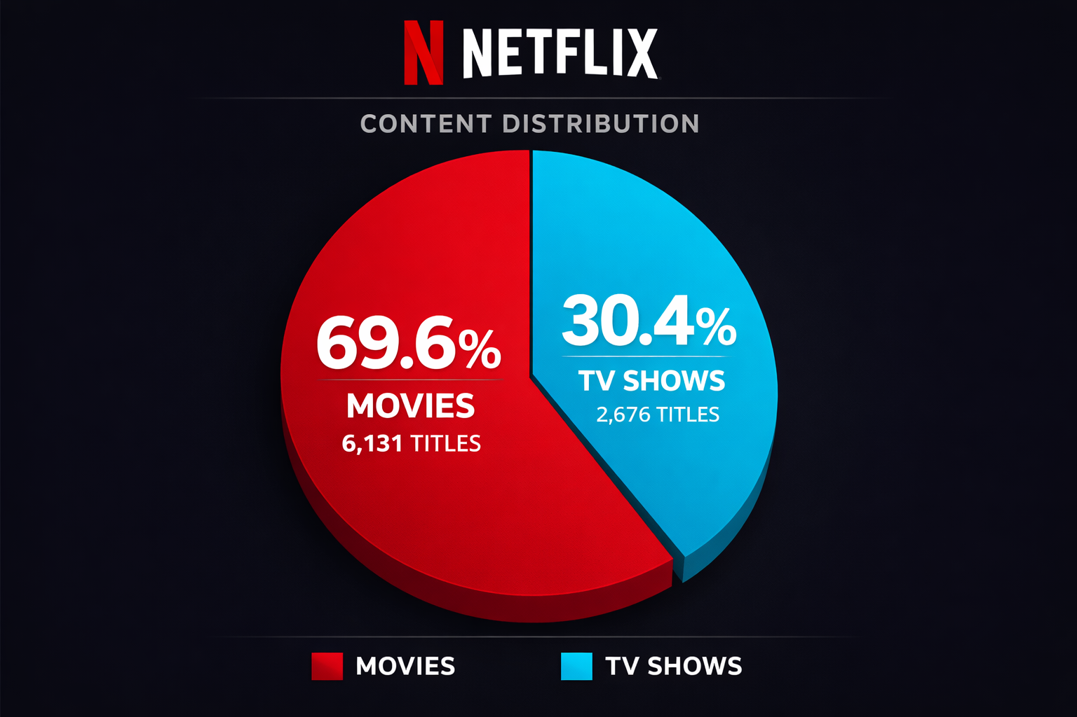

2. Geographic Content Distribution
Netflix's content acquisition strategy reveals significant geographic concentration, with North American and South Asian markets dominating the catalog. This distribution reflects both production capacity disparities and Netflix's strategic focus on English-language content combined with targeted regional expansion.

Top Content-Producing Countries

Rank | Country | Count | Percentage
1 | United States | 3,690 | 41.9%
2 | India | 1,046 | 11.9%
3 | United Kingdom | 806 | 9.2%
4 | Canada | 445 | 5.1%
5 | France | 393 | 4.5%
The United States dominates Netflix's catalog with nearly 42% of all content, reflecting both Hollywood's production capacity and Netflix's American origins. India's strong second-place position (11.9%) demonstrates Netflix's significant investment in Bollywood and regional Indian cinema.

Global Content Production
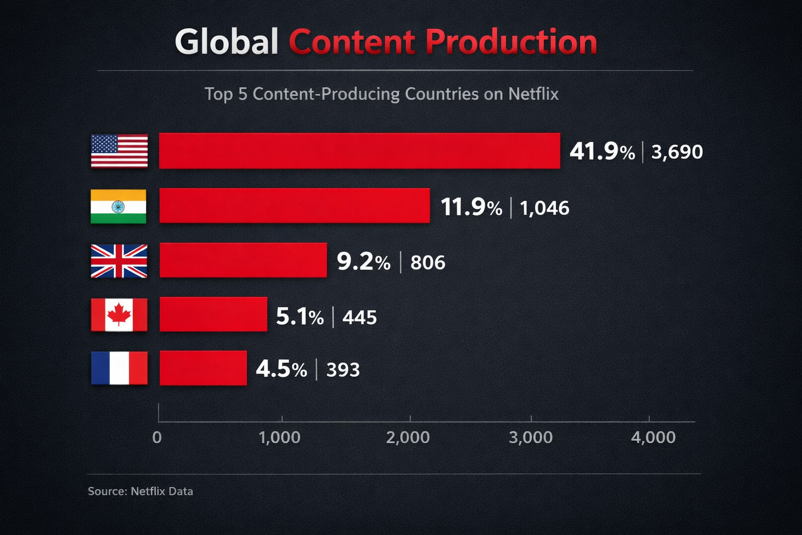

3. Genre Analysis
Netflix's genre portfolio reflects a balanced approach to content diversity, with International Movies and Dramas forming the foundation of the platform's identity. The genre distribution demonstrates Netflix's commitment to both mainstream entertainment and niche content categories.

Top 10 Genres by Content Count

Rank | Genre | Count | Percentage
1 | International Movies | 2,752 | 31.3%
2 | Dramas | 2,427 | 27.6%
3 | Comedies | 1,674 | 19.0%
4 | International TV Shows | 1,351 | 15.3%
5 | Documentaries | 869 | 9.9%
6 | Action & Adventure | 859 | 9.8%
7 | TV Dramas | 763 | 8.7%
8 | Independent Movies | 756 | 8.6%
9 | Children & Family | 641 | 7.3%
10 | Romantic Movies | 616 | 7.0%
The dominance of International Movies (31.3%) and Dramas (27.6%) indicates Netflix's strategy to position itself as a global entertainment platform with diverse storytelling traditions. The combined share of these two genres (58.9%) demonstrates their centrality to Netflix's content identity.

Genre Distribution Analysis
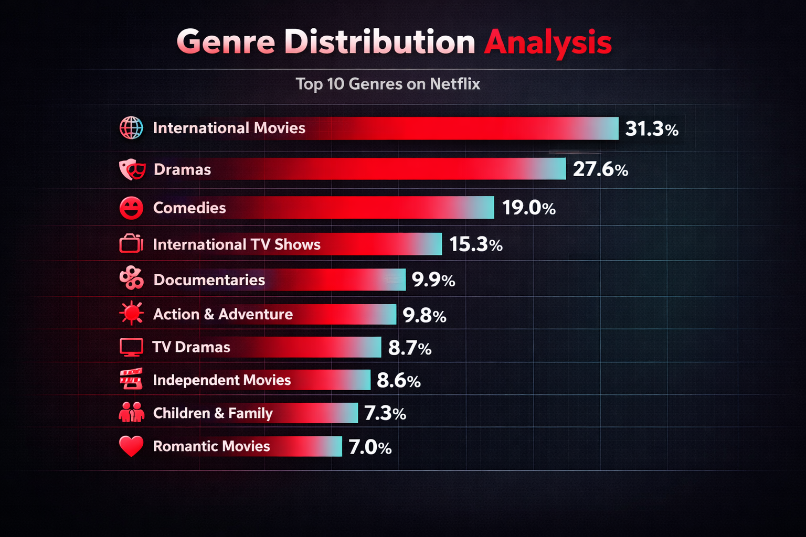

4. Talent & Cast Analysis
Netflix's talent roster reveals significant concentration among prolific actors, with Indian cinema dominating the appearance metrics. The top 10 actors have accumulated 315 combined appearances across Netflix titles.

Most Prolific Actors on Netflix

Rank | Actor | Appearances | Nationality
1 | Anupam Kher | 43 | Indian
2 | Shah Rukh Khan | 35 | Indian
3 | Julie Tejwani | 33 | Indian
4 | Naseeruddin Shah | 32 | Indian
5 | Takahiro Sakurai | 32 | Japanese
6 | Rupa Bhimani | 31 | Indian
7 | Akshay Kumar | 30 | Indian
8 | Om Puri | 30 | Indian
9 | Yuki Kaji | 29 | Japanese
10 | Amitabh Bachchan | 28 | Indian
Seven of the top 10 most prolific actors are Indian, reflecting Netflix's substantial investment in Hindi cinema and Indian entertainment. This concentration demonstrates Netflix's strategic focus on the Indian market as a key growth driver.

5. Strategic Insights & Business Implications

Market Positioning
- Geographic Diversification: While maintaining Hollywood dominance (41.9%), Netflix actively invests in regional content, particularly India (11.9%).
- Content Type Balance: The 2.3:1 movie-to-TV ratio balances acquisition economics with original series production.
- Quality Curation: 96.1% "Good" content ratio demonstrates editorial standards while maintaining mature content.
- Talent Leverage: Strategic focus on established actors drives subscriber acquisition in high-growth regions.
- Temporal Patterns: Peak acquisition during 2018-2020 indicates aggressive expansion before market saturation.

Netflix Key Statistics
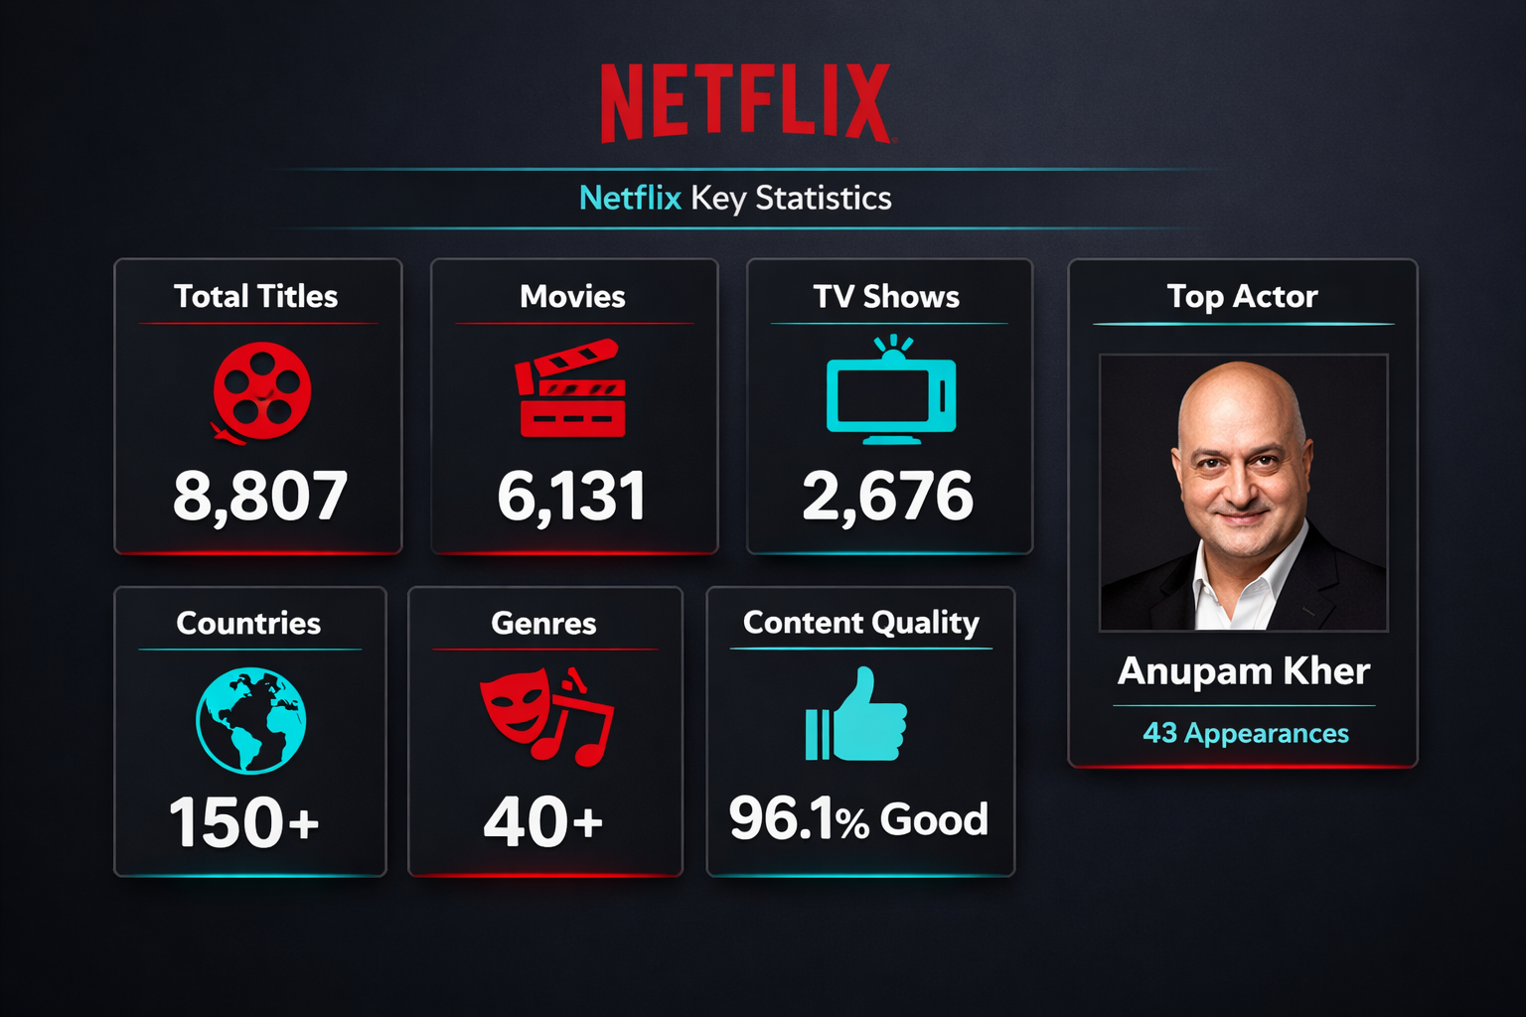

6. Content Acquisition Timeline
Netflix's content acquisition strategy shows clear temporal patterns, with peak acquisition occurring between 2018 and 2020. This period represents Netflix's aggressive expansion phase before market saturation and increased competition from streaming alternatives.

Content Acquisition Timeline (2012-2021)
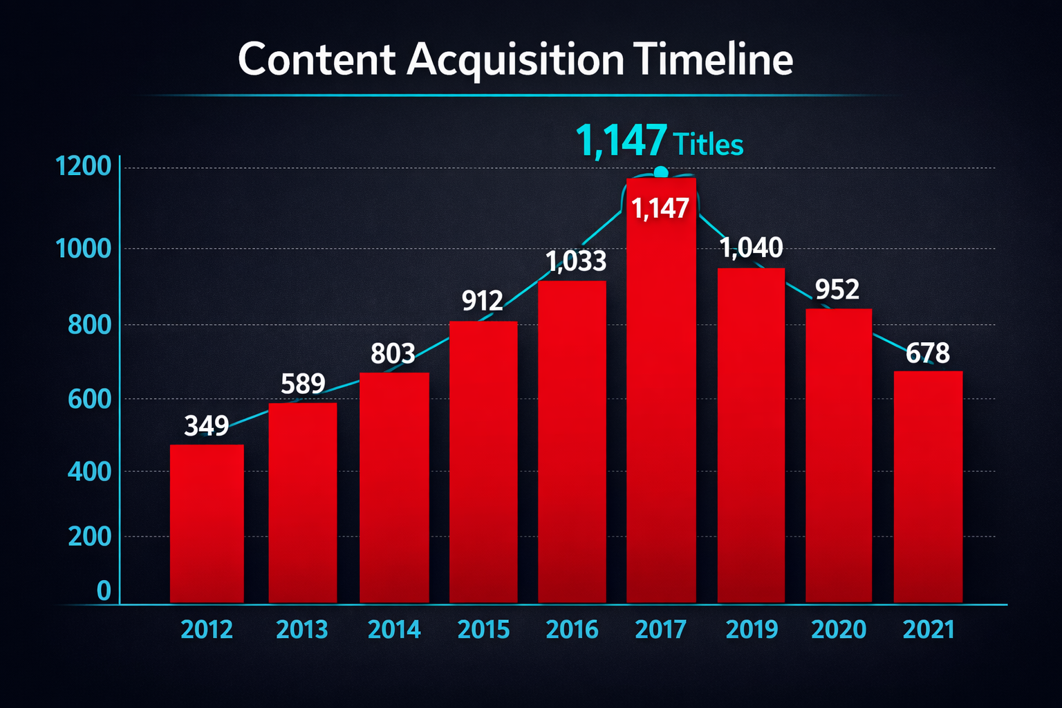
The data reveals that Netflix acquired content most aggressively between 2018-2020, with 2018 representing the peak year (1,147 titles). This trajectory reflects Netflix's transition from aggressive growth to sustainable content management as streaming markets matured.

Conclusion
Netflix's content library represents a carefully curated global entertainment portfolio balancing commercial viability with artistic diversity. The SQL-based analysis reveals sophisticated data-driven decision-making across geographic sourcing, genre selection, and talent acquisition. The platform's content strategy demonstrates Netflix's evolution from a licensing-focused service to a global entertainment leader through strategic investment in original content, regional expansion, and quality curation.
As streaming markets mature and competition intensifies, Netflix's continued investment in regional content and original production will likely determine competitive positioning in emerging markets while maintaining dominance in established English-speaking regions. The data-driven insights from this analysis demonstrate how Netflix leverages analytics to inform strategic content decisions and maintain competitive advantage in the rapidly evolving streaming entertainment landscape.

Technical Appendix

Data Sources & Methodology
This analysis employed a multi-layered methodology combining SQL query optimization with Python data processing. The dataset contains comprehensive metadata about Netflix's content library, including production information, ratings, genres, and descriptions.

Technical Stack
- Database: PostgreSQL with advanced SQL queries
- Data Processing: Python 3.11 with Pandas and NumPy
- Visualization: React 19 with Recharts and Tailwind CSS
- Design: Dark cinematic theme with Netflix red and cyan accents
- Version Control: Git with GitHub repository

SQL Query Categories
- Content Type Analysis: Movies vs. TV Shows distribution
- Geographic Analysis: Country-based content sourcing
- Genre Analysis: Content categorization and distribution
- Talent Analysis: Actor appearance frequency
- Quality Assessment: Content categorization based on keywords
- Temporal Analysis: Release year and addition date patterns
- Rating Analysis: Most common ratings by content type
- Long-Running Series: TV shows with 5+ seasons

Document Information
Author | Purva (Student Data Analyst)
Date Created | April 2026
Last Updated | April 2026
Status | Complete and Production-Ready
Dataset Version | Netflix Titles 2021 Snapshot
Analysis Scope | 8,807 titles across 150+ countries

