**Team-S**

**In Class Assignment – CRC Cards, Class Diagram**

1. CRC for use case 1 – Sign-in

|  |  |  |  |  |
| --- | --- | --- | --- | --- |
| **User** |  |  | **Vehicle** |  |
| Knows userName |  |  | Knows make |  |
| Knows PasswordHash |  |  | Knows year |  |
| Knows Which vehicle it has | Vehicle |  | Knows color |  |
| Knows home address |  |  | Knows number |  |
| Knows if email is verified |  |  |  |  |
| Knows email address |  |  |  |  |

1. CRC for use case 2 – Update profile

|  |  |
| --- | --- |
| Class: Profile |  |
| **Responsibilities** | **Collaborators** |
| knows Username |  |
| knows firstname, lastname | User |
| knows DOB |  |
| knows EmailID |
| update phone number |
| update vehical details |
| update address |

1. Class Diagram**:

1. Object Diagram**:

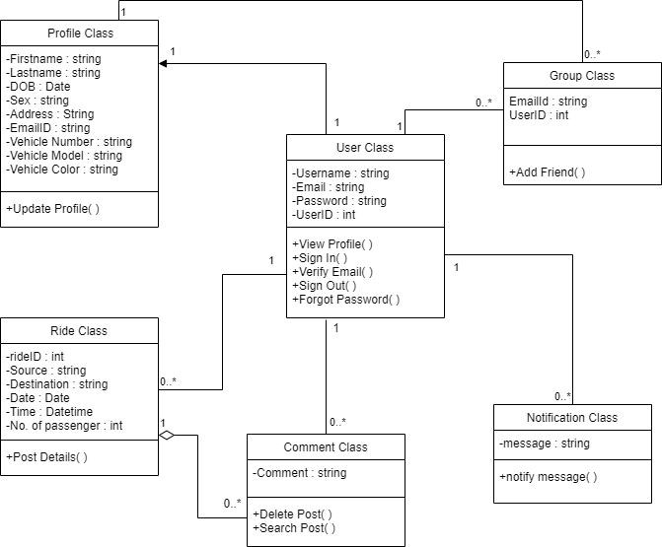

** The team is still discussing what to include within the classes. Since class diagram and object diagrams share similar structures, both undecided versions are included in this document.