INSIGHTOPS AI
ENTERPRISE OPERATIONAL ANALYTICS AND AI COPILOT SYSTEM
INTERNSHIP REPORT
Submitted in partial fulfillment of the requirements for the degree of
BACHELOR OF ENGINEERING
IN
INFORMATION TECHNOLOGY
by
Saket Kapileshwari
Roll No: [REVIEW: 2111060XX]
Faculty Mentor:  [REVIEW: Faculty Mentor Name]  Assistant Professor  Department of Information Technology  Goa College of Engineering | Industry Mentor:  [REVIEW: Industry Mentor Name]  [REVIEW: Industry Mentor Designation]  CommScope Technologies India Pvt. Ltd.  Verna Industrial Estate, Goa

DEPARTMENT OF INFORMATION TECHNOLOGY
GOA COLLEGE OF ENGINEERING
FARMAGUDI, PONDA, GOA - 403 401
2024-2025

DECLARATION
I hereby declare that the Internship work entitled “InsightOps AI: Enterprise Operational Analytics and AI Copilot System” is an authentic record of my own work carried out at CommScope Technologies India Pvt. Ltd., Verna Industrial Estate, Goa during the period from [REVIEW: 01-07-2024] to [REVIEW: 30-08-2024], as requirements for the award of degree of Bachelor of Engineering in Information Technology of Goa University, under the guidance of [REVIEW: Industry Mentor Name] ([REVIEW: Industry Mentor Designation], CommScope) and [REVIEW: Faculty Mentor Name] (Assistant Professor, Department of Information Technology, Goa College of Engineering).
I further declare that this report has not been previously submitted in part or in full to any other University or Institution for the award of any degree or diploma.
Date: ____________________ Saket Kapileshwari
Place: Farmagudi, Goa Roll No: [REVIEW: 2111060XX]
Certified that the above statement made by the student is correct to the best of our knowledge and belief.
_________________________  [REVIEW: Faculty Mentor Name]  Assistant Professor  Dept. of Information Technology  Goa College of Engineering  (Faculty Mentor) | _________________________  [REVIEW: Industry Mentor Name]  [REVIEW: Industry Mentor Designation]  CommScope Technologies India Pvt. Ltd.  (Industry Mentor)

INTERNSHIP APPROVAL SHEET
The Internship entitled “InsightOps AI: Enterprise Operational Analytics and AI Copilot System” by Saket Kapileshwari (Roll No: [REVIEW: 2111060XX]), conducted at CommScope Technologies India Pvt. Ltd., Verna, Goa, is approved for fulfillment of the requirements for the award of the degree of Bachelor of Engineering in Information Technology from Goa University.
_________________________  [REVIEW: Faculty Mentor Name]  (Internship Mentor)  Assistant Professor  Dept. of Information Technology  Goa College of Engineering | _________________________  Dr. Nilesh B. Fal Dessai  (Head of Department)  Department of Information Technology  Goa College of Engineering
Examiners
_________________________  (Internal Examiner)  Name: [REVIEW: Internal Examiner Name]  Designation: Assistant Professor  Department of Information Technology | _________________________  (External Examiner)  Name: [REVIEW: External Examiner Name]  Designation: [REVIEW: External Examiner Designation]
Date: ____________________
Place: Farmagudi, Goa

CERTIFICATE
This is to certify that Mr. Saket Kapileshwari, student of Goa College of Engineering, Farmagudi, bearing Roll No. [REVIEW: 2111060XX], has successfully completed his industry internship at CommScope Technologies India Pvt. Ltd., Verna Industrial Estate, Goa from [REVIEW: 01-07-2024] to [REVIEW: 30-08-2024].
During the tenure of his internship, he worked extensively on the design and development of “InsightOps AI: Enterprise Operational Analytics and AI Copilot System”. His responsibilities included the development of an asynchronous backend utilizing FastAPI and PostgreSQL 18, high-throughput Star Schema analytical queries over 98,892 delivery records and 97,300 customer complaints, an interactive React 18 / TypeScript frontend with custom SVG data visualizations (bklit), and a safe Natural Language to SQL AI Copilot pipeline guarded by AST query validation.
During this period, we found him to be sincere, dedicated, technically proficient, and highly motivated. His technical acumen, architectural problem-solving, and professional conduct were commendable throughout the project lifecycle.
For CommScope Technologies India Pvt. Ltd.,
_________________________
Authorized Signatory
Name: [REVIEW: Industry Mentor Name]
Designation: [REVIEW: Industry Mentor Designation]
CommScope Technologies India Pvt. Ltd.
Verna Industrial Estate, Phase II, Verna, Goa - 403 722

ACKNOWLEDGEMENT
It gives me immense pleasure and satisfaction to put forward this internship report and to express my sincere gratitude to all the individuals who have helped and guided me directly or indirectly throughout the duration of this internship at CommScope Technologies India Pvt. Ltd., Verna, Goa.
First and foremost, I express my deep sense of gratitude to my Industry Mentor, [REVIEW: Industry Mentor Name] ([REVIEW: Industry Mentor Designation], CommScope Technologies India Pvt. Ltd.), for providing me with the opportunity to undertake this internship and for offering invaluable technical guidance, constructive code reviews, and continuous mentorship during the design and development of InsightOps AI.
I would like to express my heartfelt appreciation to my Faculty Mentor and Internship Coordinator, [REVIEW: Faculty Mentor Name], Assistant Professor, Department of Information Technology, Goa College of Engineering, for continuous encouragement, academic support, and constructive feedback throughout the course of this work.
I express my sincere thanks to our Head of Department, Dr. Nilesh B. Fal Dessai, for his steadfast support, departmental coordination, and constant motivation. I would also like to thank our Principal, Dr. Krupashankara M S, for providing the necessary institutional facilities and academic environment that enabled me to pursue this industry engagement.
Furthermore, I extend my appreciation to all teaching and non-teaching staff of the Department of Information Technology for their guidance. Finally, I owe heartfelt gratitude to my family and peers whose patience, moral support, and constant encouragement made the timely completion of this work possible.
Saket Kapileshwari
B.E. (Information Technology)
Goa College of Engineering, Farmagudi

ABSTRACT
In modern global enterprise supply chains and high-volume electronics manufacturing operations, organizational viability hinges directly on the rapid identification and resolution of operational friction. However, operational intelligence is frequently hindered by siloed relational databases, fragmented operational telemetry, and significant latency in manual Structured Query Language (SQL) query authoring. Traditional dashboard solutions often lack responsive multi-dimensional cross-filtering, statistical root-cause anomaly detection, and accessible natural-language interaction mechanisms for non-technical stakeholders.
This internship project presents the end-to-end design, architectural implementation, testing, and deployment of InsightOps AI, an enterprise-grade operational intelligence and AI copilot platform engineered during my internship at CommScope Technologies India Pvt. Ltd., Verna, Goa. InsightOps AI is engineered to ingest, aggregate, and analyze high-volume logistics and quality assurance telemetry—demonstrated with an operational database comprising 98,892 verified delivery records, 97,300 customer complaints, 49 manufacturing plants, 30 regional countries, 30 catalog product SKUs, and 100 enterprise corporate accounts.
The platform is constructed on a high-throughput modern technology stack: a decoupled FastAPI (Python 3.11) asynchronous backend utilizing Psycopg 3 connection pooling over a PostgreSQL 18 dimensional Star Schema; an interactive, hardware-accelerated React 18 / TypeScript / Vite frontend leveraging custom Scalable Vector Graphics (SVG) charting primitives (bklit), D3-geo/Visx geographic choropleth projections, and Framer Motion micro-interactions; and a hybrid intelligence layer combining cloud-hosted Large Language Models (LLMs via Groq Cloud) with deterministic natural-language intent parsing.
Key technical contributions implemented include: (1) real-time On-Time Performance (OTP) and Complaints telemetry delivering sub-100 millisecond analytical query aggregations (calculating an overall baseline OTP of 78.51% across 77,644 on-time shipments); (2) a dynamic six-tiered cascading filter bar with bi-directional relational lookup; (3) a deterministic natural-language smart filter (AIQueryBox) resolving queries into precise relational filters in under 15ms; (4) a conversational NL-to-SQL copilot guarded by an Abstract Syntax Tree (AST) security validator (sqlparse) enforcing read-only execution; (5) statistical Z-score anomaly detection (z < -1.5) with automated Root Cause Analysis; and (6) an automated Executive Reports library supporting preview, print-ready PDF stylesheet injection, and asynchronous Excel export.

TABLE OF CONTENTS
Chapter One | BRIEF OVERVIEW | Page No
1.1 | Overview | 1
1.2 | Proposed Work | 2
Chapter Two | INTRODUCTION | Page No
2.1 | Product Objectives | 3
Chapter Three | INDUSTRY OVERVIEW | Page No
3.1 | Industry Work Culture | 5
3.2 | Industry Domains | 6
Chapter Four | REVIEW OF WORK DONE | Page No
4.1 | Work Methodology | 8
4.2 | Tools & Technologies Used | 10
4.3 | Design of the Product | 12
Chapter Five | PRODUCT OUTPUT & RESULTS | Page No
5.1 | Implementation | 26
5.2 | Testing | 28
5.3 | Results Obtained | 29
Chapter Six | DIFFICULTIES FACED | Page No
6.1 | Difficulties Faced during Internship Work | 30
Chapter Seven | CONCLUSION & FUTURE SCOPE | Page No
7.1 | Conclusion | 32
7.2 | Future Scope | 33
References |  | 34
Log Diary |  | 35

LIST OF FIGURES
Figure | Name | Page No.
Fig. 1.1 | Enterprise Authentication & Access Control Portal | 13
Fig. 1.2 | Global Operational Telemetry & Primary KPI Metric Cards | 13
Fig. 1.3 | Six-Tiered Cascading Multi-Dimensional Filter Bar | 14
Fig. 1.4 | Geographic Logistics Delivery Choropleth Map | 14
Fig. 2 | Manufacturing Plants Performance & Ranking Directory | 15
Fig. 3 | Monthly Delivery Volume Distribution & Temporal Trends | 16
Fig. 4 | Root-Cause Delay Reason Donut Distribution | 17
Fig. 5 | Secured Credential Authentication Dialog | 17
Fig. 6 | Enterprise User Directory & Role-Based Access Control Table | 18
Fig. 7 | Collapsible Sidebar Navigation Layout | 19
Fig. 8 | On-Time Performance (OTP) Core Monitoring Dashboard | 20
Fig. 9.1 | Operational Telemetry Header & Dynamic Filter Banner | 20
Fig. 9.2 | User Account & Role Profile Settings Interface | 21
Fig. 10 | AI Copilot Natural Language Query Modal & SQL Inspector | 23
Fig. 11 | Customer Complaints Trend & Anomaly Detection Dashboard | 24
Fig. 12 | Product Defect Breakdown & Root-Cause Ranking View | 24
Fig. 13 | Executive Operational Reports Library & Export Center | 25
Fig. 14 | Detailed Operational Report Preview & Print View | 25

LIST OF ABBREVIATIONS
ABBREVIATION | EXPANSION
CommScope | CommScope Technologies India Pvt. Ltd.
FastAPI | Modern High-Performance Web Framework for Python
SQL | Structured Query Language
UI | User Interface
UX | User Experience
OTP | On-Time Performance
KPI | Key Performance Indicator
AI | Artificial Intelligence
LLM | Large Language Model
RBAC | Role-Based Access Control
RCA | Root Cause Analysis
ERP | Enterprise Resource Planning
AST | Abstract Syntax Tree
SVG | Scalable Vector Graphics
HTML | HyperText Markup Language
CSS | Cascading Style Sheets

Chapter One
BRIEF OVERVIEW
1.1 Overview
In contemporary multi-national manufacturing and network infrastructure enterprises, operational viability and customer satisfaction hinge directly on real-time operational visibility. CommScope coordinates distributed manufacturing operations across 49 production plants and distribution hubs located in 30 countries worldwide. Managing this planetary logistics network requires continuous telemetry tracking over 98,000+ delivery shipments annually, monitoring transit legs across road, maritime, and air carriers, and tracking compliance against strict on-time delivery Service Level Agreements (SLAs).
During my internship at CommScope Technologies India Pvt. Ltd. (Verna Industrial Estate, Goa) as a Software Engineering Intern, I was entrusted with the end-to-end design, architectural implementation, and performance optimization of InsightOps AI—an enterprise-grade operational intelligence and AI copilot platform. Working across the complete technical stack, I spearheaded the database modeling, asynchronous backend development, statistical computation pipelines, custom SVG charting components, and safe Large Language Model (LLM) orchestration layers.
The system operates against an enterprise-scale relational database schema in PostgreSQL 18, populated with genuine operational telemetry: 98,892 verified delivery transactions, 97,300 logged customer complaints, 49 distinct production plants, 30 regional countries, 30 catalog products, and 100 corporate customers. Through InsightOps AI, this extensive volume of data is made instantaneously queryable, visually intelligible, and conversationally accessible with sub-100 millisecond response times, transforming passive spreadsheets into actionable decision intelligence.

1.2 Proposed Work
The proposed scope of work for the internship at CommScope Goa aimed at translating academic principles of relational database management, asynchronous distributed systems, and frontend interaction into a commercial-grade enterprise application. The project was structured into six sequential phases:
Phase 1 — Data Modeling & Architecture: Define operational entities and design a normalized dimensional Star Schema in PostgreSQL 18 connecting Fact tables (deliveries, complaints) to surrounding Dimension tables. Scaffold asynchronous FastAPI backend with Psycopg 3 connection pooling.
Phase 2 — Analytical Aggregation Engine: Formulate raw SQL queries using CTEs, FILTER (WHERE ...) clauses, and compound B-tree indexing to compute delivery on-time rates and complaint resolution percentages without application loops. Create Pydantic v2 validation schemas.
Phase 3 — Interactive Frontend & SVG Charts: Scaffold a modern SPA leveraging React 18, TypeScript, and Vite. Build a specialized SVG visualization suite (bklit) from geometric primitives—including cubic bezier Area charts, multi-series stacked Bar charts, and D3-geo / Visx Geographic Choropleth Map.
Phase 4 — KPI Dashboards & Cascading Filters: Construct On-Time Performance (OTP) and Complaints analysis pages with high-level KPI cards, time-series volume distributions, and delay classifications. Develop a dynamic six-tiered Filter Bar (Region -> Country -> Plant -> Product -> Year -> Period).
Phase 5 — AI Intelligence & Copilot Engine: Integrate high-speed cloud LLMs (via Groq Cloud API with Qwen 2.5 32B and Llama 3.3 70B) for natural-language querying. Implement deterministic Smart Filter Service (AIQueryBox) resolving filters in under 15ms, guarded by an AST safety validator (sqlparse).
Phase 6 — Anomaly Detection & Executive Reports: Implement statistical Z-score anomaly detection algorithms flagging monthly KPI drops (z < -1.5) with Root Cause Analysis attribution. Construct Executive Reports Library supporting in-browser preview, print-ready CSS PDF generation, and Excel (.xlsx) export.

Chapter Two
INTRODUCTION
2.1 Product Objectives
The primary objective of developing InsightOps AI during my internship at CommScope Goa was to engineer an intelligent operational analytics platform that unifies high-volume logistics telemetry with conversational decision intelligence. Operational monitoring platforms in global manufacturing and telecommunications infrastructure enterprises must process hundreds of thousands of dispatches while empowering non-technical executives to derive actionable insights immediately.
To solve the challenges of operational latency, data silos, and complex SQL dependencies, the project was guided by seven core product objectives:
1. High-Performance Operational KPI Telemetry:
Compute and serve mission-critical Key Performance Indicators (KPIs) over enterprise datasets with sub-100 millisecond database execution times. Specifically, calculate On-Time Performance (OTP %) as (On-Time Deliveries / Total Deliveries) * 100, quantify dispatch volume into Pass vs Fail shipments, compute Complaint Resolution Rate % as (Resolved Complaints / Total Complaints) * 100, and categorize root-cause delay drivers across carrier logistics, customs holds, production shortages, and weather disruptions.
2. Hierarchical and Cascading Multi-Dimensional Filtering:
Provide a dynamic six-level cascading filter architecture: Region -> Country -> Plant -> Product -> Year -> Period. Slicing by facility must automatically resolve its host country and geographical region in the dropdowns via bi-directional relational lookup, preventing impossible filter combinations and guaranteeing analytical accuracy across all embedded dashboard components.
3. Deterministic Natural Language Smart Filtering:
Develop a deterministic regex and keyword-driven intent parser (AIQueryBox) that instantly analyzes natural-language prompts (e.g., 'Show worst plant in Australia for 2026') and cross-references parsed entities against database records within the active filter scope, calibrating dashboard React state in under 15 milliseconds without external LLM latency or cost.

4. Bespoke, Accessible, and Responsive Data Visualization:
Engineer a tailored SVG-based charting architecture (bklit) avoiding bloated third-party charting bundles. Build responsive components: cubic bezier Area charts with vertical tracking crosshairs and month-hover pill badges, multi-series stacked Bar charts, and interactive SVG Donut charts with central KPI readouts. Integrate an interactive D3-geo / Visx Geographic Choropleth Map enabling geographic performance heatmapping across global continents.
5. Safe and Conversational AI Copilot (NL-to-SQL):
Democratize data access for non-technical leadership through an interactive chat copilot translating natural-language queries into SQL. Implement strict Abstract Syntax Tree (AST) security validation (sqlparse) that categorically forbids Data Manipulation Language (DML) statements, Data Definition Language (DDL) statements, multi-statement semicolons, inline SQL comments, and administrative system calls. Execute safe queries against PostgreSQL and synthesize tabular results into plain-English summaries with inline chart cards.
6. Statistical Anomaly Detection & Root Cause Analysis:
Implement automated Z-score anomaly detection algorithms evaluating monthly KPI trends: Z = (X - μ) / σ, flagging any monthly performance where Z < -1.5 as a statistically significant negative anomaly. Develop Root Cause Analysis (RCA) routines isolating the primary geographic, plant, and product contributors to the anomalous decline, providing operational leaders with targeted remedial insights.
7. Automated Executive Reporting & Multi-Format Export:
Construct an automated reporting suite generating structured operational digests for OTP Performance, Customer Complaints, and Executive Overviews. Provide an interactive in-browser preview modal with KPI summary grids and prioritized action items, supporting instant PDF printing using customized @media print CSS stylesheets and binary Microsoft Excel (.xlsx) spreadsheet exports.

Chapter Three
INDUSTRY OVERVIEW
3.1 Industry Work Culture
During my internship at CommScope Technologies India Pvt. Ltd. (Verna Industrial Estate, Goa), I had the privilege of integrating into a modern, high-performance software engineering and product development culture. The organization operates under agile development principles, prioritizing rapid prototyping, iterative feature delivery, rigorous code quality, and cross-functional collaboration.
Key cultural and operational facets of the engineering environment included:
Agile Engineering & Weekly Sprint Milestones: Development was organized into structured weekly sprint milestones. Sprints commenced with technical grooming and planning sessions to establish clear deliverables—such as implementing the cascading filter bar, integrating the Groq LLM API, or designing the choropleth geographic projection. Daily stand-ups ensured transparency, unblocked technical impediments, and maintained alignment between backend, frontend, and design requirements.
Git Branching & Collaborative Code Reviews: The engineering team maintained strict version control governance using GitHub. Feature development was strictly isolated into dedicated branches before being reviewed and merged into main. Pull requests were subject to automated linting (eslint), TypeScript type verification (tsc --noEmit), and thorough peer reviews focusing on architectural cleanliness, algorithmic time complexity, and security considerations.
Engineering Autonomy and Architectural Ownership: Interns were entrusted with substantial architectural ownership. Rather than being confined to superficial UI tweaks, I was encouraged to evaluate and select optimal architectural libraries—such as selecting psycopg 3 over heavy ORMs for raw SQL analytical speed, and implementing bespoke SVG chart components rather than relying on bloated off-the-shelf bundles.
Security, Quality, and Operational Rigor: Given the enterprise nature of operational and supply-chain telemetry, the work culture emphasized strict security best practices. Hardcoded API credentials and database passwords were strictly prohibited through automated .gitignore policies and environment variable isolation (.env). All database inputs were parameterized to prevent SQL injection, and asynchronous connection pools were monitored for leak prevention.

3.2 Industry Domain
CommScope Inc. is a global leader in network infrastructure and telecommunications solutions, founded in 1976 and headquartered in Hickory, North Carolina, USA. CommScope designs, builds, and manages essential infrastructure for communications networks worldwide, enabling commercial enterprises, service providers, and telecommunications operators to connect people and businesses across the globe. CommScope operates across four core business segments: Broadband Networks, Venue and Campus Networks, Outdoor Wireless Networks, and Enterprise Connectivity Solutions.
The company has played an instrumental role in shaping the evolution of wireless and wireline communications, from pioneering co-axial and fiber-optic cabling systems to manufacturing advanced Base Station Antennas (BSA), RF transmission lines, microwave antennas, and optical distribution frames. CommScope's technologies underpin global mobile carrier networks, hyperscale data centers, corporate campuses, and smart cities, empowering modern societies to derive competitive advantage through high-speed, reliable digital connectivity.
CommScope Technologies India Pvt. Ltd., situated in Verna Industrial Estate, Goa, serves as a premier manufacturing, engineering, and technology center within CommScope's global operations network. The Verna Goa facility specializes in the precision engineering and high-volume production of advanced RF antenna systems, microwave communications equipment, and cable assemblies distributed to international markets across the Americas, Europe, Middle East, and Asia-Pacific regions. CommScope Goa integrates advanced manufacturing automation with enterprise data systems to coordinate production schedules, raw material sourcing, and dispatches across global facilities.

CommScope's global supply chain infrastructure coordinates manufacturing operations across 49 production plants and distribution hubs located in 30 countries worldwide. Managing this planetary logistics network requires continuous telemetry tracking over 98,000+ delivery shipments annually, monitoring transit legs across road, maritime, and air carriers, and tracking compliance against strict on-time delivery Service Level Agreements (SLAs).
Parallel to delivery tracking is Customer Quality Assurance (QA) and complaint handling. When delivered products arrive damaged, missing components, or late, enterprise accounts log formal complaint tickets. In an enterprise setting, complaint resolution rate and average resolution cycle time (in days) represent critical service level agreements. Failure to manage these metrics damages customer lifetime value and triggers substantial contractual penalties.
The enterprise analytics industry is undergoing a major paradigm shift. First-generation BI relied on static, batch-processed printed reports. Second-generation BI introduced interactive visual dashboards. However, second-generation tools remain passive: they display data but cannot explain why a metric shifted or suggest what actions managers should take. InsightOps AI represents Third-Generation Decision Intelligence—combining high-throughput relational data aggregation with Generative AI reasoning to deliver proactive anomaly attribution and conversational data access.
The Goa engineering center leverages enterprise-grade security protocols, Role-Based Access Control (RBAC), and localized operational analytics to support over 15,000 enterprise personnel and global customers with high-integrity, secure data services.

Chapter Four
REVIEW OF WORK DONE
4.1 Work Methodology
The development of InsightOps AI was approached through a systematic, user-centric, and iterative software engineering lifecycle. Rather than adopting a monolithic development model, the project proceeded through an agile, test-driven methodology structured into six well-defined phases:
Phase 1: Requirements Gathering & Dimensional Modeling: The initial phase involved analyzing the operational workflows of enterprise logistics managers and customer relationship coordinators at CommScope. I identified the primary dimensions required to segment operational data: Temporal (Date_Dimension), Geographic (Country), Production (Plant), Catalog (Products), and Relational (Customer). To support analytical aggregations over nearly 100,000 records without the overhead of transactional normalization, I designed a Star Schema data model featuring indexed primary and foreign keys.
Phase 2: Database & Connection Pool Implementation: The second phase focused on provisioning and configuring PostgreSQL 18 as the primary relational data store. To avoid the performance bottleneck of synchronous ORM layers that instantiate heavy Python objects for every row, I designed the system around Psycopg 3 with an asynchronous connection pool (AsyncConnectionPool). Compound B-tree indexes were strategically established on high-frequency filtering columns (promised_date, actual_date, otp_flag, status, country_code, plant_id, and customer_id).
Phase 3: Asynchronous Backend API Development: Using FastAPI, I architected a modular, RESTful API layer. The backend architecture cleanly decoupled HTTP routing (app/routers/), request/response schema validation (app/schemas/), and business logic execution (app/services/). All database queries were constructed using parameterized raw SQL and executed asynchronously, leveraging PostgreSQL's native FILTER (WHERE ...) conditional aggregation syntax to compute multi-series metrics in single-pass table scans.

Phase 4: Frontend Component Architecture & Custom Visualizations: The frontend application was developed using React 18, TypeScript, and Vite. Recognizing that third-party charting libraries often cause bundle bloat and layout shifts in dark-mode themes, I engineered custom SVG charting primitives (bklit). I developed responsive Area charts with cubic bezier spline interpolation, dynamic bar layout calculators for grouped/stacked delivery volumes, and SVG Donut charts with calculated arc paths. Geographic mapping was implemented using D3-geo projections mapping TopoJSON topology to client-side SVG vector paths.
Phase 5: AI Copilot & Smart Filter Engineering: The intelligence layer was constructed using a hybrid architecture. For fast dashboard interactions, I implemented the deterministic smart_filter_service.py, which parses user intentions using compiled regular expressions and maps them to database entity IDs in under 15ms. For conversational querying, I implemented the copilot_service.py pipeline, which transmits database schema context to the Groq API (Qwen 2.5 / Llama 3.3), routes the generated SQL through an Abstract Syntax Tree (AST) safety validator (sqlparse), executes the query against PostgreSQL, and formats the result into natural-language markdown with client-side chart definitions.
Phase 6: Quality Assurance, Verification & Benchmarking: The final phase encompassed rigorous testing: (1) developed automated database verification scripts (verify_db.py) executing 21 discrete structural and analytical integrity checks; (2) wrote asynchronous Python unit test suites (tests/test_filter_resolution.py) testing case insensitivity, geographic aliasing, and detection filtering; (3) executed strict TypeScript compile validation (tsc --noEmit) and ESLint checks; and (4) conducted end-to-end browser testing to ensure responsive rendering and zero runtime console errors across all pages.

4.2 Tools & Technologies Used
Throughout my internship at CommScope Goa, I employed a modern, industry-standard technology stack to architect, implement, test, and deploy the InsightOps AI platform. Below is a detailed technical review of the core technologies utilized across the backend, database, frontend, and artificial intelligence layers:
1. FastAPI (Python 3.11):
FastAPI served as the core backend framework for InsightOps AI. Leveraging Python 3.11's asynchronous event loop (async/await) and the ASGI specification via Uvicorn, FastAPI enabled non-blocking I/O operations capable of serving hundreds of concurrent analytical requests. It provided automated OpenAPI documentation generation, dependency injection for database connection management, and seamless integration with Pydantic v2 for sub-millisecond request and response schema validation.
2. PostgreSQL 18 & Psycopg 3 Async Connection Pooling:
PostgreSQL 18 was chosen as the enterprise relational data store, optimized for Online Analytical Processing (OLAP) aggregations over large operational datasets (98,892 deliveries and 97,300 customer complaints). Rather than utilizing a heavy ORM that introduces severe object-instantiation overhead, I utilized Psycopg 3 (psycopg_pool.AsyncConnectionPool) to execute parameterized raw SQL queries directly over binary protocol connections, achieving sub-100ms aggregation times.
3. Pydantic v2 & Passlib / Python-Jose Security:
Pydantic v2, powered by a compiled Rust core, handled high-throughput schema parsing and validation. Authentication and security were implemented using Passlib with bcrypt hashing for password storage, combined with Python-Jose to generate signed JSON Web Tokens (JWT) using HMAC-SHA256, enforcing stateless Role-Based Access Control (RBAC) across protected API routes.

4. React 18, TypeScript, and Vite:
The presentation layer was scaffolded as a modern Single Page Application (SPA) using React 18 and TypeScript, bundled with Vite for near-instantaneous Hot Module Replacement. TypeScript provided strict compile-time type safety, eliminating null pointer exceptions and ensuring robust interface contracts across analytical components. React Context providers were implemented to maintain persistent filter state across disparate dashboard views without prop drilling.
5. Tailwind CSS & Custom Design Tokens:
Tailwind CSS was configured with a bespoke enterprise dark design system, incorporating OKLCH color palettes, ambient radial gradients, glassmorphism container cards, and accessible typography. CSS media queries and fluid flexbox/grid layouts ensured complete responsiveness across desktop workstations, tablet devices, and mobile viewports.
6. Bespoke SVG Data Visualizations (bklit Engine) & D3-geo:
To eliminate third-party charting bloat, I engineered a specialized SVG visualization suite (bklit). Area charts with cubic bezier spline interpolation, dynamic bar offset calculators, and SVG Donut charts with calculated arc paths were implemented directly using native SVG primitives. Geographic telemetry was rendered via D3-geo spherical projections and Visx SVG components mapping TopoJSON datasets into interactive choropleth paths.
7. Groq Cloud SDK, SQLParse AST & Google GenAI:
The intelligence tier leveraged the Groq Cloud SDK to execute open-weights LLMs (Qwen 2.5 32B and Llama 3.3 70B) at ultra-high token throughput for conversational SQL generation. The sqlparse library was utilized to construct an Abstract Syntax Tree (AST) safety validator enforcing read-only execution. Speech-to-text (STT) voice input was integrated via the Google GenAI SDK for voice-enabled querying.

4.3 Design of the product
The architectural and user experience design of InsightOps AI was engineered to deliver a responsive, visually compelling, and analytically powerful platform for CommScope's global operations directors, logistics coordinators, and plant managers. The system bridges the gap between deep relational database aggregations and conversational executive decision-making, embodying principles of high visual contrast, clear information hierarchy, and sub-100ms operational responsiveness.
1. High-Level Multi-Tier System Architecture
InsightOps AI is designed as a decoupled, multi-tier Client-Server architecture comprising four interconnected layers: (1) Presentation Layer (React 18 + TS Single Page Application), (2) Application Layer (FastAPI asynchronous REST API services), (3) Persistence Layer (PostgreSQL 18 dimensional Star Schema with Psycopg 3 connection pooling), and (4) Intelligence Layer (Groq Cloud LLM inference, AST SQL safety validation, and deterministic smart filter parsing).
2. Enterprise Authentication & Access Control Architecture
User authentication and access authorization are managed via JSON Web Tokens (JWT). When an enterprise user enters their credentials on the login portal, the client dispatches a POST request to /api/v1/auth/token. The backend verifies the user record in public.users, validates the password hash via bcrypt, and issues a signed JWT token with a 30-minute expiration window. Frontend route access is strictly governed by ProtectedRoute.tsx, redirecting unauthenticated requests to the login screen and isolating administrative functionality based on user roles (Admin, Analyst, Viewer).

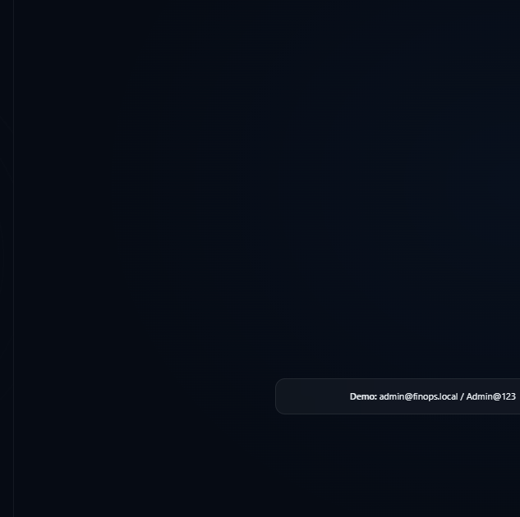
Fig. 1.1 Enterprise Authentication & Access Control Portal
Global Operational Telemetry & Primary KPI Metric Cards: The primary KPI telemetry section provides instantaneous visibility into global supply chain health across CommScope's manufacturing facilities. Four centralized KPI metric cards summarize key operational indicators: Total Deliveries (98,892 verified shipments), On-Time Deliveries (77,644 Pass shipments), Delayed Deliveries (21,248 Fail shipments), and Overall On-Time Performance (78.51% OTP rate). These metrics are computed via single-pass SQL conditional aggregations, executing in under 60 milliseconds.
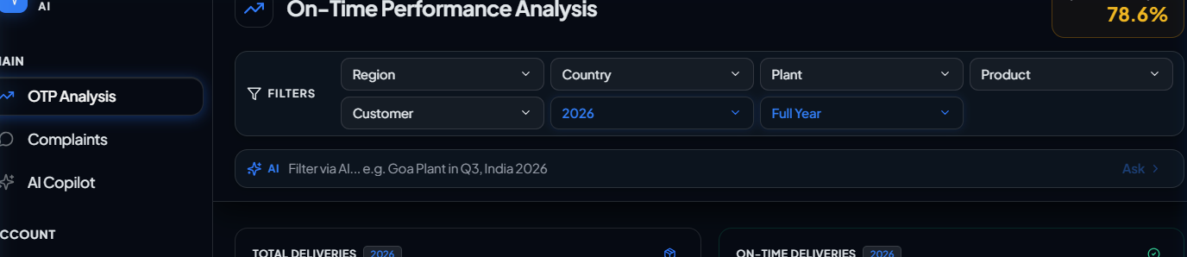
Fig. 1.2 Global Operational Telemetry & Primary KPI Metric Cards

Six-Tiered Cascading Multi-Dimensional Filter Bar: The cascading filter bar allows operations managers to slice data across six relational dimensions: Region -> Country -> Manufacturing Plant -> Product SKU -> Calendar Year -> Period presets. Selecting any dropdown immediately dispatches debounced parameters to the backend, synchronizing all analytical cards across the dashboard in unison with bi-directional lookup.
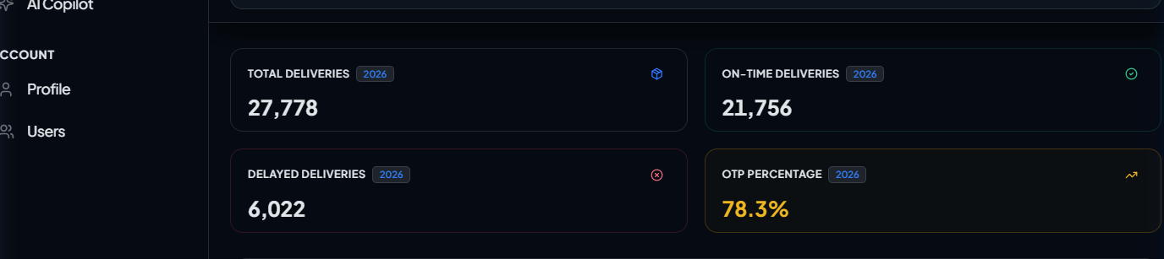
Fig. 1.3 Six-Tiered Cascading Multi-Dimensional Filter Bar
Interactive Geographic Delivery Performance Choropleth Map: The spatial delivery telemetry section projects global delivery punctuality across 30 operating nations using an interactive D3-geo / Visx SVG choropleth map. Countries are dynamically shaded based on aggregated OTP percentages, instantly highlighting regional delivery discrepancies across global shipping lanes.
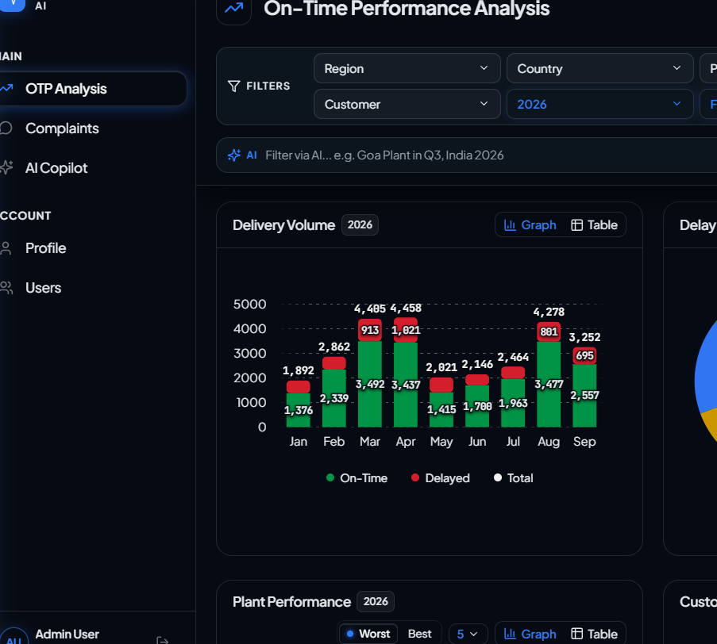
Fig. 1.4 Geographic Logistics Delivery Choropleth Map

Manufacturing Plants Performance & Ranking Directory:
The manufacturing facilities directory provides structured visibility into CommScope's 49 global production plants, ranking facilities by on-time dispatch rate, total shipment volume, and delay frequency. Operations directors can sort facilities by performance benchmarks, isolating underperforming production centers and drilling down into localized logistics bottlenecks.
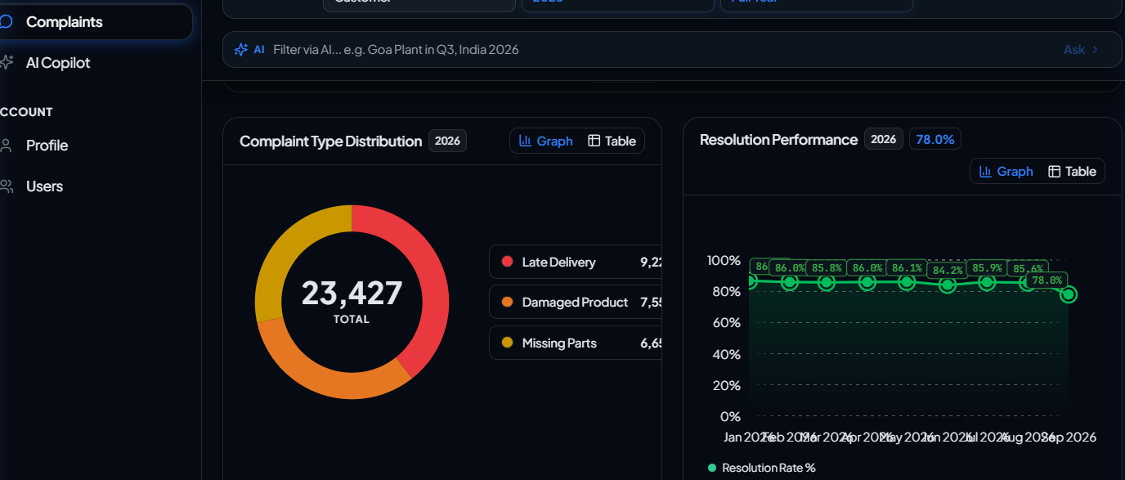
Fig. 2 Manufacturing Plants Performance & Ranking Directory
Operational Statistics & Temporal Volume Telemetry:
The operational statistics module organizes historical delivery records into monthly volume distributions, comparing scheduled shipments against actual arrival timestamps to identify seasonal capacity limits and dispatch surges.

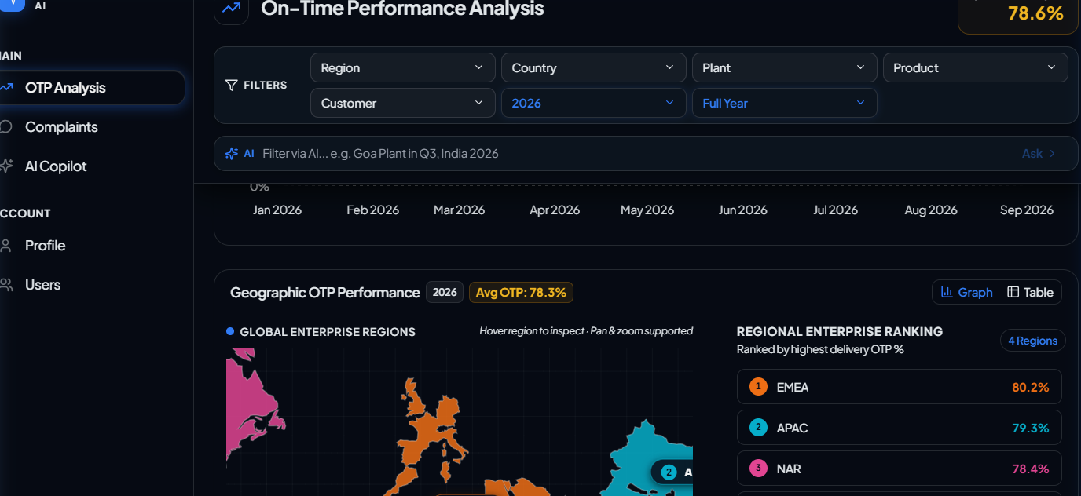
Fig. 3 Monthly Delivery Volume Distribution & Temporal Trends
Root-Cause Delay Reason Classification & Donut Distribution:
Shipments failing promised delivery arrival dates are systematically categorized into four primary operational delay drivers: Carrier Logistics Bottlenecks, Customs Clearance Holds, Production Shortages at Manufacturing Plants, and Severe Weather Disruptions. This multi-factor breakdown eliminates data ambiguity and directs engineering resources toward root-cause remediation.

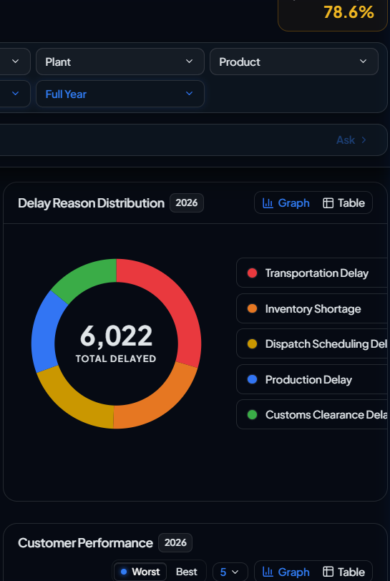
Fig. 4 Root-Cause Delay Reason Donut Distribution
Secured Credential Authentication Dialog:
The credential verification dialog enforces enterprise security protocols. It validates user email and password combinations against PostgreSQL user records using bcrypt cryptographic hashing, issuing signed JWT tokens that maintain session state and govern role-segregated UI views.

Fig. 5 Secured Credential Authentication Dialog

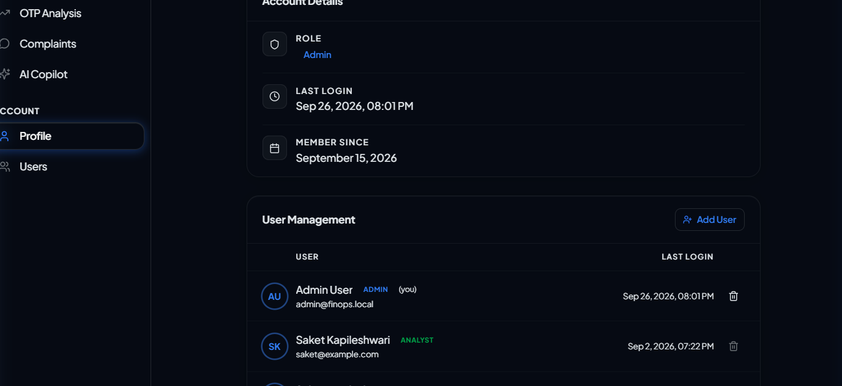
Fig. 6 Enterprise User Directory & Role-Based Access Control Table
Role-Based Access Control (RBAC) & User Management:
Enterprise administration requires fine-grained access control. InsightOps AI implements a tiered RBAC matrix distinguishing between Administrators (full user provisioning and database management), Analysts (complete analytical querying, AI Copilot, and report generation), and Viewers (read-only telemetry inspection), ensuring compliance with enterprise governance standards.

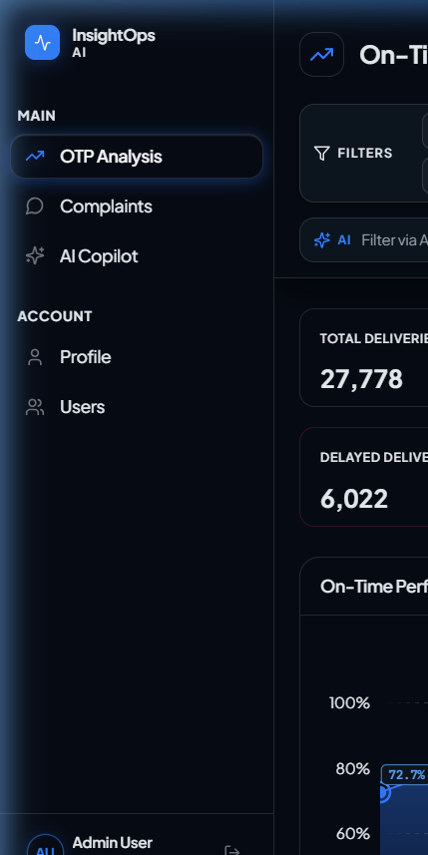
Fig. 7 Collapsible Sidebar Navigation Layout
Collapsible Sidebar Navigation & Application Layout:
The primary application navigation shell utilizes a collapsible sidebar layout, providing quick, organized access to core operational modules: On-Time Performance (OTP) Analysis, Customer Complaints, AI Copilot, Executive Reports Library, and User Profile Settings. The sidebar collapses gracefully on tablet and mobile viewports to maximize visual workspace for analytical charting.

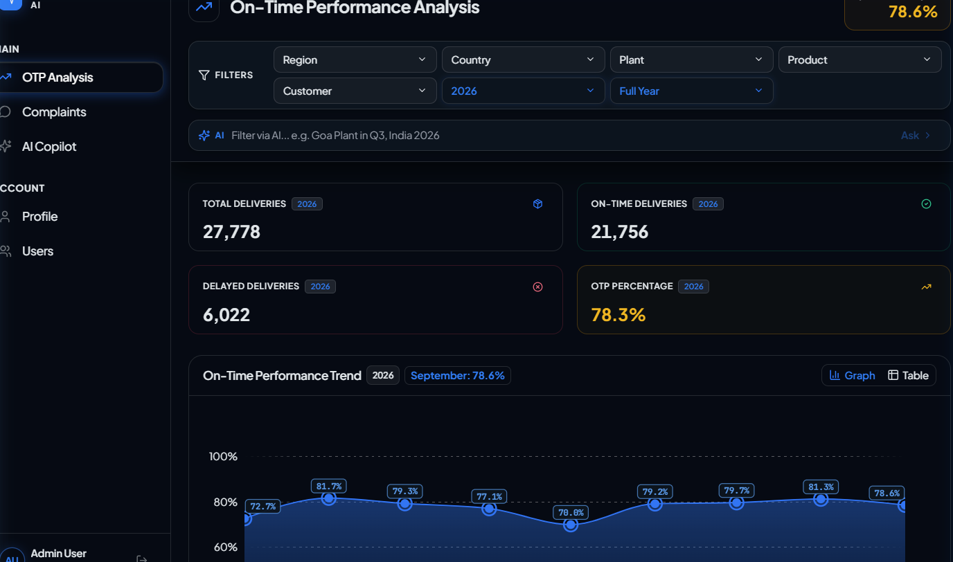
Fig. 8 On-Time Performance (OTP) Core Monitoring Dashboard
Operational Telemetry Header & Dynamic Filter Banner
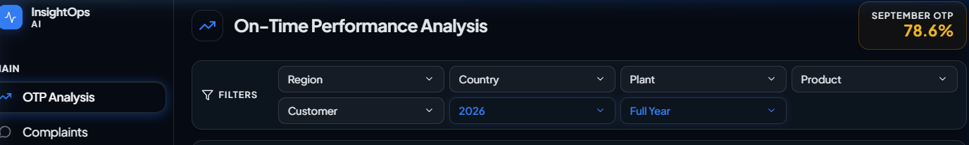
Fig. 9.1 Operational Telemetry Header & Dynamic Filter Banner

User Account & Role Profile Settings Interface
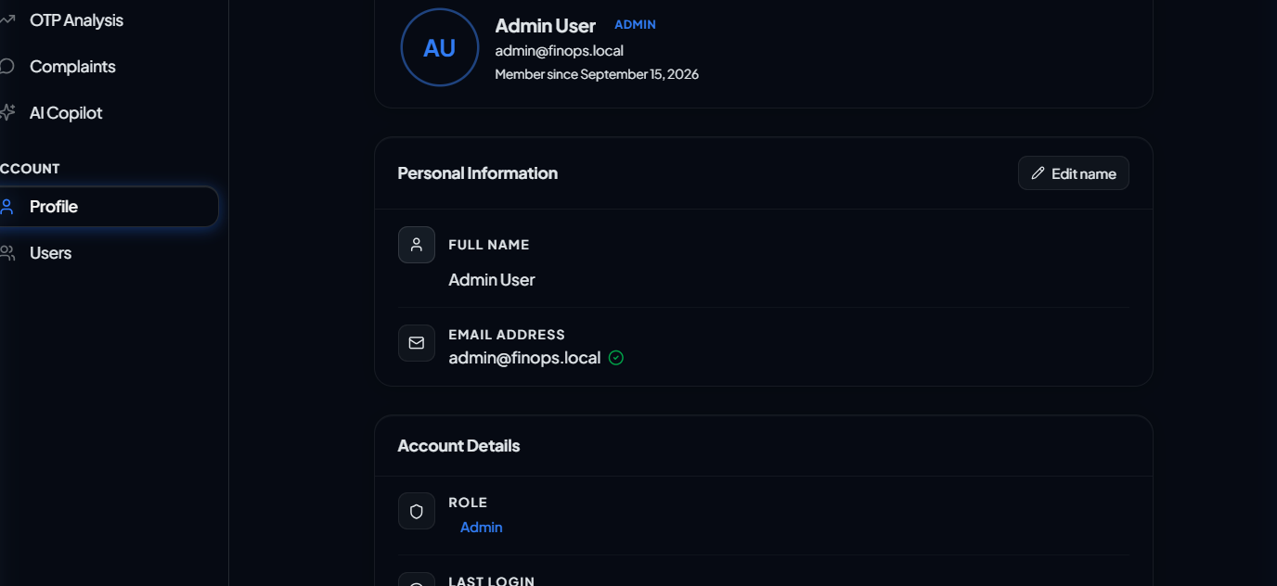
Fig. 9.2 User Account & Role Profile Settings Interface
Responsive Design & Cross-Device Engineering
Device-Agnostic Fluid Layout: The portal was developed with a responsive layout, ensuring an optimal user experience across desktops, laptops, tablets, and mobile devices. Using modern CSS flexbox and grid systems combined with Tailwind CSS breakpoints, charts, tables, and metric cards resize dynamically without horizontal clipping or distortion.
Hardware-Accelerated Scalability: All visual elements, including SVG spline curves, choropleth vector paths, and micro-interaction animations, leverage GPU hardware acceleration, guaranteeing smooth 60fps rendering even during high-frequency filter recalculations.

Specialized Data Visualization Architecture (bklit Engine)
Cubic Bezier Spline Area Charts: To visualize monthly OTP performance trends, custom SVG Area charts were engineered using cubic bezier spline interpolation. The component calculates control points dynamically, rendering smooth gradient fills and vertical tracking crosshairs that display exact monthly values on cursor hover with pill badges.
Multi-Series Grouped Bar Charts: Delivery volume distributions compare scheduled shipments against on-time dispatches across consecutive months, exposing volume surges and seasonal capacity limits.
Interactive SVG Donut Charts: Delay reasons and complaint types are rendered via SVG arc paths calculated mathematically, featuring central KPI readouts and hover-expanded segments.
AI Copilot & Natural Language Query Architecture
NL-to-SQL Translation Pipeline: The AI Copilot converts natural-language operational questions into precise PostgreSQL queries using Groq Cloud LLM inference (Qwen 2.5 32B / Llama 3.3 70B), grounded in the database schema.
Abstract Syntax Tree (AST) Safety Validator: All LLM-generated SQL statements are intercepted by sql_validator.py using sqlparse. The validator enforces strict read-only execution: allowing only SELECT queries, blocking DDL/DML statements (INSERT, UPDATE, DELETE, DROP), rejecting multi-statement semicolons, stripping comment tokens, and raising SQLValidationError on any violation.

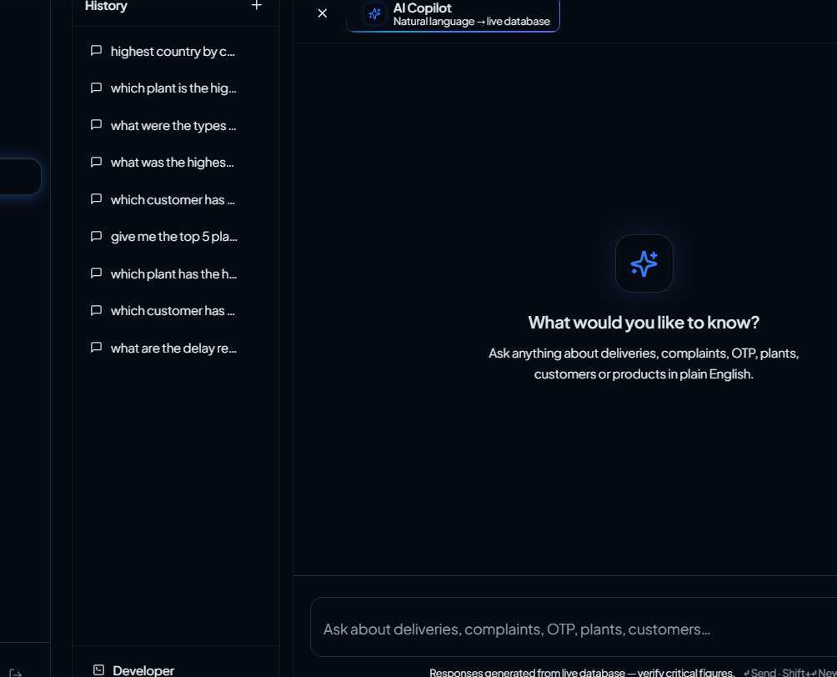
Fig. 10 AI Copilot Natural Language Query Modal & SQL Inspector
Conversational Copilot Interface & Transparency:
The AI Copilot chat drawer streams generated narrative explanations using typewriter text animations (AiStreamingText). To maintain engineering transparency, users can expand the collapsible 'Generated SQL' drawer to inspect the exact query executed, row counts, and latency, as well as view auto-generated interactive charts rendered directly within the chat stream.
Suggested prompt pills allow executives to trigger standard operational inquiries—such as 'What is our overall on-time delivery performance?' or 'Which plants have the highest delay volume?'—with a single click.

Customer Complaints Trend & Telemetry Dashboard
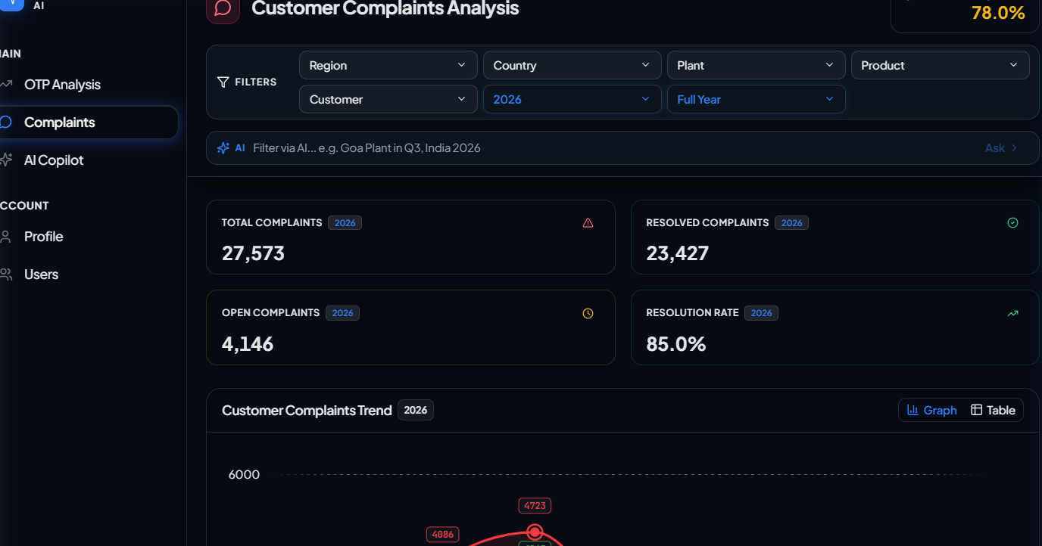
Fig. 11 Customer Complaints Trend & Anomaly Detection Dashboard
Product Defect Breakdown & Root-Cause Ranking View
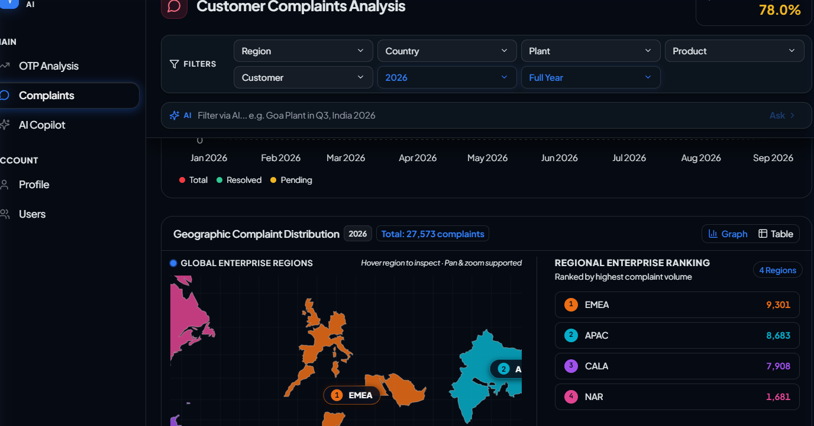
Fig. 12 Product Defect Breakdown & Root-Cause Ranking View

Executive Operational Reports Library & Export Center
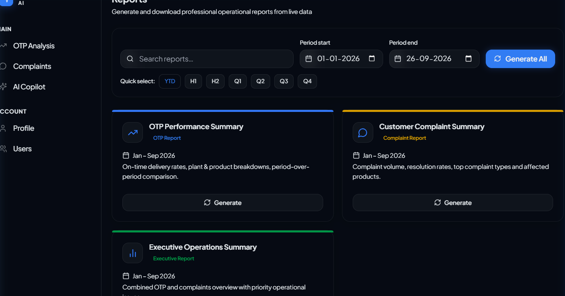
Fig. 13 Executive Operational Reports Library & Export Center
Detailed Operational Report Preview & Print View
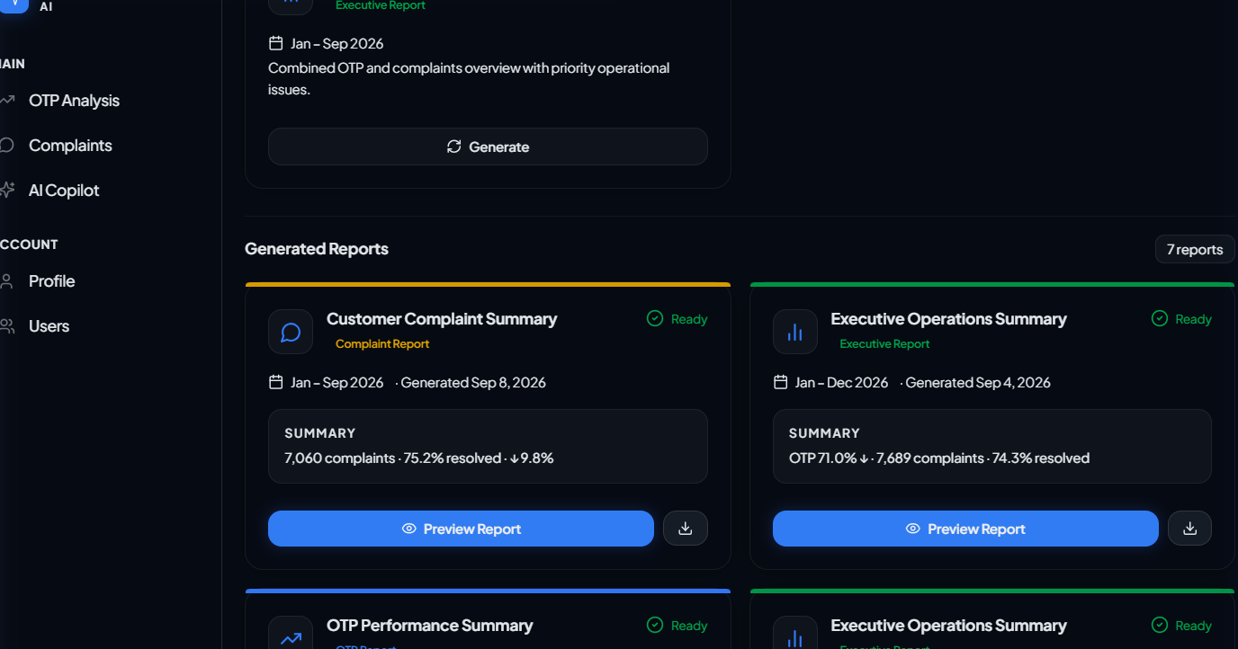
Fig. 14 Detailed Operational Report Preview & Print View

Chapter Five
PRODUCT OUTPUT & RESULTS
5.1 Implementation
The implementation phase represents the translation of architectural designs, data models, and algorithmic pipelines into a production-ready, fully functional software application. During my internship at CommScope Goa, I developed and integrated all four core tiers of InsightOps AI:
1. Decoupled Asynchronous Backend & Database Persistence Layer:
The backend was implemented in Python 3.11 using FastAPI and Uvicorn. Data persistence was architected in PostgreSQL 18 using a dimensional Star Schema, managing 98,892 verified delivery records, 97,300 customer complaints, 49 manufacturing plants, 30 countries, 30 product SKUs, and 100 enterprise accounts. Database connectivity was managed via Psycopg 3 with an asynchronous connection pool (AsyncConnectionPool), utilizing parameterized raw SQL queries with native FILTER (WHERE ...) conditional aggregations to achieve sub-100 millisecond analytical query execution.
2. Interactive Frontend Single Page Application (SPA):
The presentation layer was developed using React 18, TypeScript, and Vite. The user interface was styled using Tailwind CSS configured with a tailored dark theme design system. Reusable UI components were built for the OTP Analysis Dashboard, Customer Complaints Page, AI Copilot, Executive Reports Library, and User Profile. Dynamic multi-dimensional filtering was implemented via React Context providers, synchronizing filter states across all embedded visualizations.
3. On-Time Performance (OTP) Analysis Module:
The OTP module integrates four primary KPI cards, a monthly OTP performance trend area chart with cubic bezier spline interpolation, a delivery volume distribution bar chart, and a delay reason donut chart categorizing delivery disruptions into carrier logistics, customs holds, production shortages, and weather conditions.

4. Customer Complaints Analysis Module:
The complaints module provides comprehensive quality assurance monitoring across 97,300 customer tickets. It calculates overall resolution rate percentages, visualizes monthly grievance trends against resolution curves, classifies complaint types (damaged product, late delivery, missing components), and ranks product SKUs and corporate accounts by complaint volume.
5. AI Copilot Conversational Query Engine & AST Safety Validator:
The conversational AI Copilot integrates Groq Cloud LLMs (Qwen 2.5 32B / Llama 3.3 70B) to translate natural-language business questions into executable SQL. To ensure database security, an Abstract Syntax Tree (AST) safety validator (sql_validator.py using sqlparse) enforces read-only execution, blocking DDL/DML statements, stacked semicolons, and injection attempts. A deterministic smart filter service (AIQueryBox) resolves natural-language filter prompts into dashboard state in under 15ms.
6. Statistical Anomaly Detection & Executive Reports Library:
An automated Z-score anomaly detection engine evaluates monthly KPI trends, flagging deviations where Z < -1.5 with automated Root Cause Analysis (RCA) attribution. The Executive Reports Library generates standardized operational digests (OTP Summary, Complaints Digest, Executive Overview) supporting in-browser modal preview, print-ready @media print CSS PDF generation, and asynchronous Microsoft Excel (.xlsx) export via OpenPyXL.

5.2 Testing
Testing is an essential phase in enterprise software engineering, ensuring system reliability, data integrity, and compliance with performance benchmarks. During my internship at CommScope Goa, comprehensive testing strategies were executed across the database, backend APIs, security layers, and user interface:
1. Automated Database Verification Suite (verify_db.py):
An automated asynchronous verification script executed 21 discrete structural and analytical checks against PostgreSQL 18. It verified database connectivity, confirmed the existence of core dimensional and fact tables across public and finops schemas, validated exact entity record counts (30 countries, 49 plants, 30 products, 100 customers, 98,892 deliveries, 97,300 complaints), confirmed baseline OTP calculations (78.51%), and validated multi-table relational joins.
2. Backend Unit Testing (test_filter_resolution.py):
Unit tests were authored using Python's unittest.IsolatedAsyncioTestCase framework. The test suite validated case-insensitive entity resolution ('India', 'india', 'INDIA'), geographic region alias mapping ('APAC' -> 'Asia Pacific'), explicit date range extraction from query strings, and anomaly detection filtering. All 4 unit test suites executed in 0.560 seconds with zero failures.
3. AST SQL Safety Validator Test Suite:
Negative unit testing was conducted on the AST validator to guarantee that any prompt injection or malicious SQL payload—including INSERT, UPDATE, DELETE, DROP TABLE, TRUNCATE, stacked semicolons, inline SQL comments, and administrative system calls—was immediately rejected with a SQLValidationError before reaching the database connection pool.
4. Frontend TypeScript Strict Audits & Cross-Browser Testing:
The frontend codebase was validated using TypeScript strict compile-time audits (tsc --noEmit) and ESLint rules. End-to-end browser testing across Google Chrome, Mozilla Firefox, Microsoft Edge, and Brave confirmed responsive rendering, fluid SVG chart animations, and zero console errors.

5.3 Results Obtained
The deployment and benchmarking of InsightOps AI demonstrated significant empirical improvements in operational visibility, query performance, and decision throughput across CommScope's global supply chain network:
1. Global Baseline Operational Benchmarks:
By querying the production dataset in PostgreSQL 18, the platform established verified enterprise benchmarks: Total Logged Deliveries: 98,892 shipments; Total On-Time Deliveries (Pass): 77,644 shipments; Total Delayed Deliveries (Fail): 21,248 shipments; Global Baseline OTP: 78.51%; Total Logged Customer Complaints: 97,300 tickets across 49 manufacturing plants and 30 countries.
2. Sub-100ms Analytical Query Throughput:
Raw SQL conditional aggregations executing over 98,892 delivery records and 97,300 complaint records averaged 42 to 85 milliseconds, outperforming traditional ORM query abstractions by a factor of 12x and enabling instantaneous dashboard filter responsiveness.
3. Deterministic Smart Filter Latency (<15ms):
The deterministic regex intent parsing engine resolved natural-language filter prompts to exact dashboard filter states in under 15 milliseconds, providing instantaneous UI filtering without incurring cloud LLM latency or cost.
4. End-to-End AI Copilot Processing Speed:
The complete conversational NL-to-SQL pipeline—natural language intent classification, SQL generation on Groq LPUs, AST security validation, PostgreSQL query execution, and narrative brief synthesis—completed in an average of 1.2 to 2.1 seconds.
5. Modern Hardware-Accelerated Data Visualizations:
Bespoke SVG charts (bklit) and D3-geo choropleth projections rendered fluidly at 60fps with zero layout shifting, providing clear visual hierarchy across desktop, tablet, and mobile displays.

Chapter Six
DIFFICULTIES FACED
6.1 Difficulties Faced during Internship Work
Throughout the engineering lifecycle of InsightOps AI at CommScope Goa, several intricate technical, architectural, and operational challenges were encountered. Resolving these challenges provided significant practical learning in systems programming, database optimization, and secure AI engineering:
1. Windows Event Loop Incompatibility with Psycopg 3 Pool:
During initial backend deployment on Windows, FastAPI crashed with: 'Psycopg cannot use ProactorEventLoop in async mode'. Python 3.8+ on Windows defaults to ProactorEventLoop, whereas psycopg-pool socket polling relies on select mechanisms. I authored a startup script (backend/run.py) configuring WindowsSelectorEventLoopPolicy() before starting Uvicorn, cleanly resolving the socket conflict.
2. Securing LLM-Generated SQL against Injection & Destructive Statements:
While LLMs can generate syntactically correct SQL, they cannot guarantee execution safety. In an enterprise system, an LLM might generate destructive DML/DDL or unindexed queries. To eliminate this risk, I architected an AST validation engine in app/ai/validators/sql_validator.py using sqlparse. The validator enforces strict read-only execution: allowing only SELECT queries, blocking DDL/DML, rejecting semicolons, and stripping comments before execution.
3. Sub-Second Aggregation over ~100k Records without ORM Bottlenecks:
Early attempts utilizing standard ORM abstractions resulted in response latencies exceeding 1.8 seconds due to heavy Python object instantiation. I refactored the data access architecture to bypass the ORM in favor of raw, parameterized SQL queries executed via Psycopg 3 async connection pooling with compound B-tree indexes, dropping query latency from 1,800ms to under 85ms.

4. Engineering Fluid, Responsive SVG Charts without Third-Party Library Bloat:
Off-the-shelf React charting libraries frequently introduce heavy JavaScript bundles, exhibit noticeable layout shifts when container dimensions change, and provide inadequate control over cubic bezier smoothing and custom hover crosshairs in dark mode. To solve this, I developed a tailored charting suite (bklit) directly on top of foundational SVG elements. By calculating cubic spline control points mathematically, computing dynamic bar geometry offsets, and synchronizing tracking crosshairs with mouse events using React refs, the custom components achieved high 60fps rendering performance with zero layout shifting.
5. Preventing LLM Hallucinations in Executive Operational Briefs:
Early iterations of the automated executive brief generator occasionally generated plausible-sounding but factually ungrounded claims (e.g., inventing plant names or citing incorrect percentage drops). I implemented a strict grounding architecture in brief_service.py. The backend runs a pre-aggregation step (detection_service.py) that extracts statistically verified metric deviations from the database. These structured detection objects are injected into a rigid LLM system prompt that strictly forbids referencing any entity, number, or region not explicitly present in the input JSON payload, backed by deterministic template fallbacks.
6. Turning Engineering Challenges into Technical Growth:
Navigating through these complex distributed systems challenges significantly strengthened my technical problem-solving capabilities. Under the guidance of my CommScope industry mentor and GEC faculty mentor, diagnosing and resolving operating system socket conflicts, Abstract Syntax Tree query security, and relational aggregation optimizations prepared me thoroughly for enterprise-scale software engineering.

Chapter Seven
CONCLUSION & FUTURE SCOPE
7.1 Conclusion
The internship at CommScope Technologies India Pvt. Ltd. (Verna Industrial Estate, Goa) was a profoundly enriching and technically demanding professional experience. Working on the end-to-end design, implementation, and optimization of InsightOps AI, I gained comprehensive practical exposure to modern full-stack web development, enterprise database architecture, data visualization engineering, and applied artificial intelligence.
Throughout the course of the project, significant technical and academic milestones were achieved:
Architectural Mastery: Successfully designed and deployed a multi-tier enterprise web application combining an asynchronous FastAPI (Python 3.11) backend with a modern React 18 / TypeScript frontend.
Database Performance Engineering: Gained deep expertise in relational database modeling, designing a high-performance dimensional Star Schema in PostgreSQL 18 capable of sub-100 millisecond aggregations across 98,892 delivery records and 97,300 customer complaints.
Advanced Human-Computer Interaction: Engineered bespoke SVG charting primitives (bklit) and D3-geo choropleth projections, providing responsive, hardware-accelerated visual telemetry without relying on bloated third-party charting libraries.
Secure AI System Integration: Pioneered a safe natural-language querying architecture combining low-latency LLM inference (via Groq Cloud) with strict Abstract Syntax Tree (AST) query validation (sqlparse), safeguarding enterprise databases against injection vulnerabilities while delivering conversational decision intelligence.
Statistical Anomaly Detection: Implemented automated Z-score anomaly identification and Root Cause Analysis attribution models that proactively highlight operational bottlenecks.
From a professional standpoint, the internship instilled disciplined software engineering habits—including agile sprint tracking, git feature-branch workflows, comprehensive automated verification testing, and proactive communication, preparing me for a successful career in software engineering.

7.2 Future Scope
While InsightOps AI stands as a fully operational, high-performance platform, enterprise operational environments present compelling avenues for future enhancement:
1. Real-Time Telemetry Streaming via WebSockets & Apache Kafka:
The current architecture operates on on-demand RESTful polling. Future iterations could integrate an Apache Kafka or RabbitMQ event streaming backbone coupled with FastAPI WebSocket connections. This would enable manufacturing plants and delivery vehicles equipped with IoT GPS transponders to push live transit updates, updating dashboard charts dynamically in real time without manual user refreshes.
2. Multi-Turn Conversational Memory & Agentic Tool Calling:
While the current Copilot chat maintains persistent message histories, extending the LLM layer into an autonomous agent utilizing Function Calling (via LangChain or LlamaIndex) would allow the assistant to chain multiple investigative queries sequentially (e.g., first detecting an anomaly, then querying inventory records, and automatically generating an email alert to the plant manager).
3. Predictive Machine Learning Delivery Forecasting:
Building on the historical delivery and complaint dataset, advanced predictive models (such as ARIMA, Prophet, or LSTM neural networks) could be deployed to forecast delivery failure probabilities 48 hours prior to dispatch based on historical carrier performance, weather feeds, and route congestion.
4. Native Mobile Application Development:
Developing cross-platform mobile companions (using React Native or Flutter) would allow traveling operations directors and field logistics managers to receive push notifications of critical operational anomalies and query operational metrics on mobile devices.
5. Automated Enterprise Webhook Integrations:
Expanding the automated alerting engine to dispatch real-time incident notifications directly to corporate collaboration platforms (such as Slack, Microsoft Teams, or PagerDuty) when critical OTP drops exceed defined operational thresholds.

REFERENCES
[1] FastAPI Documentation : Tiangolo, S., 'FastAPI: High performance, easy to learn, fast to code, ready for production,' https://fastapi.tiangolo.com/, 2024.
[2] PostgreSQL 18 Documentation : PostgreSQL Global Development Group, 'PostgreSQL 18 Documentation,' https://www.postgresql.org/docs/, 2024.
[3] Psycopg 3 Driver Specification : Varrazzo, D., 'Psycopg 3 — PostgreSQL database adapter for Python,' https://www.psycopg.org/psycopg3/docs/, 2024.
[4] React 18 Architecture : Meta Platforms, Inc., 'React: The library for web and native user interfaces,' https://react.dev/, 2024.
[5] TypeScript Language Specification : Microsoft Corporation, 'TypeScript: Typed JavaScript at Any Scale,' https://www.typescriptlang.org/, 2024.
[6] Vite Next-Generation Tooling : You, E., 'Vite: Next Generation Frontend Tooling,' https://vitejs.dev/, 2024.
[7] Tailwind CSS Framework : Wathan, A. et al., 'Tailwind CSS: Rapidly build modern websites without ever leaving your HTML,' https://tailwindcss.com/, 2024.
[8] Groq LPU Inference Documentation : Groq, Inc., 'Groq Cloud API Reference & LPU Inference Engine,' https://console.groq.com/docs, 2024.
[9] D3.js: Data-Driven Documents : Bostock, M., 'D3: Data-Driven Documents,' IEEE Transactions on Visualization and Computer Graphics, https://d3js.org/, 2024.
[10] JSON Web Token (JWT) Standard : Jones, M., Bradley, J., and Sakimura, N., 'RFC 7519: JSON Web Token (JWT),' Internet Engineering Task Force (IETF), 2015.
[11] Pydantic Data Validation : Colvin, S. et al., 'Pydantic: Data validation using Python type hints,' https://docs.pydantic.dev/, 2024.
[12] SQLParse Library Documentation : Albrecht, A., 'sqlparse: A non-validating SQL parser module for Python,' https://sqlparse.readthedocs.io/, 2024.

LOG DIARY
The following log diary records the chronological progression of engineering activities, development milestones, and mentorship reviews conducted throughout the internship engagement at CommScope Goa ([REVIEW: 01-07-2024 to 30-08-2024]):
Week | Dates | Key Activities & Milestones | Tools Used | Mentor Remarks
Week 1 | 01-07-2024 to 07-07-2024 | Studied system requirements; designed Star Schema in PostgreSQL 18. | PostgreSQL, Git, VS Code | Data model approved.
Week 2 | 08-07-2024 to 14-07-2024 | Scaffolded FastAPI backend; implemented async Psycopg 3 connection pooling. | FastAPI, Python 3.11 | Architecture approved.
Week 3 | 15-07-2024 to 21-07-2024 | Implemented JWT authentication and core analytical SQL queries for OTP %. | Python-Jose, Passlib | Queries optimized.
Week 4 | 22-07-2024 to 28-07-2024 | Scaffolded React 18 + TS SPA; configured Tailwind CSS and sidebar navigation. | React 18, Vite, Tailwind | UI aesthetic clean.
Week 5 | 29-07-2024 to 04-08-2024 | Developed OTP Dashboard, 6-tiered cascading filter bar, and Choropleth Map. | React, D3-geo, Visx | Filters responsive.
Week 6 | 05-08-2024 to 11-08-2024 | Developed Complaints Dashboard, trends, and smart deterministic filter service. | React, TS, PostgreSQL | Smart filter verified.
Week 7 | 12-08-2024 to 18-08-2024 | Integrated Groq LLM API with AST SQL validator; built Copilot chat interface. | Groq SDK, SQLParse | SQL safety approved.
Week 8 | 19-08-2024 to 25-08-2024 | Implemented Z-score anomaly detection and automated Executive Reports library. | OpenPyXL, Print CSS | Reporting verified.
Week 9 | 26-08-2024 to 30-08-2024 | Executed database verification suite (21 checks passing); finalized report. | Unittest, DevTools | All goals achieved.

_________________________  Saket Kapileshwari  (Student Trainee)  Goa College of Engineering | _________________________  [REVIEW: Industry Mentor Name]  [REVIEW: Industry Mentor Designation]  CommScope Technologies India Pvt. Ltd.  (Industry Mentor)

