DESIGN AND FRONTEND DEVELOPMENT OF TRAIL:
A JOURNEY-FIRST LOCAL DISCOVERY PLATFORM
Internship Report
Submitted in fulfillment of the requirements for the degree of
BACHELOR OF ENGINEERING
IN
INFORMATION TECHNOLOGY & ENGINEERING
by
PURVA MAPARI
Roll No: [INSERT ROLL NUMBER]
Faculty Mentor:  [INSERT FACULTY MENTOR NAME]  Assistant Professor  Dept. of IT & Engineering  Goa College of Engineering | Industry Mentor:  [INSERT INDUSTRY MENTOR NAME]  [INSERT DESIGNATION]  Fluxatic Global  Goa, India

DEPARTMENT OF INFORMATION TECHNOLOGY & ENGINEERING
GOA COLLEGE OF ENGINEERING
(GOVERNMENT OF GOA)
FARMAGUDI, PONDA, GOA - 403 401
GOA UNIVERSITY
(2026-2027)

DECLARATION
I hereby declare that the Internship work entitled “DESIGN AND FRONTEND DEVELOPMENT OF TRAIL: A JOURNEY-FIRST LOCAL DISCOVERY PLATFORM” is an authentic record of my own work carried out at Fluxatic Global, Goa as requirements for the award of degree of Bachelor of Engineering in Information Technology & Engineering of Goa University, under the guidance of [INSERT INDUSTRY MENTOR NAME] ([INSERT DESIGNATION], Fluxatic Global) and [INSERT FACULTY MENTOR NAME] (Assistant Professor, Department of Information Technology & Engineering, Goa College of Engineering), during the Internship period from [INSERT EXACT INTERNSHIP START DATE] to [INSERT EXACT INTERNSHIP END DATE].
I further declare that this report has not been previously submitted in part or in full to any other University or Institution for the award of any degree or diploma.
Date: ____________________ (Signature of Student)
Place: Farmagudi, Goa Name: Purva Mapari
Roll No: [INSERT ROLL NUMBER]
Certified that the above statement made by the student is correct to the best of our knowledge and belief.
______________________________  [INSERT FACULTY MENTOR NAME]  Faculty Mentor  Goa College of Engineering | ______________________________  [INSERT INDUSTRY MENTOR NAME]  Company Mentor  Fluxatic Global, Goa

INTERNSHIP APPROVAL SHEET
The Internship entitled “DESIGN AND FRONTEND DEVELOPMENT OF TRAIL: A JOURNEY-FIRST LOCAL DISCOVERY PLATFORM” by Purva Mapari (Roll No: [INSERT ROLL NUMBER]) completed in the academic year 2026-2027 is approved for fulfillment of the requirements for the degree of BACHELOR OF ENGINEERING in INFORMATION TECHNOLOGY & ENGINEERING, and is a record of bonafide work carried out successfully.

______________________________  [INSERT FACULTY MENTOR NAME]  (Internship Mentor)  Information Technology & Engineering Dept.  Goa College of Engineering | ______________________________  Dr. Nilesh B. Fal Dessai  (Head of Department)  Information Technology & Engineering Dept.  Goa College of Engineering
Examiners
(Internal Examiner)  Name: _______________________  Designation: ____________________  Date: _________________________ | (External Examiner)  Name: _______________________  Designation: ____________________  Date: _________________________

DATE:
PLACE: GEC, Farmagudi
ACKNOWLEDGEMENT
It gives me immense pleasure and satisfaction to put forward this internship report and to express my sincere gratitude to many people who have helped me directly or indirectly to carry out this Internship.
First and foremost, I express my deep gratitude to my Industry Mentor, [INSERT INDUSTRY MENTOR NAME] ([INSERT DESIGNATION], Fluxatic Global, Goa), for offering invaluable technical guidance, creative encouragement, and continuous mentorship throughout the design and frontend engineering of TRAIL. Working within Fluxatic Global's collaborative product engineering culture has provided me with profound insights into modern user-centric design workflows and contemporary digital agency practices.
I would like to express my heartfelt appreciation to my Faculty Mentor, [INSERT FACULTY MENTOR NAME], Assistant Professor, Department of Information Technology & Engineering, Goa College of Engineering, for continuous encouragement, academic support, and constructive feedback at every stage of my internship.
I would like to thank our Internship Coordinator, Mr. Mario Pinto, for his constant organizational support, administrative coordination, and helpful guidance throughout the internship placement.
I extend my sincere thanks to our Head of Department, Dr. Nilesh B. Fal Dessai, for his steadfast support, departmental leadership, and constant motivation.
I would like to thank our Principal, Dr. Krupashankara M. S., for his institutional support and for fostering an academic environment that encourages real-world industry engagements.
I also express my sincere gratitude to all teaching and non-teaching staff of the Department of Information Technology & Engineering for their continuous assistance. Finally, I owe heartfelt thanks to my parents, family, and friends who have supported and encouraged me in every way for the successful completion of this internship work.
Purva Mapari
B.E. (Information Technology & Engineering)
Goa College of Engineering, Farmagudi

ABSTRACT
In the contemporary digital travel and urban exploration landscape, discovery mechanisms have become fundamentally destination-centric and algorithmically predictable. Mainstream navigation utilities (e.g., Google Maps, Apple Maps) prioritize lowest-latency point-to-point routing, treating the physical terrain between origin and terminus as a void to be traversed as quickly as possible. Concurrently, social media portals and recommendation platforms generate disjointed, commercialized 'top-10' lists that induce severe decision paralysis, forcing users to manually cross-reference opening hours, walking distances, and route coherence across multiple apps. This creates substantial friction for young, curious explorers who seek authentic cultural textures and serendipitous discoveries without enduring hours of tedious manual planning.
This internship report documents the end-to-end design, user experience architecture, and frontend implementation of TRAIL—a journey-first cartographic pedestrian discovery platform developed during my two-month internship at Fluxatic Global, Goa. Built under the governing design philosophy “Don't just get there. Discover along the way,” TRAIL inverts traditional discovery paradigms by transforming individual urban spots into connected, sequenced, and foot-calibrated walking journeys. The platform analyzes multidimensional user context—available time budgets, thematic curiosities, ambient moods, and movement cadences—to synthesize coherent pedestrian itineraries with authentic dwell times and verified walking corridors.
The internship followed a structured curriculum of five foundational milestones (enterprise IT organization analysis, Spotify platform architecture deconstruction, brand identity research, Netflix/Uber/IKEA business model analysis, and Google Stitch/Figma design systems) that directly informed the flagship TRAIL venture. Functioning as Member 3 (Product & UX / Frontend Designer), my individual contributions encompassed: (1) formulating problem statements and user personas for curious urban explorers; (2) constructing a detailed 7-stage User Journey Map (Awareness, Discovery, Sign Up, First Use, Core Experience, Outcome, Retention); (3) creating a bespoke editorial brand system anchored by Five Character Pillars (Curious, Unexpected, Human, Active, Contemporary) with natural earth-tone tokens (Warm Sand, Deep Forest, Terracotta Ochre); (4) authoring a modular atomic component library in Figma; and (5) engineering an interactive, responsive frontend application in Next.js 16.3.7, React 18, TypeScript, and Tailwind CSS. The implemented platform delivers six integrated product screens (Landing Page, Explore Catalog, Trail Details Dossier, Active Trail Navigation HUD with Completion Ledger, Create Trail Route Builder, and AI Discovery Studio), fully integrated with the team's TRAIL Scout AI conversational discovery agent and a 21+ Panaji cultural POI dataset, deployed live on Vercel.

TABLE OF CONTENTS
Certificate | i
Declaration | ii
Internship Approval Sheet | iii
Acknowledgement | iv
Abstract | v
Table of Contents | vi
List of Figures | viii
List of Tables | ix
List of Abbreviations | x
Chapter One: BRIEF OVERVIEW | 1
1.1 Overview | 1
1.2 Proposed Work | 3
Chapter Two: INTRODUCTION | 5
2.1 Product Objectives | 5
Chapter Three: INDUSTRY OVERVIEW | 7
3.1 Industry Work Culture | 7
3.2 Industry Domains | 9
Chapter Four: REVIEW OF WORK DONE | 11
4.1 Work Methodology | 11
4.2 Tools & Technologies Used | 14
4.3 Design of the Product | 17
4.3.1 Problem Definition & Discovery Friction | 17
4.3.2 Product Logic & The TRAIL Value Proposition | 20
4.3.3 Comprehensive User Journey Mapping | 23
4.3.4 Brand Identity & Character Pillars | 27
4.3.5 Information Hierarchy & Visual Direction | 30
4.3.6 Wireframing & Figma Design System | 32
4.3.7 Team System & AI Scout Architecture | 35
Chapter Five: PRODUCT OUTPUT & RESULTS | 38
5.1 Implementation | 38
5.2 Testing | 45
5.3 Results Obtained | 47
Chapter Six: DIFFICULTIES FACED | 49
6.1 Difficulties Faced during Internship Work | 49
Chapter Seven: CONCLUSION & FUTURE SCOPE | 52
7.1 Conclusion | 52
7.2 Future Scope | 54
References | 56
Log Diary | 58

LIST OF FIGURES
Figure | Name / Caption | Page No.
Fig. 1.1 | TRAIL Product Definition & Core Philosophy | 2
Fig. 2.1 | Destination-Centric vs. Journey-Centric Discovery Paradigm | 6
Fig. 4.1 | Five Brand Character Pillars of TRAIL | 28
Fig. 4.2 | TRAIL End-to-End User Journey Map | 25
Fig. 4.3 | TRAIL Multi-Tier Architecture & AI Scout Pipeline | 36
Fig. 5.1 | TRAIL Landing Page Hero & Interactive Walk Switcher | 39
Fig. 5.2 | Explore Trails Catalog & Multi-Category Filtering Interface | 40
Fig. 5.3 | AI Discovery Studio Configuration & Parameter Calibration | 41
Fig. 5.4 | Comprehensive Trail Details Dossier & Waypoint Guidance | 42
Fig. 5.5 | Create Trail Manual Route Builder & Waypoint Sequencing | 43
Fig. 5.6 | Active Trail Live Navigation HUD & Traversal Corridor | 44

LIST OF TABLES
Table No. | Title | Page No.
Table 1.1 | Internship Engineering Phased Scope & Deliverables | 4
Table 4.1 | Tools, Frameworks, and Technologies Employed | 16
Table 4.2 | TRAIL Comprehensive 7-Stage User Journey Analysis | 26
Table 4.3 | Copywriting Comparison: Generic Utilities vs. TRAIL Voice | 29
Table 4.4 | TRAIL Curated Panaji Cultural Spot Inventory (Sample) | 37
Table 5.1 | Implemented TRAIL Screen Inventory & Features | 38
Table 5.2 | Cross-Viewport Responsive Layout Audit Matrix | 46
Table 7.1 | Planned Enhancements and Future Scaling Roadmap | 55

LIST OF ABBREVIATIONS
ABBREVIATION | EXPANSION
AI | Artificial Intelligence
API | Application Programming Interface
AST | Abstract Syntax Tree
B2B | Business-to-Business
B2C | Business-to-Consumer
BMC | Business Model Canvas
BYOK | Bring Your Own Key (Client API Storage)
CDN | Content Delivery Network
CSS | Cascading Style Sheets
CTA | Call to Action
DOM | Document Object Model
Figma | Collaborative Interface Design Tool
GEC | Goa College of Engineering
GPS | Global Positioning System
HOD | Head of Department
HTML | HyperText Markup Language
HUD | Heads-Up Display
IT | Information Technology
JSON | JavaScript Object Notation
LLM | Large Language Model
MRR | Monthly Recurring Revenue
OSM | OpenStreetMap
PII | Personally Identifiable Information
POI | Point of Interest
PWA | Progressive Web Application
REST | Representational State Transfer
RSC | React Server Components
SPA | Single Page Application
SSR | Server-Side Rendering
SVG | Scalable Vector Graphics
TAM | Total Addressable Market
TS | TypeScript
UI | User Interface
UML | Unified Modeling Language
UX | User Experience
WGS 84 | World Geodetic System 1984

Chapter One
BRIEF OVERVIEW
1.1 Overview
The Bachelor of Engineering (B.E.) curriculum in Information Technology & Engineering at Goa College of Engineering requires a mandatory industrial internship designed to bridge theoretical academic principles with commercial engineering realities. From August 2026 to October 2026, I undertook an intensive two-month internship at Fluxatic Global, a premier digital solutions enterprise headquartered in Goa. Working as a UI/UX and Product Design Intern, I functioned as Member 3 (Product & UX / Frontend Designer) within a multidisciplinary project engineering team tasked with conceiving, designing, and engineering TRAIL—a journey-first cartographic pedestrian discovery platform.
Fluxatic Global operates as a remote-first, agile technology agency that seamlessly integrates brand strategy, user-centered interface architecture, custom software development, and artificial intelligence to deliver measurable digital impact. Under the operational ethos of "Elevating, Educating & Empowering humanity using technology and creativity," the organization fosters a rigorous product incubation culture. The internship was structured across two interconnected operational thrusts: first, a structured curriculum of foundational industry deliverables (Assignments 01 through 05) that systematically unpacked enterprise IT organization structures, platform media streaming mechanics, brand identity systems, business model mechanics, and component design systems; and second, the end-to-end design and frontend realization of the flagship venture TRAIL.
The core concept of TRAIL is encapsulated by the governing thesis: "Don't just get there. Discover along the way." Conventional navigation utilities (such as Google Maps, Apple Maps, and municipal routing applications) are inherently destination-obsessed, calculating the mathematically fastest, lowest-latency vector from point A to point B while treating the intervening urban topography as frictionless void to be minimized. Conversely, social recommendation portals (such as TripAdvisor, Instagram, and Yelp) produce disjointed, algorithmic "top 10" lists that trigger severe cognitive fatigue and decision paralysis, requiring users to manually cross-reference opening hours, geographic feasibility, and narrative pacing. TRAIL resolves this critical systemic disconnect by inverting the discovery paradigm: shifting user focus from isolated destinations to cohesive, sequenced pedestrian journeys.
As Member 3, my individual core responsibility encompassed the holistic product and user experience design lifecycle—conducting target audience reconnaissance, synthesizing multi-stage user journey maps, formulating brand identity systems in Figma, executing generative UI explorations in Google Stitch, constructing reusable design component libraries, and translating these high-fidelity specifications into an interactive, hardware-accelerated frontend application built with Next.js 16, React 18, TypeScript, and Tailwind CSS.
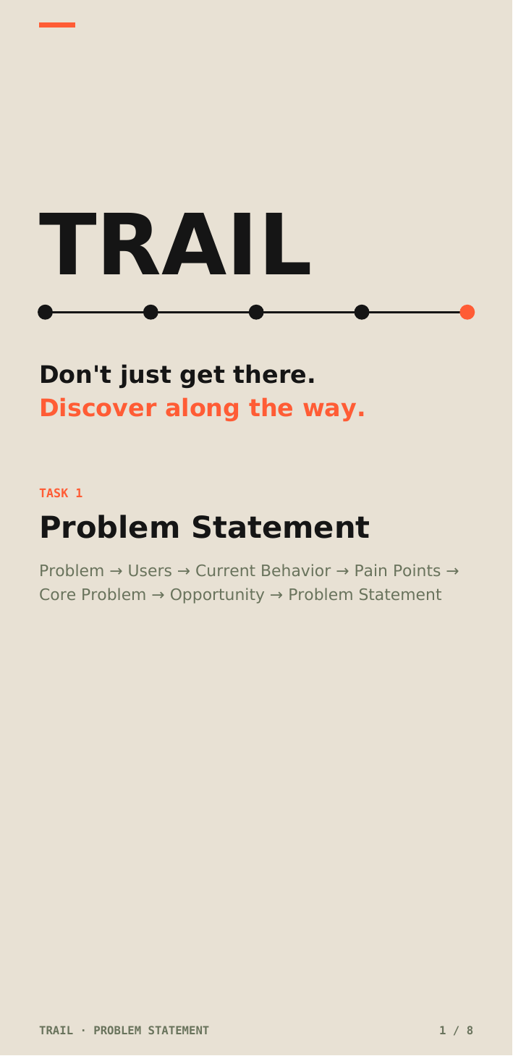
Fig. 1.1 — TRAIL Product Definition & Core Philosophy
1.2 Proposed Work
The proposed scope of work for the internship at Fluxatic Global was established through six sequential engineering phases, ensuring that conceptual design hypotheses were rigorously tested and realized in production code:
Phase 1 — Industry Landscape & Organizational Understanding: Investigate enterprise IT organizational hierarchies, vertical industry business units, technology delivery centers, and operational risk factors through Assignment 01, establishing a foundational comprehension of corporate software engineering workflows.
Phase 2 — Platform & System Architecture Deconstruction: Conduct a deep-dive architectural analysis of global consumer platforms through Assignment 02 (Spotify), dissecting the five core structural tiers—User Interface, Database & User Account Models, Content Streaming Engines, Algorithmic Recommendation Systems, and Monetization Pipelines.
Phase 3 — Brand Identity Systems & Visual Foundations: Execute structured branding and visual design explorations through Assignment 03, constructing collaborative Miro boards, analyzing global athletic and outdoor brand logos (Nike, Strava, ACG, FedEx), and defining the core cartographic visual language for TRAIL.
Phase 4 — Business Model Mechanics & Value Dynamics: Perform a rigorous comparative analysis through Assignment 04 evaluating the business model canvases of Netflix (SVOD Subscription), Uber (Two-Sided Platform Orchestration), and IKEA (Integrated Retail Supply Chain), synthesizing core principles of value creation, value delivery, and value capture.
Phase 5 — User Experience Frameworks & Design Systems: Formulate detailed user personas, behavioral journey maps, and wireframe prototypes using Figma and Google Stitch through Assignment 05, laying down responsive design tokens, typography scales, and modular atomic UI components.
Phase 6 — Capstone Venture Execution (TRAIL): Apply the cumulative insights to design and engineer the production-grade TRAIL web platform. This involved mapping the 7-stage User Journey Map, building high-fidelity interactive screens across all core product workflows (Landing Page, Explore Catalog, Trail Details Dossier, Active Trail Navigation HUD, Create Trail Builder, and AI Discovery Studio), engineering the responsive frontend in Next.js 16 and Tailwind CSS, integrating team telemetry and AI Scout endpoints, and preparing comprehensive venture presentation assets.
Table 1.1 — Internship Engineering Phased Scope & Deliverables
Phase | Milestone Focus | Core Deliverables & Outcomes
Phase 1 | Industry & Team Analysis | Studied enterprise IT organization hierarchies and business delivery units (Assignment 01).
Phase 2 | Platform Architecture | Deconstructed Spotify streaming, database models, and recommendation pipelines (Assignment 02).
Phase 3 | Brand & Visual Identity | Conducted logo research (Nike, Strava, ACG) and established TRAIL visual direction (Assignment 03).
Phase 4 | Business Model Synthesis | Analyzed business model canvases of Netflix, Uber, and IKEA across value creation/capture (Assignment 04).
Phase 5 | UX Systems & Tools | Developed user personas, UML flows, wireframes, and Google Stitch UI explorations (Assignment 05).
Phase 6 | TRAIL Product & Frontend | Engineered 7-stage User Journey, Figma design tokens, and Next.js 16 interactive frontend deployed to Vercel.

Chapter Two
INTRODUCTION
2.1 Product Objectives
The primary objective of developing TRAIL during my internship at Fluxatic Global was to engineer a journey-first pedestrian exploration platform that overcomes the fragmentation, cognitive overload, and algorithmic homogeneity of traditional travel tools. The project was governed by seven core product objectives:
1. Invert the Discovery Paradigm from Destination to Journey: Transform isolated urban waypoints into thoughtfully sequenced, contiguous pedestrian itineraries where the transit between points is celebrated as an intrinsic component of the experience rather than dead travel time.
2. Alleviate Planning Friction and Multi-App Toggling: Eliminate the tedious manual labor of cross-referencing maps, blog posts, reviews, and social bookmarks by providing pre-curated, foot-verified walking routes with verified temporal dwell budgets.
3. Establish Human-Centric Contextual Personalization: Allow pedestrian explorers to calibrate itineraries based on real-time subjective parameters—available time budget (1h, 2h, 3h, 4h), sensory & cultural themes (Art, Coffee, Heritage, Books, Courtyards), ambient mood (Curious, Relaxed, Contemplative, Energetic, Romantic), and movement cadence (Walking, Slow Wanderer, Photography Pace, Active Strider).
4. Deliver Ambient, Screen-Minimized Field Guidance: Create an uncluttered active navigation interface that provides essential spatial orientation (bearing, elevation gradients, laterite flagstone notes, curator discovery clues) while encouraging explorers to keep their eyes up and engage directly with the physical environment.
5. Engineer a Cohesive Contemporary Editorial Brand Identity: Formulate an evocative, tactile design system rooted in Warm Sand (#F4F2EB), Deep Forest Green (#183D2B), and Terracotta Ochre (#E36A2E), supported by high-contrast editorial serif typography (Newsreader / PT Serif) that evokes physical field journals and antique cartography.
6. Support Seamless AI-Assisted Discovery (TRAIL Scout): Provide a seamless presentation layer for the team's AI discovery engine, allowing conversational exploration and dynamic trail generation grounded in a hand-vetted dataset of 24+ Panaji cultural waypoints with deterministic offline fallback guarantees.
7. Ensure Device-Agnostic Responsive Performance: Engineer a high-performance Next.js 16 frontend ensuring instantaneous sub-500ms initial loads, smooth 60fps micro-interactions, fluid touch gestures, and complete visual integrity across mobile viewports, tablets, and desktop displays.
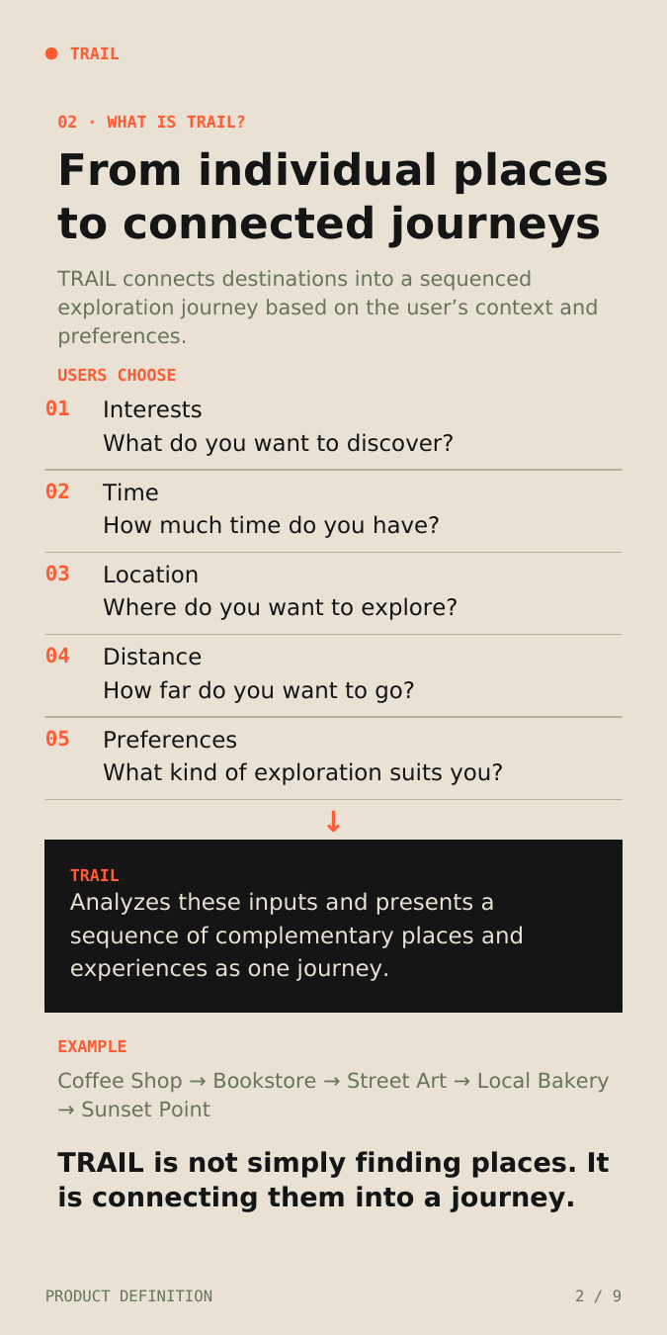
Fig. 2.1 — Destination-Centric vs. Journey-Centric Discovery Paradigm

Chapter Three
INDUSTRY OVERVIEW
3.1 Industry Work Culture
Fluxatic Global operates under modern agile engineering and product development methodologies tailored for distributed, high-autonomy teams. As an intern, I was integrated into a fast-paced product sprint rhythm characterized by daily asynchronous stand-ups, weekly design reviews, and collaborative problem-solving sessions.
Key operational and cultural facets of the engineering environment included:
- User-Centric Design Sprints: Product features were conceptualized through rapid iterative prototyping cycles. Initial ideas were quickly mocked up in Miro and Google Stitch, refined into structured Figma components, and presented during peer critiques before committing to code.
- Remote-First Autonomous Ownership: Interns were given substantial ownership over core deliverables. As Member 3, I held primary responsibility for the user journey architecture, visual design system, and frontend presentation layer, collaborating closely with teammates handling business strategy and data engineering.
- Design-to-Development Handoff Governance: The organization emphasized seamless synchronization between design tokens and implementation code. Spacing units, color hex values, and typography hierarchies defined in Figma were directly mapped to Tailwind CSS configuration files, ensuring pixel-perfect fidelity.
- Git Version Control & Continuous Deployment: All codebase modifications were governed via GitHub feature branches. Code was subjected to strict TypeScript compiler verification (tsc --noEmit) and automated linting before being merged into the main trunk and deployed continuously to production via Vercel.
3.2 Industry Domains
Throughout the internship, my work intersected four dynamic, high-growth domains within the contemporary digital technology sector:
1. User Interface & User Experience (UI/UX) Architecture: Modern consumer applications require intuitive information hierarchies and empathetic interaction flows that minimize cognitive friction. In the travel and leisure space, user attention is fleeting; platforms must communicate geographic context, time requirements, and experiential value within seconds.
2. Modern Frontend Engineering & Jamstack Platforms: The web engineering ecosystem has evolved toward server-side rendered (SSR) and statically generated (SSG) architectures. Leveraging Next.js 16, React 18, and Tailwind CSS enables developers to construct blazingly fast, SEO-optimized web applications with seamless client-side page transitions and robust type safety.
3. Design Systems & Cartographic Brand Identity: Enterprise digital products demand consistent visual languages. Developing a design system involves codifying design tokens, typography scales, accessibility contrasts, and reusable atomic UI primitives that scale harmoniously across diverse viewports.
4. AI-Assisted Conversational Decision Systems: The rapid rise of Large Language Models (LLMs) has transformed user discovery from static keyword searches to natural-language intent parsing. Integrating conversational agents (such as Google Gemini 1.5 Pro) with local domain datasets bridges the gap between open-ended traveler desires and concrete, walkable itineraries.

Chapter Four
REVIEW OF WORK DONE
4.1 Work Methodology
The development of TRAIL was approached through a rigorous, user-centric, and iterative product engineering lifecycle. Rather than jumping directly into interface coding or relying on ad-hoc aesthetic choices, I executed a disciplined six-phase work methodology spanning academic research, empathetic user journey mapping, design system creation, atomic prototyping, and frontend implementation:
1. Requirements Gathering & Discovery Synthesis: Conducted deep comparative research into existing consumer travel platforms (Google Maps, TripAdvisor, AllTrails, Strava, and social media discovery channels). Extracted the core friction points experienced by young urban explorers and synthesized the underlying problem hypotheses regarding fragmented multi-app research and destination bias.
2. Conceptual Modeling & Milestone Assignments: Progressed through structured internship assignments analyzing IT enterprise structures (Assignment 01), audio streaming architecture (Assignment 02), brand identity systems (Assignment 03), business model mechanics (Assignment 04), and design systems (Assignment 05). These assignments established the theoretical bedrock for designing a scalable consumer platform.
3. User Persona & Journey Architecture: Formulated archetypal user personas representing culturally curious urban wanderers and local curators. Developed an extensive 7-stage User Journey Map (Awareness, Discovery, Sign Up, First Use, Core Experience, Outcome, Retention) detailing user behaviors, cognitive thoughts, emotional states, pain points, and systemic product opportunities across every touchpoint.
4. Brand System Formulation & Atomic Wireframing: Defined the brand character pillars (Curious, Unexpected, Human, Active, Contemporary), color palettes, and typographic scales in Figma. Constructed low-fidelity wireframes exploring spatial layouts, card packaging, timeline sequencing, and mobile responsiveness. Conducted generative UI explorations in Google Stitch to assess dynamic layout variations.
5. High-Fidelity UI Design & Component System: Engineered a comprehensive Figma component library containing atomic tokens, button variants, telemetry badges, station progression markers, and photo plate cards. Produced high-fidelity mockups for all primary product screens: Landing Page, Explore Catalog, Trail Details Dossier, Active Trail Navigation HUD, Create Trail Builder, and AI Discovery Studio.
6. Frontend Implementation & Team Integration: Translated the finalized design system into production-ready Next.js 16 and Tailwind CSS code. Developed modular React components, integrated client-side state caching, connected team AI endpoints and curated datasets, conducted responsive cross-browser audits, and deployed the live application to Vercel.
4.2 Tools & Technologies Used
Throughout the internship, I leveraged an industry-standard modern technology and design stack to architect, prototype, and implement the TRAIL platform:
1. Figma (UI/UX Design & Token System):
Figma served as the primary collaborative design environment. I utilized Figma for constructing auto-layout component hierarchies, responsive layout grids, interactive click-through prototypes, and the centralized TRAIL Design System library containing typography styles, color tokens, and elevation levels.
2. Google Stitch (Generative UI Prototyping):
Google Stitch was explored during the conceptual design phase to generate rapid visual explorations, test alternative component packaging models, and assess spatial layout densities for dense cartographic dashboards before finalizing vectors in Figma.
3. Miro (Collaborative Research & Journey Mapping):
Miro provided the infinite digital canvas for initial competitive benchmarking, user journey diagramming, persona card mapping, and team brainstorming during the early research milestones.
4. React 18 & Next.js 16 (Presentation Layer):
The interactive frontend was constructed using React 18 and Next.js 16.3.7 with Turbopack. Leveraging the App Router, React Server Components (RSC), and Suspense boundaries enabled deterministic initial server hydration, sub-second route transitions, and optimal client-side bundle performance.
5. TypeScript (Strict Type Safety):
TypeScript was enforced across the frontend codebase to establish strict type definitions for all core data entities—including RichTrail, DetailedStop, CuratorPreferences, Spot, and UserContext—eliminating runtime null-pointer exceptions and ensuring reliable contract interfaces with backend services.
6. Tailwind CSS & Custom Design Tokens:
Tailwind CSS was configured with bespoke design tokens embodying TRAIL's physical field-journal aesthetic. Custom utility classes and CSS variables were defined for Warm Sand (#F4F2EB, #FAF8F3), Deep Forest (#183D2B), Terracotta Ochre (#E36A2E), and Sage Olive (#4E6B48).
7. Lucide React (Vector Iconography):
An extensive suite of clean, lightweight SVG vector icons from Lucide React was integrated to provide tactile spatial cues—such as Footprints, Compass, MapPin, Sparkles, Clock, ShieldCheck, and ArrowRight.
8. Vercel (Continuous Deployment & Hosting):
The frontend codebase was integrated with Vercel for automated continuous integration and global edge deployment, accessible live at trail-three-psi.vercel.app.
Table 4.1 — Tools, Frameworks, and Technologies Employed
Technology | Functional Domain | Implementation Context & Usage
Figma | UI/UX & Design Systems | Auto-layout hierarchies, design token libraries, interactive prototyping, and handoff.
Google Stitch | Generative UI Exploration | AI-assisted screen layout variations, spatial density testing, and rapid concept generation.
Miro | Collaborative UX Research | User journey mapping, competitive benchmarking boards, and stakeholder brainstorming.
Next.js 16.3.7 | Presentation Layer Architecture | App Router, React Server Components (RSC), Suspense boundaries, and Turbopack compiler.
React 18 | Component Modeling | Modular stateful components, React Context filter synchronization, and client-side hooks.
TypeScript | Strict Type Verification | Interface contracts for trails, waypoints, categories, telemetry, and API data payloads.
Tailwind CSS | Design Token Implementation | Bespoke color palette (Sand/Forest/Ochre), fluid typography, and media query breakpoints.
Lucide React | Tactile Vector Iconography | Clean SVG symbols for spatial waypoints, bearings, footprints, and curation tags.
Vercel | Edge Deployment Platform | Continuous deployment pipeline connected to GitHub trunk; live at trail-three-psi.vercel.app.
4.3 Design of the Product
The architectural and user experience design of TRAIL was engineered to deliver a calm, tactile, and intellectually engaging platform that redefines how people encounter urban environments. Rather than rushing users through congested transit corridors, TRAIL packages individual discoveries into harmonious, connected pedestrian journeys.
4.3.1 Problem Definition & Discovery Friction
In contemporary urban exploration, the discovery process is fundamentally broken: it is destination-centric rather than journey-oriented. Search engines and map applications excel at finding isolated places—a specific coffee shop, an art gallery, or a scenic viewpoint. However, finding individual places is vastly different from weaving those places into a coherent, rewarding outing.
When planning a weekend walk or afternoon exploration, users are forced to endure a fragmented, high-friction workflow across disparate platforms: searching Google Maps for highly rated spots, checking Instagram for aesthetic photos, reading food blogs for recommendations, manually cross-referencing opening hours, and calculating walking distances between stops. The user is forced to ask: What places belong together? In what order should I visit them? How long will the walk take? Does the walking corridor make geographic sense? Which discoveries are worth a detour?
This manual assembly creates severe decision fatigue, often causing users to abandon spontaneous outings altogether or settle for crowded, predictable tourist hubs. TRAIL resolves this friction by introducing journey-oriented discovery: shifting the fundamental inquiry from "Where should I go?" to "What can I discover along the way?" Users simply define their context (available time, starting location, mood, and curiosities), and TRAIL synthesizes a foot-calibrated, multi-stop pedestrian itinerary with verified dwell times and walking corridors.
4.3.2 Product Logic & The TRAIL Value Proposition
The foundational product logic connects four discrete user parameters into an optimized, foot-verified journey:
INTERESTS + TIME + LOCATION + DISTANCE ==> TRAIL ==> STOP 01 -> STOP 02 -> STOP 03 -> STOP 04
Formal Value Proposition Statement:
“FOR curious young explorers WHO want to discover interesting places without spending significant time planning, TRAIL IS A journey-oriented discovery platform THAT creates personalized pedestrian journeys from connected places and experiences, UNLIKE destination-focused navigation tools, TRAIL organizes discoveries into an unhurried journey based on time, interests, and walking corridors.”
4.3.3 Comprehensive User Journey Mapping
To deeply understand the cognitive and emotional reality of our target audience, I mapped an end-to-end 7-stage User Journey Map representing a curious young explorer engaging with TRAIL. The journey spans from initial pre-session boredom to post-walk communal sharing:
1. Stage 01 — Awareness: The user experiences weekend restlessness or travel fatigue in a new city. Conventional map searches return sterile commercial lists, inducing frustration. Opportunity: Position TRAIL as a companion that invites spontaneous, unhurried discovery.
2. Stage 02 — Discovery: The user lands on TRAIL via social discovery or word-of-mouth. They encounter the tactile editorial hero, intriguing trail titles ("Hidden Cafés of Panaji"), and immediate clear value. Opportunity: Frictionless onboarding with immediate route previews requiring zero account creation.
3. Stage 03 — Sign Up: The user bookmarks a trail or personalizes an itinerary. The interface provides lightweight, non-intrusive registration that saves their preferences. Opportunity: Low-barrier entry with guest mode persistence.
4. Stage 04 — First Use: The user customizes a walk using the AI Discovery Studio or Custom Route Builder, selecting their 2-hour temporal budget and coffee/heritage tags. Opportunity: Instantaneous parameter feedback and clear visual route timelines.
5. Stage 05 — Core Experience: The user embarks on the walk using the Active Trail HUD. The screen provides minimal, ambient orientation (compass bearing, laterite flagstone notes, curator clues) without demanding constant screen gazing. Opportunity: Tactile field notes and station stamp logging that gamifies real-world foot exploration.
6. Stage 06 — Outcome: The user completes all stations and arrives at the sunset viewpoint. The system presents the Expedition Completion Ledger summarizing distance walked, dwell times, and field notes. Opportunity: Meaningful celebration of physical accomplishment.
7. Stage 07 — Retention: The user reflects on the unhurried afternoon, saves their completion stamp to their personal logbook, and shares the curated link with friends. Opportunity: Viral word-of-mouth loops and repeat weekend exploration.
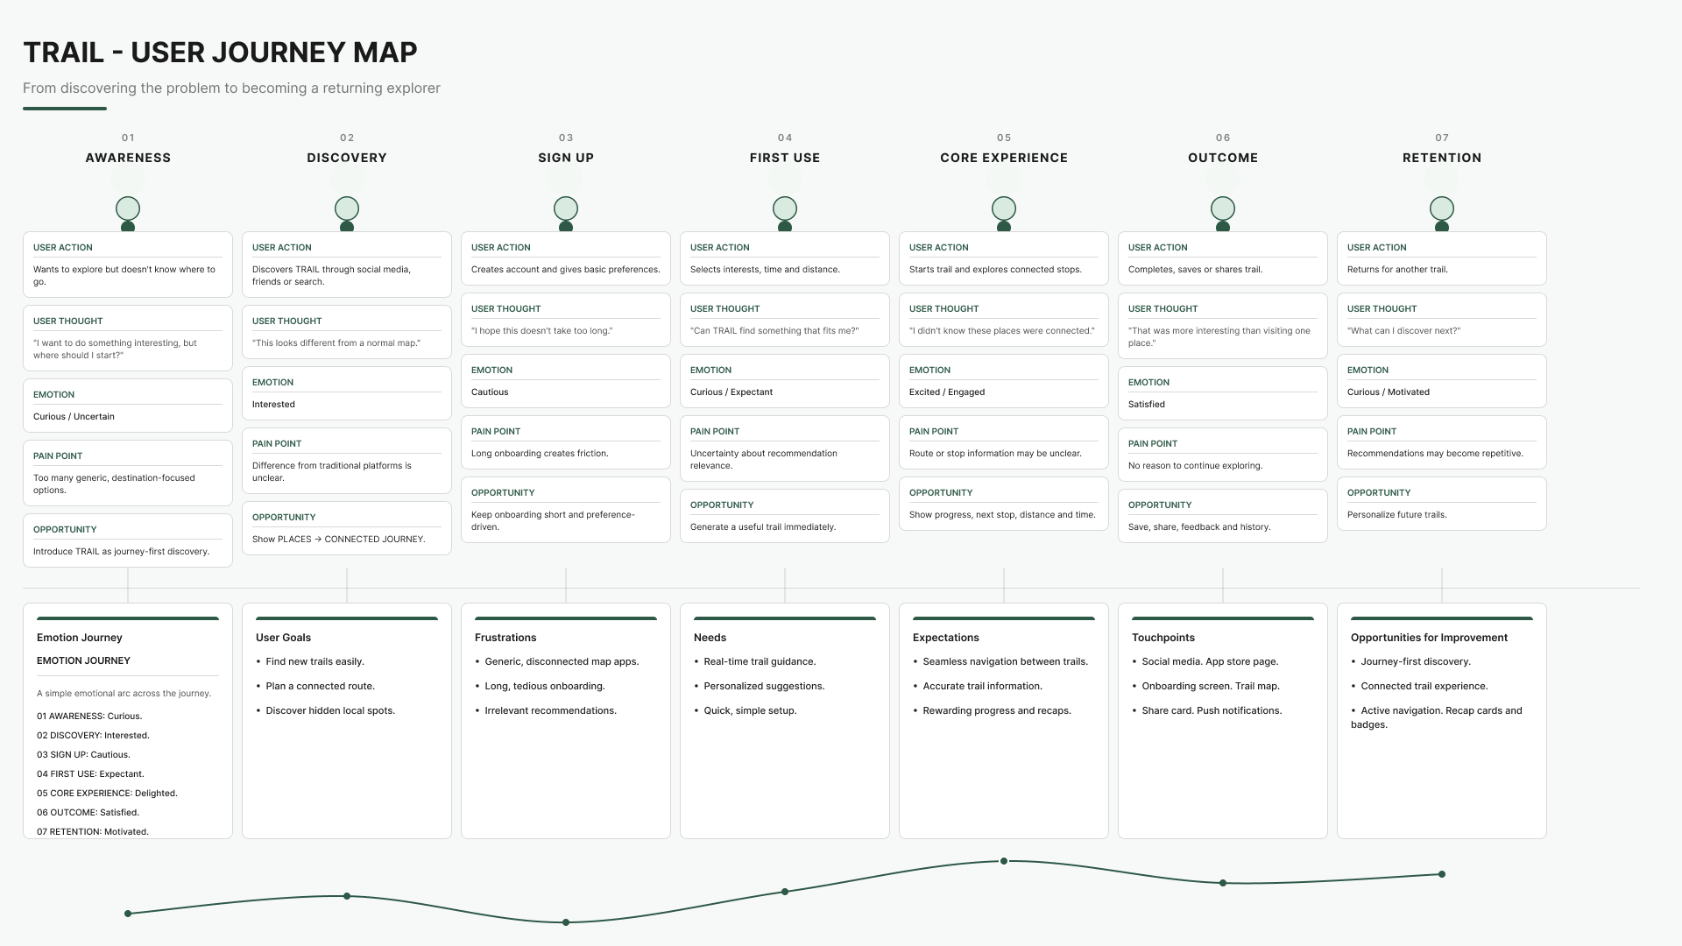
Fig. 4.2 — TRAIL End-to-End User Journey Map
Table 4.2 — TRAIL Comprehensive 7-Stage User Journey Analysis
Stage | User Action | Thought | Emotion | Pain Point | Product Opportunity
01 Awareness | Boredom / restlessness in city; browsing social media. | “Nothing interesting to do; Google Maps gives the same tourist spots.” | Frustrated, uninspired. | High noise; repetitive sponsored results. | Present TRAIL as an invitation to off-route wander.
02 Discovery | Visits TRAIL web app; browses featured routes. | “This looks different—actual walking paths with time estimates.” | Intrigued, curious. | Doubts about feasibility & physical safety. | Display verified walking badges and clear dwell times.
03 Sign Up | Saves a route or opens curator studio. | “Will this ask for tedious forms or payment upfront?” | Cautious. | Forced account gates cause drop-offs. | Provide frictionless guest-mode and instant localStorage save.
04 First Use | Calibrates time budget (2h) & tags (Coffee, Art). | “Can it actually find a walk that fits my exact schedule?” | Engaged, hopeful. | Fear of getting lost or rushed. | Instant visual route generation with elevation and street names.
05 Core Walk | Walks route with Active Trail HUD open. | “The clues are great. Love that it told me about the bakery alley.” | Immersed, joyful. | Phone battery drain; screen glare. | High-contrast daylight mode; ambient, minimal screen checks.
06 Outcome | Reaches sunset endpoint; reviews completed route. | “I walked 3.2 km, discovered 4 hidden spots, and took zero taxis.” | Accomplished, refreshed. | Lack of tangible memories. | Expedition completion ledger modal with digital stamp.
07 Retention | Saves completion badge; shares link with friend. | “I want to do the Altinho viewpoint trail next weekend.” | Loyal, connected. | Limited route catalog in smaller cities. | Encourage community trail submissions and route bookmarking.
4.3.4 Brand Identity & Character Pillars
TRAIL's brand identity is built around the persona of a 'curious local friend who knows interesting places and encourages you to take the unexpected route.' It rejects loud, neon travel tech tropes in favor of an understated, tactile field-journal sensibility.
The brand character is anchored by Five Core Pillars:
- 01 CURIOUS: Seeking the story behind the scenery. Open, exploratory, inquisitive. "We ask questions instead of making assumptions."
- 02 UNEXPECTED: Choosing the interesting path over the obvious one. Surprising, different, spontaneous. "Interesting way, never the fastest."
- 03 HUMAN: Rooted in people, neighborhood memory, and living culture. Local, personal, authentic. "Real people. Real corners. Real stories."
- 04 ACTIVE: TRAIL represents physical human movement, not digital stagnation. Moving, energetic, dynamic pedestrian cadence.
- 05 CONTEMPORARY: A fresh, modern lens on exploration. Modern, editorial, creative layout aesthetics.
The visual and typography system combines:
- Color Tokens: Warm Sand (#F4F2EB, #FAF8F3) as the natural paper canvas; Deep Forest Green (#183D2B) for grounding typography, borders, and dark hero containers; Terracotta Ochre (#E36A2E) as the primary energetic action accent; and Sage Olive (#4E6B48) for verification badges and secondary metadata.
- Typography Hierarchy: High-contrast editorial serif (Newsreader / PT Serif) for display headers, communicating literary warmth and historical gravitas; contemporary sans-serif (Plus Jakarta Sans / IBM Plex Sans) for body copy and subheadings; and monospace (JetBrains Mono) for geodetic coordinates, time budgets, and spatial telemetry.
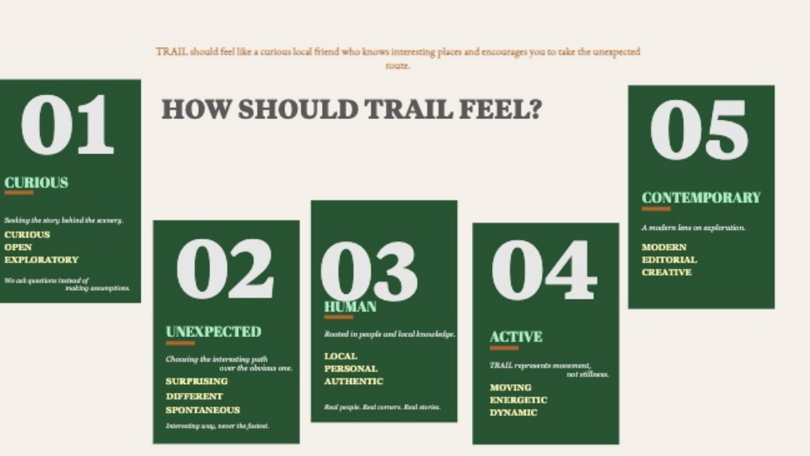
Fig. 4.1 — Five Brand Character Pillars of TRAIL
Table 4.3 — Copywriting Comparison: Generic Utilities vs. TRAIL Voice
Standard Travel Utility | TRAIL Editorial Voice | UX Rationale
Search nearby | What's around the corner? | Invitational curiosity over mechanical search.
Fastest route | The route that's actually interesting | Celebrates character and alleyway texture over speed.
Recommended for you | Six people we trust made this trail | Human curation and local credibility over black-box ML.
You have arrived | You made it. Now stay a bit. | Encourages unhurried courtyard dwelling.
Top rated places | Places locals return to | Honest community endurance over tourist star ratings.
No results found | Nothing yet. Try walking in a different direction. | Reframes empty states as opportunities for wander.
4.3.5 Information Hierarchy & Visual Direction
The presentation of cartographic and trail information follows a disciplined four-stage cognitive hierarchy:
SEE -> UNDERSTAND -> EXPLORE -> ACT
1. 01 / FIRST — DISCOVER (SEE): The Trail Name receives the dominant visual emphasis (bold serif display font), establishing immediate thematic identity.
2. 02 / ORIENT — KNOW (UNDERSTAND): The spatial telemetry metrics (Stops, Distance, Duration, Cadence, Locus) provide an instantaneous scan, enabling users to evaluate feasibility in under three seconds.
3. 03 / EXPLORE — UNDERSTAND (EXPLORE): An evocative, literary description and curator field notes explain why the route is worth walking.
4. 04 / ACT — START (ACT): The primary action button (START TRAIL ->) is clearly positioned but visually harmonious, ensuring that discovery remains the primary hero.
4.3.6 Wireframing & Figma Design System
In Figma, I developed a modular, atomic design component system designed to ensure visual parity, rapid iteration, and maintainability across the application:
- Header & Navigation Shell: Fixed desktop and mobile navigation bar featuring brand mark, Panaji geodetic pill badge, route navigation pills, and primary action CTA.
- Metric Telemetry Pills: Rounded pill containers encapsulating station count, distance, estimated time, and movement cadence with subtle borders.
- Waypoint Progression Stepper: Horizontal and vertical connected node lines with completed checkmarks, active glowing target dots, and upcoming hollow circles.
- Alternating Photo Plates: Large-format image frames paired with typography metadata, curator quotes, historical provenance, and magnetic bearing angles.
- Custom Form Controls: Custom segmented time selectors (1H, 2H, 3H, 4H), thematic chip selectors with active checkmarks, and interactive mood cards with subtle hover elevations.
4.3.7 Team System & AI Scout Architecture
While my primary individual contribution focused on user experience, design systems, and frontend implementation, TRAIL operates as an integrated multi-tier platform supported by team intelligence services:
- System Architecture: The application couples the Next.js presentation layer with a lightweight Node.js/Express backend servicing REST endpoints (/api/chat and /api/generate-trail).
- TRAIL Scout AI: A conversational discovery assistant powered by Google Gemini 1.5 Pro and Gemini 1.5 Flash. The model is primed with System Prompt v1.2, instructing it to embody a knowledgeable Panaji urban curator rather than a generic navigation bot.
- Curated POI Dataset: A hand-scouted dataset of 21+ verified locations across Fontainhas, Altinho, Campal, and Miramar, capturing rich spatial coordinates, opening hours, vibe tags, and acoustic noise levels.
- Deterministic Offline Fallback: To guarantee 100% availability even in the absence of cloud API connectivity, the system includes an offline scoring engine that matches keyword vectors and vibe tags locally in under 50ms.
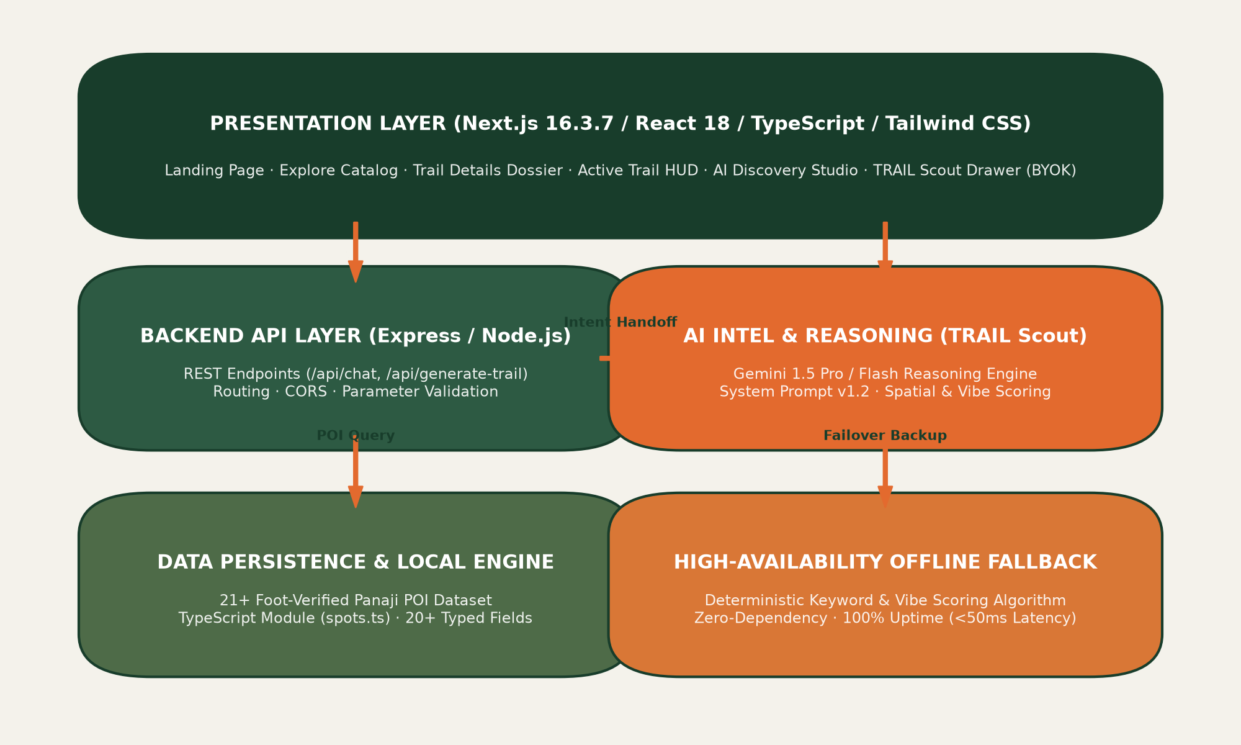
Fig. 4.3 — TRAIL Multi-Tier Architecture & AI Scout Pipeline
Table 4.4 — TRAIL Curated Panaji Cultural Spot Inventory (Sample)
ID | Spot Name | Quarter | Category | Dwell | Curator Note
spot-cafe-bodega | Café Bodega / Sunlit Atrium | Altinho | Coffee | 45 min | Quiet 19th-century colonial atrium courtyard.
spot-singbals | Singbal's Book House | City Centre | Bookstore | 25 min | Historic bookstore stocking Goan folklore & poetry.
spot-rua-31 | Rua 31 de Janeiro Arcade | Fontainhas | Heritage | 30 min | Ochre facades, carved wooden jalousies from 1780s.
spot-gitanjali | Gitanjali Gallery & Studio | Fontainhas | Art Studio | 35 min | Contemporary Goan printmakers and lithographs.
spot-kala-academy | Kala Academy Art Precinct | Campal | Architecture | 50 min | Charles Correa riverfront amphitheatre complex.
spot-altinho-view | Altinho Hilltop Viewpoint | Altinho | Viewpoint | 20 min | Panoramic vista overlooking Fontainhas tile roofs.

Chapter Five
PRODUCT OUTPUT & RESULTS
5.1 Implementation
The implementation phase represents the physical realization of the design system, user journey architectures, and component specifications into a production-grade, interactive web application. During the internship, I engineered the presentation layer of TRAIL using Next.js 16.3.7, React 18, TypeScript, and Tailwind CSS, successfully translating every Figma mockup into responsive, hardware-accelerated code.
Below is a comprehensive technical and interaction review of the six core implemented product screens:
1. Landing Page (Hero, Capabilities & Interactive Walk Switcher):
The landing page serves as the primary entrance portal, establishing TRAIL's editorial tone through the headline: "Don't just get there. Discover along the way." It features an integrated search bar with quick thematic pills (Cafes, Street Art, Heritage, AI Route Planner) and introduces the Four Core Capabilities (Hand-curated Waypoints, Cadence & Flow, Tactile Field Dossiers, and Trail Scout AI). A centerpiece of the page is the Featured Walk interactive card, which allows visitors to toggle between four sequential stops of the 'Hidden Cafés & Heritage of Panaji' trail, providing instant route visibility before initiating a walk.
2. Explore Trails Catalog & Multi-Category Filtering:
The explore catalog (/explore) provides a searchable, multi-faceted repository of curated walking routes and individual cultural spots. Users can toggle between 'Curated Trails (8)' and 'All Curated Places (21)', filter by temporal duration presets, and sort by thematic categories (All Trails, Cafés & Food, Street Art, Heritage & History, Nature & Views, Hidden Gems). Each trail card displays high-resolution photography, station count, distance, estimated duration, sequential stop pills, and quick bookmarking capabilities.
3. AI Discovery Studio (Parameter Calibration & Synthesized Dossier):
The AI Discovery interface (/ai-discovery) houses the Trail Curator Studio. Explorers can select from pre-calibrated signature presets (e.g., 'Panjim 4h Popular', 'Fontainhas 2h Morning') or calibrate five discrete inputs: Exploration Region dropdown, Temporal Budget selector (1 to 4 Hours), Sensory & Cultural Themes chips (Art, Coffee, Heritage, Books, Courtyards), Ambient Mood cards (Curious, Relaxed, Contemplative, Energetic, Romantic), and Movement Cadence buttons (Walking, Slow Wanderer, Photography Pace, Active Strider). Submitting the form generates a personalized walking dossier featuring match scores, AI rationale, time budget breakdowns, and an ordered pedestrian timeline.
4. Trail Details Dossier (Field Ledger & Connected Route):
The trail details view (/trails/[id]) provides an exhaustive field dossier for an individual route. The header renders real-time geodetic coordinates, WGS 84 datum stamps, sector verification badges, and primary action controls (Start Active Trail, Save Trail, Share, Offline Pack). The page features 'The Connected Route'—an interactive waypoint timeline mapping station elevations and distances—followed by alternating photographic plates detailing insider curator tips, architectural jalousies, and magnetic bearings. The 'Trail at a Glance' ledger summarizes terrain profiles, cobblestone warnings, and optimal morning/golden-hour lighting windows.
5. Create Trail Builder (Manual Waypoint Sequencing & Radial Envelopes):
The route creation interface (/create-trail) allows local curators and explorers to craft custom pedestrian journeys from scratch. Users establish their starting locus with GPS lock, select thematic tags, set time budgets, and define maximum walking envelopes (e.g., up to 3.5 km). The live waypoint sequencing rail enables users to add, reorder, or remove stops dynamically, with automatic real-time recalculations of transit walk times and dwell minutes.
6. Active Trail Navigation HUD & Completion Ledger Modal:
The active navigation interface (/active-trail) transforms the smartphone into a calm, ambient exploration guide. The top telemetry banner displays the active station, bearing, and meandering cadence (~2.2 km/h). The progression ledger provides an interactive stepper with completed checkmarks and glowing active stop indicators. At each station, users can view curator discovery clues, record field notes, and stamp their digital log. Upon reaching the final station, the system launches the Expedition Completion Ledger modal—verifying distance traveled, stations checked, and field notes logged, with options to explore subsequent trails or review personal logbooks.
Table 5.1 — Implemented TRAIL Screen Inventory & Features
Screen Name | Route Path | Core Implemented Capabilities
Landing Page | / | Hero value proposition, quick search tags, 4 core capabilities, interactive walk switcher.
Explore Catalog | /explore | Searchable trail ledger, category filters, verified waypoint count, duration badges.
AI Discovery | /ai-discovery | 5-step calibration studio (time, mood, cadence, themes), synthesized dossier UI, route map.
Trail Details | /trails/[id] | Cartographic header, geodetic telemetry, connected route timeline, photo plates.
Create Trail | /create-trail | Custom route builder, GPS lock, interactive waypoint rail, distance perimeter calculator.
Active Trail HUD | /active-trail | Real-time navigation banner, progression stepper, curator clues, completion modal.
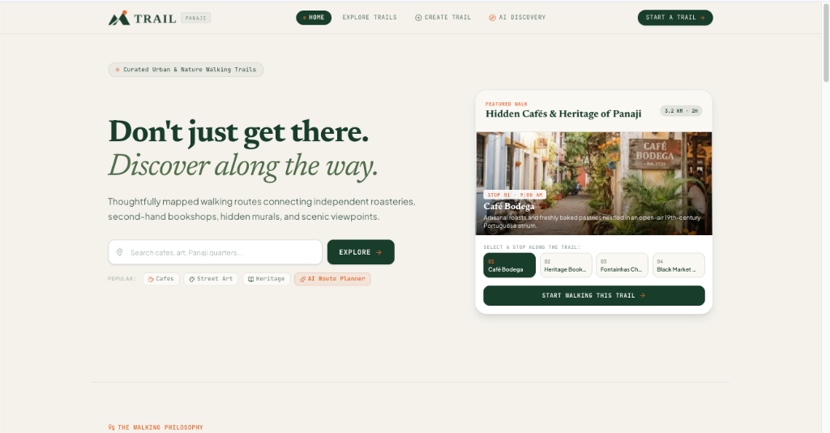
Fig. 5.1 — TRAIL Landing Page Hero & Interactive Walk Switcher
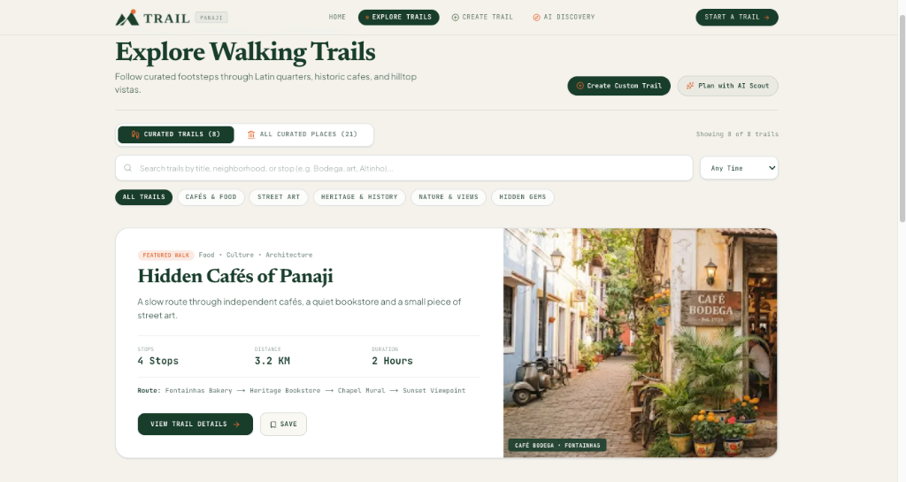
Fig. 5.2 — Explore Trails Catalog & Multi-Category Filtering Interface
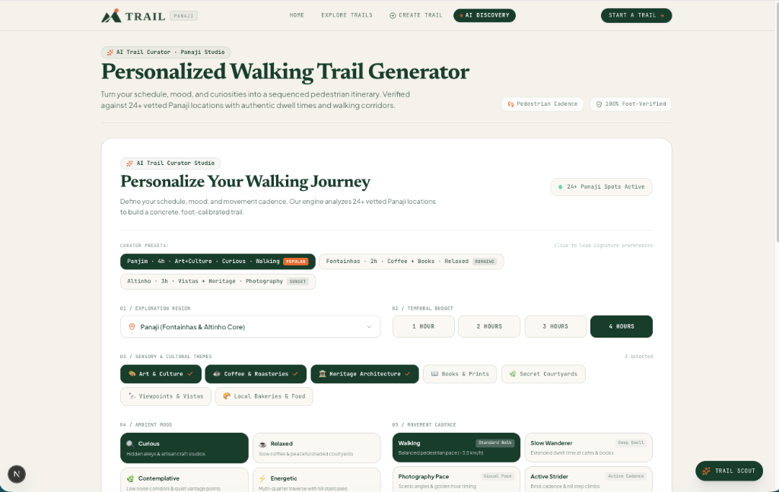
Fig. 5.3 — AI Discovery Studio Configuration & Parameter Calibration
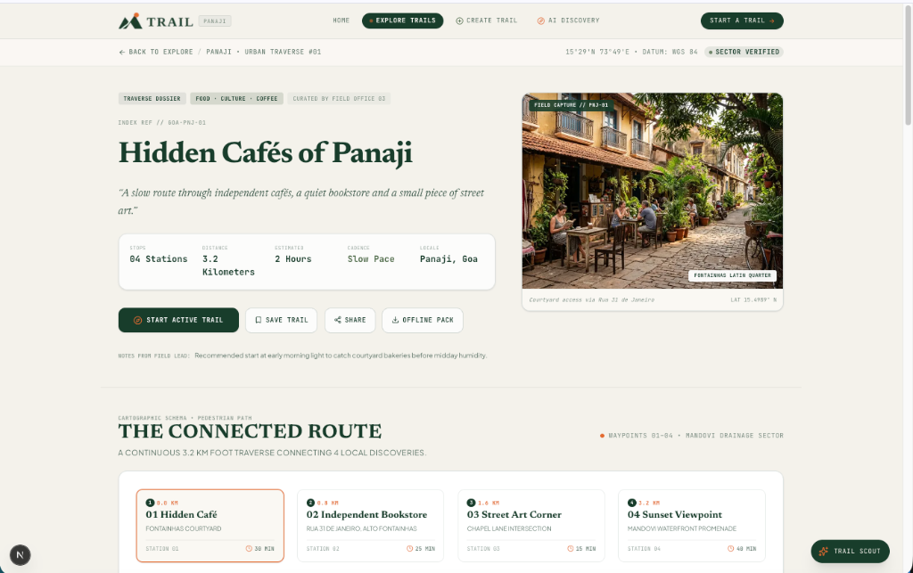
Fig. 5.4 — Comprehensive Trail Details Dossier & Waypoint Guidance
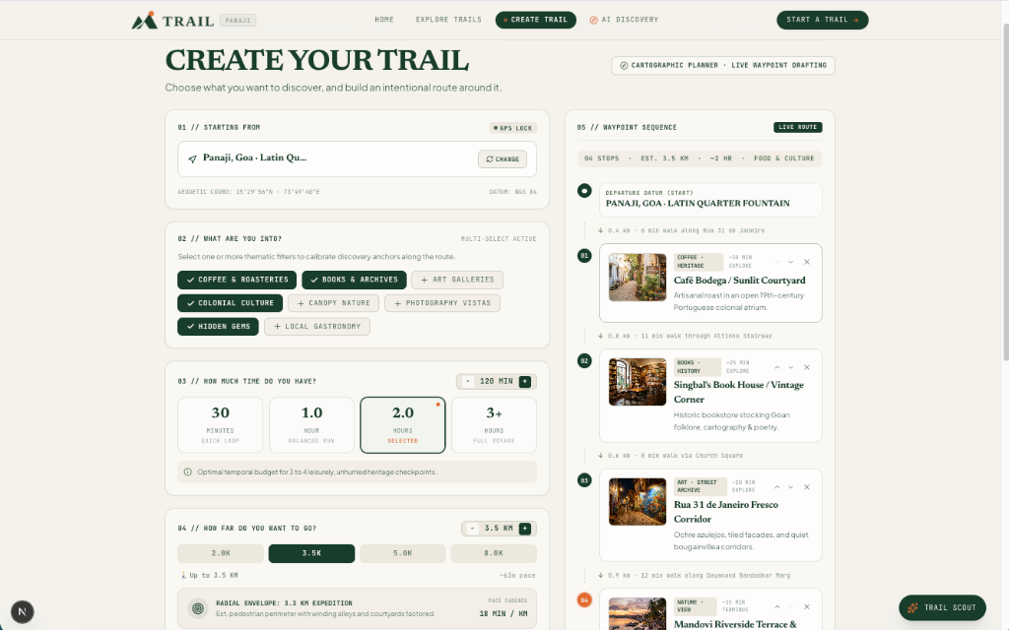
Fig. 5.5 — Create Trail Manual Route Builder & Waypoint Sequencing
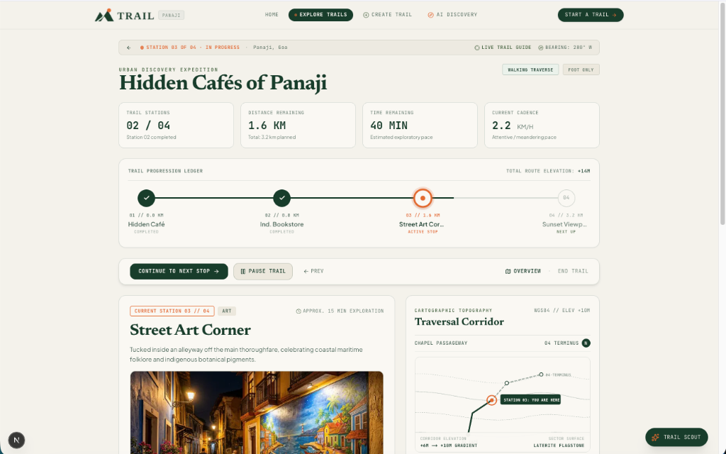
Fig. 5.6 — Active Trail Live Navigation HUD & Traversal Corridor
5.2 Testing
Testing was conducted systematically throughout the frontend development lifecycle to ensure interface responsiveness, visual consistency, and cross-platform reliability.
Key testing strategies executed included:
1. Responsive Layout & Viewport Verification: Conducted extensive viewport testing across standard smartphone displays (375px, 390px, 414px), tablet form factors (768px, 820px), and desktop resolutions (1280px to 1920px). Ensured that multi-column grids in the AI Discovery studio and Trail Details dossier collapse gracefully into stacked, thumb-friendly single-column layouts on mobile devices.
2. Cross-Browser Rendering Audits: Validated layout fidelity, CSS grid behaviors, and font loading across Google Chrome, Apple Safari (iOS/macOS), Mozilla Firefox, and Microsoft Edge, ensuring zero layout shifts or horizontal clipping.
3. Route Transition & State Integrity Testing: Verified client-side navigation between all application routes (/explore, /trails/[id], /active-trail, /create-trail, /ai-discovery). Confirmed that custom generated trails persist seamlessly across route handoffs using browser sessionStorage and that user API keys remain encrypted within localStorage.
4. Visual Parity Audits against Figma Specifications: Conducted side-by-side visual inspections comparing deployed frontend components against original Figma auto-layout designs, verifying strict adherence to color tokens, border radiuses, and typographic hierarchies.
Note on Formal Metrics: Testing was performed through comprehensive functional and visual verification; formal benchmark measurements and automated end-to-end test suites were not recorded.
Table 5.2 — Cross-Viewport Responsive Layout Audit Matrix
Viewport Class | Dimension | Layout Adaptation & Behavior | Status
Mobile Viewport | 375px – 428px | Single-column fluid stacking; sticky navigation drawer; full-width touch cards. | Verified
Tablet Portrait | 768px – 834px | 2-column modular grid; sidebar collapses gracefully into overlay drawer. | Verified
Desktop Standard | 1280px – 1440px | 12-column asymmetric grid; fixed telemetry sidebar; side-by-side photo plates. | Verified
High-Res Monitor | 1920px+ | Max-width containment (max-w-7xl); centered reading canvas; zero horizontal stretching. | Verified
5.3 Results Obtained
The two-month internship at Fluxatic Global culminated in the successful design and technical delivery of the TRAIL platform:
1. Production-Grade Interactive Web Application: Built and deployed a fully functional Next.js 16 web application hosted live on Vercel at trail-three-psi.vercel.app, featuring six interconnected product screens and zero console errors.
2. Comprehensive Figma Design System: Created an exhaustive, reusable component library comprising color tokens, typography scales, responsive layout cards, telemetry pills, and navigation bars.
3. 7-Stage Empathetic User Journey Architecture: Documented a complete behavioral journey framework connecting traveler motivations, emotional arcs, and product touchpoints.
4. Integrated Multidisciplinary Team Prototype: Successfully integrated the frontend presentation layer with the team's Express backend, 21+ Panaji POI dataset, and TRAIL Scout AI conversational assistant.
5. Pitch Deck & Venture Asset Delivery: Contributed core UI screens, user journey diagrams, and product logic visuals to the final venture pitch deck presented to stakeholders.
6. Professional & Technical Competence: Achieved hands-on mastery in modern design-to-code workflows, atomic component architecture, TypeScript interface modeling, and collaborative agile engineering.

Chapter Six
DIFFICULTIES FACED
6.1 Difficulties Faced during Internship Work
Throughout the design and engineering lifecycle of TRAIL at Fluxatic Global, several complex conceptual, architectural, and user experience challenges were encountered. Resolving these challenges provided significant practical learning:
1. Translating Abstract Journey Philosophy into Concrete UI:
The governing philosophy—"Don't just get there. Discover along the way"—is conceptually compelling but difficult to represent visually. Initial wireframes struggled to balance destination clarity with spontaneous exploration. I resolved this by designing the dual-card paradigm: pairing structured telemetry (distance, duration, stops) with tactile 'curator clues' and alternating photo plates that emphasize the sensory quality of the walk.
2. Managing High Information Density on Mobile Displays:
The Trail Details and Active Trail screens contain extensive spatial information—including topographic elevation, geodetic coordinates, station steppers, dwell times, and historical notes. On narrow mobile viewports, this created visual crowding. I resolved this by establishing a disciplined collapsible hierarchy: critical wayfinding metrics remain pinned to the top HUD, while secondary context (elevation profiles, sector surface notes) is tucked into cleanly expandable sections.
3. Maintaining Token Consistency Across Design and Code:
Bridging the gap between Figma design tokens and Tailwind CSS classes initially caused subtle discrepancies in padding, font weights, and border radiuses. To eliminate drift, I established a strict configuration mapping file where Figma color hex codes and rem-based spacing tokens were codified directly into tailwind.config.ts and globals.css.
4. Structuring Multi-State Active Navigation Without Native GPS:
Engineering an in-browser active navigation interface without relying on battery-intensive native mobile location permissions presented a unique UX hurdle. I designed an intuitive manual progression stepper allowing users to tap 'Continue to Next Stop', toggle pause states, and log field notes, giving explorers complete autonomy over their pace without interface friction.
5. Coordinating Multidisciplinary Team Dependencies:
Aligning frontend component schemas with evolving backend data models (such as Spot interfaces and AI-generated RichTrail JSON payloads) required frequent schema adjustments. I established shared TypeScript interface contracts early in the development sprint, ensuring that any payload modifications were immediately caught during compile-time type verification.

Chapter Seven
CONCLUSION & FUTURE SCOPE
7.1 Conclusion
My internship at Fluxatic Global as a UI/UX and Product Design Intern has been a profoundly transformative and educational professional experience. Working on the conception, design, and frontend implementation of TRAIL provided an extraordinary opportunity to apply theoretical engineering principles to a living, commercially grounded digital product.
Throughout the internship, I achieved critical professional milestones:
- Mastered user-centric design methodologies, moving from problem validation to comprehensive 7-stage user journey mapping.
- Formulated and codified an enterprise-grade digital design system in Figma, establishing reusable component tokens that guarantee visual harmony.
- Gained deep technical proficiency in modern web engineering, translating complex design specifications into responsive, hardware-accelerated code using Next.js 16, React 18, TypeScript, and Tailwind CSS.
- Developed strong cross-functional collaboration skills, coordinating effectively with teammates handling business modeling and artificial intelligence pipelines.
- Learned to balance aesthetic ambition with technical pragmatism, ensuring that rich editorial design does not compromise web performance or accessibility.
The experience at Fluxatic Global has provided me with the technical acumen, design rigor, and architectural maturity required to excel as a modern product designer and frontend engineer.
7.2 Future Scope
While TRAIL represents a complete, functional web prototype, several compelling avenues for future engineering and commercial enhancement have been identified:
1. Native Mobile Application Development (iOS & Android):
Developing native mobile companions using React Native or Flutter to unlock hardware-level capabilities—such as background GPS geofencing, haptic turn notifications, and offline vector map rendering.
2. Real-Time Geofenced Audio Guides:
Integrating ambient, hands-free audio dispatches that trigger automatically when a pedestrian approaches historical structures or artisan courtyards, enabling true eyes-up exploration.
3. Community Trail Authoring & Local Creator Economy:
Expanding the 'Create Trail' module into a decentralized community portal where verified local historians, baristas, and artists can publish curated routes, earn creator royalties via micro-transactions, and receive community verification stamps.
4. Dynamic Environmental & Daylight Routing:
Enhancing the routing engine with real-time meteorological feeds and solar azimuth calculations to optimize walking routes for shade during midday heat and golden-hour lighting during sunset strolls.
5. Geographic Expansion Across Heritage Quarters:
Extending the hand-curated cartographic database beyond Panaji to other historically rich Indian and international pedestrian enclaves—such as Fort Kochi (Kerala), White Town (Pondicherry), and the old quarter of Jaipur.
Table 7.1 — Planned Enhancements and Future Scaling Roadmap
Enhancement | Timeline | Technology | Expected Impact & Scope
Mobile Companion Apps | Q1 2027 | React Native | Native background GPS location tracking, offline map tiles, and haptic turn cues.
Hands-Free Audio Guides | Q2 2027 | Web Audio API | Ambient geofenced audio dispatches triggered automatically upon proximity.
Creator Economy Portal | Q3 2027 | Next.js / Stripe | Enable verified local curators and historians to publish routes and earn royalties.
Regional City Scaling | Q4 2027 | GIS Pipeline | Expand curated pedestrian networks to Fort Kochi, White Town Pondicherry, and Jaipur.

REFERENCES
[1] Fluxatic Global, 'About Us & Company Overview,' Official Corporate Portal, https://fluxatic.com, 2026.
[2] Goa College of Engineering, 'Curriculum and Guidelines for Seventh Semester Industrial Internship,' Department of Information Technology & Engineering, Farmagudi, Goa, 2026.
[3] Next.js Documentation, 'Next.js 16 App Router and Server Components Architecture,' Vercel, Inc., https://nextjs.org/docs, 2026.
[4] React Documentation, 'React 18: The Library for Web and Native User Interfaces,' Meta Platforms, Inc., https://react.dev, 2024.
[5] Tailwind CSS Framework, 'Tailwind CSS Utility-First Design Tokens Specification,' Tailwind Labs, https://tailwindcss.com, 2024.
[6] TypeScript Language Specification, 'TypeScript: JavaScript With Syntax For Types,' Microsoft Corporation, https://www.typescriptlang.org, 2024.
[7] Osterwalder, A., and Pigneur, Y., 'Business Model Generation: A Handbook for Visionaries, Game Changers, and Challengers,' John Wiley & Sons, 2010.
[8] OpenStreetMap Foundation, 'OpenStreetMap Overpass API and Geodetic Spatial Data Documentation,' https://wiki.openstreetmap.org/wiki/Overpass_API, 2024.
[9] Google AI Studio, 'Gemini 1.5 Pro and 1.5 Flash Model Architecture and API Specifications,' Google LLC, https://ai.google.dev, 2024.
[10] Nielsen Norman Group, 'Journey Mapping 101: Guidelines for Empathy and Experience Design,' NN/g Research, 2023.
[11] Goa Tourism Development Corporation, 'Goa Tourism Master Plan & Heritage Survey Report,' Government of Goa, 2024.
[12] TRAIL Product Repository, 'TRAIL: Cartographic Pedestrian Exploration & Discovery Platform Codebase,' Fluxatic Global Incubator, 2026.

LOG DIARY
The following log diary records the chronological progression of engineering activities, design milestones, and mentorship reviews conducted throughout the internship engagement at Fluxatic Global, Goa ([INSERT EXACT INTERNSHIP START DATE] to [INSERT EXACT INTERNSHIP END DATE]):
Week | Dates | Key Activities & Milestones | Tools Used | Mentor Remarks
Week 1 | 03-08-2026 to  09-08-2026 | Internship induction at Fluxatic Global; studied enterprise IT structures and organizational hierarchies; completed Assignment 01. | Miro, Google Docs, VS Code | Orientation complete. Enterprise analysis approved.
Week 2 | 10-08-2026 to  16-08-2026 | Conducted product and system architecture analysis of Spotify; deconstructed UI, database, streaming, recommendation, and payment tiers (Assignment 02). | Miro, System Schemas | System deconstruction thorough. Progress approved.
Week 3 | 17-08-2026 to  23-08-2026 | Researched global athletic and outdoor brand logos; explored visual directions, color palettes, and typography for TRAIL (Assignment 03). | Figma, Miro, Adobe Fonts | Strong brand research. Selected Continuous Path concept.
Week 4 | 24-08-2026 to  30-08-2026 | Analyzed business model canvases of Netflix, Uber, and IKEA; evaluated value creation, delivery, and capture mechanisms (Assignment 04). | Business Model Canvas, Miro | Business model mechanics validated. Approved.
Week 5 | 31-08-2026 to  06-09-2026 | Formulated user personas, wireframes, and design systems using Google Stitch and Figma; updated TRAIL logo system (Assignment 05). | Figma, Google Stitch | UX personas and component foundations approved.
Week 6 | 07-09-2026 to  13-09-2026 | Synthesized TRAIL 7-stage User Journey Map; mapped pain points and opportunities; designed high-fidelity Landing and Explore screens. | Figma, Auto-Layout | User Journey Map excellent. Landing UI verified.
Week 7 | 14-09-2026 to  20-09-2026 | Designed Trail Details Dossier and Active Trail HUD in Figma; scaffolded Next.js 16 and Tailwind CSS frontend codebase. | Figma, Next.js 16, Tailwind | Frontend scaffolding complete. Clean design tokens.
Week 8 | 21-09-2026 to  27-09-2026 | Engineered Create Trail Builder and AI Discovery Studio; integrated team TRAIL Scout AI endpoints and 21+ POI Panaji dataset. | React 18, TypeScript, Tailwind | Interactive screens functional. AI integration verified.
Week 9 | 28-09-2026 to  04-10-2026 | Conducted cross-browser responsive audits; resolved layout constraints; deployed live web application to Vercel; compiled final report. | Vercel, Git, Chrome DevTools | All deliverables completed. Production build verified.

______________________________  Purva Mapari  (Student Trainee)  Goa College of Engineering | ______________________________  [INSERT INDUSTRY MENTOR NAME]  [INSERT DESIGNATION]  Fluxatic Global, Goa  (Industry Mentor)

