Create database RentalCars;

Use RentalCars;

1. **Creating car details table -**

create table Car_details(car_id int primary key, car_model varchar(20) not null, Plate_number varchar (20) unique key, car_available enum ("yes","no"), car_rating int check (car_rating < = 5), car_price float not null);

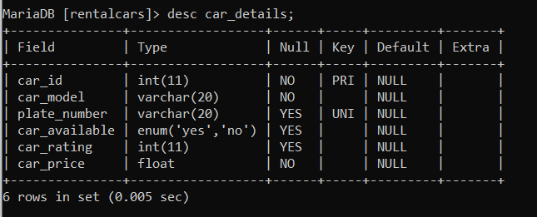

1. **Creating customer details table -**

create table customer_details (customer_id int primary key, first_name varchar (20), last_name varchar(20), Address varchar(30));

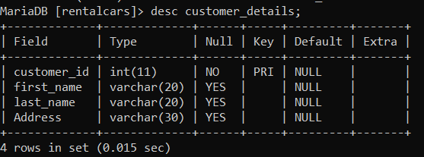

1. **Creating Rental details table -**

create table rental_details (customer_id int, foreign key (customer_id) references customer_details (customer_id), car_id int, foreign key(car_id) references car_details (car_id), pick_up date, return_date date,payment enum ("yes","no"), booking_no int primary key);

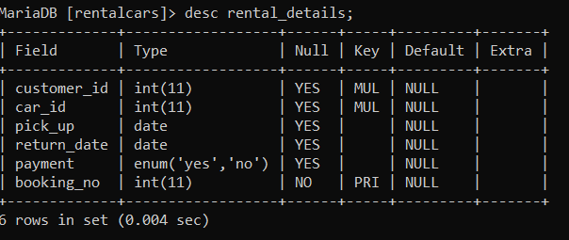

**Inserting values into tables -**

1. insert into car_details values(101,"toyotaInnova","MH02VD2636","Yes",3,58.99),(102,"marutiBrezza","MH02MP2939","No",4,67.24),(103,"MarutiSwift","MH02PR2112","Yes",3,58),(104, "mahindraScorpio","MH12DL3969","Yes",4,69.45),(105,"toyotaInnova","MH14DR1111","Yes",4,69.45),(106,"MarutiWagonR","MH02LL3311","No",3,65.04),(107,"HondaCity","MH04DM1213","Yes",3,67.24),(108,"Toyotafortuner","MH02LM9494","Yes",4,90.94);

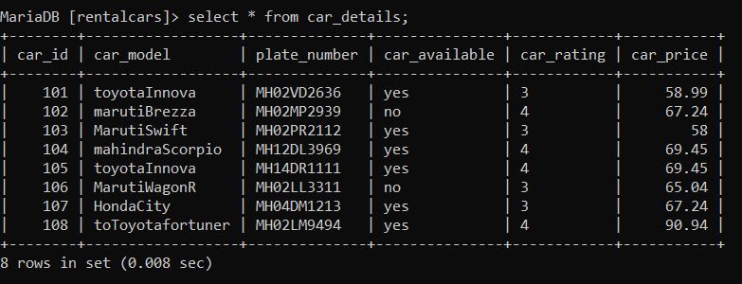

1. insert into customer_details values(1,"Jui","Panse","PUNE"),(2, "Pratik","Manjare","PUNE"),(3,"Meghana","Garbhe","Mumbai"),(4, "Sayali","Gosavi","Delhi"),(5,"Apoorva","Janorkar","Uttarakhand"),(6,103, "sourabh","panigrahi","Odisa");

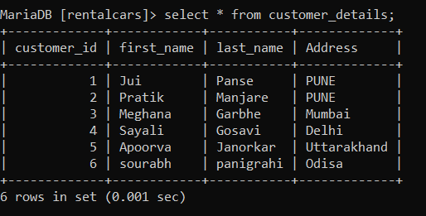

1. insert into rental_details values(1,101,"2022-06-12","2022-06-18","yes",111),(3,104,"2022-05-11","2022-05-16","yes",110),(4,102,"2022-06-13","2022-06-19","no",112),(2,108,"2022-06-13","2022-06-16","yes",113),(5,106,"2022-06-14","2022-06-16","no",114),(6,103,"2022-06-14","2022-06-16","yes",115);

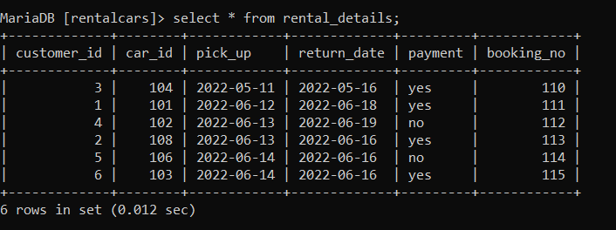

Using DQL –

1. select * from customer_details where address = "mumbai";

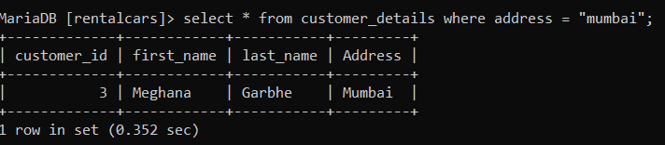

1. select * from customer_details where customer_id = 5 ;

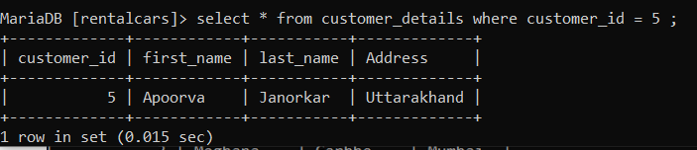

1. select car_model, plate_number from car_details where car_rating >= 4;

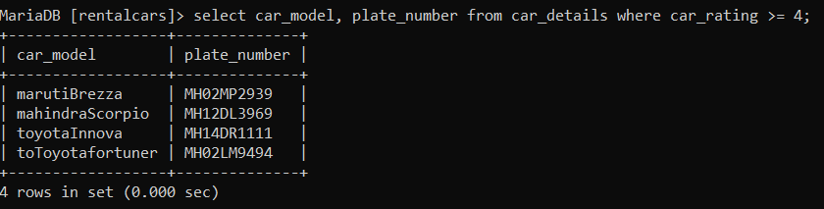

Using order by clause –

select * from car_details order by car_model;

