**Assignment 1 - NSDB**

INSERTING DATA IN EMPLOYEE DATABASE:

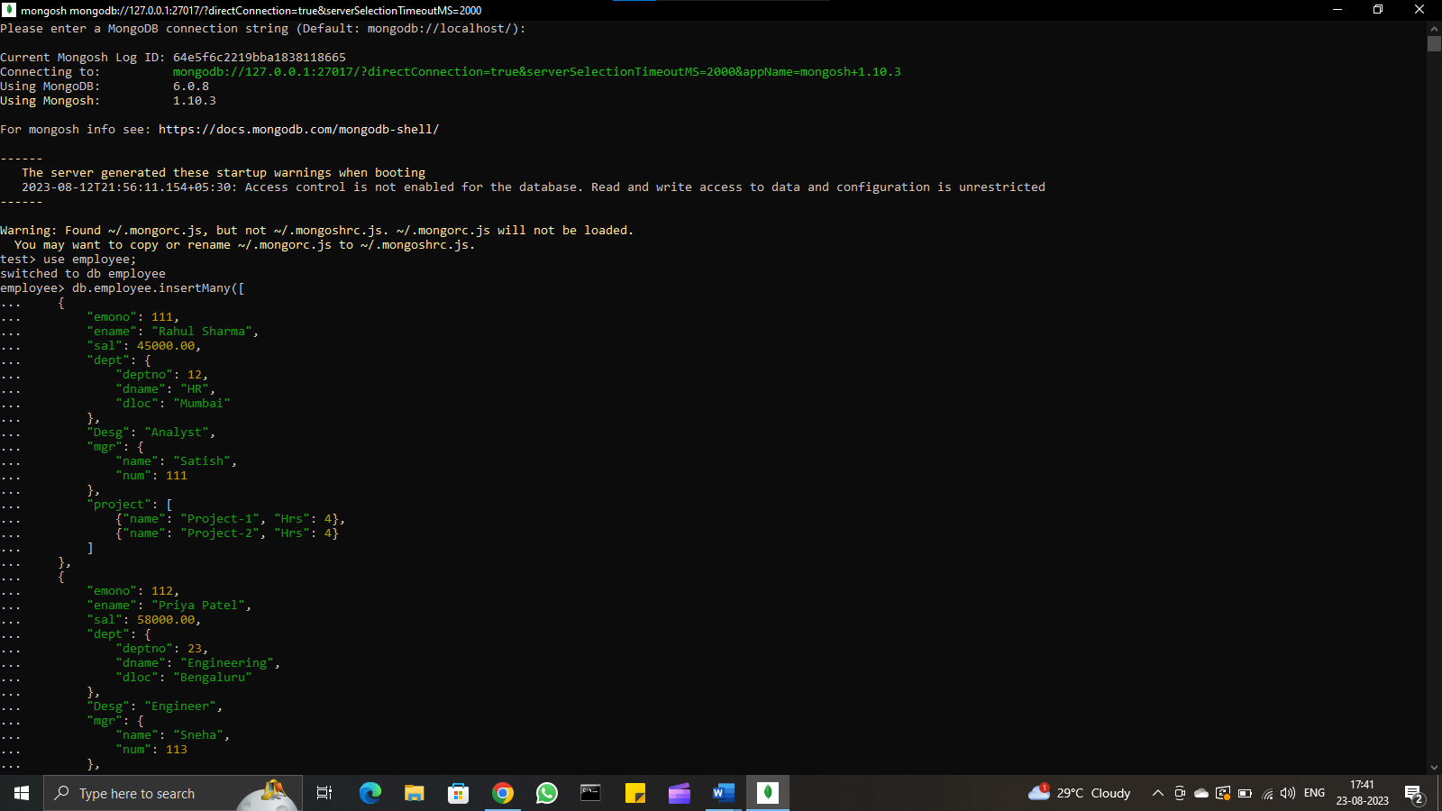

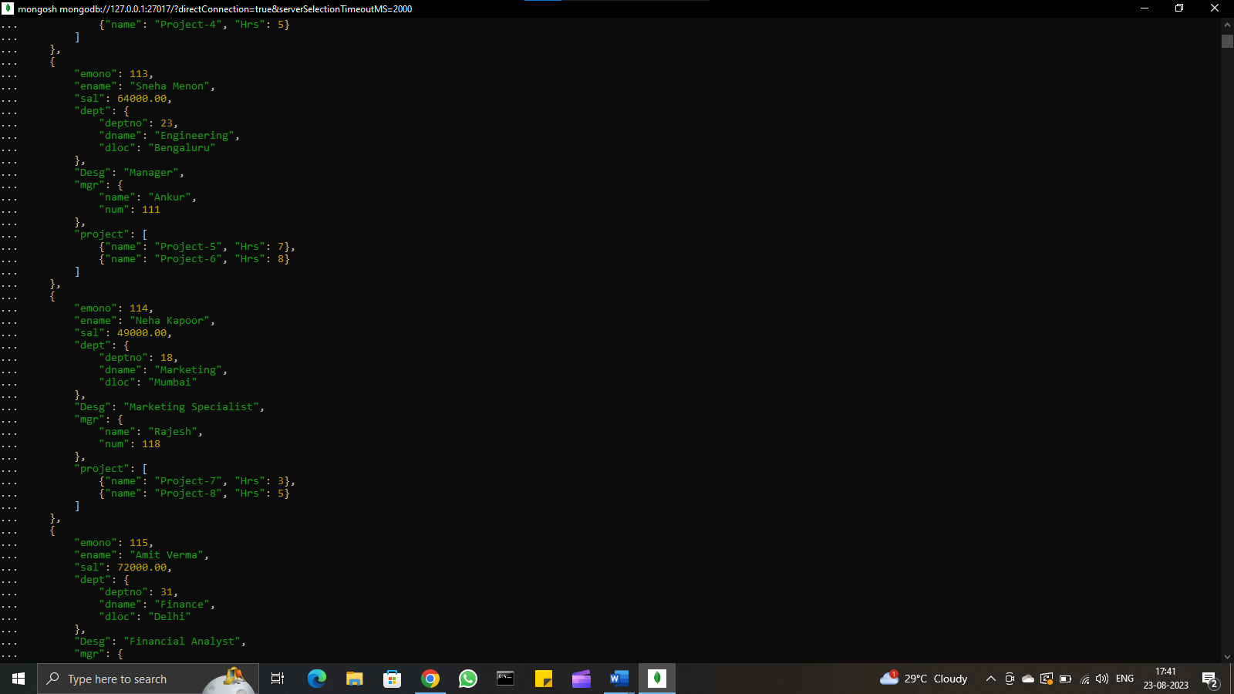

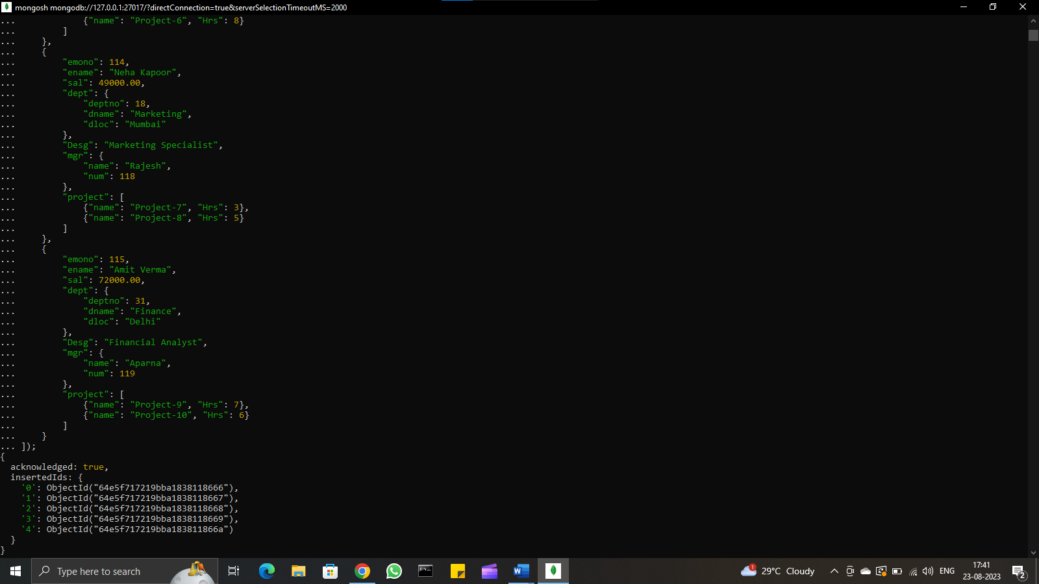

QUESTIONS

1. All employees with the desg as 'CLERK' are now called as (AO) Administrative Officers. Update the Employee collection for this.

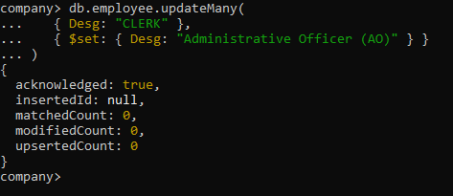

1. Change the number of hours for project-1 to 5 for all employees with designation analyst

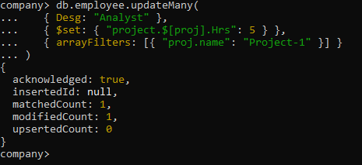

1. Add 2 projects project-3 and project-4 for employee whose name starts with "Deep" with 2hrs

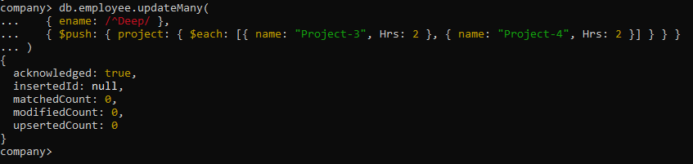

1. Add bonus rs 2000 for all employees with salary > 50000 and 1500 if salary <50000 and >30000 otherwise the bonus will be 1000

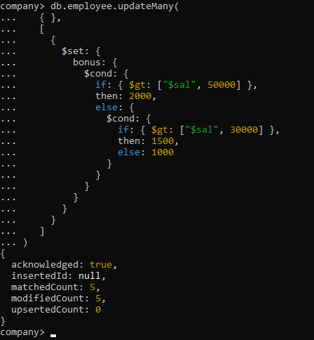

1. Change manager name to Tushar for all employees whose manager is currently "satish" and manager number to 3333

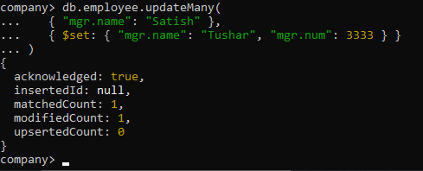

1. Increase salary of all employees from "purchase department" by 15000

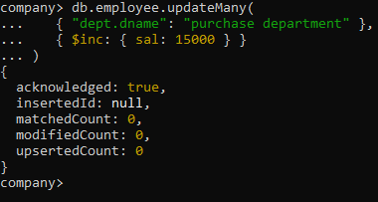

1. Decrease number of hrs by 2 for all the employees who are working on project-2

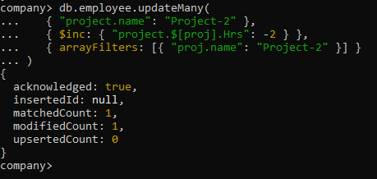

1. Delete project-2 from all employee document if they are working on the project for 4 hrs

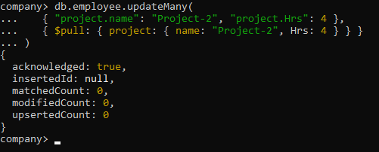

1. Change the salary of employees to 10000 only if their salary is <10000.

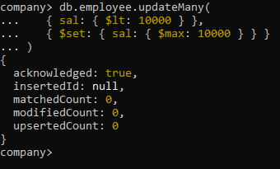

1. Increase bonus of all employees by 500 if the bonus is <2000 or their salary is <20000 or if employee belong to sales department

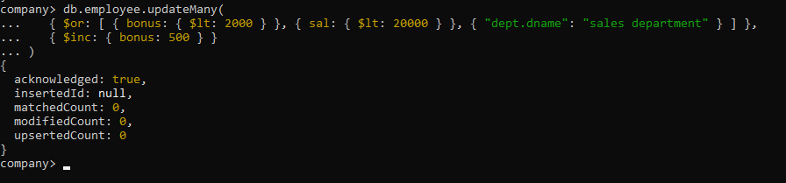

1. Add 2 new project at position 2 for all employees with designation analyst or salary is equal to either 30000 or 33000 or 35000.

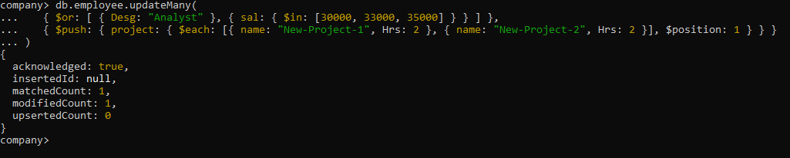

1. Delete last project for all employees with department name is "HR" and if the location is Mumbai

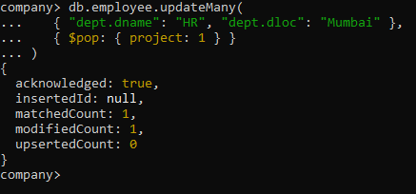

1. Change Designation for all employees to senior programmer if they are working on name:"Project-1" for 4hrs

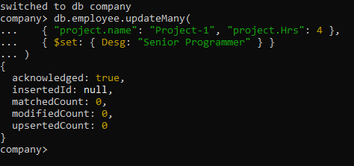

1. Add list of hobbies in all employees document whose manager is Rajan or Revati

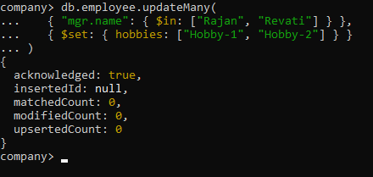

1. Add list of skill-set in all employee documents who are working on project-4 for 3 hrs or on project-3 for 4 hrs

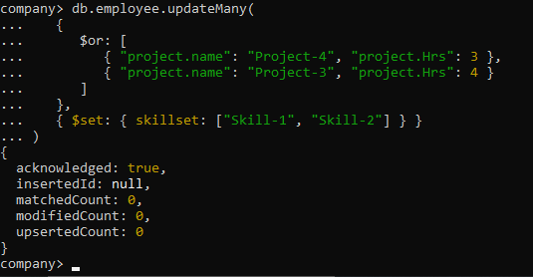

1. Add a new hobby as blogging at 3 positions in hobbies array for all employees whose name starts with R or P and ends with J or S

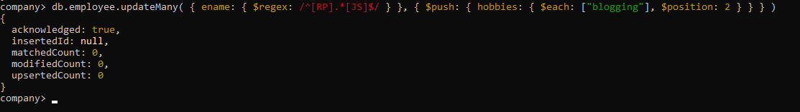

1. Increase salary by 10000 for all employees who are working on project-2 or project-3 or project-1

Decrease bonus by 1000 Rs and increase salary by 1000 Rs for all employees whose department location is Mumbai

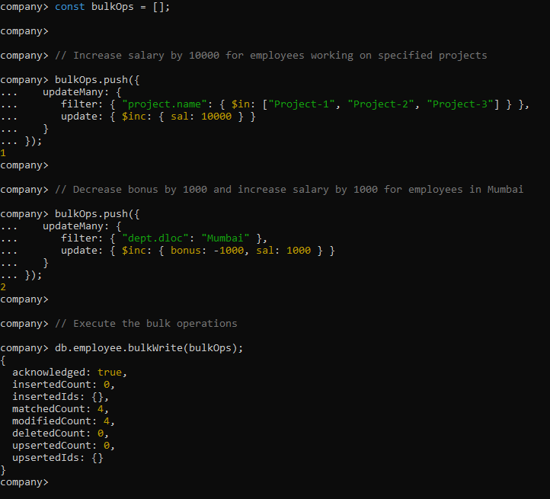

1. Remove all employees working on project-1

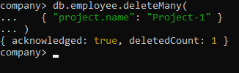

1. Replace document of employee with name "Deepak" to some new document

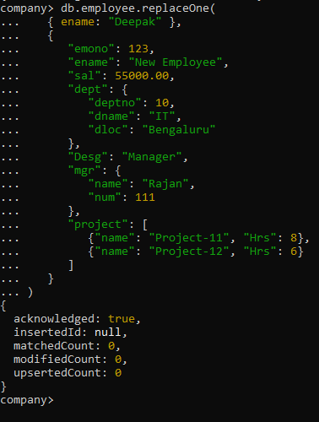

1. Change skill python to python 3.8 for all employees if python is there in skillset

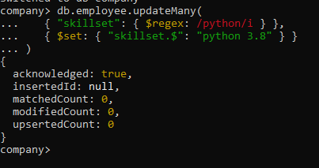

1. Add 2 skills Mongo DB and Perl at the end of the skillset array for all employees who are working at Pune location

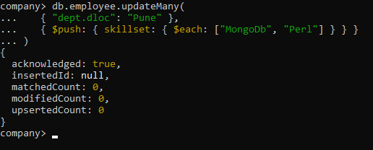

1. Delete first hobby from hobby array for all employees who are working on project-1 or project-2

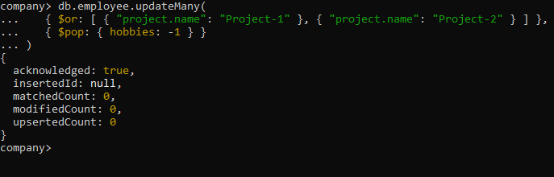

1. Delete last hobby from hobbies array for all employees who are working on project which is at 2nd position in project array for 4 hrs

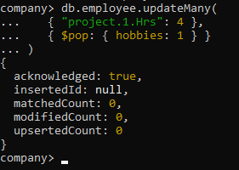

1. Add 2 new projects at the end of the array for all employees whose skillset contains Perl or python

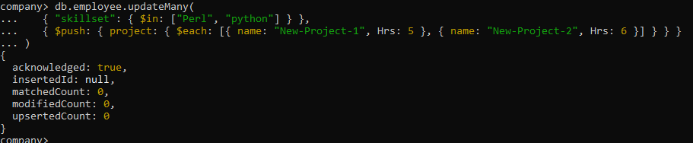

1. Change hrs to 6 for project-1 for all employees if they are working on the project-1 for <6 hrs, otherwise keep the existing value

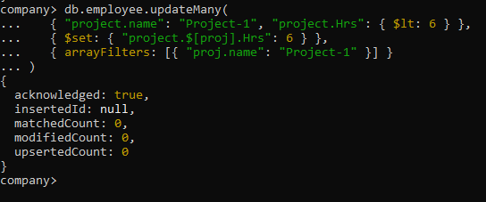

**DATA AT THE END**

